搭建开发环境
Csdm原文
https://qingsong.blog.csdn.net/article/details/124630072?fromshare=blogdetail&sharetype=blogdetail&sharerId=124630072&sharerefer=PC&sharesource=2201_75475875&sharefrom=from_link
安装插件
- C/C++
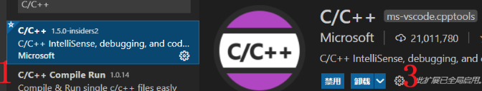
- Keil Assistant
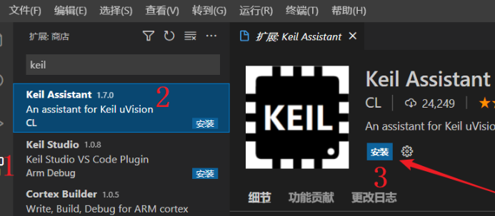
设置里面修改编译器路径
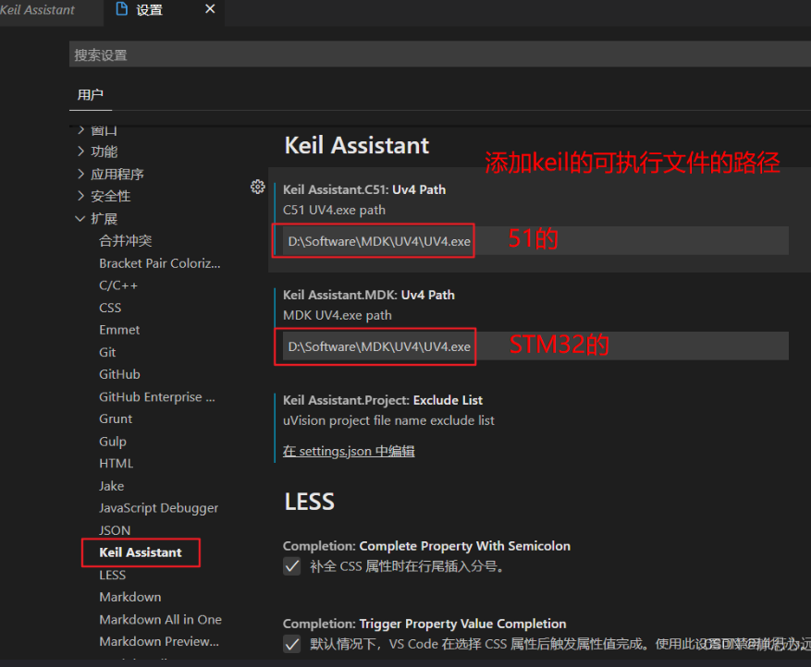
路径为：在桌面找到Keil的图标，右键查看文件所在位置，就能看到keil的可执行文件的路径，把它复制到上面就可以了。
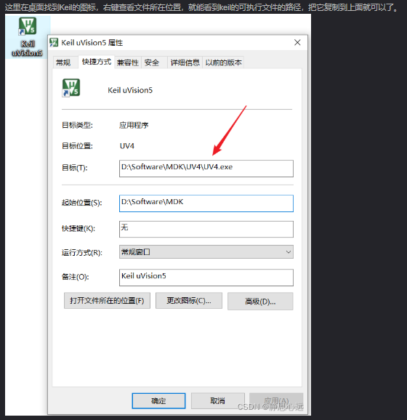
打开工程
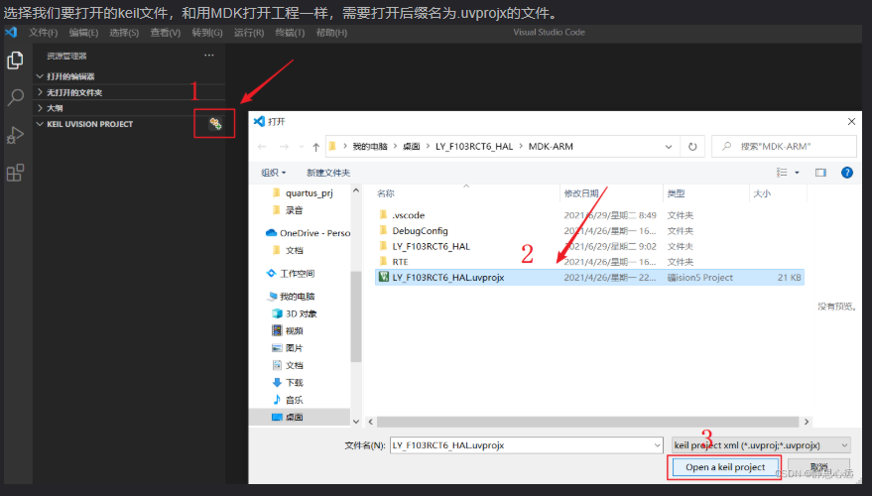

解决参数不能跳转到定义处问题
Csdn原文
https://blog.csdn.net/qq_63312142/article/details/151326969?fromshare=blogdetail&sharetype=blogdetail&sharerId=151326969&sharerefer=PC&sharesource=2201_75475875&sharefrom=from_link
在C/C++的扩展插件设置中，输入intelli sense engine，将提示器选项勾选为TagParser
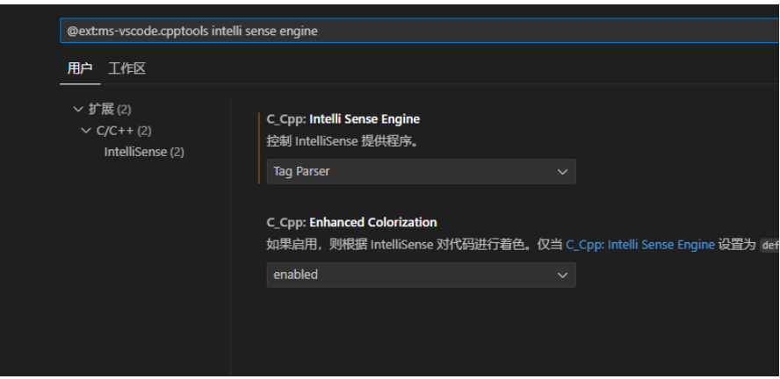

修改不同类型变量颜色
Csdn原文
https://blog.csdn.net/a123789999/article/details/117551437?fromshare=blogdetail&sharetype=blogdetail&sharerId=117551437&sharerefer=PC&sharesource=2201_75475875&sharefrom=from_link
设置搜索栏中搜索主题

搜索结果显示有许多个在setting.json中编辑，任意点开一个，即可编辑代码的颜色。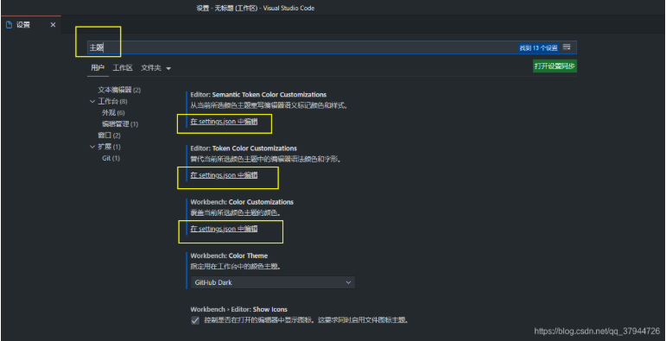
在文件setting.json的代码后面，插入相应的代码，然后保存。
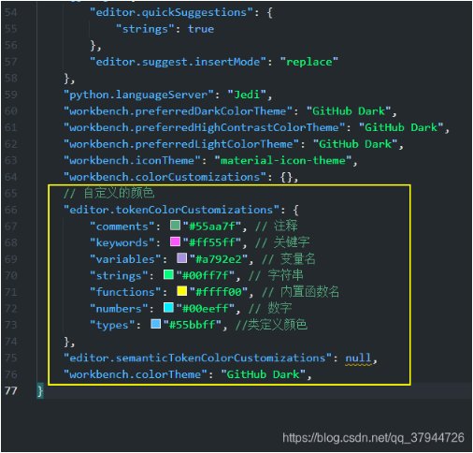
代码如下：
// 自定义的颜色
"editor.tokenColorCustomizations": {
"comments": "#55aa7f", // 注释
"keywords": "#ff55ff", // 关键字
"variables": "#a792e2", // 变量名
"strings": "#00ff7f", // 字符串
"functions": "#ffff00", // 内置函数名
"numbers": "#00eeff", // 数字
"types": "#55bbff", //类定义颜色
},

嵌入AI模型
使用拓展codegeex
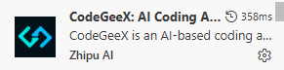
Uint_8/16/32,定义报错
uint32_t 实际是在D:/Keil_v5/ARM/ARMCC/include/stdint.h中定义的。将D:/Keil_v5/ARM/ARMCC/include添加到系统include目录。
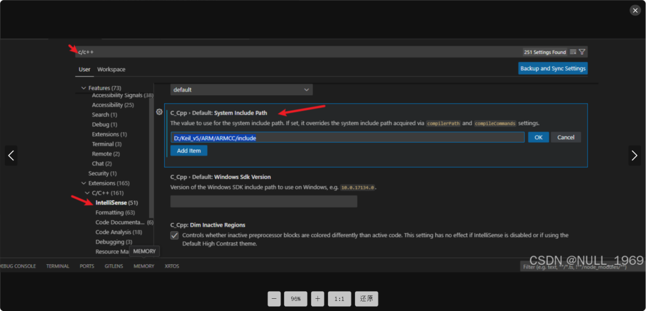

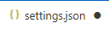配置
{
"cortex-debug.liveWatchRefreshRate": 500,
/* 交叉编译工具链安装的位置，具体到 xxx-gcc.exe 的目录即可 */
"cortex-debug.armToolchainPath": "D:/sofeware_officail/keil5MDK_V43/TOOLS.INI",
/* gdb的路径，需要指定到具体的.exe位置 */
"cortex-debug.gdbPath": "D:/sofeware_officail/MinGW/MinGW/bin/gdb.exe",
/* openocd的安装路径，需要指定到具体的.exe位置 */
"cortex-debug.openocdPath": "D:/sofeware_officail/openOCD/OpenOCD-20260302-0.12.0/bin/openocd.exe",
/* jlink的位置，如果使用stlink调试，此配置可以不用配置 */
//"cortex-debug.JLinkGDBServerPath": "${your_install_path}/JLinkARM_V415e/JLinkGDBServerCL.exe",
"files.encoding": "gb2312",
"terminal.integrated.detectLocale": "off",
"KeilAssistant.C51.Uv4Path": "D:\\sofeware_officail\\keil5MDK\\UV4\\UV4.exe",
"KeilAssistant.MDK.Uv4Path": "D:\\sofeware_officail\\keil5MDK_V43\\UV4\\UV4.exe",

"C_Cpp.intelliSenseEngine": "Tag Parser",
"KeilAssistant.Project.ExcludeList": [

"template.uvproj", "template.uvprojx"],
"editor.mouseWheelZoom": true,
"editor.fontLigatures": false,
"editor.semanticTokenColorCustomizsations": {
"enabled": true,
},
"workbench.preferredDarkColorTheme": "Default Light Modern",
"workbench.preferredHighContrastColorTheme": "Default Light Modern",
"workbench.preferredHighContrastLightColorTheme": "Default Light Modern",
"clangd.detectExtensionConflicts": false,

"editor.tokenColorCustomizations": {
"textMateRules": [
// 注释
{
"scope": "comment",
"settings": {
"foreground": "#139152"
}
},

// 关键字（if/else/for/while/return/switch等）
{
"scope": "keyword.control",
"settings": {
"foreground": "#0000FF"
}
},

// 变量合集：普通变量 + 函数参数
{
"scope": " variable.parameter",
"settings": {
"foreground": "#800080"
}
},

// 结构体成员合集（. / -> 后面的变量 + 结构体成员）
{
"scope": "variable.other.object.access",
"settings": {
"foreground": "#ff0000"
}
},
// 结构体成员合集（. / -> 后面的变量的结构体成员）
{
"scope": "variable.other.member",
"settings": {
"foreground": "#FFA500"
}
},

// 字符串
{
"scope": "string",
"settings": {
"foreground": "#bd28bd"
}
},

// 函数名（定义 + 调用）
{
"scope": "entity.name.function, entity.name.function.call",
"settings": {
"foreground": "#000000"
}
},

// 常量合集（数字 + 内置常量NULL/true/false）
{
"scope": "constant.numeric, constant.language",
"settings": {
"foreground": "#00d9ff"
}
},

// 类型合集（自定义类型 + 结构体/枚举/联合体）
{
"scope": "entity.name.type, entity.name.struct, entity.name.enum, entity.name.union",
"settings": {
"foreground": "#FF0000"
}
},

// 预处理指令 #include #define
{
"scope": "keyword.control.directive",
"settings": {
"foreground": "#bebb07"
}
},

// 基础数据类型 int/char/float/void
{
"scope": "storage.type",
"settings": {
"foreground": "#0000FF"
}
},

// 类型修饰符 static/const/extern
{
"scope": "storage.modifier",
"settings": {
"foreground": "#77ddbb"
}
},

// 运算符 + - * / = 等（白底优化为深灰色）
{
"scope": "keyword.operator",
"settings": {
"foreground": "#e737d9"
}
},

// 括号 () {} []（白底优化为深灰色）
{
"scope": "punctuation.bracket",
"settings": {
"foreground": "#a9f320e1"
}
},

// 标点符号 ; , . ->（白底优化为灰色）
{
"scope": "punctuation.terminator, punctuation.separator, punctuation.accessor",
"settings": {
"foreground": "#000000"
}
}
]
},
"C_Cpp.dimInactiveRegions": false,

"Codegeex.License": "",
"Codegeex.Privacy": false,
"Codegeex.Chat.LanguagePreference": "中文",
"Codegeex.Comment.LanguagePreference": "中文",
"Codegeex.SidebarUI.LanguagePreference": "中文",
"Codegeex.CompletionModel": "CodeGeeX Pro[Beta]",
"Codegeex.CommitMessage.LanguagePreference": "中文",
"Codegeex.RepoIndex": true,
"editor.bracketPairColorization.independentColorPoolPerBracketType": true,
"debug.onTaskErrors": "debugAnyway",
"explorer.confirmDelete": false,
"continue.showInlineTip": false,
"terminal.integrated.automationProfile.windows": null,
"terminal.integrated.profiles.windows": {
"PowerShell": {
"source": "PowerShell",
"icon": "terminal-powershell",
"path": "C:\\Windows\\System32\\WindowsPowerShell\\v1.0\\powershell.exe",
},
"Command Prompt": {
"path": "C:\\Windows\\System32\\cmd.exe",
"args": [],
},
"Git Bash": {
"source": "Git Bash",
"icon": "terminal-git-bash",
"path": "D:\\sofeware_officail\\cursor\\git\\Git\\bin\\bash.exe",
"args": ["--login", "-i"],
},
"Windows PowerShell": {
"path": "C:\\Windows\\System32\\WindowsPowerShell\\v1.0\\powershell.exe",
},
},
"terminal.integrated.defaultProfile.windows": "Command Prompt",
"http.systemCertificatesNode": true,
"terminal.explorerKind": "both",
"C_Cpp.default.systemIncludePath": [
"",
"D:\\sofeware_officail\\keil5MDK\\ARM\\ARMCC\\include",
],
"editor.language.colorizedBracketPairs": [],
"editor.defaultColorDecorators": "always",
"workbench.colorTheme": "Default Light Modern",
"C_Cpp.enhancedColorization": "disabled",
"cmake.cacheInit": "string",
"code-runner.runInTerminal": true,
"code-runner.defaultLanguage": "C",
"code-runner.ignoreSelection": true,
"code-runner.clearPreviousOutput": true,
"code-runner.fileDirectoryAsCwd": true,
"code-runner.languageIdToFileExtensionMap": {

"bat": ".bat",
"powershell": ".ps1",
"typescript": ".ts"
},
"chat.viewSessions.orientation": "stacked",
"window.autoDetectHighContrast": false,
}

