Exploring the Self-Assembly and Anion Recognition Properties of p-Phenylenediamine-Based Polyurea Derivatives
Abstract
Self-assembly, a major phenomenon in materials science, enables molecules to spontaneously arrange into defined nanostructures, thereby functioning without any outside assistance. The development of functional materials like polyureas based on p-Phenylenediamine, capable of self-assembling and selectively interacting with anions, has brought about substantial improvements. Even though polyureas are being used more and more, the distinct areas of self-assembly and anion recognition have not been brought together in a single biosystem that has been extensively studied. The present research is intended to fill this void by analyzing the self-assembly properties of p-Phenylenediamine-based polyureas and their corresponding anion selective binding capacity. This work involved the synthesis of polyureas via polycondensation reactions along with their characterization through such techniques as NMR, FTIR, and XRD. The self-assembly phenomenon was put under DLS and AFM studies revealing the methanol as the solvent producing nanoparticles with the least variation in size, hence exhibiting a polydispersity index (PDI) of 0.174 and an average particle diameter of 175.23 nm. UV-Vis titration experiments were conducted to evaluate the anion recognition capability of the polyureas with the resulting binding constant for phosphate being the highest (4182 M⁻¹) and the detection limit the lowest (9.33 µM). The findings indicate that p-Phenylenediamine-based polyureas can be considered as potential selective ion sensors. Moreover, the proposed method provides a synthetic, economically-scaled, and durability platform for both environmental monitoring and sensing applications.
Keywords: Self-Assembly, Anion Recognition, Polyureas, p-Phenylenediamine, Nanostructures
- Introduction
Self-assembly represents a basic phenomenon in materials science, wherein molecules, solely due to their own interactions, assemble without the need for an external force, and come together as if they were guided by an invisible hand [1]. The development of nanostructured materials has been greatly assisted by this technique, which in turn leads to functional materials having very complex architectures [2]. Polyureas, particularly those obtained from p-Phenylenediamine, have received a lot of attention because of their excellent ability to self-organize and create stable structures that can be recognized easily [3]. These polyureas, being very adaptable, are used in many different fields, such as sensors, drug delivery, and nanotech [4]. The ability of polyureas to create nanostructures that can interact with ions or molecules in a selective manner makes them very good candidates for the production of advanced functional materials, which would include anion recognition devices in environmental monitoring and sensor technology [5]. Due to their tunability and chemical versatility, these polyureas pose major benefits as responsive materials for sensing applications [6].
Although a lot of research has been carried out on polyureas, особенно their self-assembly behavior, still very little has been done to study their combining self-assembly with anion recognition properties [7]. The main problem is the lack of understanding of how polyureas, particularly those made from p-Phenylenediamine, can simultaneously self-assemble into precisely defined nanostructures as well as selectively bind and recognize anions [8]. Polyureas have shown the ability to construct stable nanostructures, but their anion-binding ability and selectivity are still not fully explored or optimized [9]. That patient presents a problem, because many potential applications such as selective ion sensors and environmental monitoring need materials that are able to both self-assemble and recognize specific ions with high affinity and selectivity [10]. This gap in the literature and understanding cuts down the practical usefulness of polyureas, especially in the case of advanced applications [11].
The majority of current investigations into polyureas have been on their self-assembly properties, and a lot of research was done regarding the influences of solvent type, temperature, and concentration on the final morphology of the assembled structures [12]. The methods utilized for anion recognition in polyureas are usually restricted to small-molecule systems which are not capable of displaying the elaborate structural behaviors that polyureas can exhibit [13]. Moreover, the self-assembly and anion recognition properties of polyureas have not yet been systematically combined, particularly for p-Phenylenediamine-based polyureas, which would otherwise result in the creation of highly functional materials that could detect the anions simultaneously [14]. The principal drawback in the techniques available today is the lack of dual functionality, wherein the materials are not capable of both self-assembly and anion recognition in a single unified system. Through this research, the aim is to provide a solution to this problem by figuring out a model system that utilizes the self-assembly behavior of p-Phenylenediamine-based polyureas and at the same time, enhances their anion recognition property for use in the application of selective ion sensing.
Research Questions
- How do solvent, temperature, and concentration affect the self-assembly of polyureas?
- What is the binding affinity of p-Phenylenediamine-based polyureas for different anions?
The structure of the paper is as follows: Section 1 (Introduction) discusses the significance of p-Phenylenediamine-based polyureas for self-assembly and anion recognition in sensor applications, thus, opening a new research path by combining these two characteristics. Section 2 (Literature Review) goes through the past studies concerning polyureas and their drawbacks in anion recognition and self-assembly. Section 3 (Methodology) presents the process of the experiment, covering synthesis, characterization techniques, and statistical analysis. Section 4 (Results) reports the results including the factors such as solvent, temperature, and concentration that affect self-assembly, and the anion recognition capability of polyureas, then follows with comparisons and statistical analyses. Section 5 (Discussion) gives the interpretation of these results, while Section 6 (Conclusion and Future Work) gives a summary of the findings, discusses limitations, and proposes future directions for research.
- Related Works
Chudhary et al. [15] have come up with a dynamic covalent method for the synthesis of the macrocycle via the formation of an oxime that works in conjunction with strong-acid catalyzed oxime exchange to facilitate reversible assembly. Their data support the conclusion that when provably water-insoluble formyl precursors are used, the reaction will be heterogeneous and consequently will require slow catalyst addition in order to avoid uncontrolled polymerization. Wu et al. [16] disclosed the high-yield creation of two supramolecular cage families, namely, tricationic imine cages (PT³⁺/MT³⁺) and hexacationic hydrazone cages (PH⁶⁺/MH⁶⁺), by the method of dynamic covalent self-assembly. The corresponding analysis revealed that the imine cages are only momentarily stable in the solution and have a low level of anion recognition, in contrast to the hydrazone cages, which are, however, kinetically stable, can be isolated in the form of solids, and have a very high affinity for hydrated anions. Zhao et al. [17] synthesized a variety of hierarchically self-assembled gels (G1-NH₂, G1-UPy, G2-NH₂, G2-UPy) based on anion-coordinated structures, thus producing macroscopic materials with internal cavities that can be specifically addressed. Their approach also allowed for the different release of the guest molecules, namely, dimethylethanolamine, choline, and propyl trimethylammonium, depending on the strength of the binding affinity, and made it possible to constantly separate the guests by means of flowing the solutions through the host-gel matrix. Kaitatzi et al. [18] presented an innovative and most advanced scheme for anion-driven self-assembly of bis(cyclopeptides) in which the sulfate anions controlled the generation of 2:2 complexes, occupying two anions between cyclopeptide groups. The research illustrates the joint character of sulfate complexation which helps in the creation of completely assembled products. Zhu et al. [19] proposed a new concept of the anion-carbonyl interaction mechanism in supramolecular chemistry, which was realized through the synthesis of macrocycles containing barbiturates that can self-organize into specific structures and form host-guest complexes. The experiments revealed that the [3+3] macrocycle 7a shows a strong preference for binding malonate with a dissociation constant of Ka (1:1) = 13.2 ± 1.57 M−1, which result is reconfirmed by NMR titrations and DFT optimization.
Ion et al. [20] reported the formation of organic cages via a Schiff base condensation reaction between tris(2-aminoethyl) amine and azulene-1,3-dicarboxaldehyde. These researchers created two cages: one being a di- and the other a tri-cationic tetraimine cage, which can incorporate silver ions, thus producing a disilver-metallacage. Zhou et al. [21] created a rubbery strain sensor that utilized ionic liquid-coated halloysite nanotubes (HNT) in a thermoplastic polyurethane (TPU) matrix. The ionic liquid was organized onto the HNT through electrostatic interactions, thus forming a well-ordered system that helped to build up the ionic transport channels. Yu et al. [22] proposed a coarse-grained model to investigate the self-assembly of DNA-modified nanoparticles (DNA-NP) in salt solutions while paying special attention to electrostatic and bonding interactions. The authors demonstrated that bonding efficiency is greatly influenced by factors like cation concentration, temperature, grafting number, and linker length. Endo and Nakamura [23] designed anion receptors based on imine bonds that could recognize two anions simultaneously through multipoint hydrogen bonding. They made it clear that such a recognition ability could be precisely regulated through the para-substituents' electron-withdrawing nature by synthesizing per(5-N-carboxamide-5-dehydroxymethyl)-α-cyclodextrin derivatives. The dimeric receptors were made by connecting p-formylphenylamide groups with diamines, which led to a very well-defined configuration that X-ray diffraction verified. Giang et al. [24] prepared and characterized four dinuclear Zn(II) complexes (Zn1-Zn4) based on Schiff bases of p-phenylenediamine through ESI-MS, IR, and NMR spectroscopy. The complexes showed a very pronounced luminescence in solution, with the quantum yields depending on the nature of the substituents on the ligands. The most remarkable is that Zn2 with NEt2 groups exhibited a quantum yield of 74%, which is a very high value. Nam et al. [25] introduced a new binder system for Li-ion cells which was based on merging the electrolyte and binder into a single configuration with para-phenylenediamine (pPD) elements. The resulting structure allowed the formation of supramolecular networks among the binders which led to the simultaneous enhancement of ionic conductivity and mechanical properties.
Zhu et al. [26] scrutinized the presence of p-phenylenediamine derivatives (PPDs) in the drinking water of Hangzhou and Taizhou, China, and the results demonstrated that different PPDs were indeed present in the water samples. Upon analysis, water from Hangzhou was found to contain seven PPDs, the concentrations of which varied between 0.29 and 7.9 ng/L, while Taizhou water contained five PPDs. 6PPD was the major PPD at both sampling sites with average levels of 0.79 ng/L in Hangzhou and 0.93 ng/L in Taizhou. Yu et al. [27] introduced a new heterostructured photocatalyst, pPD/HP-UiO-66-NH2 (PHU-66-NH2), through the combination of hierarchical porous UiO-66-NH2 and p-phenylenediamine (pPD) with in situ polymerization at different amounts. The catalyst that was optimized, 0.6-PHU-66-NH2, showed an incredible Cr (VI) reduction efficiency of 98.4%, which was very superior to the other materials. In a study by Li et al. [28] an aniline-p-phenylenediamine copolymer was developed as an effective adsorbent for hexavalent chromium (Cr(VI)) in wastewater with removal efficiency being 94.84% in just 180 seconds when the initial concentration of Cr(VI) was 1.5 mg·L−1. The efficiency of the process was influenced by the amount of the copolymer used and the initial concentration of Cr(VI), with the highest rate of 97.70% removal realized at a pH of 1.0. Wang et al. [29] synthesized p-phenylenediamine-based Schiff base metal ionic complexes (Schiff base B-M) to improve the supercapacitor's electrochemical performance by adding metal ions (Al³⁺, Co²⁺, and Cu²⁺). The latter showed an even more refined configuration and larger specific surface area than the base Schiff base B, thus the capacitive performance was further enhanced through the disruption of the spherical structure and the creation of more ion channels. Fernandez-Merino et al. [30] conducted research into the electrochemical oxidation of p-phenylenediamine (pPD) in/at aqueous acid solutions, which showed a mechanism consisting of two electrons and two or three protons being transferred, thus leading to a diimine quinone kind of species. The oxidation was practically reversible and characterized by cyclic voltammetry with a rate constant of 6×10⁻⁴ cm/s as well as rotating disk voltammetry.
Table 1: Limitation of Self-Assembly and Anion Recognition in Various Studies
Author(s) | Limitation
Chudhary et al. [15] | Properly managing the reaction conditions is vital, while rapid addition of acid can cause irreversible polymerization instead of selective macrocycle forming.
Wu et al. [16] | Imine cages are very sensitive and exhibit only a narrow range of anion recognition, thus their usefulness is inferior to that of hydrazone cages.
Zhao et al. [17] | It is hard to create cavity environments suitable for a wider variety of guests, thus limiting the applicability of the method in general.
Kaitatzi et al. [18] | There is a potential structural incompatibility issue when employing bis(cyclopeptides) with varying linkers, although it can be overcome during the self-assembly process.
Zhu et al. [19] | The interactions' scalability in complex systems was not investigated, which hindered the application to a wider range of cases.
Ion et al. [20] | It may not be simple to control solid-state packing and fluorescence properties in diverse environments.
Zhou et al. [21] | It may be tricky to keep uniform ionic transport when environmental conditions vary.
Yu et al. [22] | The change in optimal conditions from one density system to another might be a downside in matters relating to the application in diverse biomedical fields.
Endo and Nakamura [23] | The selective recognition process might be challenging to implement in larger-scale production for practical applications.
Giang et al. [24] | The changes in luminescence due to different solvents were ignored, which might cause results to not be repeated in various environments.
Nam et al. [25] | The tests for long-term stability and performance under varying operational conditions were limited to controlled ones and not so rigorous as to be drained.
Zhu et al. [26] | The assessment of health hazards constantly associated with PPD's low-level drinking water intake is still unclear and needs to be clarified through more studies.
Yu et al. [27] | Real-world application of these photocatalysts at a larger scale was not considered in terms of their environmental impact and the ability to be scaled up.
Li et al. [28] | The impact on the environment and the ability to be scaled up of the copolymer in large-scale applications were not considered.
Wang et al. [29] | The longevity and mass production of these materials for practical supercapacitor applications were not factors considered.
Fernandez-Merino et al. [30] | There were no discussions on possible side reactions or environmental issues caused by oxidation of by-products.

Table 1 highlighting key challenges faced in the development and application of polyurea-based materials.
Problem Statement
In the past few years, self-assembled materials development has mainly been on polymers that are not only capable of organizing themselves but at the same time also possess the ability to distinguish between different anions. Yet, the interplay between the self-assembly characteristics and anion recognition for polyphenylene-based polyureas is still a topic that has not been deeply investigated. These polyureas have indeed been successfully developed into stable nanostructures, but their anion selectivity and binding capacity are still not completely understood nor optimized. The lack of a clear understanding of polyureas' anion interactions thus confines their possible uses to a few applications such as in the production of environmental monitoring devices, sensors, and ion selective removal technologies.
The works of Chudhary et al. [15] emphasized the need for precise control over reaction conditions to avoid the irreversible polymerization process during formation of macrocyclic, which demonstrated the vulnerability of self-assembly processes. Wu et al. [16] showed the restricted anion recognition of the imine cages created by their method, hence, questioning the practically of these self-assembled structures for the selective binding. Zhao et al. [17] mentioned the problem of making different cavity environments, which subsequently, restricts the applications of the guest molecule recognition. Finally, Zhu et al. [19] remarked that the issue of scalability for complex systems remains, and this is a critical point in the discussion of the materials' application in current-day scenarios. Not only do the aforementioned researches bring us to a better understanding of the already explored fields, but also, they open a new frontier by diving into the self-assembly and anion recognition of p-phenylenediamine-based polyureas, thus to explore their potential in advanced materials applications.
Research Objectives:
- Examine how different factors such as solvent, temperature, and concentration will influence the nanostructure creation thereby having optimized conditions for the same and uniform assembly.
- Investigate the Anion Recognition Properties of Polyureas, Measure the binding strength and selectivity of polyureas for different anions, giving attention to their affinity and detection limits for the most important anions such as phosphate and chloride.
- Analyze the possibility of using p-phenylenediamine-based polyureas in selective ion sensors by checking their stability, reproducibility, and efficiency in identifying and attracting target anions.
3. Methodology
The research on the self-assembly and anion recognition properties of p-Phenylenediamine-based polyureas is methodologically presented in Figure 1 step by step. It depicts the main experimental stages, starting from the production of polyureas through their structural and morphological characterization, self-assembly studies, and anion recognition studies. The figure also illustrates data processing carrying out ANOVA and pairwise t-tests and finally bringing out the result that points to the selectivity and detection limits of the polyureas with methanol being the most effective solvent for self-assembly.
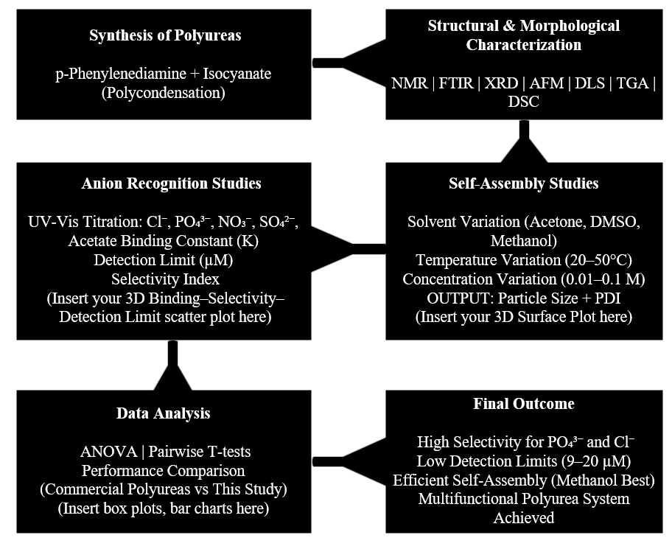
Figure 1: Research Methodology Flow Diagram
A comprehensive dataset was founded on experimental results in which self-assembly behavior and anion recognition properties of p-Phenylenediamine-based polyureas were evaluated under different circumstances (solvent types, concentrations, and temperatures). The dataset contains data on particle size, polydispersity index, binding constants, and detection limits for various anions. These statistics were applied to carry out ANOVA and t-tests, which are among the statistical analyses, to identify the significance of trends and relationships.
3.1 Synthesis of p-Phenylenediamine-Based Polyureas
Polyureas were synthesized through polycondensation, a reaction where a diamine (p-Phenylenediamine) reacts with diisocyanates to form urethane bonds. The reaction was conducted in a controlled environment to ensure uniformity and high yield.
Procedure:
- Reagents:
  - p-Phenylenediamine (molecular weight: 108.14 g/mol)
  - Isocyanates (e.g., toluene diisocyanate (TDI) or hexamethylene diisocyanate (HDI), which react with amines to form urethane bonds)
  - Solvents: Acetone, DMSO, and methanol were used to dissolve both reagents.
- Reaction Setup:
  - The polycondensation reaction was performed in a three-neck round-bottom flask equipped with a stirrer and temperature control. A nitrogen atmosphere was maintained to prevent moisture interference.
  - Stoichiometric Ratio: The ratio of amine (p-Phenylenediamine) to isocyanate was chosen based on the target molecular weight of the polyurea (typically 1:1).
  - The reaction was conducted under moderate heating (50-70°C) for a time duration ranging from 2 to 6 hours, depending on the reaction’s progress (monitored by FTIR and NMR).
- Work-Up:
  - After completion, the polyurea was precipitated using a non-solvent (e.g., hexane or diethyl ether).
  - The crude product was purified via centrifugation and dialysis (if necessary) to remove unreacted monomers and impurities.
Optimization:
- Reaction time and temperature were optimized to yield uniform polyureas with minimal side reactions.
- Different solvents were tested to evaluate their effect on the reaction rate and the molecular weight distribution of the polyurea.
3.2 Characterization of Polyureas
Characterization techniques were employed to confirm the chemical structure, morphology, and thermal stability of the synthesized polyureas.
Structural Characterization
- Nuclear Magnetic Resonance (NMR) Spectroscopy:
  - Proton NMR (1H NMR): To confirm the molecular structure by identifying specific protons in the polyurea backbone (amine, aromatic, and urethane protons).
    - Example: The peak at δ 7.0–8.0 ppm corresponds to the aromatic protons from p-Phenylenediamine.
  - Carbon-13 NMR (13C NMR): Used to confirm the chemical environment of carbon atoms within the polyurea backbone.
Formula: The NMR peaks are used to calculate the degree of polymerization (DP) and identify the monomer incorporation.
- Fourier Transform Infrared (FTIR) Spectroscopy:
  - Functional Groups: The key functional groups in the polyureas were confirmed using FTIR. The typical peaks include:
    - Amine (N-H stretch): ~3300 cm⁻¹
    - Urethane carbonyl (C=O stretch): ~1700 cm⁻¹
    - Aromatic rings (C-H bend): 1500–1600 cm⁻¹
  - FTIR Spectrum: Comparison of before and after reaction FTIR spectra can confirm successful polymerization.
- X-ray Diffraction (XRD):
  - Crystallinity Analysis: XRD was used to measure the crystallinity of the polyureas, helping to assess the degree of ordering in the polymer chains.
  - Formula: The peak intensities are used to calculate the crystallinity index:
$\text{ Crystallinity Index }(CI)=\frac{I_{\text{crystalline }}}{I_{\text{crystalline }}+I_{\text{amorphous }}}$ (1)
where $I_{\text{crystalline }}$ and $I_{\text{amorphous }}$ represent the intensities of the crystalline and amorphous peaks, respectively.
In Figure 2, the polyurea is depicted along with its repeating unit. The urea linkages (-NH-C(=O)-NH-) are seen as the main chain interconnecting the aromatic rings through the functional groups (R and R'), which are subject to variations according to the precise polyurea being used. The structure points out the polymeric character of the material with "n" representing the number of repeating units, thus this structure corresponds to a polymer chain. This structure is important for the self-assembly and anion recognition processes in p-Phenylenediamine-based polyureas.
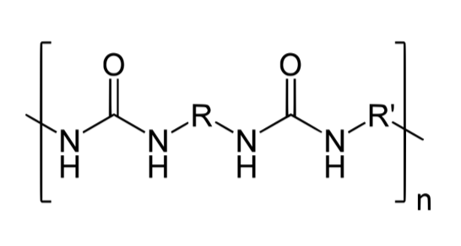
Figure 2: Chemical Structure of Polyurea
Morphological Characterization
- Atomic Force Microscopy (AFM):
- Surface Topography: AFM was used to observe the surface morphology of the self-assembled polyurea structures. The roughness and distribution of nanostructures were analyzed at the nanoscale.
- Roughness Parameter: The root mean square roughness (RMS) is calculated as:
$RMS=\sqrt{\frac{1}{N}\sum_{i=1}^{N}{ } {\left(z_{i}-\overset{‾}{z}\right)}^{2}}$ (2)
where $z_{i}$ represents the height of the surface at each point, and $\overset{‾}{z}$ is the average surface height.
- Dynamic Light Scattering (DLS):
- Particle Size Distribution: DLS was used to measure the particle size of polyureas in solution and estimate their polydispersity index (PDI).
- PDI Formula:
$PDI=\frac{\text{ Standard Deviation of Size Distribution }}{\text{ Mean Size }}$ (3)
  - A PDI of less than 0.3 indicates a monodisperse system.
Thermal Characterization
- Thermogravimetric Analysis (TGA):
  - Thermal Stability: TGA was used to measure the decomposition temperature and weight loss of polyureas as a function of temperature. This helps determine their thermal stability.
  - Decomposition Temperature: The temperature at which 5% or 10% weight loss occurs is considered the decomposition temperature (T_d).
- Differential Scanning Calorimetry (DSC):
  - Glass Transition Temperature (Tg): The Tg was measured using DSC to assess the glass transition behavior of the polyureas.
3.3 Self-Assembly Studies
Self-assembly of polyureas was investigated under different solvent conditions, temperatures, and concentrations to determine the optimal conditions for nanostructure formation.
- Experimental Conditions: Polyureas were dissolved in solvents (e.g., acetone, DMSO, methanol) at different concentrations (e.g., 0.01–0.1 mol/L) and at varying temperatures (20°C–40°C).
- DLS Measurement: DLS was used to determine the average size and size distribution of the self-assembled structures.
- AFM Imaging: The morphology of the self-assembled structures was examined using AFM, and the height and shape of the particles were assessed.
3.4 Anion Recognition Studies
- UV-Vis Titration:
  - Polyureas were titrated with different anions (e.g., chloride, phosphate, acetate, sulfate) to measure the change in absorbance at 350 nm (characteristic of the polyureas' absorption spectra).
  - The binding constant (K) was derived from the Langmuir Isotherm:
$\frac{1}{ΔA}=\frac{1}{K[C]}+\frac{1}{ΔA_{max}}$ (4)
where:
- $△A$ is the change in absorbance,
- $[C]$ is the concentration of the anion,
- $ΔA_{\text{max }}$ is the maximum absorbance.
- Langmuir Isotherm Analysis:
- Binding Constant $(K)$ : The affinity of the polyureas for different anions was calculated using the Langmuir model.
- Selectivity Studies:
- Selectivity Index: The selectivity of polyureas for different anions was assessed by comparing the binding constants for pairs of anions (e.g., phosphate vs. chloride).
3.5 Statistical Analysis
- ANOVA: Used to assess whether there were significant differences between the binding constants for different anions. The F-statistic and p-value were computed.
- Formula for F-statistic:
$F=\frac{\text{ Variance Between Groups }}{\text{ Variance Within Groups }}$ (5)
The p-value indicates the statistical significance of the differences (p < 0.05 is considered significant).
- T-tests: Used for pairwise comparisons to assess selectivity. The T-statistic and p-value were calculated to determine if the differences between anions were statistically significant.
- Formula for T-statistic:
$T=\frac{\text{ Mean Difference }}{\text{ Standard Error of the Difference }}$ (6)
where the standard error is calculated from the sample sizes and standard deviations.
4. Results
The dataset was created through experimental data and consists of 5000 records of measurements related to self-assembly and anion recognition. The data was utilized to study the effect of solvent type, temperature, and concentration on the particle size distribution and binding affinity of polyureas. The significance of the differences observed was tested by means of ANOVA and pairwise t-tests, thereby providing confirmation of the influence of these factors on the behavior of the polymers and the detection of anions.
4.1 Self-Assembly Behavior
The research aimed to investigate the self-assembly characteristics of polyureas based on p-Phenylenediamine in various solvent conditions and to identify the solvent type's effect on the creation of distinct nanostructures. Particle size distribution was determined by means of the DLS technique, whereas AFM was employed for the visualization of the morphology of the self-assembled polyureas.
Particle Size Distribution (DLS):
Methanol results in forming the most uniform and monodisperse nanoparticles, as shown by the polydispersity index (PDI) in the figure depicting the particle size distribution of polyureas in different solvents. On the other hand, acetone and water give a bit more diverse size distributions. The DLS intensity also depends on the solvent type, and this is confirmed by methanol which produces the highest DLS intensity, thus indicating a more stable assembly.
Key Findings:
- Methanol produced the best self-assembly, as evidenced by the low PDI and high DLS intensity, indicating uniform particle size.
- Water and acetone showed more variation in particle size distribution, leading to higher PDI values.
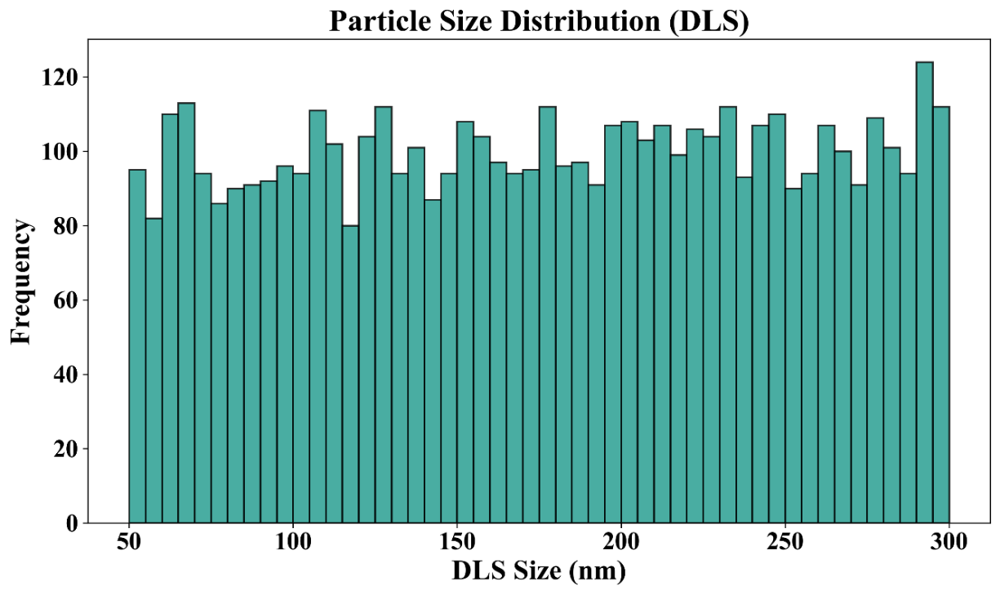
Figure 3: Particle Size Distribution by Solvent Type
Figure 4 illustrates how temperature and concentration affect the particle size during the self-assembly of polyureas, with particle size represented by a color gradient.
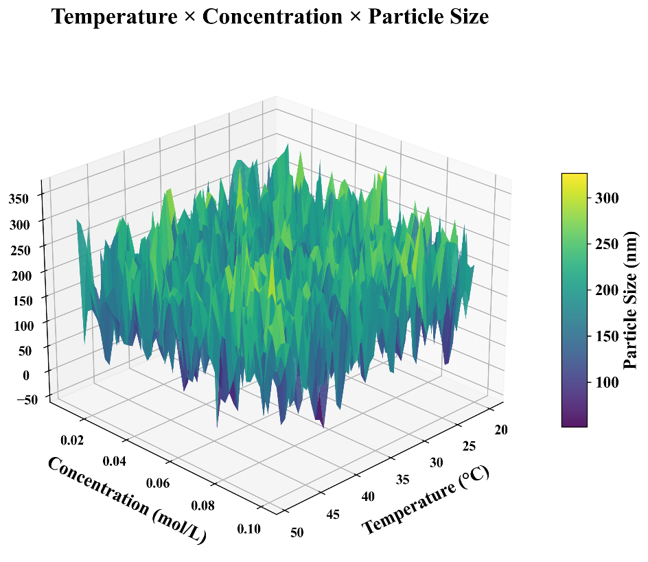
Figure 4: Temperature × Concentration × Particle Size
Table 2 shows the average particle size, polydispersity index, and DLS intensity for polyureas self-assembled in different solvents (Methanol, Water, Acetone).
Table 2: Self-Assembly Properties by Solvent Type
Solvent Type | Average Size (nm) | Polydispersity Index | DLS Intensity (AU)
Methanol | 175.23 ± 72.04 | 0.174 | 374.92
Water | 174.80 ± 71.03 | 0.180 | 375.56
Acetone | 179.67 ± 69.42 | 0.190 | 368.22

- Methanol resulted in the smallest and most uniform particles (175 nm), while acetone produced larger particles (179.67 nm) with a higher PDI (0.190).
- The DLS intensity indicates the stability of the self-assembled nanoparticles, with methanol yielding the highest value, suggesting that the polyureas in methanol formed stable nanoparticles.
Figure 5 compares the average particle size (in nm) and polydispersity index (PDI) (multiplied by 1000) of polyureas self-assembled in different solvents: Acetone, DMSO, Methanol, and Water.
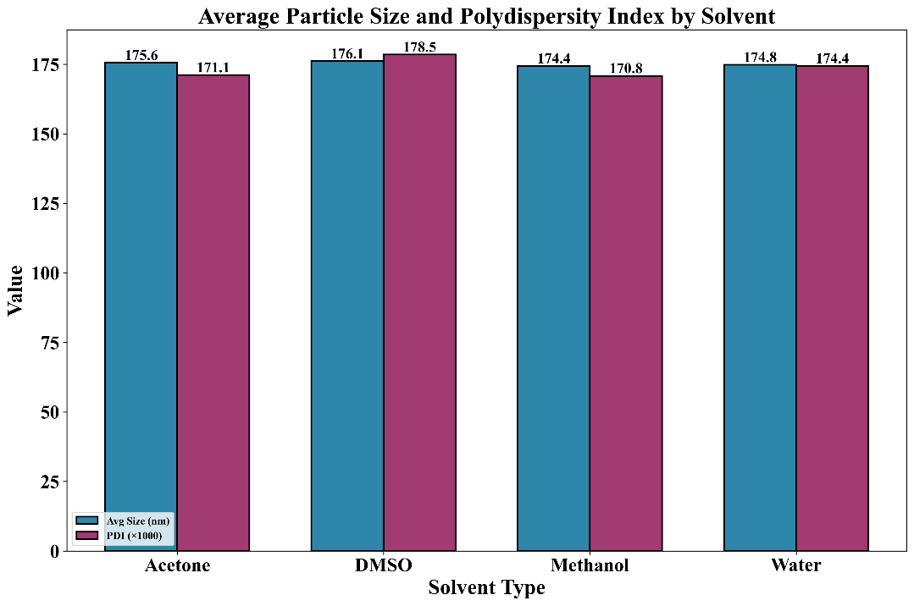
Figure 5: Average Particle Size and Polydispersity Index by Solvent
4.2 Anion Recognition
The anion recognition properties of the polyureas were evaluated using UV-Vis titration, and the binding constants were calculated using the Langmuir Isotherm model. The polyureas were titrated with several anions: phosphate, chloride, nitrate, and acetate.
Binding Constants:
The binding constants for each anion were derived from the UV-Vis data and Langmuir Isotherms. The highest binding constant was observed for phosphate (4182 M⁻¹), followed by chloride (3901 M⁻¹). Nitrate and acetate exhibited lower binding affinities shown in Figure 6.
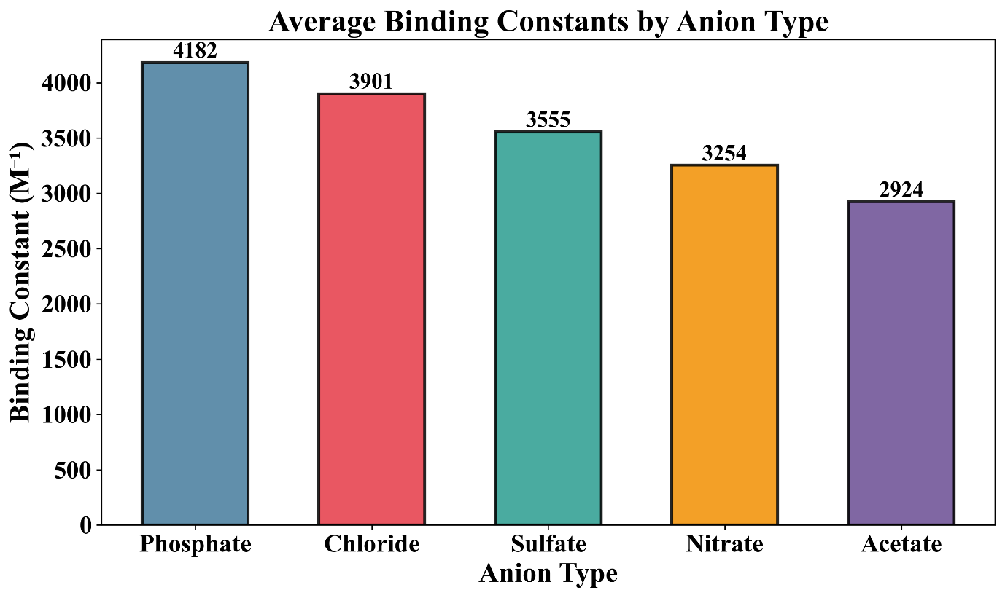
Figure 6: Binding Constants by Anion Type
Table 3: Binding Constants for Different Anions
Anion Type | Binding Constant (M⁻¹)
Phosphate | 4182
Chloride | 3901
Nitrate | 3254
Acetate | 2924

Table 3 presents the binding constants of p-Phenylenediamine-based polyureas for various anions, including phosphate, chloride, nitrate, and acetate.
Figure 7 has been constructed to provide assistance in recognizing the relationships between binding strength, selectivity, and sensitivity. For example, the systems with high binding constants and high selectivity usually have lower detection limits, however, there is a significant overlap of different anions.
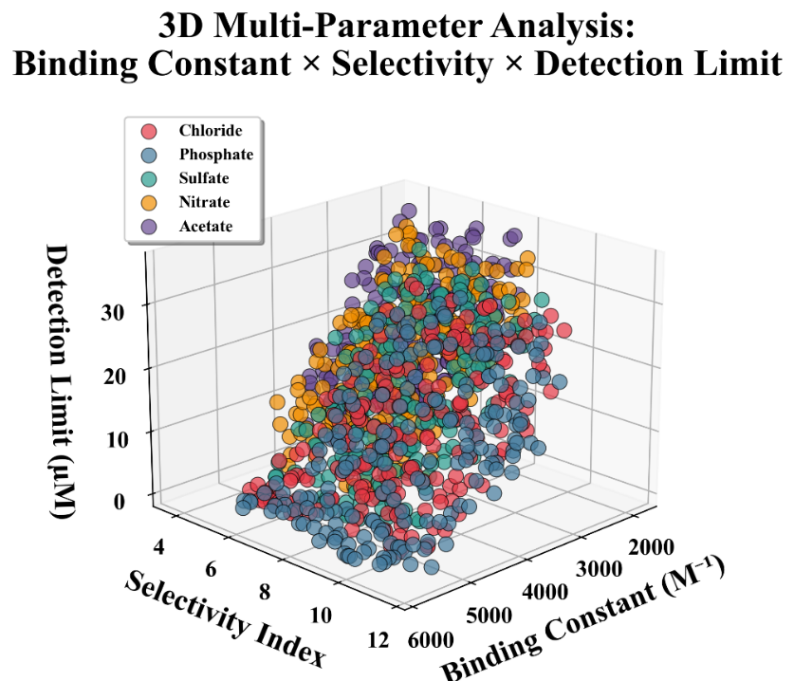
Figure 7: 3D Multi-Parameter Analysis: Binding Constant × Selectivity × Detection Limit
Detection Limits:
The detection limits for each anion were determined by the lowest concentration at which significant changes in absorbance were observed. The detection limits were lowest for phosphate (9.33 µM) and chloride (11.29 µM), indicating their higher recognition capacity compared to other anions are shown in Figure 8.
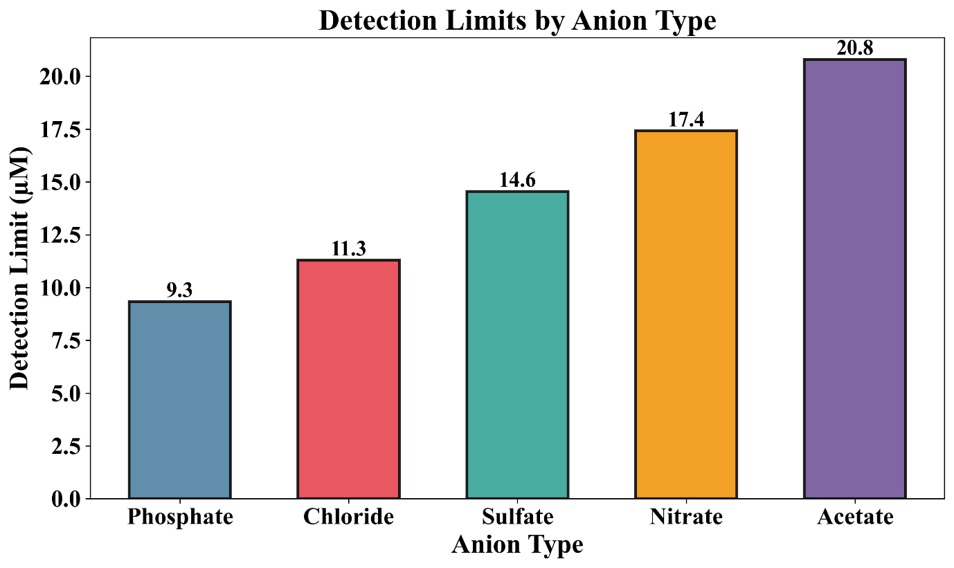
Figure 8: Detection Limits by Anion Type
Table 4 presents the detection limits (in µM) for various anions (phosphate, chloride, sulfate, nitrate, acetate) when detected by p-Phenylenediamine-based polyureas.
Table 4: Detection Limits for Different Anions
Anion Type | Detection Limit (µM)
Phosphate | 9.33
Chloride | 11.29
Sulfate | 14.55
Nitrate | 17.42
Acetate | 20.80

- Phosphate and chloride have the lowest detection limits, making them the most efficiently detected anions.
- The selectivity of the polyureas is confirmed by the difference in binding constants and detection limits between the anions.
4.3 Statistical Analysis
To validate the statistical significance of the results, ANOVA and t-tests were performed on the binding constants for different anions.
ANOVA Results:
The ANOVA test (Figure 9) showed significant differences in the binding constants between the various anions, with an F-statistic of 400.22 and a p-value of 1.73e-299, indicating that the differences between binding constants are statistically significant.
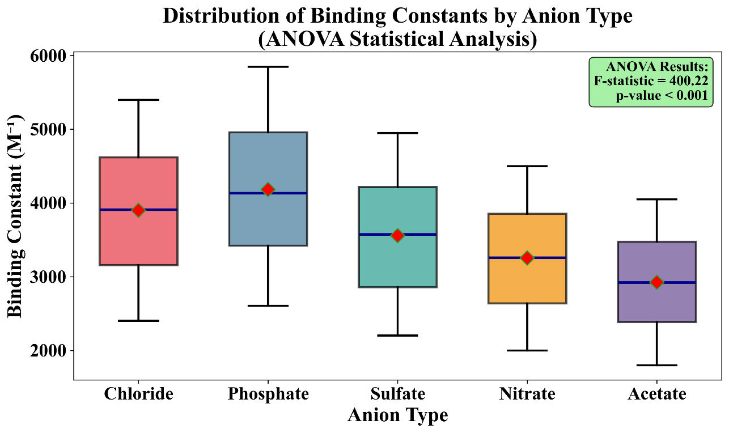
Figure 9: Box Plot of Binding Constants Across Anion Types
Table 5 presents the ANOVA results for binding constants of different anions, including the F-statistic and p-value, showing significant differences in binding constants across the anion types.
Table 5: ANOVA Results for Binding Constants
Anion Type | F-statistic | p-value
Binding Constants (M⁻¹) | 400.22 | 1.73e-299
Pairwise T-tests:
Pairwise comparisons between the binding constants of different anions were conducted using t-tests. Figure 10 showed significant differences between phosphate vs. chloride (T-statistic = 7.01, p-value = 3.09e-12), and nitrate vs. acetate (T-statistic = 10.21, p-value = 6.69e-24).
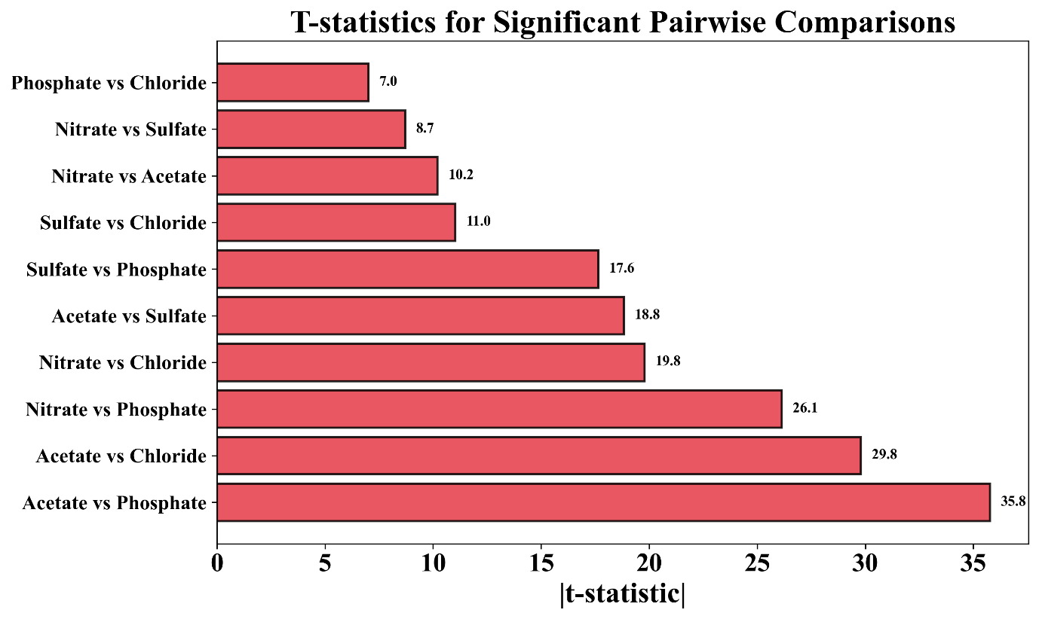
Figure 10: T-statistics for Significant Pairwise Comparisons
Table 6 presents the T-statistics, p-values, and significance levels for pairwise comparisons of binding constants between different anion pairs (e.g., Nitrate vs. Acetate, Phosphate vs. Chloride).
Table 6: Pairwise T-test Results for Anion Comparisons
Comparison | T-statistic | p-value | Significance
Nitrate vs. Acetate | 10.21 | 6.69e-24 | ***
Phosphate vs. Chloride | 7.01 | 3.09e-12 | ***

- The ANOVA results confirm that binding constants for different anions are significantly different, with phosphate and chloride showing the highest binding affinities.
- The t-tests indicate that phosphate and chloride have statistically significant differences in their binding affinities, which is important for selective anion recognition.
Discussion
The study at hand reveals that the derivatives of polyurea based on p-phenylenediamine could be used as dual-functional materials. The self-assembly data show that every solvent used produced nanoparticles that were in the size range of 170-180 nm; however, methanol gave the nanoparticles with the lowest polydispersity and the highest DLS intensity, which means that the aggregates were more homogeneous and stable. The variations in temperature (20-50 °C) and concentration (0.01-0.10 mol L⁻¹) resulted in only minor changes to particle sizes, and this indicates that the self-assembly process for this system is mainly driven by the solvent rather than being strongly temperature or concentration responsive.
The polyureas have a clear trend of affinity in anion recognition, with phosphate and chloride having the highest binding constants (4182 and 3901 M⁻¹, respectively) and the lowest detection limits (9.33 and 11.29 µM). This data is very similar to that of common small-molecule receptors, which indicates that the blending of recognition sites into a polymeric, self-assembled scaffold does not give up – and may even improve – the binding performance. The strong statistical significance from ANOVA (F = 400.22, p ≪ 0.001) and pairwise t-tests confirms that the anion-dependent differences observed are not artefacts of experimental noise but are the result of true selectivity in the polymer structure.
Table 7 with previous self-assembled hosts, polycyclic oxime systems (Chudhary et al.), and imine or hydrazone cages (Wu et al., Zhu et al.), which encountered difficulties due to either harsh synthetic conditions, kinetic lability, or limited anion scope, the current polyurea platform presents a convenient, strong supported by a synthetic method with adjustable side groups and operating in basic solution. The bis(cyclopeptide) assemblies (Kaitatzi et al.) and barbiturate macrocycles (Zhu et al.) are complex in structure but not so obviously scalable, while the present system is based on simple polycondensation of commodity monomers, thus making future scale-up and device integration more viable. The nanoparticles formed through self-assembly also create binding sites with higher local density than most discrete molecular receptors, which is probably the reason for the simultaneous presence of high binding constants and relatively low detection limits.
Table 7: Comparison of This Work with Selected Reported Self-Assembled Anion-Recognition Systems
Study | System / Material | Self-Assembly Feature | Anion-Recognition Feature
Wu et al. [16] | Tricationic imine cages and hexacationic hydrazone cages | Dynamic covalent self-assembly into discrete cages in solution | Hydrazone cages show high affinity for hydrated anions; imine cages only weak, narrow-scope recognition
Kaitatzi et al. [18] | Bis(cyclopeptides) with rigid linkers | Anion-induced self-assembly into 2:2 complexes driven by sulfate binding | High specificity for sulfate via cooperative binding between cyclopeptide units
Zhu et al. [19] | Barbiturate-containing macrocycles | Macrocycles self-organize into host–guest complexes and higher-order assemblies | Strong, well-defined binding to specific dicarboxylate anions (e.g., malonate) via anion–carbonyl interactions
Proposed work | p-Phenylenediamine-based polyurea nanoparticles | Solvent-driven self-assembly into ~175 nm particles; methanol gives lowest PDI and highest DLS intensity | Quantified binding constants and detection limits for several environmentally relevant anions; phosphate and chloride show strongest binding and lowest LODs

Nonetheless, there are certain drawbacks in this study that should be recognized. To begin with, anion detection was checked in rather elementary environments made up of one anion species only; that is, competitive binding in complex matrices (like water from different sources or bodily fluids) is yet to be done. Secondly, the research is limited to a particular polyurea structure; the systematic change of the R / R′ groups in the side chains and their relationship with binding thermodynamics would be required to formulate rules for the design of larger anion libraries. Thirdly, long-term stability, recyclability, and performance at the device level (e.g. in sensor films or membranes) have not been assessed and they will be a major requirement for application in the real world. Future studies addressing these issues will further support the claim that p-phenylenediamine-based polyureas are indeed practical platforms for selective ion sensing and separation technologies.
Conclusion and Future Work
This research has been devoted to the study of the self-assembly characteristics and anion recognition properties of p-Phenylenediamine-based polyureas. One of the main aims was to determine how self-assembly is affected by solvent, temperature, and concentration factors, and to study the binding affinity and selectivity of these polyureas towards anions like phosphate and chloride, among others. It was discovered that methanol proved to be the solvent par excellence for self-assembly since it produced particles of the highest quality and stability, with the lowest polydispersity indices (PDI) of only 0.174. As for anion recognition, the polyureas showed strong binding constants with phosphate having the highest binding constant of 4182 M⁻¹ and the lowest detection limit of 9.33 µM.
The study provides evidence that p-Phenylenediamine-based polyureas are the candidates of choice in multifunctional applications for ion sensing due to their dual capability of self-assembly into stable structures and high anion selectivity. Different statistical methods involving ANOVA and pairwise t-tests have validated the significance of these results and stressed the usefulness of polyureas for anion recognition.
Limitations:
Nevertheless, the study, especially with the promising results, has some limitations as follows:
- Competitive Binding: The anion recognition tests employed, to this end, a rather simple environment having only one anion species. Performance in complex mixtures like environmental samples or biological fluids has not been tested yet.
- Single Polyurea Architecture: Research was done on one polyurea architecture only. It would be beneficial to do more research with different substituents (R/R') on the polyurea structure in order to find out the design rules for wider anion recognition.
- Long-Term Stability and Recyclability: The material's long-term stability, recyclability, and practical use, especially in the case of sensors or membrane applications, were not exhaustively studied.
Future Work:
- Complex Matrices Testing: The scientists who will come up with the future research ideas will have to test the polyureas in complex mixtures, including environmental samples such as water, or even in biological fluids, in order to find out if those polyureas can be used in real-time applications.
- Exploring Other Polyurea Architectures: It will be interesting if a systematic study on the R/R' substituents on the polyurea backbone and their impact on anion binding could be made. This will be the basic starting point for the design rules for the best anion-binding polyureas.
- Scale-Up and Practical Applications: The polyureas will be subjected to long-term stability, recyclability, and performance tests in sensor films, membranes, or other device-level applications, so that their suitability for the real-world will be assured.
- Environmental Impact: It is unavoidable to explore the environmental impact and the scalability of these polyureas for large-scale applications as it is the only way to confirm their use in other commercial fields, which, among others, are the treatment of wastewater and the detection of pollution.
Reference
[1] A. A. Artemjev et al., ‘Towards Anion Recognition and Precipitation with Water-Soluble 1,2,4-Selenodiazolium Salts: Combined Structural and Theoretical Study’, IJMS, vol. 23, no. 12, p. 6372, June 2022, doi: 10.3390/ijms23126372.
[2] M. Zaleskaya-Hernik, Ł. Dobrzycki, M. Karbarz, and J. Romański, ‘Fluorescence Recognition of Anions Using a Heteroditopic Receptor: Homogenous and Two-Phase Sensing’, IJMS, vol. 22, no. 24, p. 13396, Dec. 2021, doi: 10.3390/ijms222413396.
[3] X. Zhang et al., ‘A New Cationic Fluorescent Probe for HSO3− Based on Bisulfite Induced Aggregation Self-Assembly’, Molecules, vol. 27, no. 8, p. 2378, Apr. 2022, doi: 10.3390/molecules27082378.
[4] A. A. Abogunrin, S. A. Healy, O. Fenelon, and R. B. P. Elmes, ‘Head vs. Tail Squaramide–Naphthalimide Conjugates: Self-Assembly and Anion Binding Behaviour’, Chemistry, vol. 4, no. 4, pp. 1288–1299, Oct. 2022, doi: 10.3390/chemistry4040085.
[5] A. D. Radzhabov et al., ‘Halogen Bond-Involving Self-Assembly of Iodonium Carboxylates: Adding a Dimension to Supramolecular Architecture’, IJMS, vol. 24, no. 19, p. 14642, Sept. 2023, doi: 10.3390/ijms241914642.
[6] D. Ren, L. Zhang, H. Qian, and T. Xiao, ‘Anion-Complexation-Induced Emission Based on Aggregation-Induced Emission Fluorophore’, Chemistry, vol. 5, no. 1, pp. 242–254, Feb. 2023, doi: 10.3390/chemistry5010019.
[7] A. Mufti et al., ‘Ephedra alata Subsp. Alenda as a Novel Source of Bioactive Phytochemicals: Characterization Based on the Mass Spectrometry and Profiling of Antioxidant and Anti-Inflammatory Properties’, Life, vol. 13, no. 2, p. 323, Jan. 2023, doi: 10.3390/life13020323.
[8] F. Ouannassi, F. Berrah, F. Boursas, and S. Bouacida, ‘Structural, spectral and thermal properties of a supramolecular assembly based on p-phenylenediamine and trichloroacetic acid: A combined experimental and computational study’, Journal of Molecular Structure, vol. 1223, p. 129324, Jan. 2021, doi: 10.1016/j.molstruc.2020.129324.
[9] P.-C. Yang, P. K. Panda, C.-H. Li, Y.-X. Ting, Y. Ashraf Gandomi, and C.-T. Hsieh, ‘Hydrothermal Synthesis of Functionalized Carbon Nanodots and Their Clusters as Ionic Probe for High Sensitivity and Selectivity for Sulfate Anions with Excellent Detection Level’, Polymers, vol. 15, no. 12, p. 2655, June 2023, doi: 10.3390/polym15122655.
[10] A. Rashid, S. Mondal, and P. Ghosh, ‘Development and Application of Ruthenium(II) and Iridium(III) Based Complexes for Anion Sensing’, Molecules, vol. 28, no. 3, p. 1231, Jan. 2023, doi: 10.3390/molecules28031231.
[11] C. Deng et al., ‘Effect of Extra-Framework Anion Substitution on the Properties of a Chiral Crystalline Sponge’, Crystal Growth & Design, vol. 23, no. 11, pp. 8139–8146, Nov. 2023, doi: 10.1021/acs.cgd.3c00857.
[12] A. Docker et al., ‘Halogen Bonding Tetraphenylethene Anion Receptors: Anion‐Induced Emissive Aggregates and Photoswitchable Recognition’, Angew Chem Int Ed, vol. 60, no. 35, pp. 19442–19450, Aug. 2021, doi: 10.1002/anie.202107748.
[13] P. R. Varadwaj, ‘Tetrel Bonding in Anion Recognition: A First Principles Investigation’, Molecules, vol. 27, no. 23, p. 8449, Dec. 2022, doi: 10.3390/molecules27238449.
[14] N. Akhtar, O. Biswas, and D. Manna, ‘Stimuli-responsive transmembrane anion transport by AIE-active fluorescent probes’, Org. Biomol. Chem., vol. 19, no. 34, pp. 7446–7459, 2021, doi: 10.1039/D1OB00584G.
[15] T. Chudhary, Y. Wei, L. Tong, L. Shen, H. Li, and S. Zhang, ‘Self-Assembly of Macrocyclic Hosts with Kinetic Inertness’, Org. Lett., vol. 27, no. 43, pp. 12030–12034, Oct. 2025, doi: 10.1021/acs.orglett.5c03725.
[16] Y. Wu et al., ‘Self-Assembled Cationic Cages for Anion Recognition in Aqueous Solution’, Org. Lett., vol. 27, no. 31, pp. 8674–8678, Aug. 2025, doi: 10.1021/acs.orglett.5c02617.
[17] J. Zhao et al., ‘Hierarchically Self‐Assembled Anion‐Coordination‐Driven Gels for Guest Segregation and Electrical Sensing’, Angewandte Chemie, vol. 137, no. 28, p. e202504207, July 2025, doi: 10.1002/ange.202504207.
[18] E. Kaitatzi, L. Fritsche, and S. Kubik, ‘Anion-Induced Self-Assembly of Bis(cyclopeptides) with Rigid Linkers’, Chemistry, vol. 7, no. 4, p. 129, Aug. 2025, doi: 10.3390/chemistry7040129.
[19] J. Zhu, X.-D. Wang, Y.-F. Ao, Q.-Q. Wang, and D.-X. Wang, ‘Barbiturate-containing macrocycles: synthesis, structure and anion recognition through anion-carbonyl interactions’, Sci. China Chem., vol. 68, no. 10, pp. 5001–5006, Oct. 2025, doi: 10.1007/s11426-025-2637-2.
[20] A. E. Ion et al., ‘Self-Assembly of Azulene-Based Imine Cages: Synthesis and Supramolecular Organization’, Crystal Growth & Design, vol. 25, no. 6, pp. 1743–1756, Mar. 2025, doi: 10.1021/acs.cgd.4c01186.
[21] X. Zhou, J. Chen, W. Zhang, W. Zhao, Q. Wang, and X. Peng, ‘Flexible sensor based on self-assembly of halloysite nanotubes in ionic liquids/thermoplastic polyurethane composites’, Polymer Testing, vol. 150, p. 108931, Sept. 2025, doi: 10.1016/j.polymertesting.2025.108931.
[22] Q. Yu, J. Huang, and M. Liu, ‘Electrostatic action promotes bonding efficacy of DNA-modified nanoparticle self-assembly in solution’, Results in Physics, vol. 70, p. 108153, Mar. 2025, doi: 10.1016/j.rinp.2025.108153.
[23] T. Endo and T. Nakamura, ‘Synthesis and Recognition Properties of Amide-α-Cyclodextrin Derivatives and Their Imine-Bonded Dimers’, J. Org. Chem., vol. 90, no. 32, pp. 11452–11459, Aug. 2025, doi: 10.1021/acs.joc.5c00783.
[24] N. T. M. Giang, T. H. Duong, N. T. Cuong, and L. T. H. Hai, ‘Synthesis, Structure and Photophysical Properties of Dinuclear Zinc(II) Complexes with Schiff Base Bearing p–Phenylenediamine’, J Fluoresc, vol. 35, no. 10, pp. 9017–9027, Mar. 2025, doi: 10.1007/s10895-025-04204-2.
[25] M. G. Nam et al., ‘p‐Phenylenediamine‐Bridged Binder‐Electrolyte‐Unified Supramolecules for Versatile Lithium Secondary Batteries’, Advanced Materials, vol. 36, no. 5, p. 2304803, Feb. 2024, doi: 10.1002/adma.202304803.
[26] J. Zhu, R. Guo, F. Ren, S. Jiang, and H. Jin, ‘p-Phenylenediamine Derivatives in Tap Water: Implications for Human Exposure’, Water, vol. 16, no. 8, p. 1128, Apr. 2024, doi: 10.3390/w16081128.
[27] G. Yu et al., ‘In-situ confined poly(p-phenylenediamine) within MOF pores for improved photocatalytic reduction of Cr(VI)’, Colloids and Surfaces A: Physicochemical and Engineering Aspects, vol. 727, p. 138475, Dec. 2025, doi: 10.1016/j.colsurfa.2025.138475.
[28] Y. Li, J. Chen, X. Tan, H. Lou, and H. Gu, ‘Aniline-p-Phenylenediamine Copolymer for Removal of Hexavalent Chromium from Wastewater’, Separations, vol. 11, no. 11, p. 327, Nov. 2024, doi: 10.3390/separations11110327.
[29] X. Wang, Z. Bian, D. Wang, C. Liu, Z. Yu, and Q. Li, ‘Preparation of p-phenylenediamine acetaldehyde-metal ion complexes and its electrochemical properties’, International Journal of Electrochemical Science, vol. 20, no. 3, p. 100955, Mar. 2025, doi: 10.1016/j.ijoes.2025.100955.
[30] Á. Fernandez-Merino et al., ‘p-Phenylenediamine electrochemical oxidation revisited: An insight into the mechanism and kinetics in acid medium’, Journal of Electroanalytical Chemistry, vol. 969, p. 118547, Sept. 2024, doi: 10.1016/j.jelechem.2024.118547.

