Urban Expansion Monitoring: Lulu Mall Project, Trivandrum (2017–2024)

Post Applied: Imagery Analyst

Prepared by: Ajin P Asok
Date: December 11, 2025

Introduction & Objectives
This project analyzes urban sprawl in Trivandrum, specifically monitoring the construction of the Lulu Mall complex and surrounding infrastructure. The analysis spans from January 2017 (pre-construction) to January 2024 (post-construction/operational), utilizing a multi-sensor approach with Sentinel-1 (SAR) and Sentinel-2 (Optical) imagery.
- Data Sets Used
The analysis relied on open-source Earth Observation data ingested via the Microsoft Planetary Computer STAC API:
- Sentinel-2 Level-2A (Optical): Bottom-of-Atmosphere (BOA) reflectance.
  - Resolution: 10m (Visible/NIR bands), 20m (SWIR bands).
  - Selection Criteria: Cloud cover < 10%, dry season acquisition (Jan–May) to minimize phenological variance.
- Sentinel-1 (SAR): C-band Synthetic Aperture Radar.
  - Product: Radiometric Terrain Corrected (RTC).
  - Polarization: VV (Vertical-Vertical) and VH (Vertical-Horizontal).
  - Mode: Interferometric Wide (IW).
3. Methods & Results
A. Optical Analysis: NDBI Change Detection
- Method: Calculated the Normalized Difference Built-up Index (NDBI) using SWIR (B11) and NIR (B08) bands.
  - NDBI = (SWIR - NIR) / (SWIR + NIR)
- Why this method: Unlike NDVI (which only detects vegetation loss), NDBI specifically highlights materials with high SWIR reflectance, such as concrete and asphalt.
- Results: The difference map (NDBI_2024 - NDBI_2017) successfully isolated the newly constructed building surrounding the mall. The mall building footprint was already there.
  - Pros: Easy to interpret; distinguishes built-up land from bare soil better than simple RGB.
  - Cons: Can confuse bare dry soil with concrete if spectral signatures are similar.
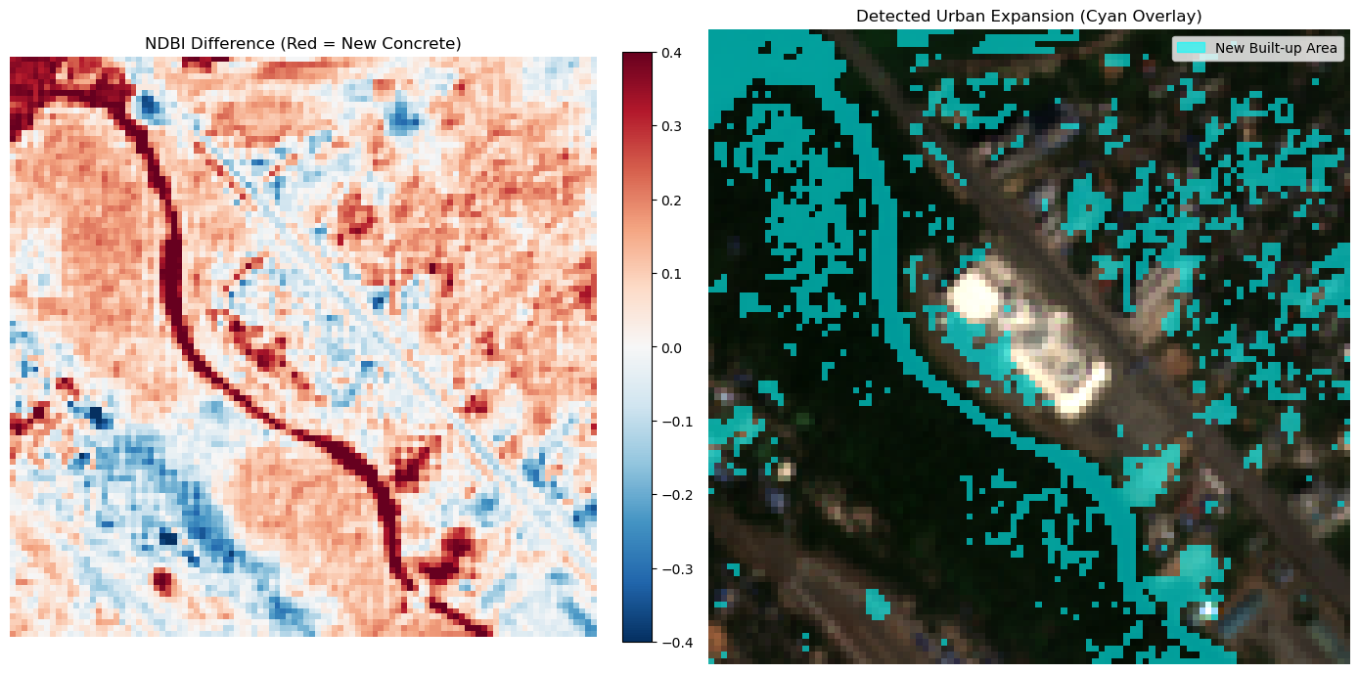
Figure 1: Optical analysis showing new built-up areas (Cyan) overlaid on 2024 True Colour imagery.
Lulu mall
B. SAR Analysis: Dual-Pol Log-Ratio
- Method: Applied a Log-Ratio change detection on VV and VH channels.
  - Log_Ratio = log10(Image_2024 / Image_2017)
- Why this method: Simple subtraction in SAR is prone to "speckle" noise. The ratio method effectively highlights relative changes in backscatter intensity. VV polarization was weighted heavily to detect "double-bounce" scattering typical of vertical walls and metal structures.
- Results: The method identified high-intensity changes corresponding to the mall's main structure. The vertical expansion of buildings was very clear in SAR.
  - Pros: Works day/night and through clouds; highly sensitive to man-made geometry (metal/concrete).
  - Cons: Susceptible to false alarms from temporary metal objects (vehicles, shipping containers).

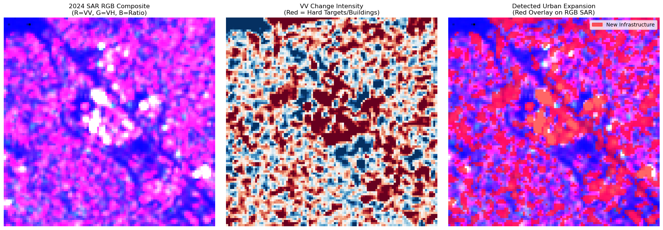
Lulu mall
4. Geolocation Accuracy & Coregistration
- Input Accuracy: Sentinel-2 absolute geolocation accuracy is within 12.5m (2σ). Sentinel-1 is highly accurate due to orbital precision.
- Processing: All datasets were dynamically reprojected and coregistered to EPSG:32643 (UTM Zone 43N) using the 2024 Sentinel-2 pixel grid as the master reference. This ensures sub-pixel alignment between the optical and radar layers.
5. False Positives/Negatives
- False Positives:
  - Optical: Some riverbanks appeared as "buildup" due to high SWIR reflectance in the dry season.
  - SAR: High traffic density or temporary parking lots can mimic permanent structures due to corner reflection from vehicles.
- False Negatives:
  - Low-rise residential expansions under heavy tree canopy were missed by Optical (canopy obstruction) but partially captured by SAR.
6. Quality Checks & Edge Cases
- Edge Case: The "No-Data" boundaries (0 values) in SAR were handled by clamping inputs to a minimum of 0.001 to prevent logarithmic math errors.
- Cloud Artifacts: Although <10% cloud cover filters were used, thin cirrus clouds can slightly skew NDBI values. The SAR analysis provided a robust cross-check in these areas.

7. Recommendations
- Workflow: Integrate a "Water Mask" (NDWI) to automatically exclude river banks from the buildup detection, reducing false positives.
- UI Improvement: For a client-facing tool, add a "confidence slider" that allows the user to adjust the change threshold (currently fixed at 0.15 for Optical and 0.20 for SAR) in real-time.

