SmartEduSync
A Privacy-First, Emotion-Aware AI Tutoring Robot
System Requirements & Design Specification (SRS)
Combined Blueprint — Part 1 (Companion & Emotion Engine) + Part 2 (Knowledge & Intelligence Engine)
Prepared for: Final Year B.Tech Project
Platform: Raspberry Pi 5 · Tabletop Form Factor (25–30 cm)
Document Version 1.0

Table of Contents

1. Introduction

1.1 Project Overview
SmartEduSync is a tabletop, AI-powered educational robot that combines an emotionally intelligent companion layer with a privacy-first knowledge and tutoring engine. The project reconciles two prior draft concepts — “EduSync” and “SmartEduBot” — and two independently developed goal sets (the Companion Robot goals and the Group 2 module plan) into a single, buildable system. All core reasoning, perception, and student data remain local to the robot's Raspberry Pi; only speech services may optionally use the cloud, as decided in Section 4.
The robot detects when a student is engaged, distracted, or struggling; proactively intervenes with contextual, data-grounded encouragement or reminders; and teaches using a Socratic, syllabus-grounded tutoring engine backed by a local knowledge graph. It expresses itself physically through head/arm movement and a facial display, and vocally through emotionally modulated speech.

1.2 Purpose of This Document
This SRS gives both teams a single shared reference: what the robot must do, how the hardware and software are structured, how Part 1 and Part 2 communicate, and in what order to build it. It resolves inconsistencies found in the two original abstracts (see Section 1.4) so both teams are building toward the same system.

1.3 Scope
- In scope: on-device emotion/engagement sensing, proactive intervention logic, syllabus-grounded Socratic tutoring via local LLM + GraphRAG, exam-risk tracking via Bayesian Knowledge Tracing, expressive voice and physical (head/arm) emotion display, and a shared orchestration layer tying both halves together.
- Out of scope (for this version): mobile app companion, multi-student/classroom mode, cloud analytics dashboards, and continuous learning / model fine-tuning on live student data.

1.4 Reconciling the Two Draft Abstracts
The EduSync and SmartEduBot abstracts described the same underlying system with different emphasis and one direct conflict (voice pipeline: hybrid cloud STT/TTS vs. fully local). This document adopts the following resolved decisions for both teams to build against:
Topic | Resolved decision
Project name | SmartEduSync (working title — rename freely, but use one name in all docs going forward)
Voice pipeline | Hybrid: STT/TTS may use cloud APIs (e.g., ElevenLabs) for expressiveness; all vision/emotion data and student records stay local. This must be stated explicitly in the final abstract.
Emotion tracking | Elevated to a first-class feature in the abstract — it is a full Part 1 goal (Goal 2) and should not be a footnote.
Socratic tutoring | Kept as the core teaching philosophy (Part 2, Module 4), not just “Q&A over documents.”
Facial recognition | Scoped down to face + landmark detection for emotion/gaze (not identity recognition), to avoid extra privacy/ethics review.

2. System Overview

2.1 Two-Team Structure
The project is delivered by two teams working on complementary halves of one robot:
- Part 1 — Companion & Emotion Engine: proactive persona, multimodal emotion/engagement sensing, intervention triggering, academic-risk tracking (BKT), expressive voice.
- Part 2 — Knowledge & Intelligence Engine: local LLM dialogue, RAG + GraphRAG retrieval over syllabus content, Socratic tutoring logic, answer verification and learning memory.
Both halves run on the same Raspberry Pi and communicate through a shared Integration Layer (Section 5), so neither team can finish in isolation — the interfaces in Section 5.2 are the contract between teams and should be agreed on in week 1.

2.2 Unified Concept Statement
SmartEduSync is a privacy-first, emotion-aware AI tutoring robot that watches how a student studies — not just what they ask — and responds with syllabus-grounded, Socratic guidance and proactive, data-driven encouragement, all while keeping camera and academic data processing local to the device.

3. Hardware Design

3.1 Physical Form Factor
- Tabletop robot, approx. 25–30 cm tall, static base (no wheels/locomotion).
- Head: pan + tilt (2 DOF minimum) to orient toward the student and nod/tilt for emotion; houses a small round or square display for a simple animated face, plus study-guide text/flashcards/progress info.
- Arms: 2 arms, 1–2 DOF each (shoulder + optional elbow) for simple expressive gestures (wave, shrug, “think” pose, celebratory raise) — not manipulation/grasping.
- Enclosure: 3D-printed shell; internal mounting for Pi, camera, mic, speaker, servo driver, and wiring channel from base to head.

3.2 Bill of Materials (starting point)
Component | Suggested part | Purpose
Compute | Raspberry Pi 5 (8GB) | Runs both Part 1 and Part 2 software stacks locally
Camera | Raspberry Pi Camera Module 3 (wide) | Facial emotion, gaze, posture input for Perception Service
Microphone | ReSpeaker 2/4-Mic array (USB or HAT) | Far-field voice capture for STT
Speaker/Audio out | I2S DAC + amp (e.g., MAX98357A) + small 3–5W speaker | TTS playback, low-latency via PipeWire
Head display | 3.5–5″ round/square LCD (e.g., GC9A01 round, or small HDMI/DSI panel) | Animated face, study guide, engagement/exam alerts
Actuation | 4–6x digital servos (e.g., MG90S) + PCA9685 16-ch PWM driver (I2C) | Head pan/tilt, arm gestures
Power | 5V/5A USB-C PD supply for Pi; separate 5–6V/3A rail for servos (isolated from Pi rail) | Prevents servo current spikes from browning out the Pi
Optional accelerator | Coral USB Accelerator or Hailo-8 (optional) | Speeds up on-device face/gaze inference if TFLite alone is too slow
Storage | 128GB+ microSD (A2 rated) or USB SSD boot | Local LLM weights, vector DB, SQLite, model caches

3.3 Actuation & Sensing Notes
- Drive servos via the PCA9685 over I2C, not directly from Pi GPIO — protects the Pi and centralizes PWM timing.
- Run the camera pipeline at a modest resolution (e.g., 640×480) at 5 Hz sampling to match the Goal 2 engagement-score requirement and keep CPU headroom for the LLM.
- Keep the servo power rail electrically separate from the Pi's 5V rail; share only ground — this is the single most common cause of Pi reboots in small robot builds.

4. System Architecture

4.1 High-Level Architecture
All sensing, reasoning, and actuation happen on a single Raspberry Pi 5, split into two cooperating engines that communicate through a lightweight event bus.
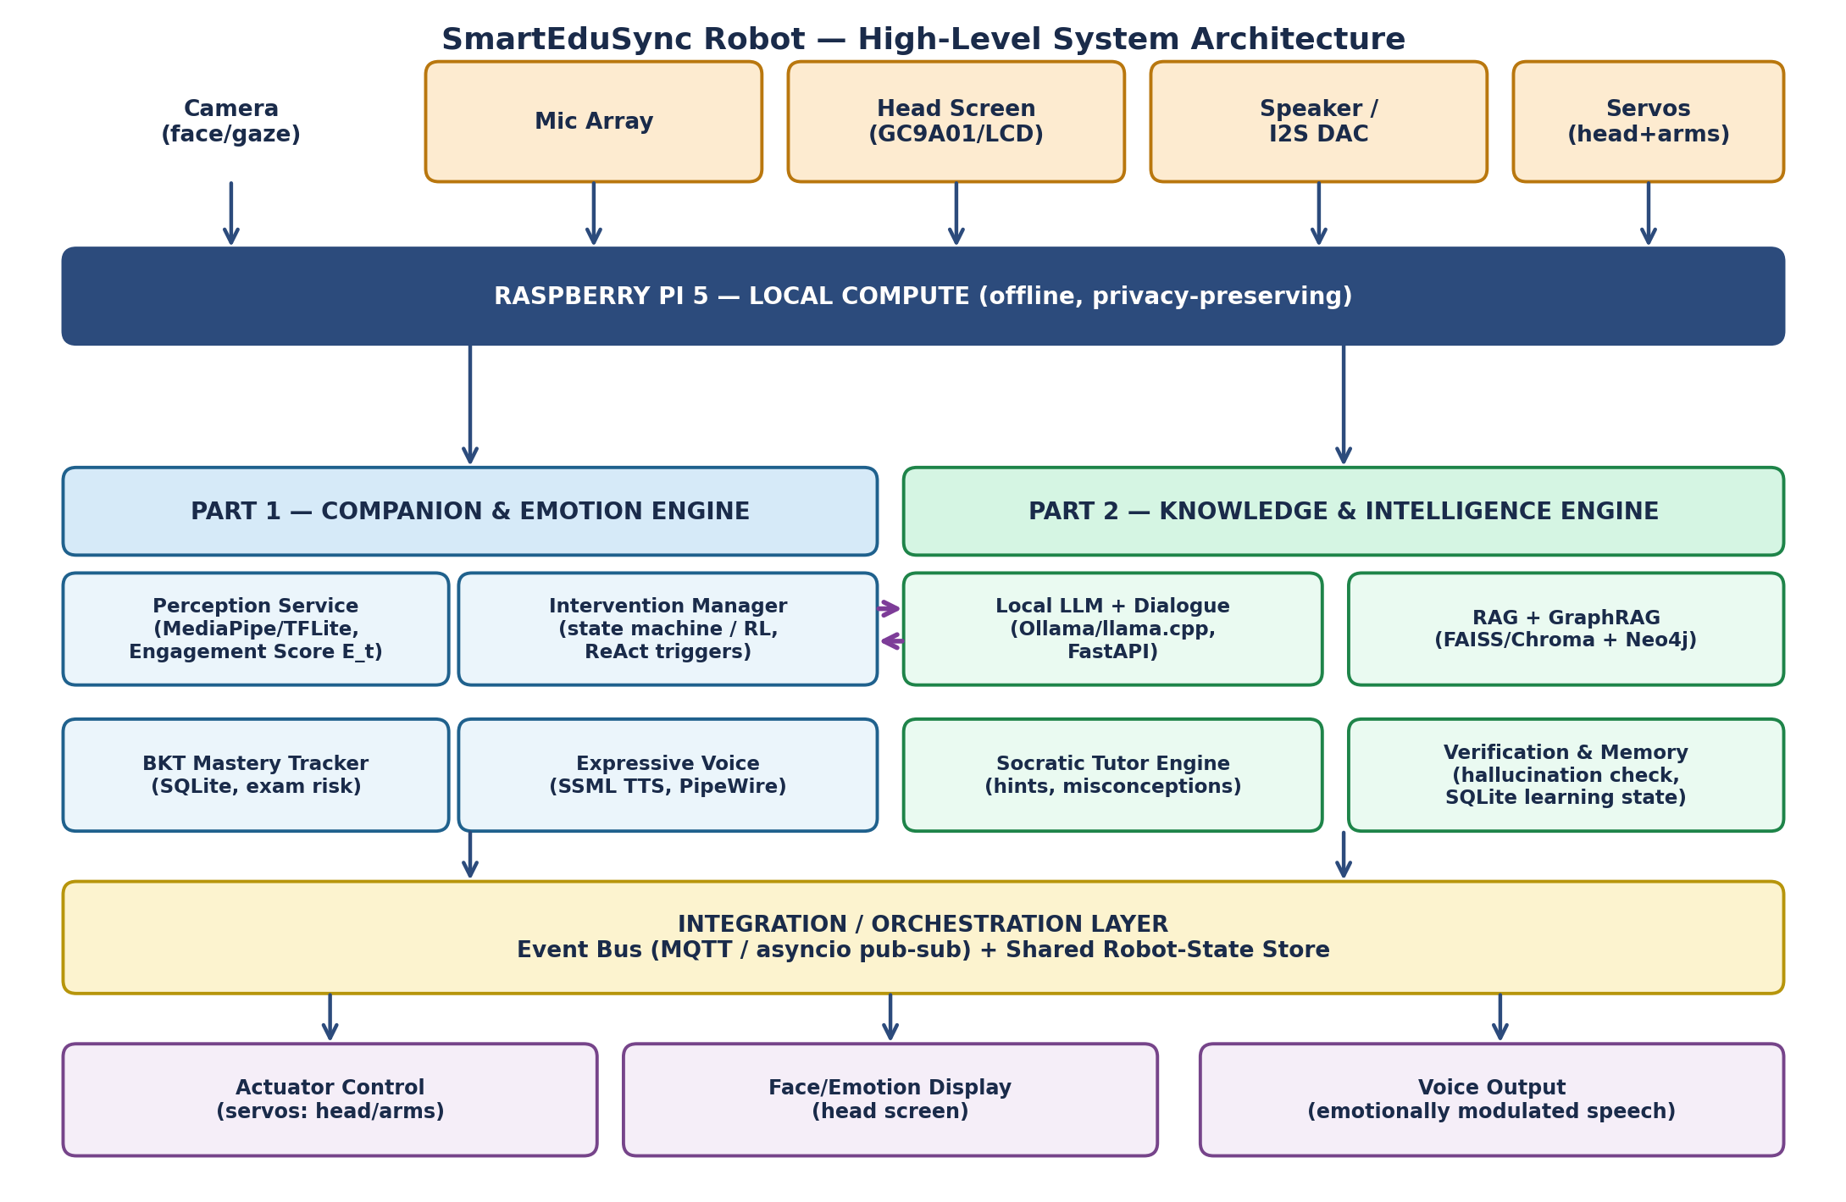

4.2 Component Communication
Recommended integration pattern: a lightweight local message broker (Mosquitto MQTT, or a simple Python asyncio pub-sub if the teams prefer to avoid an extra service) carries small JSON events between the two engines. A shared “robot state” store (a small SQLite table or in-memory store behind a FastAPI endpoint) holds the current engagement score, emotion label, active study topic, and intervention state so either engine can read the latest state without tight coupling.
Event | Publisher | Subscriber(s) | Payload (example)
engagement.update | Part 1 – Perception Service | Part 1 Intervention Manager, Part 2 Dialogue | { E_t: 0.38, emotion: "frustrated", ts }
intervention.trigger | Part 1 – Intervention Manager | Part 2 Dialogue, Actuator Control, Voice | { level: "gentle"|"firm", reason, topic }
tutor.response | Part 2 – Socratic Tutor | Voice Output, Head Screen | { text, ssml_hint, topic, confidence }
mastery.update | Part 1 – BKT Tracker | Part 2 Dialogue (for difficulty adjustment) | { topic: "Robotics", p_mastery: 0.42 }
exam.alert | Part 1 – BKT Tracker | Intervention Manager, Head Screen | { subject, days_left, risk: "high" }

5. Part 1 Software — Companion & Emotion Engine

5.1 Module: Proactive Persona & Safety Layer
Owns the robot's conversational “personality” rules and tone guardrails. Wraps outgoing nag/encouragement text through a self-refinement check (rule-based first; an Uptrain-style automated check can be added later) to block toxic, demotivating, or factually unsupported statements before they reach TTS.

5.2 Module: Perception Service (Multimodal Emotion Sensing)
- Runs MediaPipe Face Landmarker + a lightweight TFLite emotion classifier and a simple posture/gaze heuristic, all on-device.
- Computes a fused engagement score E_t at 5 Hz from facial emotion, gaze direction, and posture alignment.
- Publishes engagement.update events; never sends raw frames off-device.

5.3 Module: Intervention Manager
- State machine (idle → watching → gentle nudge → firm nag → escalated alert) driven by E_t thresholds (default trigger: E_t < 0.45 while a study session is active) and elapsed idle time.
- Uses a ReAct-style loop to decide actions: check the assignment/exam database, or emit an intervention.trigger event.
- A simple state machine is the recommended starting point; the RL variant mentioned in the original goals is a stretch goal once the state machine version works end-to-end.

5.4 Module: Academic Risk Tracker (BKT)
- Implements Bayesian Knowledge Tracing per syllabus topic, stored in SQLite (per-student, per-topic mastery probability).
- Combines mastery probability with exam-calendar proximity to generate exam.alert events and grounds nag text in specifics (e.g., topic name, days remaining, mastery %).
- Persists across sessions/semesters so the companion relationship and history carry forward.

5.5 Module: Expressive Voice Output
- Manages audio I/O concurrency on PipeWire/WirePlumber so the robot can listen while speaking (barge-in support).
- Maps emotion/intervention state to SSML (rate, pitch, emphasis) sent to the TTS API — slower/softer for confusion or frustration, faster/sharper for urgent nags.

6. Part 2 Software — Knowledge & Intelligence Engine

6.1 Module: General AI & Dialogue
A local LLM (Llama 3.1 8B or Phi-3.5-mini via Ollama/llama.cpp) exposed through a FastAPI service. Owns multi-turn conversation state and routes requests to RAG/GraphRAG for grounding before generating a response.

6.2 Module: Knowledge Base & RAG Engine
- Ingests syllabus PDFs/notes/slides with PyMuPDF + LangChain, chunks them, embeds with Sentence Transformers, and stores vectors in FAISS/Chroma/Qdrant.
- Retrieves the most relevant chunks for a query and passes them as grounding context to the LLM.

6.3 Module: Knowledge Graph & GraphRAG
- Builds a concept graph (prerequisites, related topics, definitions) in Neo4j or NetworkX.
- Combines graph traversal with vector retrieval (GraphRAG) so answers can reference connected concepts, not just isolated text chunks.

6.4 Module: Socratic Teaching & Adaptive Tutor
- Given a topic and the student's current mastery estimate (from Part 1's BKT tracker), generates guiding questions and progressive hints rather than direct answers by default.
- Detects likely misconceptions from student responses and adjusts question difficulty accordingly.

6.5 Module: Verification, Evaluation & Memory
- Cross-checks generated answers against retrieved RAG/GraphRAG content to catch hallucinations before they're spoken.
- Evaluates student answers for correctness/missing concepts and stores learning state (doubts, performance, conversation history) in SQLite.
Overall Part 2 flow: Local LLM (Think) → RAG (Know) → GraphRAG (Connect) → Socratic Engine (Teach) → Verifier/Memory (Improve).

7. Functional Requirements
ID | Requirement | Owner
FR-1 | System shall compute an engagement score at ≥5 Hz using camera input, without transmitting raw video off-device. | Part 1
FR-2 | System shall trigger an intervention when E_t falls below the configured threshold during an active study session. | Part 1
FR-3 | System shall track topic-level mastery probability per student using BKT and persist it across sessions. | Part 1
FR-4 | System shall reference specific exam dates and mastery levels when generating academic nudges (not generic phrasing). | Part 1
FR-5 | System shall answer student questions grounded in ingested syllabus content via RAG/GraphRAG, not general LLM knowledge alone. | Part 2
FR-6 | System shall default to Socratic hints before giving direct answers, escalating to direct answers after repeated struggle. | Part 2
FR-7 | System shall verify generated answers against retrieved content before speaking them. | Part 2
FR-8 | System shall express current emotional/intervention state via head screen, head/arm movement, and modulated voice simultaneously. | Integration
FR-9 | System shall support simultaneous listening and speaking (barge-in) without audio dropouts. | Part 1
FR-10 | System shall allow the student to upload/add new syllabus material and have it searchable within one session. | Part 2

8. Non-Functional Requirements
Category | Requirement
Privacy | All camera frames, engagement scores, and academic records are processed and stored locally on the Pi; only text for STT/TTS may leave the device, and only if cloud voice is enabled.
Latency | Engagement score updates ≤200 ms; a spoken response to a direct question should begin within ~2–3 s of query end (budget-dependent on LLM size chosen).
Reliability | Servo and Pi power rails are electrically isolated; a servo stall/short must not crash or reboot the Pi.
Maintainability | Part 1 and Part 2 communicate only through the documented event schema (Section 4.2) so either team can refactor internals independently.
Safety/Tone | All generated nag/encouragement text passes through the safety/tone guardrail (Section 5.1) before being spoken.
Portability | Software should run on a stock Raspberry Pi OS (64-bit) image with documented setup scripts; avoid hard-coded absolute paths.

9. Development Roadmap
Suggested phased plan so both teams have working, demoable pieces early and integrate incrementally rather than at the very end.

Phase 0 (Week 1–2): Foundations
- Agree on and freeze the event schema (Section 4.2) — this unblocks both teams to work in parallel.
- Part 1: get camera + MediaPipe running on the Pi, log raw engagement scores to console.
- Part 2: get local LLM running via Ollama on the Pi, basic FastAPI chat endpoint, no RAG yet.

Phase 1 (Week 3–5): Core Engines
- Part 1: implement engagement fusion, SQLite BKT schema, basic state-machine intervention manager (no voice/servo yet, just console/log output).
- Part 2: implement RAG over 1–2 sample syllabus PDFs; add basic Socratic prompt template.

Phase 2 (Week 6–8): Integration
- Stand up the event bus; wire engagement.update → intervention.trigger → tutor.response end-to-end.
- Add TTS output (SSML) and connect to speaker; add GraphRAG on top of RAG.

Phase 3 (Week 9–11): Hardware & Expression
- Mount and wire servos via PCA9685; implement head pan/tilt reacting to interaction state; add basic arm gestures.
- Wire the head display; implement a simple animated face plus study-guide/exam-alert screens.

Phase 4 (Week 12–14): Polish & Evaluation
- Add verification/hallucination checks, tune intervention thresholds with real test users, tone-safety pass on nag phrasing.
- Write up final report using the reconciled abstract (Section 1.4) and this SRS as the design chapter.

10. Risk Register
Risk | Impact | Mitigation
Local LLM too slow on Pi 5 CPU alone for real-time tutoring | High | Start with Phi-3.5-mini (smaller); consider a Hailo/Coral accelerator or quantized GGUF models; cap context length
Servo current draw destabilizes Pi power | High | Separate power rails, share ground only; add capacitor buffering on servo rail
Emotion classifier misreads engagement (false nags) | Medium | Use a rolling average of E_t rather than instantaneous value; require sustained low engagement before triggering
Two teams' modules drift apart / interfaces mismatch | Medium | Freeze the event schema early (Phase 0); integrate on a shared branch weekly, not just at the end
Cloud TTS dependency breaks offline demo | Low–Medium | Keep a local TTS fallback (e.g., Piper) for offline/demo-safe operation

11. Appendix — Technology Stack Summary
Layer | Technology
Compute | Raspberry Pi 5 (8GB), Raspberry Pi OS 64-bit
Perception | MediaPipe, TensorFlow Lite
Local LLM | Ollama or llama.cpp running Llama 3.1 8B / Phi-3.5-mini
RAG | PyMuPDF, LangChain, Sentence Transformers, FAISS / Chroma / Qdrant
Knowledge Graph | Neo4j or NetworkX (GraphRAG)
Backend/API | Python, FastAPI
Data storage | SQLite (BKT mastery, learning memory, conversation history)
Voice | PipeWire/WirePlumber (audio routing), cloud TTS (e.g., ElevenLabs) with SSML, local fallback (e.g., Piper)
Integration | MQTT (Mosquitto) or asyncio pub-sub event bus
Actuation | PCA9685 PWM driver + digital servos (I2C)
Display | Round/square LCD (e.g., GC9A01) driven from Pi GPIO/SPI

End of document.

