Is the world making meaningful development progress? For decades the answer has been a clear yes. We have seen historic reductions in poverty and significant gains in life expectancy, education and other vital areas. But this era of steady advancement may be grinding to a halt.
The world is currently developing at its slowest pace in three quarters of a century.
This slowdown represents a profound threat to the wellbeing of millions, and it could reverse decades of hard-won gains if the trajectory of the last five years continues.
Understanding whether the pace of progress has changed requires comparing development progress across time, development indicators, and stages of development. We analyzed cross-country data for six key indicators going back to 1950, these being extreme poverty, life expectancy, years of schooling, women's political empowerment, electricity supply, and carbon intensity of the economy.
For each indicator, we mapped out a "typical" development path.
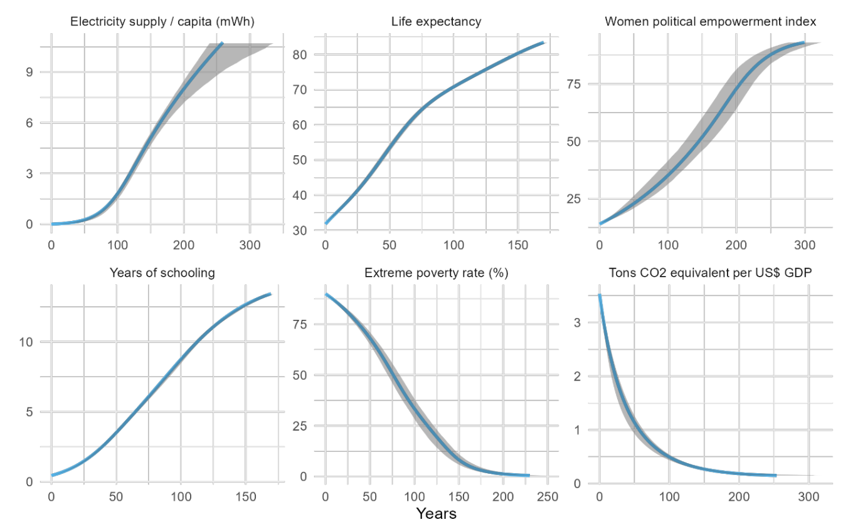
This path shows the expected journey from the worst-observed outcomes to the best based on the collective experience of all countries over the last 75 years.
This path is not a straight line. Progress is often slow at the beginning, accelerates in the middle, and then slows again as a country approaches the highest levels of development (see an interactive visual explanation of the method here).
The central finding from this new analysis is a dramatic deceleration in global progress. When we average the speed of development across all six indicators, we see a sharp decline that began around 2010. Today that speed is at its lowest point since 1950, well below the typical pace of development observed over the last three-quarters of a century.
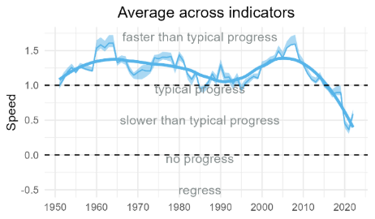
This method models the “typical” path of development for an indicator, calculating how long it usually takes to move between any two development stages based on past experiences around the world, and allows fair and intuitive comparisons across countries and contexts—we can see how fast a country is moving relative to the typical pace or identify best performing countries.
You can explore this approach applied to [X number] key indicators from the Atlas of Global Development and investigate how your country has performed relative to others and the typical path.
To explore how your country has performed in [X number] key development indicators from the Atlas of Global Development, investigate the dashboard below.

