Somalia Hunger Field Notes
Below is an outline of the story line largely with some questions for now. We would be grateful if you can plug in information and your knowledge on this topic throughout but especially on points that are highlighted in yellow.
Structure of Story:
- What does a hunger crisis look like?
  - We will add some statistics and visualizations about global hunger here.
- IPC Classifies a Crisis as Phase 3 and above.
  - In the 30 countries that the IPC/CH analyzes, a group that contains the nations with the most dire hunger circumstances, currently 146.53 million people are in crisis of worse, Phase 3+ (IPC/CH Dashboard)
- Another indicator is the FAO’s Food Insecurity Experience Scale
  - 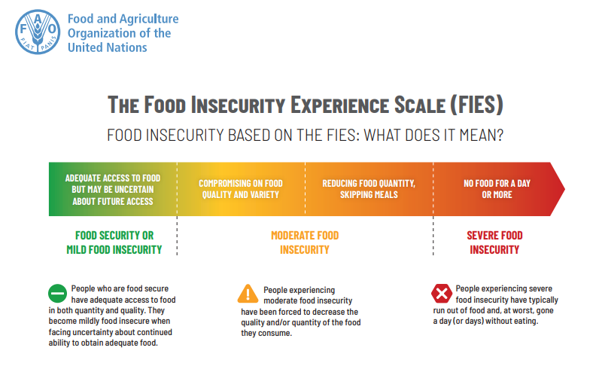(source )
  - It takes data from a survey that ask questions that capture what it’s like to live in an ongoing food crisis. These questions are: (FAO microdata)
    - You were worried you would not have enough food to eat?
    - You were unable to eat healthy and nutritious food?
    - You ate only a few kinds of foods?
    - You had to skip a meal?
    - You ate less than you thought you should?
    - Your household ran out of food?
    - You were hungry but did not eat?
    - You went without eating for a whole day?
  - Depending on the data from this survey, the FAO places a proportion of the population into three categories, mild, moderate, and severe food insecurity.
- (Reference to the data availability and collection section) One of the “scariest” things is that it might not look like anything at all, at least at the beginning. The people that are most likely to be affected by these things are the people that are the hardest to reach and the people that might not be the most “visible”
  - Maybe a graph talking about the proportion of people suffering from hunger being from more rural areas
- There are many things that could cause a hunger crisis
  - Structural Instability in the government can make it harder to provide aid
  - Price instability in food and fuel
  - Climate is a large factor as well. It exacerbates many of the other factors
    - More variable rainfall patterns mean a smaller harvest, forcing farmers to lean on volatile food prices
      - Maybe we can include a graph about the amount of rainfall or the year-over-year change in rainfall
    - Fewer resources, like arable land and fresh water, lead to increased hostility within a nation, leading to civil unrest and instability
      - Include figures about Somalia’s total number of displaces peoples
- All of these factors are present in Somalia, a nation that has continuously suffered from crisis after crisis.

- Current outlook of Somalia in terms of Hunger and Undernourishment
- As of July 2026, Somalia has the 7th highest proportion of people in IPC Phase 3+ (Dashboard)
  - 31% of population, over 6 million people
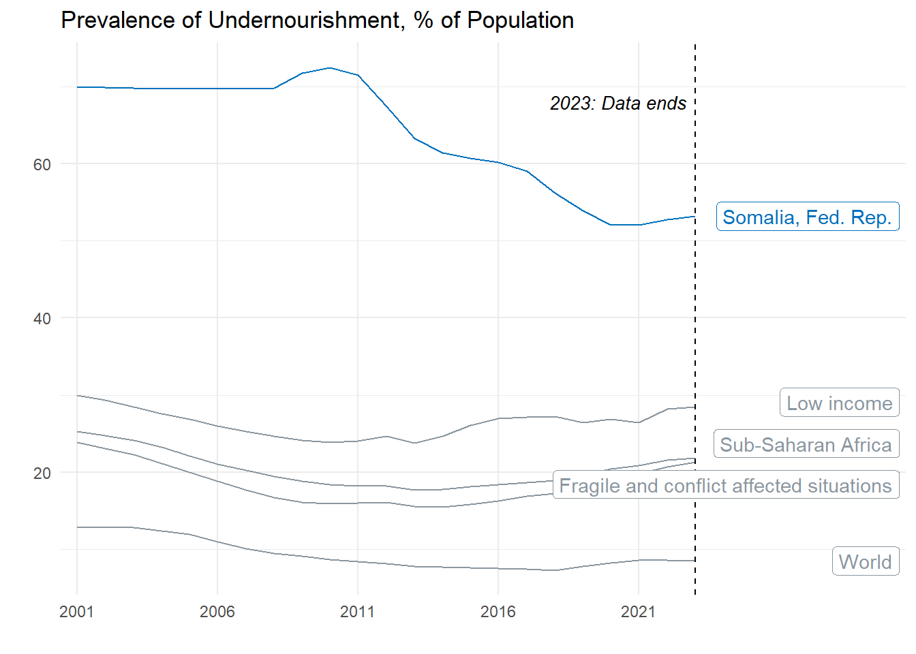
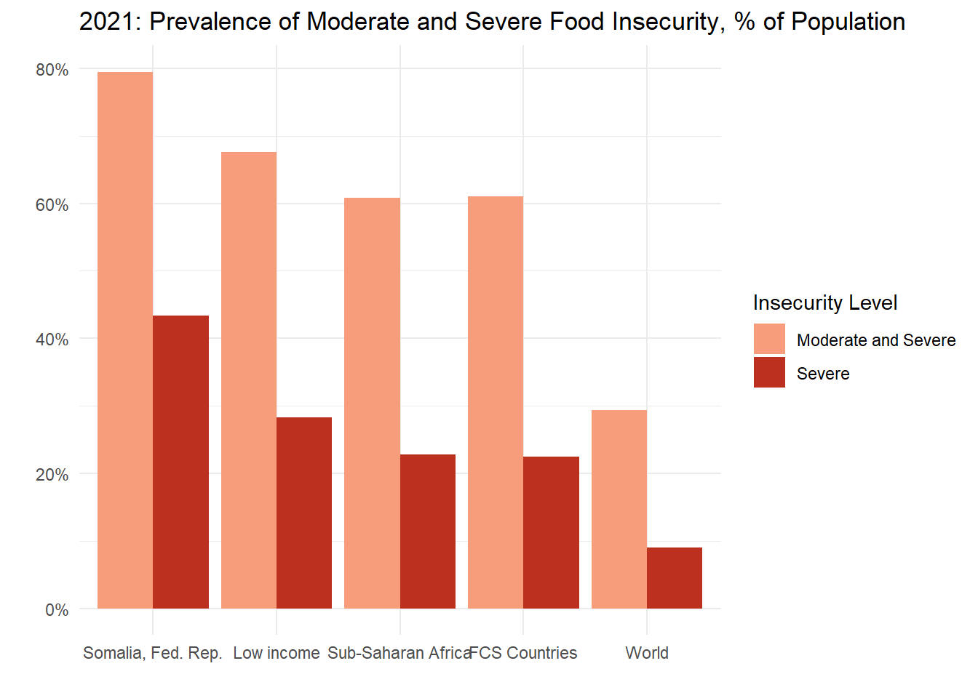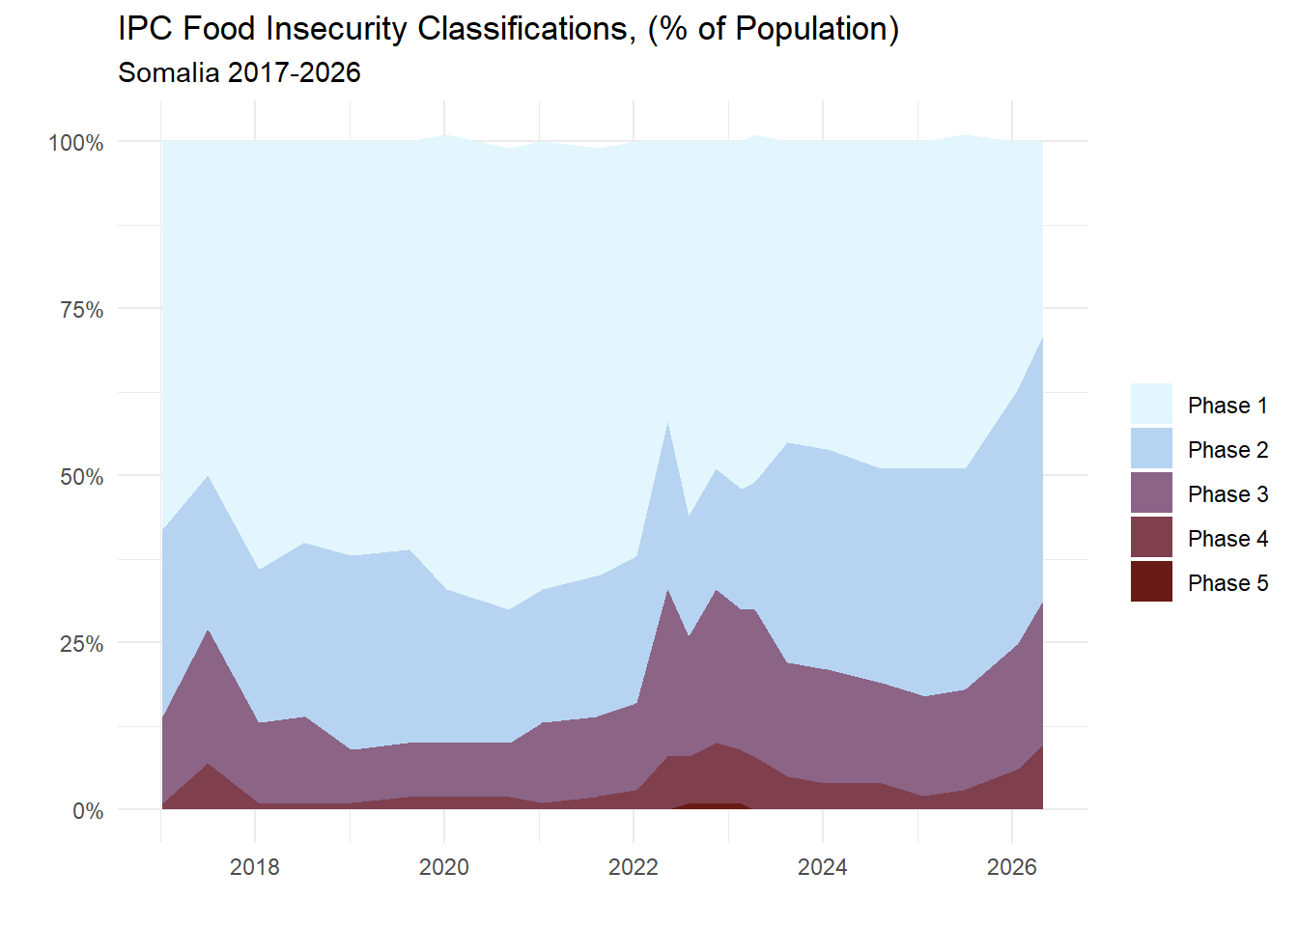
  - We will again add some statistics and visualizations for Sonalia (to be shared soon).
  - Main Factors:
- Current Crisis: Climate, Decreasing humanitarian assistance, and 2026 Middle East Conflict are the biggest factors for the current crisis.
  - Rainfall during the Gu season (April-June primary rainy season) is below predicted levels, which has persisted in the ongoing drought. The was preceded by a failed 2025 Deyr season (Oct-Dec secondary rainy season) and especially harsh and dry Jilaal (Dec-March harsh dry season)
    - El Nino forecasts signal increased flooding risk later in the year (Steve talked about this in the meeting, how the JMR reporting was especially needed for this El Nino year, Meeting 18:12)
  - Failed 2025 Deyr harvest has impacted the carry-over stock from previous seasons, along with increases in fuel prices and imported food costs, this has caused an increase in food prices in the country
  - Each factor exacerbates the other factors, creating a feedback loop that means the situation can get worse very quickly. This is a big reason why early reporting and “nowcasting” is so important
- Structural Drivers: Climate, Conflict, Food dependency, and Chronic underfunding of humanitarian relief efforts are the main structural causes of the ongoing food crises
  - Climate
    - Gaps between droughts are shrinking and the severity is increasing
    - 2022-23 drought was the worst in 40 years, five consecutive failed seasons. There have been three “worst droughts in decades” in the past 15 years (ConcernUSA 2022)
    - Drought then flood whiplash: the 2023 El Niño floods came immediately after drought
  - Conflict and collapse of government
    - Continued conflict leads to perpetual, and increasing, displacement
      - the time the 2010 drought hit, 1.46 million Somalis were already internally displaced, almost entirely due to conflict. Today 3.4 million people are internally displaced. (Maxwell 2012) (IPC May 2026)
      - arable and grazing lands were commandeered by powerful insurgent groups in many different regions, the same regions where the hunger was the worst (Maxwell 2012)
      - Displacement strips a family of land, assets, livestock, and social networks, eroding coping strategies
    - Continued conflict disrupts agriculture, markets and humanitarian access (IPC May 2026)
    - The government collapse of 1991 decreased security, infrastructure and services
      - Basic services such as healthcare, education, agricultural extension and veterinary services were either privatized or provided through humanitarian services (Maxwell 2012).

  - How does it look in relation to other countries?
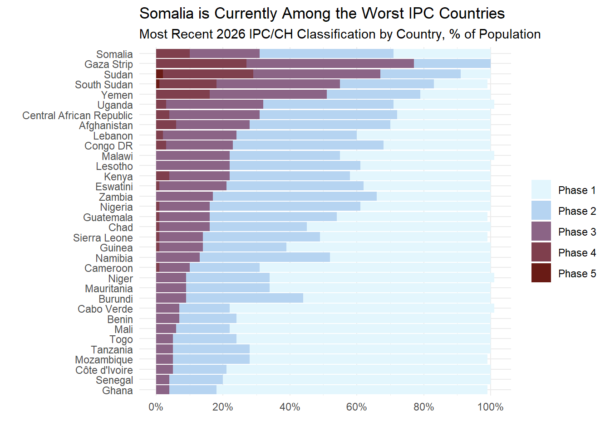
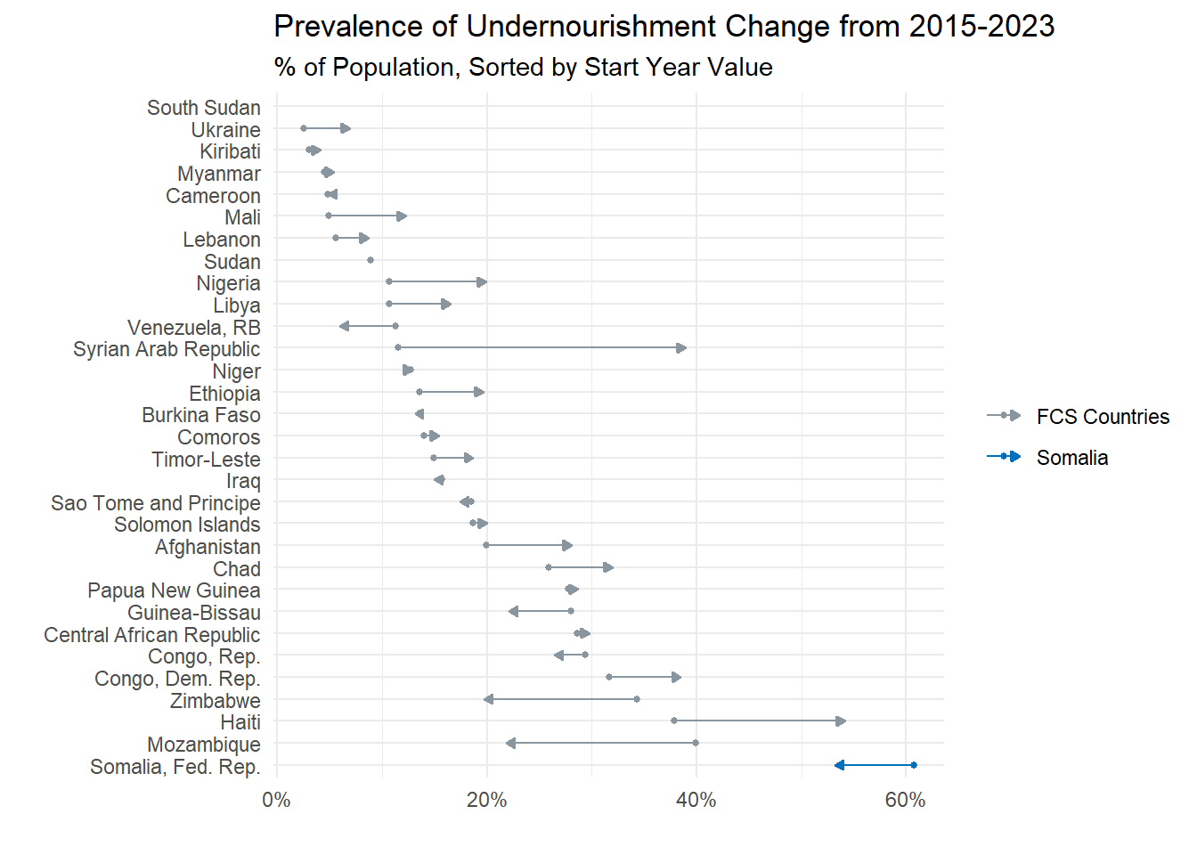

- What does an Early Warning System look like?
  - What did you do?
    - Preparedness Plans for Food and Nutrition Security Crises Program is a requirement for the Crisis Response Window (Meeting 12:43). Somalia’s Preparedness Plan was launched on Dec 4, 2023, and became operational Jan 1, 2024 (Preparedness Plan)
      - Joint Monitoring Report is a part of this: To provide faster, more flexible, data driven approach to monitoring food security
      - Bi-monthly (I think every other month) snapshots of food and nutrition security risks using advanced statistical methods, machine learning, and artificial intelligence. (Geneva Talk)
      - Conflict, climate, economic shocks
  - How did the data you provided fill a knowledge gap?
    - “Conventional food insecurity assessment methods typically involve extensive data collection, consensus-building processes, and expert evaluations.” Yemen JMR Blog
    - JMR: innovative data-driven methodology aimed at the early detection of food and nutrition security emergencies in Yemen.” Yemen JMR Blog
  - Can we track the full cycle of this data from production to use for policy making?
    - Data gets collected >
    - Country Risk Team (led by national bureau of stats + line ministries) recognizes risk >
    - Programming team creates a response plan (organized by the nations’ ministry of planning or finance) >
    - Senior Team approves and triggers the plan and an international Round table is convened to bolster multinational awareness (Geneva Talk Slides)
  - How can this data help take action?
    - It decreases the gap between the events occurring and the government finding out about them. By employing models to analyze high-frequency data, governments can get a better sense of oncoming crises as they are happening, instead of after they have gotten out of control.
    - A risk team takes the JMR along with other data like IPC data to determine whether there is an emergent crisis (Geneva Talk)
  - How are the governments involved?
    - The WB sets up the Food Preparedness plan in the first step. Then a while later they set up a workshop for the nation’s Risk Team (Meeting 17:10)
      - The workshops “brought the different ministries together. So Ministry of Agriculture, Labour, Statistics, and then also the international community like FAO, WFP, UNICEF, brought them together to help establish this risk team with the idea that they would use the existing Food and Nutrition Security analysis in country. So, often these countries had an IPC and integrated phase classification of Food Security set up established, and then we'd also showcase the, we call the JMR, the Joint Monitoring Report Risk Model, which is data of high frequency” (Meeting 7:50)
    - The WB acts as a liaison/advisor, helping each nation set up their own network and system. Depending on the country, the WB takes a more or less hands-on approach to the data collection process (Meeting 11:28)
  - How does the analytical work reach the people who are using it?
    - There is a direct pipeline from the data to the senior team and the international community via the senior team (Geneva Talk Slides)
- What made this particular case successful?
- Although Somalia is has been one of the worst hunger situations in the world, it is improving. It ranks 5th out of 29 FCV countries (where data was available)
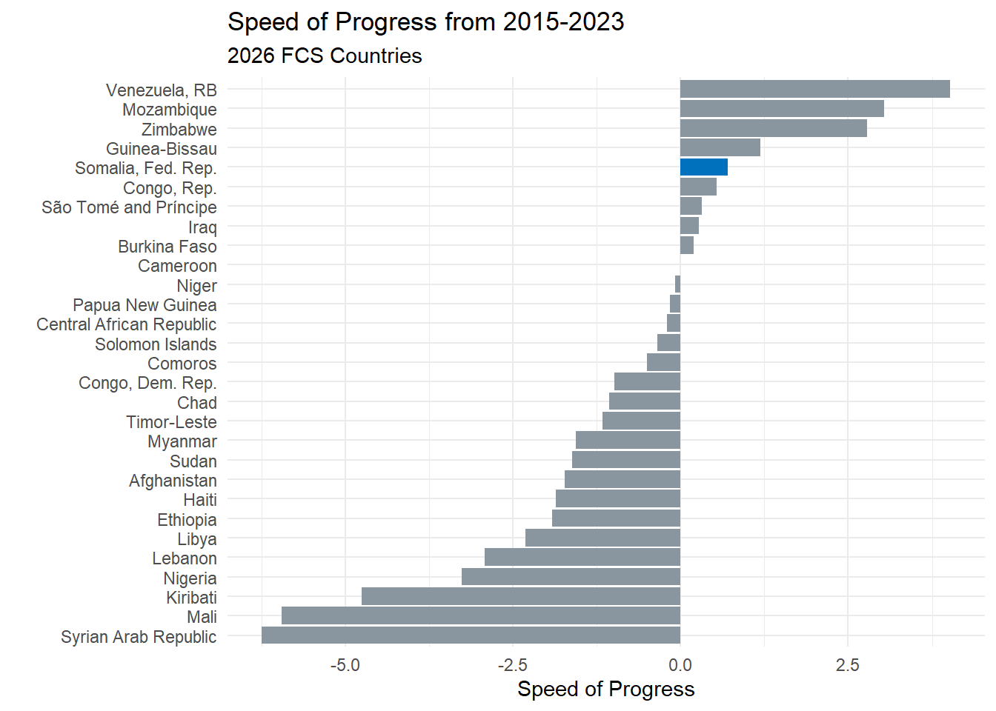
While Somalia hasn’t made progress that is extraordinary compared to the standard speed of progress. Other countries in their situation often fall off the curve. As seen here, most of the FCV Countries not only fall off the typical speed of progress path, but they actually end up regressing.
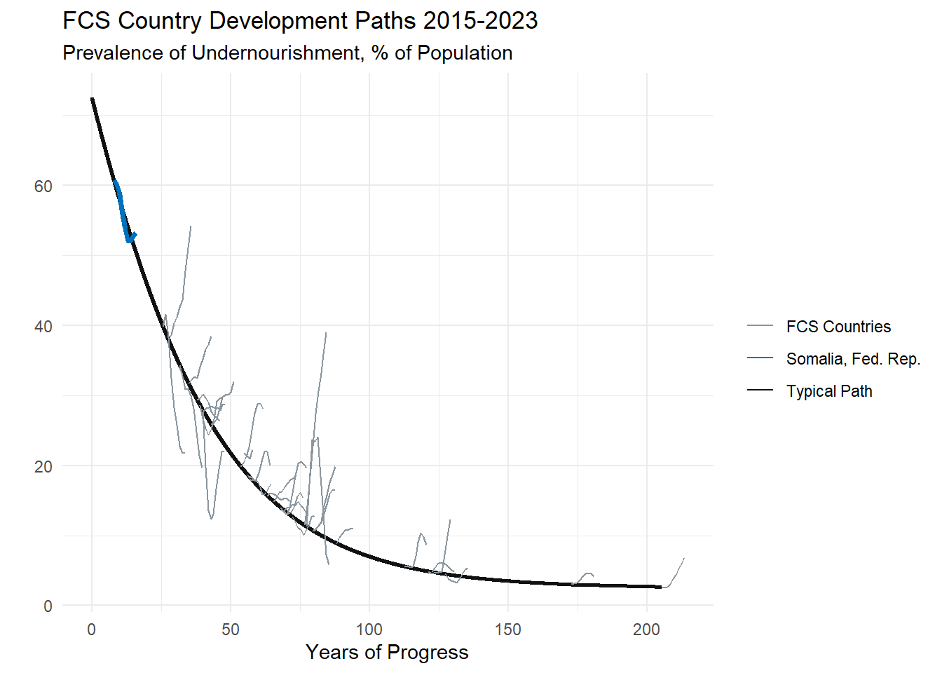
Much of this was due to the many
- Where there any challenges in this process and how were they addressed?
One of the biggest barriers to the efficient and effective execution of preparedness plan is the availability of data. In order to calibrate these models, there needs to be sufficient up-to-date ground truth data. Even the most advanced AI models risk misrepresenting data and presenting inaccurate analysis. There has been some investigation on alternative sources of data, ex. Market price data from Telegram channels or crowdsourced market data, but the idea is that we can tie these data that are being used to more national statistics. (Meeting 31:08)
- How do we take the lessons from here and apply them to other countries?
This is already being applied to multiple other countries. There are preparedness plans in many countries and they are currently holding workshops for the Risk Teams in those countries. The most recent one was Haiti, July 24th (Meeting 19:40) Currently 17 countries with JMR, 15 of which are govt led (Geneva Talk Slides)

We also include below some points on how we want to approach this field note. We would be grateful if you can help with points 3, 5, and 6 right now. We would also like your help and ideas on point 4 after we have a rough draft ready.

Approach:
- Use development data in the public domain to give broad understanding of the landscape on the hunger crisis.
- Also, use this data and literature to explain what is happening in Somalia.
- Use prepared briefs and materials to explain what is the data gap filled by the world bank and Somali government. How did this data get used to influence decision making and ultimately help the hunger crisis?
- Conduct some interviews from different stakeholders to give first person storytelling to demonstrate successful data use.
- Use existing footage/videos on Somalia or other countries on workshops, meetings, other interactions.
- The message of these videos can also help communicate how to (and how it is already) scale this work to other teams.

