更改的Controller
web.boot.pj.controller.contract.ContractCheckController
web.boot.pj.controller.office.ContractOfficeController
web.boot.pj.controller.contract.ContractChangesController
web.boot.pj.controller.contract.ContractController
web.boot.pj.controller.contract.HousingBindingController
web.boot.pj.controller.contract.ContractDeclarationController
更改的Dao
web.boot.pj.dao.contract.ContractChangesDao
更改的实体类
web.boot.pj.entity.contract.HousingBinding
web.boot.pj.entity.contract.ContractChanges

T_Housing_Binding表 增加字段(备注:CONTENT 类型nvarchar2(2000))
T_CONTRACT_CHANGES表 增加字段(提交人user表的ID : FOUNDER_ID 类型NUMBER
提交人公司Id : FOUNDER_COMID 类型NUMBER )
更改的service
web.boot.pj.service.contract.ContractChangesService

更改的页面
申报部分
templates/cms/contract/contractDeclarationList.html
templates/cms/contract/contractDeclarationEdit.html
注销部分
templates/cms/contract/contractCancelDetails.html
templates/cms/contract/contractChangeEdit.html
templates/cms/contract/ContractChangesEdit.html
templates/cms/contract/ContractChangesEX.html
templates/cms/contract/ContractReviewcheck.html
templates/cms/contract/contractReviewDetails.html
templates/cms/contract/ContractReviewEdit.html
买受人绑定部分
templates/cms/contract/housingBindingDetail.html
templates/cms/contract/housingBindingList.html
templates/cms/contract/housingBingdingAdd.html
templates/cms/contract/subjectBingding.html
合同审核页面的”总套数”去掉
templates/cms/contract/ContractCheck.html

更改的js
static/office/error-contract.js

模板
Webapp/doc/ht1.doc
Webapp/doc/xsht1.doc
菜单配置
工作流配置
现售合同申报流程
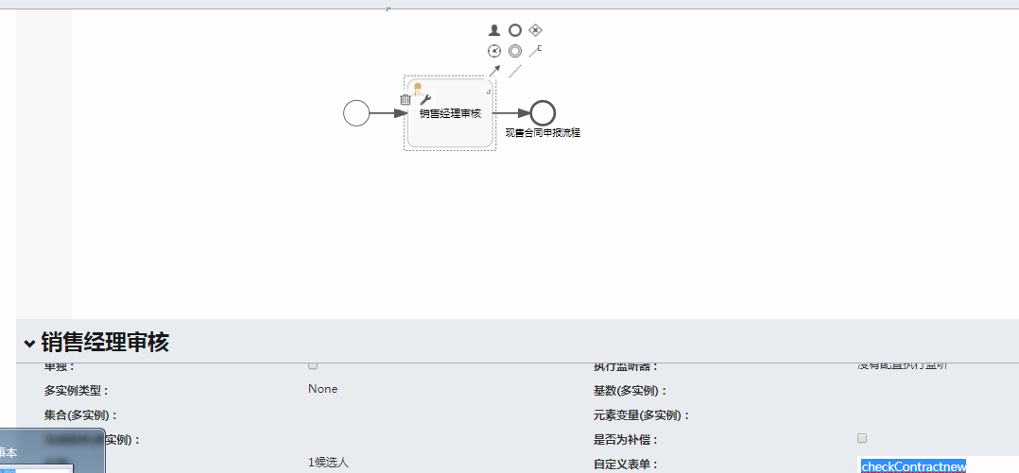

指派人:
${userService.getUserIdByRoleName(startUserId,'销售经理')}
formKey:checkContractnew
现售合同申报流程2
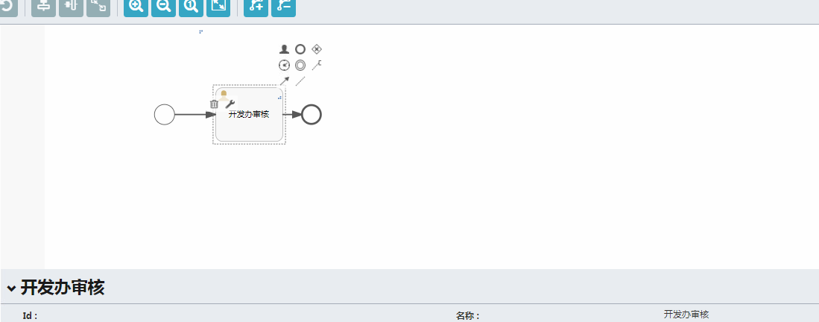

指派人:
${userService.getUserIdByRoleName('开发办管理员')}
formKey:checkContractnew

