Front End Developer Test
Objective
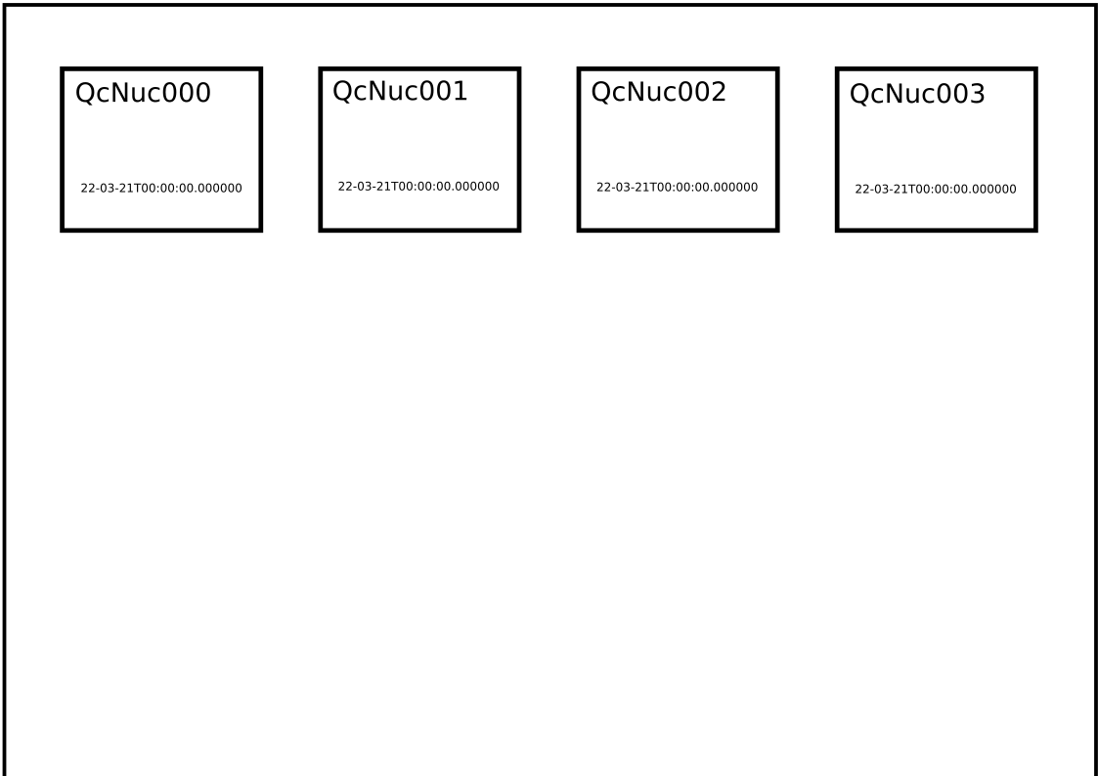
Create a page that resembles the mock view below.

How to use the test folder
- Do not modify the HTML page
- Follow the instructions inside the “main.js” file and complete the functions according to the description (which is intentionally somewhat vague)
- Style the cards, so that they appear as a grid of rectangular OR square cards

Submit
- You can zip the file and send it to the interviewer
- You can create a repository on GitHub or GitLab and send the interviewer a link

