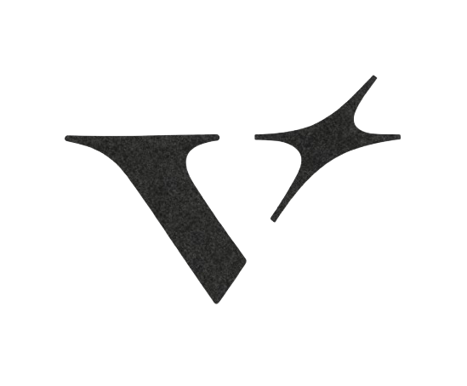

V.E.L.O.R.A

Validation Engine for Logic driven Orchestration and Risk Assurance

APPROACH DOCUMENT

TABLE OF CONTENTS:

1. Document Scope 3
2. Solution Overview 3
2.1 Core Objectives 3
3. Architectural Overview 4
3.1 Architectural Highlights 4
3.2 Key Capabilities 5
3.3 High-Level Architecture 5
3.4 Key Architectural Characteristics 5
3.5 Architecture Layers 6
A) Presentation Layer 6
B) API Layer 6
Platform Functions 7
C) Storage Layer 8
D) Agentic Layer 9
LangGraph-Powered Analysis 9
a) Interpreter Node 9
b) Evidence Gatherer Node 9
Specialized Agent Categories 10
3.6 Role of Google ADK within VELORA 11
Tool-Driven Agent Execution 11
ADK Session Lifecycle 13
Outcome: 13
4. Control Testing Lifecycle: 14
5 . VELORA Knowledge Graph Overview 16
5.1 Key Observations 16
6. Summary 18

Document Scope
This document presents the architectural approach, component design, execution workflow, technology landscape, and control testing framework implemented within the VELORA platform. It provides a detailed view of how audit evidence is processed, analyzed, validated, and transformed into structured compliance outcomes through the platform’s agentic architecture.

Solution Overview
VELORA is an audit validation and control testing platform designed to automate evidence assessment, control evaluation, and audit justification generation through an agent-driven execution framework.
The platform combines a structured preprocessing layer, agentic orchestration, semantic retrieval capabilities, knowledge graph integration, and real-time execution streaming to support automated audit testing workflows. VELORA processes audit control definitions, evidence artifacts, and testing methodologies to execute control validations and generate structured compliance outcomes.
The solution is built around a multi-layered architecture consisting of:
- React-based user interface
- FastAPI service layer
- LangGraph-powered preprocessing workflows
- Google ADK agent landscape
- Azure AI Search integration
- Azure OpenAI embedding models
- Neo4j knowledge graph
- PostgreSQL metadata repository
- Azure Blob Storage evidence repository
- Azure Key Vault secret management

2.1 Core Objectives
VELORA enables the automation of control testing activities through:
- Evidence ingestion and preprocessing
- Test methodology classification
- Automated work-order compilation
- Agent-driven control assessment
- Evidence analysis across multiple formats
- Audit justification generation
- Structured compliance evaluation

Architectural Overview
VELORA follows a layered architecture that combines audit management capabilities, intelligent preprocessing, agent-based execution, semantic retrieval, and persistent storage services to automate control testing workflows.
The platform receives control testing requests from the frontend layer and processes them through a structured execution pipeline consisting of preprocessing, methodology mapping, work-order generation, agent routing, evidence analysis, and result persistence.
The architecture is designed around clearly separated responsibilities, enabling independent management of user interactions, workflow orchestration, knowledge retrieval, agent execution, and data persistence.

3.1 Architectural Highlights
- Agentic Processing Framework
VELORA utilizes a specialized agent execution model where control testing requests are classified, mapped to testing methodologies, and routed to dedicated agents responsible for performing category-specific audit validations.
- Knowledge-Driven Analysis
The platform incorporates Azure AI Search, Azure OpenAI embedding models, and Neo4j knowledge graph capabilities to support retrieval, contextual understanding, and structured reasoning during control evaluation workflows.
- Real-Time Workflow Visibility
The execution pipeline supports Server-Sent Events (SSE) streaming, allowing consumers to monitor workflow progress across preprocessing, graph execution, agent selection, tool invocation, and final result generation stages.
- Persistent Audit Traceability
Control testing results, metadata, execution information, and validation outcomes are persisted within PostgreSQL, while supporting evidence artifacts are maintained within Azure Blob Storage.

3.2 Key Capabilities
- Agentic AI Orchestration
- Semantic Search & Retrieval
- Knowledge Graph Integration
- Evidence Processing
- Methodology-Based Control Testing
- Real-Time Workflow Streaming
- Audit Justification Generation
- Structured Compliance Assessment
- Multi-Format Evidence Analysis

3.3 High-Level Architecture

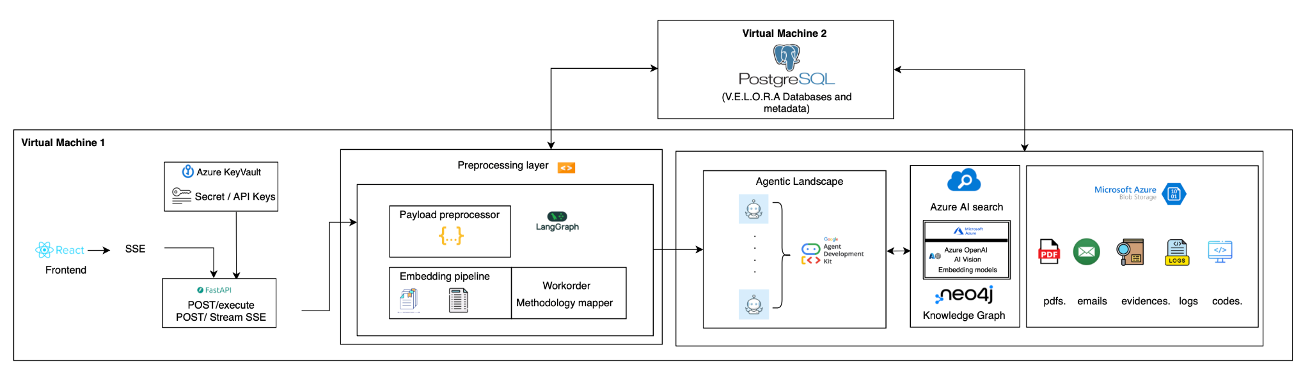

3.4 Key Architectural Characteristics
- Structured Processing Pipeline
A phased execution model ensures consistent transformation of incoming requests from payload preprocessing through final result generation.
- Methodology-Driven Execution
Control testing activities are aligned with predefined methodologies resolved during preprocessing and applied throughout agent execution.
- Agent-Based Assessment
Specialized agents perform category-specific evidence analysis and compliance evaluation activities.
- Knowledge-Enabled Processing
Azure AI Search, Azure OpenAI Embedding Models, and Neo4j support retrieval and contextual processing requirements.
- Real-Time Visibility
Server-Sent Events provide execution transparency across all major workflow stages.
- Persistent Audit Records
Control testing outputs and execution metadata are stored within PostgreSQL while evidence artifacts are maintained within Azure Blob Storage.

3.5 Architecture Layers

A) Presentation Layer
The presentation layer consists of the React frontend which serves as the primary interaction point for users.

Responsibilities include:
- Control testing initiation
- Execution monitoring
- Real-time result visibility
- SSE event consumption
- User interaction management
Communication with backend services is performed through FastAPI endpoints supporting both synchronous execution and streaming workflows.

B) API Layer
The API layer is implemented using FastAPI and serves as the entry point for all control testing requests.
Key responsibilities include:
- Request acceptance
- Payload validation
- SSE event streaming
- Workflow invocation
- Response generation

ENDPOINT | PURPOSE
POST/execute | Synchronous control testing
POST/stream | Real time streaming execution

The agentic layer performs the actual control assessment process.
Responsibilities include:
- Agent selection
- Tool execution
- Evidence analysis
- Compliance evaluation
- Audit justification generation
Agent routing is driven by methodology classification outputs generated during preprocessing.

Platform Functions
VELORA combines preprocessing workflows, methodology-driven execution, agent orchestration, evidence analysis, retrieval services, and persistent storage into a unified control testing platform. The architecture enables the processing of audit control definitions, evidence artifacts, and testing methodologies through a structured execution lifecycle.

CAPABILITY AREA | DESCRIPTION
Payload Processing | Normalizes incoming requests and enriches them with control-specific testing information
Classification & Analysis | Identifies testing categories and extracts relevant execution parameters
Methodology Resolution | Maps controls to predefined testing methodologies
Work Order Generation | Produces structured execution instructions for agent processing
Agent Orchestration | Routes requests to category-specific agents and toolsets
Evidence Analysis | Processes evidence artifacts to support control validation
Compliance Assessment | Evaluates control effectiveness and testing outcomes
Audit Justification Generation | Produces  structured explanations supporting assessment results
Real-Time Monitoring | Provides execution visibility through SSE event streaming

C) Storage Layer
VELORA utilizes dedicated storage services for structured and unstructured information.

Storage Components | Purpose
PostgreSQL | Metadata and testing results
Azure Blob Storage | Evidence Artifacts
Azure Key Vault | Secret and API key management
These services support information retrieval and contextual analysis during control evaluation workflows.

D) Agentic Layer
VELORA utilizes an agent-driven execution framework that transforms control testing requests into structured assessment workflows. Rather than applying a single evaluation mechanism across all controls, the platform dynamically selects specialized agents based on the nature of the testing requirement. This approach allows each control category to be assessed using methodologies, tools, and output structures specifically aligned to the control under review.
The agentic framework acts as the intelligence layer of the platform and is responsible for interpreting testing requirements, selecting the appropriate assessment strategy, executing evidence analysis, generating compliance outcomes, and producing audit justifications.

LangGraph-Powered Analysis
Before an agent is selected, VELORA performs parallel analysis using LangGraph.
Two independent nodes execute simultaneously:

Interpreter Node
The Interpreter Node evaluates the testing description and determines:
- Control testing category
- Relevant testing methodology
- Target parameters
- Execution context
This classification step determines which specialized agent will be responsible for the assessment.

Evidence Gatherer Node
The Evidence Gatherer Node identifies and validates supporting evidence.
Responsibilities include:
- Filename extraction
- Evidence path construction
- Storage validation
- Evidence availability verification
The outputs from both nodes are merged before the workflow progresses to methodology resolution.

Specialized Agent Categories
The platform contains dedicated agents designed to execute category-specific control assessments.
- Price Change Agent
Responsible for validating price modification activities and identifying anomalies within pricing evidence.
- Email Analysis Agent
Responsible for reviewing approval communications and validating stakeholder authorization evidence.
- Row Level Analysis Agent
Responsible for performing structured row-level comparisons between datasets and validating alignment criteria.
- SAP Image Validation Agent
Responsible for assessing SAP screenshots and validating expected attributes extracted from image-based evidence.
- Generic Validation Agent
Responsible for processing controls that do not fall within a specialized methodology category.

3.6 Role of Google ADK within VELORA
The Google ADK framework acts as the central execution engine responsible for transforming compiled work orders into structured compliance outcomes.

REPONSIBILITY | DESCRIPTION
Session Management | Creates and manages execution sessions for each control test
Tool Orchestration | Coordinates tool invocation during agent execution
Event Processing | Handles tool requests, responses, and execution events
Structured Outputs | Generates category-specific response formats
Execution Management | Controls the lifecycle of the control testing workflow
Agent Selection | Routes work orders to the appropriate specialized agent

Tool-Driven Agent Execution
Agents operating within the Google ADK framework utilize dedicated tools to perform evidence analysis activities. During execution, the selected agent determines which tools should be invoked based on the methodology instructions and evidence requirements contained within the work order.
Examples of supported tool activities include:
- Spreadsheet analysis
- Image processing
- Text extraction
- Email evidence assessment
- Row-level validation
- Attribute comparison

GoogleADK execution flow:
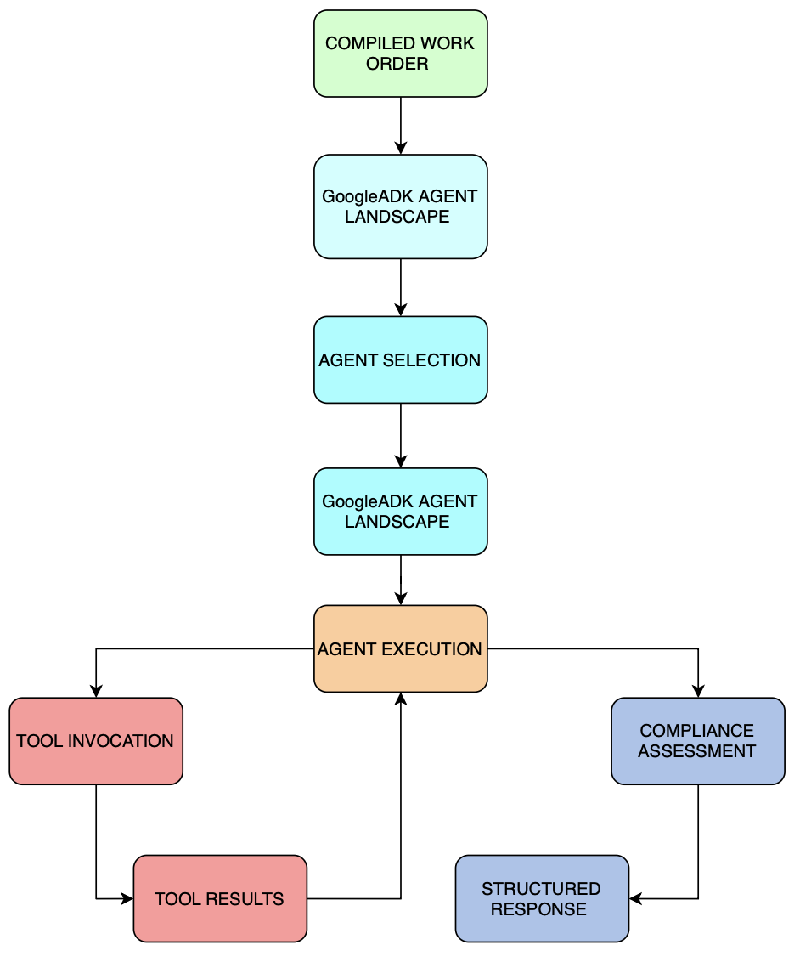

Each agent is configured with:
- Methodology-specific instructions
- Category-specific tools
- Structured input schemas
- Structured output schemas
- Compliance assessment logic
This specialization enables the platform to align agent behavior with the testing requirements of each control category.

ADK Session Lifecycle
For every control testing request, Google ADK establishes a dedicated execution session. The session exists only for the duration of the assessment and manages the interaction between the selected agent and its associated tools.
The execution lifecycle consists of the following stages:
- Session creation
- Agent initialization
- Work order ingestion
- Tool invocation
- Tool response processing
- Compliance evaluation
- Response generation
- Session completion
This lifecycle ensures that each control test is executed independently while maintaining a consistent processing framework across all testing methodologies.

Outcome:
Upon completion of evidence analysis and validation activities, the Google ADK framework produces a structured response aligned with the output schema of the selected testing category. These outputs may contain compliance status, validation findings, extracted attributes, anomaly details, comparison results, and audit justification information.
The generated response is then passed to the persistence layer where execution metadata and assessment outcomes are stored for future retrieval and audit traceability.

4. Control Testing Lifecycle:
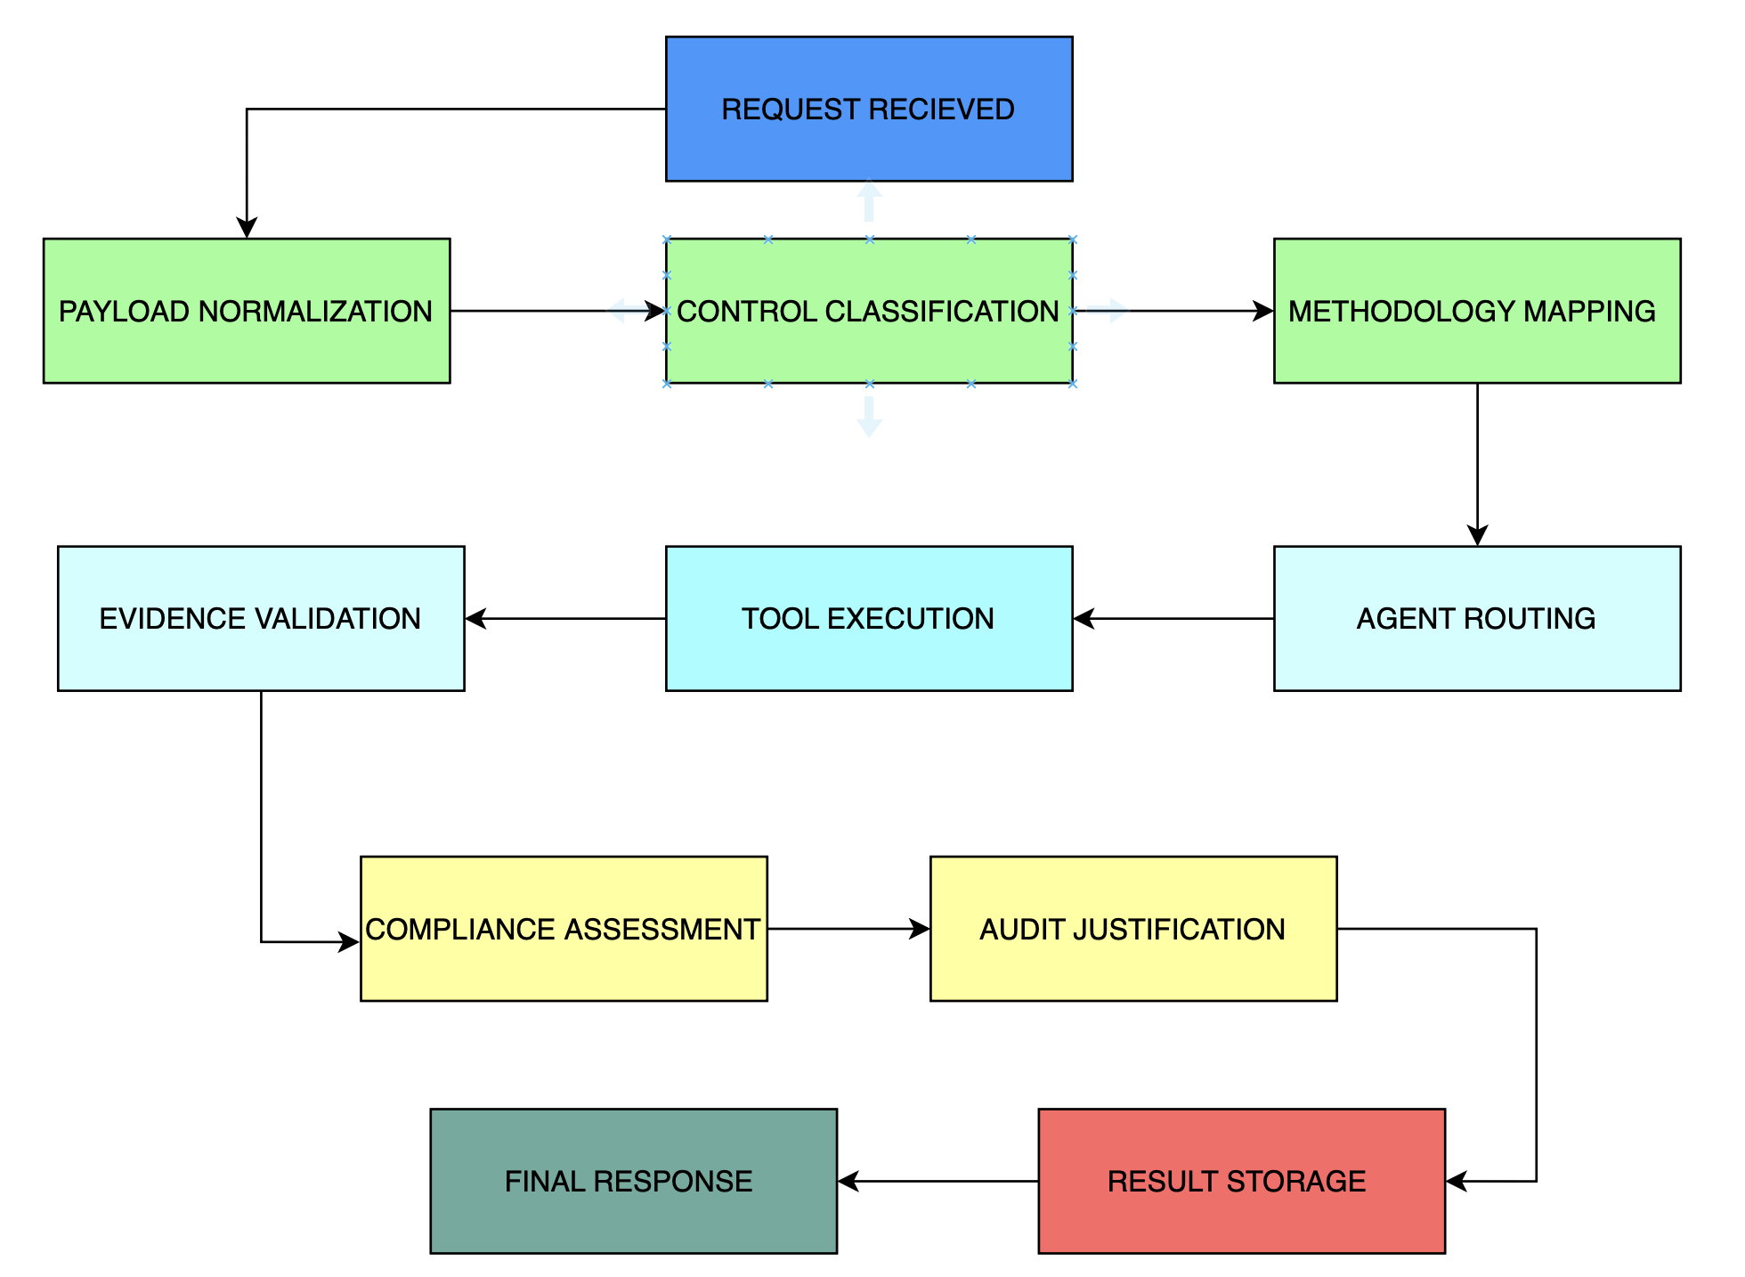

VELORE WORKFLOW :
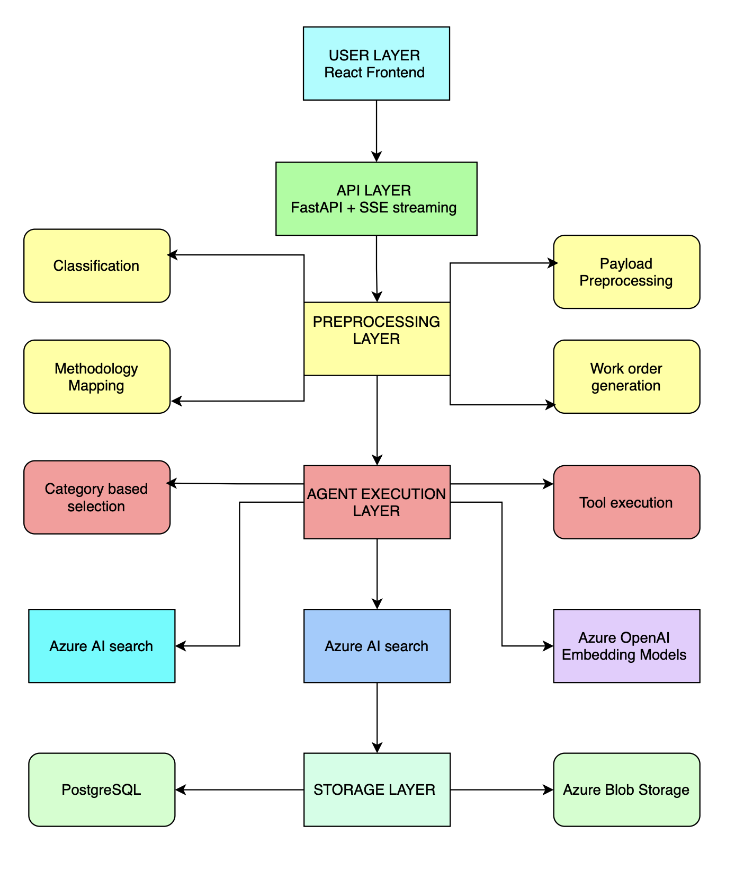

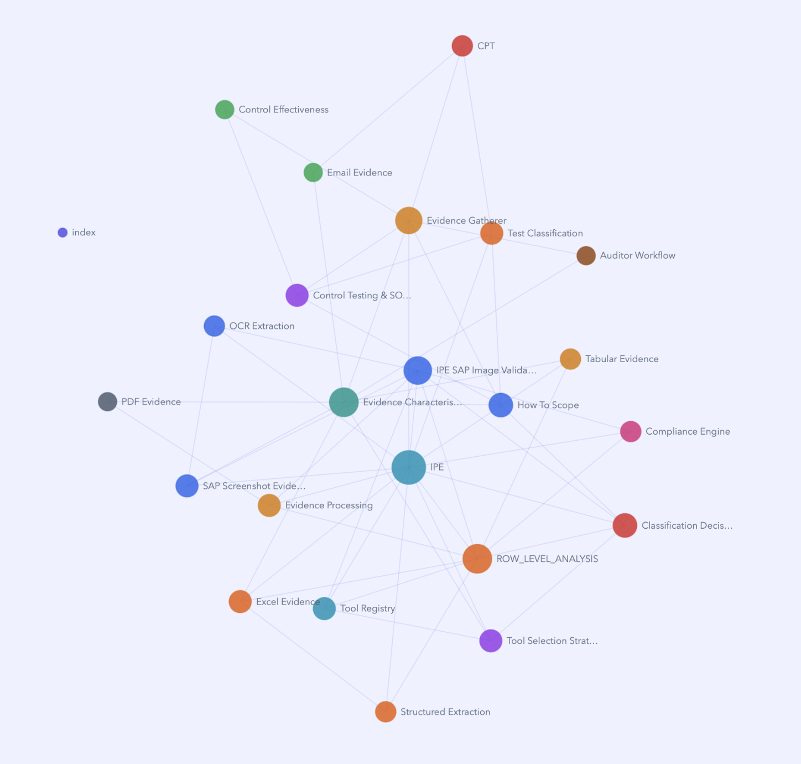

5 . VELORA Knowledge Graph Overview
The VELORA Knowledge Graph represents the interconnected relationships between audit methodologies, evidence types, processing techniques, classification logic, and control testing workflows. At the center of the graph are key concepts such as IPE, Evidence Characterisation, ROW_LEVEL_ANALYSIS, and IPE SAP Image Validation, which act as primary knowledge hubs connecting evidence sources, extraction methods, testing methodologies, and compliance assessment processes. This interconnected structure enables the platform to provide contextual understanding, support intelligent agent decision-making, and enhance evidence-driven control testing through relationship-based knowledge retrieval.

5.1 Key Observations
- IPE serves as a central knowledge domain, linking evidence processing, extraction methods, validation workflows, and assessment outcomes.

- Evidence Characterisation connects multiple evidence formats including PDF evidence, SAP screenshots, Excel evidence, and OCR-derived information.

- Control Testing & SOX is associated with evidence gathering, control effectiveness evaluation, and email-based audit evidence.

- ROW_LEVEL_ANALYSIS is linked to structured extraction, tool selection strategies, and classification decision workflows.

- IPE SAP Image Validation integrates OCR extraction, SAP screenshot evidence, tabular evidence, and compliance validation activities.

- Evidence Gatherer and Test Classification act as important orchestration nodes supporting methodology identification and workflow execution.

- The graph establishes relationships between audit evidence, processing techniques, testing methodologies, and compliance outcomes, providing a knowledge foundation for agent-driven assessments within VELORA.

6. Summary
VELORA is an AI-powered control testing and audit validation platform that combines evidence analysis, methodology-driven execution, and agent-based assessment within a unified architecture. Through a structured processing pipeline leveraging LangGraph, Google ADK, Azure AI Search, Azure OpenAI Embeddings, Neo4j, PostgreSQL, and Azure Blob Storage, the platform transforms control testing requests into compliance outcomes supported by audit justifications. By integrating preprocessing, intelligent agent routing, evidence validation, real-time workflow visibility, and persistent audit traceability, VELORA provides a scalable and consistent framework for automating end-to-end control testing activities across audit engagements.

