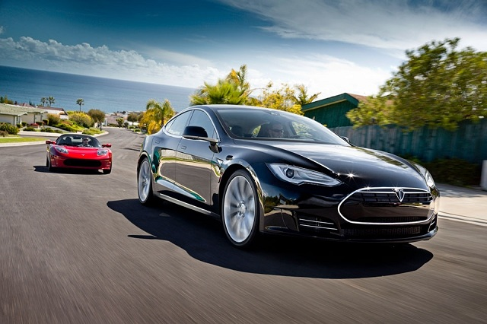

Light weight Electric cars for optimum utilization of battery power using Nano-materials.

KENNETH PRABAKARAN

U101116FCS275

-Interdisciplinary Aspects & Value Creation (s-5)

INDEX

1. Introduction
2. Interdisciplinary knowledge
3. Value Creation
4. Conclusion
5. References

WEBQUEST

http://zunal.com/webquest.php?w=350006

introduction

Putting simply, an electric car which is powered by a rechargeable battery, converter present in the car converts the current from DC to AC so that the electric motor can work by converting the electrical energy into mechanical energy. Nanotechnology is basically engineering and manufacturing at the molecular scale, using the unique properties that exist at that scale. Electric cars topped the list of new vehicle registrations for the second time in the Scandinavian country. We all know electric cars provide smoother drive than petrol cars, combining with the range extended with nanotechnology can become our primary vehicle for transport. Most of the research organizations and institutes have already started working on maximizing the output of electric cars from the tires, windshield, rooftop, battery and even making the body panels light. Our main motive is to make the electric car light and produce better performance equal to the fueled cars. The basic trends that nanotechnology provides for automobiles are - lighter but stronger materials, improved engine efficiency, miniaturized and improved electronic systems and better economies.

Interdisciplinary knowledge

Interdisciplinary means relating to more than one branch of knowledge. Alternatively means research.

- Diving into greater aspects of physics with Nano science we can increase the mechanical properties of the electric car like higher hardness, super elasticity at high temperatures. This results in a optimized lightweight car.

- Combining with Electronics and magnetism - In the nanometer range quantum effects ta place that cannot be observed in larger objects. An increase in the specific electrical resistance and a change in the temperature dependency of the resistance in comparison to a material with crystals in the micrometer range can often be observed. Such type of manipulation on a material allows tuning of the electronic properties. The Giant magneto effect is used in magnetic field sensors and in magnetic storage devices or in glues which are modified with nanoparticles such that the adhesive property becomes switchable.

- Optical functionalities - being smaller than the wavelength of visible light, no reflection occurs. Nanoparticles can also cause dispersion effects where shorter wavelengths are deflected more than longer wavelengths which can cause color effects.

- Chemical functionalities - It is based on surface structure. As the atoms are highly reactive because of their unsaturated bonding. In the future Graphene batteries would likely replace Lithium ion battery because it could offer more than 400 miles of a driving range on a charge.

value creation

|  |  |
| --- | --- |
| |  | | --- | |  | |

We define value creation as a firm level tasks that would likely increase the value of final services or goods as compared to the value of raw materials, services and other production expenses. Measuring value creation at firm level would be the value added during the production and labor productivity. As creating value is the most important step of a org/corp/firm, capturing that value also has the equal priority. It refers to the share of the created value that is retained by the firms. We can evaluate value capture through the salary, investment, domestic sourcing, tax revenues, etc. The economic effects of the automobile industry depend upon its capital intensity of the production, especially in terms of salary and value added per labor, which would tend to increase with the increasing capital intensity of the production or vice-versa. Nowadays, the companies are trying to specialize on some activities more than on others by interlinking industries and other entities which leads to a higher concentration on core competences which are important to competition. For example, Germany is getting their automobile parts from everywhere around the world, trying to put more effort in the design and technology development. But this process requires a high demand of coordination. By deciding where and how to perform the company activities, a competitive advantage is possible. Making coordination and configuration the main two pillars of value creation. In recent years many companies like Ford, Volkswagen, Renault, etc. have placed their production lines in Russia, this is because of the low labor costs, high import taxes and a great demand for cars. A major success factor for the future of the automobile industry is to concentrate more on the needs of the customer.

Conclusion

Nanotechnology, the word looks simple but carries a heavy burden promising a better future. The future that we are going to face is quite disturbing, with most of the natural resources depleted, begging the sun to provide us energy, as always. So, we have to take care of the present resources combining them with nanotechnology, making the product a lot stable and increasing its life span. As discussed above, the Nano-engineered materials are helping in upgrading the present technology, from the exterior to the interior of an electric car. Every aspect of a car matters in making them light and increasing the overall performance. Nanosteel which is believed to be a lot stronger than normal steel, making the car lighter, as well as decreasing the battery consumption. Graphene stacked together with supercapacitor, increases the potential of the battery, just like HENRY FISKER producing an electric car in late 2017. Which is going to change the value of electric cars, increasing the range, better automation, better sensors, better build quality and a better riding experience, just like the world is going to be in the future.

Starting from the basic subject that we learn from high school physics, chemistry, mathematics and electronics that we are learning currently are important to understand the basic of nanotechnology. When all the subjects under nanotechnology are covered, we would obviously get a better product. Practically all physical and chemical properties of polymers can be modified using fillers. Innovations and the cutting-edge technologies are needed imperatively to maintain competitiveness in automotive engineering. Spin off effects of the invasion of nanotechnology in automobiles has been a trendsetter for the modernization of cars. Ultimately, Nanotechnology is going to be a common technology which is going to be accepted worldwide. Nanotechnology awaits a luxury in the electric car industry.

references

1. <https://www.google.co.in/url?sa=t&rct=j&q=&esrc=s&source=web&cd=1&cad=rja&uact=8&ved=0ahUKEwj61sDQnM7TAhWGuY8KHaxRAmYQFggpMAA&url=http%3A%2F%2Fwww.businessinsider.com%2Fhenrik-fisker-is-using-revolutionary-battery-tech-for-electric-car-2016-10&usg=AFQjCNEdqzi3xQ0QJnzuQtj-zwbfeTpZSA&sig2=qRxw9zF-4oEetkzOU7jDAw>
2. <https://www.greentechmedia.com/articles/read/the-future-of-the-electric-car>
3. <http://www.bloglet.com/tips-for-a-successful-customer-value-creation/>