Course name: Get started with web development

Project Name: Simply Blogging

Git repository link: <https://github.com/ajinkyadhekre/simplyblogging.git>

Project Developments steps are as below:

1. Creating a git repository on github.com and initializing an empty git repository by the “git init” command.
2. Creating folder structure for project which includes:
3. Images folder
4. Js folder
5. Index.html file

**Index.html file steps:**

* Create HTML page structure with title “Simply Blogging” and include **bootstrap** “bundle.js” and “min.css” cdn links to include bootstrap to html file.

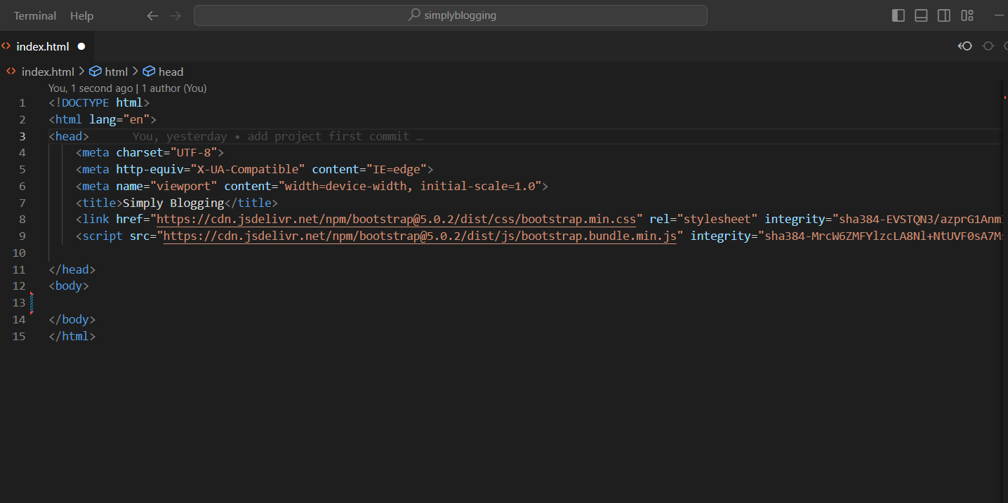

* Create a navigation bar with the help of bootstrap navigation bars with necessary links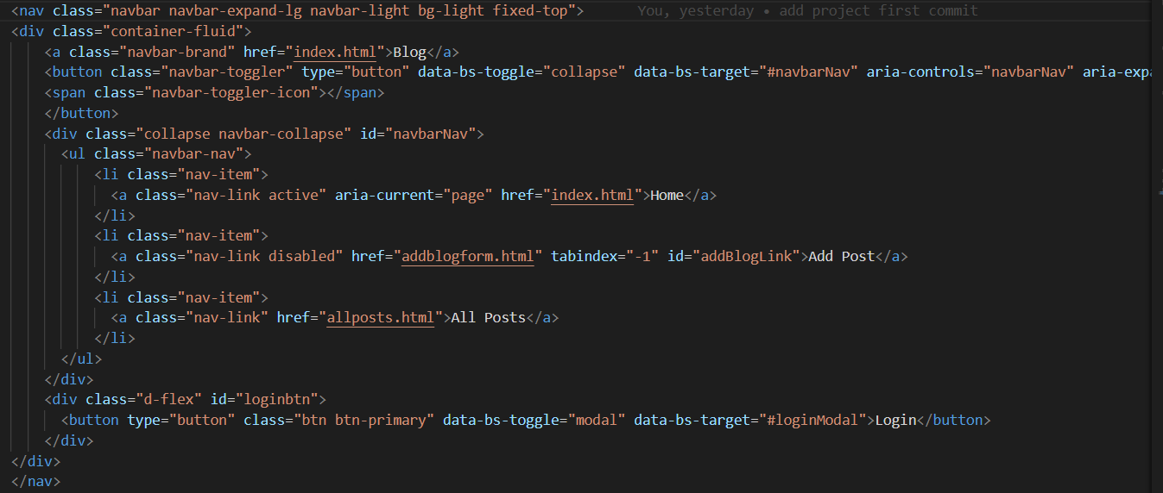



* Create a login modal for users to login( without any authentication as we didn’t had any data to compare and I didn’t wanted to use static data). 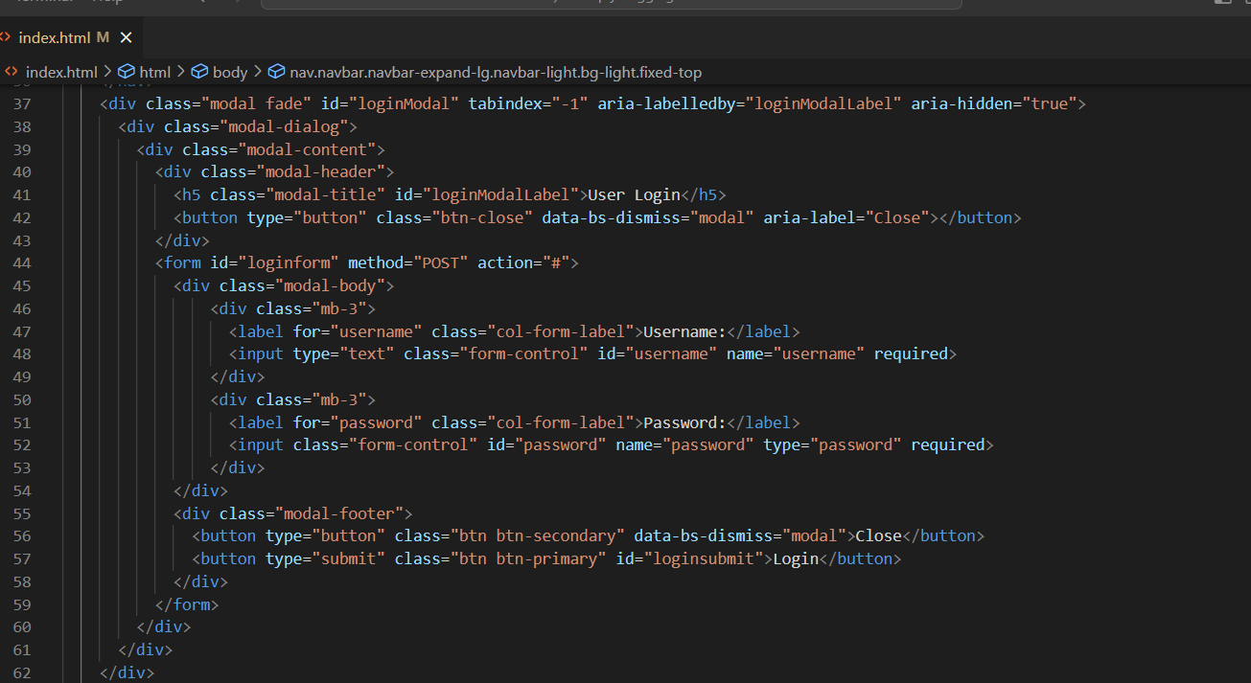

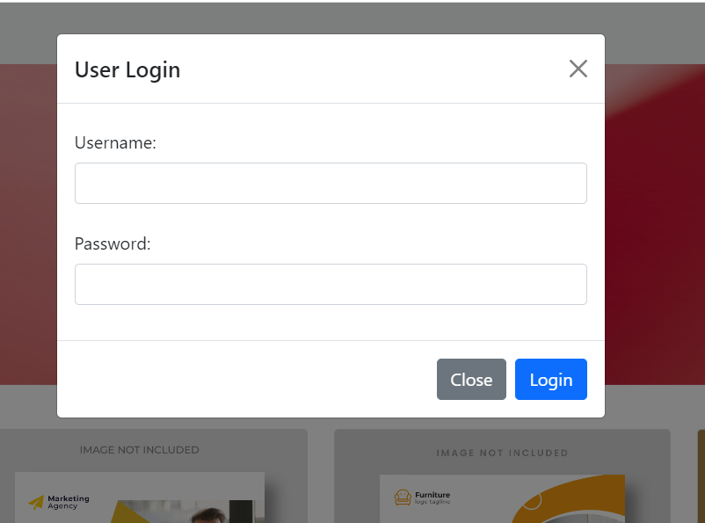

* Add images slider to the page for banner purposes using bootstrap carousals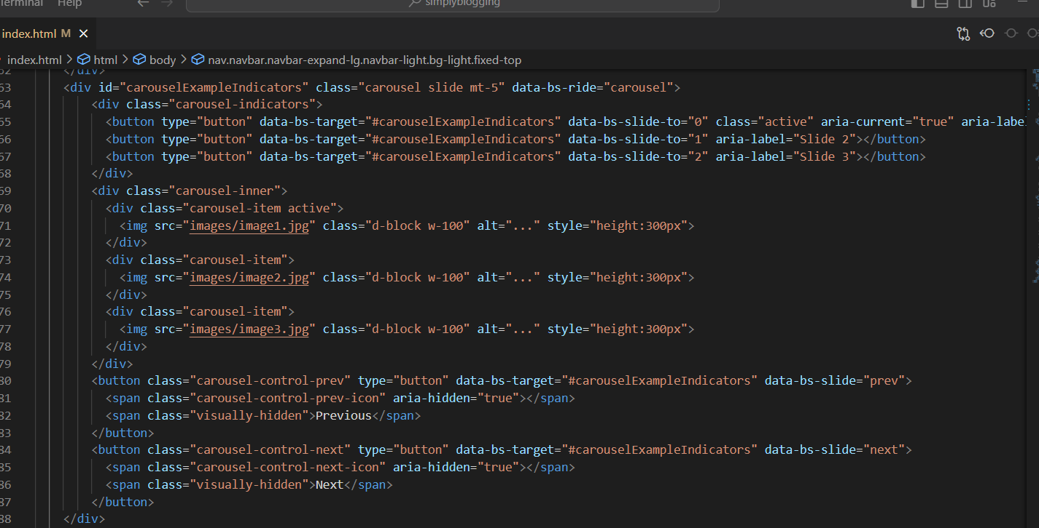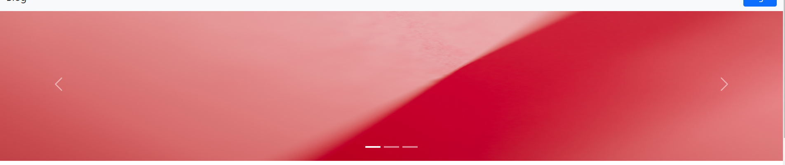
* Added a featured posts section to show featured posts for the month by using static images which are placed in projects images folder. 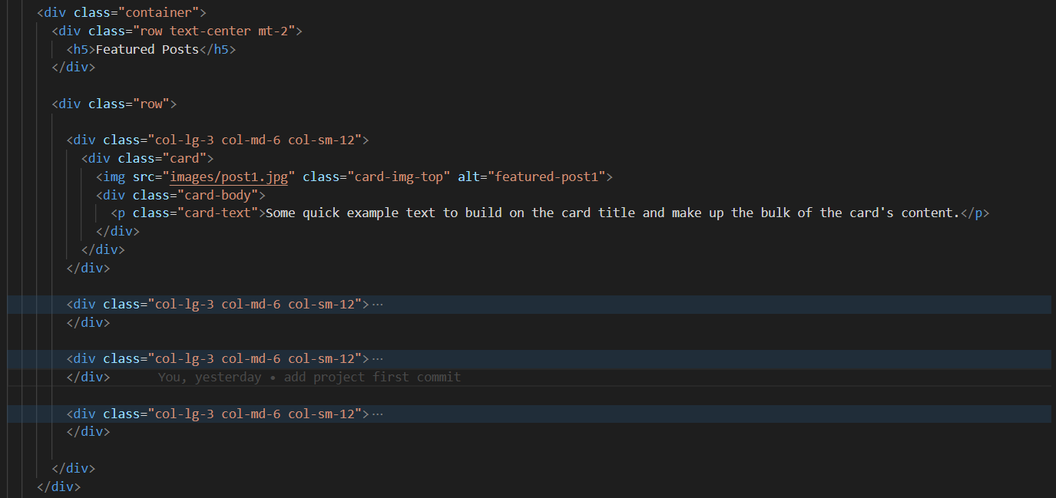
* Added a section to show 1 or 2 posts in big format. 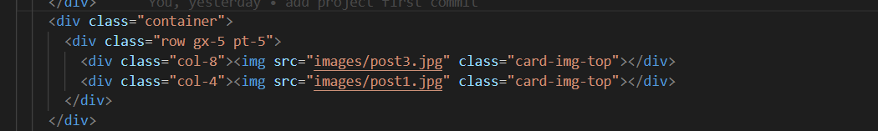
* Added footer to the website the help of bootstrap footers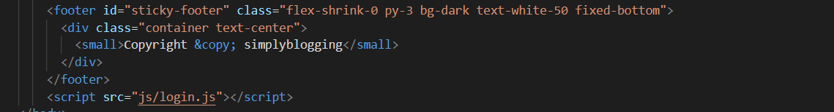
* Added a file named login.js to allow user to **login** to the website and make the **add blog button** visible on **login** **only**
* Here i have used javscripts onsubmit button event and evenlistner to collect the login form data submitted by user. If there is user data present then only further action is performed or else the login form is validated and gives proper error messages accordingly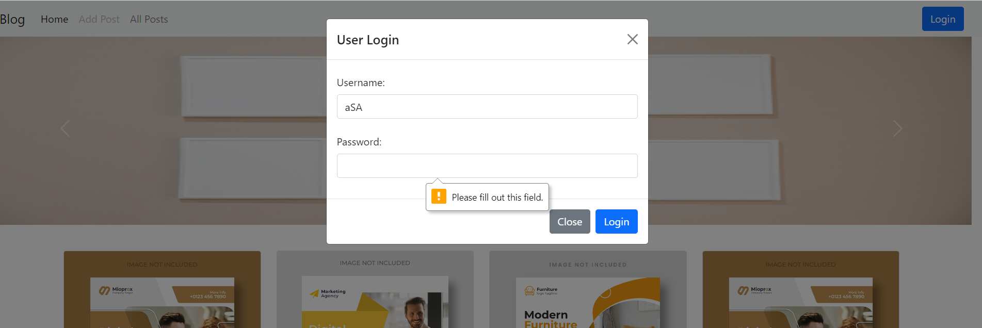
* The form data i.e username and password are stored in local storage variable of browser to protect data from getting vanished on page reload.
* Once a user log’s in to the website he gets to see a logout button instead of Login button at same position as of Login button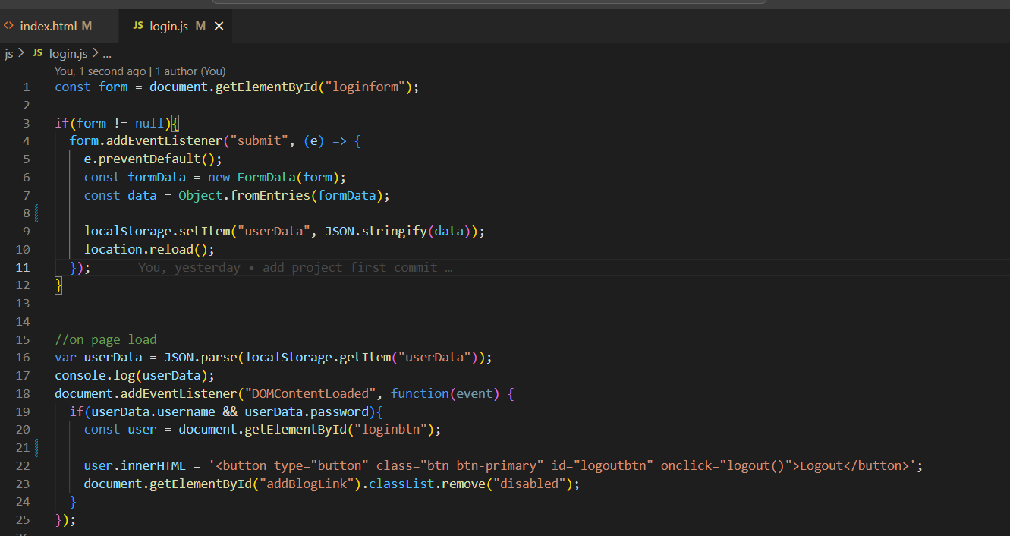
* As user logout from website his data will be removed from local storage and user will again see login button on nav bar. 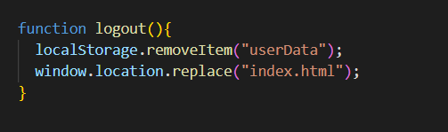

**Addblogform.html page steps:**

* Create a page using the same basic structure of index.html file. Which includes the navigation bar and its functionalities, footer and bootstrap essential links
* Create a html form having fields such as first name ,last name ,email ,address ,city ,state ,zip ,blog title , blog content , images , checkbox for terms and conditions and a submit button.

<form class="row g-3 was-validated" method="post" action="allposts.html" id="addblogform">

                <div class="col-md-4">

                  <label for="inputfirstname" class="form-label">First name</label>

                  <input type="text" name="fname" class="form-control" placeholder="First name" aria-label="First name" id="inputfirstname" required>

                  <div class="invalid-feedback">Please enter first Name</div>

                </div>

                <div class="col-md-4">

                  <label for="inputlastname" class="form-label">Last name</label>

                  <input type="text" name="lname" class="form-control" placeholder="Last name" id="inputlastname" aria-label="Last name" required>

                  <div class="invalid-feedback">Please enter last Name</div>

                </div>

                <div class="col-md-4">

                  <label for="inputEmail" class="form-label">Email</label>

                  <input type="email" name="email" class="form-control" id="inputEmail" required>

                  <div class="invalid-feedback">Please enter email</div>

                </div>

                <div class="col-12">

                  <label for="inputAddress" class="form-label">Address</label>

                  <input type="text" name="address" class="form-control" id="inputAddress" placeholder="1234 Main St" required>

                  <div class="invalid-feedback">Please enter address</div>

                </div>

                <div class="col-md-6">

                  <label for="inputCity" class="form-label">City</label>

                  <input type="text" name="city" class="form-control" id="inputCity" required>

                  <div class="invalid-feedback">Please enter city</div>

                </div>

                <div class="col-md-4">

                  <label for="inputState" class="form-label">State</label>

                  <select id="inputState" name="state" class="form-select" required>

                    <option selected>Choose...</option>

                    <option>...</option>

                  </select>

                </div>

                <div class="col-md-2">

                  <label for="inputZip" class="form-label">Zip</label>

                  <input type="text" name="zip" class="form-control" id="inputZip" required>

                  <div class="invalid-feedback">Please enter zip</div>

                </div>

                <div class="col-12">

                  <label for="inputTitle" class="form-label">Blog Title</label>

                  <input type="text" name="blogTitle" class="form-control" id="inputTitle" placeholder="Blog Title" required>

                  <div class="invalid-feedback">Please enter blog title</div>

                </div>

                <div class="col-12">

                  <label for="inputContent" class="form-label">Blog Content</label>

                  <textarea class="form-control" name="blogContent" id="inputContent" placeholder="Content for blog goes here..." rows="10" required></textarea>

                  <div class="invalid-feedback">Please enter blog content</div>

                </div>

                <div class="col-12">

                  <label for="inputImages" class="form-label">Images</label>

                  <input type="file" name="blogImage" class="form-control" id="inputImages" placeholder="1234 Main St">

                </div>

                <div class="col-12">

                  <div class="form-check">

                    <input class="form-check-input" name="termsaccepted" type="checkbox" id="gridCheck" required>

                    <label class="form-check-label" for="gridCheck">

                      Accept Terms and Conditions

                    </label>

                  </div>

                </div>

                <div class="col-12">

                  <button type="submit" class="btn btn-primary">Submit</button>

                </div>

            </form>

* Added adblogform.js file to add blog data to session variables by using javascript submit form events. 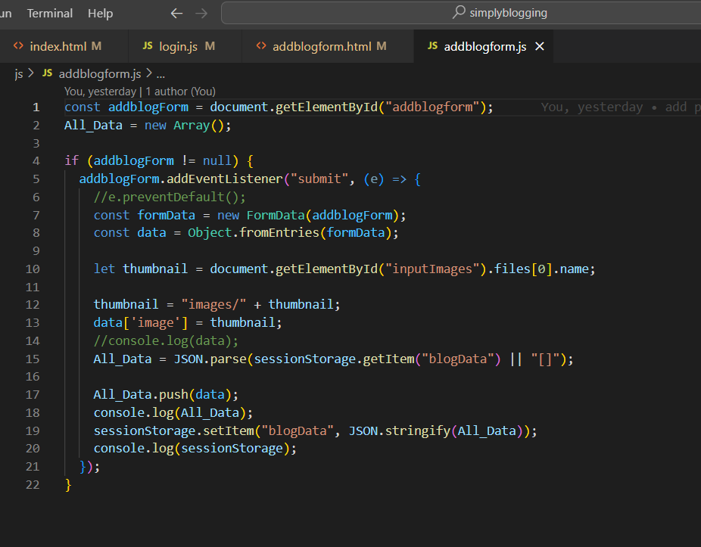
* Create allposts.html file to show the posts which are submitted from above step and the layout same as index.html.
* I have used bootstrap cards to show the submitted blogs from addblogform.html form using basic container. 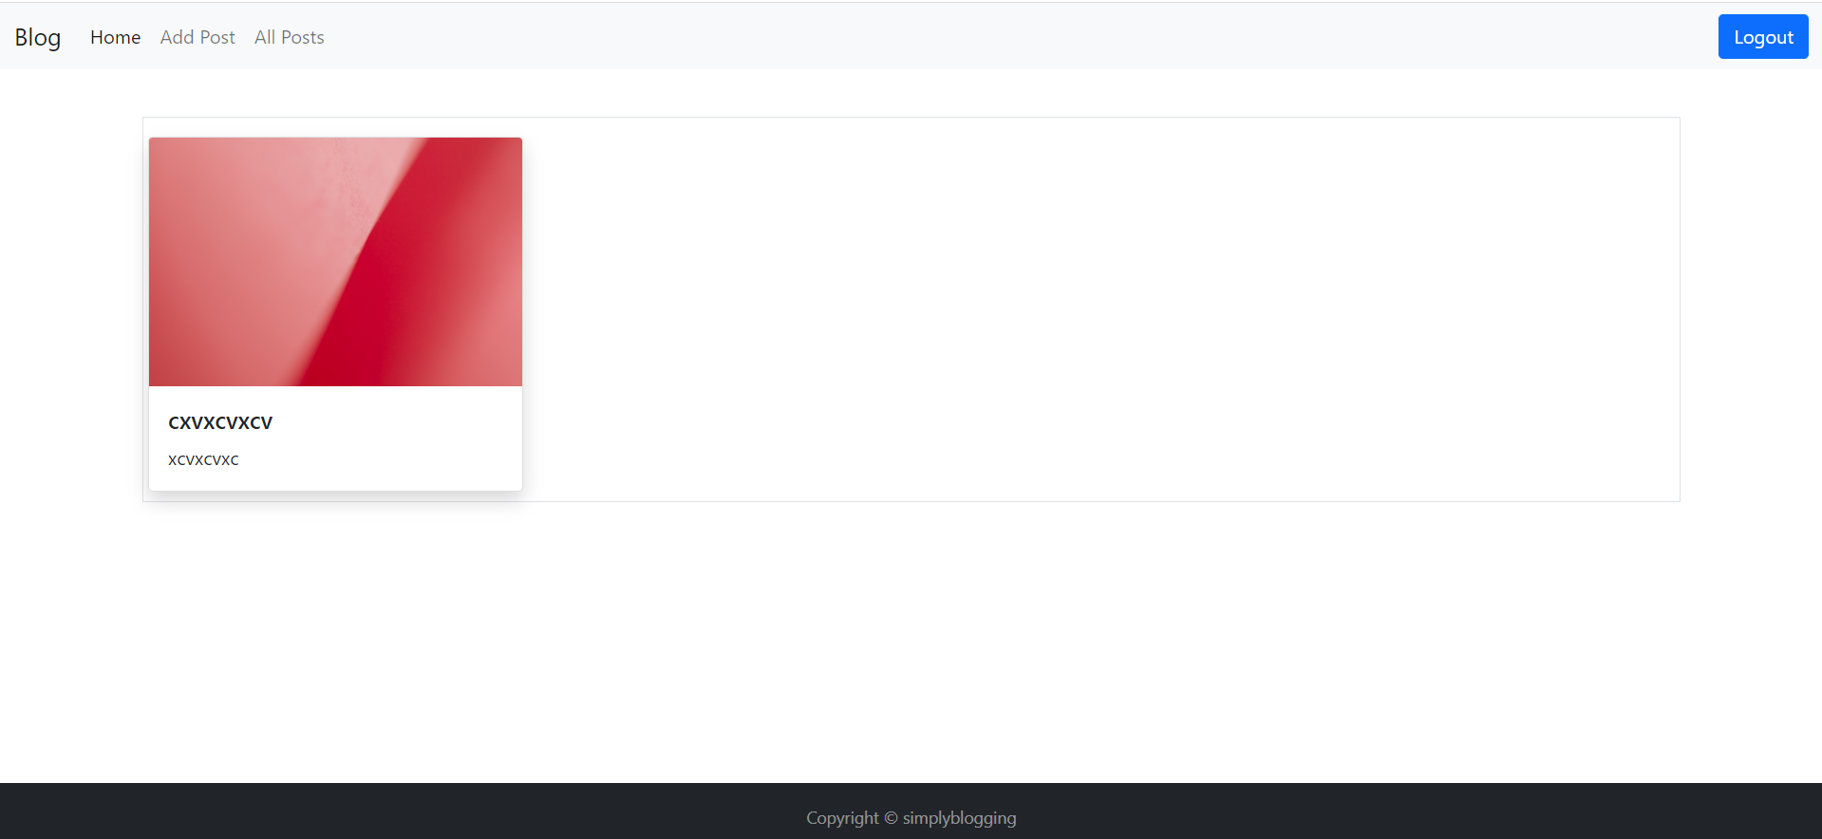
* Allposts.js file added In which used javascript callback function to show the session stored data to html file. 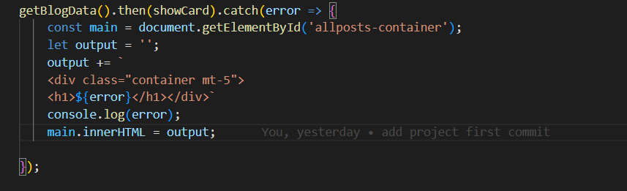
* Used promise to verify if data is present in session variables or not and give error message if no data found. 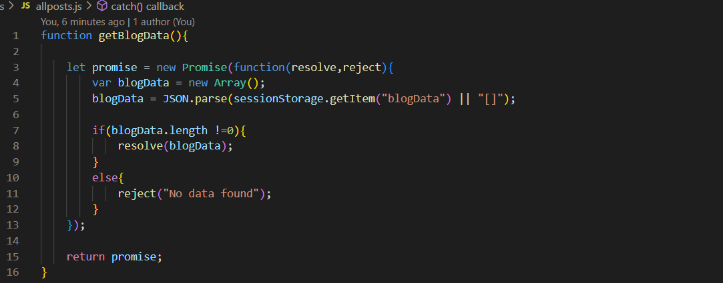
* Used showcard function to organize the data by using foreach loop to create an html cards and pass them to getBlogData() function to display. 