**Answer 1: Sequence Diagram**

**Answer 2: Object Classes**

**Answer 3: Activity Diagram**

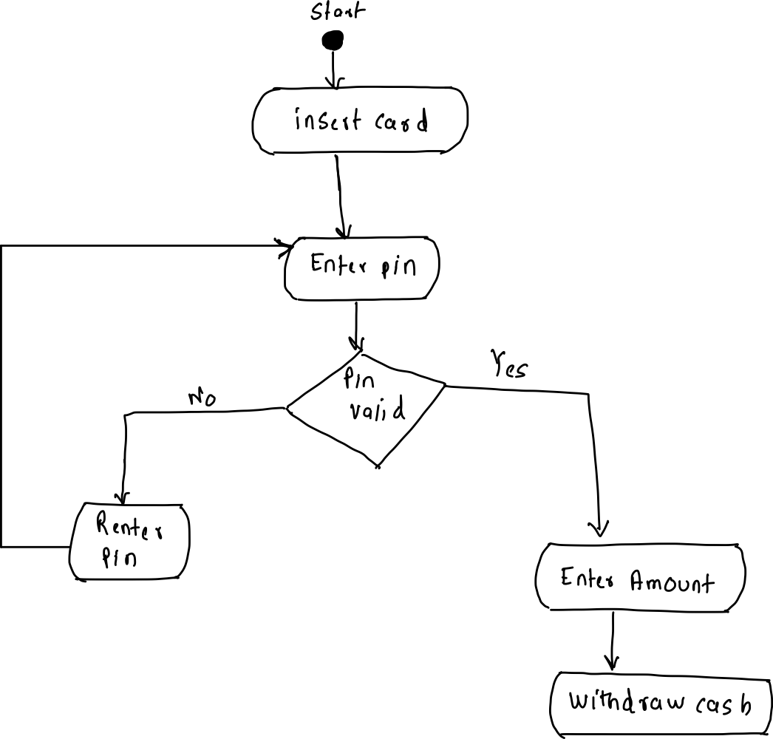

**Answer 4:**

Model driven engineering approach that uses models to describe a system. Models which are at different abstraction level are created. It is possible to create a system from high level platform independent models without manual effort.

Following factors are considered

1. Before moving to model driven engineering, it is necessary to check if the team has expertise in UML and creating advanced models because that is one of the important skills for model driven approach.
2. If the project is using Agile methodology, it becomes a little difficult to add Model Driven engineering approach as it requires everything at start but in agile, we change as per requirement. But if the agile approach is planned then it is possible
3. Check for future benefits of using the system. If the system is developed from scratch, then it makes sense to use Model Driven engineering.
4. Cost associated with the tools to develop advanced models and if the tools are available in the team.