Computer Comm & Networks - ITCS 6166 /8166

# Assignment - 1 Part 1 (50 Points) Due on: 09/22/2021 11:59pm

## This exercise will help you to install Virtual Box and get you familiar with VM setup. This part will help you to get ready with the required setup to work on the future assignments.

**VirtualBox Virtualization:** This software is a free software that allows users to run multiple guest operating systems from a single computer.

### Download VM image

We recommend installing the following VM image:

(This is a 64-bit image, make sure you have enabled VT-x or any other virtualization feature in your BIOS)

<https://drive.google.com/file/d/13Ydbd2SQR55tYX-egAosx-6_UvefyQLL/edit>

# Download Virtualization System

## You can use any virtualization system of your choice, but we recommend installing VirtualBox. It’s free and runs on Windows, Linux and OS X. VirtualBox : https://[www.virtualbox.org/wiki/Downloads](http://www.virtualbox.org/wiki/Downloads) For other

virtualizations systems, visit here.

**Installation Process:**

By clicking on the download virtualbox setup file the below window should popup.

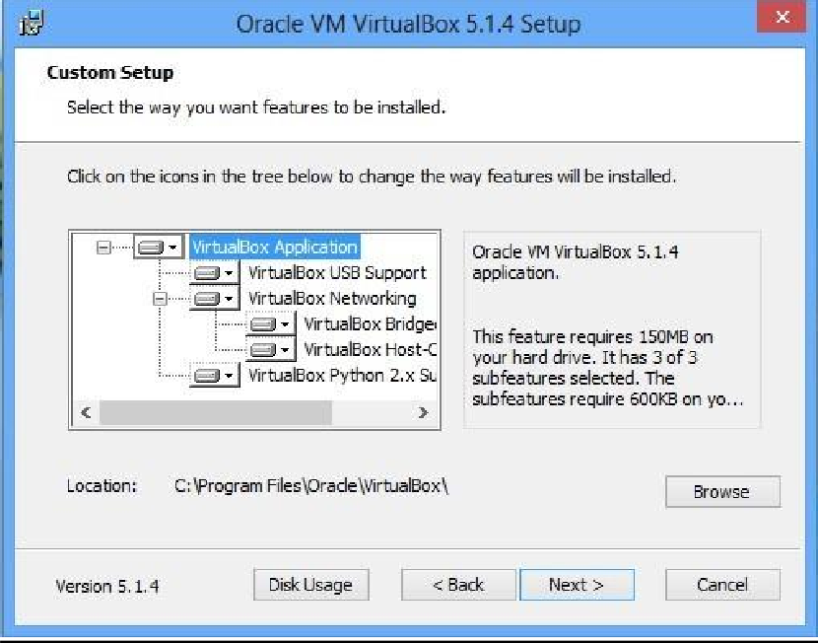

After downloading run the executable file to begin installing the software. When you start the installation, you should get a prompt like one below.

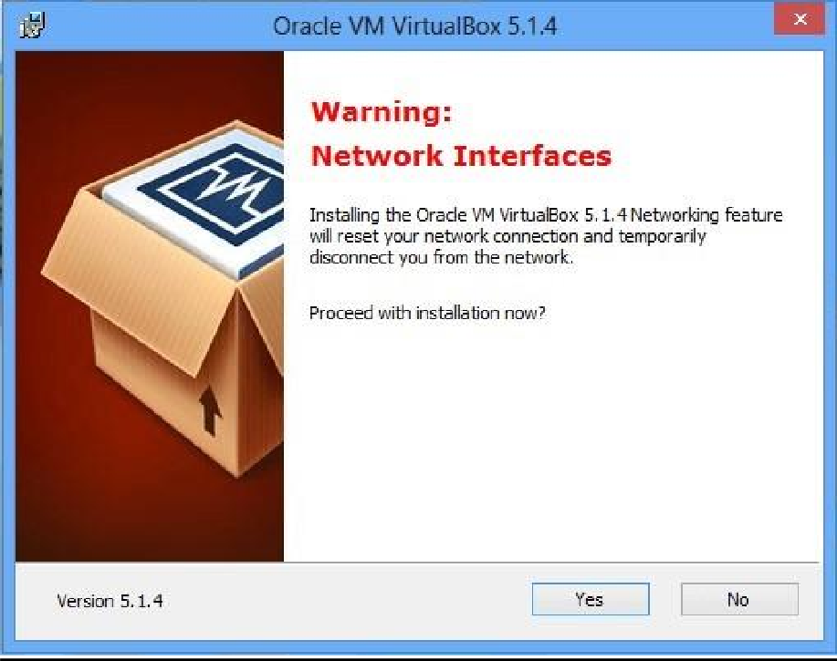

When the above warning pops up click yes to proceed to the installation.

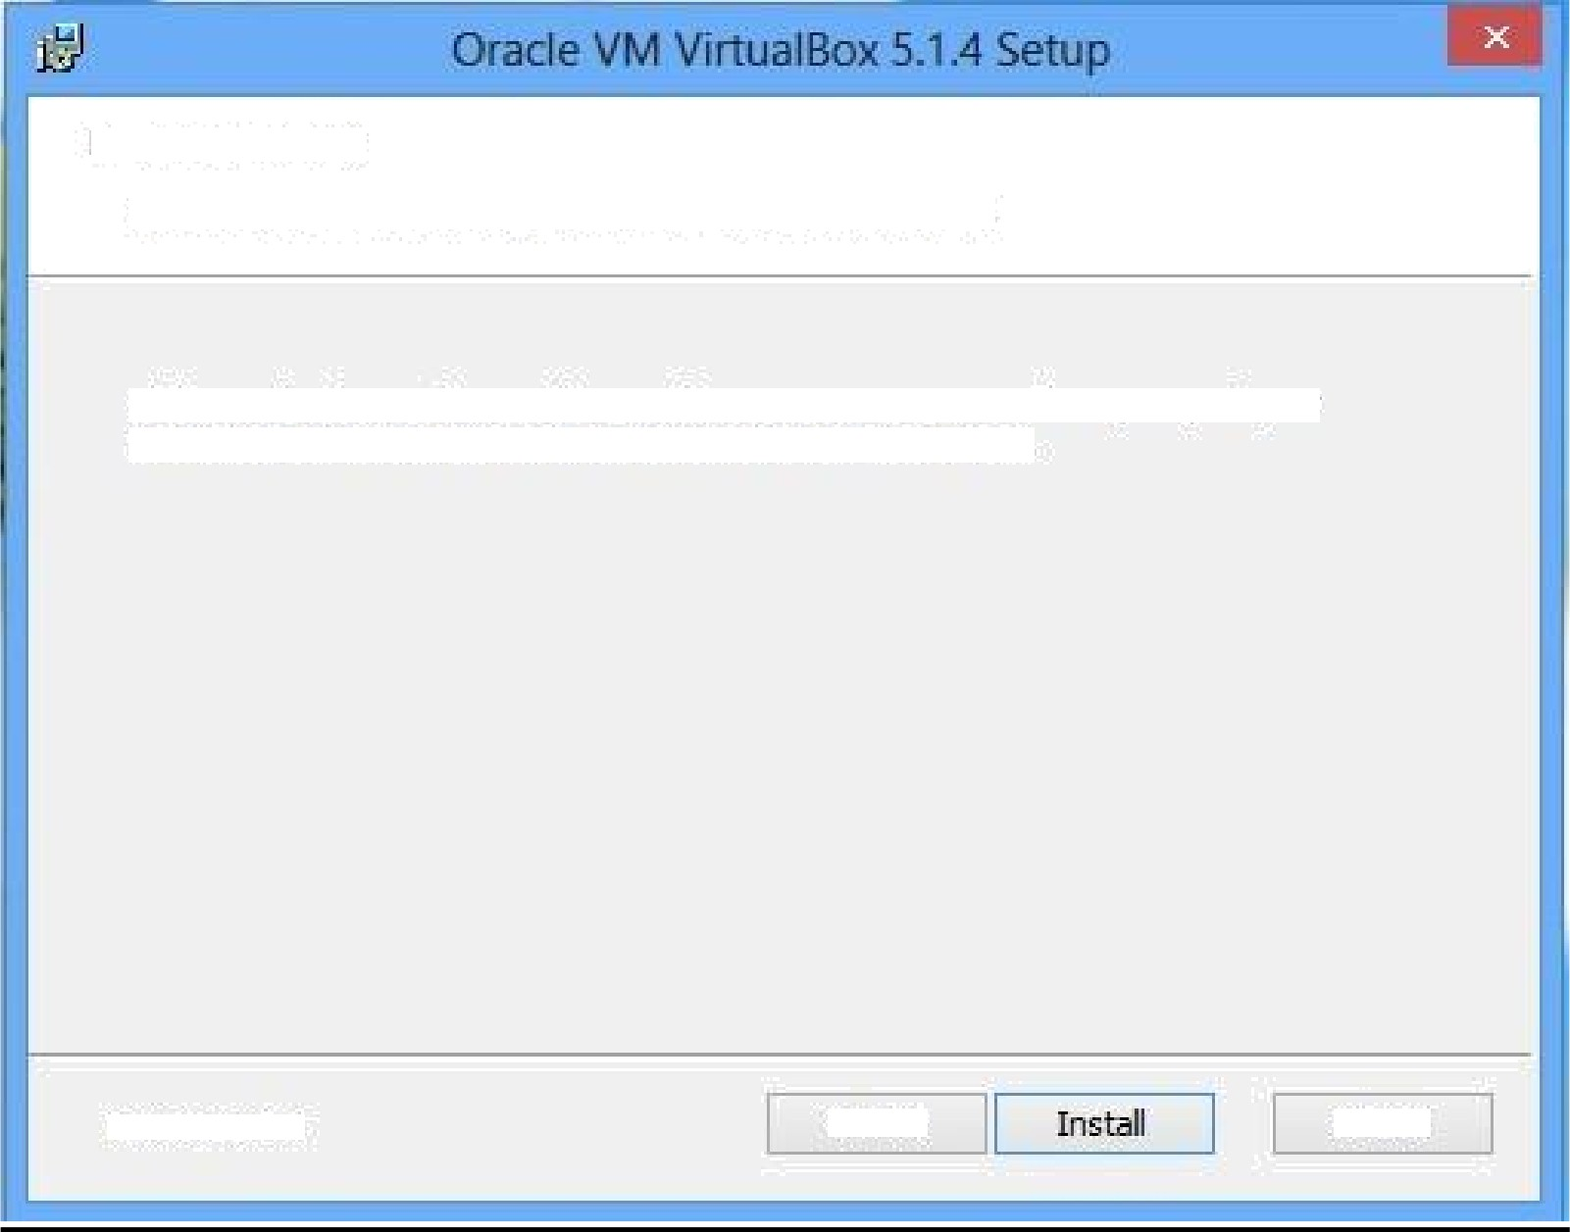

Ready to Install

The Setup \‘/izard is ready to begin the Custom installation.

Click Install to begin the installation. If you want to review or change any of your installation settings, dick Bad‹. Click Cancel to exit the ' 'izard.

\/ersion 5.1.4

Cancel

 Oracle VM VirtualBox 5.1.4 Setup - —

Would you like to install this device software?

* Name: Orac Ie Corporation Universal Serial Bus ...

P ublisher: Oracle Corp oratio n

Always trust *safimva* re from " Orac Ie Corporation".

Install

tenDon t

' ' You should only install driver software from publishers you trust. Hcw c an I decide which cl e ice scfto/are i. safe tc in.tally

Version 5. 1. 4 me C

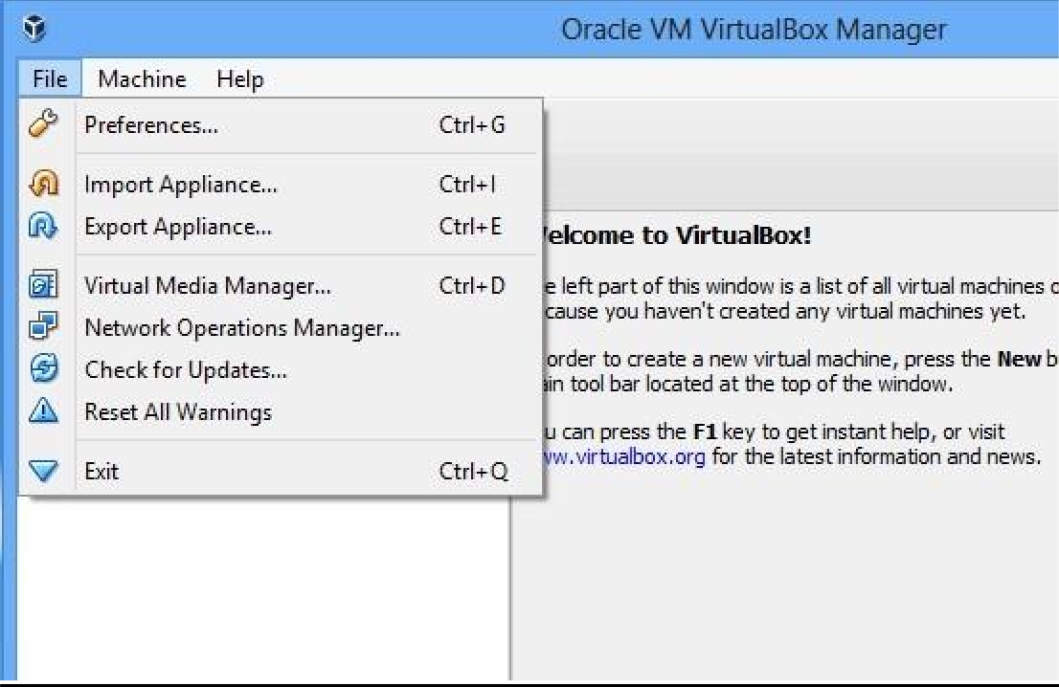

Once you have completed the installation of preferred virtualization software. We would import an existing downloaded image of VM in order to complete the next part of the assignment. Follow the below steps for same

**Step 1:** Go to virtual box and in file menu, select “Import Appliance”

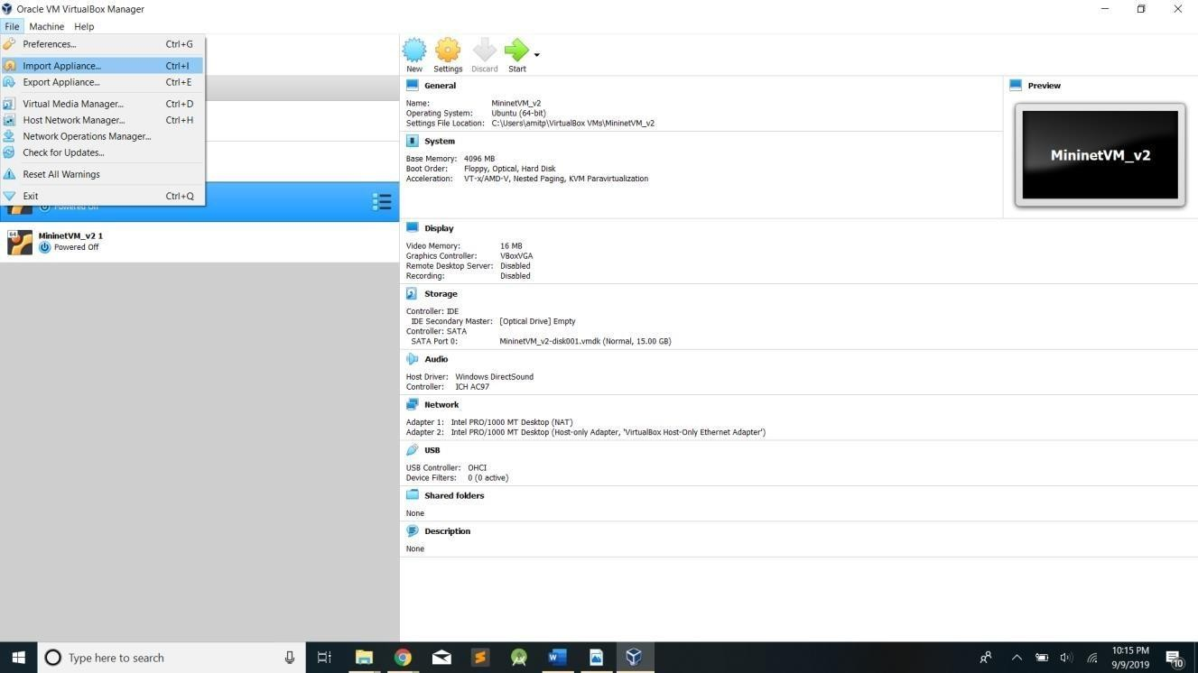

### Step 2:

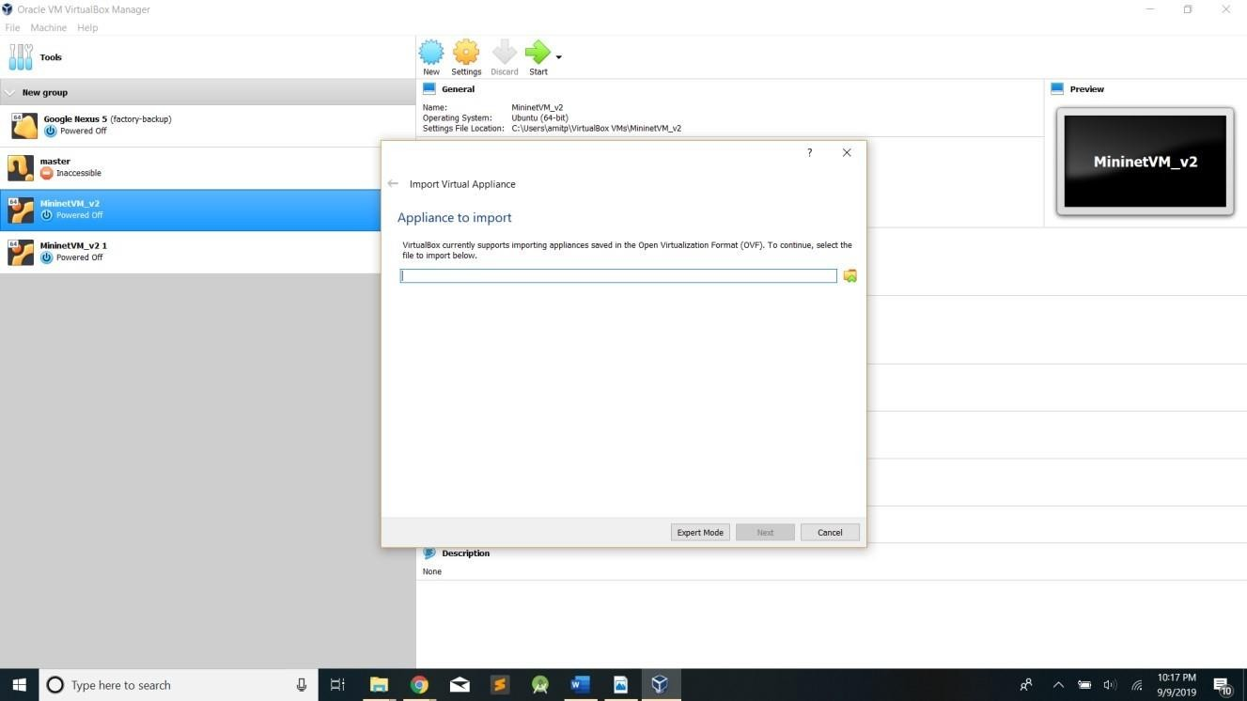

**Step 3**: Browse the downloaded VM image as shown below

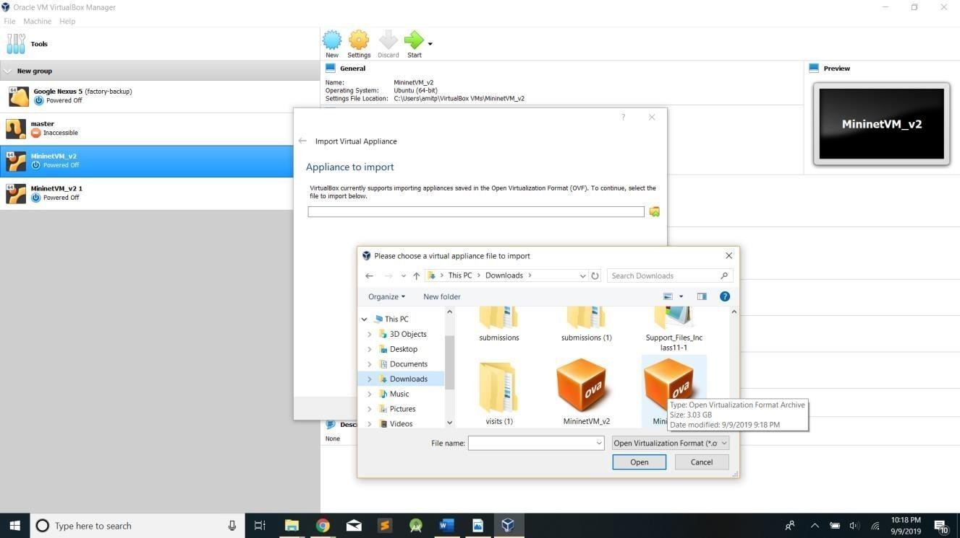

### Step 4:

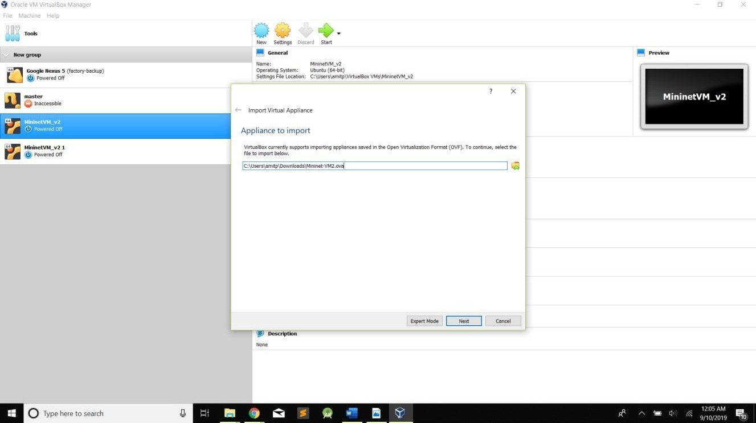

**Step 5:** Once clicked on next, it will ask to “import’. Click on “import”

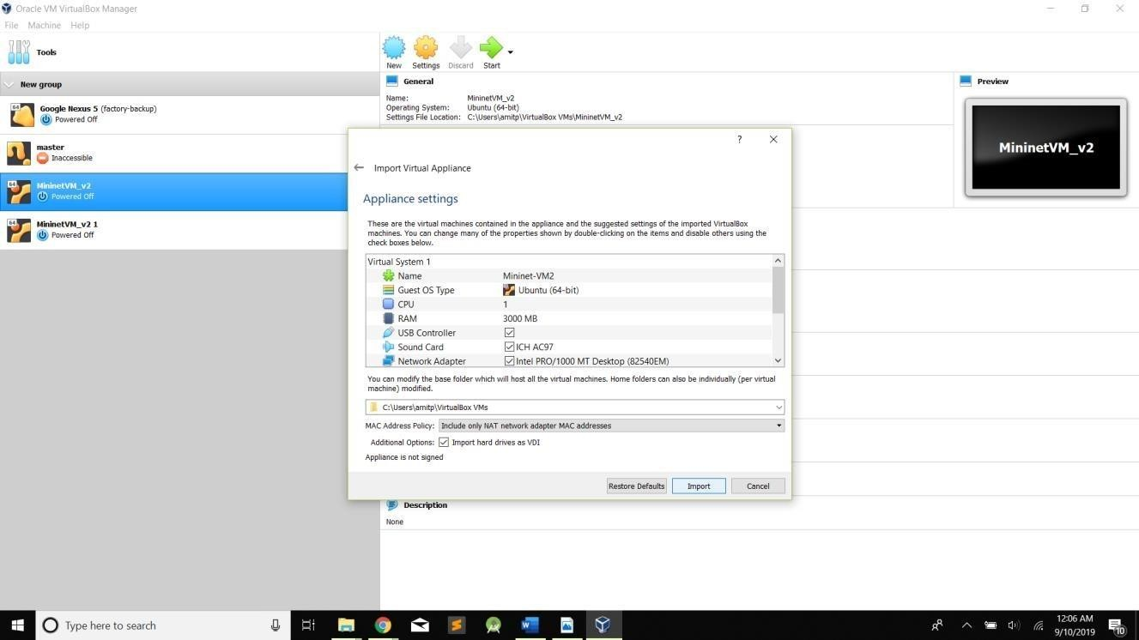

### Step 6:

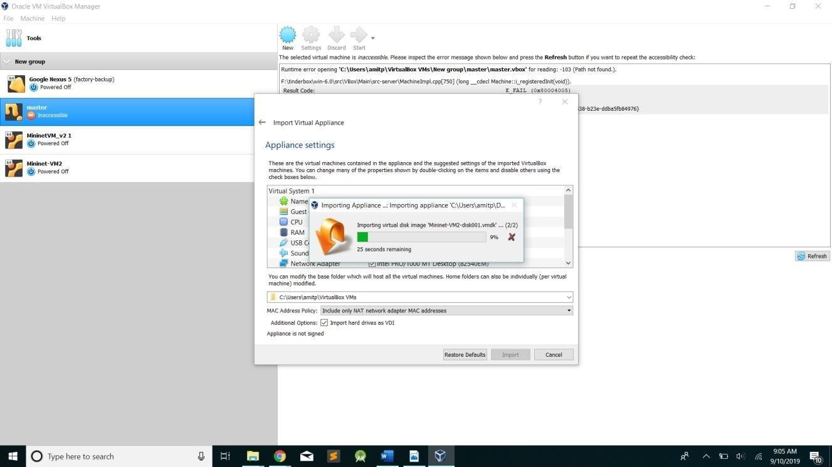

**Step 7:**

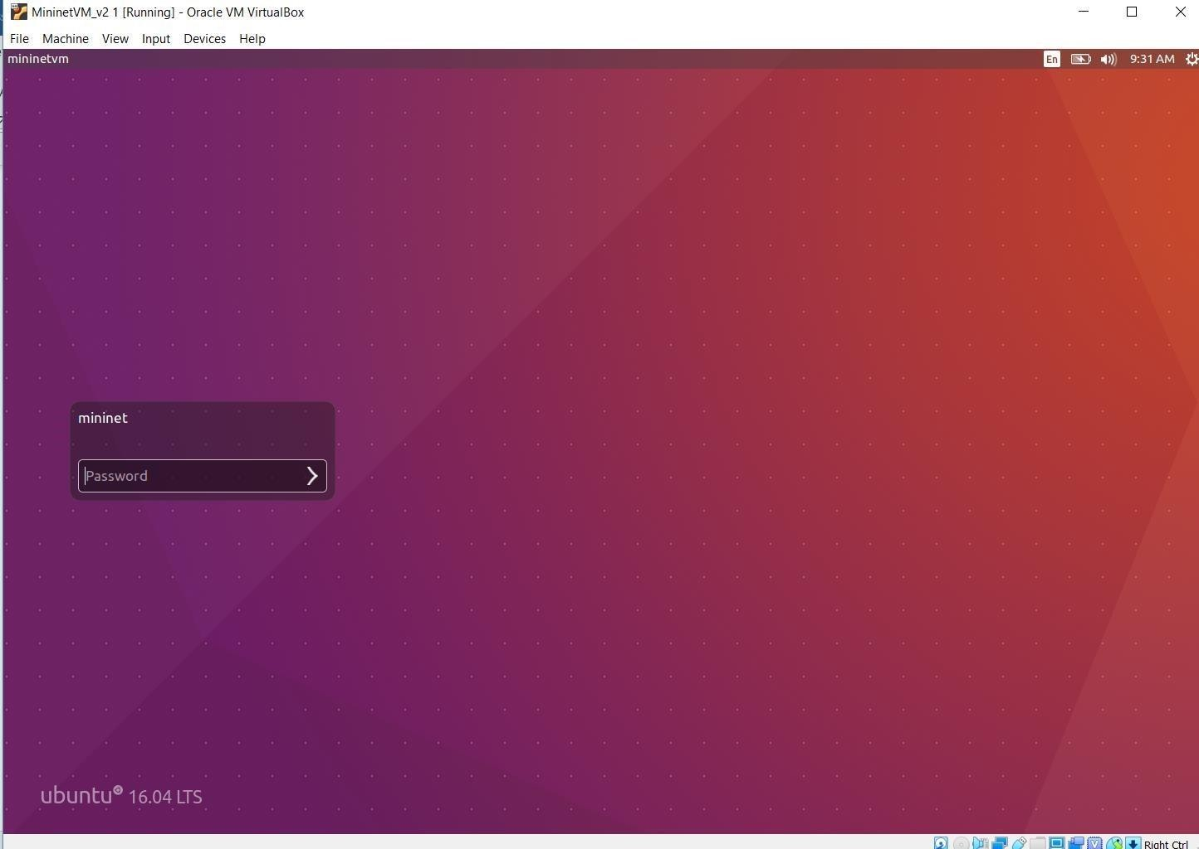

**Boot VM**

At this point you should be ready to start your VM. Press the "Start" arrow icon or double-click your VM within the VirtualBox window.

In the VM console window, log in with the username and password for your VM. The username and

password for this VM are:

* + Username - **mininet**
  + Password - **mininet**

Note that this user is a sudo user, so you can execute commands with root permissions by typing *sudo command*, where *command* is the command you wish to execute with root permission.

**Step 8:** Open the terminal in VM

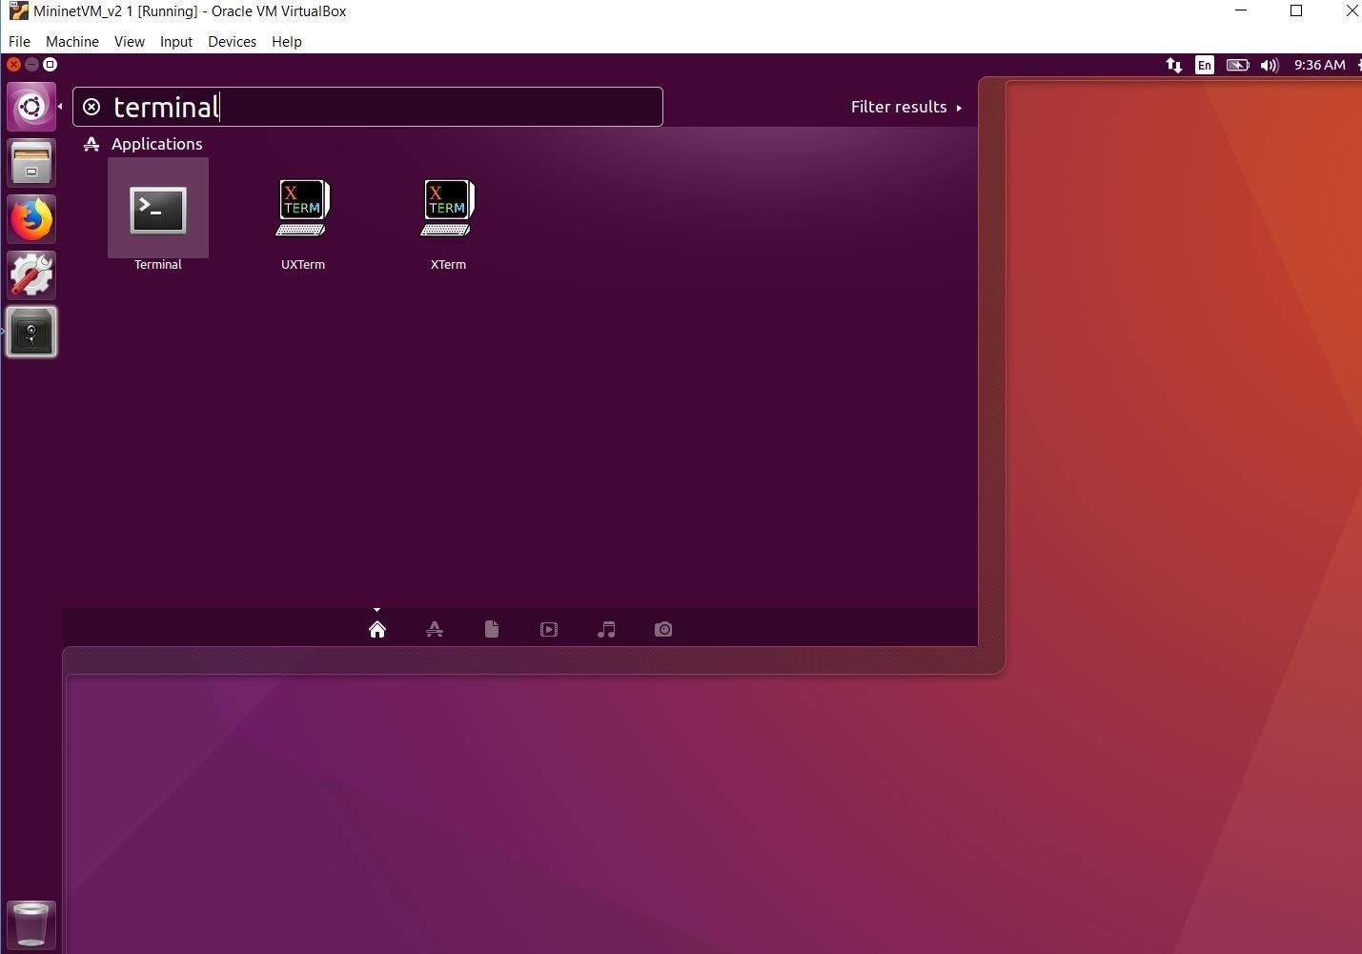

**Step 9:** Switch to root by executing following command.

Please get familiar with root users vs normal users in case of linux.



**Note:** It is not necessary to be in root to carry out below tasks. You need to be root only under certain situations such if you want to install any package, if you want to execute any file with root permissions .

# Assignment - 1 Part 2 (50 Points) Due on: 02/03/2021 11:59pm

## Before directly jumping on to SDN programming, we want to you get familiar with some basic linux features and python programming by completing this part. In part-2 of assignment 1 you will become familiar with python data types, class, functions, decorators, loops and library which helps you in future assignments of programming ryu controllers. The program should be written in python language and run only in provided vm.

Discussion Topic subject: Python Programming – Post any questions and collaborate with your peers.

**1:** Read and try out below commands (with options) in the given terminal. You must identify the purpose of the commands and get familiar with it. (10 Points)

sudo man ls cd

cd.. cd

~

mkdir cp rm mv grep

cat

and many other Linux commands.

You can take help of tutorials such as https://tutorials.ubuntu.com/tutorial/command-line-for-beginners#0 to get familiar with above commands.

Create some sample files, directories, move them, copy them, etc. and capture the outputs.

Get familiar with any type of editor to create files and its manipulations. For example, one of the frequently used editor is vi editor. https://[www.tutorialspoint.com/unix/unix-vi-editor.htm](http://www.tutorialspoint.com/unix/unix-vi-editor.htm) . Another one is “nano”

**2:** write a python program which will print “hello world”. You must write this program in Linux terminal using any editor and then execute it on the same. (10 points) hint: use “sudo python <file-name.py>” to run any python file from the terminal

**3:** Write a program that asks the user to enter their name and their age. Print a message addressed to them that tells them if he/she is eligible to vote if the user age is 18 or more or else print a message saying user is not eligible to vote. (hint: Use if/else conditions to code the logic) (10 points) Ref: https://[www.tutorialspoint.com/python/python_basic_syntax.htm](http://www.tutorialspoint.com/python/python_basic_syntax.htm) https://[www.tutorialspoint.com/python/python_variable_types.htm](http://www.tutorialspoint.com/python/python_variable_types.htm)

Write a python program in which bandwidth between 4 hosts (given as below) into a dictionary and a



**4:**

function to return the bandwidth of a link, when link is passed as a parameter. (10 points) Links have bandwidth as following {(1,2):10Mbps, (2,3):5Mbps, (3,4):10Mbps}

For example, Input: Enter the link: (2,3)

Output should be: Bandwidth for link between h2 and h3 is 5Mbps Hint: Use dictionary, tuples, tuple unpacking in python

Ref: https://realpython.com/python-lists-tuples/ https://realpython.com/python- dicts/

Write a decorator function that takes in 3 strings as arguments and returns them in reverse order. (10 points)



**5:**

Example input: ab,bc,cd

              Output: ba,cb,dc

Ref: https://realpython.com/primer-on-python-decorators/, https://[www.youtube.com/watch?v=FsAPt_9Bf3U](http://www.youtube.com/watch?v=FsAPt_9Bf3U)

# Submission:

Submit a combined word file with

* + - screenshots of your installation and setup of Part1 and Programming output Screenshots of Part 2
    - Note: output screenshots of all the mentioned commands in above Question 1 not just output of 1 or 2 commands
    - All the programs should be coded in python and in the given mininet-vm
    - Both parts of assignment1 combined will be of 100 Points.

Include the following in your word file:

* + - Your name and student ID
    - Software Details
      1. Host Operating System version
      2. Virtualization tool name and version

# Common issues and fixes while setting up your VM:

* + - Make sure your laptop is VT enabled – else it won’t allow you to install oracle box or create virtual machine. You can check if it is VT enabled or not in your BIOS settings.
    - Explore all the options in file menu of virtual box as it would help you to fix issues in upcoming assignments
    - For below error

Failed to open a session for the virtual machine MininetVM_v2 1.

The virtual machine 'MininetVM_v2 1' has terminated unexpectedly during startup with exit code 1073741819 (0xc0000005). More details may be available in 'C:\Users\Adwait\VirtualBox VMs\MininetVM_v2 1\Logs\VBoxHardening.log'.

Result Code: E_FAIL (0x80004005)

Component: MachineWrap

Interface: IMachine {5047460a-265d-4538-b23e-ddba5fb84

### Solution:

It seems you have improved the VM twice. Delete them and import a fresh copy.

* + - For below error

Could not start the machine MininetVM_v2 because the following physical network interfaces were not found:

vboxnet0 (adapter 2)

You can either change the machine's network settings or stop the machine.

### Solution:

Go to VirtualBox Preferences>Network>Host-only Networks and Add host-only network for vboxnet0. and then try.