**Self Study Project**

**2015 , May-June**

**ARM Based**

**Standalone Dual Channel Oscilloscope**

-by-

*Ajinkya Gorad*

IIT Bombay

**This page is intentionally left blank**

# About

This document describes about the software and hardware part of the hobby project named ‘Standalone Oscilloscope’ based on ARM LPC2148 processor.

This document describes the proto version.

# Index

Contents

[About 3](#_Toc429687473)

[Index 5](#_Toc429687474)

[Introduction 6](#_Toc429687475)

# Introduction

It is a ARM processor LPC2148 based Dual channel Oscilloscope using ILI9225 LCD display which can show two voltage waveforms simultaneously from a windowed sampled data. It can also display the frequency spectrum for both the channels and X-Y plot between the channels. It can also output a custom programmed periodic analog signal through inbuilt DAC hence can generate varied waveforms.

It can be operated from a 3.7V lithium ion battery enabling portable applications.

# Components

Following components were used in making of the oscilloscope

* Hardware Components
  + LPC2148 ARM processor shield

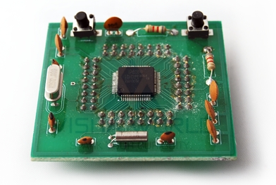

* + ILI9225 2.2” TFT LCD module

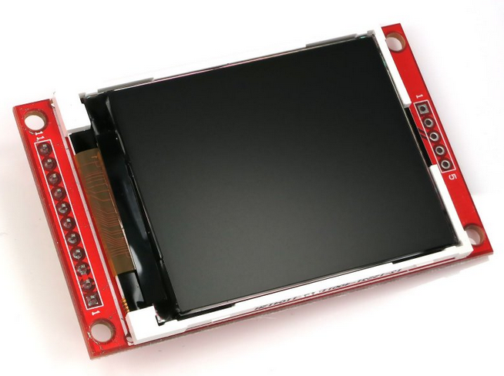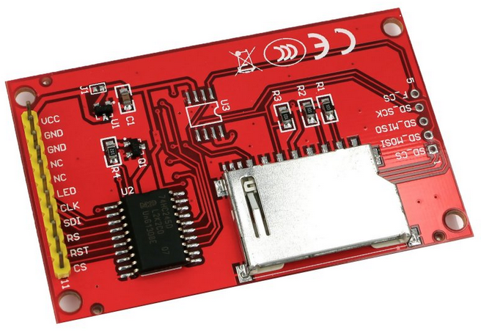

* + CP2102- USB to UART ( for programming uC)

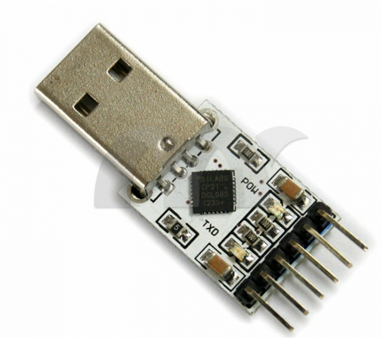

* Software Used

# Schematic Circuit Diagram

# C:\Users\Ajinkya\Documents\ARM\LPC2148_Oscilloscope\Documents\Schematic\OscilloscopeSchematic.pngSoftware Modules

* uVision IDE for ARM (limited version)
* Flash Magic ( for programming LPC2148)