Restaurtant Bot

We all know about chatbots, At the most basic level, a chatbot is a computer program that simulates and processes human conversation (either written or spoken), allowing humans to interact with digital devices as if they were communicating with a real person.
There are many chatbots of different kinds and doing different work, nowadays chatbots are
becoming intelligent.

This Project is all related to making a chatbot using native NLP and Python Libraries
for native NLP, I’ve used NLTK and created using PyTorch.

This bot has been trained on FeedForward Neural Network with 2 layers,

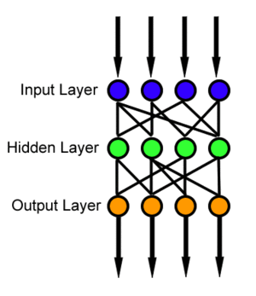

A quick glance on how FFN works

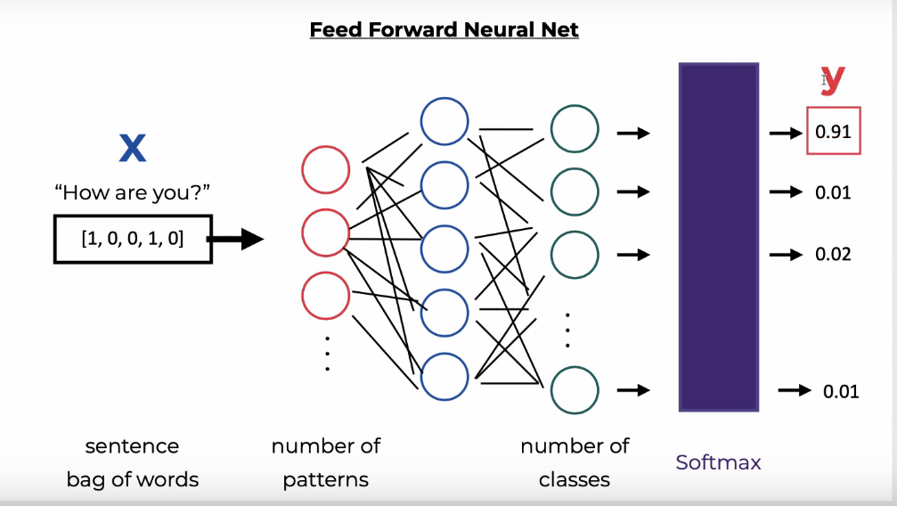

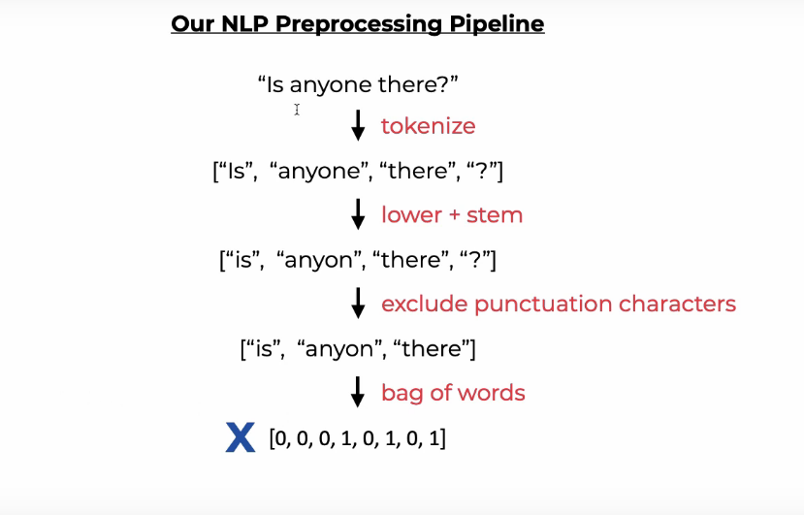

NLP Pipeline

This bot calls the Zomato API for the location, restaurtant and preferred cuisine for the users, making them much easier to explore the food life in there respctive areas.

