**Firearm Classification**

**Ajinkya Malhotra, Roger Miao**

**CSC-180 Fall 2017**

**Project 3 - Neural Networks and Deep Learning**

Part Three

We decided to train our neural network to classify different types of firearms. We divided our types into seven subcategories:  Assault Rifle, Launcher, Machine Gun, Pistol, Shotgun, Submachine Gun and Sniper Rifle.

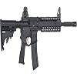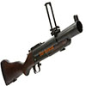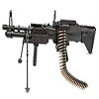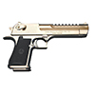

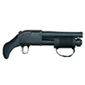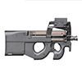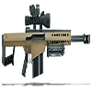

For our training and testing sets, we used a Google image search to grab pictures from various sources. We were able to collect 110 training images, and 37 validation images. We decided to convert our images to 100x100 with Photoshop to keep consistent sizes on images.

The Convolutional Neural Network architecture that worked best for us was AlexNET. We were motivated to try this neural network because it did not have the limitations of LeNET which only worked with 32x32 images and the skeleton code that was given to us was similar to AlexNET.

The training of the neural network took around two hours to complete with a 0.78 accuracy running with an 870M GPU. Overall it seemed to generalize well with each correct output having at least a 50% accuracy and none of the other six categories being close.

We believe that the neural network learned the problem well but it was far from perfect. For 1000 epochs, there was at least a 30% ratio of wrong outputs to correct outputs. This could have been caused by our images having multiple objects in them. Some of the pictures would have a person in it or other factors which could have made the training difficult.

**TensorBoard Graphs**

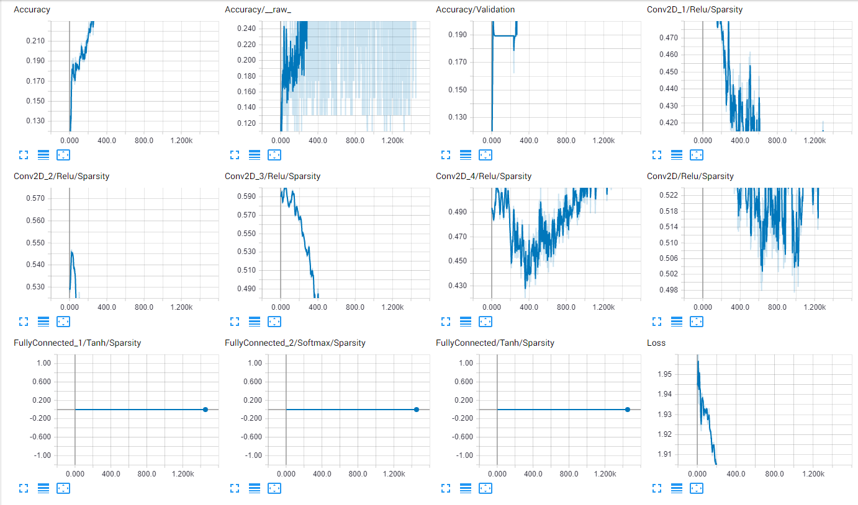  
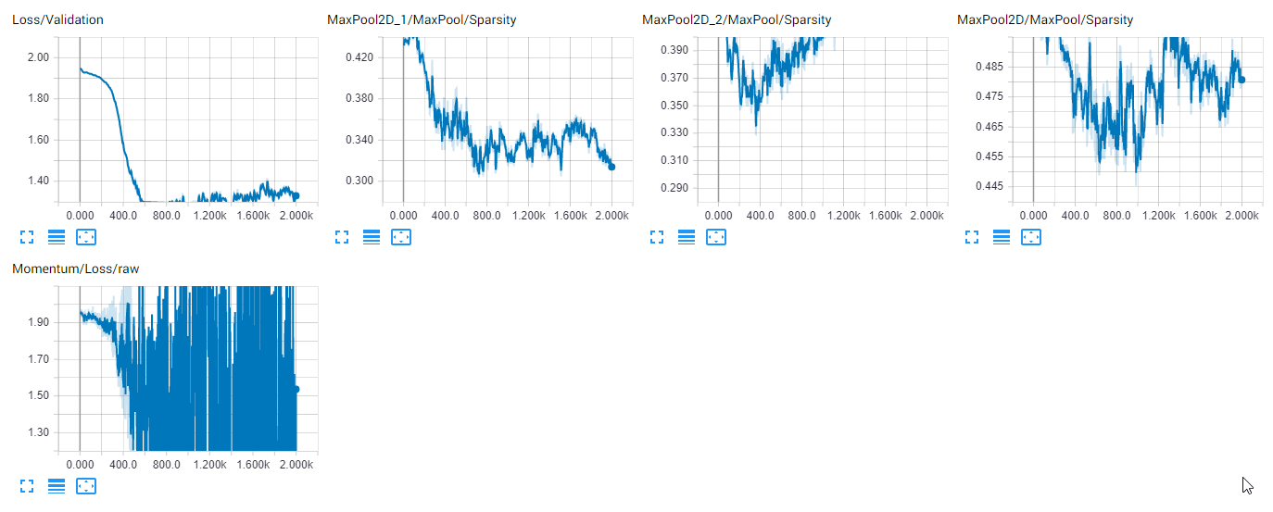  
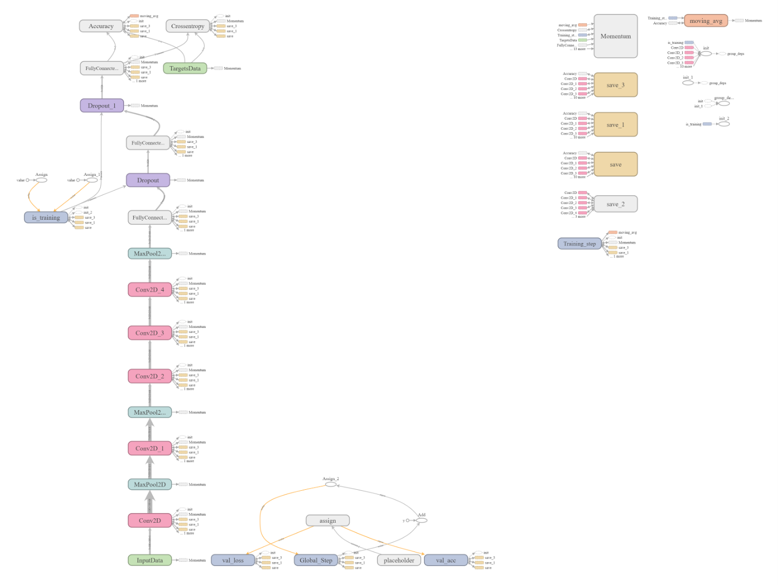

**TfLearn Script code**

**deepneutralnet.py**

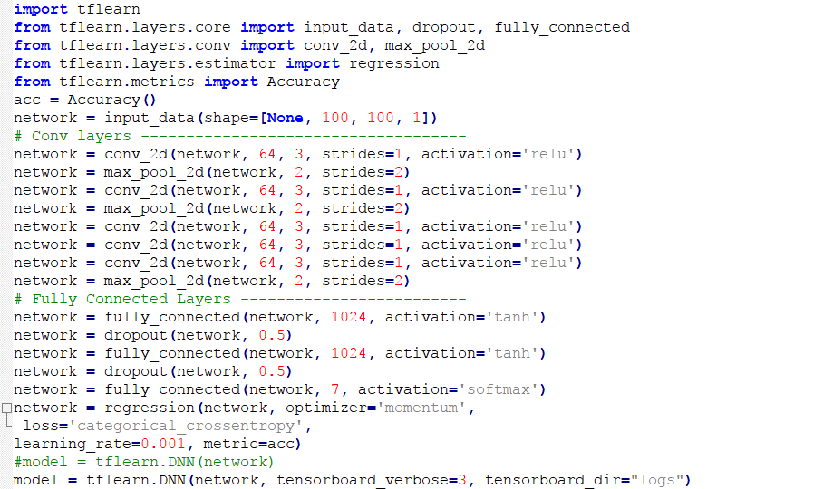

**train.py**

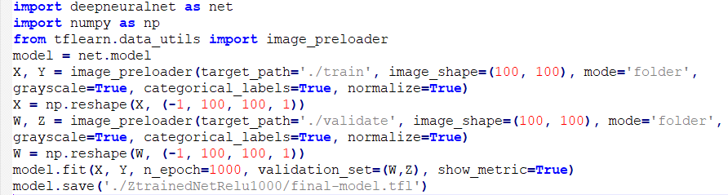

**predict.py**

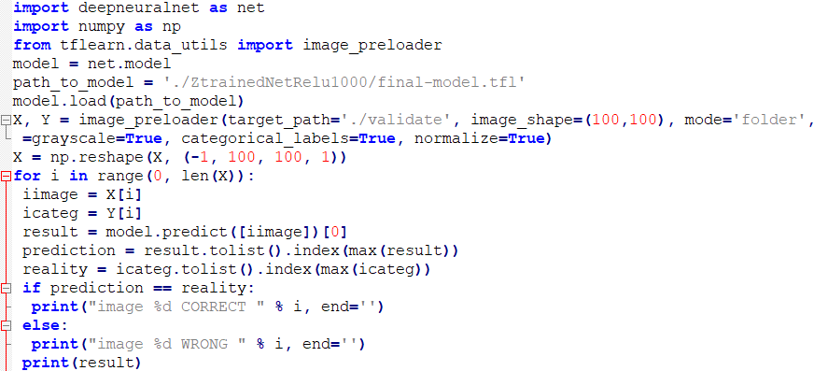

**Screenshot last 12 epochs**

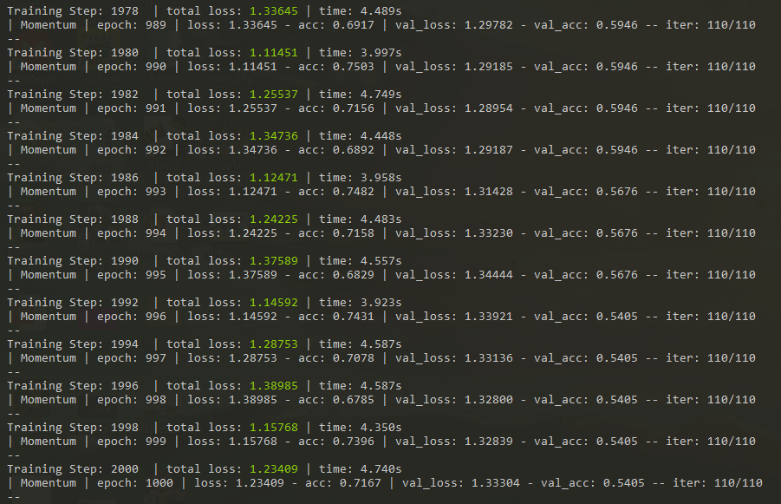

**Final Result for Testing Data**

