**Project Features:**

1. Inclusion of Power BI and Tableau
2. Flow:
   1. Problem Statement
   2. Project Planning
   3. Data discovery
   4. Analysis using sql
   5. Same analysis using Power BI such as data cleaning, etl, building dashboards
      1. Feedback from customers and then you build version 2.
      2. 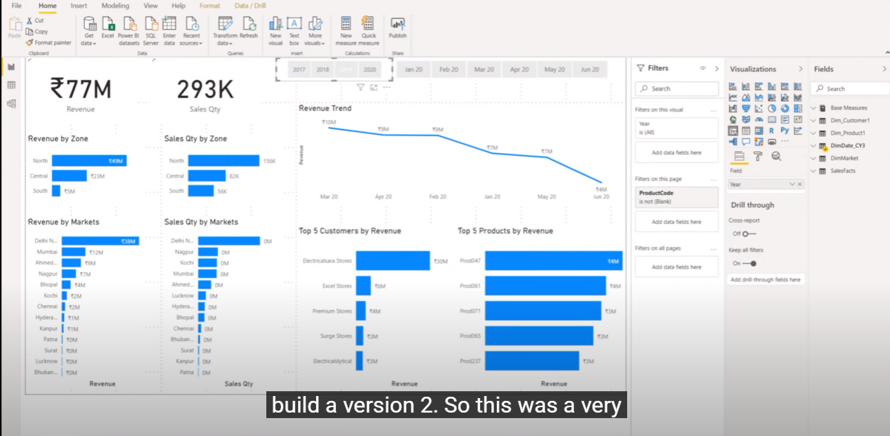
      3. 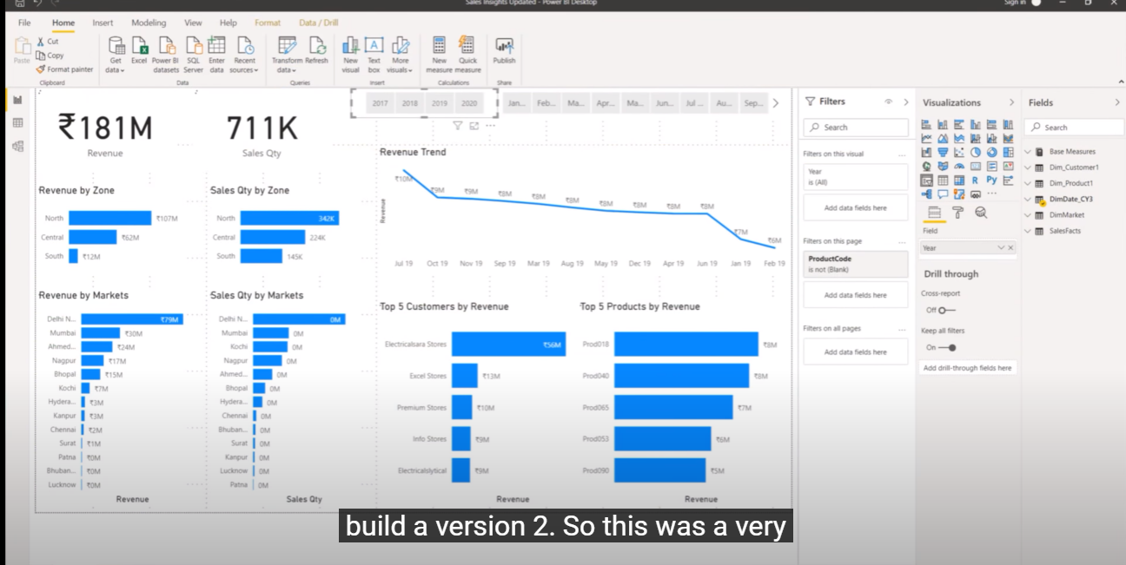
   6. Kaggle, Nasdaq datalink
      1. Personal Finance Project:
3. Machine Learning Projects:
   1. 
   2. Celebrity classification end to end with flask
4. Regression Project:
   1. Banglore property price prediction project
5. 