**Finding the best nearby restaurants using foursquare API in the Munich**

**Background information of the subject:**

Munich is the capital of second populous state 'Bavaria' in the German federal state. And it is the third largest city in the Germany. As per the statistic of A total of 7.8 million guests were welcomed in the city, of which roughly 3.5 million were from abroad in year 2017. (<https://www.statista.com/statistics/569562/key-figures-tourism-Munich-Germany/>).

As Munich is populous city in the Germany no. of tourist and localized population always search for the restaurants in the city, night life. For people that are new to Munich, it can be daunting to figure out what restaurants are worth going to and where they are. For people that used to live in Munich or are visiting Munich, how do you know what the best places are to get something to eat?

**Business Problem Statement:**

There are many tourist agencies in the Munich. People travel from all over the world to visit Germany. So these people need food categorical availability to take consideration with respect to worldwide tourist/visitor in the city.

So successful tourist agency should suggest visitor the best restaurants according to their food choices or they should give them proper suggestions.

**Audience:**

Audience for this service are the Tourists, Hotel or Restaurant owners & Native People.

**Business Problem Solution:**

The solution to this is to use the foursquare location data. In order to advise the tourist about restaurant locations, we will consider the different categorization factors to categorize restaurants as per the likes & categorize.

**Data Sources:**

For this project, I am going to create a simple guide on where to eat based on Foursquare likes, restaurant category and geographic location data for restaurants in Munich. I will then cluster these restaurants based on their similarities so that a user can easily determine what type of restaurants are best to eat at based on Foursquare user feedback.

GeoCoder/Google Geolocation APIs: converts addresses into geographic coordinates

Foursquare APIs: offers rich location-based experiences and enables access to millions of up to date business venues, tips, photos and many other helpful tips

**Geocoder/Google Geolocation API:**

Geocoding is the process of converting addresses (like "Munich,Germany") into geographic coordinates (like latitude 48.1371079 and longitude 11.5753822), which you can use to place markers or position the map.

The Maps JavaScript API provides a geocoder class for geocoding and reverse geocoding dynamically from user input. If instead you wish to geocode static, known addresses, see the Geocoding web service. For this project a csv file containing the coordinates was provided by IBM.

**Data Requirement:**

For this project, I will be utilizing the Foursquare API to pull the following location data on restaurants in Munich, Germany:

• Venue Name

• Venue ID

• Venue Location

• Venue Category

• Count of Likes

**Methodology:**

The thought process behind this is that likes are a proxy for quality. The more likes there are, the better the restaurant is. I have then combined this data into a quality categorical variables so we can cluster appropriately.

I am also going to create new categorical variables for the restaurants to better group them based on type of cuisine. This way you can look for good food or now what type of food might be best to eat in Munich if you are new to the area.

Now we will take the gathered data (see above in Data Acquisition Approach and Data Required sections) and will create a k-means clustering algorithm that groups restaurants into 4-5 clusters so that people looking to eat in Munich can easily see which restaurants are the best to eat at, what cuisine is available and where in Munich they can look to eat.

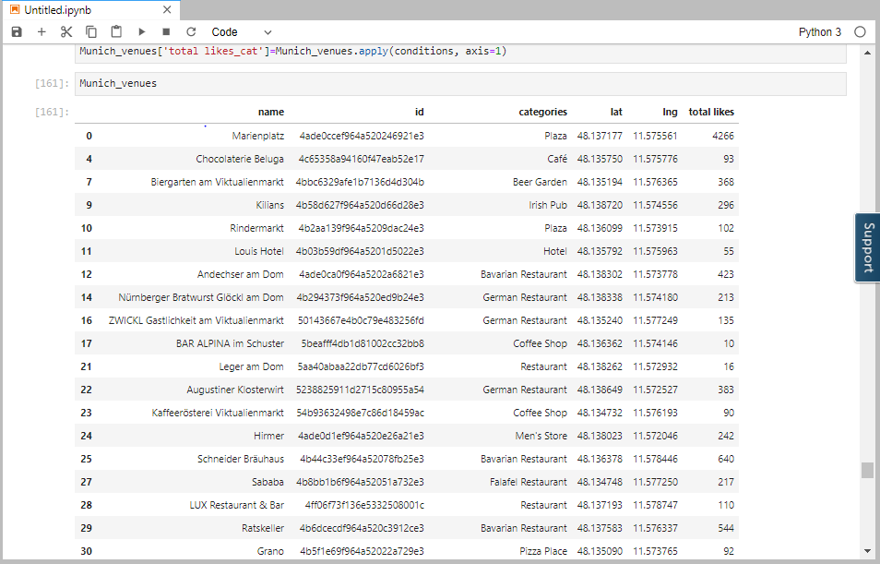

Image: Recording likes for the particular restaurant

**Exploratory Data Analysis:**

After extracting data from the foursquare API.I performed some EDA as follows. Following are the likes as per the restaurants.

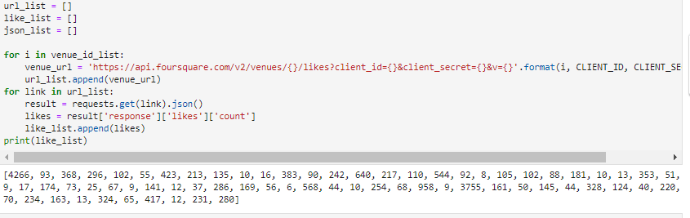

Image: Likes for the restaurant stored in an array

Following are the maximum, minimum, median & mean values of likes for all the restaurants.

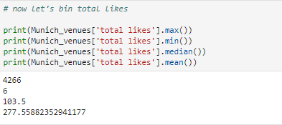

Following is the histogram for the likes:

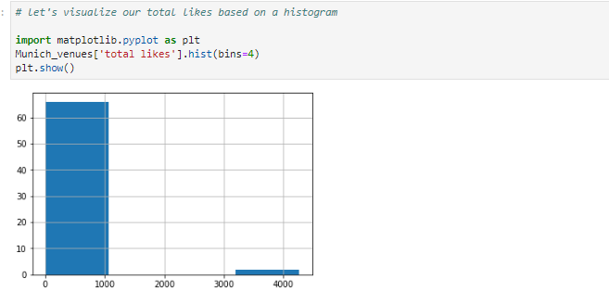

Image: Histogram for the no. of likes

**Results:**

Following are the output after clustering

Cluster-1

Here we have listed the restaurant with total likes great.

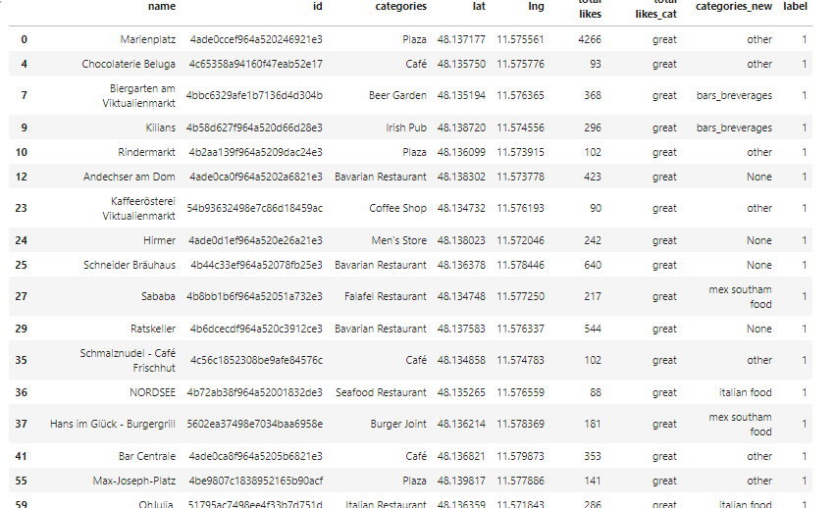

Cluster-2

Here we have listed the restaurant with total likes poor.

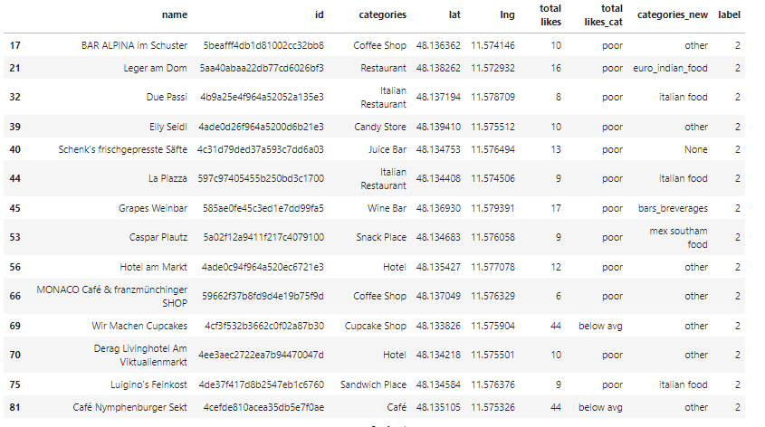

Cluster-3

Here we have listed all the restaurants with avg rating.

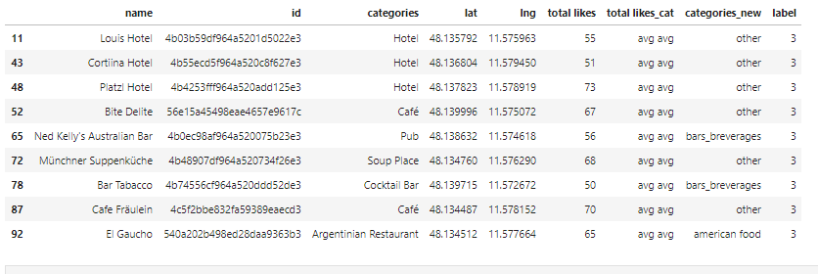

We have also created category list as follows:

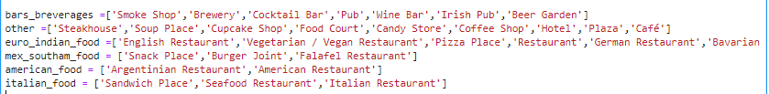

We have also classified all these listing in the above categories.