ADVANCED DEVOPS CASE STUDY

Automated Deployment with Monitoring
- Concepts Used: Jenkins, EC2, Nagios.
- Problem Statement: "Set up a Jenkins CI/CD pipeline to deploy a simple web application on an EC2 instance. Configure Nagios to monitor the deployed application's availability."
- Tasks:
  - Create a Jenkins pipeline that builds and deploys a sample web app to an EC2 instance.
  - Install and configure Nagios to monitor the HTTP status of the deployed application.
  - Verify the pipeline by triggering a build and checking the monitoring status in Nagios.

1. Introduction
This report outlines the process of setting up a Continuous Integration/Continuous Deployment (CI/CD) pipeline using Jenkins, an automation tool, to deploy a web application on an Amazon Web Services (AWS) EC2 instance. Additionally, it covers the integration of Nagios, a powerful monitoring tool, to ensure continuous availability and functionality of the deployed application by monitoring its HTTP status.

Concepts Used
- Continuous Integration (CI): Frequent integration of code changes into a shared repository with automated builds and tests.
- Continuous Deployment (CD): Automatic deployment of every code change that passes testing to production.
- Automation: Reducing manual intervention in build, test, and deployment processes using Jenkins.
- Monitoring: Real-time application monitoring using Nagios to maintain availability and performance.
- Webhooks: Automatic triggering of Jenkins pipelines upon changes pushed to GitHub repositories.
- SSH and Secure Access: Secure communication between Jenkins and EC2 instances for deployment.
- HTTP Status Monitoring: Using Nagios to check the application's HTTP status for accessibility and responsiveness.

2. Objectives
The primary goals of this setup are:
- Automating the build and deployment of a web application using Jenkins.
- Deploying the application on an AWS EC2 instance.
- Automatically triggering the CI/CD pipeline whenever changes are pushed to the GitHub repository.
- Ensuring continuous availability and functionality of the application using Nagios for monitoring.

3. Prerequisites
Before starting the pipeline setup, the following prerequisites are necessary:
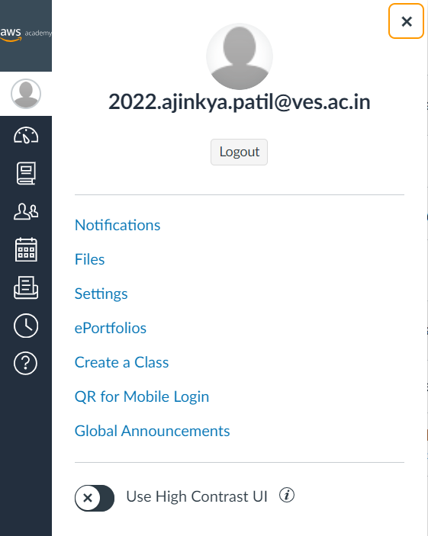
- AWS account.
- AWS EC2 Instance: EC2 instances(CaseStudy)

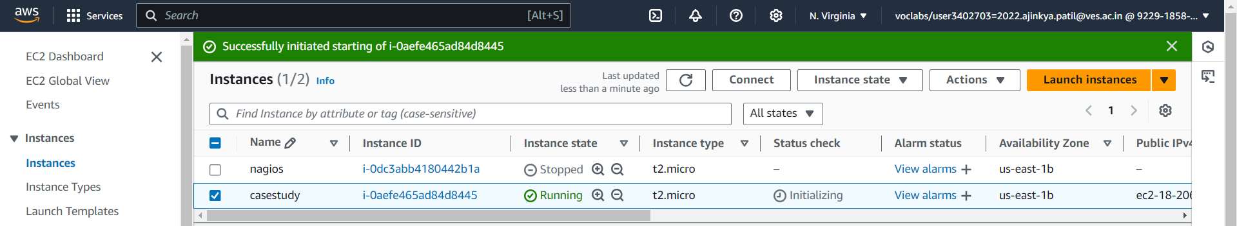
- GitHub Repository: The web application code should be hosted on GitHub.
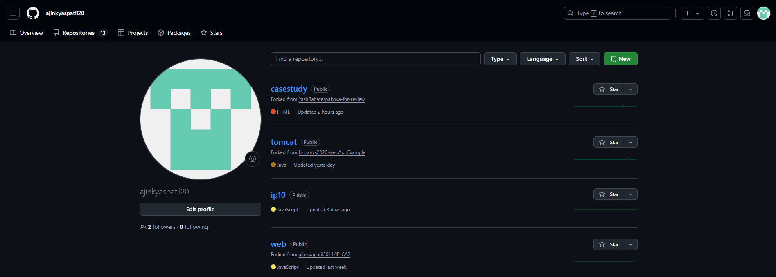
- Security Groups: Proper security groups on AWS to allow Jenkins and Nagios to communicate with the web application server.
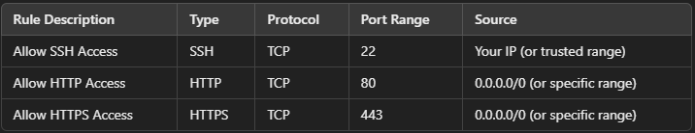
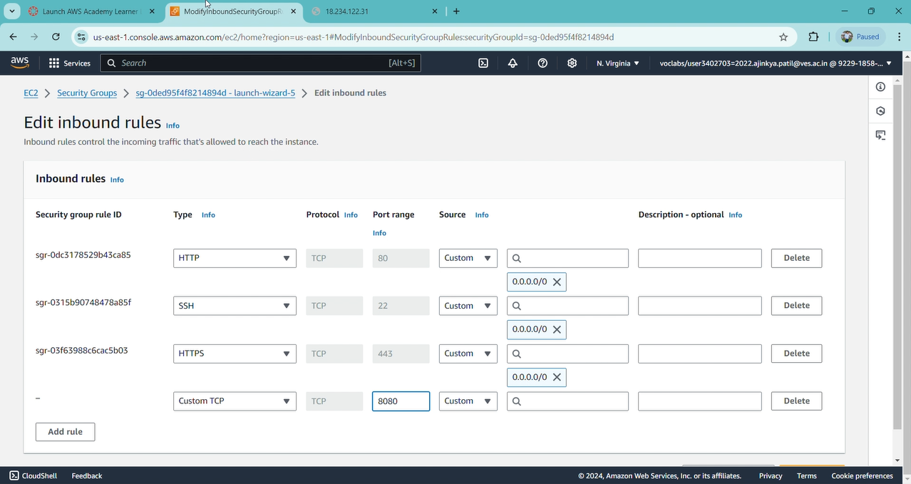
4. Jenkins Setup for CI/CD
Jenkins is used to automate the build, testing, and deployment of the web application. The steps below outline the configuration process:

4.1.Install Jenkins
EC2 Setup: Launch an EC2 instance (Ubuntu) and install Jenkins.
ssh -i "your-key.pem" ubuntu@your-ec2-ip
-
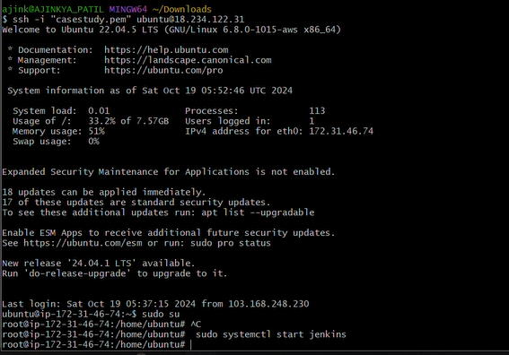

Setting up Jenkins for CI/CD

Step 1: Install Jenkins
If you haven't installed Jenkins yet, either:
- Install it on your local machine, or
- EC2 instance to run Jenkins.
For Ubuntu, follow these steps:

sudo apt update
sudo apt install openjdk-11-jdk -y
wget -q -O - https://pkg.jenkins.io/debian/jenkins.io.key | sudo apt-key add -
sudo sh -c 'echo deb http://pkg.jenkins.io/debian-stable binary/ > /etc/apt/sources.list.d/jenkins.list'
sudo apt update
sudo apt install jenkins -y

Start Jenkins:

sudo systemctl start jenkins
sudo systemctl enable jenkins

It shows error
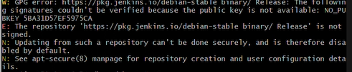

Jenkins error solve by

1. Remove Existing Jenkins Repository
First, let's clean up the old Jenkins repository reference before adding the correct one.
Run the following command to remove the problematic Jenkins repository:

sudo rm /etc/apt/sources.list.d/jenkins.list

2. Add the Correct Jenkins GPG Key and Repository
Now, let's properly add the GPG key and the Jenkins repository again:
Add the Jenkins GPG key:
curl -fsSL https://pkg.jenkins.io/debian/jenkins.io-2023.key | sudo tee \
/usr/share/keyrings/jenkins-keyring.asc > /dev/null

Add the Jenkins repository to your sources list:
echo deb [signed-by=/usr/share/keyrings/jenkins-keyring.asc] https://pkg.jenkins.io/debian-stable binary/ | sudo tee /etc/apt/sources.list.d/jenkins.list > /dev/null
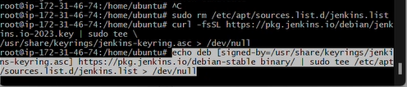

3. Update the System
After that, update the package lists again:

sudo apt update
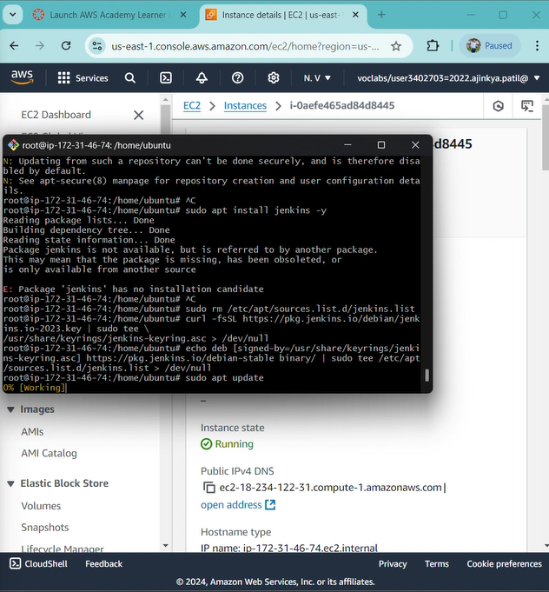

4. Install Jenkins
Now, try installing Jenkins again:

sudo apt install jenkins -y

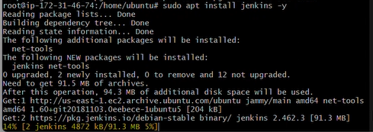

5. Start Jenkins Service
Once installed, start Jenkins with:
sudo systemctl start jenkins
Check the status of Jenkins to ensure it's running properly:
sudo systemctl status jenkins
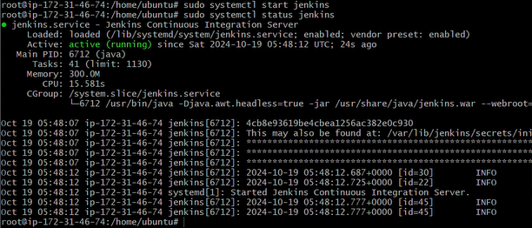

6. Access Jenkins
To access Jenkins, go to your web browser and type:

http://<your-ec2-public-ip>:8080

ERROR
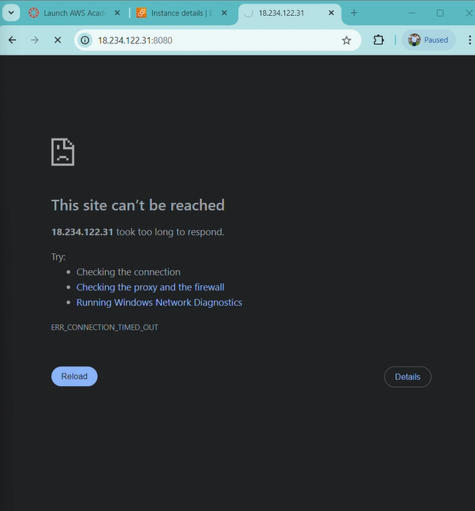

In security group adding new inbound port rule

Then it showing that port
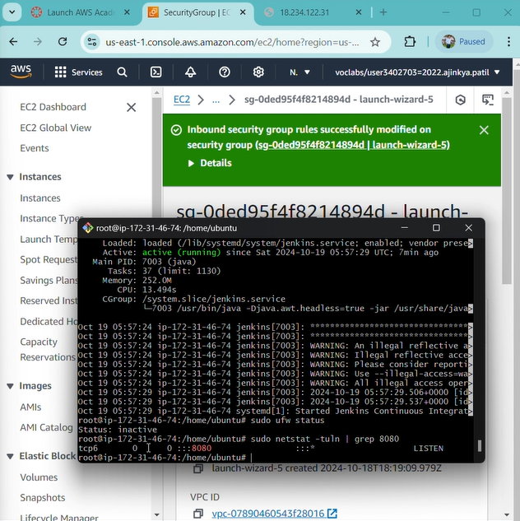

Open the Jenkins configuration file:
sudo nano /etc/default/jenkins

Look for the line that sets JENKINS_LISTEN_ADDRESS. If this is set to 127.0.0.1, change it to 0.0.0.0 to allow connections from any IP:
JENKINS_LISTEN_ADDRESS=0.0.0.0

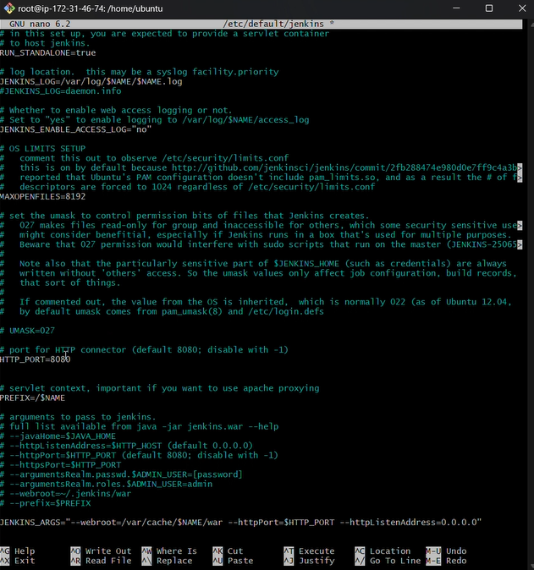

Save the file and restart Jenkins:
sudo systemctl restart jenkins
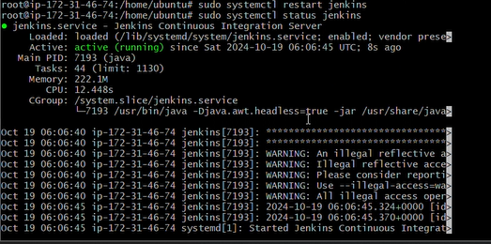

Once you have the initial Jenkins admin password, follow these steps to complete the setup:

1. Access Jenkins
Open your browser and go to http://<your-ec2-public-ip>:8080.
You should now see the Jenkins setup screen.
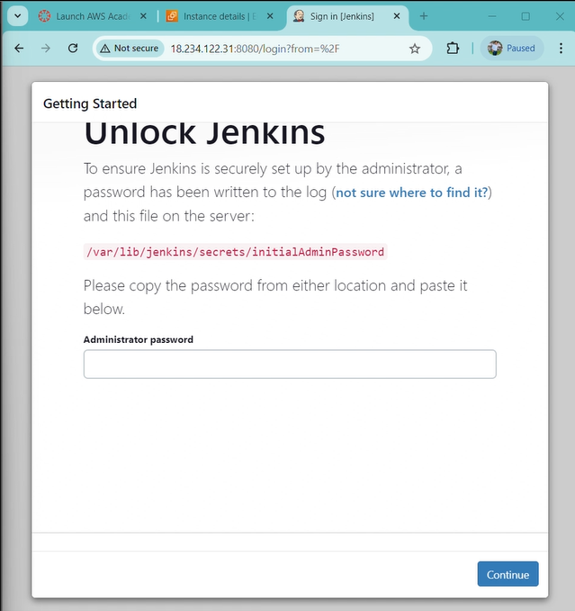

2. Enter the Initial Admin Password
Enter the password you retrieved from:
/var/lib/jenkins/secrets/initialAdminPassword.
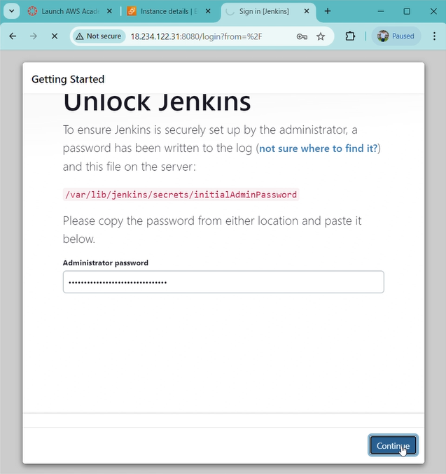

3. Customize Jenkins
Jenkins will ask whether you want to install the suggested plugins or select specific plugins. For most users, it's easiest to select Install suggested plugins.
Jenkins will begin installing the selected plugins. This might take a few minutes.

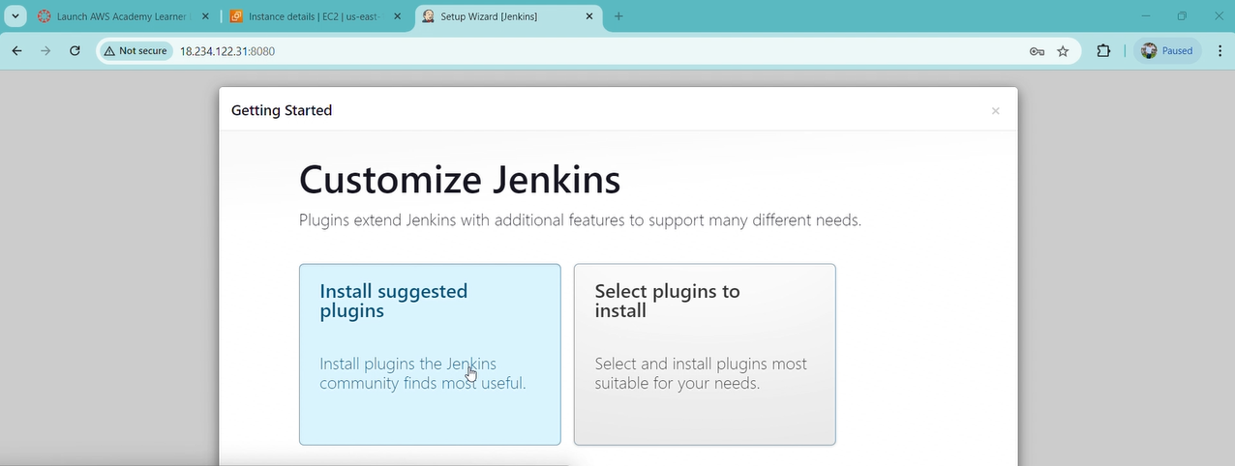
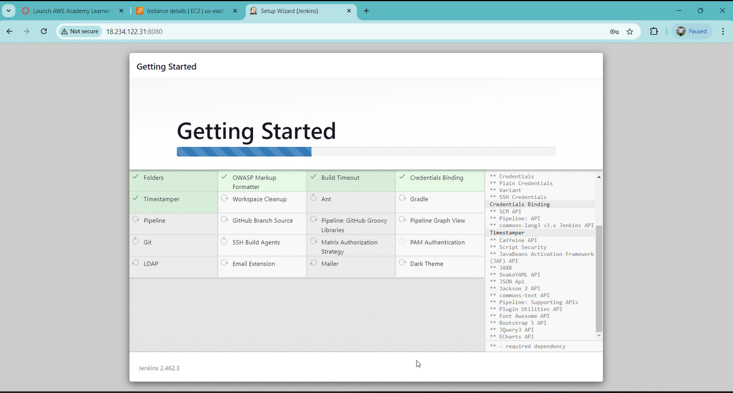
4. Create Your First Admin User
After the plugins are installed, Jenkins will prompt you to create your first admin user.
Username: Choose your desired username.
Password: Set your password.
Full Name: Enter your name.
Email: Provide an email address.
Click Save and Continue.
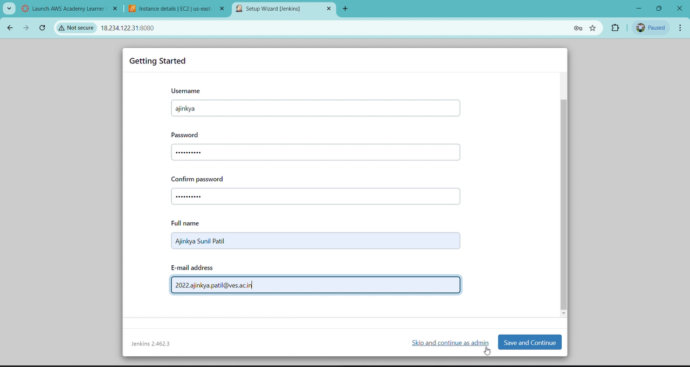
5. Configure the Jenkins URL
Jenkins will display its URL, which should automatically be set to http://<your-ec2-public-ip>:8080.
Verify the URL and click Save and Finish.
6. Start Using Jenkins
Jenkins is now ready to use! Click Start using Jenkins to access the dashboard.
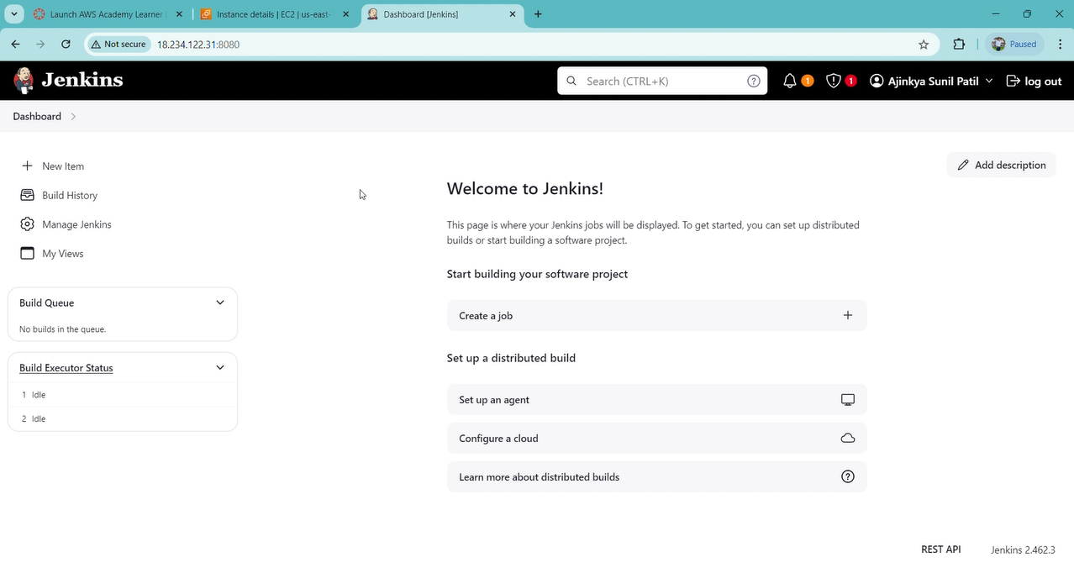

- Integrate Source Code Management (SCM)
  - Jenkins works well with Git, GitHub, GitLab, and other version control systems.
  - To integrate Git:
    - Go to your project’s dashboard.
    - Click on "Configure" for your pipeline.
    - Scroll to "Pipeline" and set the "Definition" to "Pipeline script from SCM."
    - Select Git as the SCM, and enter the repository URL.

    - Provide credentials if needed (you may need to create SSH keys or token-based access for your repository).
Generating the git personal access token for credentials on github
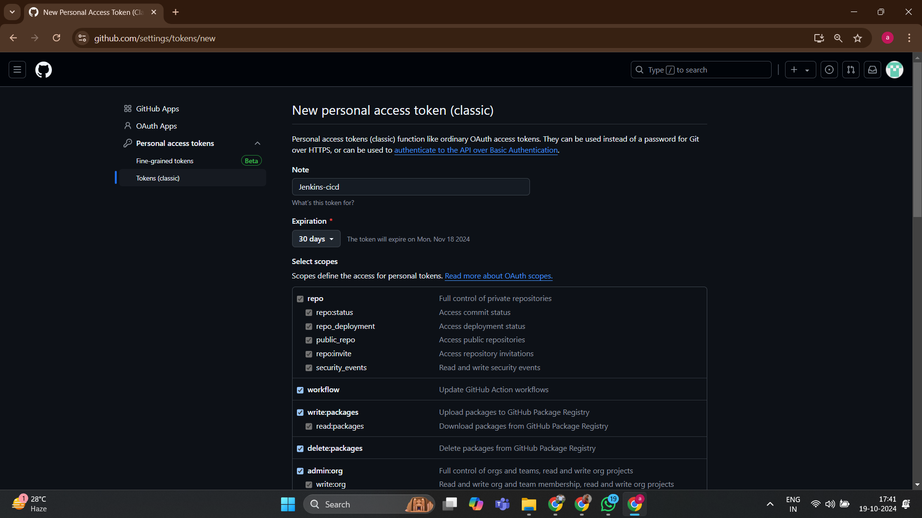
Token
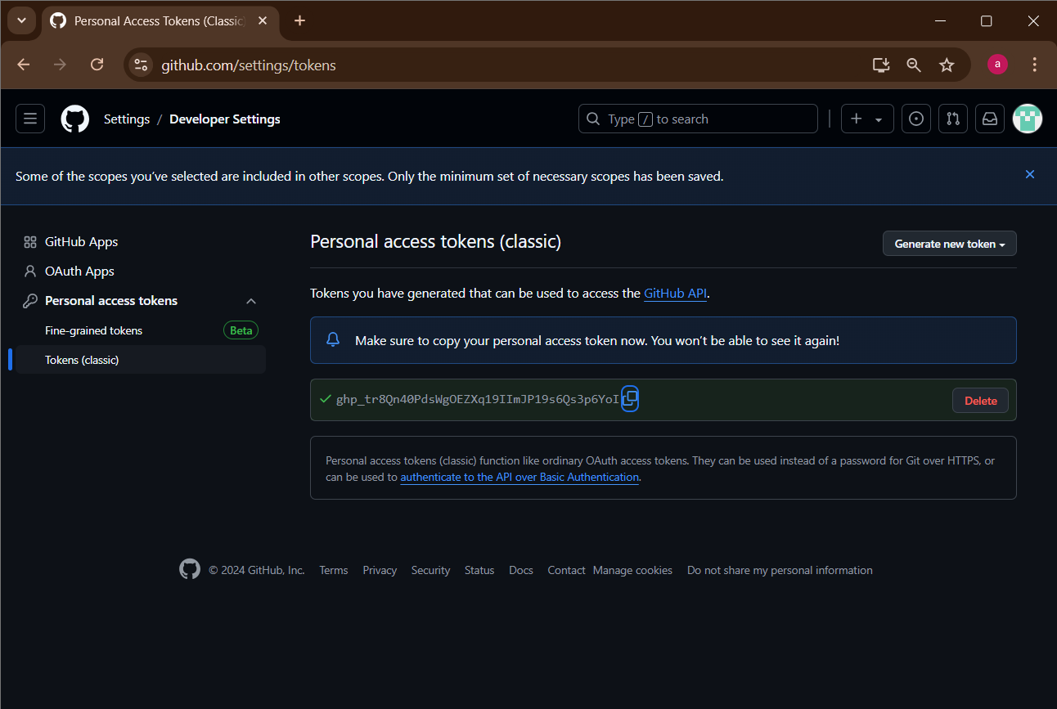

Adding credentials in jenkins to access my github account easily
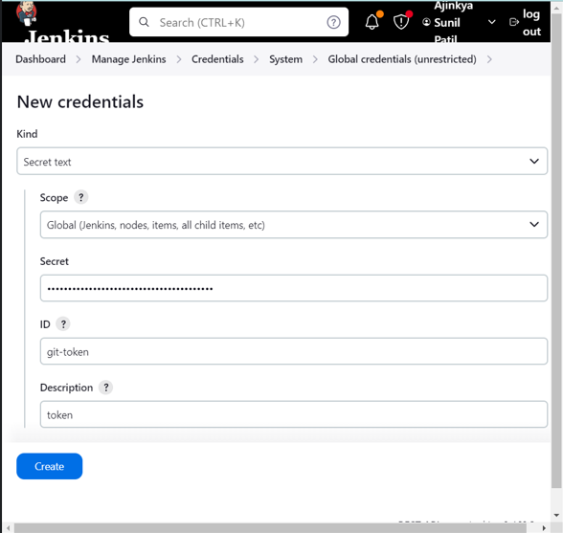

Trigger Automated Builds (Build Triggers)
- Go to your pipeline’s configuration page.
- Scroll down to "Build Triggers."
- Select:
  - "GitHub hook trigger for GITScm polling" (for GitHub)
- Integrate webhooks to notify Jenkins of commits or pull requests for automatic builds.
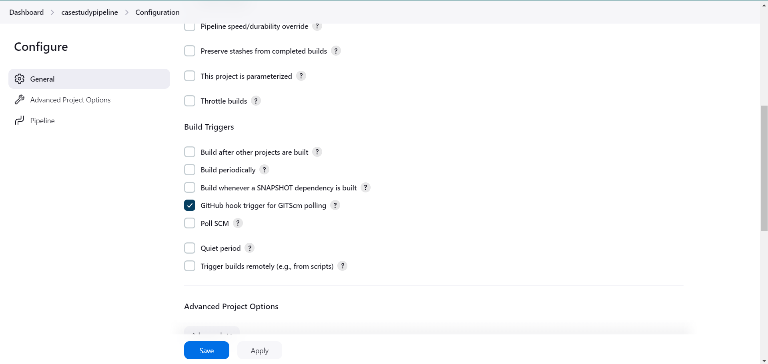
FOR CREATING WEBHOOK FOLLOW THE STEPS
Navigate to Your GitHub Repository:
- ➜ Open GitHub
- ➜ Log in
- ➜ Go to repository
Access Repository Settings:
- ➜ Click Settings
Locate Webhooks:
- ➜ Click Webhooks
Add a New Webhook:
- ➜ Click Add webhook
Configure the Webhook:
- ➜ Payload URL: http://<your-jenkins-url>/github-webhook/
- ➜ Content Type: application/json
- ➜ Secret: Optional
- ➜ Events: Just the push event
- ➜ Active: Checked
Save the Webhook:
- ➜ Click Add webhook

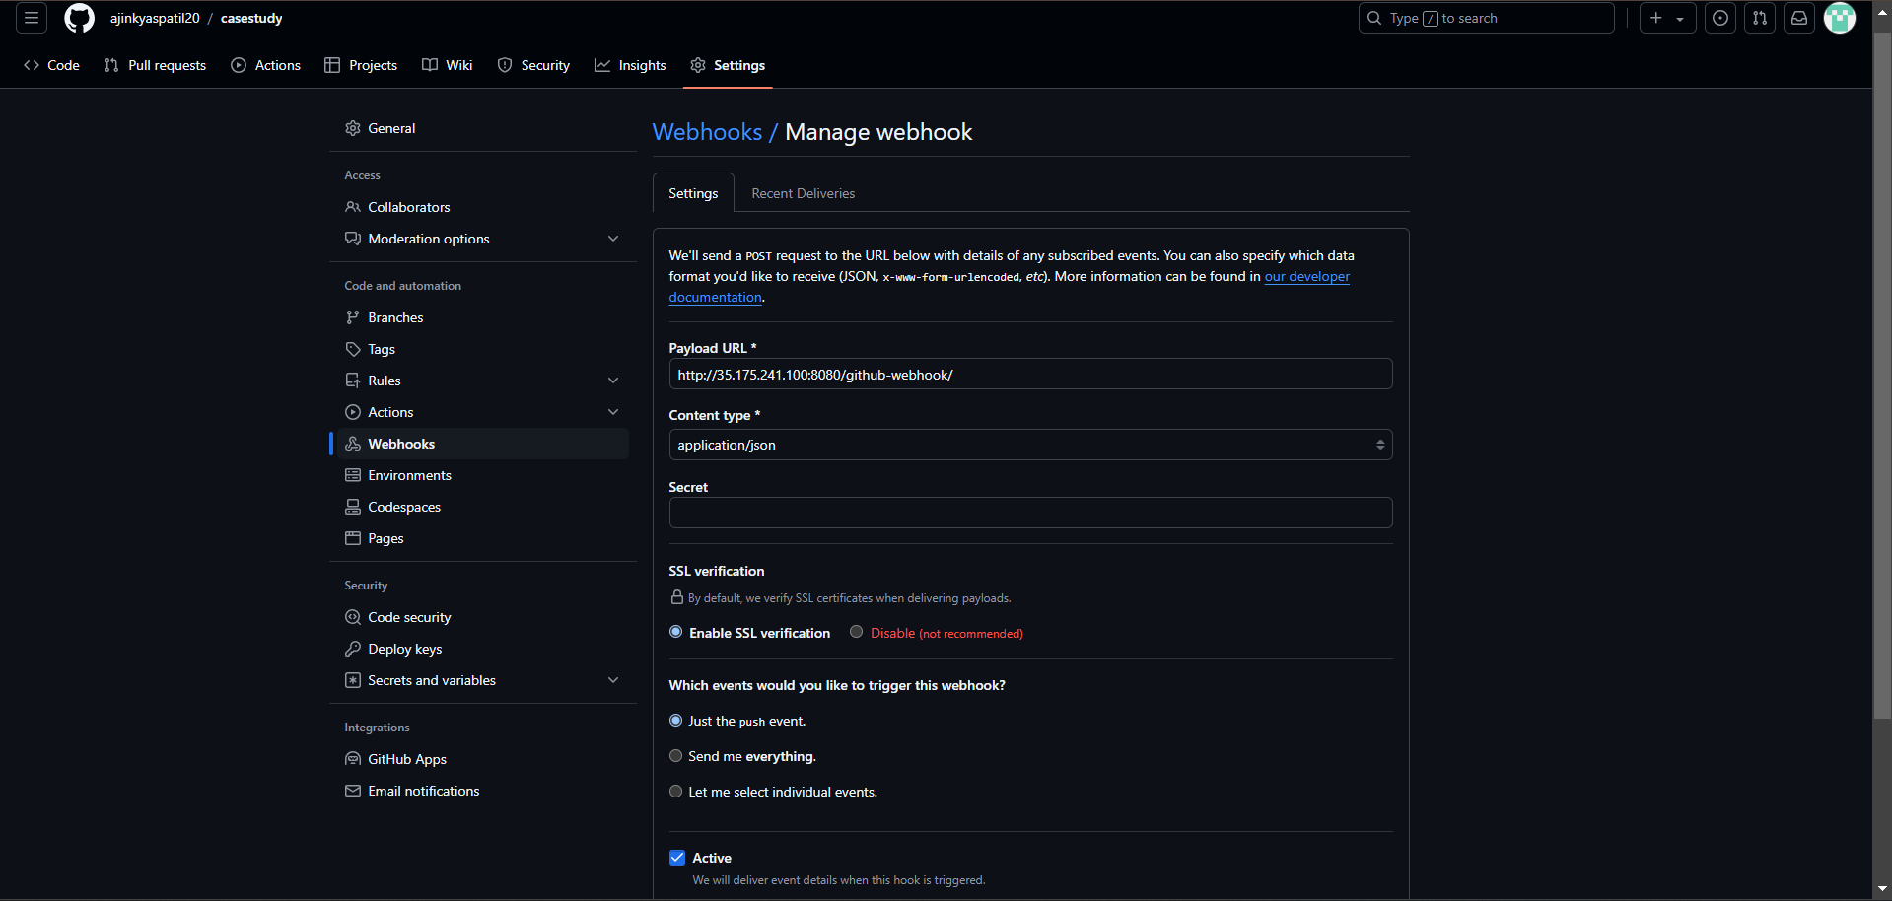

4.2 Jenkins Pipeline Configuration
- Create a New Pipeline:
  - Navigate to Jenkins Dashboard.
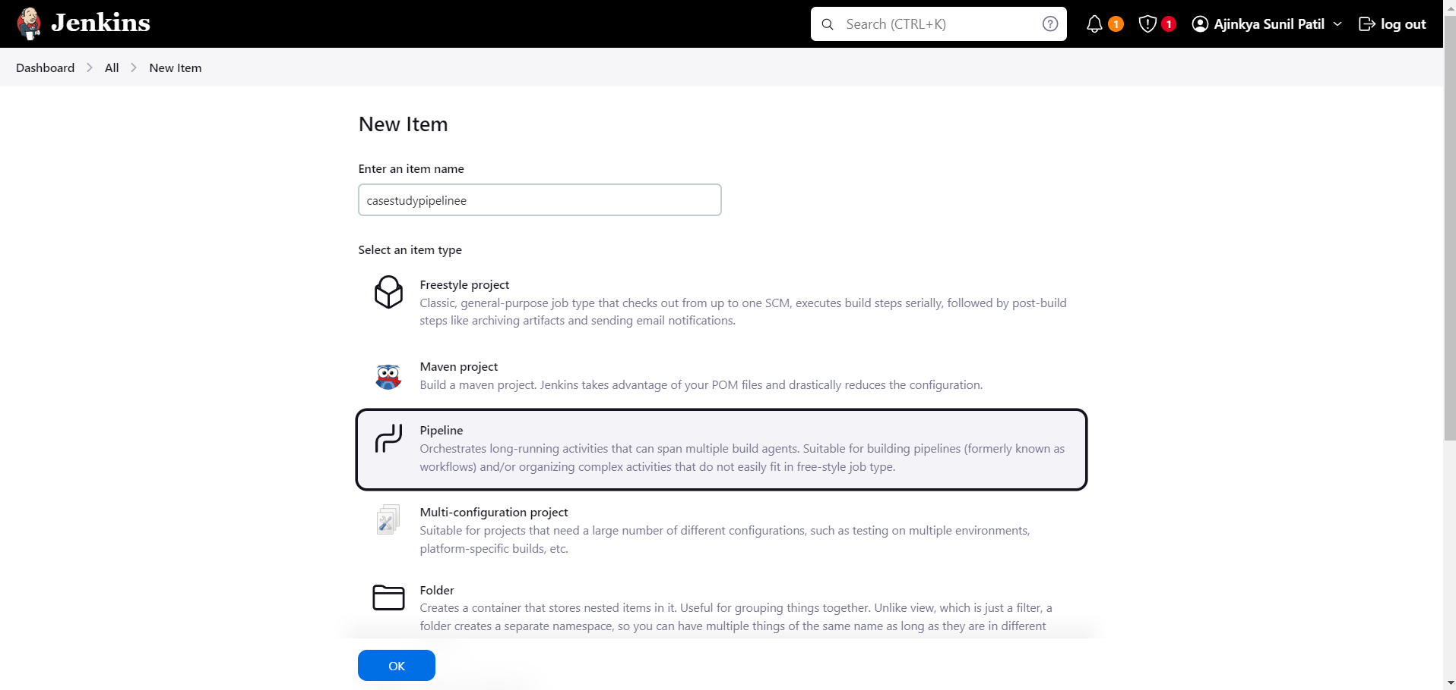
  - Create a new pipeline job (casestudypipelin) to define the steps for building and deploying the application.

- GitHub Integration:
  - Configure Jenkins to pull the web application’s source code from the GitHub repository (e.g., https://github.com/ajinkyaspatil20/casestudy).
  - Set up Jenkins credentials for accessing the repository securely.
- Pipeline Script:
  - Write a Jenkinsfile that defines the CI/CD pipeline stages:
    - Build Stage: Compile or package the application (if needed).
    - Test Stage: Run automated tests to ensure functionality.
    - Deploy Stage: Use SSH to deploy the application on the target EC2 instance.
PIPELINE SCRIPT
pipeline {
agent any

environment {
GIT_CREDENTIALS = credentials('gittoken') // Use the correct credentials ID
}

stages {
stage('Checkout Code') {
steps {
git branch: 'main',
credentialsId: 'gittoken', // Jenkins credentials ID
url: 'https://github.com/ajinkyaspatil20/casestudy.git'
}
}

stage('Build') {
steps {
echo 'Building the project...'
}
}

stage('Test') {
steps {
echo 'Running tests...'
}
}

stage('Deploy') {
steps {
echo 'Deploying the project...'
}
}
}

post {
always {
echo 'Cleaning up...'
}
success {
echo 'Build succeeded!'
}
failure {
echo 'Build failed.'
}
}
}
4.3Triggering the Pipeline:
  - Set up webhook triggers to automatically start the pipeline whenever a new commit is pushed to the GitHub repository.
Adding new file on github repo to trigger in jenkins
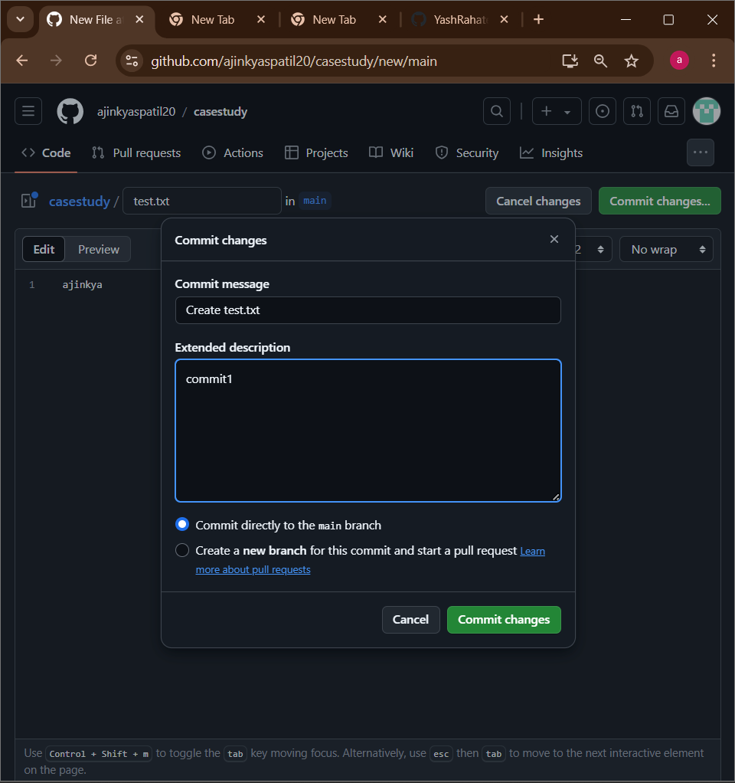

New build auto generated or triggered
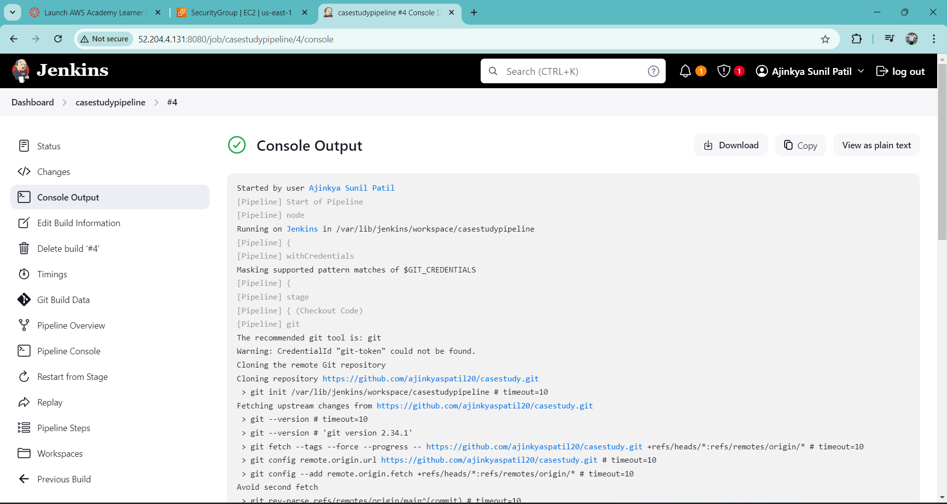
In git also they show that last delivery was successful
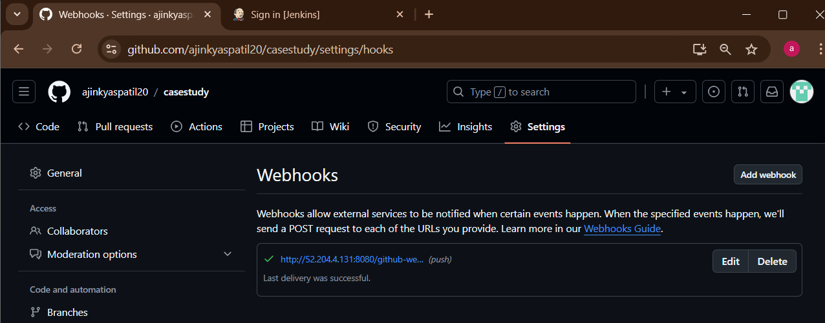

5. Application Deployment on EC2
After building and testing, the application is deployed on the target EC2 instance using Jenkins. The steps include:
- Copying the application files to the EC2 instance via SSH.
This pipeline will:

Clone the repository.

Optionally build the web app (if there’s a build process).

Use SSH to transfer the files to the EC2 instance where the web server hosts the app.
ERROR
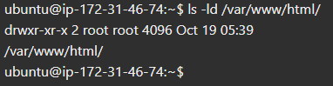
Solution
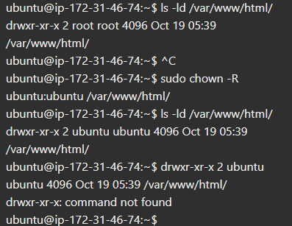
5.1. Testing the Pipeline

Trigger a build manually by clicking on Build Now.
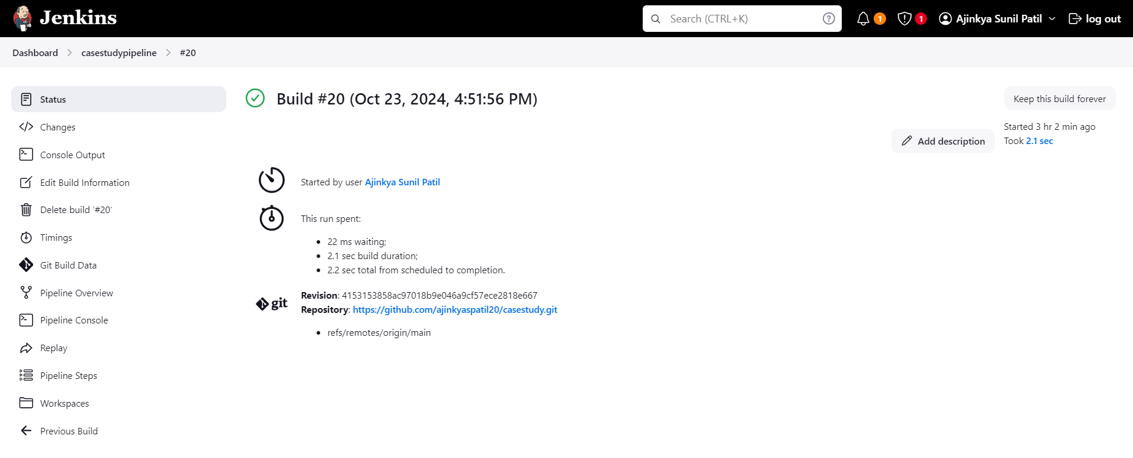

Verify that the web application is deployed on the EC2 instance by accessing its public IP or domain name via a browser.
http://3.88.24.184/


6. Monitoring with Nagios
Nagios is used to continuously monitor the availability of the web application. If the application becomes unavailable, Nagios will alert the administrators to investigate and resolve the issue.

6.1 Nagios Installation

Installing and Configuring Nagios to Monitor the Web Application
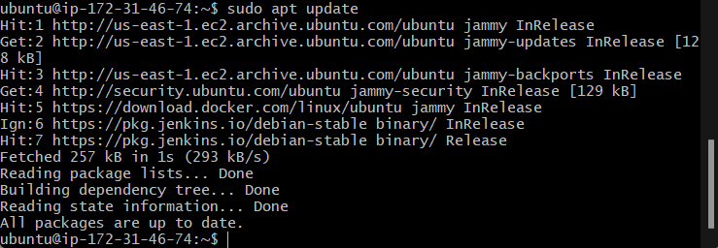
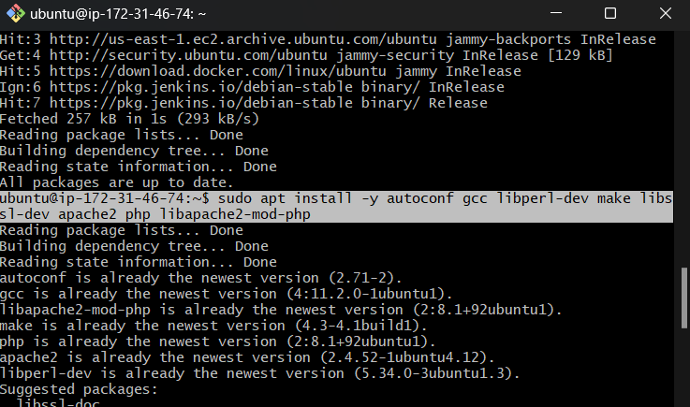
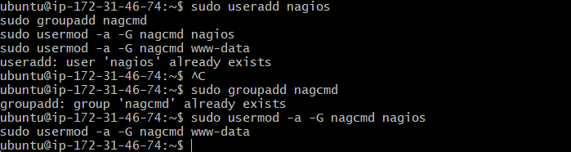
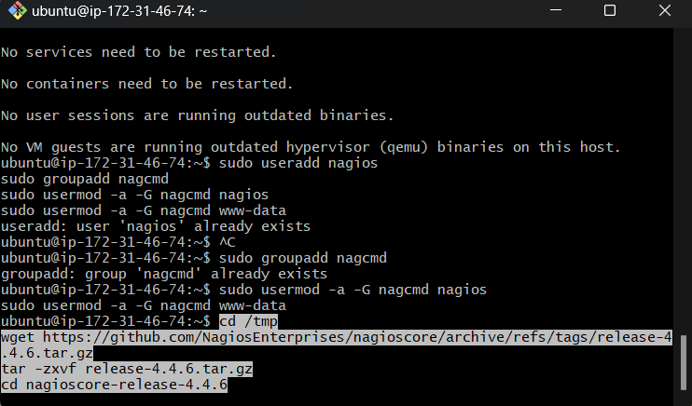

6.2 Nagios Installation

Prerequisites:

An EC2 instance running Ubuntu to host the Nagios monitoring server.

Steps:

Update package lists and install necessary dependencies:

sudo apt update

sudo apt install -y apache2 libapache2-mod-php php wget unzip

Download and install Nagios Core.

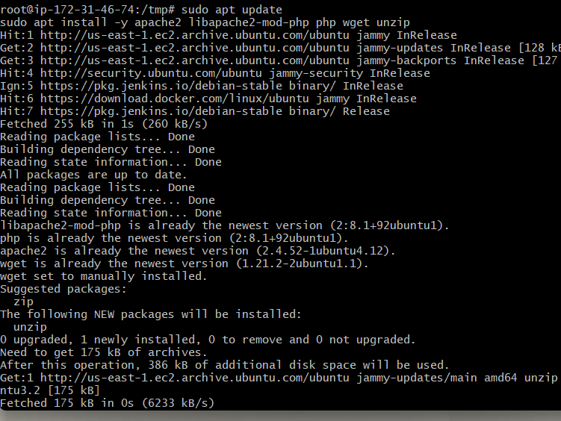

wget https://assets.nagios.com/downloads/nagioscore/releases/nagios-4.4.6.tar.gz
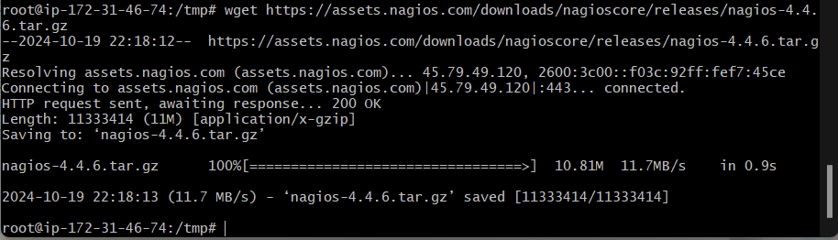

tar -xvf nagios-4.4.6.tar.gz

cd nagios-4.4.6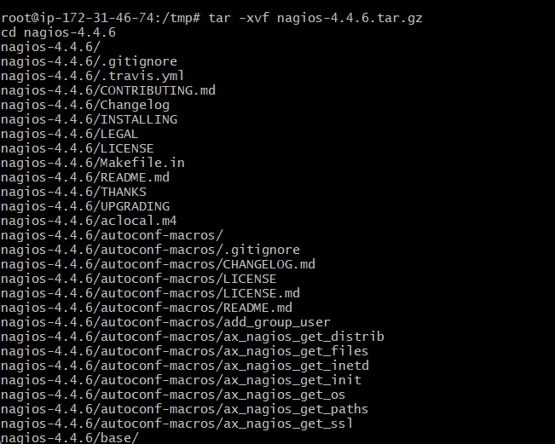

./configure --with-httpd-conf=/etc/apache2/sites-enabled

make all
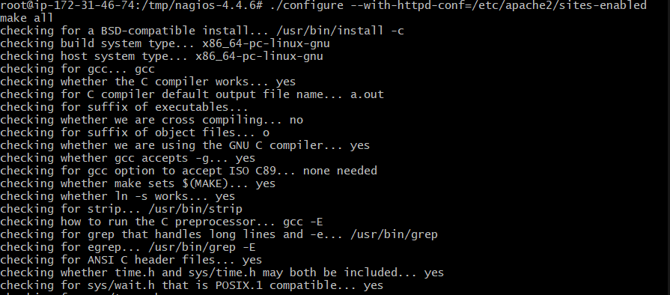
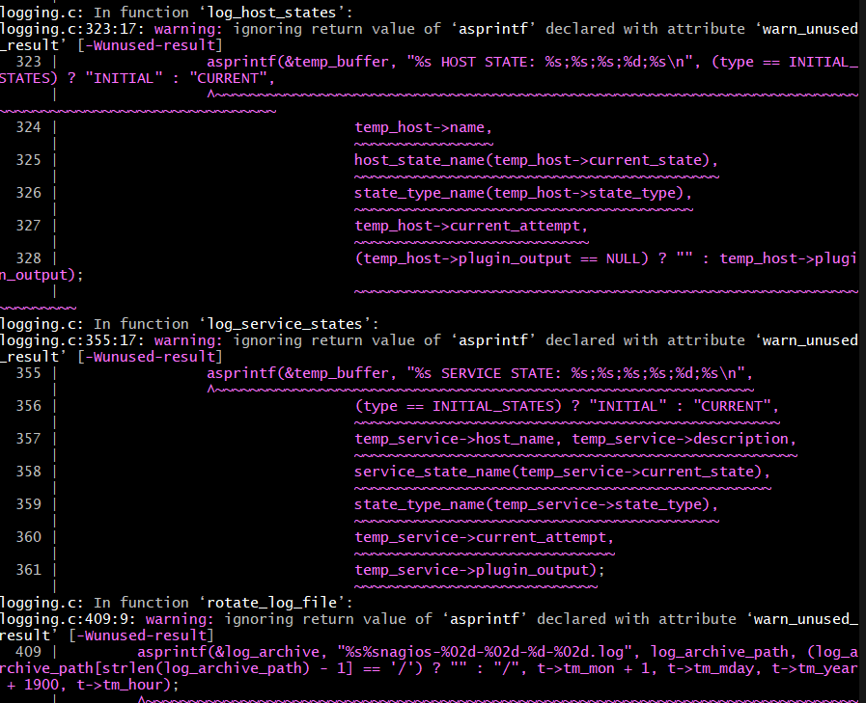
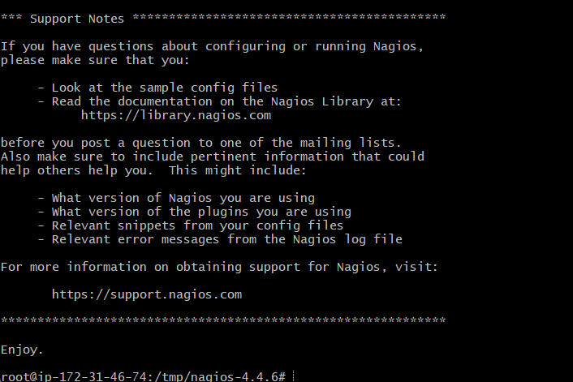

sudo make install

sudo make install-commandmode

sudo make install-init

sudo make install-config
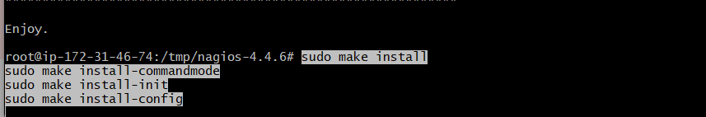

Configure Nagios:

Enable the web interface and create an admin user:

sudo htpasswd -c /usr/local/nagios/etc/htpasswd.users nagiosadmin
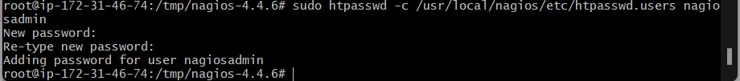

sudo a2enmod cgi

sudo service apache2 restart
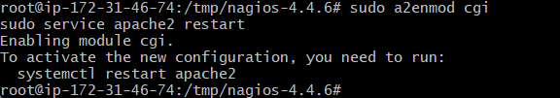

Install Nagios plugins to allow HTTP status checks.:

sudo apt install nagios-plugins nagios-nrpe-plugin
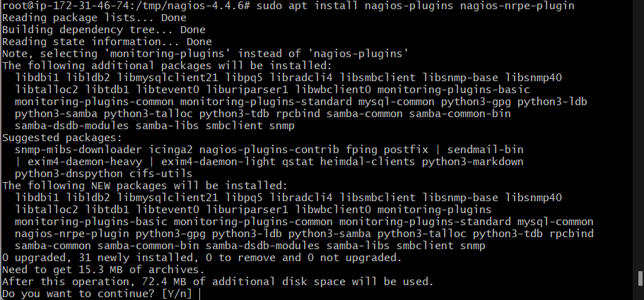

6.3Configuring Nagios to Monitor EC2 Instance and Web App

Add Web Application Monitoring:

Open the Nagios configuration file /usr/local/nagios/etc/nagios.cfg and add a new service check for HTTP.
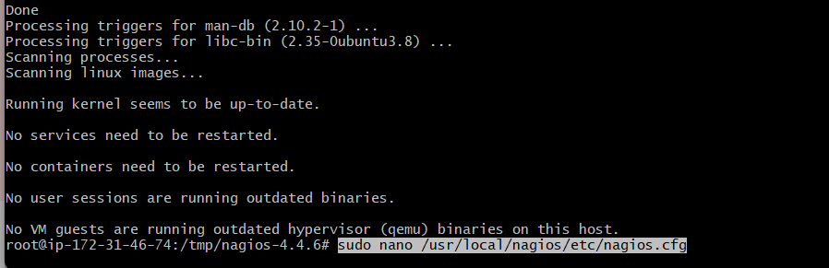

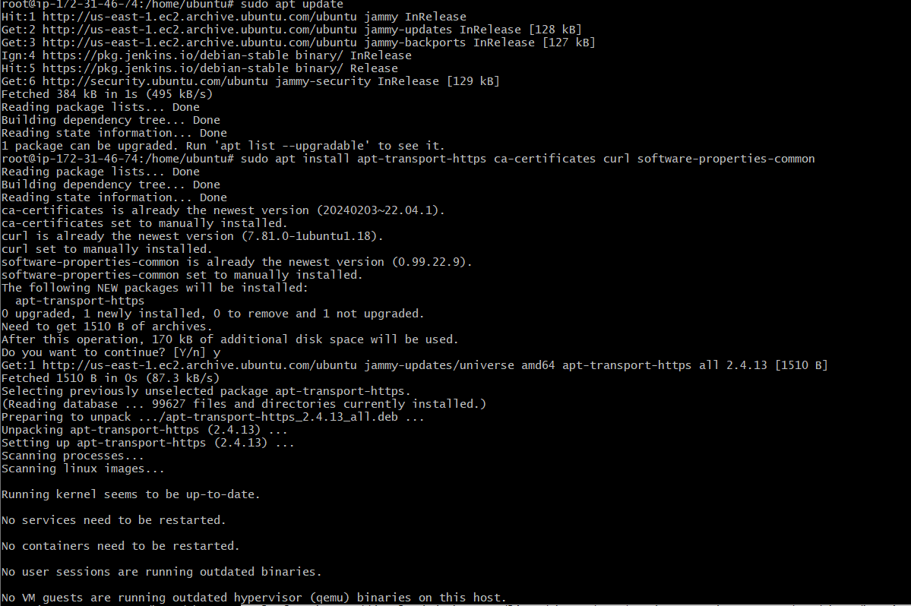
6.4Create a New Configuration File for Your Custom Services:
- Instead of modifying the nagios.cfg directly, it's cleaner to create a separate configuration file. For example, you could create a file called myservices.cfg in the Nagios configuration directory.
Open the Terminal:
bash
Copy code
sudo nano /usr/local/nagios/etc/objects/myservices.cfg

Add Your Service Check Definition: In the new file, you can add your service check definition:
bash
Copy code
define service {
use generic-service
host_name ec2-instance-ip # Replace with your EC2 instance's IP
service_description HTTP
check_command check_http
}

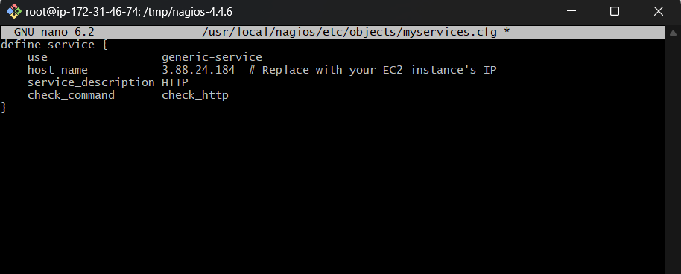
Include Your New Configuration File in nagios.cfg: Now, you need to include this new configuration file in the main nagios.cfg. Open nagios.cfg again:
bash
Copy code
sudo nano /usr/local/nagios/etc/nagios.cfg

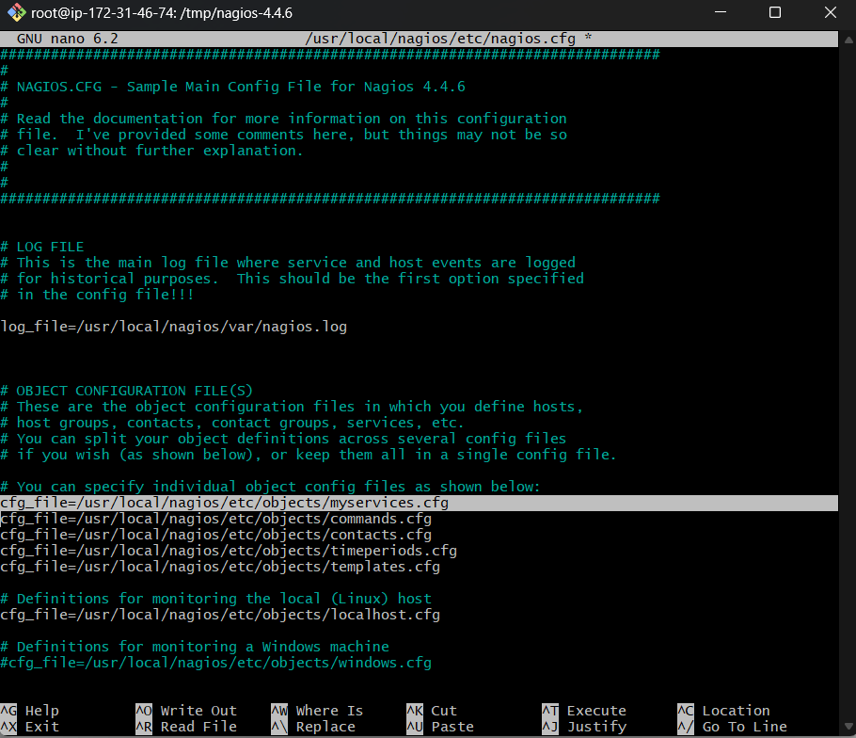

bash

Copy code

define service {

use generic-service

host_name ec2-instance-ip

service_description HTTP

check_command check_http

}
Include Your New Configuration File in nagios.cfg: Now, you need to include this new configuration file in the main nagios.cfg. Open nagios.cfg again:
bash
Copy code
sudo nano /usr/local/nagios/etc/nagios.cfg

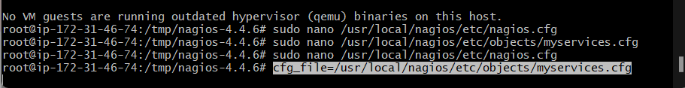

Restart Nagios:

Apply the changes by restarting Nagios:

bash

Copy code

sudo systemctl restart nagios
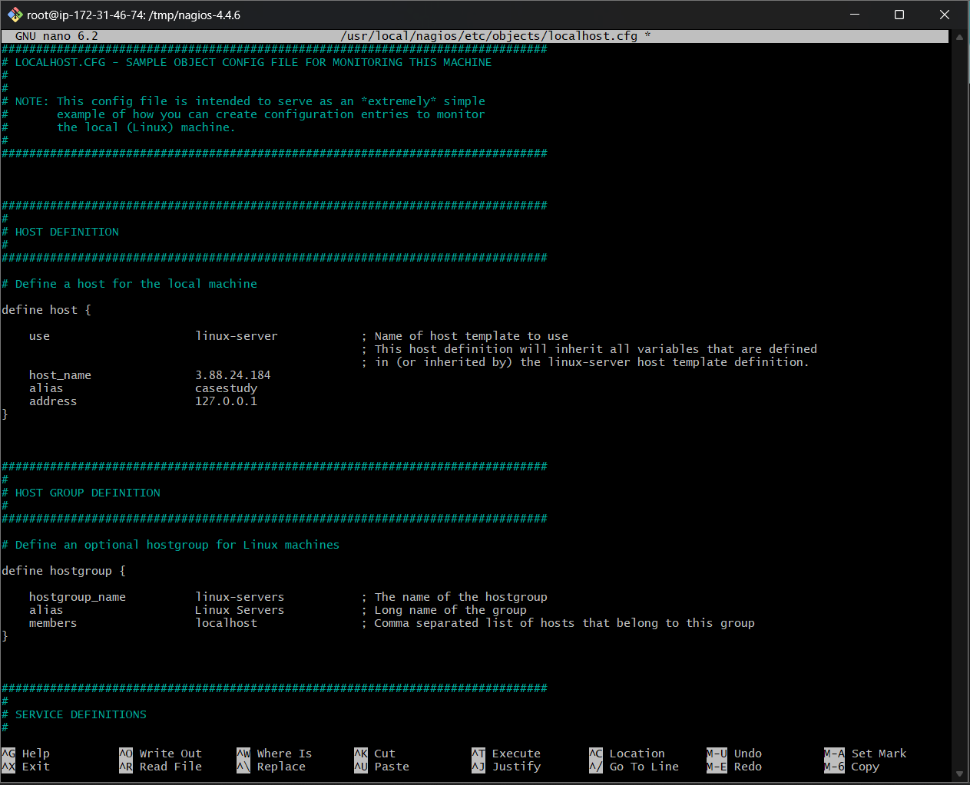
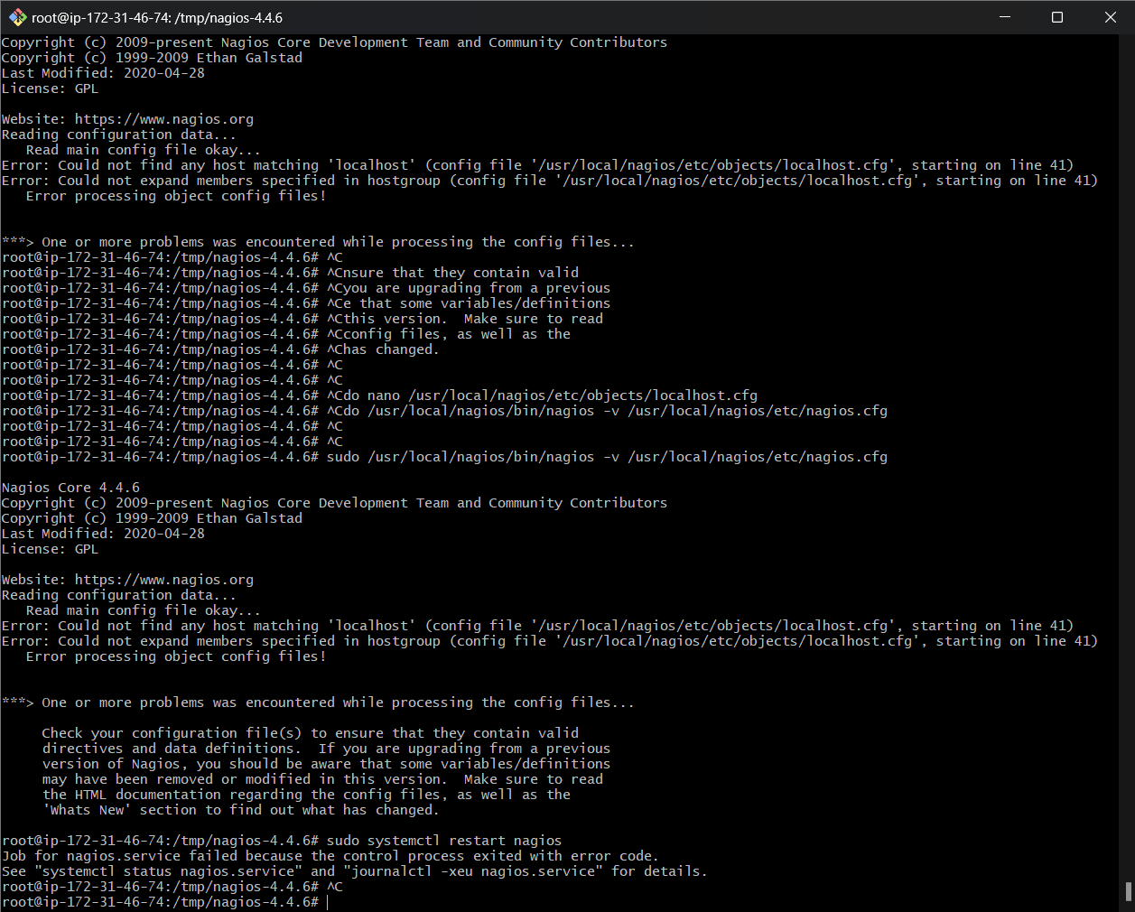
Error continues
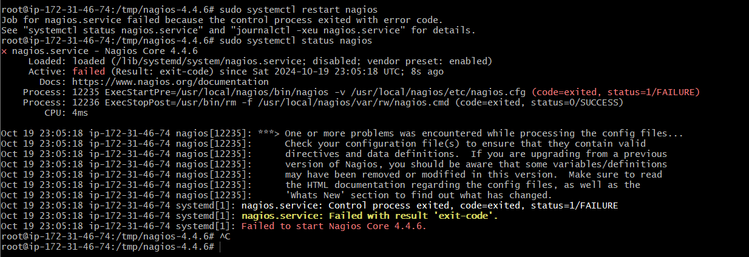

*SO WE TOOK DECISION TO REMOVE EXISTING NAGIOS AND INSTALL NEW LATEST VERSION
HERE ARE THE STEPS:

1. Stop and Remove Existing Nagios
sudo systemctl stop nagios
sudo apt-get remove --purge nagios*
sudo rm -rf /usr/local/nagios/ /usr/local/nagiosxi/ /var/nagios/ /var/log/nagios/ /var/lib/nagios/ /etc/nagios/

2. Install Dependencies
sudo apt-get update
sudo apt-get install -y wget build-essential libgd-dev openssl libssl-dev unzip apache2 php libapache2-mod-php php-gd libmcrypt-dev bc gawk dc snmp libnet-snmp-perl gettext

3. Download the Latest Version of Nagios
wget https://assets.nagios.com/downloads/nagioscore/releases/nagios-X.X.X.tar.gz
# Replace X.X.X with the latest version number.

4. Extract and Install Nagios
tar xzf nagios-X.X.X.tar.gz
cd nagios-X.X.X
sudo ./configure --with-httpd-conf=/etc/apache2/sites-enabled
sudo make all
sudo make install
sudo make install-init
sudo make install-config
sudo make install-commandmode
sudo make install-webconf

5. Create Nagios User and Group
sudo useradd nagios
sudo groupadd nagios
sudo usermod -aG nagios www-data

6. Configure Web Interface
sudo htpasswd -c /usr/local/nagios/etc/htpasswd.users nagiosadmin
sudo systemctl restart apache2

7. Start Nagios Service
sudo systemctl enable nagios
sudo systemctl start nagios

8. Verify Installation
Open a browser and navigate to http://<your-server-ip>/nagios. Log in with the nagiosadmin user and the password you set earlier.
Result IN SUCCESS
http://<your-server-ip>/nagios
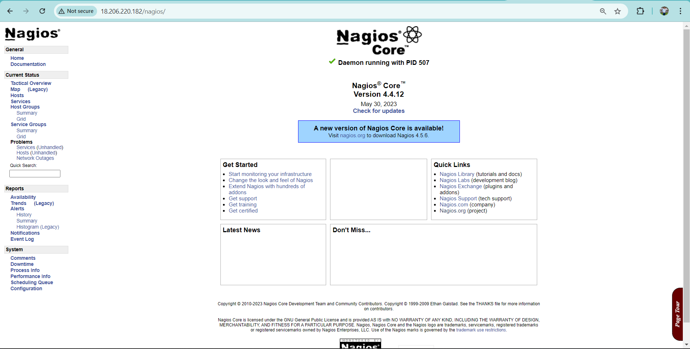
- Testing Monitoring:
  - After configuration, test the monitoring setup by stopping the web server and ensuring Nagios sends alerts when the application becomes unavailable.
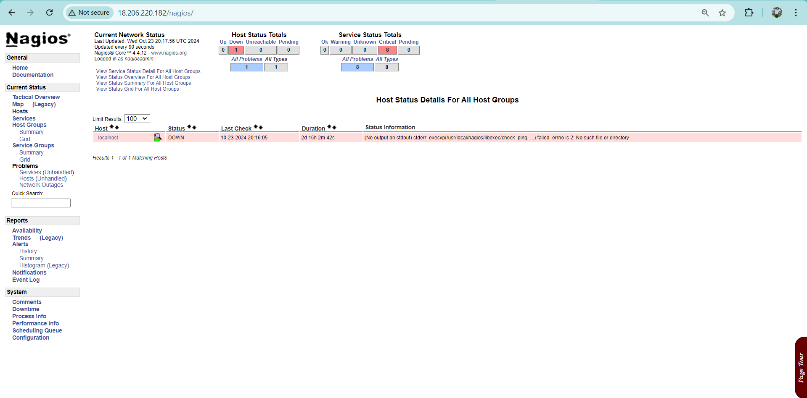
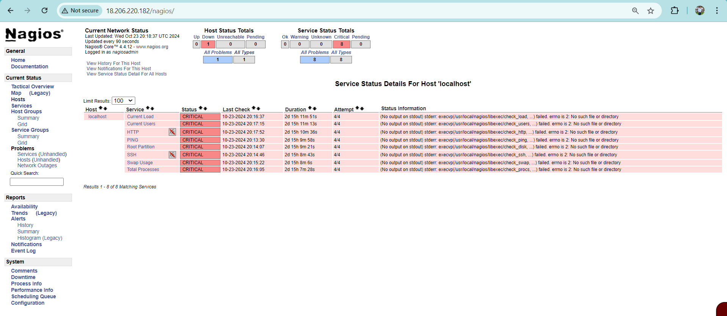
Due to ssh connection time out my hosting (CI/CD) (jenkins)real time update on website not done for this ec2 instance ,issue of connection timed out this issue occurs due to overloading on ec2
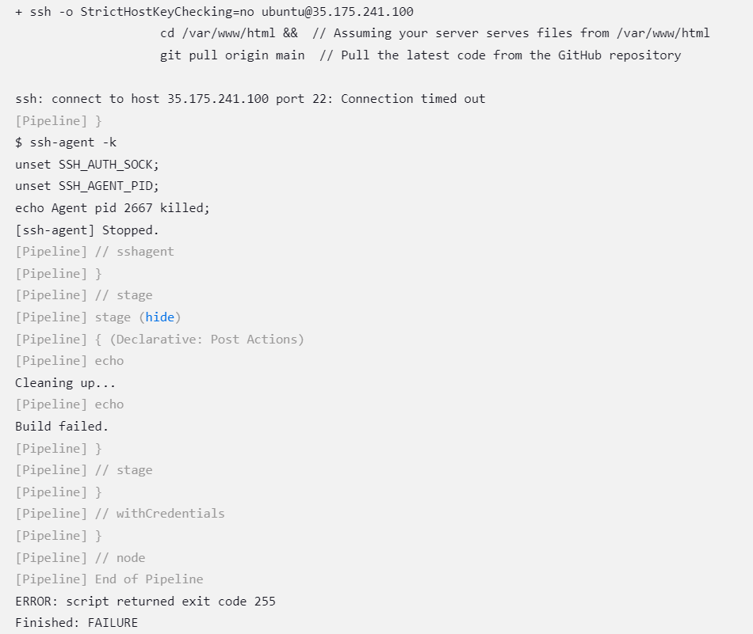

7. Conclusion
This setup creates an efficient CI/CD pipeline using Jenkins to automatically deploy a web application on an AWS EC2 instance. It ensures that every new change in the code is tested and deployed automatically, reducing manual intervention and increasing the speed of deployments. By integrating Nagios, the pipeline further ensures the continuous availability of the application by monitoring its HTTP status and alerting administrators when issues occur.
By combining Jenkins' automation with Nagios' monitoring capabilities, the application remains reliable and resilient, minimizing downtime and ensuring a smoother user experience.
My EC2 instance is overloaded and in a running state, but I'm unable to connect via Bash or the console. When a trigger action occurs, my Jenkins pipeline auto-triggers and builds the job, but the hosted web application is not updated due to the SSH connection issue with the EC2 instance. Additionally, Nagios shows the server as down, whereas earlier, when the EC2 instance was connected, it was actively monitoring all my activities, but now it's not.

