Content Management System
Table of Contents
1 Introduction 4
1.1 Defination 4
1.2 Features 4
1.3 Purpose 5
1.4 Benefits 6
1.5 Examples 7
1.6 Stakeholders 8
1.7 Scope 8
1.8 Goals and Objectives 9
1.8.1 Support marketing 9
1.8.2 Reduce duplication of information 10
1.8.3 Improve customer experience 10
1.8.4 Support sales 10
1.8.5 Support website growth 10
1.8.6 Improve business responsiveness 11
1.8.7 Improve publishing process 11
1.8.8 Capture business knowledge 11
1.8.9 Improve staff efficiency 11
1.8.10 Reduce publishing costs 12
1.8.11 Reduce customer support costs 12
1.8.12 Reduce website maintenance costs 12
1.8.13 Increase website audience 12
1.8.14 Improve information accuracy 13
1.8.15 Business-specific goals 13
2 Supported Platforms & Architectures 14
2.1 Supported architectures 14
2.2 Well supported platforms 14
3 Databases 14
3.1 Relational Databases 15
3.2 Non - Relational Databases 15
4 Prerequisites Softwares 15
4.1 Well supported Browsers 15
4.1.1 Browser Must Support 16
5 Logical Strcuture Design 16
5.1 Classes 16
5.2 Classes and thier Attributes 17
5.3 Classes and thier Methods 18
6 Diagrams 19
6.1 Use Case Diagram 19
6.2 Activity Diagram 20
6.2.1 Login Activity Diagram 20
6.2.2 Class Management Activity Diagram 21
6.3 Class Diagram 22
6.4 Sequence Diagram 22

Introduction

Defination
A Content Management System or CMS is software that is used for creating, managing and editing a website even if you do not have any specialized technical skills or knowledge.

With CMS, you can develop and design a website without even having to write the code. In short, a CMS website is a website that is developed by using a content management system.

CMS not only helps in managing the text or images which are being displayed on the website, but they also help in tracking the user sessions, handling the search queries, collecting visitor feedback and comments, etc.

Features
- Content creation (allows users to easily create and format content)
- Content storage (stores content in one place, in a consistent fashion)
- Content storage (stores content in one place, in a consistent fashion)
- Publishing (organizes and pushes content live)

Purpose
- Increase efficiency – Content can be published easily and efficiently as editing and revisions do not require visual design or coding knowledge. This allows for fast and efficient updates, saving your business cost and time.
- Increase your search engine ranking – To improve or maintain your search engine ranking your business has to remain relevant, and a good and easy-to-use CMS will help your publishers keep the content fresh. This invites external contribution (e.g. comments, forum, likes etc…), an integral component in staying relevant and improving your search engine ranking.
- Maintain control over your content - Workflow is a core feature of any good CMS. Irrespective of how basic your workflow needs might be, workflows will ensure your business maintains control over content.
- Help your visitors in their search for information – With powerful CMS search engines new content is indexed automatically so it can be instantly found. Visitors can also use taxonomy applications, sorting lists, saved searches and more to personalize the search experience.
- Cross-selling – Sophisticated Content Management Systems can learn user behavior and preferences, making your cross-selling and up-selling efforts much more cost effective.

Benefits
- One major advantage of a CMS is its collaborative nature. Multiple users can log on and contribute, schedule or edit content to be published. Because the interface is usually browser-based, a CMS can be accessed from anywhere by any number of users.
- he second major advantage of a CMS is that it allows non-technical people who don’t know programming languages to easily create and manage their own web content. The WYSIWYG editors of a typical content management platform allows users to enter text and upload images without needing to know any HTML or CSS.
- When a company uses a CMS to publish its pages, it reduces its reliance on front-end engineers to make changes to the website, making it quicker and easier to publish new content.

Examples
- Episerver
- Drupal
- Wordpress
- Joomla
- Magenta
- ModX
- Squarespace
- Wix
- Weebly

Stakeholders
- Consumers or General Audience
- Individuals
- Educators
- Enterprise
- Publishers
- Freelancers
- Web Developers
- Authors
- Bloggers
- Small Business Owners

Scope
In this digital world, content management systems will go far away from the mark and bring the latest revolution, for sure that is very helpful for the internet. So, if we talk about CMS, it helps create, publish and update website content very effectively.

Nowadays technology is at its top. And it is very important we have to upgrade our website, from time to time.
- Quick Implementation
- User Experience
- Virtual and Augmented Reality
- Ease of Use
- Scalability
- Flexibility
- Ongoing Support

Goals and Objectives

Support marketing
Websites have become a key marketing channel for businesses. The CMS should facilitate the delivery of marketing material, as well as supporting current brands and corporate identity.

Reduce duplication of information
Duplication of information across business units and platforms increases maintenance costs and error rates. Wherever possible, information should be stored once, and reused multiple times.

Improve customer experience
The CMS should enhance the ability to provide a full-featured, rich environment for website visitors. This will include enhancements to the quality of the site, and the ease of use.

Support sales
E-commerce sales are growing steadily, and the CMS should provide further sales material to enhance the sales impact of the website. It should also complement current e-commerce infrastructure.

Support website growth
There is a strategic need to substantially increase the amount of information published on corporate websites. The CMS should deliver efficiency and management benefits to support the goal of website growth.

Improve business responsiveness
The CMS should support the development of new products and services, as well as other changes in corporate direction. This is achieved by providing a rapid and efficient mechanism to update internal corporate information and resources.

Improve publishing process
Ad-hoc publishing processes prevent effective management and tracking. The CMS should improve on this, as well as providing greater transparency and accountability.

Capture business knowledge
All information presented on the corporate website exposes the business to legal liability. This should be reduced by establishing greater control and accountability over the review and publishing processes.

Improve staff efficiency
Staff efficiency can be improved by supporting key business processes with sufficient information. The CMS must aim to provide staff with the information they need, when they need it.

This will translate into direct time savings by avoiding fruitless searches for required information.

Reduce publishing costs
Many business manuals are still produced in paper form. Direct cost savings would be realised by replacing these with online resources.

Reduce customer support costs
Customer support requirements should be reduced, by providing more accurate and comprehensive information to customers.

Reduce website maintenance costs
By replacing the current labour-intensive maintenance activities, the CMS should reduce the need for website administration staff, and other associated costs.

Increase website audience
The CMS should allow a wide audience to access the corporate website. All customers of the business will then benefit from the site. (This includes non-English speakers.)

Improve information accuracy
The overall quality of the information is to be improved, on both the website and intranet. All pages should be:
- Accurate
- Up-to-date
- Comprehensive

Business-specific goals
- Beyond the general CMS goals outlined above, there will be a number of very specific goals that relate directly to your business.
- Identifying these ensures that the CMS matches the unique nature of your business, and that it meets the overall strategic direction.
- Examine the key products, services and processes within the business to identify these business-specific goals.
Without business goals, success is impossible to measure

Supported Platforms & Architectures

Supported architectures
- Intel x86 (32-bit) and x86_64 (64-bit, aka AMD64)

Well supported platforms
- Linux
- Windows Vista and newer
- FreeBSD 10 and newer
- macOS Snow Leopard (macOS 10.6, 2008) and newer
- Android 4.4 and newer

Databases
We officially supports the following databases:

Relational Databases
- PostgreSQL
- MariaDB
- MySQL
- Oracle
- SQLite

Non - Relational Databases
- MongoDB

Prerequisites Softwares

Well supported Browsers
- Google Chrome
- Firefox
- Safari
- Opera
- Brave

Browser Must Support
- HTML
- Javascript
- CGI

Logical Strcuture Design

Classes
- User class : Manages all the operations of user.
- Role class : Manages all the roles of user.
- Permission class : Manage all the operation of permission assigned to each user.
- Blog class : Manages all the operations on Blog.
- Comment class : Manages all the operation of comment on each Blog.
- Content class : Manages the content of each Blog.
- Viewer class : Manages all the operation for each Blog viewed by each User.

Classes and thier Attributes
- User Attributes : user_id, user_role_id, user_name, user_email, user_dob, user_ address
- Role Attributes : role_id, role_title, role_description
- Permission Attributes : permission_id, permission_role, permission_title, permission_module, permission_description
- Blogs Attributes : blog_id, blog_user_id, blog_type, blog_content, blog_description
- Content Attributes : content_id, content_blog_id, content_title, content_type, content_description
- Comment Attributes : comment_id, comment_user_id, comment_type, comment_title, comment_description
- Viewer Attributes : viewer_id, viewer_blog_id. viewer_user_id

Classes and thier Methods
- User : addUser(), editUser(), deleteUser(), searchUser()
- Role : addRole(), editRole(), deleteRole(), searchRole()
- Permission : addPermission(), editPermission(), deletePermission(), searchPermission()
- Blogs Methods : addBlogs(), editBlogs(), deleteBlogs(), searchBlogs()
- Content Methods : addContent(), editContent(), deleteContent(), searchContent0
- Comment Methods : addComment(), editComment(), deleteComment(), searchComment()
- Viewer Methods : addViewer(), editViewer(), deleteViewer(), searchViewer()

Diagrams

Use Case Diagram
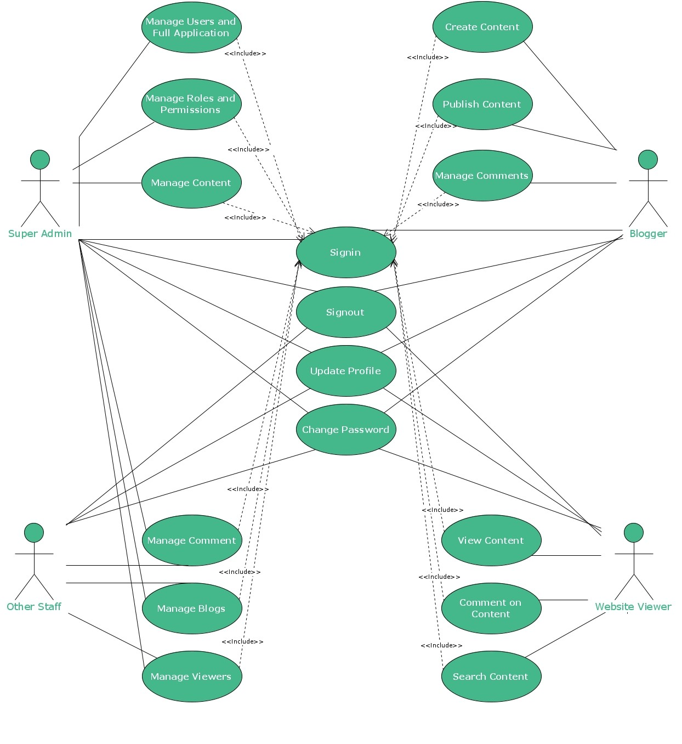

Activity Diagram

Login Activity Diagram
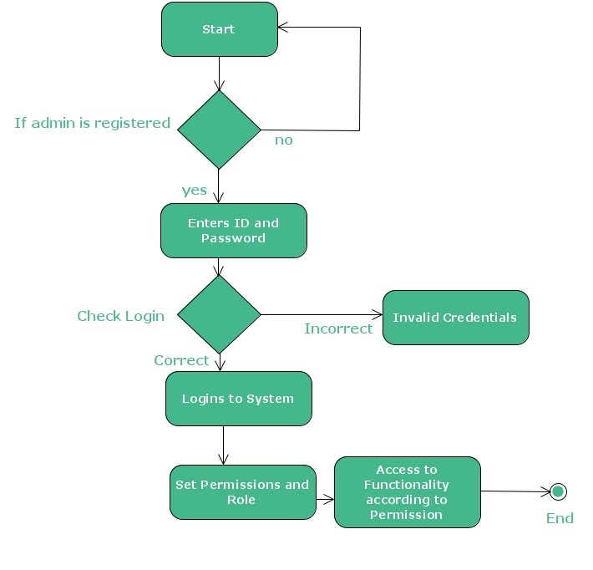

Class Management Activity Diagram
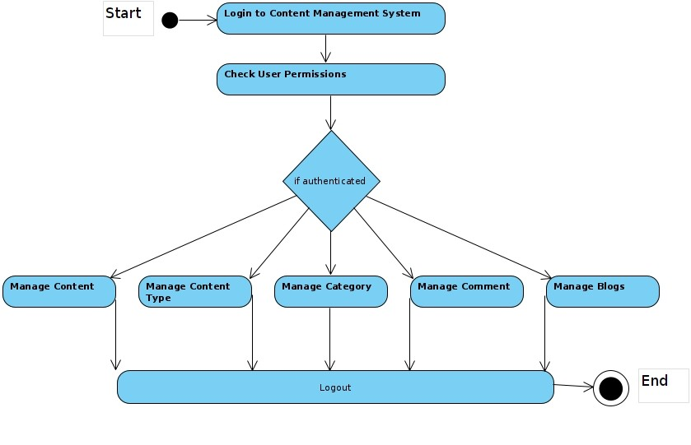

Class Diagram
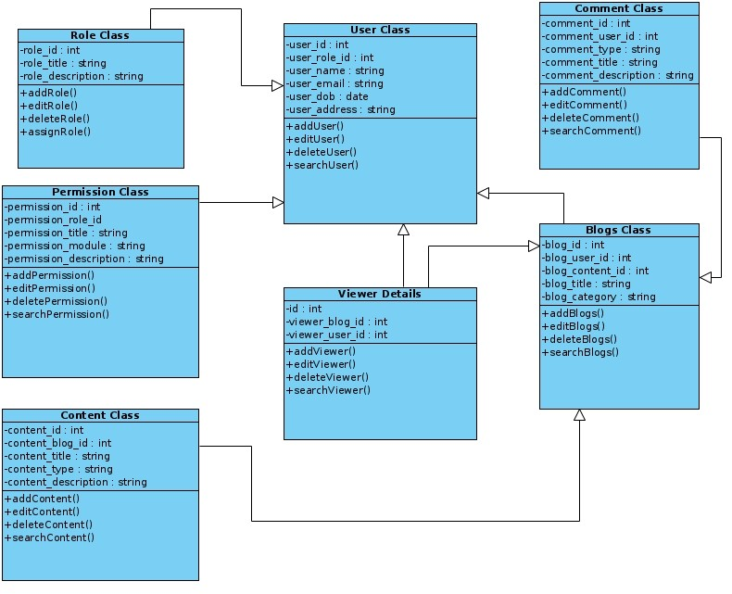

Sequence Diagram

