***Identification of Annotators Agreement Using Microblogs Related to Grievances***

By

Shivangi Chotaliya

Ajinkya Rathod

A Dissertation Thesis Submitted

To

**Gujarat University**

In Partial fulfilment of the requirements

For

The Degree of

**Master of Computer Application**

Under the Supervision and Guidance of

**Dr. Hardik Joshi**



**DEPARTMENT OF COMPUTER SCIENCE**

**ROLLWALA COMPUTER CENTER**

**GUJARAT UNIVERSITY**

**JANUARY 2022**

Department Of Computer Science

Gujarat University



**Certificate**

**R**oll No: 06 Seat No: _50005_

This is to certify that Ms. **Shivangi Chotaliya** student of MCA Semester – V, has duly completed her Dissertation titled **Identification Of Annotators Agreement Using Microblogs Related To Grievances** towards partial fulfilment of her Degree of Masters in Computer Science & Application.

Date of Submission Guide(s)

Head of Department

Department Of Computer Science

Gujarat University



**Certificate**

**R**oll No: 30 Seat No: _50024_

This is to certify that Ms. **Ajinkya Rathod** student of MCA Semester – V, has duly completed her Dissertation titled **Identification Of Annotators Agreement Using Microblogs Related To Grievances** towards partial fulfilment of her Degree of Masters in Computer Science & Application.

Date of Submission Guide(s)

Head of Department

# Abstract

We are working on tweets that has been done by users who travel in trains and have tweeted about the complaint of Indian Railways. Determine whether the tweet is grievance or non-grievance with the help of Cohen’s kappa score pinpoint precision. Our initial task is to identify whether they are relevant or not. And the users who do this task is called Annotators. Our main goal is to check the inter-rater reliability between 2 ratters. For evaluation, data has been retrieved from @RailMinIndia which is an official Account of Railway Government of India. A confusion matrix is created based on annotators reviews. Cohen's Kappa is apply to the matrix and acquire the correct accuracy and evaluate if the tweet is grievance or non-grievance. The overall point of all these is Evaluating a classification model when overall accuracy is biased. The implementation of the methodology is done using Django framework which is Python based programming language.

# Acknowledgement

A research project like this is never the work of any one alone. The contributions of many different people, in their different ways, have made this possible. We would like to extend our appreciation especially to the following.

It is our pleasure to take this opportunity to thank all those who helped us directly or indirectly in our research work. Not everything that we have received can be acknowledged with few words.

We are thankful to our guide **Dr. Hardik Joshi**, **Dr. Hiren Joshi**, **Ms. Khushboo Shah** their valuable help during the work of this thesis. Their suggestions were always there whenever we needed and their guidance helped us in all the time of research and writing of this thesis.

We articulate our deep sense of respect and gratitude to **Dr. Jyoti Pareek** (Head of Department, Department of Computer Science, Gujarat University). We are also thankful to all the faculties of the **Department of Computer Science, Rollwala Computer Centre.**

Our deepest thanks to all staff of the lab in the Department of Computer Science, Gujarat University for providing the necessary infrastructure for the research.

Shivangi Chotaliya

Ajinkya Rathod

Table of Contents

Abstract 4

Acknowledgement 5

Grievance 10

Importance of Grievance 10

Complaint vs grievance 10

Types of Grievance 11

1. Visible Grievances or Hidden Grievances: 11

2. Individual or Group Grievances 11

Grievance Redressal Mechanism in India 11

Microblogging 14

Annotators 15

Tagger 15

Cohen’s Kappa 16

Inter-rater agreement 16

History 16

Definition 17

Steps 18

Interpretation of Kappa 20

Random Rating 21

Limitations of Cohen’s Kappa 23

Literature Review 24

Paper: A Simplified Cohen’s Kappa for Use in Binary Classification Data Annotation Tasks 24

Introduction to Binary Classification 24

Data Annotation 25

Cohen’s Kappa 25

Methods 28

Conclusion 31

Paper: SMART APPROACH TO RECOGNIZE PUBLIC GRIEVANCE FROM 31

MICROBLOGS 31

Microblogging on Social Media – A New Way to Express Dissatisfaction 34

Research Paper: A random forest classifier for lymph diseases 35

Research Paper: A Simplified Cohen’s Kappa for Use in Binary Classification Data Annotation Tasks 35

Research Paper: Facing Imbalanced Data - Recommendations for the Use of Performance Metrics 36

Proposed Approach 37

Language Used 37

Python: 37

Applications for Python 38

API Used(Libraries) 41

Pandas: 41

Features 41

metrics 44

Pylab 44

Matplotlib 45

Features 46

Seaborn 46

pycm 47

Dataset Used 48

Screenshots 49

Conclusion and Future Work 52

Conclusion 52

What you have done? 53

What can be done to improve? 53

References 54

# Grievance

* Something that you think is unfair and that you want to complain or protest about it. A grievance is kind of a formal complaint that is raised by an user towards Railway Ministry of India (here).
* For instance, I officially mailed the Railway Ministry of India is considered as Complaint. A grievance, for example, is that some issue raised on twitter towards Railway Ministry of India.

## Importance of Grievance

A grievance process is designed to give users and travellers a fair and objective system to raise and review serious issues and complaints without bias.

A formal grievance procedure should support users to raise concerns relating to a safe working environment without the fear of any negative repercussions.

## Complaint vs grievance

While the terms grievance and complaint are used interchangeably, they are marginally different from each other. While a complaint is usually informal and is generally accusation in nature, a grievance is a formal complaint raised by an employee to the concerned authorities, often in a written format. While complaints tend to be coloured with emotions and not always based on facts, grievances are more objective and are based on facts that made the employee feel uncomfortable about something at work.

## Types of Grievance

### Visible Grievances or Hidden Grievances:

When the grievances are clearly visible to the others is called visible grievances. But it is not necessary that all times these are visible then these are called hidden one. It is called hidden grievances.

### Individual or Group Grievances

When an individual is affected then it is called an individual grievance. When a group is affected due to the grievances and reported then it becomes a group grievance.

## Grievance Redressal Mechanism in India

* Public grievance redress in a time bound manner and improving public service delivery in banking, insurance and pension sectors are key priorities of the Department of Financial Services.
* Grievances received in the Department of Financial Services online or by post / manually in the Department of are processed and forwarded through CPGRAMS (Centralized Public Grievance Redress and Monitoring System) to the concerned organizations for resolution/disposal and are monitored and periodically reviewed.
* As per guidelines/instructions of DARPG the maximum time limit of resolution of a grievance is 45 days. The maximum time limit for disposal of COVID-related grievances is 3 days. The Portal is accessible at www.pgportal.gov.in.
* For Instance, Centralised Public Grievance Redress and Monitoring System (CPGRAMS) is an online platform available to the citizens 24x7 to lodge their grievances to the public authorities on any subject related to service delivery. It is a single portal connected to all the Ministries/Departments of Government of India and States.
* Every Ministry and States have role-based access to this system. CPGRAMS is also accessible to the citizens through a standalone mobile application downloadable through the Google Play store and a mobile application integrated with UMANG.
* The status of the grievance filed in CPGRAMS can be tracked with the unique registration ID provided at the time of registration of the complainant.
* CPGRAMS also provides an appealing facility to the citizens if they are not satisfied with the resolution by the Grievance Officer.
* After the closure of grievance, if the complainant is not satisfied with the resolution, he/she can provide feedback. If the rating is ‘Poor’ the option to file an appeal is enabled. The status of the Appeal can also be tracked by the petitioner with the grievance registration number.

# Microblogging

Microblogging is an online broadcast medium that exists as a specific form of blogging. A microblog differs from a traditional blog in that its content is typically smaller in both actual and aggregated file size.

Micro-blogs "allow users to exchange small elements of content such as short sentences, individual images, or video links", which may be the major reason for their popularity. hence small messages are sometimes called micro-posts.

Twitter is a “microblogging” Web site. Recall that blogs emerged in the late 1990s and resembled online diaries. People could write anything they wanted and post it for people to read or comment on.

While blogs could take any form, the posts were often essay length. Microblogging allows users to make posts, but they tend to be very short. Twitter limits posts to 140 characters.

This creates an environment that is fundamentally different from blogging since it is easy for someone to read hundreds of posts in a short amount of time.

This chapter presents an overview of the different types of information people share on the site and how to find those people.

# Annotators

* Annotators is someone who is an expert and who observes and comments or give reviews on something.
* Annotator is type of: commentator or a observer
* In our scenario, experts are those who are qualified enough to observe and classify tweets accordingly.

# Tagger

* A piece of software that adds identifying or classifying tags to pieces of text or data.
* NOTE: In our case, taggers and annotators are one and the same.

# Cohen’s Kappa

Cohen's kappa coefficient (κ) is a statistic that is used to measure inter-rater reliability (and also inter-rater reliability) for qualitative (categorical) items.

It is generally thought to be a more robust measure than simple percent agreement calculation, as κ takes into account the possibility of the agreement occurring by chance.

The kappa statistic is frequently used to test interrater reliability. The importance of inter-rater reliability lies in the fact that it represents the extent to which the data collected in the study are correct representations of the variables measured.

## Inter-rater agreement

In statistics, inter-rater reliability (also called by various similar names, such as inter-rater agreement, inter-rater concordance, inter-observer reliability, and so on) is the degree of agreement among independent observers who rate, code, or assess the same phenomenon. It gives a score of how much homogeneity, or consensus, there is in the ratings given by judges.

## History

The first mention of a kappa-like statistic is attributed to Galton (1892) and Smeeton (1985).

The seminal paper introducing kappa as a new technique was published by Jacob Cohen in the journal Educational and Psychological Measurement in 1960.

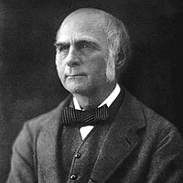

He introduced the Cohen’s kappa, developed to account for the possibility that raters actually guess on at least some variables due to uncertainty.

## Definition

Cohen's kappa measures the agreement between two raters who each classify N items into C mutually exclusive categories.

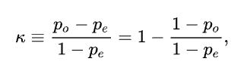

P0 is the relative observed agreement(Actual) among raters.

Pe is a chance agreement(Expected) among raters.

If the raters are in complete agreement then k=1.

If there is no agreement among the raters then k=0.

It is possible for the statistic to be negative, which implies that there is no effective agreement between the two raters or the agreement is worse than random.

### Steps

* Collecting all the tweets from Railway official Accounts
* Ex. we collect 9 Tweets.
* @RailMinIndia PNR 8535486976 dirty and used blanket and used bedroll given no one is responding very bad
* @sureshpprabhu @RailMinIndia Dear Sir I am travelling in 19046 train &amp; there is no water in toilets. The condition of the train is worst
* There are two parts to this:
  + Calculate observed agreement (Actual)
  + Calculate agreement by chance (Expected)

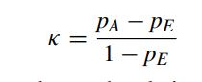

* Let’s say we’re dealing with “yes” and “no” answers and 2 raters. Here are the ratings:
  + Tagger1 = ['yes', 'no', 'yes', 'yes', 'yes', 'yes', 'no', 'yes', 'yes']
  + Tagger2 = ['yes', 'no', 'no', 'yes', 'yes', 'yes', 'yes', 'yes', 'yes']
* Turning these ratings into a confusion matrix:

Tagger 2 YES Tagger 2 NO

Tagger 1 YES 6 1

Tagger 2 NO 1 1

* Observed agreement = (6 + 1) / 10 = 0.7
* Chance agreement = probability of randomly saying yes (P_yes) + probability of randomly saying no (P_no)

P_yes = (6 + 1) / 10 * (6 + 1) / 10 = 0.49

P_no = (1 + 1) / 10 * (1 + 1) / 10 = 0.04

Chance agreement = 0.49 + 0.04 = 0.53

* Since the observed agreement is larger than chance agreement we’ll get a positive Kappa.

Kappa = 1 - (1 - 0.7) / (1 - 0.53) = 0.36

* Using sklearn's implementation

from sklearn.metrics import cohen_kappa_score

cohen_kappa_score(Tagger1, Tagger2)

which returns 0.35714.

## Interpretation of Kappa

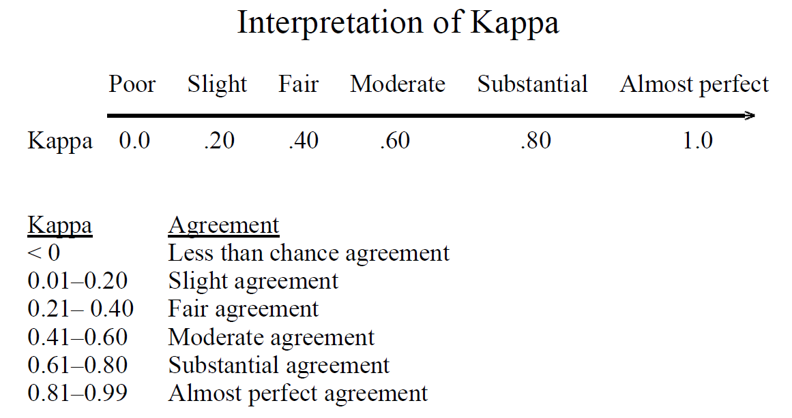

**Special Case**

Less than chance agreement

Tagger1 = ['no', 'no', 'no', 'no', 'no', 'yes', 'no', 'no', 'no', 'no']

Tagger2 = ['yes', 'no', 'no', 'yes', 'yes', 'no', 'yes', 'yes', 'yes', 'yes']

cohen_kappa_score(rater1, rater2)

= -0.2121

* If all the ratings are the same and opposite
* This case reliably produces a kappa of 0

Tagger1 = ['yes'] * 10

Tagger2 = ['no'] * 10

cohen_kappa_score(rater1, rater2)

0.0

## Random Rating

* For random ratings Kappa follows a normal distribution with a mean of about zero.
* As the number of ratings increases there’s less variability in the value of Kappa in the distribution.
* 10 random ratings for each rater (random sample of 1,000 inter-rater Kappa calculations) as shown in *Figure 1*.

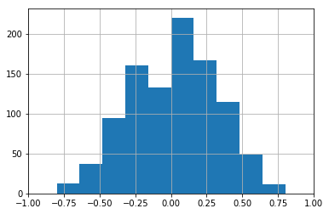

Figure 1

* 100 random ratings for each rater (random sample of 1,000 inter-rater Kappa calculations) as shown in *Figure 2*

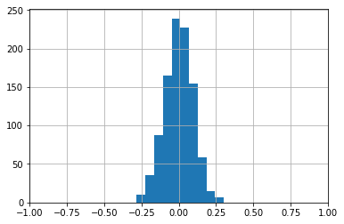

Figure 2

* 1000 random ratings for each rater (random sample of 1,000 inter-rater Kappa calculations) as shown in *Figure 3*

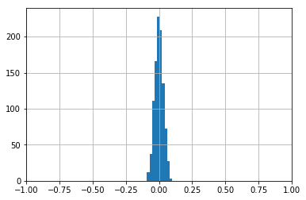

Figure 3

## Limitations of Cohen’s Kappa

* Cohen's Kappa only applied to 2 raters rating the exact same items.
* κ = 0 when the observed allocation is apparently random
* Kappa is an index that considers observed agreement with respect to a baseline agreement.
* Kappa's baseline agreement is the agreement that would be expected due to random allocation.

# Literature Review

## Paper: A Simplified Cohen’s Kappa for Use in Binary Classification Data Annotation Tasks

|  |  |  |  |
| --- | --- | --- | --- |
| Title | Authors | Published In | Year |
| A Simplified Cohen’S Kappa for Use in Binary Classification Data Annotation Tasks | Juan Wang, Yongyi Yang, Bin Xia | IEEE Access | 2019 |

### Introduction to Binary Classification

* Binary classification refers to those classification tasks that have two class labels.
* Examples: Email spam detection (spam or not).
* Typically, binary classification tasks involve one class that is the normal state and another class that is the abnormal state.
* For example “not spam” is the normal state and “spam” is the abnormal state. Another example is “cancer not detected” which is the normal state of a task that involves a medical test and “cancer detected” is the abnormal state.
* The class for the normal state is assigned the class label 0 and the class with the abnormal state is assigned the class label 1.

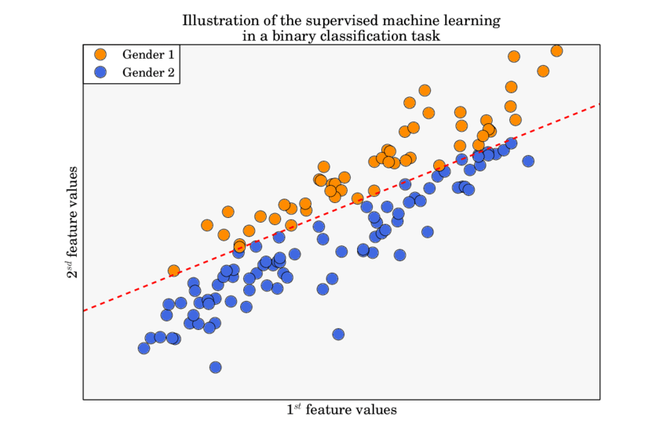

### Data Annotation

* Data annotation is simply the process of labelling information so that machines can use it.
* It is especially useful for supervised machine learning (ML), where the system relies on labelled datasets to process, understand, and learn from input patterns to arrive at desired outputs.
* it has been demonstrated that the quality of the data labels can have a number of effects on the resulting classifier, ranging from the classification performance, the complexity of the classifier model, to the number of required training samples
* Therefore, it is important to assess the quality of annotations prior to their use in supervised learning

### Cohen’s Kappa

* One such metric is Cohen’s kappa coefficient (or kappa in short), which has been accepted as the de facto standard for the measurement of inter-annotator agreement.
* Cohen's kappa coefficient (κ) is a statistic that is used to measure inter-rater reliability for qualitative (categorical) items.
* In binary classification tasks, Cohen’s kappa is often used as a quality measure for data
* annotations, which is inconsistent with its original purpose as an inter-annotator consistency / inter-rater reliability (two or more people agree on the same point) measure.
* Therefore, it is important to assess (judge or form the opinion about something) the quality of annotations prior to their use in supervised learning
* One such metric is Cohen’s kappa coefficient which has been accepted as the de facto standard for measurement of inter-annotator agreement
* Mathematically, Cohen’s kappa is defined as:



* where pA is the observed(actual) relative agreement between two annotators, and pE is the hypothetical (expected) probability
* Cohen’s kappa is also cited for its problems associated with bias and prevalence in the interpretation of kappa values. The bias problem is caused by the difference in the distribution of annotation categories of the two annotators, while the prevalence problem arises when the underlying distribution of class categories is skewed.
* For example, based on the 2×2 confusion matrix, Feuerman and Miller obtained the following relationship:

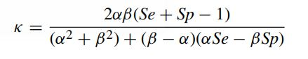

* for Se not equal Sp, where Se is sensitivity, Sp is specificity, α is the proportion of examples in the positive class, and β = 1 − α
* The analytic relationship between kappa and commonly used classification metrics (e.g., sensitivity and specificity) is non-linear, and thus is difficult to be applied for interpretation of the classification performance of the annotations
* In the previous study, based on an annotation generation model, we derived a linear relationship.
* κ = Se + Sp − 1 derivation to the more general case of biased annotations
* In this study we extend this derivation to the more general case of biased annotations. We derive a simplified, linear relationship of kappa, sensitivity, and specificity by employing the 1st-order Taylor approximation. This relationship is further simplified by relating to Youden’s J statistic, a metric used for classification performance
* The results demonstrate the effectiveness of the developed relationship when no severe bias and prevalence issues exist. In addition, the relationship between kappa and Youden’s J is also validated on a real-life dataset collected from diabetic retinopathy (DR) screening study, wherein the discrepancy between kappa and Youden’s J is applied for annotator assessment
* We provide an analysis on the linear coefficients in the simplified relationship and the approximation error, and conduct a linear regression analysis to assess the relationship by using a synthetic dataset where the ground truth is known
* The results demonstrate the effectiveness of the developed relationship when no severe bias and prevalence issues exist.

In addition, the relationship between kappa and Youden’s J is also validated on a real-life dataset collected from a diabetic retinopathy (DR) screening study.

* The discrepancy between kappa and Youden’s J is demonstrated to be an effective measure for annotator assessment when no ground truth is available.
* Ground truth is a term used in various fields to refer to information that is known to be real or true, provided by direct observation and measurement as opposed to information provided by inference.

### Methods

1. Annotation Generation Model

2. Cohen’s Kappa coefficient

3. Sensitivity and Specificity

4. Kappa Approximation

#### 1) Annotation Generation Model

* Let LXi be the annotation of an instance provided by the ith annotator (i ∈ {1, 2}) and c ∈ {0, 1} be the category of the labels, in which c = 1 denotes positive class and c = 0 is negative class. The annotation process above suggests an annotation generation model with latent variable l for the easy and hard types, i.e., l = E (easy) and l = H (hard).
* (Hint : Xi is annotator , c=1 denotes positive class , c=2 denotes negative class, E= easy , H=hard
* latent variable – a variable that cannot be observed because it is hidden and no measurement error associated with it. )
* It is described by conditions as follows:
  + P(X1 = c|l = E) = P(X2 = c|l = E) (2)
  + P(X1 = X2|l = E) = 1 (3)
  + P(X1, X2|l = H) = P(X1|l = H)P(X2|l = H) (4)
* Equations (2) and (3) represents that the two annotators perfectly agree on the easy instances. Equation (4) denotes that the two annotators independently provide labels for the hard Instances.
* The annotation generation model yields κ = 1 for easy instances and κ = 0 for hard instances [26]. When the population consists of both easy and hard instances, 0 < κ < 1. These results together indicate that 0 ≤ κ ≤ 1 when the annotation generation model is considered

#### Cohen’s Kappa coefficient

* To investigate the relationship between kappa and classification metrics, one annotator has to be ground-truth annotator.
* Cohen’s kappa can be expressed as:

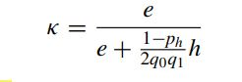

#### Sensitivity and Specificity

* Se + Sp = 1 + e
* This relationship indicates that the summation of sensitivity and specificity is determined by the proportion of easy instances in the dataset.
* Youden’s J statistic is a performance summary for binary classification task. It is defined as J , Se+Sp−1. Equation suggests the following relationship between eand Youden’s J:
  + J = e
* It indicates that Youden’s J measures the proportion of the easy instances.

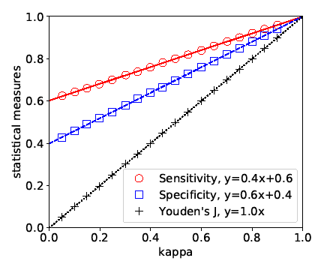

#### Kappa Approximation

* To deal with this issue, we consider kappa approximation in this section. To ensure low approximation error, we derive kappa approximation with respect to e and h, respectively.
  + I.KAPPA APPROXIMATION WITH RESPECT TO E,For e > 0, equation
  + KAPPA APPROXIMATION WITH RESPECT TO H, H is used to eliminate the issue of potential great error when e is large
  + FINAL KAPPA APPROXIMATION, kappa approximation with respect to e and h yield errors:

### Conclusion

In binary classification tasks, Cohen’s kappa is often used as a quality measure for data annotations, which is inconsistent with its original purpose as an inter-annotator consistency measure. In this study, based on an annotation generation model, we derive a simplified, linear relationship for Cohen’s kappa, sensitivity, and specificity by using the 1st-order Taylor approximation. This relationship is further simplified by relating to Youden’s J statistic, performance metric for binary classification tasks. The relationship between kappa and Youden’s J is validated on an annotation dataset from seven graders in a diabetic retinopathy screening study. The discrepancy between kappa and Youden’s J is demonstrated to be an effective measure for annotator assessment when no ground truth is available.

## Paper: SMART APPROACH TO RECOGNIZE PUBLIC GRIEVANCE FROM

## MICROBLOGS

|  |  |  |  |
| --- | --- | --- | --- |
| Title | Authors | Published In | Year |
| SMART APPROACH TO RECOGNIZE PUBLIC GRIEVANCE FROM  MICROBLOGS | Ms. Khushboo Shah  Dr. Hardik Joshi  Dr. Hiren Joshi | Gujarat University | 2021 |

* The foremost priority for the government of any country is to resolve the citizen's problems. Indian government provides various ICT (Information Communication Technology) based platforms such as website and mobile application for the Indian citizens to lodge their grievance against ministries and departments.
* Due to the easy access and transparency of social media, people prefer to raise their voices there. The dissatisfaction and anger that they express through microblogging is also a kind of complaint. This paper discusses the various categories of public grievance, their importance and its redressal mechanism in India.
* The main aim of this research is to take these social media complaints into consideration and solve them rapidly with the help of Artificial Intelligence where, it’s one branch Natural Language Processing, processes the text to retrieve the information from the piece of text and another branch Machine Learning helps to know the priority and severity of the grievance.
* The influence of social media has changed the way people express their views publicly. Here they have chance to exhibit their views and opinions to the world. Statistics shows how much does global social media growth rates increased year on year. In the year 2020, there are 3805 million active users on social media around the world that is an increase of 9.2% from 3484 million active users from the year 2019. Earlier in the year 2015, this number was 2078 million which was increased 11%, 21% and 9.0% in the year 2016,2017 and 2018 respectively

#### A Public Survey on the Popularity of CPGRAMS Vs. Social Media

* To know the popularity of CPGRAMS and Social Media to lodge the grievance, a survey form was designed with 10 questions, with the help of google forms and shared with the people through email and WhatsApp. Questions were designed in such a way to get the information about the popularity of CPGRAMS and Social Media among population which can help to understand the importance of microblogging grievances.
* Total 468 responses received from different age groups from both male and female genders.
* First four questions are about the name, surname, age and gender. Out of 468, 60.3% of male and 39.7% of female responded, which shows the active participation of male gender is high.
* The next question was about the awareness of CPGRAMS where only 23.9% people are aware about the CPGRAMS in India while 76.1% people said that they don’t know about the CPGRAMS which seems to be a major concern for the Government of India. Out of 23.9% CPGRAMS aware people, only 5.8% have registered with it

## Microblogging on Social Media – A New Way to Express Dissatisfaction

* The influence of social media has changed the way people express their views publicly. Here they have chance to exhibit their views and opinions to the world.
* Statistics shows how much does global social media growth rates increased year on year. In the year 2020, there are 3805 million active users on social media around the world that is an increase of 9.2% from 3484 million active users from the year 2019. Earlier in the year 2015, this number was 2078 million which was increased 11%, 21% and 9.0% in the year 2016,2017 and 2018 respectively.
* Microblogging is a small piece of content on social media which could be text, links, pictures and short videos. Microblogging tools provide a light-weight and easy way of communication with the world where user can broadcast and share information, knowledge, viewpoint, status and activities.
* Microblogging is an example of individual’s freedom which changes with the evolution of state of art technologies. This microblogging service has a large and rapidly growing micro-bloggers base where they post status messages for updating what is on their mind.
* Not only this, also they express their opinion towards services, events, products, people and a government as well, irrespective of the nature of the opinion.

## Research Paper: A random forest classifier for lymph diseases

* The performance of classifier, and hence the quality of selected features, will be evaluated also by means of Cohen’s kappa coefficient or kappa statistic (KS) to measure the agreement between predicted and observed values of a dataset while correcting the agreement that occurs by chance
* The cost of error must also be taken into account, while making such assessments

## Research Paper: A Simplified Cohen’s Kappa for Use in Binary Classification Data Annotation Tasks

* Cohen’s kappa is also cited for its problems associated with bias and prevalence in the interpretation of kappa values
* The bias problem is caused by the difference in the distribution of annotation categories of the two annotators, while the prevalence problem arises when the underlying distribution of class categories is skewed

Wang, Juan, Yongyi Yang, and Bin Xia. "A Simplified Cohen’s Kappa for Use in Binary Classification Data Annotation Tasks." IEEE Access 7 (2019): 164386-164397.

## Research Paper: Facing Imbalanced Data - Recommendations for the Use of Performance Metrics

* Cohen’s kappa is a coefficient developed to measure agreement among observers.
* It shows the observed agreement normalized to the agreement by chance
* Krippendorff’s α-reliability measures the observed disagreement normalized to the observed disagreement

Jeni, László A., Jeffrey F. Cohn, and Fernando De La Torre. "Facing imbalanced data--recommendations for the use of performance metrics." 2013 Humaine association conference on affective computing and intelligent interaction. IEEE, 2013.

# Proposed Approach

## Language Used

### Python:

Python is a programming language that lets you work more quickly and integrate your systems more effectively.

Advantages/Benefits of Python:

The diverse application of the Python language is a result of the combination of features that give this language an edge over others. Some of the benefits of programming in Python include:

* Presence of Third Party Modules
  + The Python Package Index (PyPI) contains numerous third-party modules that make Python capable of interacting with most of the other languages and platforms.
* Extensive Support Libraries
  + Python provides a large standard library which includes areas like internet protocols, string operations, web services tools and operating system interfaces. Many high use programming tasks have already been scripted into the standard library which reduces length of code to be written significantly
* Open Source and Community Development
  + Python language is developed under an OSI-approved open source license, which makes it free to use and distribute, including for commercial purposes. Further, its development is driven by the community which collaborates for its code through hosting conferences and mailing lists, and provides for its numerous modules.
* Learning Ease and Support Available
  + Python offers excellent readability and uncluttered simple-to-learn syntax which helps beginners to utilize this programming language. The code style guidelines, PEP 8, provide a set of rules to facilitate the formatting of code. Additionally, the wide base of users and active developers has resulted in a rich internet resource bank to encourage development and the continued adoption of the language.
* User-friendly Data Structures
  + Python has built-in list and dictionary data structures which can be used to construct fast runtime data structures. Further, Python also provides the option of dynamic high-level data typing which reduces the length of support code that is needed.
* Productivity and Speed
  + Python has clean object-oriented design, provides enhanced process control capabilities, and possesses strong integration and text processing capabilities and its own unit testing framework, all of which contribute to the increase in its speed and productivity. Python is considered a viable option for building complex multi-protocol network applications. As can be seen from the above-mentioned points, Python offers a number of advantages for software development. As upgrading of the language continues, its loyalist base could grow as well.

### Applications for Python

Python is used in many application domains.

Web and Internet Development:

* Python offers many choices for web development:
* Frameworks such as Django and Pyramid.
* Micro-frameworks such as Flask and Bottle.
* Advanced content management systems such as Plone and django CMS.

Python's standard library supports many Internet protocols:

* HTML and XML
* JSON
* E-mail processing.
* Support for FTP, IMAP, and other Internet protocols.
* Easy-to-use socket interface.

And the Package Index has yet more libraries:

Requests, a powerful HTTP client library.

Beautiful Soup, an HTML parser that can handle all sorts of oddball HTML.

* Feedparser for parsing RSS/Atom feeds.
* Paramiko, implementing the SSH2 protocol.
* Twisted Python, a framework for asynchronous network programming

Scientific and Numeric:

* Python is widely used in scientific and numeric computing:
* SciPy is a collection of packages for mathematics, science, and engineering.
* Pandas is a data analysis and modeling library.
* IPython is a powerful interactive shell that features easy editing and recording of a work session, and supports visualizations and parallel computing.
* The Software Carpentry Course teaches basic skills for scientific computing, running bootcamps and providing open-access teaching materials.

Education:

* Python is a superb language for teaching programming, both at the introductory level and in more advanced courses.
* Books such as How to Think Like a Computer Scientist, Python Programming: An Introduction to Computer Science, and Practical Programming.
* The Education Special Interest Group is a good place to discuss teaching issues.

Desktop GUIs:

* The Tk GUI library is included with most binary distributions of Python.
* Some toolkits that are usable on several platforms are available separately:
* wxWidgets
* Kivy, for writing multitouch applications.
* Qt via pyqt or pyside
* Platform-specific toolkits are also available:
* GTK+
* Microsoft Foundation Classes through the win32 extensions

Software Development:

* Python is often used as a support language for software developers, for build control and management, testing, and in many other ways.
* SCons for build control
* Buildbot and Apache Gump for automated continuous compilation and testing.
* Roundup or Trac for bug tracking and project management.

Business Applications:

* Python is also used to build ERP and e-commerce systems:
* Odoo is an all-in-one management software that offers a range of business applications that form a complete suite of enterprise management applications.
* Tryton is a three-tier high-level general purpose application platform.

## API Used(Libraries)

### Pandas:

* pandas is a fast, powerful, flexible, and easy-to-use open-source data analysis and manipulation tool, built on top of the Python programming language.
* pandas is a software library written for the Python programming language for data manipulation and analysis.
* In particular, it offers data structures and operations for manipulating numerical tables and time series.

## Features

Handling of data

* The Pandas library provides a really fast and efficient way to manage and explore data. It does that by providing us with Series and DataFrames, which help us not only to represent data efficiently but also manipulate it in various ways. These features of Pandas is exactly what makes it such an attractive library for data scientists.

Alignment and indexing

* Having data is useless if you don’t know where it belongs and what it tells us about. Therefore, labeling of data is of utmost importance. Another important factor is an organization, without which data would be impossible to read. These two needs: Organization and labeling of data are perfectly taken care of by the intelligent methods of alignment and indexing, which can be found within Pandas.

Handling missing data

* As discussed above, data can be quite confusing to read. But that is not even one of the major problems. Data is very crude in nature and one of the many problems associated with data is the occurrence of missing data or value. Therefore, it is pertinent to handle the missing values properly so that they do not adulterate our study results. Some Pandas features have you covered on this end because handling missing values is integrated within the library.

Cleaning up data

* Like we just said, Data can be very crude. Therefore it is really messy, so much so that performing any analysis over such data would lead to severely wrong results. Thus it is of extreme importance that we clean our data up, and this Pandas feature is easily provided. They help a lot to not only make the code clean but also tidies up the data so that even the normal eye can decipher parts of the data. The cleaner the data, the better the result.

Input and output tools

* Pandas provide a wide array of built-in tools for the purpose of reading and writing data. While analyzing you will obviously need to read and write data into data structures, web service, databases, etc. This has been made extremely simple with the help of Pandas’ inbuilt tools. In other languages, it would probably take a lot of code to generate the same results, which would only slow down the process of analyzing.

Multiple file formats supported

* Data these days can be found in so many different file formats, that it becomes crucial that libraries used for data analysis can read various file formats. Pandas aces this sector with a huge scope of file formats supported. Whether it is a JSON or CSV, Pandas can support it all, including Excel and HDF5. This can be considered as one of the most appealing Python Pandas features.

Merging and joining of datasets

* While analyzing data we constantly need to merge and join multiple datasets to create a final dataset to be able to properly analyze it. This is important because if the datasets aren’t merged or joined properly, then it is going to affect the results adversely and we do not want that. Pandas can help to merge various datasets, with extreme efficiency so that we don’t face any problems while analyzing the data.

A lot of time series

* These Pandas features won’t make sense to beginners right away, but they will be of great use in the future. These features include the likes of moving window statistics and frequency conversion. So, as we go deeper into learning Pandas we will see how essential and useful these features are, for a data scientist.

Optimized performance

* Pandas is said to have a really optimized performance, which makes it really fast and suitable for data science. The critical code for Pandas is written in C or Cython, which makes it extremely responsive and fast.

## metrics

* The original idea of metrics was a platform that can be extended with many different metrics. At the time I will focus only on SLOC and McCabe complexity metrics. metrics is built in a way to support many, many languages. Currently, we test support for Python, C, C++, Go, and JavaScript.
* Sklearn metrics are import metrics in SciKit Learn API to evaluate your machine learning algorithms. Choices of metrics influences a lot of things in machine learning :

Machine learning algorithm selection

▪ Sklearn metrics reporting

## Pylab

* Pylab is basically just Numpy and Matplotlib under a unified namespace. Learn about either of those and you will understand Pylab.
* If you want to plot things in scripts it is generally preferred that you use import matplotlib.pyplot instead of import pylab, but really the choice is up to you.
* If you want to have interactive plotting (for instance, by calling ipython --pylab) then pylab is the way to go. However pyplot can also be put in an interactive mode using pyplot.ion().
* Matplotlib is a plotting library for the Python programming language and its numerical mathematics extension NumPy. It provides an object-oriented API for embedding plots into applications using general-purpose GUI toolkits like Tkinter, wxPython, Qt, or GTK. There is also a procedural "pylab" interface based on a state machine (like OpenGL), designed to closely resemble that of MATLAB, though its use is discouraged

## Matplotlib

* Matplotlib is a plotting library for the Python programming language and its numerical mathematics extension NumPy. It provides an object-oriented API for embedding plots into applications using general-purpose GUI toolkits like Tkinter, wxPython, Qt, or GTK.
* Matplotlib is a cross-platform, data visualization and graphical plotting library for Python and its numerical extension NumPy. As such, it offers a viable open source alternative to MATLAB. Developers can also use matplotlib's APIs (Application Programming Interfaces) to embed plots in GUI applications.

### Features

* Setting the aspect ratio of the axes box
* Colored labels in legends
* Ticks and labels
* rcParams can be passed as Decorators
* 3D plots now support minor ticks
* Specifying backend while saving the figure
* Infinite lines through two points

## Seaborn

* Seaborn is a Python data visualization library based on matplotlib. It provides a high-level interface for drawing attractive and informative statistical graphics.
* For a brief introduction to the ideas behind the library, you can read the introductory notes or the paper. Visit the installation page to see how you can download the package and get started with it. You can browse the example gallery to see some of the things that you can do with seaborn, and then check out the tutorial or API reference to find out how.
* To see the code or report a bug, please visit the GitHub repository. General support questions are most at home on StackOverflow or discourse, which have dedicated channels for seaborn.
* Matplotlib is a plotting library for the Python programming language and its numerical mathematics extension NumPy. It provides an object-oriented API for embedding plots into applications using general-purpose GUI toolkits like Tkinter, wxPython, Qt, or GTK. There is also a procedural "pylab" interface based on a state machine (like OpenGL), designed to closely resemble that of MATLAB, though its use is discouraged. SciPy makes use of Matplotlib.

## pycm

* PyCM is a multi-class confusion matrix library written in Python that supports both input data vectors and direct matrix, and a proper tool for post-classification model evaluation that supports most classes and overall statistics parameters. PyCM is the swiss-army knife of confusion matrices, targeted mainly at data scientists that need a broad array of metrics for predictive models and accurate evaluation of a large variety of classifiers.
* PyMC (formerly known as PyMC3) is a Python package for Bayesian statistical modeling and probabilistic machine learning which focuses on advanced Markov chain Monte Carlo and variational fitting algorithms.
* It is a rewrite from scratch of the previous version of the PyMC software.Unlike PyMC2, which had used Fortran extensions for performing computations, PyMC relies on Aesara, a Python library that allows to define, optimize, and efficiently evaluate mathematical expressions involving multi-dimensional arrays. From version 3.8 PyMC relies on ArviZ to handle plotting, diagnostics, and statistical checks. PyMC and Stan are the two most popular probabilistic programming tools. PyMC is an open source project, developed by the community and fiscally sponsored by NumFOCUS.

# Dataset Used

a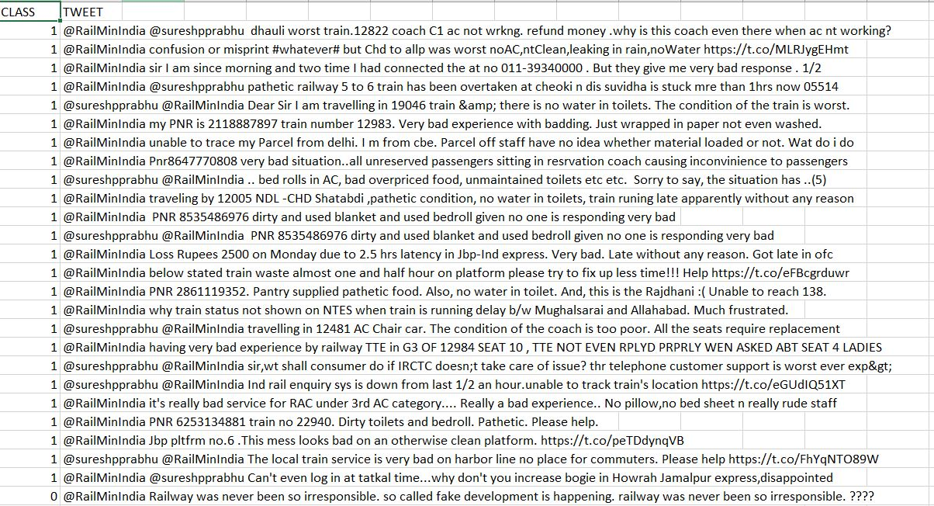

# Screenshots

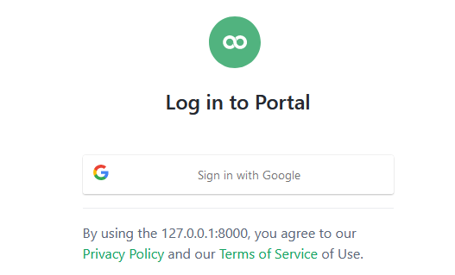

Login Page

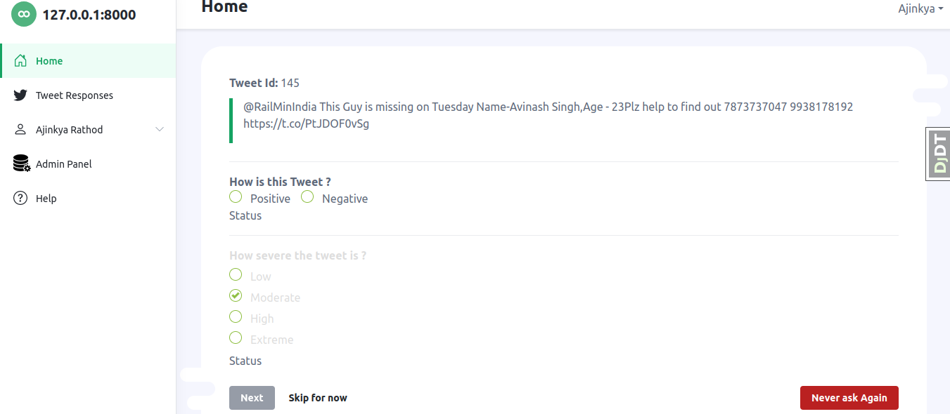

Home Page

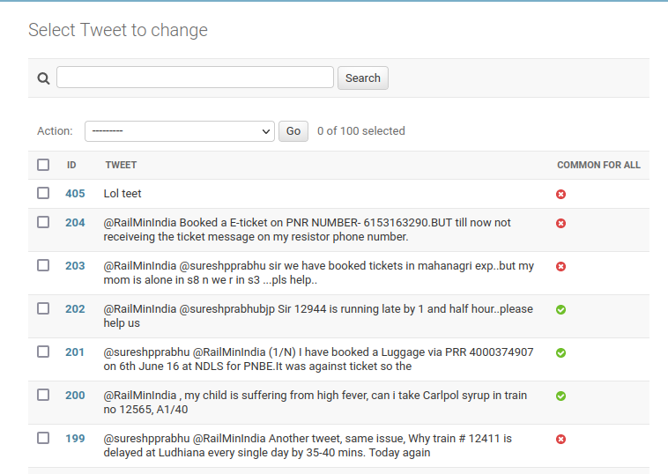

Tweets

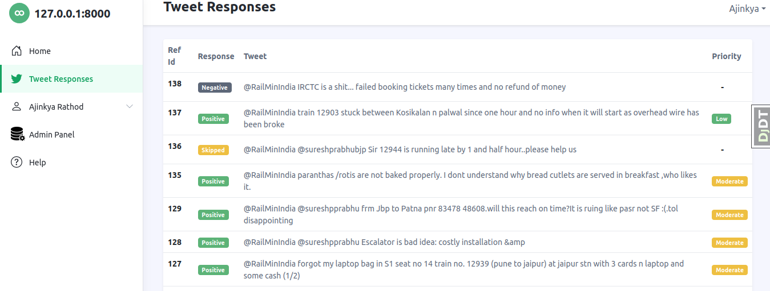

Responses

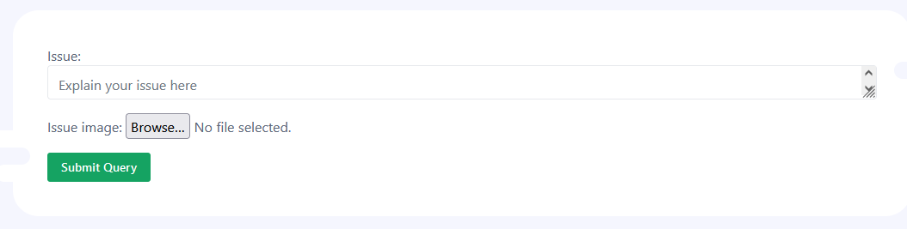

Help Page

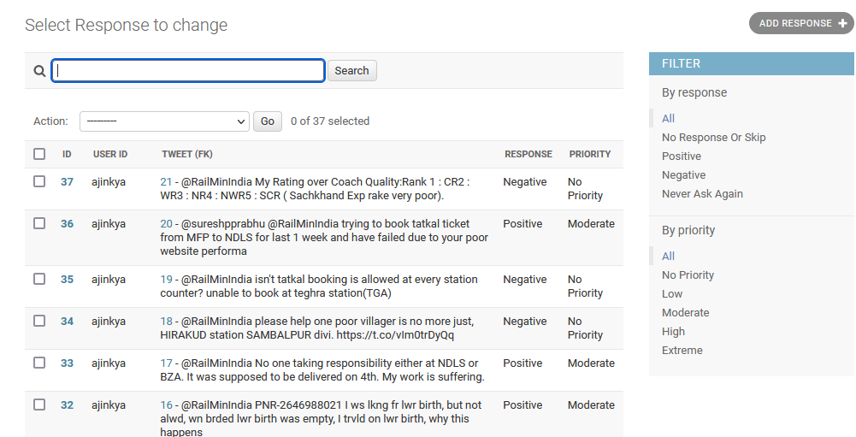

Responses

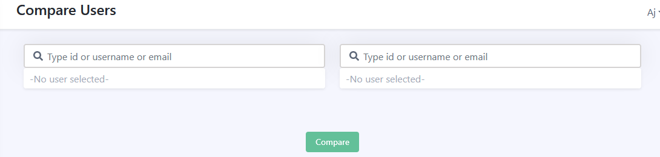

Compare Users

# Conclusion and Future Work

## Conclusion

* If used and interpreted appropriately, the kappa coefficient provides valuable information on the reliability of data obtained with diagnostic and other procedures used in musculoskeletal practice. We conclude with the following recommendations:
* Alongside the obtained value of kappa, report the bias and prevalence.
* Relate the magnitude of the kappa to the maximum attainable kappa for the contingency table concerned, as well as to 1; this provides an indication of the effect of imbalance in the marginal totals on the magnitude of kappa.
* Construct a confidence interval around the obtained value of kappa, to reflect sampling error.
* Test the significance of kappa against a value that represents a minimum acceptable level of agreement, rather than against zero, thereby testing whether its plausible values lie above an “acceptable” threshold.
* Use weighted kappa on scales that are ordinal in their original form, but avoid its use on interval/ratio scales collapsed into ordinal categories.
* Be cautious when comparing the magnitude of kappa across variables that have different prevalence or bias, or that are measured on different scales.

## What you have done?

o The purpose of this research was to identify effective strategies for dealing with inter-rater reliability identified in individuals with various aspects.

o Based on the analysis conveyed, it can be concluded that there are multiple agreements modification is important for the improvement of this these things.

## What can be done to improve?

o Future exploration into these modification techniques could be useful to finding further such techniques. The amount this could improve the algorithm of others with repetitive checking behaviours is worth exploring.

# References

Towards Data Science, <https://towardsdatascience.com/inter-rater-agreement-kappas-69cd8b91ff75>, accessed on 1st Aug 2021

Towards WikiWand, <https://www.wikiwand.com/en/Cohen%27s_kappa#/History>, accessed on 21st Sep 2021

Towards Machine Learning Mastery <https://machinelearningmastery.com/types-of-classification-in-machine-learning/>, accessed on 4th Oct 2021

Towards Science Direct https://www.sciencedirect.com/science/article/pii/S016740481730250X

Towards Small Business, https://smallbusiness.chron.com/crowdsource-twitter-34435.html

Towards Github, https://github.com/amirziai/learning/blob/master/statistics/Inter-rater%20agreement%20kappas.ipynb

Towards Gujarat University, https://hrdc.gujaratuniversity.ac.in/Uploads/EJournalDetail/30/1046/6.pdf