1. **Run on RIS V with -o1 option**

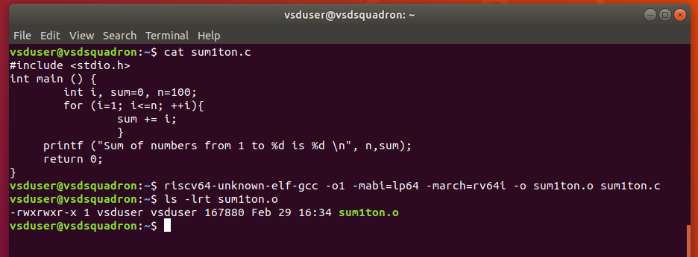

# In a new tab, get the assembly address

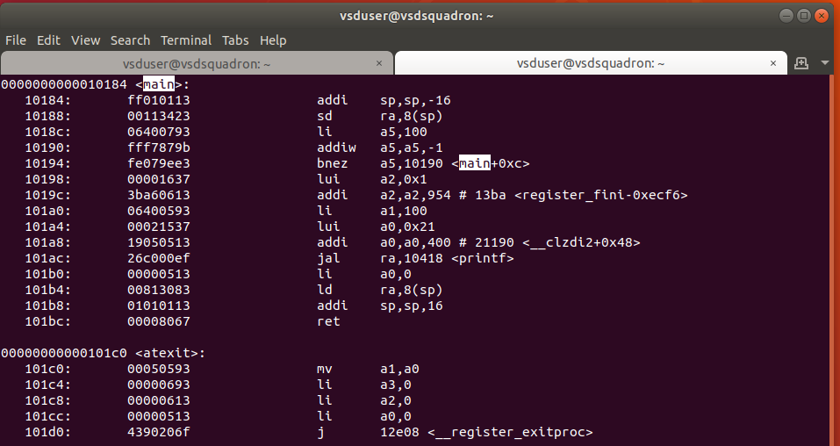

# Number of instructions is (101c0- 10184) / 4 , there are 15 instructions

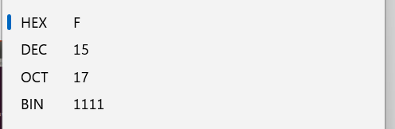

-----------------------------------------------------------------------------------------------------------------------------------

1. **Run on RIS V with -ofast option**

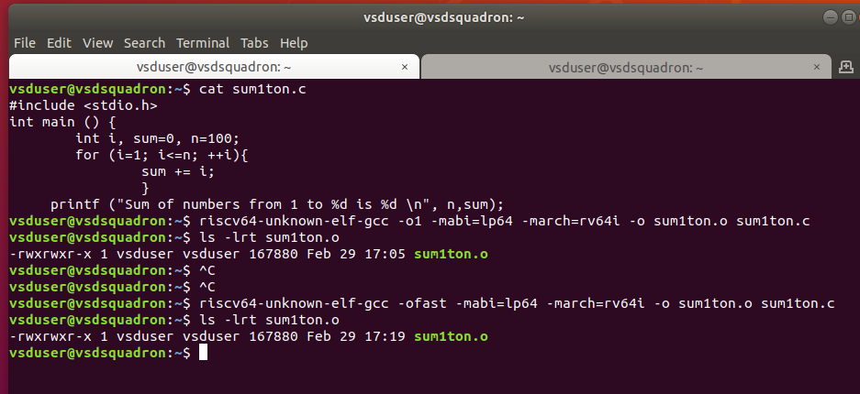

# New tab and get assembly code

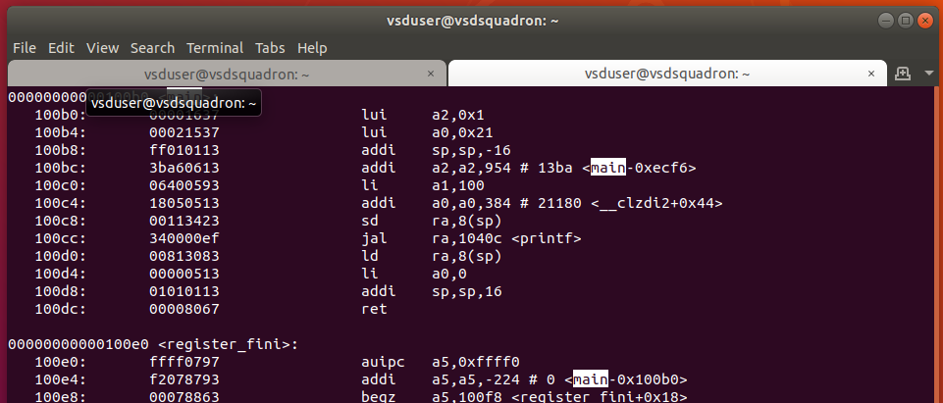

# Number of instructions is (101e0- 100b0) / 4 , there are 12 instructions

-------------------------------------------------------------------------------------------------------------------------------------