MilesTag™

CORE
Operation Manual

Firmware Version 5.6X

(RevH & RevJ Main Boards)

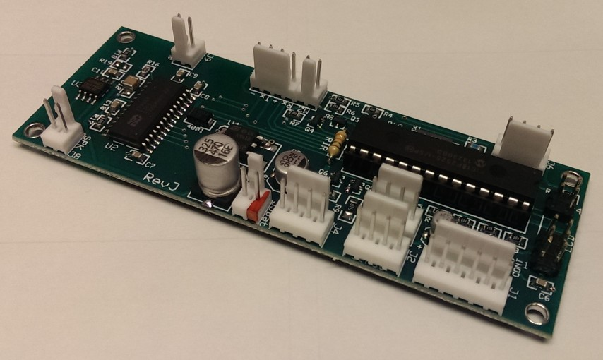

DRAFT

NOTICE: This document and the systems described herein are protected by international copyright laws. It may not be reproduced in full or in part, for any purpose public or private, without the express written consent of the author. All features, specifications and information detailed in this publication are subject to change without notice. Use of the information and the systems described is entirely at your own risk. The author assumes no liability for injury to persons or damage to property and equipment resulting from the use and or misuse of the information, procedures, circuits and systems described. The author also assumes no liability for typographical errors or omissions.

18 April 2015
WARNING ABOUT LITHIUM BATTERIES
- Lithium Polymer and Li-ion batteries are volatile. Failure to read and follow the instructions below and/or improper charging/use may result in fire, personal injury and damage to property.
- By installing Lithium Polymer or Li-ion batteries, the user assumes ALL RISKS associated with lithium batteries. If you do not agree with this condition, please use NiMh or NiCad batteries.
- Li-Ion and Polymer batteries & packs may explode and/or cause a fire if they are misused or defective. We expect all Li-ion battery users to be knowledgeable of the related risks and how to mitigate them.
- Follow the manufacturer’s instructions to control charging and discharging current.
- When charging, place battery in a fire proof container. Do NOT leave battery pack and charger unattended during charging. Avoid charging on wood, carpet or other flammable surfaces.
- Keep Li-Ion & Polymer battery packs away from children.
- If you build your own battery pack by our battery module, please make sure to charge each module separately using a smart charger recommended by the manufacturer. The purpose is to keep each battery pack balanced during charging. The PCB inside will protect this module only.
- Observe connection polarity carefully when charging and discharging battery packs. Always double check the polarity of the battery's connector to make sure red wire to red wire and black wire to black wire.
- Lithium batteries have a cycle life. Please replace old battery packs with a new one when it reaches its service life or when it is two year old, whichever comes first.

DISCLAIMER OF WARRANTIES & LIMITATION OF LIABILITY
Combat TAG, LLC makes no warranty, either express or implied with respect to any product or service, and specifically disclaims all other warranties, including, without limitation, warranties for merchantability, non-infringement and fitness for any particular purpose. Combat TAG, LLC's sole obligation and liability for product defects shall be, at Combat TAG, LLC's option, to replace such defective product or refund to buyer the amount paid by the buyer therefore. In no event shall Combat TAG, LLC's liability exceed the buyer's purchase price. The foregoing remedy shall be subject to the buyer's written notification of defect and return of the defective product within ninety (30) days of purchase (date of invoice). The foregoing remedy does not apply to products that have been subjected to misuse (including without limitation static discharge), neglect, accident or modification, or to products that have been soldered or altered during assembly, or are otherwise not capable of being tested, or if damage occurs as a result of the failure of buyer to follow specific instructions. In no event shall Combat TAG, LLC be liable to the buyer or to any third party for any indirect, incidental, special, consequential, punitive or exemplary damages (including without limitation lost profits, lost savings, or loss of business opportunity) arising out of or relating to any product or service provided or to be provided by Combat TAG, LLC, or the use or inability to use the same, even if Combat TAG, LLC has been advised of the possibility of such damages.

“Laser Tag Parts” and “MilesTag™” are alternate business names of Combat TAG, LLC.

www.lasertagparts.com
www.CombatTAG.com

NOTICE: Microcontroller firmware and sound effects (wav files) are available for download from www.LaserTagParts.com/mtcore.htm. If you want to re-flash firmware to the microcontroller yourself, you will need a “PIC programmer” that supports the Microchip PIC18F series. Firmware updates may be released to address bug-fixes and feature updates.

We do not provide information or assistance on PIC programming. There are numerous websites, manufacturers and support forums dedicated to this. Please refer to the manufacturer of your programmer for assistance.

Pre-programmed microcontrollers, printed circuit boards and other parts are available from http://shop.LaserTagParts.com.

OVERVIEW OF SYSTEM FEATURES

- 50 Players
- 4 Teams
- Built-in editor for all Weapon, Game and System settings
- Body Armor simulation with armor hit sound and pickups
- Armor minimum damage threshold
- “Short Range Kill” feature increases damage at close range
- Updated Zombie Mode including new Sound Effects
- Zombie Health and Damage values are adjustable
- Re-designed Weapon Pickups (Game Box V4)
- “Quick Save” feature for faster editing
- Fast Score Download via Infrared Link
- Selectable LiPo, NiMH or Alkaline battery chemistry
- Game Box V4 programmer mode (Set boxes via IR command)
- Team Specific Respawns
- Stun & Stasis hits with variable Delay
- Enable/Disable sensor flashing for Respawn and Flag Carry
- Support for Medic, Ammo, Armor “pick-ups”
  - Players can “pick up” additional Health, Clips, Armor on the field
- Automatic Respawn – Adjustable Time Delay
- Automatic Timed Games – Game Over after time limit expires
- Electronic “Flags” – Sensor LEDs flash to indicate “carry”; drop flags when killed
- ”Zombie” game mode – dead players come back…. as zombies!
- IR Cloning feature allows you to copy all settings to multiple taggers
- Intelligent LCD backlight control, auto-off
- Anti-cheating features
- Battery monitor w/ low battery warning (Alkaline, NiMH or LiPo selectable)
- Built-in Referee Gun functions (any tagger can be configured as the Ref Gun)
- Built-in ISD recorder function for uploading custom sound effects

Built-in Referee Gun Mode:
- New Game, Admin Kill, Respawn, etc
- Test Sensors
- Program Game Boxes (Game Box V4 modules)
- Program Domination Module (6 Game Types)
- Assign Teams

Add-on Devices Supported:
- Flag Station - up to 16 unique flags
- Medic Box – up to 16 medic boxes (pick-ups)
- Ammo Box – up to 16 ammo boxes (pick-ups)
- Armor Box – up to 16 shield boxes (pick-ups)
- Respawn Station
- Team Respawn Station
- First Aid Kit (Medic)
- Ammo Can (Armorer)
- Grenade (Instant Kill, Variable Damage)
- Claymore (Instant Kill or Variable Damage)
- Stun Grenade (Variable stun time)
- Stasis Grenade (Variable stasis time)
- Bomb / Trip Mine (Instant Kill)
- Radiation Emitter (Area Denial; Variable Damage)
POWER ON
Turn the key switch ON. The system will power up, LEDs will flash. You will hear “Ready to Engage!”.

Hold this button while turning power on: | To access this menu:
MODE | Edit Weapon/Game/System, Cloning
MODE | Edit Player/Team/Battery | Hold 3 seconds
RELOAD | Referee Functions
MODE + RELOAD | Reset Parameters, Display Version
MODE + RELOAD + TRIGGER | Full Factory Initialize (Factory Reset)
MODE + RELOAD + TRIGGER | Sound Effects Editor* | Hold TRIGGER 8 seconds
(*Editing Sound Effects requires serial and audio connections to a PC running the Sound Editor software.)

PLAYER DISPLAYS (Use the MODE button to scroll through the displays)
Red  R040 100 | Team  Rounds / Health | Zombie  R001 200 | Team  Rounds / Health
Main Display |  | Zombie Mode (Team=Zombie or Human)
Press and Hold the MODE button to toggle the LCD Backlight on/off.
The LCD Backlight will turn off automatically while firing.
The LCD Backlight will turn off automatically after 30 seconds of inactivity.

Armr OFF  Mags 019 | Armor Remaining  Mags Remaining
Armor & Mags (Clips)

Batt: 10  T+005:34 | Battery Level  Elapsed Time (Mins:Secs)
Battery & Time

Resp UNL  Flag 000 | Respawns Remaining  Flags Captured
Respawns and Flags

*Viper*  Hit! 090 | Call sign of shooter  Hit indication / Health
While receiving a HIT
Call Sign of shooter is displayed for 5 seconds.

RELOADING
Press the Reload Button to initiate a reload. During the Reload Delay, you can’t fire but you can still receive hits. You can reload at any time if the current magazine (clip) is not full.
Ammo0270   | Total rounds remaining  Progress bar
During Reload

Ammo Calculations:
If you initiate a reload with a partial magazine, no rounds are lost. All remaining rounds in the partial mag are added to the Total Rounds remaining. After a reload, the number of Mags remaining is calculated by:
Mags = (Total_Rounds / Rounds_per_Mag) – 1

Notice that one Mag is subtracted from the total. This is the “currently loaded” Mag.

WEAPON PICKUPS (Game Box V4)
When a player “picks up” an alternate weapon, the top line of their Main Display will show the name of the new weapon (SNIPER, SHOTGUN, MINIGUN, AK47, BLASTER, etc). This alternate weapon will remain active until the end of the current game, or until another weapon is picked up.
SNIPER  R040 100 | Alternate Weapon Name
Alternate Weapon is Active
The alternate weapon is “dropped” when a New Game command is received.
The alternate weapon is “dropped” during automatic or manual Respawn (unless System / Weap RoR = OFF).
See the Game Box V4 documentation for more information on Weapon Pickups.

SET PLAYER AND TEAM (Hold the BLACK button LONG PRESS while powering tagger ON)
PlayerID | 0 to 49 | Each tagger must be set to a unique ID (Call Sign)
TeamID | Red/Blue/Yellow/Green | You can also use the Referee Mode (Assign Teams) to set the Team ID remotely.
Battery | NiMH, LiPo, 6xAA | The battery chemistry/voltage affects the operation of the Battery Meter and Low Battery warning. This setting allows for 6xAA (9V), NiMH (7.2V) or LiPo (7.4V) battery packs.
These settings are not affected by cloning.

EDITOR MODE (Hold the BLACK button while powering tagger ON)
Use the RED and BLACK buttons to navigate the sub-menus. Press the TRIGGER to enter a sub-menu. Use the RED and BLACK buttons to adjust parameter values. Press the TRIGGER to accept a setting. Press and HOLD the TRIGGER to “quick-save” the current settings and jump straight to “CLONE TAGGER”.

EDIT WEAPON
EDIT GAME
EDIT SYSTEM
CLONE TAGGER Press TRIGGER to “clone” (copy settings to) another tagger.

WEAPON SETTINGS
Sounds | Mil-Sim, Sci-Fi, Silencer | Changes the “firing” and “reload” sound effects
Mag Size | 1,5,10,15….250,UNL | Rounds per “magazine”
Mags | 2,4,6,8….200 | Number of “magazines” available (initial loadout)
Reload | 0 to 30 | Reload delay in Seconds
Selector | SemiAuto, FullAuto, Burst
Burst X | 1,2,3,4,5,6 | Maximum burst rounds per trigger pull
Rnds/Min | 250,300,350….700 | Cyclic Rate (Rate of fire) in Rounds Per Minute
MuzFlash | On, Off | Enables the simulated “Muzzle Flash” LED
IR Power | Outdoor, Indoor | Sets the overall Infrared Emitter (IRLED) intensity
Range | MIN/10/20/40/60/80/MAX | Adjusts the duty cycle of the IR carrier affecting range
Damage | 1 to 100 (16 values)
SRK Enable | On, Off | See section on SRK feature
SRK Range | MIN/10/20/40/60/80/MAX | See section on SRK feature
SRK Damage | 1 to 100 (16 values) | See section on SRK feature

GAME SETTINGS
FrndFire | On, Off | Friendly Fire. OFF=Hits from same team are ignored
Unl Ammo | Yes, No | Unlimited Ammo. YES=Unlimited Mags
HitDelay | 0 to 20 | Lockout delay after each hit in Seconds
Life | 1 to 999 | Initial Life value.
BodyArmr | On, Off | Enables the Body Armor function
Armr Max | 5,10,15….250
Armr Min | 1 to 100 | Minimum damage value to “penetrate” armor
Zom Mode | On, Off | Enable Zombie Game Mode
Zom Life | 1 to 999 | Initial Life value for Zombie team
Zom Damg | 1 to 100 (16 values) | Damage value for Zombie team
ZomSound | On, Off | Enable Zombie Sound Effects. Taggers will periodically emit a “Zombie Roar” sound. A second Zombie sound is played when a Human Player respawns as a Zombie.
#Respawn | 0 to 25, Unlimited | Number of Respawns available. This setting affects Automatic and Manual Respawns. (Limited to “1” if Zombie Mode is enabled)
AutoResp | Manual,5,10,15….180 | Automatic Respawn delay time in seconds. If this is set to Manual then players must use a Respawn Station (Respawn Game Box) to Respawn.
StartDly | 0,5,10….120 | Seconds
GameTime | 0 to 120 | Game Time limit in minutes. 0=No Time Limit
BleedOut | 0,5,10….120 | “Bleed Out” time in Seconds. After being tagged out, player can be “healed” by receiving health from a medic or a Medic Station (Game Box) before the delay expires.

SYSTEM SETTINGS
HitFlash | On, Off | Sensor LEDs flash once to indicate hit
FlgFlash | On, Off | Sensor LEDs flash slowly when carrying a “flag”
RspFlash | On, Off | Sensor LEDs flash rapidly during Auto Respawn.
ZomFlash | On, Off | Sensor LEDs flash slowly to identify Zombie players.
Medi Box | 0 to 100 | Medic Game Box – Sets the number of Life points received from any Medic Game Box.
Ammo Box | 0 to 30 | Ammo Game Box – Sets the number of Mags received from any Ammo Game Box.
Armr Box | 0 to 100 | Armor Game Box – Sets the number of Body Armor points received from any Armor Game Box.
Ammo RoR | Yes, No | Ammo Reset on Respawn. Full ammo loadout
Weap RoR | Yes, No | Weapon Reset on Respawn.
GBox RoR | Yes, No | Game Box Reset on Respawn.
GBoxStay | Yes, No | Game Box Stay
Flag End | Yes, No | Yes = Game Ends when flags are returned to Home Flag station.
NearMiss | On, Off | Enables the “Near Miss” sound effect. In some environments (such as fluorescent or electronically dimmed lighting) it may be necessary to turn near-miss OFF to prevent false indications.
Volume | 0 to 5 | 0 = Loudest
Kill LED | Off, 30 to 240 | Timeout for sensor LEDs after “killed”.  Off = no timeout (LEDs stay on until New Game)
RoR = “Reset on Respawn”

CLONING
Cloning refers to copying all of the settings from one tagger to another via infrared (no cables). Just point the barrel of the sending tagger at the sensor on the receiving tagger and pull the trigger. All of the Weapon, Game and System settings are instantly copied and saved on the receiving tagger.

Excluded Parameters: Cloning does not change the Player ID, Team ID or Battery Type. These must be set individually on each tagger. (The Team ID can also be set remotely from the Referee Gun using the “Assign Teams” function).

ZOMBIE MODE
Giant bugs may be ridiculous, but Zombies are awesome! Since the Zombie craze just won’t die, we not only kept our Zombie Mode, but we improved it. Part of that improvement was eliminating a few small bugs, and we added a few new features. We think we have given rise to a killer version of the Zombie Game Mode.

In Zombie Mode the team names are automatically changed to “Zombie” & ”Human”. There are only two teams allowed in Zombie Games. You are either a Human or you are a Zombie. That’s it.

Zombie players are limited to a single-shot weapon and no body armor. You can adjust the initial Life and Damage values for Zombies.

When a “Human” player is tagged out, he will automatically respawn as a Zombie Team player.

As a freshly-reanimated Zombie, he will of course receive the full Zombie Life and Zombie Damage values.

When a Zombie player is tagged out, he will NOT respawn. Tagged-out Zombies are dead, dead, dead.

SRK (Short-Range Kill):
SRK is a new experimental feature. It should be used in OUTDOOR mode ONLY.
When enabled, the SRK settings allow you to set a higher damage value for “short-range” targets, and the normal damage setting will still affect longer range targets. Some experimentation will be required to determine the actual range of each signal, and it will also depend on the conditions, lighting, sun, etc.
For every shot, there are TWO infrared packets transmitted. The first packet is sent at “indoor” IR level using the SRK Range value and SRK Damage setting (higher damage). The second packet is sent at “outdoor” IR level using the normal Damage setting (lower damage).
There is some possibility of targets in the “transition area” (the range limit of the lower power SRK signal) receiving a near-miss from the first packet and therefore missing the second packet entirely.

SCORING SYSTEM
To download scores, the Score Pod must be updated to V10 firmware or higher.

SOUND EFFECTS
You can replace any of the sound effects on the CORE mainboard by downloading the free Sound Editor software application. Just be aware that this can be a tricky process. You will also need to build or purchase special cables to provide audio and serial data connections between your PC and the CORE mainboard. Schematics for these cables are included below.

The CORE mainboard uses a Nuvoton ISD17XX MLS chip for sound effects storage and playback. Rather than storing the sound files on a memory card, they are recorded directly into the chip’s EEPROM memory. So the process of changing sounds actually consists of “erasing” the existing sounds and “re-recording” each of the new sounds into preset memory locations. Be forewarned -- sometimes it requires a little experimentation to get just the right volume settings on your PC; and sound effects that sound great on your PC speakers may sound very different (not as good) playing back from the CORE board. It usually takes some effort to find sound effects that work well. I would also strongly recommend using an audio editing program such as GoldWave to eliminate artifacts and to normalize the volume of each file.

To put the CORE mainboard into “sound recording” mode:
Hold ALL THREE buttons (Mode, Reload, Trigger) while turning power ON. Then continue holding the TRIGGER until the LCD shows "Sound FX Ready". If you decide NOT to change the sounds, simply turn the power OFF.

REFEREE FUNCTIONS (Hold the RED button while powering tagger ON)
ANY tagger can be used as a Referee Gun. You do not need to purchase a special referee device. This is also one of the reasons you should use keylock power switches on your taggers. You don’t want the players to reboot their taggers into Referee or Editor modes.
RESPAWN PLAYER
NEW GAME
END GAME
TEST SENSOR |  | Flash sensor LEDs and play “beep” sound.
FULL AMMO |  | Player ammo is restored to full initial loadout
RESET CLOCK |  | Resets Elapsed Game Time to “0”
GUN JAM
STASIS 6 SECOND * |  | Player can’t shoot or receive hits for 6 seconds
STUN 6 SECOND * |  | Player can’t shoot for 6 seconds
ADMIN KILL
DISARM PLAYER |  | Player ammo loadout is set to “0”
Assign Team IDs
Game Box Programmer

ASSIGN TEAMS
FrndFire | On, Off | Friendly Fire. OFF=Hits from same team are ignored
Unl Ammo | Yes, No | Unlimited Ammo. YES=Unlimited Mags

GAME BOX PROGRAMMER
Ammo | Box ID = 0 to 15 | Set each box to a unique ID
Medic | Box ID = 0 to 15 | Set each box to a unique ID
Shld | Box ID = 0 to 15 | Set each box to a unique ID
Flag | Flag ID = 0 to 15 | Set each box to a unique ID
Respawn |  | Respawn Station All Teams
TmResp A |  | Respawn Station Team A Only
TmResp B |  | Respawn Station Team B Only
TmResp C |  | Respawn Station Team C Only
TmResp D |  | Respawn Station Team D Only
Hazard | 0 to 15 damage points | Variable Damage, Auto transmit every 5 seconds
FullAmmo |  | Restore Player to full initial ammo loadout
Stun | 1 to 15 seconds | Variable Stun, Auto transmit every 5 seconds
Stasis | 1 to 15 seconds | Variable Stasis, Auto transmit every 5 seconds

BASIC OPERATIONS

Firing
Press the TRIGGER button to fire.

Reloading
Press the RELOAD button to simulate removing an empty (or partial) clip and replacing it with a full clip.

The Reload Delay parameter simulates the time required to perform a clip change. You can initiate a Reload at any time to ensure you have a full Clip. You will not be able to fire during the Reload Delay, but can still take hits from opponents. During reloading, the Total Ammo (rounds) remaining is displayed above the Reload progress bar on the LCD.

⬄ You can perform a Reload at any time. Reloading a partial clip will not result in any loss of ammo. The tagger automatically manages your ammo, so any partial clips are recombined into full clips.

⬄ If you are hit during a reload, the LCD will revert to the main firing display, but you must still wait until the reload cycle is complete before firing.

Full-Auto Switch (optional)
OFF = Semi-Auto or Burst (depending on setting of the Fire Select parameter)
ON = Full-Auto

Battery Status
When the battery monitor reaches “--” it should be recharged immediately to avoid permanent damage to the battery pack. The “Low Battery” sound effect will play also.

NOTE: The battery chemistry is selectable for 7.2V NiCad/NiMh or 7.4V LiPo rechargeable battery packs. You can also select 6xAA for a 9V battery pack made of 6 AA cells.

GAME OVER DISPLAYS
These screens are only accessible when you are “Tagged Out” (Dead), or after receiving an End Game command from Referee Gun. Use the RELOAD button to scroll through stats.

GAME OVER

Game Time T+ mins:secs shows how long player survived in the game.

Hits By Number of times player was “hit” by each opponent. Use the RELOAD button to scroll through Player IDs. Only players that landed hits will be displayed.

Last Hit Player that “hit you” last.

Last Kill Player that “tagged you out” last.

Tag Outs Number of times you were killed (tagged out). Usually this is 1 or 0 unless Respawns were allowed in the game.

Flags Total number of Flags captured during the game.

Rounds Fired Total number of Rounds fired during the game.

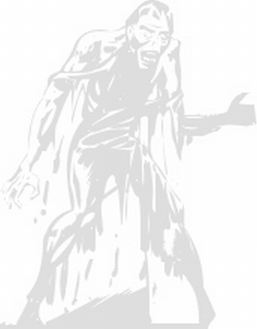
ZOMBIE MODE

Zombie Mode is designed to provide a very unique, fun and creepy game scenario.

First, if you have never seen one of the many zombie movies released over the past 60 years, go rent one and watch it (with the lights on, of course). Then come back here to continue reading…

Okay, now that you grasp the basic rules of human / zombie interaction, we can continue.

Here’s how the game works: The players are divided into two teams. One team will be the “Humans” and the other team will be the “Zombies”. The Zombies, as their nature dictates, try to eliminate the Humans. The Humans, in the interest of self-preservation, try to eliminate the Zombies. So far this sounds like a standard “Team Elimination” scenario, right? Well, not so fast, movie fans… Here comes the creepy twist: Whenever a Human player is tagged out, after a short delay, they will respawn (come back to life) as a……. ZOMBIE!! (it’s okay to scream)

On the MilesTag CORE system, the “transformation” from Human to Zombie is taken care of automatically. When Zombie Mode is enabled, Human players are preset to 1 auto-respawn, and their team setting is changed automatically from Human to Zombie.

As you have probably figured out, this will create a potentially ever-increasing problem for the Humans as the Zombies gain additional players from the ranks of “eliminated Humans”. If the Humans don’t keep up with eliminating that relentless horde of un-dead opponents, they may soon be outnumbered and overwhelmed.

Important note for Humans: One thing that the Humans will have on their side is that dead Zombies STAY dead. Dead Zombies do NOT come back to life. At least that’s the rule for MilesTag Zombies. Your movie may have been different, but in MilesTag…. They’re out!

What does a Zombie look like?
In the movies, the Zombies are pretty easy to spot. They stagger around, make weird noises, tend to be fairly unattractive and – if you are a Human – they are probably chasing you. For the purposes of Zombie Laser Tag, we will assume that Zombies didn’t have time for scary make-up or learning the “zombie walk”… so we’ll help the Humans a little by making the Zombies’ head sensors flash and their taggers will emit a “zombie sound” occasionally. This way you can see and hear them ‘coming for you’. Zombies aren’t traditionally good at hiding anyway.

What do Zombies eat?
Laser Tag Zombies aren’t hungry for brains. So they don’t have to catch you like the ones in the movies. Instead, Laser Tag Zombies are surprisingly well-armed and harder to kill than your average Human. Again, to help the Humans out a little, since we can’t make the Zoms move slower, we will settle for making them shoot slower. They will have to reload after every shot (bolt-action).

Dead Humans
If you are a human and you get tagged out, don’t worry. Just stay where you are and wait for the “transformation” (auto respawn) to happen. If you are a human and your teammate gets killed…. worry. There’s no question that he is coming back as a zombie and you need to get away… quickly.

“Standard Issue” Zombies
In MilesTag, the Zombies are limited to certain fixed settings. Whether a player starts as a zombie or respawns from human to zombie, these “fixed settings” are loaded automatically and cannot be changed.

Zombies do have their own adjustable Life parameter so you can make them harder or easier to kill than Humans. You can also decide how much damage the Zombie’s weapon can inflict. But… Zombies can only fire one shot at a time with a 1-second reload delay to simulate their limited aptitude for weapons.

Human Settings
The settings for Humans are not limited, but we do have some suggestions. Humans should be set to 100 life points to simulate “normal life”.

Team Assignments
Be careful when deciding how many players are initially assigned to each team. Keep in mind that the Zombie team gains in size as human players are eliminated. You should balance the team sizes against how well-armed the humans are.
Zombie Human
Health = ___ Health = 100
Clip Size = 1 Clip Size = ___
Clips = 200 Clips = ___
Damage = ___ Damage = ___
Reload Delay = 1 second Reload Delay = ___
Hit Delay = .25 second Hit Delay = .25 second
Fire Select = Semi Fire Select = ___
Respawns = 0 Respawns = 1
Resp Delay = NA Resp Delay = 30 seconds

BOLD items are “fixed” values for Zombies

Suggested Rules for Zombie Games

- When a Human is killed, they may not move until they are respawned as a Zombie.
- When a Zombie is killed, they must leave the field immediately.
ISD1700 Sound Programmer (Windows)

The sound programmer application allows you to record sound effects into the ISD1790 chip without removing it from the MilesTag CORE main board. The main board firmware (V5.40 and later) includes a programming mode that works with the PC application to install/erase/test sounds recorded to the ISD1790 chip. You can also install custom sound effects by renaming your custom .wav files and placing them in the same folder as the programmer application. Be sure to observe the maximum length allowed for each sound effect.

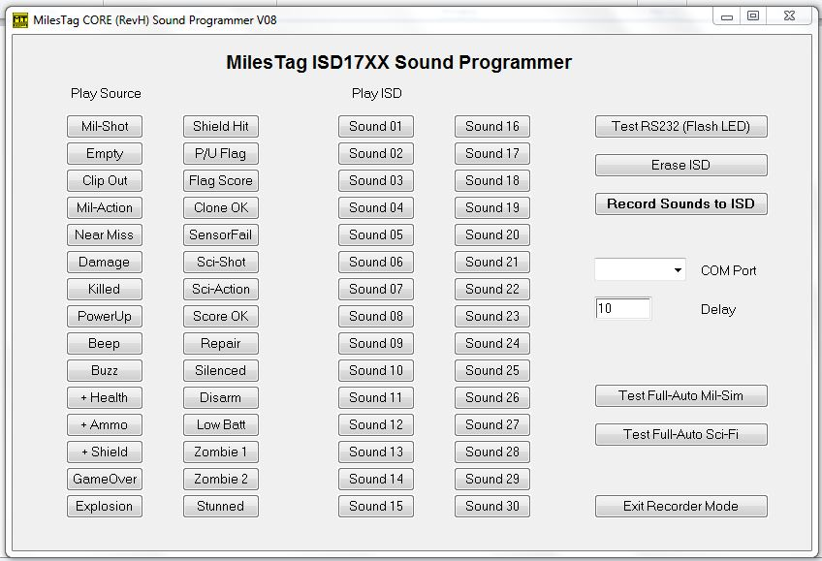

Sound Programmer Setup

- Connect PC audio line out or headphone out to the CORE main board Audio Input.
- Connect PC Serial Port to CORE Serial Port using adapter cable.
- Start MilesTag Core Sound Programmer application.
- Boot the CORE system into Sound Editor Mode
- LCD shows "Sound FX Ready"
- Set COM Port as required.
- To test COM Port and serial connection, click on "Test RS232" button.
- The sensor LEDs should flash briefly to indicate connection OK.

NOTE: All audio from the PC is routed to the CORE’s audio amplifier and speaker. This way you can test the audio quality of the recording and the source through the same speaker (A/B comparison).

Sound Programmer Operation

Delay - 1 to 100, adjusts for PC timing if sounds are cut off or starting late.

Play Source - Plays the PC sounds (source) through the CORE system speaker.

Play ISD - Plays the recorded sound from the CORE internal sound chip (ISD1790).

Erase ISD - Erase ALL sounds on the CORE internal sound chip.

Record Sounds to ISD - Record ALL sounds to CORE internal sound chip.

Test Full-Auto - Plays the firing sound (Mil or Sci-Fi) rapidly for testing purpose.

If the Full-Auto does not sound correct - edit the .wav file or adjust the DELAY.

Exit Recorder Mode - Press this when you are done recording BEFORE powering the main board OFF. If you do not do this, some sounds may be corrupted.

Custom Sounds
Remember to back up (or rename) the original wav files in the Sound Programmer folder before overwriting them with new sounds.

For best results, use an audio editor to convert your .wav files to mono and trim any silence from the beginning and end of the file.

MilesTag CORE Sound Effects
ORDER | SOUND | MAX LENGTH | ORDER | SOUND | MAX LENGTH
1 | Shot (Mil-Sim) | 1500mS | 16 | + Armor | 1000mS
2 | Empty Chamber | 1000mS | 17 | + Flag | 2000mS
3 | Start Reload (Clip Out) | 1000mS | 18 | Flag Score (siren) | 6000mS
4 | End Reload (Mil-Sim) | 1500mS | 19 | Clone Okay | 2000mS
5 | Near Miss | 1500mS | 20 | Sensor Fail | 1000mS
6 | Hit - Damage | 2000mS | 21 | Shot (Sci-Fi) | 1000mS
7 | Dead | 3000mS | 22 | End Reload (Sci-Fi) | 1000mS
8 | Power Up | 4000mS | 23 | Scores Okay | 1000mS
9 | Beep | 1000mS | 24 | Repair | 1000mS
10 | Buzz | 1000mS | 25 | Shot (Silenced) | 1000mS
11 | + Medic | 1000mS | 26 | Disarm Player | 1000mS
12 | + Ammo | 1000mS | 27 | Low Battery | 1500mS
13 | Armor Hit | 1500mS | 28 | Zombie 1 | 1500mS
14 | Game Over | 4000mS | 29 | Zombie 2 | 1000mS
15 | Explosion | 3000mS | 30 | Stunned | 1000mS

NOTE: Make sure your sound effects fit the maximum length. If sounds are longer than the allotted space, they will be cut short during recording.

ISD SOUND PROGRAMMER SERIAL CONNECTIONS

When you connect the RevH board to your PC serial port for the ISD Recorder Application, do NOT use an RS232/TTL adapter such as the one used for score download on the Ref Gun. During ISD record functions, the serial port is configured specially to allow constructing a simple adapter cable using one 20K resistor. In this way, you can permanently fit a serial connector on every gun without the more expensive level-conversion adapters.

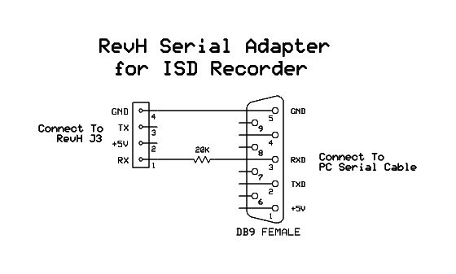
Audio Input Cable
Used for ISD Sound Recording. For best results, the audio cable should use resistors to “mix” the left and right channels into a mono signal for input to the CORE main board. Otherwise the left and right channels may interact and degrade the audio quality.

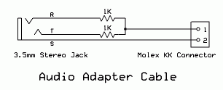

U.S. MILITARY PHONETIC ALPHABET

Alpha
Bravo
Charlie
Delta
Echo
Foxtrot
Golf
Hotel
India
Juliet
Kilo
Lima
Mike
November
Oscar
Papa
Quebec
Romeo
Sierra
Tango
Uniform
Victor
Whiskey
X-ray
Yankee
Zulu
GLOSSARY

Admin Administrator, Game Official, Referee

Clone Copy settings from one tagger to another using infrared link (wireless).

Cyclic The ‘cyclic’ or ‘cyclic rate’ is the rate at which a weapon can fire successive rounds
also referred to as ‘Rate of Fire’; specified in Rounds-per-Minute

Friendly Fire Hits received from players on your own team. With the MilesTag system you have the option to turn Friendly Fire on or off. When Friendly Fire is turned off, you will not be able to shoot your teammates.

Hit-Delay After a player is hit, this is a delay time during which the player cannot shoot or be hit by opponents, the player is effectively ‘locked out’ during the Hit Delay.

IR Infrared

ISD Abbreviation for the Nuvoton sound chip used on MilesTag systems (e.g. ISD1790)

LED Light Emitting Diode

Mil-Sim Military Simulation

Muzzle Flash Visible flash of light emitted from a gun barrel during firing; simulated by bright LEDs

Respawn To bring a player back to life (within the same game). Allow player to continue game.

Zombie Brain-eating reanimated corpse.
NOTES:

MilesTag IR Data Transmission Format

First Bit Transmitted (0=Shot, 1=Control)

1 | 2 | 3 | 4 | 5 | 6 | 7 | 8 | 9 | 10 | 11 | 12 | 13 | 14 | 15 | 16

Shot Packet

1 | 7 | 2 | 4 | 1
0 | PID | TID | Damage | Zone

PID = Player ID

TID = Team ID (4 teams)
0 = Alpha / Red (Zombie)
1 = Bravo / Blue (Human)
2 = Charlie / Yellow
3 = Delta / Green

Damage = 16 Values (each weapon can inflict different damage)

Zone =
0 = Zone A
1 = Zone B

Control Packet

1 | 7 | 8
1 | Control ID | Data | … additional bytes …

Referee Control Signals
Respawn Player
End Game
New Game
Test Sensors
etc

Game Devices
Medic Box
Flag Stations

Data Transfers
Cloning (Tagger Settings)
Weapon Pickup
Score Download

IR Modulation
Infrared LED: 940nm
LED current: 1500mA / 100mA
Carrier: 50, variable duty cycle
Data Encoding: Pulse-Length Modulation, 600uS time base

