Building a 3-Day Spending Tracker in Python: A Report on Program Design, Implementation, and Testing

Ajit Shrestha
International American University
AIM 401 Python Programming for Data Science
Professor Dhiraj Bashyal
September 26, 2026

Introduction
In this assignment, I created a small Python command-line program to help a user see the amount of money that they spend over a period of 3 days and ensure that they stick to a spending limit of $20 per day and $60 over 3 days. It was a very simple scenario, but it was a good chance for me to incorporate all the basic building blocks of python programming (variables, user input, loops, conditional logic) and to work in a very narrow range of boundaries that excluded some of the tools I normally use, like functions and lists.
In this report, I will discuss the logic for each section of the code, include the program with two different sets of input, and discuss how the boundaries of the problem affected the way I wrote the solution.
Program Design and Logic
The program is broken into three parts, matching the three tasks in the assignment.
The starting state of the program is set up in Task 1. I used input() to ask for the user's name, and made a variable total_spent that was equal to 0. This variable keeps a running total as the user enters amounts, which means that it must be initialized to 0 before the loop begins and it must be there at the beginning of the loop.
Task 2 is a for loop with range(1, 4) that will be repeated exactly three times, once for every day. In the loop, I asked the user how much they spent that day, and put the input() function inside of the float() function, so that the user's text is converted to a number that I can do arithmetic with. I then added the amount to total_spent, using the usual idiom of a loop: total_spent = total_spent + spent Immediately following this, an if/else statement is used to check the amount spent in one day: If amount spent is greater than 20, the program prints a warning that the user exceeded their daily spending limit; if the amount spent is less than or equal to 20, the program prints a brief message to confirm that the user did not exceed the spending limit. This check occurs within the loop and once a day, to give the user immediate feedback after each entry rather than waiting for the end.
After completing all 3 repetitions of the loop, task 3 will run. I print the total amount spent, I convert the total_spent to a string with the str(), then concatenate it to the rest of the string. A second if/else statement compares the value of total_spent to the limit of 60 which is the number of days the user is allotted for the three days.A second if/else is used to compare the value of total_spent to the value 60, which is the number of days the user is given for the 3 days.
I chose a for loop instead of while loop because the number of days is 3 and known beforehand – which is what a for loop with range() is designed for. There would be an additional counter variable in a while loop that would count how many days had passed, but it is not necessary here.
Under the Boundaries of the Assignment
Custom functions, classes, file I/O and lists or dictionaries of any data are not permitted in the assignment. A few habits I would normally revert to were different in these restrictions. If I didn't have the list, I would only be able to store the amount that I spent each day for the next day, and the running total_spent after the total has been accumulated. This is okay for this program since the requirements only specified that I need to know how much each day and how much that was overall, but not a list of each day's amount.
I wouldn't be able to split up the program into smaller functions such as get_daily_spending() or print_summary() without def. Rather, the entire program is coded as a single bottom-to-top script, and as you can see, this is fine for a few dozen lines, but clearly why functions exist as programs grow beyond a few dozen lines.
I did use range(1,4) to control the loop, which is allowed by 'basic loop constructs' as it's only being used to repeat the loop body a fixed number of times and is not stored or treated as a set of data.
Testing and Output
The entire program code when I wrote it and ran it inside the IDE is shown below.
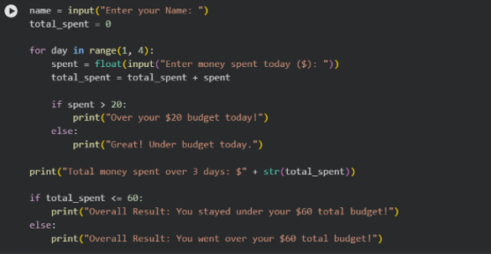
Figure 1: Complete program source code
I tried the program with two sets of input values to make sure that both arms of the if/else statements function properly.
For the first test, I used $12, $11 and $10 each day. The program said "Great! " for each of these, all of which were under $20 per day. After each entry, write "Under budget today. The total of the three days was $33.00, which is within the overall budget of $60, so the program properly printed the "Staying within budget" message.
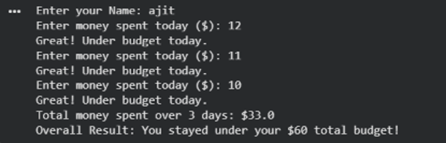
Figure 2: Program output when expenditures are within daily and total budget
During the second test run, I put in a lot bigger numbers: $234, $214 and $123. Each of these was over the $20/day budget, so the program printed the message "Over your $20 budget today!" three times. The total was $571.00, much more than the overall budget of $60, so the program printed the correct message stating that the user had exceeded his total budget.
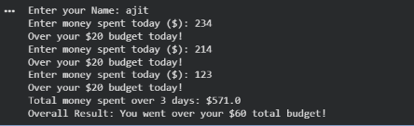
Figure 3:The results of a program if spending is in excess of daily and overall budgets.
These two runs test all paths in the program - the under-budget path (shortcut through the loop) and the over-budget path (long path through the loop), as well as the under-budget path (shortcut out of the loop) and the over-budget path (long path out of the loop) of the day's test checks. The outputs were the same for both sets of inputs, so I'm sure the logic is functioning as I would anticipate.

Reflection
This assignment helped me to see how a running total worked in a loop, because I had to increment total_spent in the loop, instead of calculating it at the end. It also caused me to consider better when a check should be located in a loop vs outside a loop. The reason for placing the per-day budget check inside the loop is that the value of spent depends on that day, and only exists for one pass through the loop, whereas the overall budget check has to be placed outside the loop because the value of total_spent is only complete once the three days are all entered.
Tackling the problem without using functions and lists was beneficial. It made me consider what data I do need to keep around (only the running total) and what data I might have stored because of habit (a list of each day's amount).
GitHub Repository
The complete source code for this program is available at: https://github.com/ajit-byte/python_programming_for_data_science.git

References
Alenazi, M., & Sas, C. (2023). Evaluating budgeting apps: Limited support for budgeting compared to tracking. In Proceedings of the 36th International BCS Human Computer Interaction Conference (HCI 2023). BCS Learning & Development Ltd. https://doi.org/10.14236/ewic/BCSHCI2023.1
Matthes, E. (2023). Python crash course: A hands-on, project-based introduction to programming (3rd ed.). No Starch Press.
Python Software Foundation. (2024). The Python tutorial. Python 3 Documentation. https://docs.python.org/3/tutorial/

