In-Memory Inventory Management Tool: Processing Customer Orders with Python Dictionaries and Lists

Ajit Shrestha
International American University
AIM 401 Python Programming for Data Science
Professor Dhiraj Bashyal
October 1, 2026

1. Scenario Overview
This assignment comes in the form of a project where you will create an in-memory inventory management solution for a distribution center. The customer orders are stored in a list of lists and the inventory of the product in a python dictionary. Orders from customers are stored as a list of list and stock of the product as a Python dictionary. They repeat through the list of orders, match each order line to stock and fill the order, or what stock is available, on the first and last line of each order. It sets up the red flag for invalid or out-of-stock items, and provides an end-of-batch summary printout. The program contains no custom functions, classes, import statements or file operations, only the standard Python data structures and control flow are used, as required in the assignment.
2. Program design and implementation
2.1 Create an inventory and order queue setup.
The inventory is a dictionary because for every product name, there is one count, which can be searched for quickly by key in Python (Python Software Foundation, 2025a). Initial Stocks are:
The order queue is an array of arrays, each of which contains the name of the order and the quantity of the order.
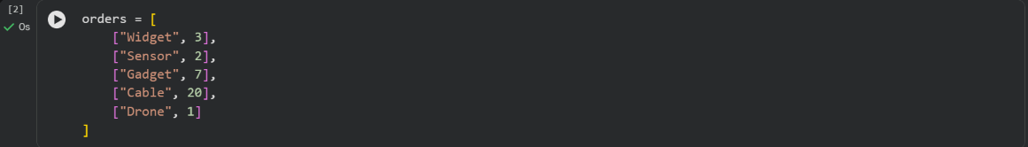
The program uses the five orders to process all types of orders it encounters: a normal order where there is plenty of stock available (Widget), an order for an item which has no stock (Sensor), two orders for items that have more of them than the program has on hand (Gadget and Cable), and an order for an item that is not in stock (Drone).
2.2 Task 2: Creating a Customized Response to the Order
The program will use a for loop to go through the order list, order by order (Lambert, 2023). For each of the orders that it invokes to retrieve the stock from inventory it will call the get(item) method. To prevent throwing a KeyError (Python Software Foundation, 2025a), the .get() method was used to return None for keys that were not found, instead of using inventory[item] (Python Software Foundation, 2025b) which would cause a KeyError. The program then branches out from the first case into four cases (see below) via the if/elif/else statement (Python Software Foundation, 2025b):
1. The key does not exist in the inventory because the stock is None in the invalid item.
2. No stock: stock is equal to 0.
3. 100% fulfillment: Stock is sufficient to fill an order or 100% or more of the order is filled and the stock is deducted.
4. Partial Fulfillment: Stock is not zero but less than requested quantity, the remaining stock is shipped, the stock is set to 0, and a shortfall is recorded.
Firstly the none should be check, Otherwise if it was later, None >= requested_qty will raise a TypeError. The check to see if it is None is there to avoid comparing a missing item to numbers.
2.3 Task 3: Tracking and Summary Output.
The two variables are constructed outside the loop to store the results; fulfilled_count is a whole number that is incremented with each fulfilled order, and unfulfilled_items is a list of all the [item, shortfall] pairs of the orders that are partially fulfilled. This then prints the final inventory, the number of orders that were completely filled and the list of the items that were not completely filled.
3. Testing and Output Verification
The script was built cell by cell following a testing phase in a notebook and then played from start to end. The order processing loop is shown in Figure 1 and the console output for all five of the orders.
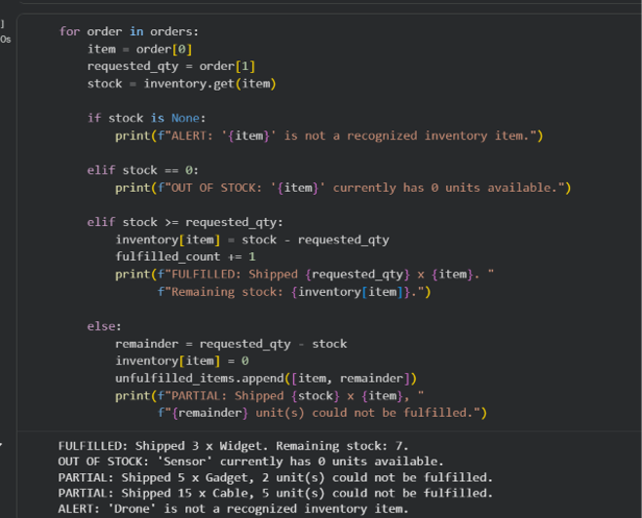
Figure 1. Task 2: The for loop is finished with if/elif/else branching and all five orders are printed out to the console. Widget was fulfilled, Sensor was out of stock, Gadget and Cable were partially fulfilled and Drone was invalid item.
End of batch summary is depicted in figure 2.
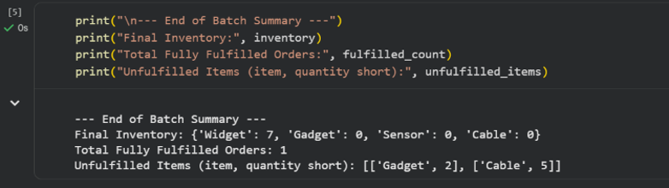
Figure 2. Task 3: End of batch summary will display the final number of widgets (7), gadgets (0), sensors (0), and cables (0), it will display 1 order fulfilled and 2 orders not fulfilled; it will display 2 gadgets short and 5 cables short.
3.1 Interpreting the Results
The results shown in Figures 1 and 2 confirm that the behavior of each branch of the program is as expected:
- Widget had 10 units, and 3 were requested; the order was satisfied and 7 units were left.
- Sensor began at 0, therefore it is flagged as out of stock and no comparison is made to the quantity requested.
- Gadget (5 in stock, 7 requested) was partially fulfilled, Cable (15 in stock, 20 requested) was partially fulfilled. They had lost all their inventory, and their deficit (minus 2 and minus 5) was contributed to unfulfilled_items.
- When the program was called on to return its value, it printed out "invalid-item" and returned None because Drone wasn't a key in the inventory.
This can be seen in the final summary: stock is updated (based on inventory), fulfilled_count is set to 1 (not all of Widget was fulfilled) and unfulfilled_items is filled with both partial shortages.
4. Design Notes and Constraint Compliance
dictionary, .get() and .append() (built in) methods storing data, For loop stepping through data and If/elif/else branching (Lambert, 2023; Python Software Foundation, 2025a, 2025b). Script is extremely well structured, and it has no def statements, classes, imported modules, file reads or writes. All intermediate state (the running count as well as the list of shortfalls) is stored in plain variables and the tool stays in-memory and in-scenario as needed for the scenario.
5. GitHub Repository
Repository Link: https://github.com/ajitbyte/python_programming_for_data_science.git

References
Lambert, K. A. (2023). Fundamentals of Python: First programs (3rd ed.). Cengage Learning.
Python Software Foundation. (2025a). Data structures. Python 3 documentation. https://docs.python.org/3/tutorial/datastructures.html
Python Software Foundation. (2025b). More control flow tools. Python 3 documentation. https://docs.python.org/3/tutorial/controlflow.html

