Digital Banking Audit Tool: Cleaning Transactions and Summing Nested Batches in Python

Ajit Shrestha
International American University
AIM 401 Python Programming for Data Science
Professor Dhiraj Bashyal
October 14, 2026

1. Scenario Overview
This assignment was about creating a smaller version of an audit tool for a digital banking system. Transactions are received in batches and some high value operations spawn nested sub transactions which are received as deeply nested list. This program has two tasks. The first one cleans a batch of amounts and applies a service fee with the functional tools filter() and map() using lambda expressions. Second, it adds up the total value of a batch of lists, regardless of the depth of nesting, by using a purely recursive function. All rules applied in assignment were followed i.e. no for or while loops and no global variables within the recursive function.
2. Implementation
2.1 Task 1: cleaning and applying fees.
The function clean_transactions(amounts, min_threshold=10.0) filters out any amounts below the threshold and below 0. I separated out the x > 0 check from the threshold check as if someone passed the threshold at 0 or a negative number, the negative transactions would pass through as well. The amount is stored exactly as it was set, as the rule subtracts the amount below that. The default value for min_threshold is set, so that function can be used without any second argument.
The function apply_service_fee(amounts, fee_rate=0.02) applies the fee in one step by using map function with a lambda that subtracts the fee from each amount. Each of the values is approximately correct to two decimal places, so that they appear like amounts of money and not long floating-point numbers. The reason that both functions return list() is that map() and filter() in Python 3 are lazy iterators and do not return finished lists (Udacity, 2024). This leads to a functional style like that described in the Python documentation, which has the advantage that small functions operate only on the input and can be easily tested and debugged (Python Software Foundation, 2025a).
2.2 Task 2: Recursive Nested Total
There are two base cases and one recursive step in calculate_nested_total(data). When the list is empty it returns 0.0. If only one number is entered, as an int or float, it returns that number. If it's not an empty list, then the input is a list, I split it into the first element (the head) and the remaining elements (the tail), and return the sum of the head and the sum of the tail. The function takes care of nesting at any level because the head itself can be a list.
The order of checks is important. The empty-list check is done first, so data[0] will not be accessed if data is an empty list, and the isinstance() check is done first, so a simple number won't be sliced if data is an instance of a simple numeric type. For example, with [100, [50, 25]], the head is 100 and the tail is [[50, 25]]. The head of the tail is [50, 25] which becomes [50, 25] and so forth, until all the branches reach a base case and the values are combined again. Each call makes a call to something smaller, either one less element or one less level of nesting, thus always terminating. The return values contain all of the state, so there are no loops or global variables. There is also a local variable area for each call, with the call's return address, which makes up its stack frame (Lambert, 2023).
2.3 Complete Source Code
def clean_transactions(amounts, min_threshold=10.0):
# keep only positive amounts that also meet the minimum threshold
return list(filter(lambda x: x > 0 and x >= min_threshold, amounts))
def apply_service_fee(amounts, fee_rate=0.02):
# deduct the fee percentage from every amount
return list(map(lambda x: round(x * (1 - fee_rate), 2), amounts))
def calculate_nested_total(data):
# base case 1: empty list
if data == []:
return 0.0
# base case 2: single number
if isinstance(data, (int, float)):
return data
# recursive step: split into head and tail
head = data[0]
tail = data[1:]
return calculate_nested_total(head) + calculate_nested_total(tail)
3. Testing and Output
I tested the functions in a notebook with a raw batch containing a negative amount, a zero and two amounts which are lower than the threshold, then with some nested batches. The figures below show the code and the results.
Figure:
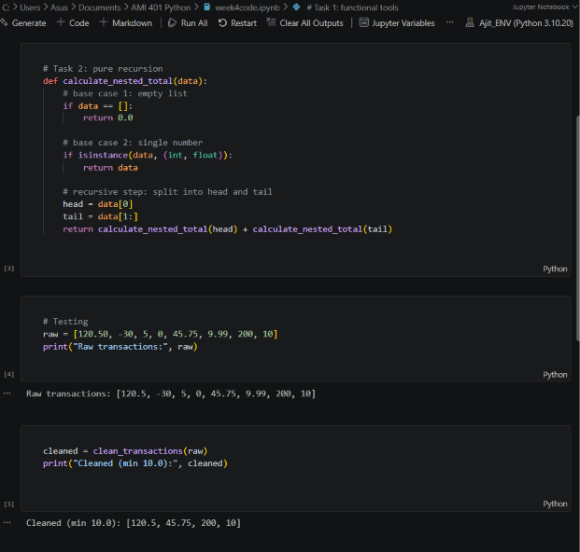
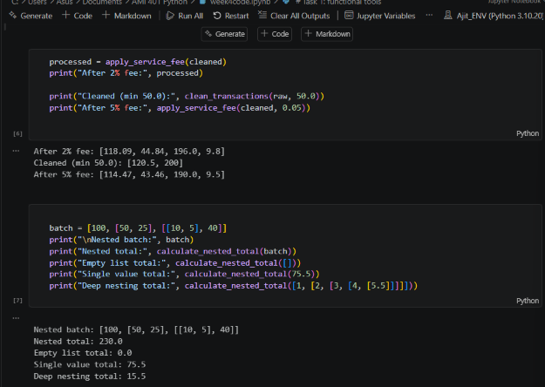
3.1 Interpreting the Results
The raw batch contains 8 amounts for this figure, as shown in Figure 3. The default threshold is 10.0, and the -30, the 0, the 5, and the 9.99 are removed; the 10 is not removed because it is equal to the threshold. After the 2% fee, 120.5 becomes 118.09 and 200 becomes 196.0. If it's increased to 50.0, 120.5 and 200 remain – demonstrating that the default argument can be changed. In Figure 4, the nested batch [100, [50, 25], [[10, 5], 40]] adds up to 230.0, which matches 100 + 50 + 25 + 10 + 5 + 40 by hand. It prints as a float because the empty-list base case returns 0.0. The empty list returns 0.0, the single number 75.5 returns itself, and the five-level list [1, [2, [3, [4, [5.5]]]]] totals 15.5.
4. Limitations
There are two restrictions for the recursive solution. First, the Python recursion depth limit is reached, resulting in a RecursionError (Python Software Foundation, 2025b).First, there is a limit to the number of items or levels in a batch, and if there are too many it will raise a RecursionError (Python Software Foundation, 2025b). Second, every call to data[1:] makes a copy of the rest of the list, hence very long lists are slow. If the banking data is large and is made up of huge batches, then an iterative version or an explicit stack would be more secure. For this assignment the recursive version is clear and meets the requirements.
5. GitHub Repository
Source code repository: https://github.com/ajitbyte/python_programming_for_data_science.git

References
Lambert, K. A. (2023). Fundamentals of Python: First programs (3rd ed.). Cengage Learning.
Python Software Foundation. (2025a). Functional programming HOWTO. Python 3 documentation. https://docs.python.org/3/howto/functional.html
Python Software Foundation. (2025b). sys: System-specific parameters and functions. Python 3 documentation. https://docs.python.org/3/library/sys.html
Udacity. (2024). Our guide to map, filter and reduce functions in Python. https://www.udacity.com/blog/our-guide-to-map-filter-and-reduce-functions-in-python/

