Caesar Cipher Log Decryptor: Program Explanation and Implementation

Ajit Shrestha
International American University
AIM 401 Python Programming for Data Science
Professor Dhiraj Bashyal
September 28, 2026
Introduction
Security logs track system activity and allow an organisation to detect an unauthorised access (Kent & Souppaya, 2006). In this case, it was a remote server that stored its system event logs, but used a Caesar shift to encrypt them. The challenge was to write a Python script to read in the encrypted file, decrypt each line, write each decrypted line to a master file and copy all of the lines that contain the word "BREACH" to an alert file. There were strict limitations for the program, such as no lists, dictionaries, sets, custom functions or external libraries. This report provides an explanation of the design of the program, screenshots of the program code, and an illustration of the program's fulfillment of each of the requirements in the assignment.
Program Design
Caesar Cipher is a cipher that substitutes every character by another character in the alphabet that is a certain number of letters ahead. (Singh, 1999; Sweigart, 2018) The logs are shifted 3 to the right, which means they must be shifted 3 to the left to decrypt. In Python this is easy using the two built in functions ord() which returns the integer code of a character and chr() which returns a character from an integer code (Python Software Foundation, n.d.-a). In the above example, ord(‘V’) is 86, so ord(‘V’) – 3 is 83, which chr() converts to ‘S’. If used for each individual character, the encrypted text V|vwhp is "System".
The spaces and newline characters are not shifted; this keeps the lines and words separated. With this program, each line is read, one character at a time is decrypted, it is "cleaned" using string methods, and then written in the appropriate location. All the solution operations are: file I/O, for loop, if statement, string methods and so remain within the bounds set.
Implementation
The notebook screenshots are from the notebook I used to test the program in. The explanation for each figure is followed by the requirement that it is supposed to meet.
Figure 1
The encrypted input file, raw_logs.txt, was created.
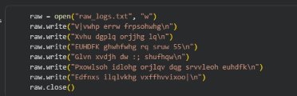
This cell opens raw_logs.txt in write mode ("w"), writes six encrypted lines to it, and then closes it: Each line consists of a normal log message indented with 3 spaces. For example, "BREACH detected on port 22" will be stored as "EUHDFK ghwhfwhg rq sruw 55" (the numbers are also shifted, from "22" to "55").
Requirement met: Task 1 - The raw_logs.txt file has 6 lines of encrypted dummy data (5 minimum).
Figure 2
Opening the input file and the two output files.
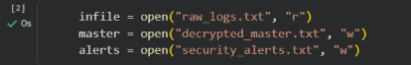
The script opens up raw_logs.txt for reading ("r") and opens decrypted_master.txt and security_alerts.txt for writing ("w"). All three files are opened prior to the loop and thus remain open throughout the loop. This is equal to the task 1 condition where the input is provided when both the output files are opened for writing.
Requirement met: Task 1 open an input file and open two output files.
Figure 3
Cleaning and filtering strings, decrypting strings
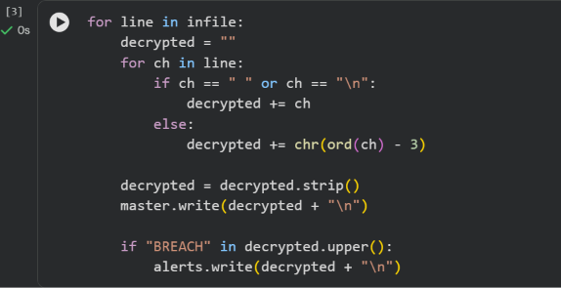
The main component of the programme. The outer for loop in the infile loop is used to read the encrypted line by line from the infile. A new empty string is created for each line, and this is decrypted. Inner for ch loops through all the characters. The character will be copied directly when it is a space or a newline, otherwise it will be decrypted using chr(ord(ch) - 3).
Then the inner loop removes the leading and trailing spaces, and the line from which the spaces have been removed is appended to the master file, with the newly added line containing the newline. Then, decrypted.upper() makes a copy of the text, it is then converted to capital letters and the in operator looks for the string BREACH. The check also picks up "breach" when it is written in lower case due to the case-ness of the conversion. Lines are written to alert file that are matched.
Requirements fulfilled: Task 2 (iterate through lines and characters, left shifting by 3, ord() and chr(), spaces and newlines preserved) and Task 3 (remove any whitespace, print each line to the master file, print matches to the alert file and check the master file for “BREACH” in uppercase).
Figure 4
Closing all three files
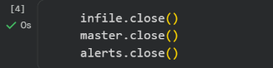
After each file is closed with .close() following the loop. When you close a file, any data that remains in memory will be written to the disk and the files will be released (Python Software Foundation, n.d.-b). This is important here because the following cell reads the output files back; if it wasn't closed, there might be some text that hasn't been written.
Requirement met: Allowed file I/O operations (open, write, close) and good file-handling practice.

Figure 5
Program output: decrypted_master.txt and security_alerts.txt
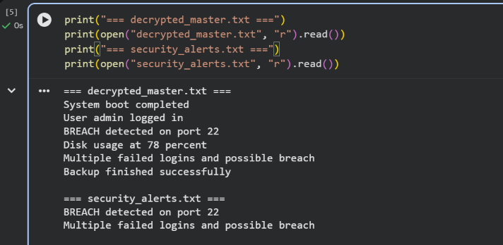
The last cell prints both output files. All six lines in the log are readable in the master file and only the two lines with the keyword "BREACH detected on port 22" and "Multiple failed logins and possible breach" are included in the alert file. As the case insensitive check is carried out (its lower case), the 2nd line is caught.
Requirement satisfied: Task 3, all decrypted logs in the master file and only BREACH logs in the emergency alert file.

Requirements Checklist
Requirement | How the program meets it | Evidence
Encrypted input file, 5+ lines | raw_logs.txt holds six encrypted lines | Figure 1
Open input for reading, two outputs for writing | open() with "r" and two with "w" before the loop | Figure 2
Left shift of 3 using ord() and chr() | chr(ord(ch) - 3) on each character | Figure 3
Preserve spaces and newlines | if ch == " " or ch == "\n" copies them unchanged | Figure 3
Strip whitespace | decrypted.strip() | Figure 3
Write every line to master file | master.write(decrypted + "\n") | Figures 3, 5
Uppercase check for "BREACH" | "BREACH" in decrypted.upper() | Figures 3, 5
Write matches to alert file | alerts.write(decrypted + "\n") | Figures 3, 5
No lists, dictionaries, sets, def, or libraries | Only strings, loops, if statements, and file I/O are used | Figures 1-4

Limitations and Conclusion
The program contains no wrap around logic. This is OK as per the assignment note, but it means that for the encrypted text "A" would move to a letter in front of the alphabet (rather than "X"). Also, it decrypts all non-spaces characters (digits and symbols), so it will only work on text encrypted with the same +3 rule. Wrap-around logic could be added in a future version. Finally, a Caesar Cipher is quite weak as a real protection, since a potential attacker could simply guess all 25 letter shifts and try them all out (Stallings, 2017); it is used here not for any security, but to practice string handling.
To summarize, the script is opening an encrypted log file, decrypting it character by character using ord() and chr(), removing unwanted characters from each line in the log file using string methods, and sorting the output into a master file and a security alert file. Correctly works for the test data and respects coding restrictions. The entire source code is provided in the GitHub repository on the first page.
GitHub repository:
https://github.com/ajit-byte/python_programming_for_data_science.git

References
Kent, K., & Souppaya, M. (2006). Guide to computer security log management (NIST Special Publication 800-92). National Institute of Standards and Technology. https://doi.org/10.6028/NIST.SP.800-92
Python Software Foundation. (n.d.-a). Built-in functions. Python 3 documentation. https://docs.python.org/3/library/functions.html
Python Software Foundation. (n.d.-b). Input and output. The Python tutorial. https://docs.python.org/3/tutorial/inputoutput.html
Singh, S. (1999). The code book: The evolution of secrecy from Mary, Queen of Scots, to quantum cryptography. Doubleday.
Stallings, W. (2017). Cryptography and network security: Principles and practice (7th ed.). Pearson.
Sweigart, A. (2018). Cracking codes with Python: An introduction to building and breaking ciphers. No Starch Press.

