**Steps to install Admin UI:**

* Download & unzip the package (<http://obsidianscheduler.com/download/>)
* Install the package by executing Obsidian-Install-3.6.0.jar from the unzipped folder (instructions: <http://obsidianscheduler.com/wiki/Getting_Started#Quick_Start>)
* Create MySQL tables in the schema specified while installing Obsidian with Scripts available under {package_folder}/db_scripts/mysql/complete.sql (replace $px$ in the script with the table name prefix specified while installation)
* Deploy the {installation_dir_from_step_1}/standaloneObsidianAdmin.war in a Tomcat
* Access the UI by httP://{host}:{port}/standaloneObsidianAdmin (credentials: admin/changeme)

**Steps to execute a demo JOB**

* Download the project (https://github.com/ajit-kulkarni/obsidian-demo)
* Install whatever jars that are not available in repo's to local m2 repo (these jars would be available under {installation_dir_from_step_1}/standalone)
* Start the demo project by mvn spring-boot:run from CMD/Terminal

**Adding and configuring the Job:**

* Open the admin UI screen.
* If the application is successfully running with mvn spring-boot:run the ‘No Hosts Active’ notification should go away from Admin page if you refresh the page and it should show ‘1 Host Active’.

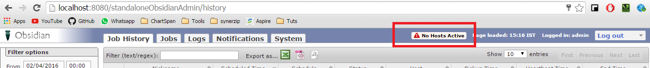

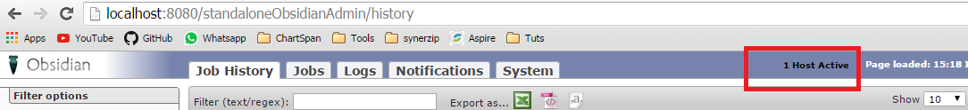

* Click on Jobs -> Add job links and configure the job as below:

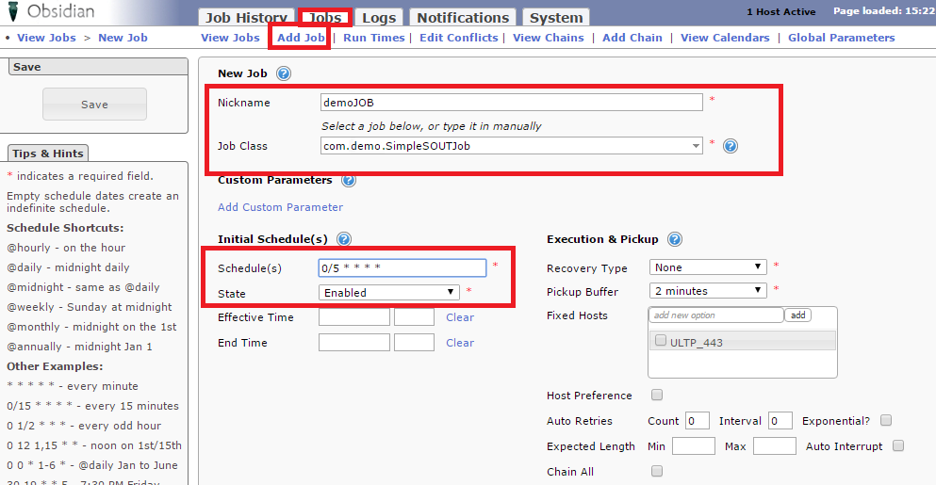

**Note**:

* + If ‘com.demo.SimpleSOUTJob’ is not available under the dropdown, please type manually.
* Save the configuration, the job should not run every five min.
* Navigate back to job history tab to see the execution history.
* You can manually trigger the job by clicking ‘job -> view job -> Submit Run’.

