1. Basics analysis by stock name

(CandleStick Pattern)

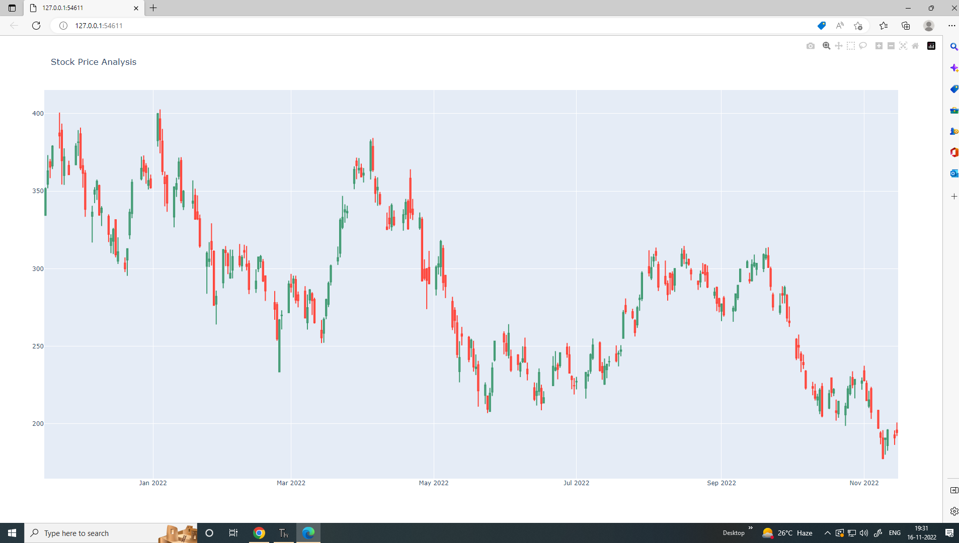

(2) visualizing the stock price in bar plot

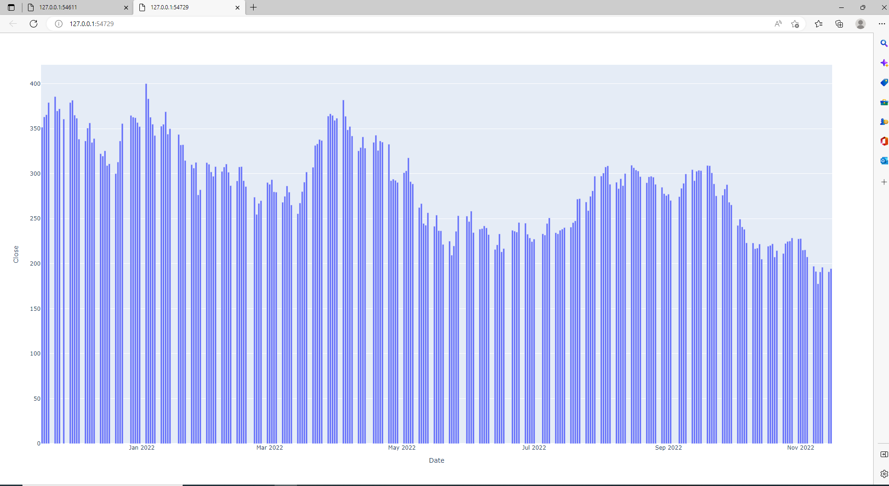

1. Range Slider

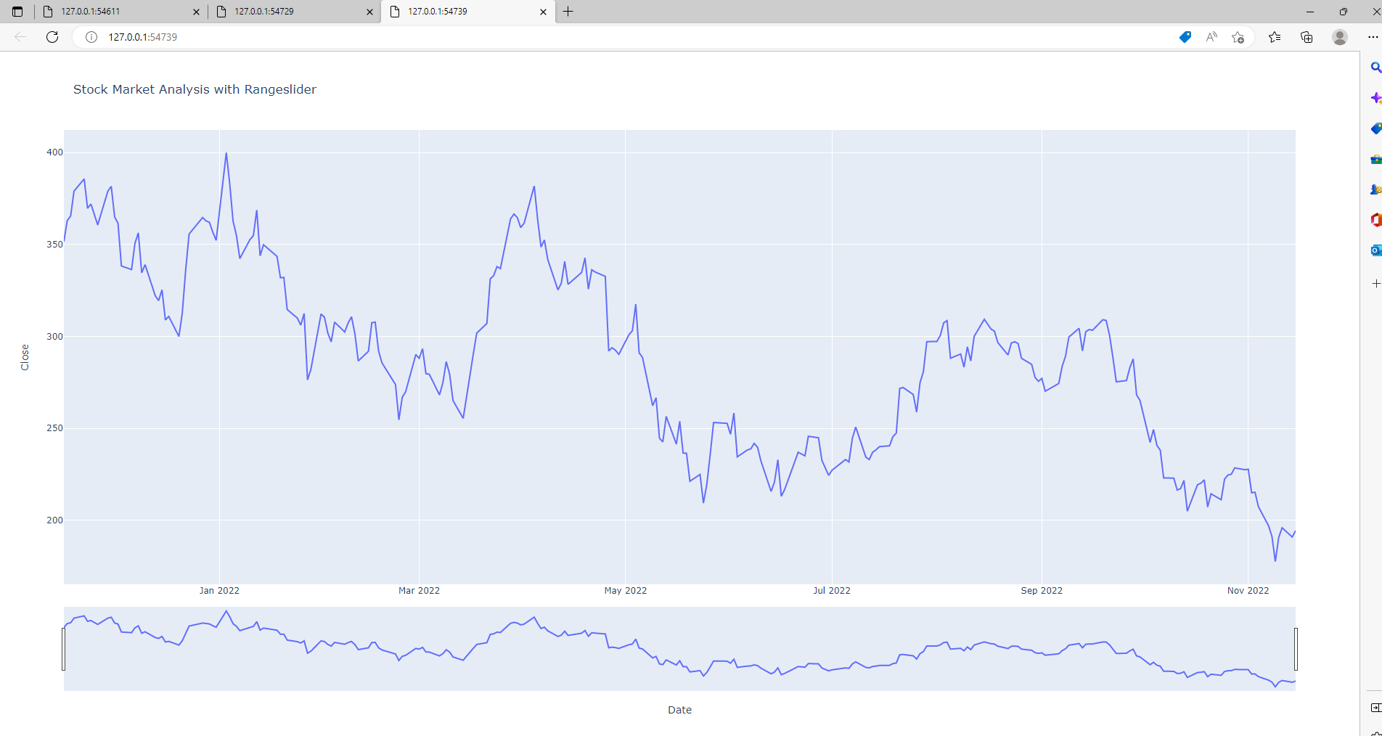

(4 ) Particular Time Period

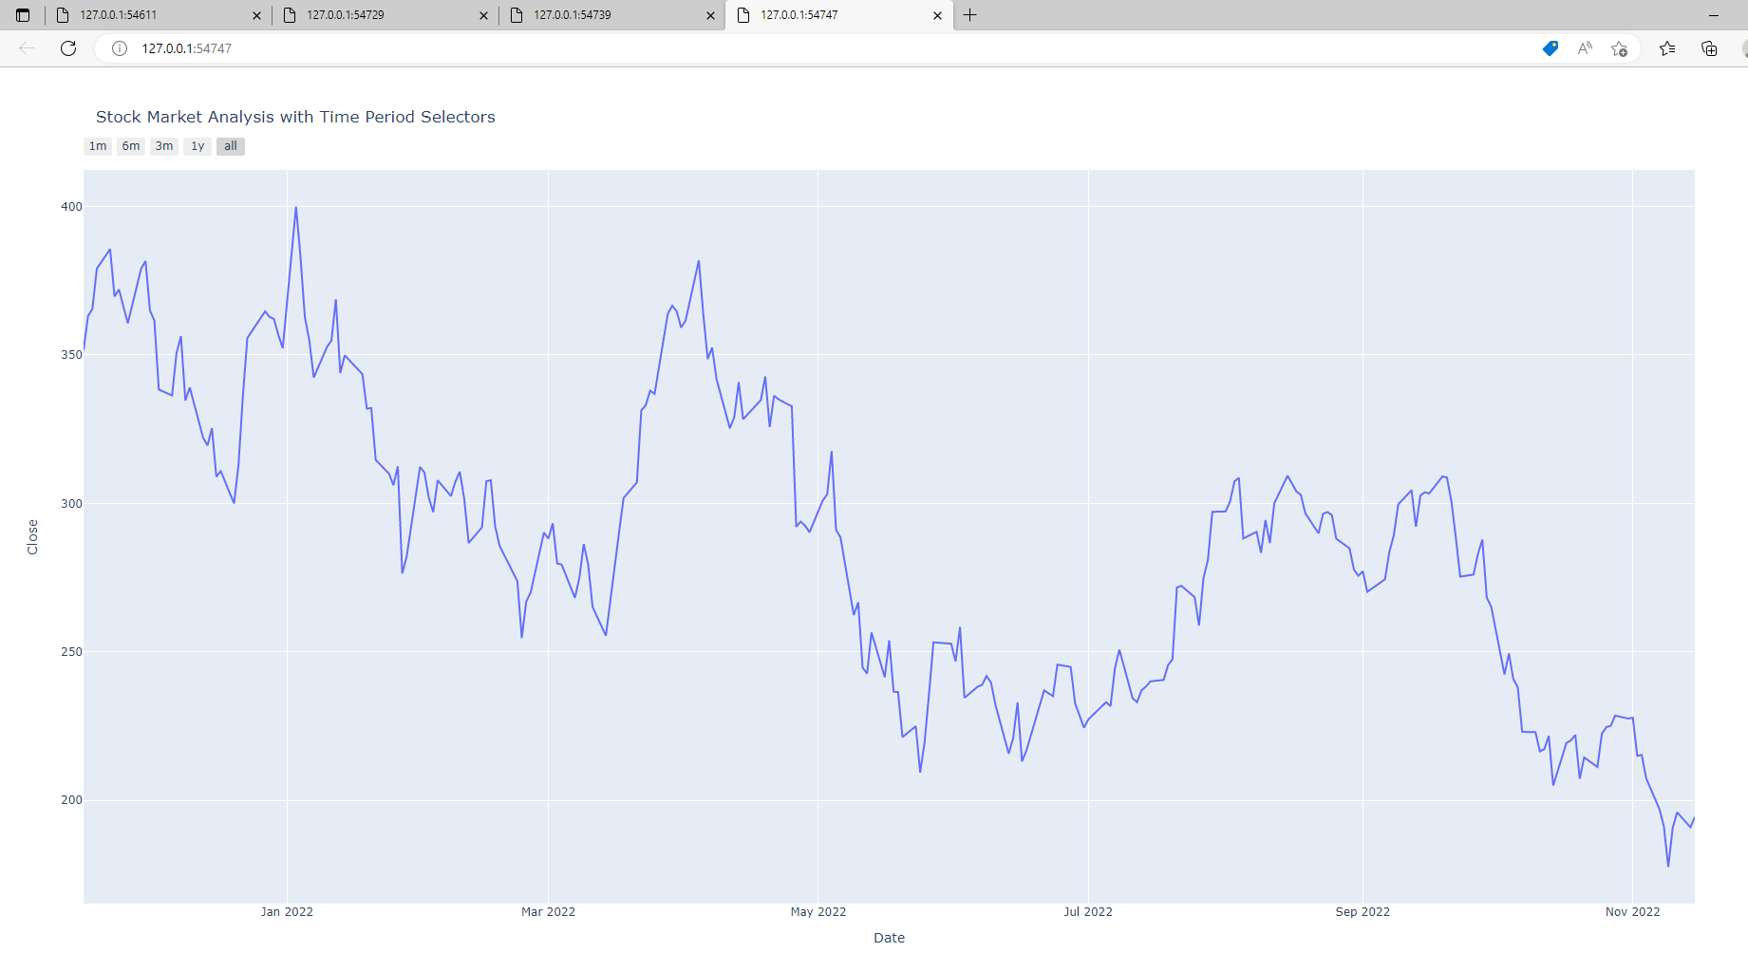

(5) removing weekends values

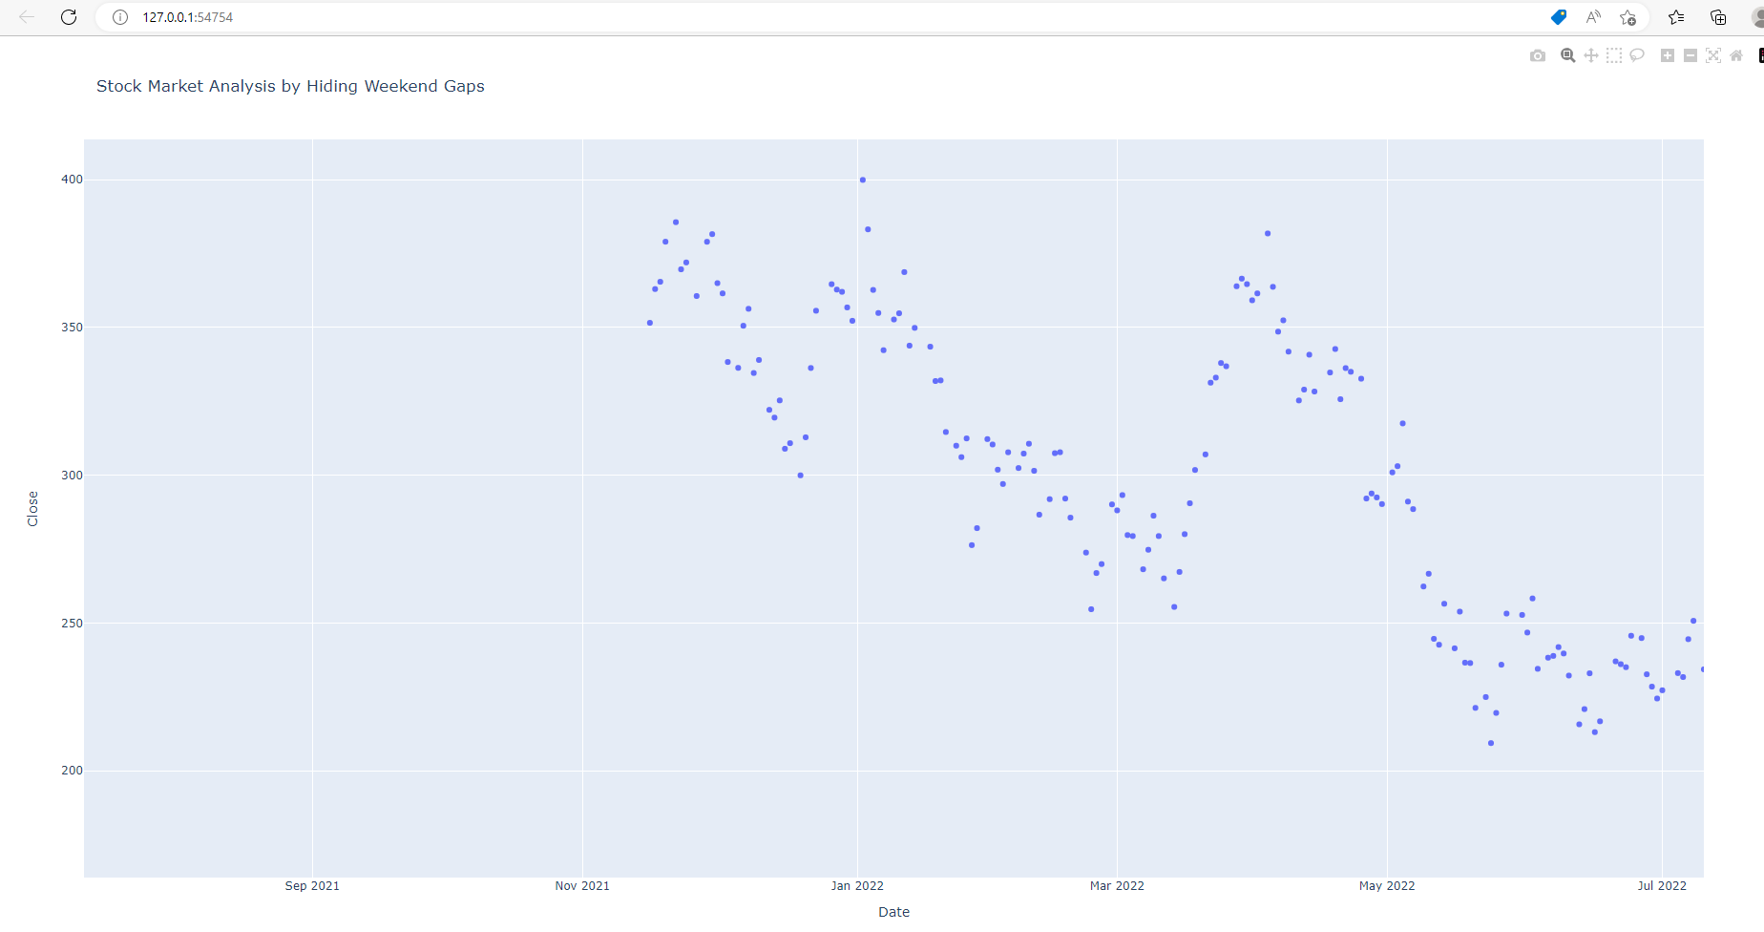

These are the outputs of the following code where stocks are visualized by different visualization techniques.

# Important points to be remembered

# |About Nasdaq |

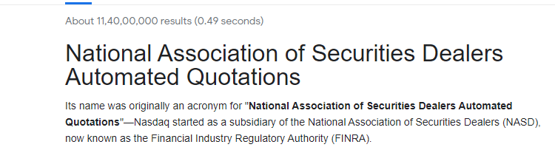

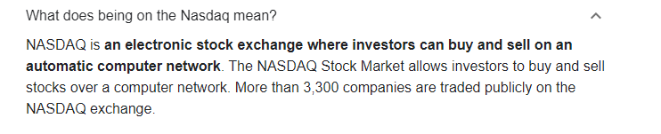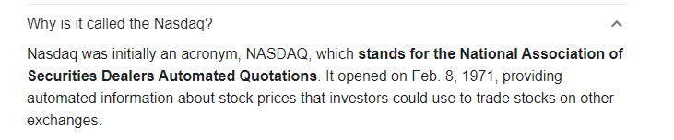

# To Fetch Data From Indian Stock market

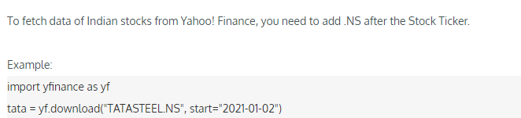

# list of all the stocks of the Nasdaq with ticker

<https://pkgstore.datahub.io/core/nasdaq-listings/nasdaq-listed_csv/data/7665719fb51081ba0bd834fde71ce822/nasdaq-listed_csv.csv>