Complete Product Prompt & Implementation Plan
AI Software: Hyperlocal Agri-Mandi & Agricultural Input Assistant (India)
This is a production-grade prompt that you can give to an AI coding agent (GPT-5, Claude, Cursor, Lovable, Bolt, Replit AI, Windsurf, etc.) to build the complete software.
Important Requirement: The system must fetch live mandi grain prices only from official Government of India sources (AGMARKNET / data.gov.in / eNAM where applicable) after the user selects State → District → Mandi. It must never invent prices.

Agmarknet+2
MASTER AI DEVELOPMENT PROMPT
Project Name
KrishiMitra AI – Hyperlocal Agri Mandi & Input Intelligence Platform
Objective
Build a multilingual AI-powered web and WhatsApp platform that helps farmers, traders, FPOs, and agri dealers obtain live mandi prices, MSP information, fertilizer availability, bulk buyers, weather alerts, and crop advisory using voice or text in their local language.
The platform must support Tier-2 and Tier-3 rural India with extremely simple UX.
Primary Users
|
User
|
Goal
|
| --- | --- |
|
Farmer
|
Know today's mandi price
|
|
Trader
|
Compare prices across nearby mandis
|
|
FPO
|
Find verified bulk buyers
|
|
Fertilizer Dealer
|
Receive customer leads
|
|
Government Extension Officer
|
Share schemes & advisories
|
Core Features
Voice-first interaction
Farmers can press one microphone button and ask questions in Hindi, Kannada, Marathi, Tamil, Telugu, Punjabi, Bengali, Gujarati, Malayalam, or English.
Automatic language detection
Detect spoken language automatically from speech. If confidence is below 80%, ask the user to choose a default language. Save the preference for future conversations.
Live Government mandi prices
Fetch official modal, minimum, and maximum prices from AGMARKNET/data.gov.in APIs after State → District → Mandi → Commodity selection.

Agmarknet+1
Verified buyer marketplace
Connect farmers with verified wholesalers, processors, exporters, and FPO buyers. Include GST verification, phone verification, and rating.
Agri input discovery
Find fertilizer, seeds, pesticides, and equipment dealers within a selected radius.
MSP & profitability calculator
Compare mandi price vs MSP, estimate transport cost, and recommend the better selling option.
Supported Languages
The platform must support these languages end-to-end.
|
Language
|
Code
|
| --- | --- |
|
English
|
en
|
|
Hindi
|
hi
|
|
Kannada
|
kn
|
|
Marathi
|
mr
|
|
Tamil
|
ta
|
|
Telugu
|
te
|
|
Malayalam
|
ml
|
|
Gujarati
|
gu
|
|
Punjabi
|
pa
|
|
Bengali
|
bn
|
Language Logic
User opens app

↓

Ask permission for microphone

↓

User speaks

↓

Detect language

↓

Confidence >80% ?

YES → reply in same language

NO → Show language selector

↓

Save preferred language

↓

All future responses in that language
User Flow

Open app
Speak or type
Language detection
Select location
Fetch official data
AI answers with voice + text
UI Screens
1. Welcome Screen
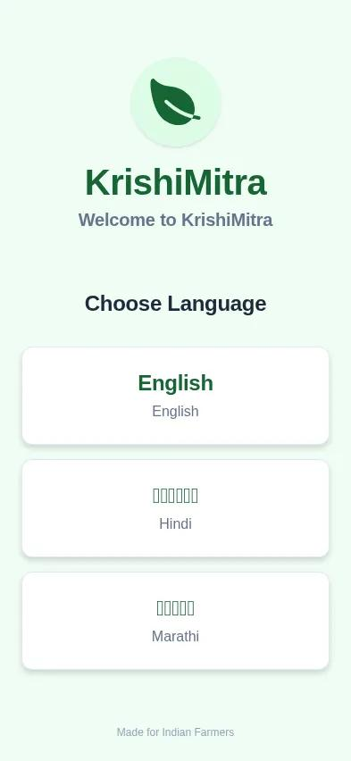
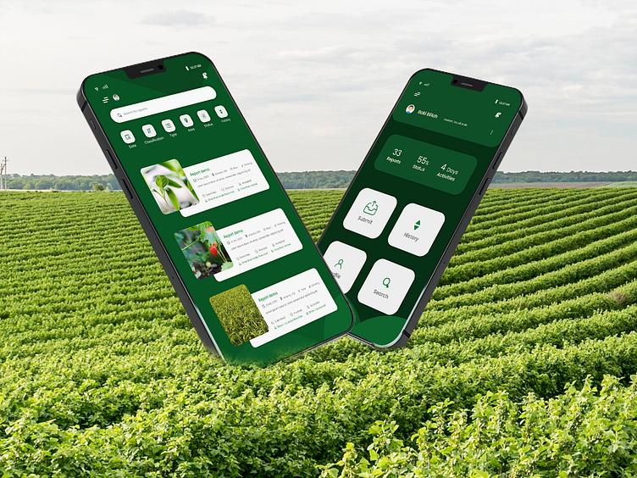
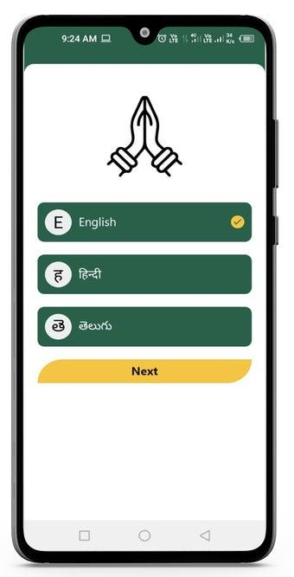
5
Features:
- Logo
- Voice button
- Select language
- Continue
- Offline mode
2. Language Selection
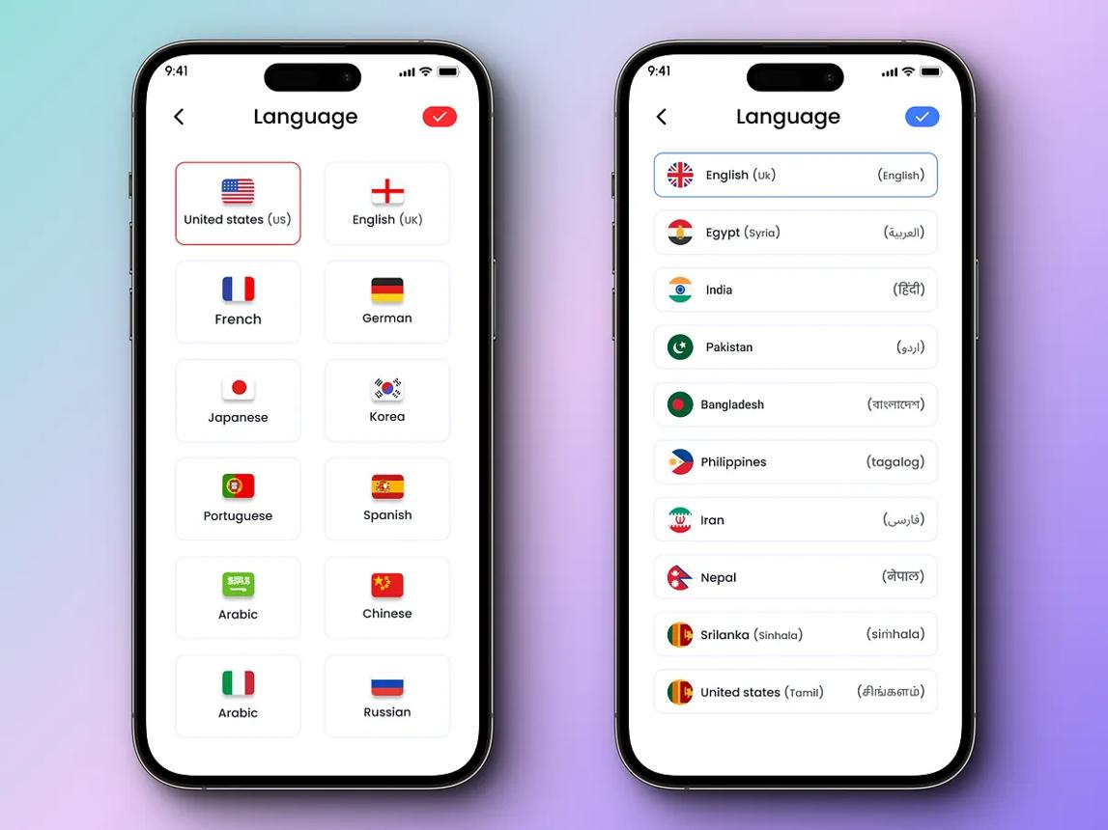
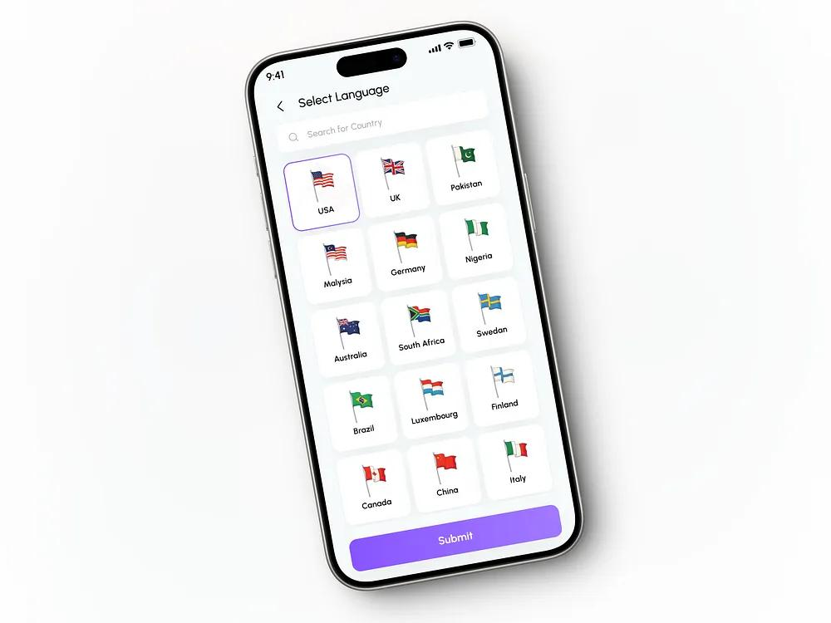
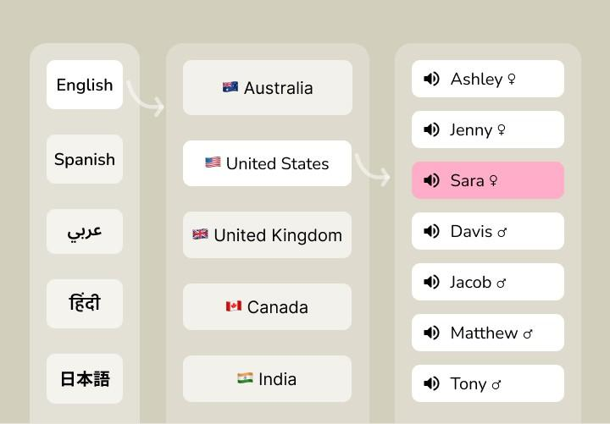
6
Requirements:
- Grid of languages
- Native script
- Flag not required
- Search language
- Save default
Example:
|
Display
|
Value
|
| --- | --- |
|
हिन्दी
|
hi
|
|
ಕನ್ನಡ
|
kn
|
|
मराठी
|
mr
|
|
தமிழ்
|
ta
|
3. Location Selection
This is mandatory before fetching prices.
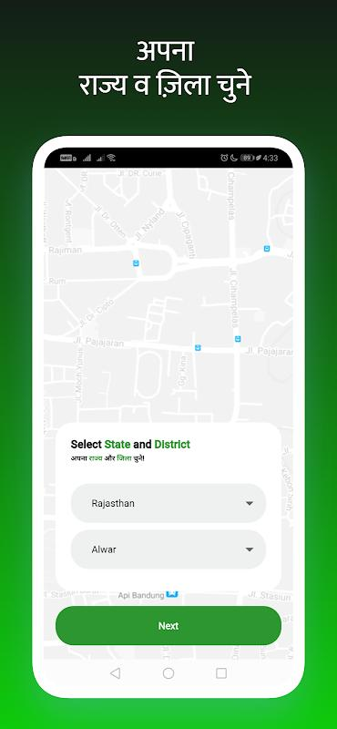
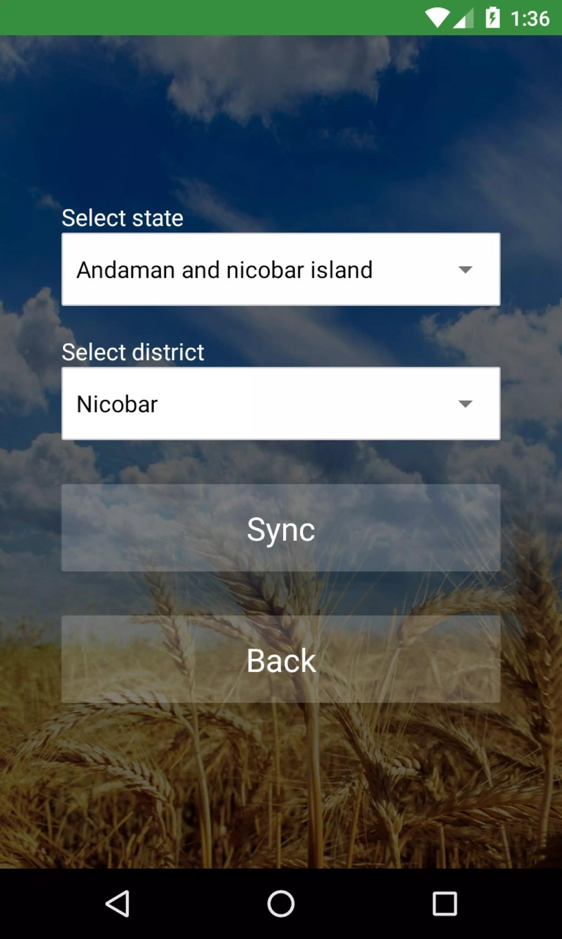
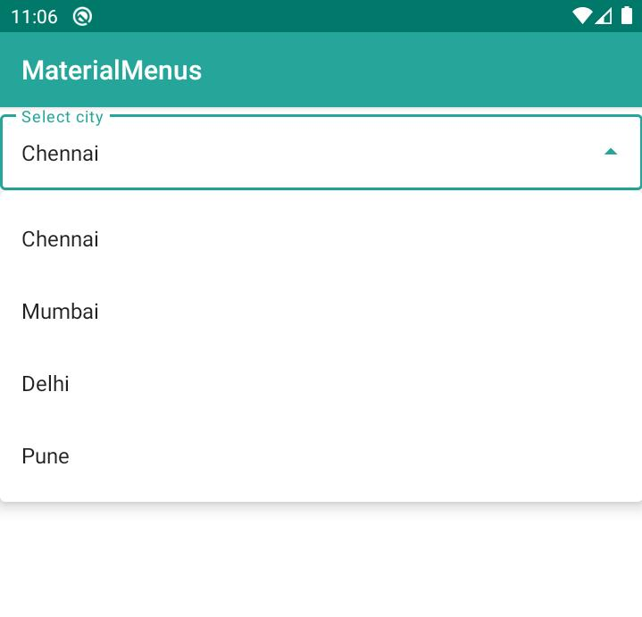
4
Hierarchy:
State

↓

District

↓

Taluka (optional)

↓

APMC / Mandi

↓

Commodity
Example:
- State → Karnataka
- District → Shivamogga
- Mandi → Shimoga APMC
- Commodity → Maize
The dropdown values should come from Government mandi master data.

Agmarknet
4. Live Mandi Price Screen
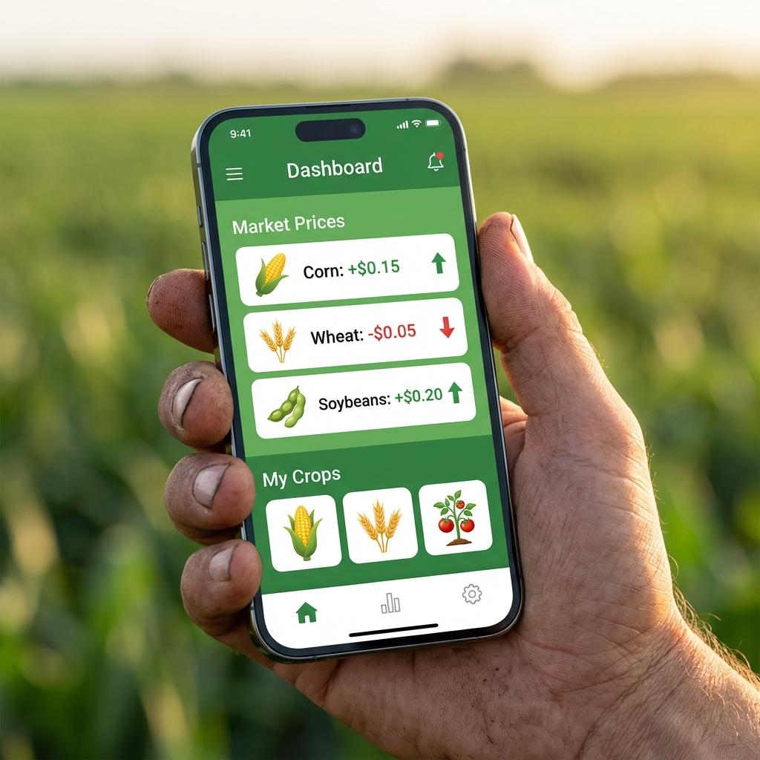
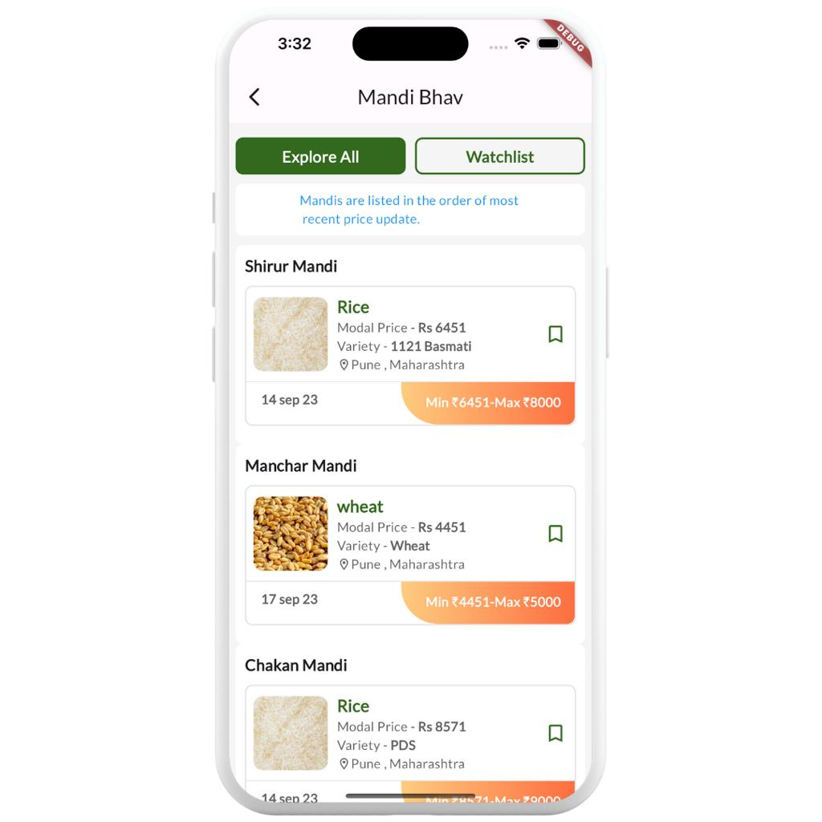
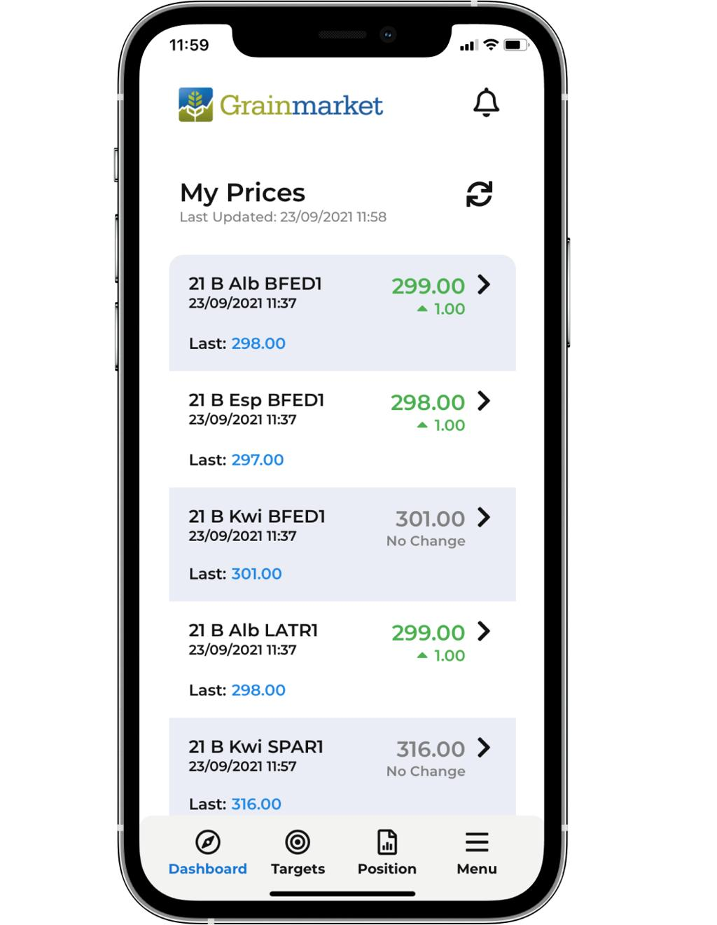
7
The system should display:
|
Item
|
Value
|
| --- | --- |
|
Commodity
|
Maize
|
|
Mandi
|
Shivamogga
|
|
Date
|
Today
|
|
Modal Price
|
₹2,320
|
|
Min
|
₹2,180
|
|
Max
|
₹2,460
|
|
MSP
|
₹2,225
|
|
Source
|
AGMARKNET
|
Green badge: Official Government Data
Source must always be visible.

Data.gov.in+1
Voice AI Conversation
Example 1
Farmer (Kannada Voice)
ಇವತ್ತು ಶಿವಮೊಗ್ಗದಲ್ಲಿ ಜೋಳದ ರೇಟ್ ಎಷ್ಟು?
System:
- Detect Kannada
- Convert speech → text
- Extract:
  - Commodity = Maize
  - District = Shivamogga
- Query Government API
- Reply in Kannada (text + speech)
Example 2
Hindi:
आज इंदौर में गेहूं का भाव क्या है?
Reply:
आज इंदौर मंडी में गेहूं का मॉडल भाव ₹2,540 प्रति क्विंटल है। MSP ₹2,425 है।
Government Data Integration (Most Important)
Official Data Sources
Use only these sources in priority order:
|
Source
|
Purpose
|
| --- | --- |
|
AGMARKNET
|
Daily mandi prices
|
|
data.gov.in
|
Open mandi API
|
|
eNAM Dashboard
|
Cross verification
|
|
State APMC APIs
|
State-specific data
|
These government platforms publish daily wholesale minimum, maximum, and modal prices for regulated mandis.

Agmarknet+2
API Architecture
User selects location

↓

Backend validates

↓

AGMARKNET API

↓

JSON response

↓

Cache in Redis

↓

AI formats response

↓

Voice + Text
Never scrape if official API is available.
Cache expiry:
- Price data: 30 minutes
- Mandi master: 7 days
- Commodity master: 30 days
Database Design
Users
SQL
id
name
mobile
preferred_language
state
district
village
created_at
Mandis
SQL
id
state
district
mandi_name
apmc_code
latitude
longitude
Commodities
SQL
id
commodity_name
local_name
category
Daily Prices
SQL
id
mandi_id
commodity_id
date
min_price
modal_price
max_price
source
Buyers
SQL
id
company
gst_number
district
commodity
phone
verified
rating
Dealers
SQL
id
shop_name
fertilizer
seed
pesticide
location
verified
AI Intent Recognition
The model should classify queries.
|
Intent
|
Example
|
| --- | --- |
|
Price
|
Maize rate
|
|
MSP
|
Wheat MSP
|
|
Buyer
|
Sell soybean
|
|
Dealer
|
Need urea
|
|
Weather
|
Rain tomorrow
|
|
Scheme
|
PM Kisan
|
Output JSON:
JSON
{
"intent":"price",
"commodity":"Maize",
"state":"Karnataka",
"district":"Shivamogga",
"language":"kn"
}
Buyer Marketplace
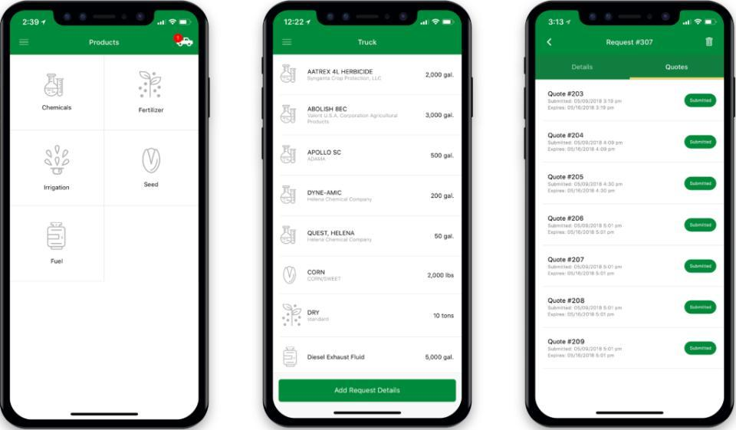
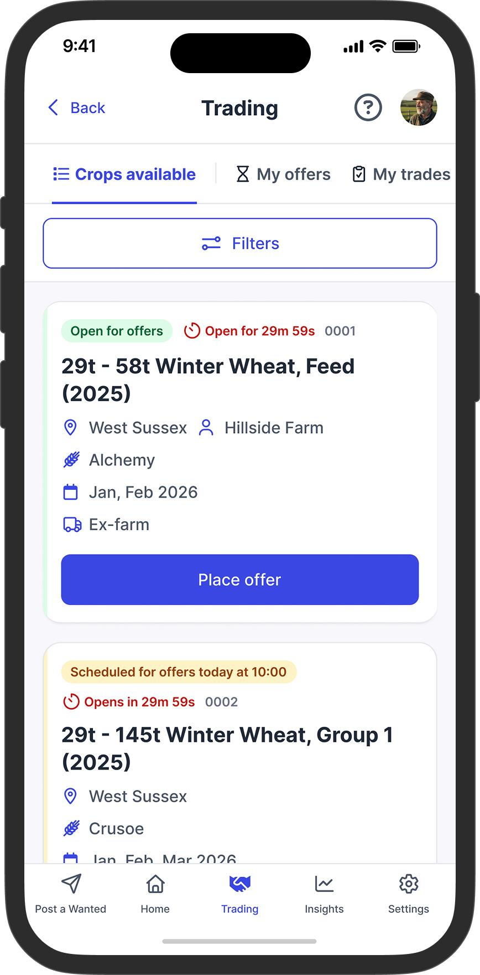
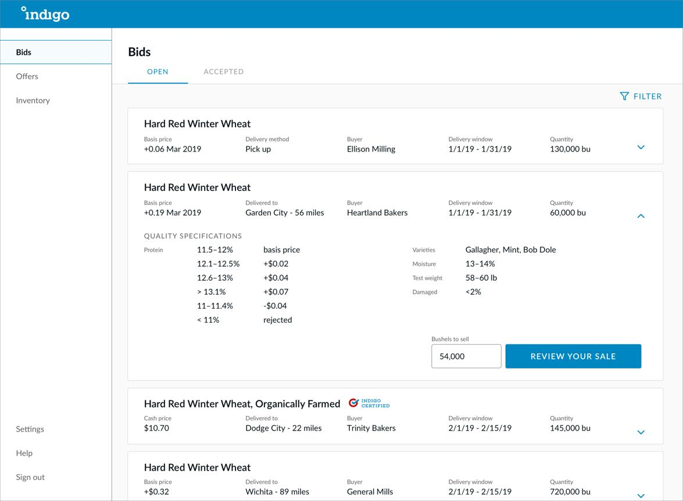
6
Each buyer profile:
- Company
- GST verified
- Phone
- Distance
- Commodity
- Rating
- WhatsApp
Filters:
- Commodity
- Distance
- Payment within 24 hrs
- Exporter
- Processor
Fertilizer Dealer Module
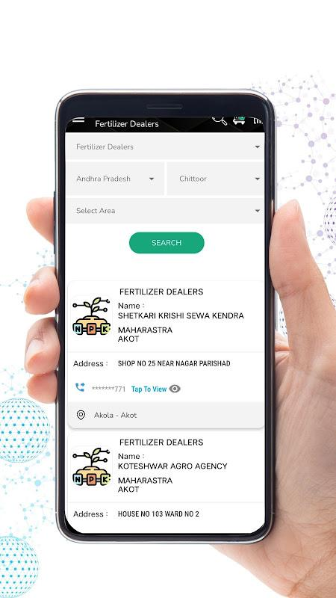
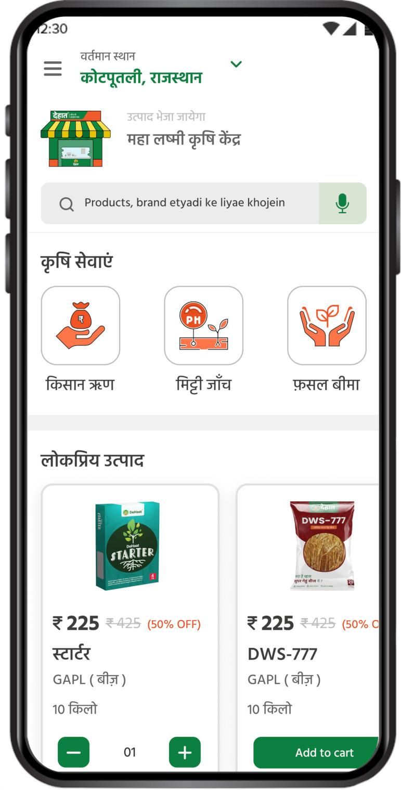
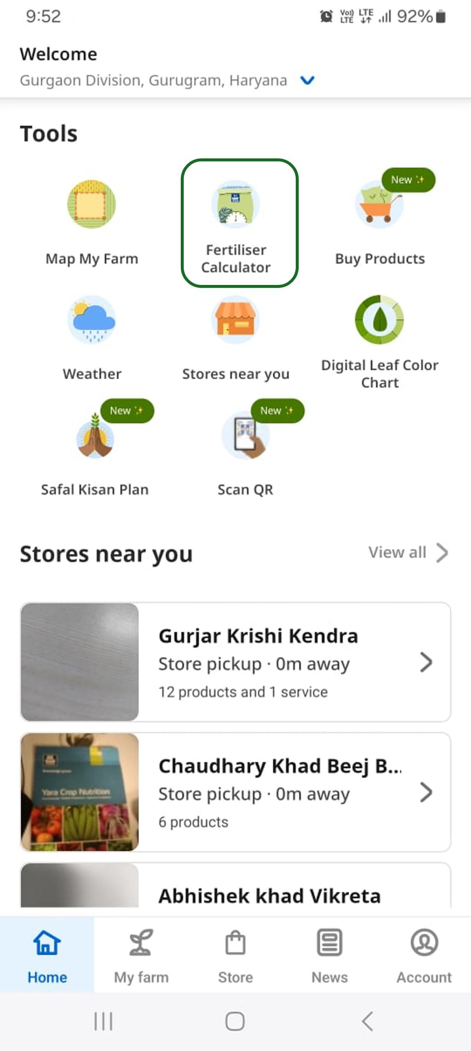
6
Search by:
- Urea
- DAP
- NPK
- Seeds
- Pesticides
Show:
- Stock availability
- Dealer phone
- Distance
- Navigation
Voice Technology
Use:
|
Function
|
Tech
|
| --- | --- |
|
Speech to Text
|
Whisper
|
|
Language Detection
|
Whisper + FastText
|
|
Text to Speech
|
Azure / Google / ElevenLabs
|
|
Translation
|
NLLB / IndicTrans2
|
Supported:
- Streaming voice
- Interrupt AI
- Low bandwidth mode
AI Response Rules
The assistant must:
- Answer in user's language.
- Keep replies under 80 words.
- Mention data source.
- Never hallucinate prices.
- Ask follow-up if location missing.
Example:
Which mandi? Please choose your district.
Admin Dashboard
Modules:
- Users
- Dealers
- Buyers
- Commodity master
- Price logs
- API health
- Language analytics
- Voice transcripts
Charts:
- Most searched crops
- Top districts
- Active farmers
- Buyer leads
- Daily API requests
Tech Stack
|
Layer
|
Technology
|
| --- | --- |
|
Frontend
|
Next.js 15
|
|
Mobile
|
React Native
|
|
Backend
|
FastAPI
|
|
AI
|
OpenAI GPT-5
|
|
Voice
|
Whisper
|
|
Database
|
PostgreSQL
|
|
Cache
|
Redis
|
|
Search
|
Elasticsearch
|
|
Maps
|
Google Maps
|
|
Auth
|
Firebase OTP
|
|
Storage
|
S3
|
Security
- OTP Login
- JWT Authentication
- Role-based access
- API Rate Limiting
- Voice encryption
- GDPR + DPDP compliant
- Consent before recording voice
Offline Mode
If internet unavailable:
- Store voice locally
- Sync later
- Show last cached mandi prices
- Mention: "Last updated 9:30 AM"
Smart Features (Phase 2)
Price Trend
Show last 7 days.
Chart options
7-day maize modal price trend (example)
Illustrative trend visualization for one mandi.
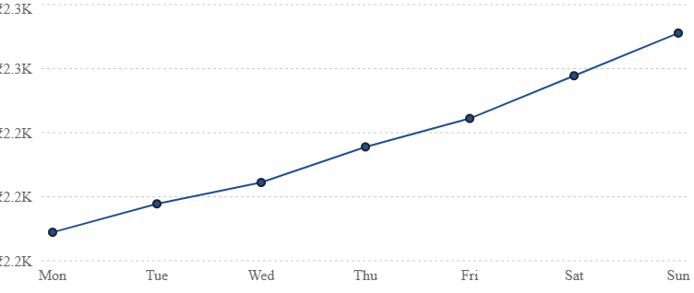
AI Selling Recommendation
Inputs:
- Harvest quantity
- Transport cost
- Moisture %
- Nearby mandis
Output:
Sell in Davanagere instead. Net profit +₹185/quintal.
Crop Disease
Farmer uploads leaf photo.
AI detects:
- Rust
- Blast
- Leaf spot
Returns treatment in local language.
WhatsApp Integration
Supported messages:
|
User Message
|
Bot Action
|
| --- | --- |
|
Wheat rate
|
Ask location
|
|
571201
|
Detect pincode
|
|
Voice
|
STT
|
|
Photo
|
Disease detection
|
|
Buy DAP
|
Dealer search
|
Implementation Roadmap
Phase 1 (Weeks 1–2): Foundation
Authentication, multilingual UI, language detection, voice input, State/District/Mandi selection, and AGMARKNET integration.

Agmarknet+1
Phase 2 (Weeks 3–4): Marketplace
Verified buyers, fertilizer dealers, WhatsApp chat, notifications, and admin dashboard.
Phase 3 (Weeks 5–6): AI Intelligence
Price prediction, crop advisory, disease detection, weather alerts, and analytics.
Final Deliverables
The AI should generate a complete production-ready solution containing:
- Full Next.js frontend
- FastAPI backend
- PostgreSQL schema
- AGMARKNET API integration
- Multilingual voice assistant
- WhatsApp Business integration
- Admin dashboard
- Buyer & dealer marketplace
- MSP calculator
- Price trend analytics
- Offline caching
- Docker deployment
- CI/CD pipeline
- API documentation (Swagger)
- Unit & integration tests
- English + Hindi + Kannada UI translations
This specification is designed for a real-world commercial agritech platform and explicitly requires official government mandi price integration through AGMARKNET/data.gov.in with multilingual, voice-first interactions.

Agmarknet+2
7-day maize modal price trend (example)
Illustrative trend visualization for one mandi.
day | price
Mon | 2,180
Tue | 2,200
Wed | 2,215
Thu | 2,240
Fri | 2,260
Sat | 2,290
Sun | 2,320

