**Dst Index Prediction**

**Introduction**

Disturbance storm time index(Dst) is a measure in context of space weather, there has been lot of research papers for the prediction of Dst index on the basis of different factors in interplanetary magnetic field (IMF) dataset. Here I giving an implementation of a research [paper](http://www.ae.metu.edu.tr/~ae454/AE454-GED594%20Term%20Paper_March2009.pdf) with such an attempt published in 20002.

**Implementation**

Here I choose to experiment the implement on the dataset timeline specified in the paper. Because they have come up with the reason why they choose the particular dataset & also their reasoning that the model fits with this data.

1. *Data preprocessing:*

In the dataset there are 55 variables, so to choose & pick , paper suggest to choose 4 variable which is significantly related to Dst.

Variables:

Bz = z coordinate of (IMF)

𝞼z = mean square of Bz

n = the plasma density of solar mind

v = bulk velocity of solar wind

Then there is data transformation in the interval (0,1)

2. Artificial neural network

In this paper they suggests Feed forward & recurrent neural network. By doing that & tuning it more I manage to match their results.

Here I am explaining the approach I used to make it more effective.

LSTM with 50 neurons & a LeakyRelu to get the output from 700 loops.

Suggestively the optimiser used is a adamprop.

*What Could Have done better:*

I think more loops & more neurons with same proportion as of now would have done better, results of CNN were not convincing nor of feed forward network.

**Results:**

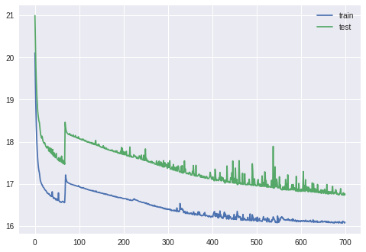

**Why this Implementation:**

I landed on this project very lately so to explore on this more I study this paper & decide to implement this rather than investing time elsewhere, cause there is very little time to proposal deadline. I really like this project, I would love to work on its proposal & project.