AWS Resources Created using Cloid froamtion Stack for VPC , Ec2 instances and Laod Balancer

**1.CF created confirmation**

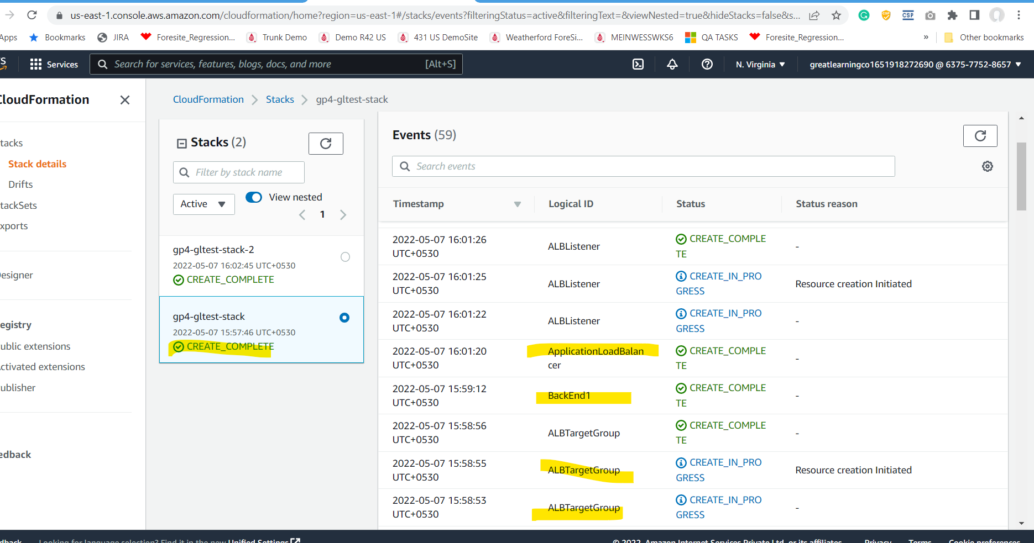

**2. Load Balancer created**

**3. Target Groups created**

4. **EC2 instances Running**

5. **Application Accessed from Load Balancer URL**

6. **Define Area Page**

**7. Confirmation from UI**

**8. Records inserted on MongoDB Atlas DB for area boudary**

**9. Bulk users added from a csv file**

**10. Resisted List of Taxis (from csv bulk add for demo)**

**11. User Register Form**

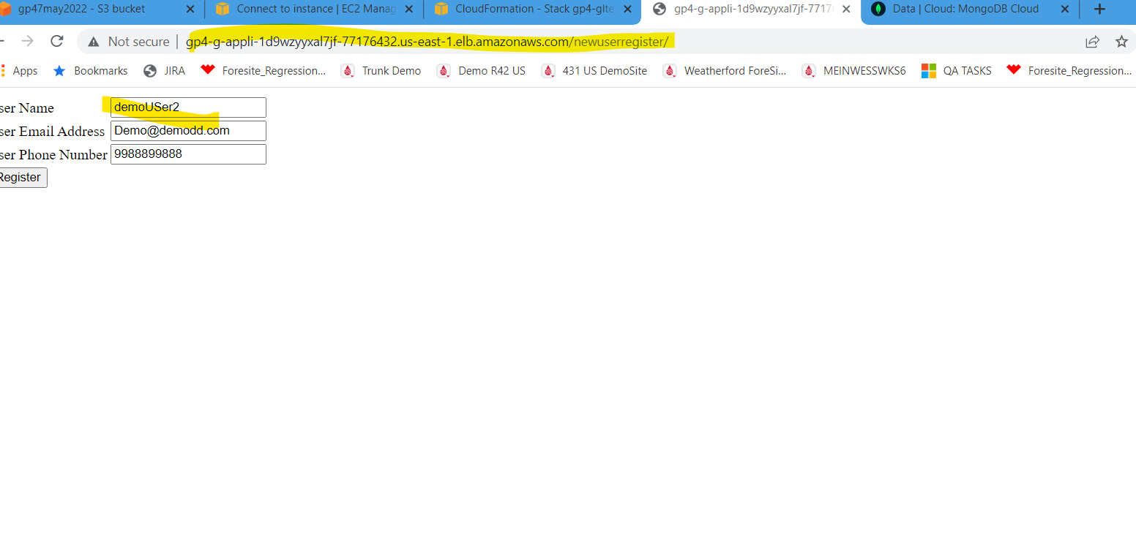

**12. API Response from UI confirmation**

**13. Retuned user from db shown from UI**

**14. Taxi Registration Form**

**15. Confirmation Message for Taxi Registration**

**16. Successful Taxi Booking message**

**17. Taxi Simulation Data:**

**18. Taxis Simulated Location Data published for 5 mins**

**19.Get the Nearest Taxi for User**

**20. Show Conformed Bookings**

**21. Show Simulated Lat Long Data for Users , Taxis and Nearest Taxis from Mongo DB ATLAS(Real time Map View)**

**AWS SNS Email notification for confirmed Taxi Booking (Advanced feature list)**

