# Recipe Maker Program

This program is a standalone java program which makes use of Apache CSV parser and GSON library to parse JSON string.

The program is pretty simple to use, Simply download the JAR file RecipeMakerByAjitabh.jar and run it from the command line using following command:

* java –jar RecipeMakerByAjitabh.jar c:\\aj\\pactera\\fridge.csv c:\\aj\\pactera\\recipes.json

Before running the program ensure you have download all three CSV files and 1 JSON file and placed them in the directory “c:\aj\pactera”

Change the path in above command as applicable to your folder hierarchy.

The program has been tested using JUnit and the tests can be run from the command line by providing third argument “test”to the above command as follows:

* java –jar RecipeMakerByAjitabh.jar c:\\aj\\pactera\\fridge.csv c:\\aj\\pactera\\recipes.json test

The screenshot for the sample test runs is attached:

* java –jar RecipeMakerByAjitabh.jar c:\\aj\\pactera\\fridge.csv c:\\aj\\pactera\\recipes.json

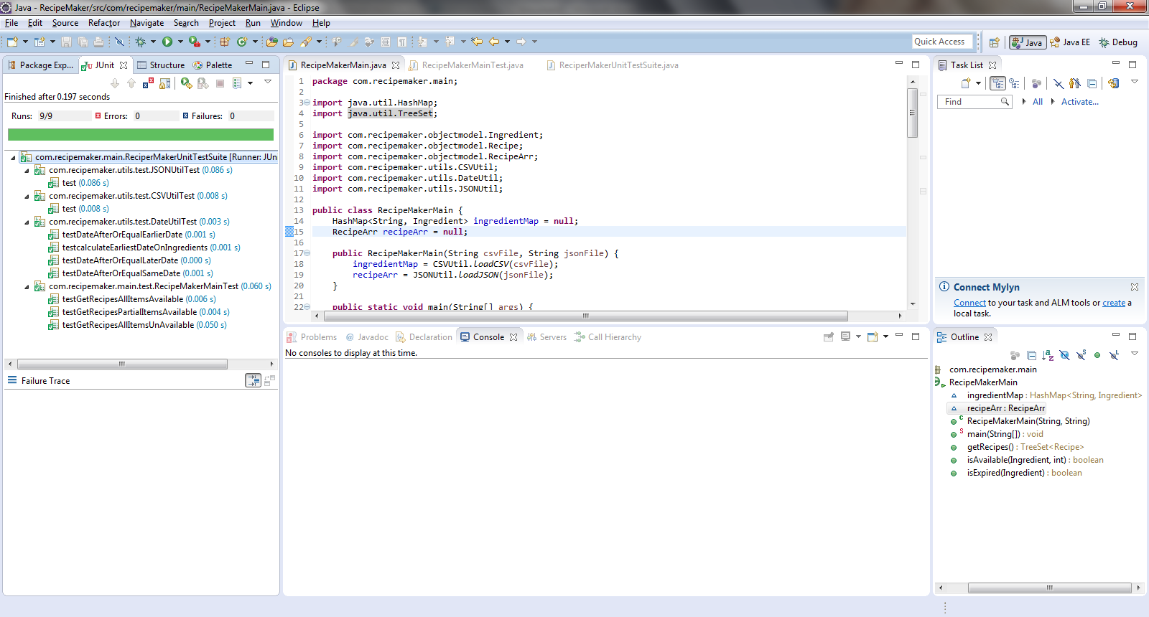

In order to fail some test cases, try renaming the files or expiring/unexpiring the ingredients from the fridge*.csv files.