A problem can be defined by 4 components

Initial state, successor functions, goal state and path cost

1.Initial State –

One or more states that describes the possible situations from where the problem-solving process starts.

2.Successor Function – Initial state and successor function together defined as state space which is all possible states reachable from initial state

3.Goal State -

Where we want to reach as destination

4.Path Cost (Optimal) –

A function that assigns some numeric value to each path

* AI => study of rational agent and its environment.
* **Agent**

anything that perceive its environment through sensors and act upon that environment through actuators. An Agent runs in the cycle of **perceiving**, **thinking** and **acting**.

* **Agents can be**

**human** (actuators: sense organs),

**robotic** (actuators: cameras, sensors),

**software** (actuators: keystrokes, file contents).

* **Sensor**: detects change in environment and sends information.
* **Actuators**: machine components that convert energy into motion. Responsible for moving and controlling a system.
* **Effectors**: devices which affect the environment.
* **Intelligent agents**: autonomous entity which act upon an environment using sensors and actuators for achieving goals.
* **Rational agents**: an agent which has clear preference, models uncertainty and acts in a way to maximize its performance measure with all possible actions.
* Following are the main **four rules for an AI agent**:

**Rule 1:** An AI agent must have the ability to perceive the environment.

**Rule 2:** The observation must be used to make decisions.

**Rule 3:** Decision should result in an action.

**Rule 4:** The action taken by an AI agent must be a **rational action**.

* Rationality can be judged on the basis of following points:

Performance measure which defines the success criterion.

Agent prior knowledge of its environment.

Best possible actions that an agent can perform.

The sequence of percepts.

* Agent = architecture (machinery that an ai agent executes on) + agent program (used to map a percept to an action)
* **PEAS** is a type of model on which an AI agent works upon. When we define an AI agent, we can group its properties under PEAS representation model. It is made up of four words:
* **P:** Performance measure
* **E:** Environment
* **A:** Actuators
* **S:** Sensors
* **Constraint Satisfaction Problems (CSP)**

Satisfiability problem, Scheduling, Timetabling, Graph colouring, Puzzles

Can be solved using Backtracking search (DFS),

* **Mean ends analysis algorithm**

It is a mixture of Backward and forward search technique.

Until the goal is reached or no more procedures are available:

* Define and evaluate the difference between Initial State and final State.
* Select the various operators which can be applied for each difference.
* Apply the operator at each difference, which reduces the difference between the current state and goal state.
* If goal is reached then success otherwise fail.
* **Operator subgoaling**

Sometimes if an operator cannot be applied to the current state, we create the subproblem of the current state, in which operator can be applied, in such type of cases, when sub goals are set up to establish the preconditions of the operator is called **Operator Subgoaling**.

* Varieties of constraint

• Unary Constraint

• Binary Constraint

• Higher-order Constraint

• Preferences / soft constraint

* **Unification** is a process of making two different logical atomic expressions identical by finding a substitution. Unification depends on the substitution process.

**Atomic sentences** are the most basic sentences of first-order logic. These sentences are formed from a predicate symbol followed by a parenthesis with a sequence of terms.

Process of finding substitutions for terms of variables to make the expressions identical is called unification.

The set of substitutions is called unifier.

* **Unification algorithm:**

**Step.1:** Initialize the substitution set to be empty.

**Step.2:** Recursively unify atomic sentences:

1. Check for Identical expression match.
2. If one expression is a variable vi, and the other is a term ti which does not contain variable vi, then:
   * 1. Substitute ti / vi in the existing substitutions
     2. Add ti /vi to the substitution setlist.
     3. If both the expressions are functions, then function name must be similar, and the number of arguments must be the same in both the expression.

**For each pair of the following atomic sentences find the most general unifier (If exist).**

* Horn clause: a clause containing at most one positive literal.
* **Resolution** is a theorem proving technique that makes the use of proofs by contradictions method to prove any theorem. It’s used when we have various statements given and we need to prove the conclusion.

Steps for Resolution:

1. Conversion of facts into first-order logic.
2. Convert FOL statements into CNF (conjunctive normal form).
3. Negate the statement which needs to prove (proof by contradiction)
4. Draw resolution graph (unification).

* **Resolution inference rule**: Resolution can resolve two clauses if they contain complementary literals, that is, they share no variables.

**Conjunctive Normal Form**: A sentence represented as a conjunction of clauses is said to be **conjunctive normal form** or **CNF**.

**Clause**: Disjunction of literals (an atomic sentence) is called a **clause**. It is also known as a unit clause.

* **Hill climbing algorithm** is a greedy **local search technique** which is used for optimizing the mathematical problems. It continuously moves in the direction of increasing elevation/value to find the peak of the mountain or best solution to the problem. It terminates when it reaches a peak value where no neighbour has a higher value.

It is mostly used when a good heuristic is available.

Problems in hill climbing algorithm:

* + **depending on the initial state, may get stuck at a local maximum**
  + **solution:** Backtracking technique can be a solution of the local maximum in state space landscape. Create a list of the promising path so that the algorithm can backtrack the search space and explore other paths as well.
  + **Plateau:** flat area of the search space in which all the neighbour states of the current state contains the same value, because of this algorithm does not find any best direction to move.
  + **Solution:** take big steps or very little steps while searching, to solve the problem. Randomly select a state which is far away from the current state so it is possible that the algorithm could find non-plateau region.
  + **Ridge:** a special form of the local maximum, looks like peak because movement in all possible directions is downward.
  + **Solution:** use of bidirectional search, or by moving in different directions, we can improve this problem.
* **Simulated Annealing**is an algorithm which yields both efficiency and completeness. In simulated annealing in the algorithm picks a random move, instead of picking the best move. If the random move improves the state, then it follows the same path. Otherwise, the algorithm follows the path which has a probability of less than 1 or it moves downhill and chooses another path.
* **Types of search algos:**

**Uninformed (no problem specific knowledge. Like bfs, dfs)**

**Informed (uses problem specific knowledge. Like greedy, a*)**

* **Best first search** is a traversal technique that decides which node is to be visited next by checking which node is the most promising one and then check it. It uses a cost function at each node to decide the traversal.The cost of nodes is stored in a **priority queue**. The **greedy best first search** technique of tree traversal uses a heuristic search or informed search technique. F(n) = h(n)
* **A*:** expands node with lowest value of *f (n) = g*(*n*) *+ h*(*n*)
* *g*(*n*) = cost to reach node from initial state
* *h*(*n*) = estimated cost to goal from current node
* **Depth first search:** search algorithm that always expands the deepest node in the frontier.Stack is used for traversal.

**Dis adv:** may stuck in infinite loop

* **Breadth first search:** search algorithm that always expands the shallowest node in the frontier. Queue is used for traversal.

**Adv:** provides minimal path to the goal

**Dis adv:** requires lots of storage and time

* **IDDFS**combines depth-first search’s space-efficiency and breadth-first search’s fast search. IDDFS calls DFS for different depths starting from an initial value. In every call, DFS is restricted from going beyond given depth. So basically, we do DFS in a BFS fashion.

**Adv:** guarantee of goal node at minimum depth

**Dis adv:** repetition of task

* **IDA\*** iterative deepening algorithm the cut- off for nodes expanded in iteration is decided by the f value of the nodes.
* If f val of node > limit, prune it and f limit = min cost of the pruned node.

**Strong AI** refers to machines that exhibit human intelligence. **They have** complex algorithms that helps them act in different situations, while all the actions in **weak AIs** are pre-programmed by a human. **Weak AIs** are the systems that are programmed to address a wide range of problems but operate within a pre-defined range of functions.

**Adversarial search** is a search, where we examine those problems which arise when we try to plan ahead of the world and other agents are planning against us.

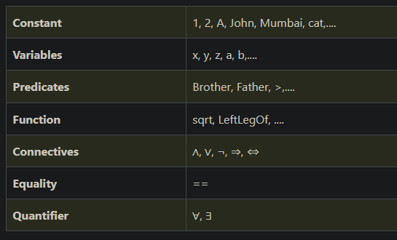

* A **quantifier** is a language element which generates quantification, and quantification specifies the quantity of specimen in the universe of discourse.

Eg: universal quantifier (for all), existential quantifier (there exists)

Types of ai:

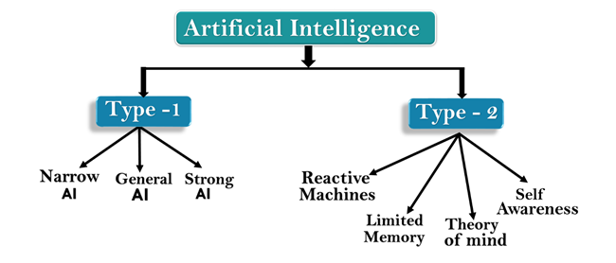

* Narrow AI
  + Type of AI which is able to perform a dedicated task with intelligence. The most common and currently available AI is Narrow AI in the world of Artificial Intelligence. Eg: Siri
* General AI
  + Type of intelligence which could perform any intellectual task with efficiency like a human. Currently, there is no such system exist.
* Strong/Super AI
  + It is a level of Intelligence of Systems at which machines could surpass human intelligence, and can perform any task better than human with cognitive properties.
* Reactive Machines
  + Purely reactive machines are the most basic types of Artificial Intelligence.
  + Such AI systems do not store memories or past experiences for future actions.
  + These machines only focus on current scenarios and react on it as per possible best action.
* Limited Memory
  + Limited memory machines can store past experiences or some data for a short period of time.
  + These machines can use stored data for a limited time period only.
  + Eg: self-driving cars
* Theory of Mind
  + Theory of Mind AI should understand the human emotions, people, beliefs, and be able to interact socially like humans.
  + This type of AI machines are still not developed
* Self-Awareness
  + Self-awareness AI is the future of Artificial Intelligence. These machines will be super intelligent, and will have their own consciousness, sentiments, and self-awareness.
  + These machines will be smarter than human mind.
* **Forward/backward chaining**: forward/backward deduction or reasoning while using an inference engine (ai component that infers new information by applying logic rules on facts and knowledge base provided to it).
* Types of environments:
  + - Fully Observable vs Partially Observable
    - Deterministic vs Stochastic
    - Competitive vs Collaborative
    - Single-agent vs Multi-agent
    - Static vs Dynamic
    - Discrete vs Continuous
    - Episodic vs Sequential
    - Known vs Unknown
    - Accessible vs Inaccessible
* Types of agents:
  + Simple Reflex Agent
    - The Simple reflex agents are the simplest agents. These agents take decisions on the basis of the current percepts and ignore the rest of the percept history.
    - These agents only succeed in the fully observable environment.
  + Model-based reflex agent
    - The Model-based agent can work in a partially observable environment, and track the situation.
    - These agents have the model of the knowledge of the world and based on the model they perform actions.
  + Goal-based agents

Apart from the knowledge of the world and information about the current state, goal-based agents also have the information about the final goal. They consider sequence of possible actions before deciding the final move.

* + Utility-based agent
    - These agents are similar to the goal-based agent but provide an extra component of utility measurement which makes them different by providing a measure of success at a given state.
    - The Utility-based agent is useful when there are multiple possible alternatives, and an agent has to choose in order to perform the best action.
  + Learning agent
    - A learning agent in AI is the type of agent which has learning capabilities. It can learn from its past experiences.
    - It starts to act with basic knowledge and then able to act and adapt automatically through learning.
    - 4 components: learning element, critics, performance element, performance generator.
* **Minimax algorithm** is a recursive or backtracking algorithm which is used in decision-making and game theory. It provides an optimal move for the player assuming that opponent is also playing optimally.
* **Alpha-beta pruning** is a modified version of the minimax algorithm. It is an optimization technique for the minimax algorithm.
* In the minimax search algorithm, the number of game states to be examined are exponential in depth of the tree. Since we cannot eliminate the exponent, but we can cut it to half. Hence there is a technique by which without checking each node of the game tree we can compute the correct minimax decision, and this technique is called pruning. This involves two threshold parameter Alpha and beta, so it is called alpha-beta pruning.
* **Knowledge-based agents** are those agents who have the capability of maintaining an internal state of knowledge, reason over that knowledge, update their knowledge after observations and take actions. These agents can represent the world with some formal representation and act intelligently.
* **Well-formed formula**
* 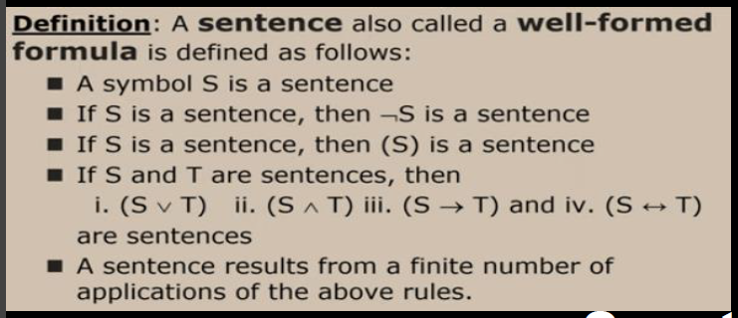
* **What is Expert System?**
* An Expert System contains knowledge about a specific field to assist human experts or provide information to people who do not have access to an expert in the particular field.
* An Expert System acts as intelligent assistants to human experts.
* What is **Planning**?

**AI Planning is a field of Artificial Intelligence which explores the process of using autonomous techniques to solve planning and scheduling problems**

* **Goal Stack Planning**
* In this method, the problem solver makes use of a single stack that contains both goals and operators.
* A database describes the current situation and a set of operators described as PRECONDITION, ADD and DELETE lists.
* **Hierarchical planning**
* To solve complex problems, long plans need to be generated. Planning starts with most complex action on the top. Firstly, its actions are decomposed. Then substitute the complex action with a plan of less complex actions. But the overall plan must generate the effect of the complex action.