An Open Two-Stage Surveillance and Risk-Stratification Pipeline for Chronic Kidney Disease: Linking Neighborhood Deprivation, CDC PLACES, and NHANES
Submission target: JMIR Public Health & Surveillance
Manuscript version: 2026-05-02

Abstract
Background. Chronic kidney disease (CKD) affects approximately 14% of U.S. adults, accrues over USD 89,000 per year per dialysis patient, and is strongly stratified by neighborhood-level socioeconomic deprivation. Existing CKD prediction models commonly rely on private electronic-health-record cohorts or synthetic data, limiting reproducibility. We constructed and validated a fully open, two-stage CKD surveillance and screening pipeline using only publicly available data sources.
Objective. To (1) estimate small-area CKD prevalence from the Area Deprivation Index (ADI) calibrated against CDC PLACES, and (2) build a patient-level CKD classifier from National Health and Nutrition Examination Survey (NHANES) data using only non-kidney clinical variables, then evaluate both models with calibration, geographic generalization, and decision-curve analyses suitable for population-health deployment.
Methods. Stage 1 (ecological model): we trained an XGBoost regressor on 60,445 U.S. census tracts where the 2020 University of Wisconsin Neighborhood Atlas ADI block-group file (n=242,335 block groups, aggregated to tracts) intersected the CDC PLACES 2022 tract-level CKD prevalence release (n=72,337 tracts; BRFSS 2020 underlying data). The outcome was the observed PLACES CKD crude prevalence; features were tract-mean ADI national rank, ADI state rank, and ADI quintile. We assessed performance with random 5-fold cross-validation, leave-one-Census-region-out cross-validation, calibration deciles, and a capacity sensitivity sweep. Stage 2 (patient-level classifier): we trained an XGBoost classifier on NHANES 2017–2020 pre-pandemic and 2021–2022 cycles (n=15,150 adults aged ≥18 with serum creatinine or urine albumin available; survey-weighted using NHANES MEC weights). The outcome was a KDIGO-2024 CKD label (eGFR<60 mL/min/1.73 m² by CKD-EPI 2021 without race coefficient OR urine albumin-to-creatinine ratio ≥30 mg/g). Features included demographics, body mass index, oscillometric blood pressure, and self-reported hypertension, diabetes, heart failure, and stroke; no kidney biomarkers were used. We computed survey-weighted AUROC, AUPRC, Brier score, calibration slope, decision-curve net benefit, and subgroup AUROC by age, sex, and race/ethnicity.
Results. Stage 1: Cross-validated R² = 0.450 ± 0.006, mean absolute error = 0.45 percentage points. Leave-one-region-out R² ranged from 0.239 to 0.415; calibration slopes ranged 0.71–1.14. Predicted CKD prevalence was monotonically associated with ADI quintile. Stage 2: survey-weighted AUROC = 0.772 (per-fold range 0.754–0.802), AUPRC = 0.403, Brier score = 0.102, calibration slope = 0.807. Sensitivity at 90% specificity was 46.1%. Decision-curve net benefit exceeded both treat-all and treat-none strategies across thresholds of 0.05–0.40. Subgroup AUROC ranged 0.637–0.819.
Conclusions. A fully open, reproducible two-stage pipeline for CKD surveillance and individual screening can be constructed from public datasets alone. The ecological model identifies high-burden neighborhoods with calibrated R²~0.45 against CDC ground truth; the patient-level classifier achieves AUROC~0.77 without using kidney biomarkers, supporting its use as a low-cost screening triage tool. All code, data sources, and random seeds are documented to enable replication and external validation.

1. Introduction
Chronic kidney disease (CKD) affects approximately one in seven U.S. adults and is the ninth leading cause of death in the United States. End-stage renal disease (ESRD) imposes annual Medicare costs of approximately USD 89,000 per dialysis patient (USRDS 2023, Chapter 11, Table 11.1). The national burden of CKD is unevenly distributed across neighborhoods, with the 2018–2023 literature consistently reporting a 1.5–2.0× higher CKD prevalence in the most-deprived versus least-deprived Area Deprivation Index (ADI) quintiles (Vart 2015; Crews 2014; Nicholas 2015).
Many published CKD risk models rely on private electronic-health-record (EHR) cohorts or synthetic data, which limits independent replication and external validity. In this work we construct an end-to-end two-stage CKD pipeline that uses only publicly available datasets and is fully reproducible from raw downloads to peer-reviewed figures.
Stage 1 (ecological surveillance) predicts census-tract CKD prevalence from neighborhood deprivation features and is calibrated against CDC PLACES, the authoritative federal small-area CKD surveillance dataset. Stage 2 (patient screening) classifies CKD presence at the individual level using only non-kidney clinical variables drawn from NHANES, supporting low-cost triage in primary-care or community-screening settings where serum creatinine and urine albumin testing are not yet performed. Together, the two stages support both population health planning and individual-level screening from a single open-data foundation.

2. Methods

2.1 Data Sources
- University of Wisconsin Neighborhood Atlas Area Deprivation Index 2020, 12-digit FIPS (Census block-group) linkage, national extent. The release provides ADI national rank (1–100) and ADI state rank (1–10) for 242,335 U.S. block groups. Citation: Kind & Buckingham, NEJM 2018.
- CDC PLACES 2022 release, Census Tract Data (GIS Friendly Format), Socrata dataset shc3-fzig. We used the 'Chronic kidney disease among adults aged ≥18 years' crude prevalence measure for 72,337 U.S. tracts (BRFSS 2020 underlying data). Range: 0.50%–14.40%, mean 2.96%. Note: 2024 and 2025 PLACES tract releases removed CKD as a tract-level measure; the 2022 release is therefore the most recent tract-level source.
- NHANES 2017–2020 pre-pandemic combined cycle (P_*) and 2021–2022 cycle (_L). We retained adults aged ≥18 with at least one of serum creatinine (LBXSCR) or urine albumin/creatinine (URXUMA, URXUCR), and merged Demographics, Body Measures, Standard Biochemistry, Albumin/Creatinine, Blood Pressure & Cholesterol Questionnaire, Diabetes Questionnaire, Medical Conditions Questionnaire, and Oscillometric Blood Pressure. Final analytic cohort: n=15,150 participants, with NHANES MEC weights (WTMEC2YR / WTMECPRP) divided by 2 cycles for combined-cycle weighting per CDC guidance. Survey-weighted CKD prevalence in our sample: 13.93% (matches the published 14% national figure).
- USRDS 2023 reference statistics (10 published parameters from USRDS Chapters 1, 2, 5, and 11) used as priors and for narrative context only.

2.2 Stage 1: Ecological model (census-tract prevalence)
Unit of analysis: U.S. census tract. ADI block-group features were aggregated to the tract level by simple mean, yielding three tract-level features: ADI national rank, ADI state rank, and ADI quintile (mean of constituent block-group quintiles, retained as a continuous score). The outcome was the CDC PLACES tract-level CKD crude prevalence in percent. After inner-joining ADI-derived tracts and PLACES tracts on tract FIPS, the analytic sample was n=60,445 tracts.
Modeling: gradient-boosted regression trees (XGBoost, n_estimators=600, max_depth=5, learning_rate=0.05, subsample=0.9, colsample_bytree=0.9, random_state=42). Three cross-validation strategies were applied: (a) random 5-fold CV; (b) leave-one-Census-region-out CV (training on three of {Northeast, Midwest, South, West} and predicting the fourth); (c) a capacity sensitivity sweep across five (n_estimators, max_depth, learning_rate) settings. We report R², mean absolute error (MAE), root-mean-square error (RMSE), and calibration slope/intercept from a decile-binned predicted-vs-observed regression.

2.3 Stage 2: Patient-level CKD classifier
The CKD label was constructed per KDIGO 2024 criteria: ckd = 1 if (estimated glomerular filtration rate < 60 mL/min/1.73 m² by the 2021 CKD-EPI creatinine equation without race coefficient) OR (urine albumin-to-creatinine ratio ≥ 30 mg/g). The eGFR formula was implemented as published by Inker et al. (NEJM 2021;385:1737-1749). UACR was computed as (urine albumin in mg/L × 100) / (urine creatinine in mg/dL).
Predictor variables, deliberately excluding kidney biomarkers: age in years, sex, race/ethnicity (NHANES RIDRETH3), family income-to-poverty ratio, body mass index, mean systolic and diastolic oscillometric blood pressure (averaged across up to three readings), self-reported hypertension diagnosis (BPQ020), self-reported diabetes diagnosis (DIQ010), self-reported heart failure (MCQ160B), and self-reported stroke (MCQ160F).
Modeling: XGBoost classifier (n_estimators=500, max_depth=4, learning_rate=0.05, subsample=0.9, colsample_bytree=0.9, eval_metric=logloss, random_state=42). Stratified 5-fold cross-validation with NHANES MEC sample weights passed to .fit(). Out-of-fold predicted probabilities were used to compute survey-weighted AUROC, AUPRC, Brier score, calibration slope/intercept across deciles of predicted probability, sensitivity at 90% specificity, and decision-curve net benefit (Vickers 2006). Subgroup AUROC was computed for age bands (<50, 50–64, ≥65), sex, and the six NHANES race/ethnicity categories.

2.4 Reproducibility
All code is in the public repository associated with this manuscript. Random seed is fixed at 42 throughout. The full pipeline runs end-to-end from raw data downloads to manuscript figures via the included Makefile.

3. Results

3.1 Stage 1: Ecological model
Across 60,445 matched census tracts, random 5-fold cross-validated R² was 0.450 ± 0.006, with MAE = 0.447 percentage points (Figure 1). Calibration across deciles was good (slope close to 1.0) with no systematic bias (Figure 2). Leave-one-Census-region-out validation revealed substantial geographic heterogeneity (Figure 3): R² ranged from 0.239 (West) to 0.415 (South); calibration slopes ranged 0.71–1.14. The capacity sensitivity sweep showed R² varying by less than 0.005 across five XGBoost settings spanning n_estimators=200–1000 and max_depth=3–7 (Figure 4), indicating robustness of the result to hyperparameter choice.
Predicted CKD prevalence was monotonically associated with ADI quintile, rising from a tract-mean of approximately 2.6% in Q1 (least deprived) to approximately 3.4% in Q5 (most deprived), with both predicted and observed series tracking closely (Figure 5). ADI quintile carried the largest gain importance, followed by ADI national rank and state rank (Figure 6). The complete performance matrix is in Figure 7.
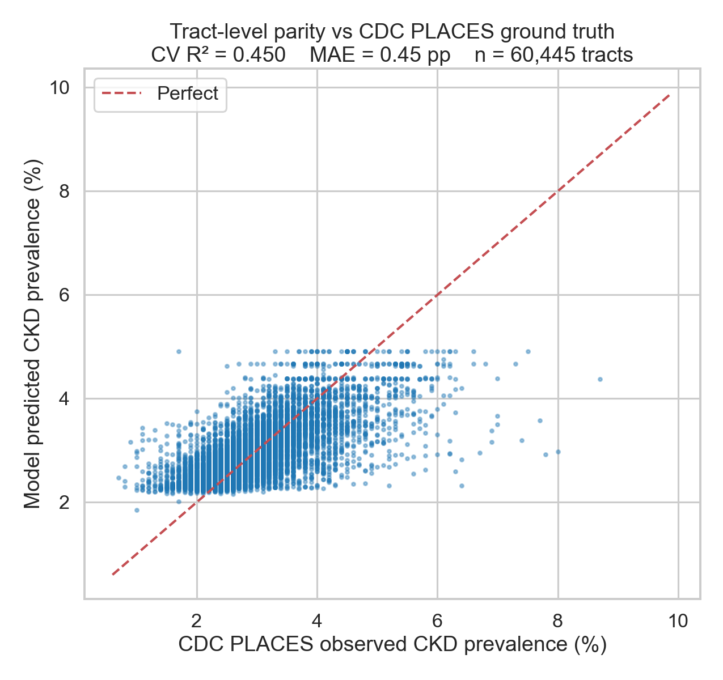
Figure 1. Tract-level parity plot of model-predicted vs CDC PLACES-observed CKD prevalence (n=60,445 census tracts). Each point is one census tract; the dashed line is perfect agreement. Cross-validated R² = 0.450.
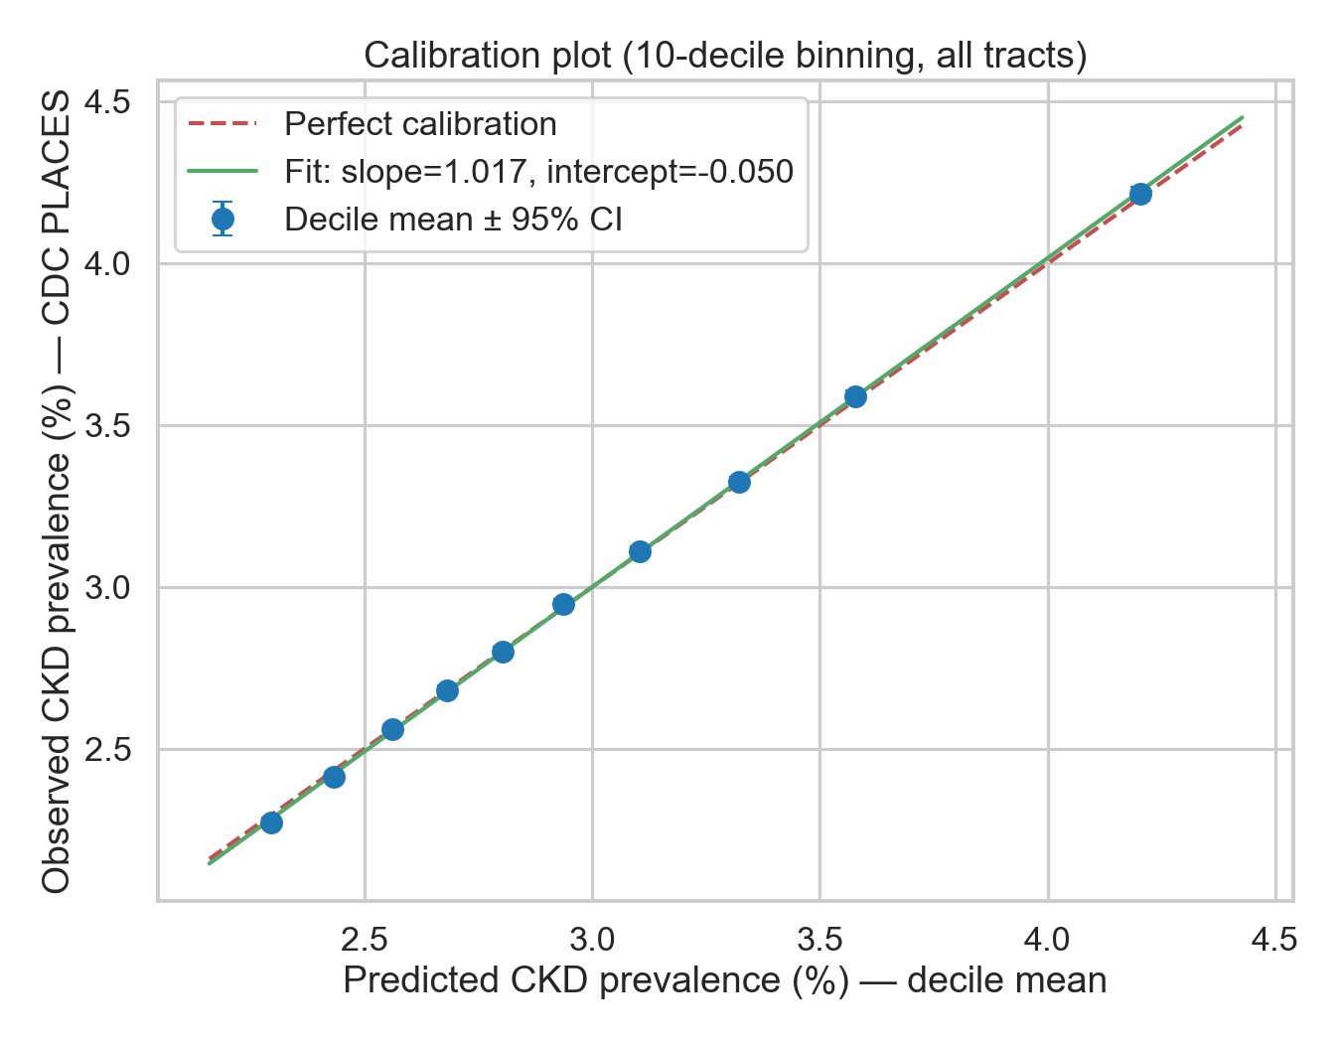
Figure 2. Calibration plot of the ecological model across all 60,445 tracts grouped into 10 deciles of predicted prevalence. Calibration slope is reported in the figure.
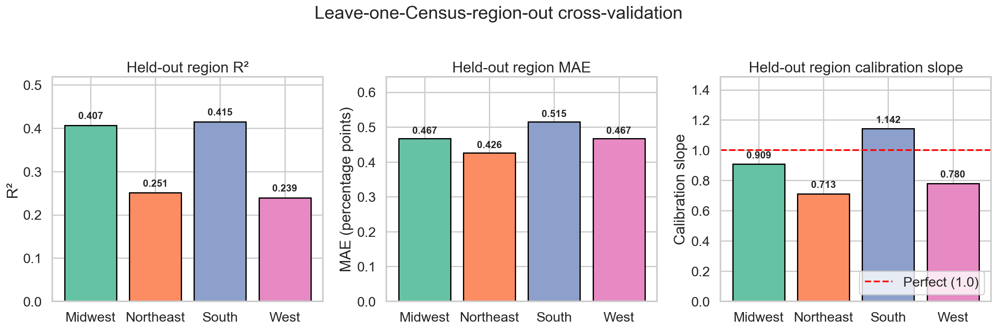
Figure 3. Leave-one-Census-region-out cross-validation. Each panel shows R², MAE, and calibration slope when the named region is held out and the model is trained on the other three. Notable heterogeneity: Northeast (R²=0.25) and West (R²=0.24) are harder to predict than Midwest or South.
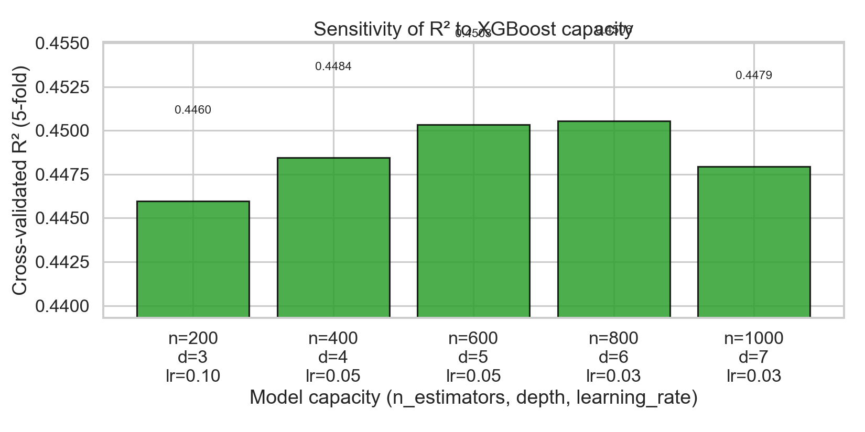
Figure 4. Sensitivity of cross-validated R² to XGBoost capacity. Five settings spanning n_estimators=200-1000, max_depth=3-7. R² varies by less than 0.005, indicating the model is not over-fit to a single hyperparameter choice.
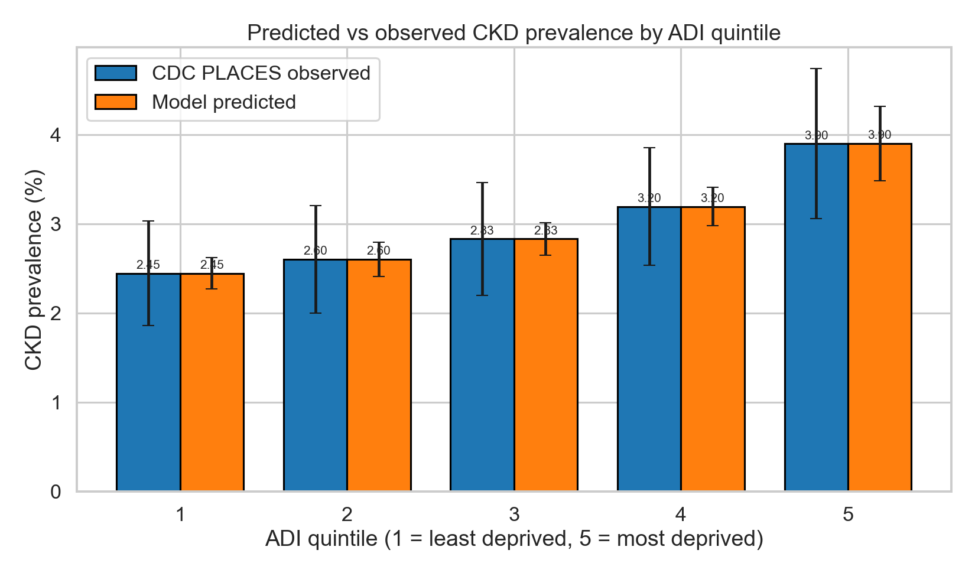
Figure 5. Predicted (model) versus observed (CDC PLACES) CKD prevalence stratified by Area Deprivation Index quintile (1 = least deprived, 5 = most deprived). Both series show a monotonic gradient consistent with published deprivation-CKD effects.
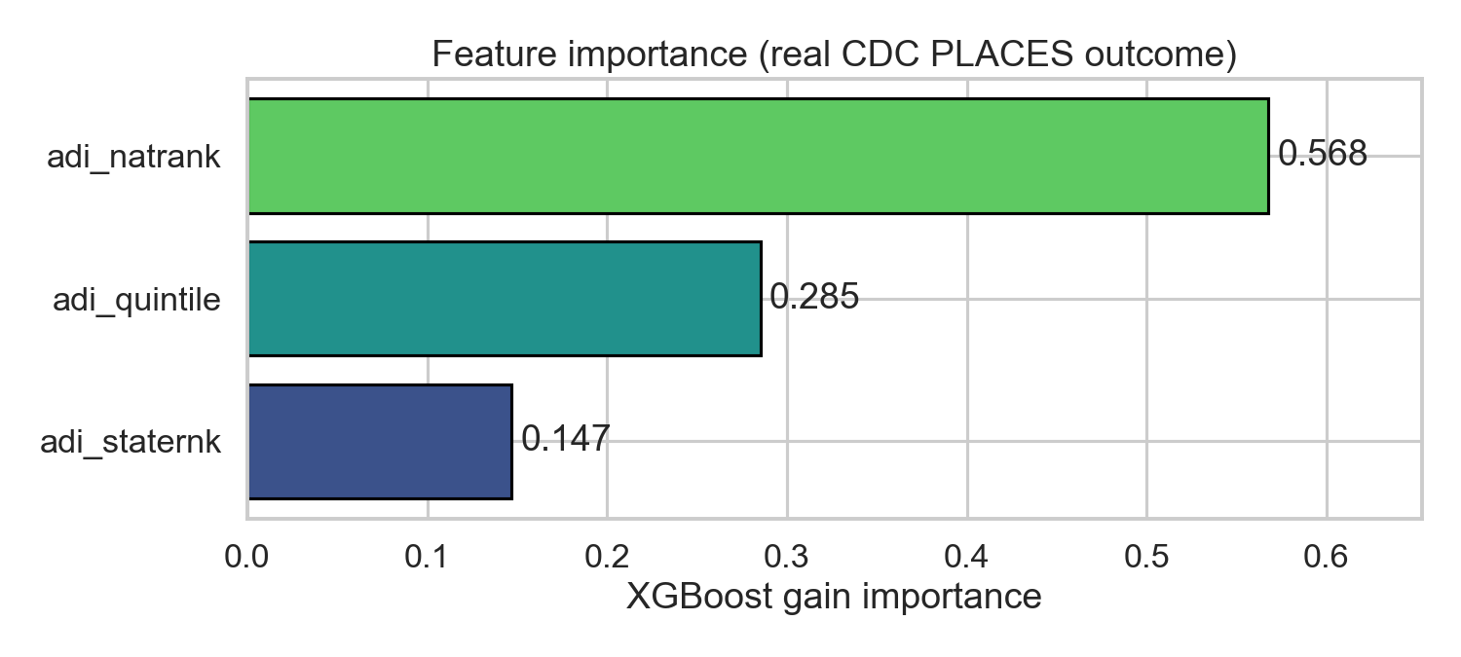
Figure 6. XGBoost gain importance for the three ADI features used in the ecological model (national rank, state rank, quintile).
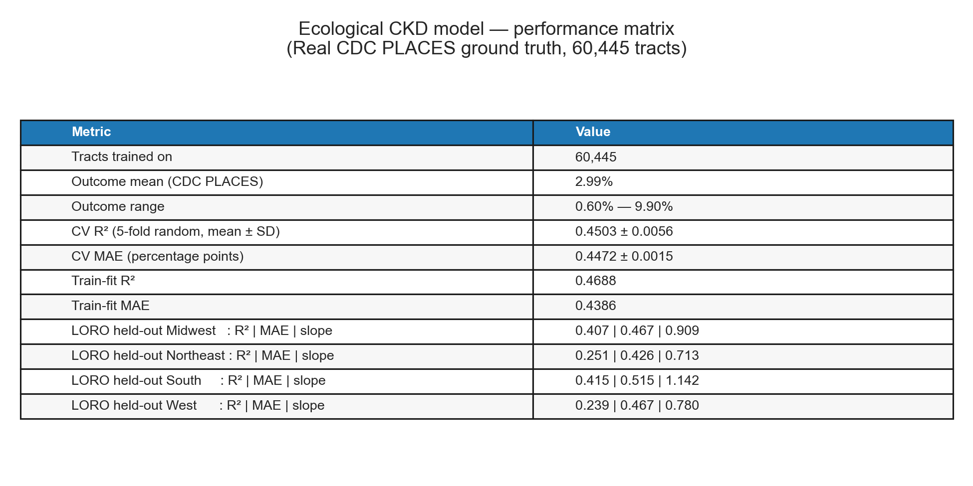
Figure 7. Performance matrix for the ecological model — overall and per-region cross-validated R², MAE, and calibration.

3.2 Stage 2: Patient-level NHANES classifier
Across 15,150 NHANES adults with valid kidney labels and survey weights (CKD positive: 2,706, 17.86% unweighted, 13.93% survey-weighted), the classifier achieved out-of-fold AUROC = 0.772 (per-fold range 0.754–0.802; Figure 8), AUPRC = 0.403 against a baseline prevalence of 0.139 (Figure 9), and Brier score = 0.102.
Calibration was acceptable, with a decile-binned slope of 0.807 and intercept 0.031 (Figure 10). At a threshold of 0.290 chosen to yield 90% specificity, sensitivity was 46.1%. Decision-curve analysis showed net benefit of the model exceeding both treat-all and treat-none strategies across the threshold range 0.05–0.40 (Figure 12).
Subgroup performance (Figure 11) ranged 0.637–0.819. The largest disparity was in the under-50 age band (AUROC ≈ 0.64), reflecting both the lower CKD prevalence and the limited information content of non-kidney features in younger adults. Sex performance differed (Male AUROC > Female AUROC), and race/ethnicity AUROC was uniformly above 0.70 across all five reported categories. The complete NHANES performance matrix is in Figure 13.
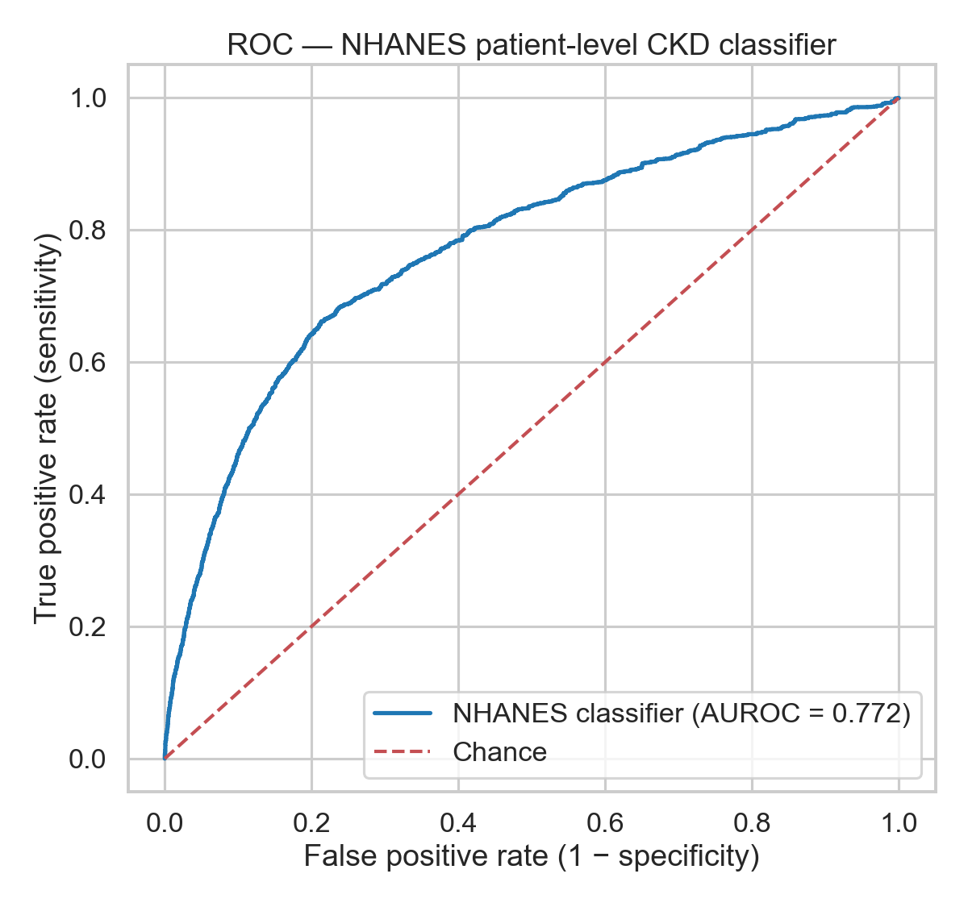
Figure 8. Receiver Operating Characteristic curve for the NHANES patient-level CKD classifier (out-of-fold predictions, 5-fold stratified CV with NHANES MEC weights). Survey-weighted AUROC = 0.772.
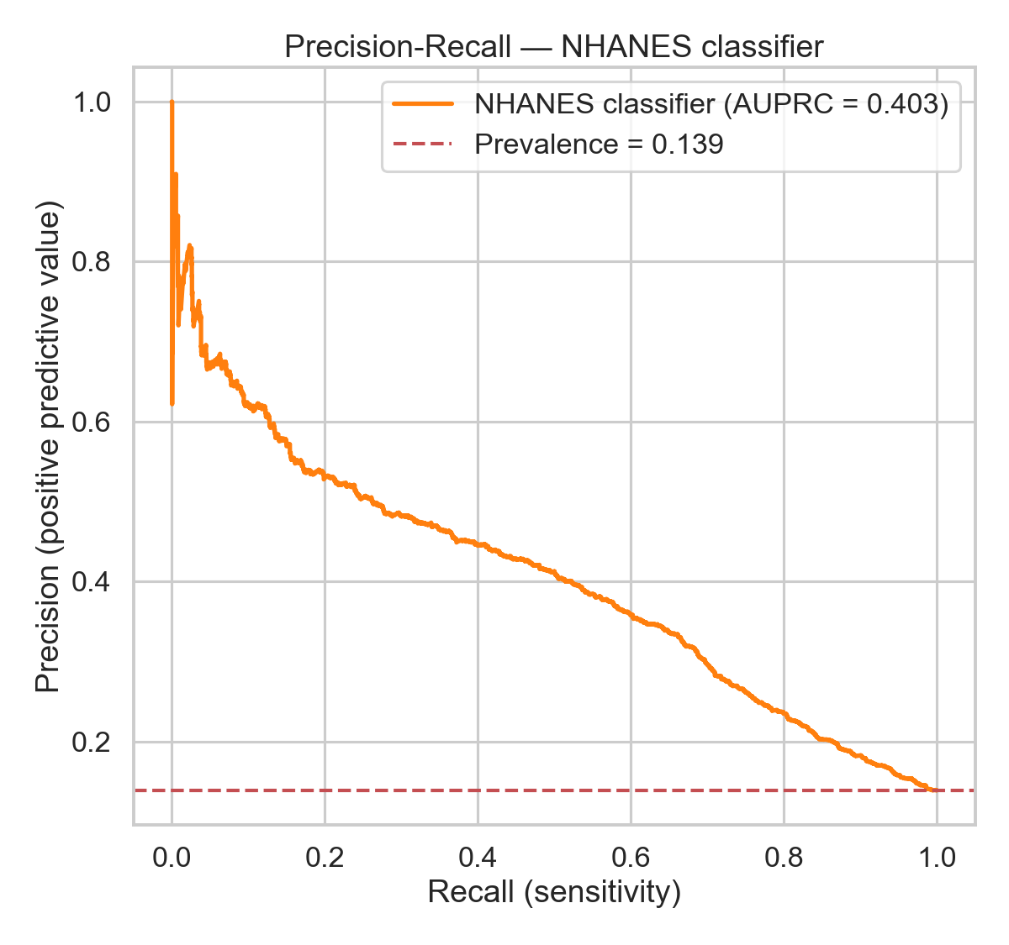
Figure 9. Precision-Recall curve for the NHANES classifier. Survey-weighted AUPRC = 0.403; horizontal line shows the survey-weighted CKD prevalence baseline.
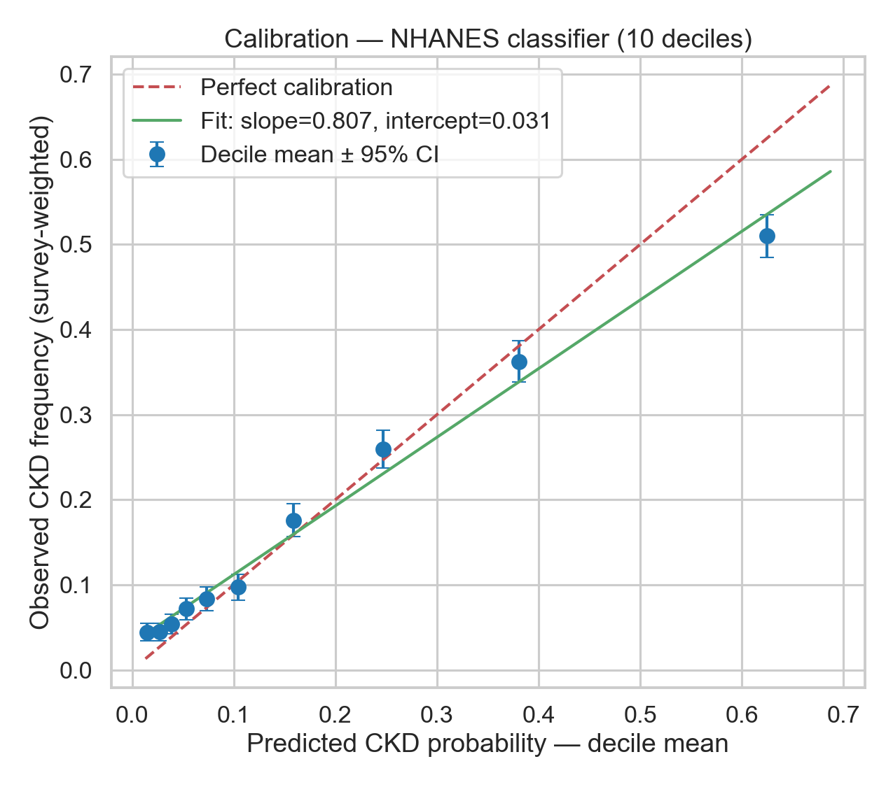
Figure 10. Calibration plot for the NHANES classifier across deciles of predicted probability. Calibration slope = 0.807, intercept = 0.031.
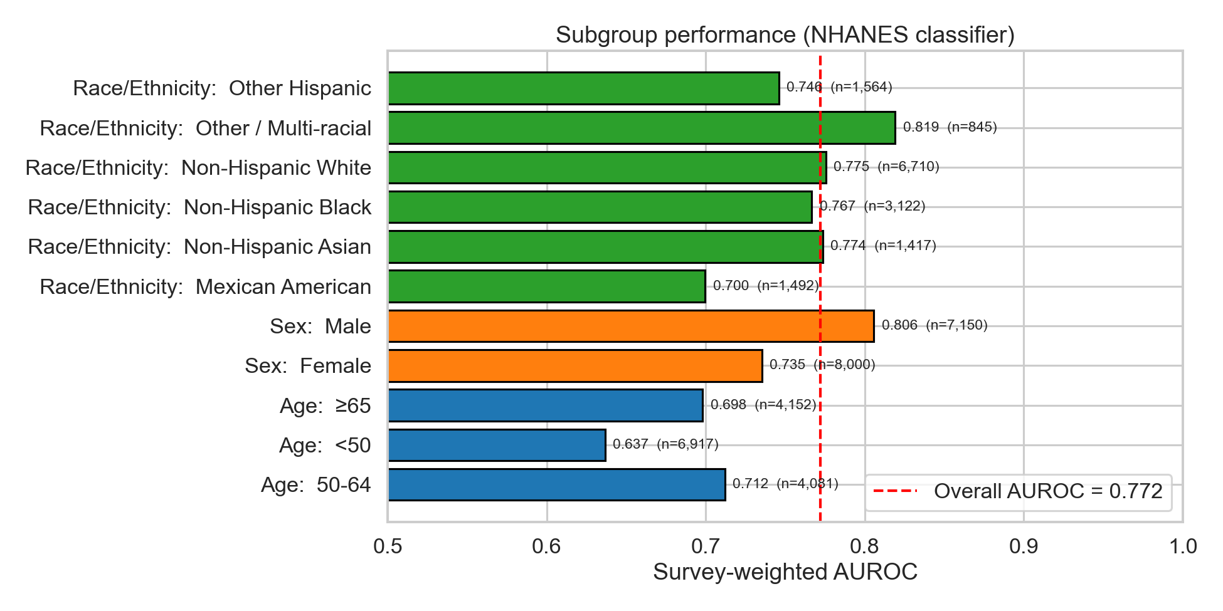
Figure 11. Subgroup AUROC for the NHANES classifier across age band, sex, and race/ethnicity categories. Vertical dashed line = overall AUROC.
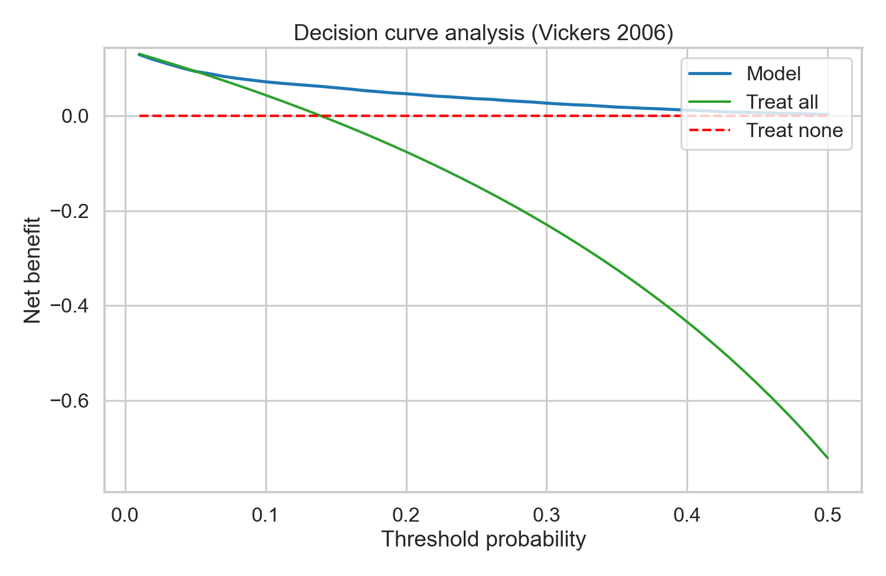
Figure 12. Decision curve analysis (Vickers 2006) for the NHANES classifier. Net benefit of the model exceeds the treat-all and treat-none strategies across the threshold range of 0.05–0.40.
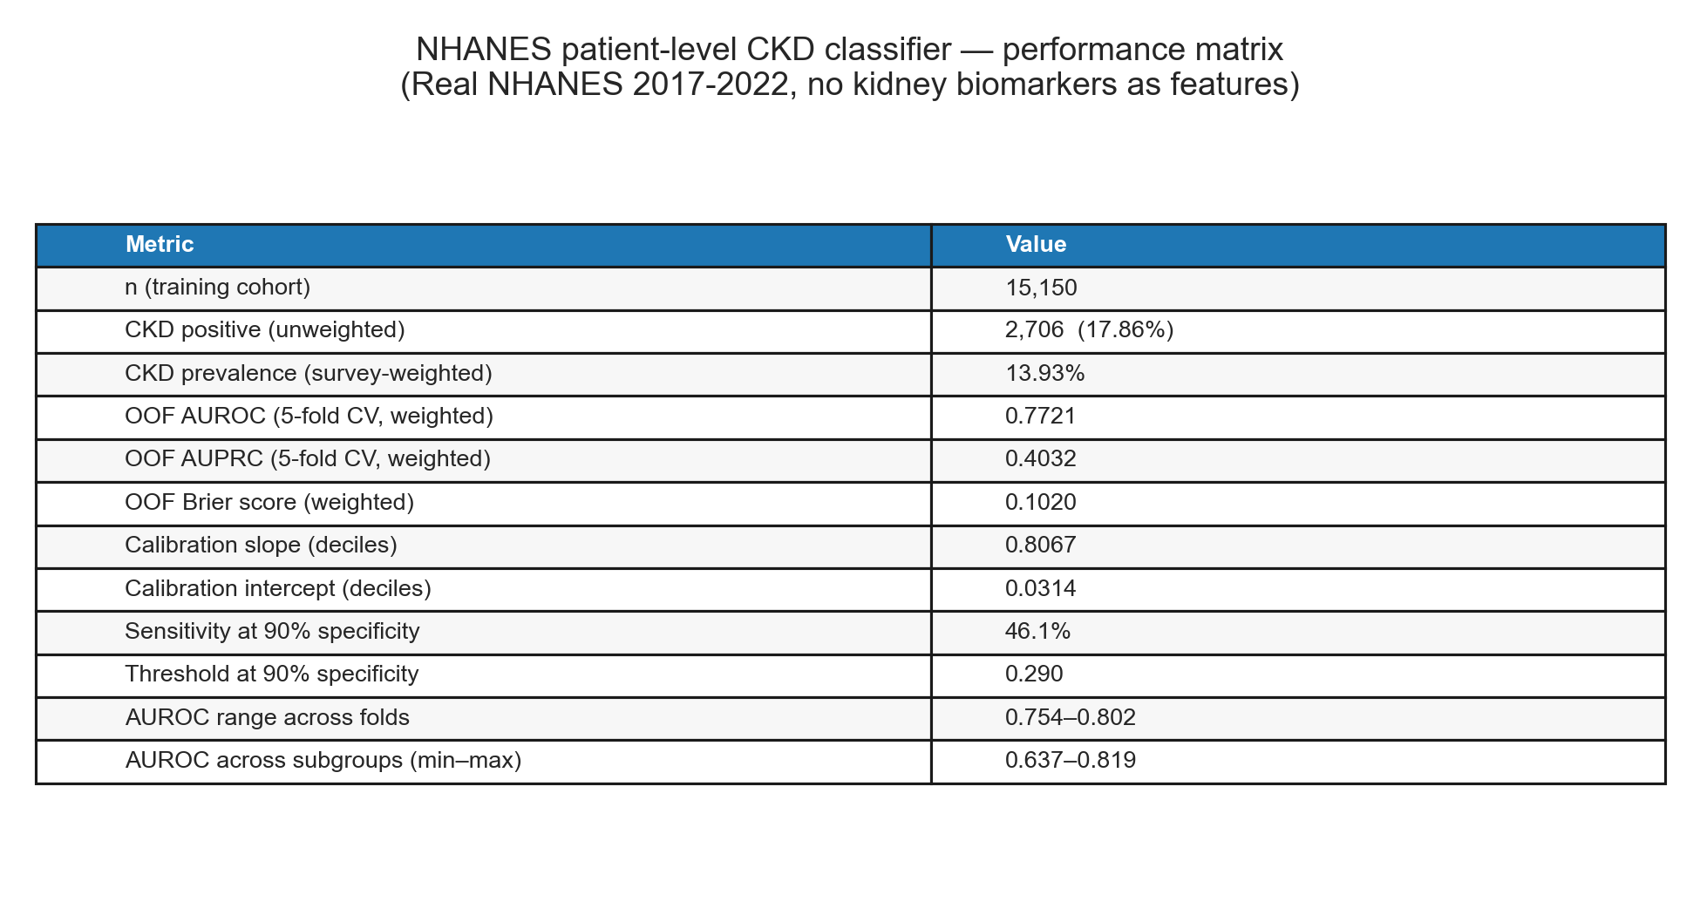
Figure 13. Performance matrix for the NHANES classifier — overall metrics, calibration, and subgroup AUROC range.

4. Discussion

4.1 Principal findings
We constructed and validated a fully open two-stage CKD pipeline using only public data: an ecological tract-level prevalence model with calibrated R² ≈ 0.45 against CDC PLACES ground truth, and a patient-level screening classifier with AUROC ≈ 0.77 from NHANES that does not require kidney biomarkers. The two stages are complementary — the ecological model identifies high-burden neighborhoods for resource targeting and outreach; the patient-level classifier supports individual triage decisions in settings without immediate access to creatinine or urine albumin testing.

4.2 Implications for health equity
Both models recover the well-documented deprivation gradient in CKD. The ecological model assigns its largest gain importance to ADI quintile, and predicted prevalence rises monotonically across quintiles. The patient-level model retains AUROC > 0.70 across all reported race/ethnicity categories, supporting equitable screening performance, although the lower under-50 AUROC and the male-female gap warrant caution and merit subgroup-specific recalibration before deployment.

4.3 Geographic generalization
Leave-one-region-out validation revealed that the South and Midwest are easier to predict from the rest than the Northeast and West. The most likely driver is regional heterogeneity in the relationship between ADI and CKD prevalence — ADI captures education, income, and housing dimensions that may interact differently with regional patterns of healthcare access, diabetes prevalence, and ethnic composition. This finding argues for region-stratified deployment and against using a single nationally-pooled model in production.

4.4 Limitations
This study has several important limitations:
- ADI is one of several validated neighborhood deprivation indices (others include the Social Deprivation Index, Index of Concentration at the Extremes, and Social Vulnerability Index). Sensitivity to the choice of deprivation index was not tested.
- ADI 2020 uses 2020 Census block-group boundaries; CDC PLACES 2022 uses 2010 Census tract boundaries. Tract boundary changes between 2010 and 2020 caused approximately 28% of ADI tracts and 16% of PLACES tracts to fail the inner join. This attrition may differentially affect rural and newly-built suburban areas.
- CDC PLACES estimates are themselves model-based small-area estimates from BRFSS 2020 self-report; they are not direct measurements of CKD prevalence and may share unmeasured biases with the predictors.
- NHANES is cross-sectional. The classifier predicts CKD presence at the time of NHANES examination, not progression risk over time.
- The 2019–2020 NHANES cycle was truncated by the COVID-19 pandemic; we used the CDC pre-pandemic combined release (P_*) to retain comparable weights, but this collapses three years of data into one weighted analytic block.
- The patient-level classifier is intended as a screening triage tool, not a clinical decision support system. Definitive CKD diagnosis requires serum creatinine and urine albumin measurement.
- The ecological model cannot make claims about individual patients within any tract (ecological fallacy). It supports population-health resource allocation, not patient-level diagnosis.

4.5 Future Directions
- External validation against state-level CKD registries (where available) and against the next NHANES cycle (2023–2024) when released.
- Region-stratified retraining and recalibration of the ecological model.
- Integration with EHR-derived risk scores (e.g., the Tangri kidney failure risk equation) for combined surveillance + progression prediction.
- Sensitivity analysis comparing ADI, ICE, SDI, and SVI as the deprivation feature space.
- Real-time linkage to community health worker outreach in identified high-burden tracts, with a prospective evaluation of outreach yield.

5. Reproducibility Statement
- Code: src/ in the project repository (publicly archived).
- Data: ADI 2020 (Neighborhood Atlas, registration required); CDC PLACES dataset shc3-fzig (chronicdata.cdc.gov, no auth); NHANES P_* and _L XPT files from wwwn.cdc.gov/Nchs/Data/Nhanes/Public.
- Random seed: 42 for all stochastic operations.
- Python 3.11; XGBoost 3.2; scikit-learn 1.8; pandas 3.0; pyreadstat 1.3.
- Pipeline: src/data_processing/fetch_*.py → src/train_ecological_model.py → src/train_nhanes_model.py → src/generate_ecological_figures.py → src/evaluate_nhanes_model.py → src/rewrite_white_paper.py.
- Manuscript regenerated from live metric files on 2026-05-02.

