IEEE Std 830-1998 SOFTWARE REQUIREMENTS SPECIFICATION
AgriVision: Intelligent Agronomy, Leaf Pathology & Mandi Advisory System
A Unified Multilingual PWA Platform for Smallholder Farmers in Maharashtra, India
Document Version | 2.0.0 (Production Release Architecture)
Standard Compliance | IEEE Std 830-1998 (Recommended Practice for SRS)
System Architecture | React 18 PWA + Flask 3.0 Gateway + FastAPI ML Engine (EfficientNet-B0 + XGBoost)
Domain Coverage | 38 Crop Leaf Diseases, 15L Knapsack Sprays, Dynamic Soil pH Curves, 8 Pune APMC Mandis
Language Localization | Marathi (मराठी), Hindi (हिंदी), Indian English (En-IN) with Audio TTS
Performance Baseline | Apache JMeter Validated: 3,500 Requests, 0.00% Error Rate, 3.40ms Latency, 110.1 TPS

1. Introduction
1.1 Purpose
This Software Requirements Specification (SRS) establishes the complete functional, interface, performance, and architectural requirements for AgriVision, an AI-augmented agricultural decision support system. AgriVision is specifically engineered to resolve critical information asymmetries experienced by smallholder and marginal farmers across Maharashtra and semi-arid agro-ecological zones. This specification adheres rigorously to the IEEE Std 830-1998 standard.
1.2 Document Conventions & Definitions
Requirements in this document follow the standard RFC 2119 keyword conventions: SHALL indicates a mandatory requirement, SHOULD denotes a strongly recommended requirement, and MAY indicates an optional extension. Specialized agronomic and computing terminology used throughout includes:
APMC Mandi | Agricultural Produce Market Committee: Regulated physical market yards (e.g., Pune Gultekdi, Khed, Baramati).
15L Knapsack | Standard manual shoulder-mounted backpack sprayer (15 Litre water volume) used by Indian farmers.
Sodic / Alkaline Soil | Soil having pH > 8.2 with high exchangeable sodium percentage requiring Gypsum (जिप्सम) amendment.
Acidic Soil | Soil having pH < 5.5 with aluminum/manganese toxicity requiring Agricultural Lime (चूना) amendment.
Hick-Hyman Law | HCI principle stating decision response time scales logarithmically with the number and complexity of choices.
Fitts's Law | HCI model specifying the time required to rapidly move to a target area as a function of distance and size (48px touch targets).
1.3 Intended Audience and Reading Suggestions
This document is intended for software engineers, machine learning researchers, agricultural extension officers (KVK / Krishi Vigyan Kendra scientists), UI/UX designers, and academic evaluators. Section 3 details the user and API interfaces; Section 4 specifies functional requirements; Section 5 defines non-functional performance benchmarks from JMeter load tests; and Section 6 provides formal UML diagrams.
1.4 Project Scope and Objectives
AgriVision eliminates predatory agrochemical over-prescription and emergency distress selling by providing four core pillars on a single unified platform: (1) Instant computer vision disease diagnosis with exact 15L knapsack dosages, (2) Dynamic non-linear soil pH crop yield forecasting, (3) Real-time APMC Mandi price discovery with 7-day momentum forecasts, and (4) A 24/7 vernacular AI agronomist (Krishi Mitra) with dual speech recognition and text-to-speech synthesis.
1.5 References
- IEEE Std 830-1998: IEEE Recommended Practice for Software Requirements Specifications.
- Indian Council of Agricultural Research (ICAR): Handbook of Agriculture, 7th Edition, New Delhi (2024).
- Ministry of Agriculture & Farmers Welfare: Agmarknet APMC Daily Market Price Dissemination Standard (2024).
- Open-Meteo Meteorological Archive & Real-time Global Weather API Specification (v1.4, 2024).
2. Overall Description
2.1 Product Perspective & Architectural Topology
AgriVision operates as a high-performance Progressive Web Application (PWA) client coupled to a dual-tier Python microservice backend. The architectural layers comprise:
- Presentation Layer: Vite + React 18 PWA utilizing Tailwind CSS, Lucide icons, Web Speech Synthesis API, and offline IndexedDB.
- API Gateway Layer: Python Flask 3.0 REST Gateway (:5000) orchestrating request routing, user authentication, and data transformation.
- Deep Learning Inference Tier: FastAPI Service (:8000) hosting Keras EfficientNet-B0 (38 classes) and ICAR non-linear yield regression engines.
- Data Persistence Layer: Relational SQLite/PostgreSQL database storing farmer profiles, field acreage, and cached APMC daily arrivals.
2.2 User Classes and User Personas
Field user research conducted across Pune rural districts revealed three distinct operational archetypes:
Persona Profile | Agricultural Context | Primary AgriVision Use Case
Bandu Patil (Age 48)  Marginal Farmer, Daund | 2.5 Acres Black Soil; Cultivates Soybean & Cotton; 2G/4G budget Android phone; Semi-literate. | Relies heavily on Marathi Voice Assistant and 15L Knapsack chemical spray dosages to avoid pesticide seller scams.
Rukmini Shinde (Age 39)  SHG Leader, Shirur | 3.0 Acres Medium Black; Vegetables, Onion & Floriculture; Active smartphone user. | Uses live Mandi price alerts to schedule truck dispatch to Gultekdi and checks soil pH to treat alkaline sodic patches.
Dattatray Deshmukh (Age 55)  Commercial Grower, Baramati | 12 Acres Well-Irrigated; Sugarcane, Pomegranate, Wheat; Tech-forward. | Simulates custom soil lab NPK & pH sliders to maximize quintals per hectare and tracks 7-day Mandi price momentum.
2.3 Operating Environment & Technical Stack
Client: Android 8.0+ Chrome / Mobile Safari with WebRTC camera permissions, Web Speech API, and PWA ServiceWorker support.
Server: Ubuntu 22.04 LTS / Windows Server 2022, Python 3.10+, Node.js 18 LTS, PyTorch / TensorFlow 2.15, XGBoost, Uvicorn.
2.4 Design & Implementation Constraints
- Network Bandwidth: Must operate smoothly under intermittent 3G rural cellular connections with aggressive payload compression.
- Phytotoxicity Safety: Chemical remediation outputs must strictly enforce 15L knapsack tank proportions with mandatory protective gloves/mask warnings.
- Cognitive Usability: In compliance with Hick-Hyman Law, diagnostic screens must present no more than 3 primary actionable choices at any given step.
3. External Interface Requirements
3.1 User Interfaces (HCI & Ergonomics)
The AgriVision UI enforces Fitts's Law by providing touch targets of at least 48x48 dp for all primary actions. Diagnostic reports utilize high-contrast visual status cards (Emerald Green for Safe/Optimal, Amber for Moderate/Warning, and Crimson Red for High Risk/Severe Disease). Trilingual switching (Marathi, Hindi, English) is persisted in localStorage and seamlessly synchronized with the Web Speech speech synthesis voice.
3.2 Hardware Interfaces
The system interfaces with standard smartphone hardware: (1) Rear Camera autofocus module via HTML5 MediaStream API for instant leaf capture at 1080p, (2) GPS Receiver via HTML5 Geolocation API for automatic weather coordinates, and (3) Audio Microphones/Speakers for speech synthesis and voice input.
3.3 Software Interfaces & External REST APIs
1. Open-Meteo Meteorology API: Fetches hourly relative humidity, wind velocity, and precipitation probability to compute spray windows.
2. Pune APMC Mandi Data Source: Ingests daily modal prices across 8 regional market yards (Gultekdi, Khed, Baramati, Junnar, etc.).
3. Google Gemini 2.5 Generative AI: Augments the Krishi Mitra advisory engine with context-grounded agronomic dialogues.
4. Functional Requirements
FR-1: Multilingual Authentication & Onboarding
The system SHALL allow farmers to authenticate via mobile phone number and choose Marathi (मराठी), Hindi (हिंदी), or English as their primary interface. All UI labels, audio feedback, and diagnosis text SHALL immediately reflect the selected locale.
FR-2: AI Deep Learning Crop Leaf Disease Identification
The system SHALL accept mobile camera photos and classify plant health across 38 distinct botanical classes with >95% accuracy. The response SHALL complete in <500 ms and return top-3 probability confidence rankings.
FR-3: Pathology Intelligence & 15L Knapsack Spray Advisory
Upon disease detection, the system SHALL automatically query the DiseaseKnowledgeEngine to return: (a) Pathogen genus/type (fungal, bacterial, viral), (b) Outbreak triggers (humidity >85%, temps 18-24°C), (c) Exact 15L knapsack chemical spray dosages (e.g., Mancozeb 75% WP @ 30-35g / 15L water), and (d) Organic bio-control remedies (Neem Oil, Trichoderma viride).
FR-4: Dynamic Soil pH & Field Yield Prediction Engine
The system SHALL provide a continuous soil pH slider (4.0 to 10.0). When pH deviates from optimal ranges, the system SHALL apply a non-linear stress penalty curve: Yield = BaseYield * (1 - 0.28 * |pH - 6.8|^1.55). In strongly acidic soils (pH < 5.5), the system SHALL issue Lime (चूना) recommendations; in alkaline sodic soils (pH > 8.2), it SHALL issue Gypsum (जिप्सम) recommendations. The UI SHALL calculate both Quintals per Hectare and Total Farm Yield (Quintals) based on user acreage.
FR-5: APMC Mandi Real-Time Price Tracking & 7-Day Forecasting
The system SHALL stream daily arrivals, minimum, maximum, and modal prices across 8 Pune APMC market yards. The system SHALL compute 7-day momentum trends (Bullish / Stable / Bearish) and trigger price alerts when commodity rates exceed farmer-defined thresholds.
FR-6: 24/7 AI Vernacular Agronomist Voice Assistant (Krishi Mitra)
The system SHALL provide a conversational agronomist supporting Marathi and Hindi voice interactions. When the user taps the speaker button, the system SHALL synthesize speech using the native Devanagari voice corresponding to the selected language.
FR-7: Meteorological Spray Window Advisory
The system SHALL evaluate hourly wind speeds and rainfall forecasts to output an operational spraying rating: 'EXCELLENT' (Wind < 10 km/h, RH 50-70%), 'CAUTION' (Wind 12-20 km/h), or 'DO NOT SPRAY' (Rain imminent or Wind > 20 km/h).
FR-8: Offline-First PWA Synchronization
The system SHALL cache recent diagnostic history, mandi prices, and soil profiles in IndexedDB. In offline mode, the PWA SHALL queue field records and synchronize transparently upon network restoration.
5. Non-Functional Requirements & Performance Benchmarks
5.1 Apache JMeter Load & Stress Testing Benchmark
AgriVision was subjected to rigorous performance validation using Apache JMeter 5.6.3 executing a ramped multi-thread test plan. The empirical findings are summarized below:
Testing Metric | Target Specification | Empirical JMeter Result
Total Synthetic Requests | >= 3,000 transactions | 3,500 Completed HTTP Transactions
Error Rate (%) | < 1.00% | 0.00% (Zero dropped or failed requests)
Average Response Latency | < 50.0 ms | 3.40 ms (Sub-5ms response across all endpoints)
Peak System Throughput | >= 80 transactions/sec | 110.1 Transactions Per Second (TPS)
99th Percentile Latency | < 100.0 ms | 12.00 ms (Predictable worst-case performance)
5.2 Security, Reliability & Usability
Security: Farmer session tokens SHALL utilize SHA-256 JWTs with a 24-hour expiration. Zero unencrypted personal identifiable information (PII) is stored.
Availability: System architecture targets 99.9% uptime with automated health checks at /api/health.
Usability: In accordance with Hick-Hyman Law, all primary workflows (diagnosis, yield calculation, price query) SHALL require <= 3 taps from the home screen.

6. UML System Architecture Diagrams
This section embeds the four standard UML software engineering architectural diagrams generated at 300 DPI for AgriVision. All diagrams are also persisted locally in the project repository at docs/uml/.
6.1 System Use Case Diagram
Figure 6.1 defines the system boundary, primary actor (Farmer), secondary actor (Agricultural Extension Officer), and external backend services (EfficientNet ML, APMC Mandi APIs, Gemini AI). Key relationships include <<include>> dependencies for pathogen enrichment and <<extend>> flows for soil pH adjustment.
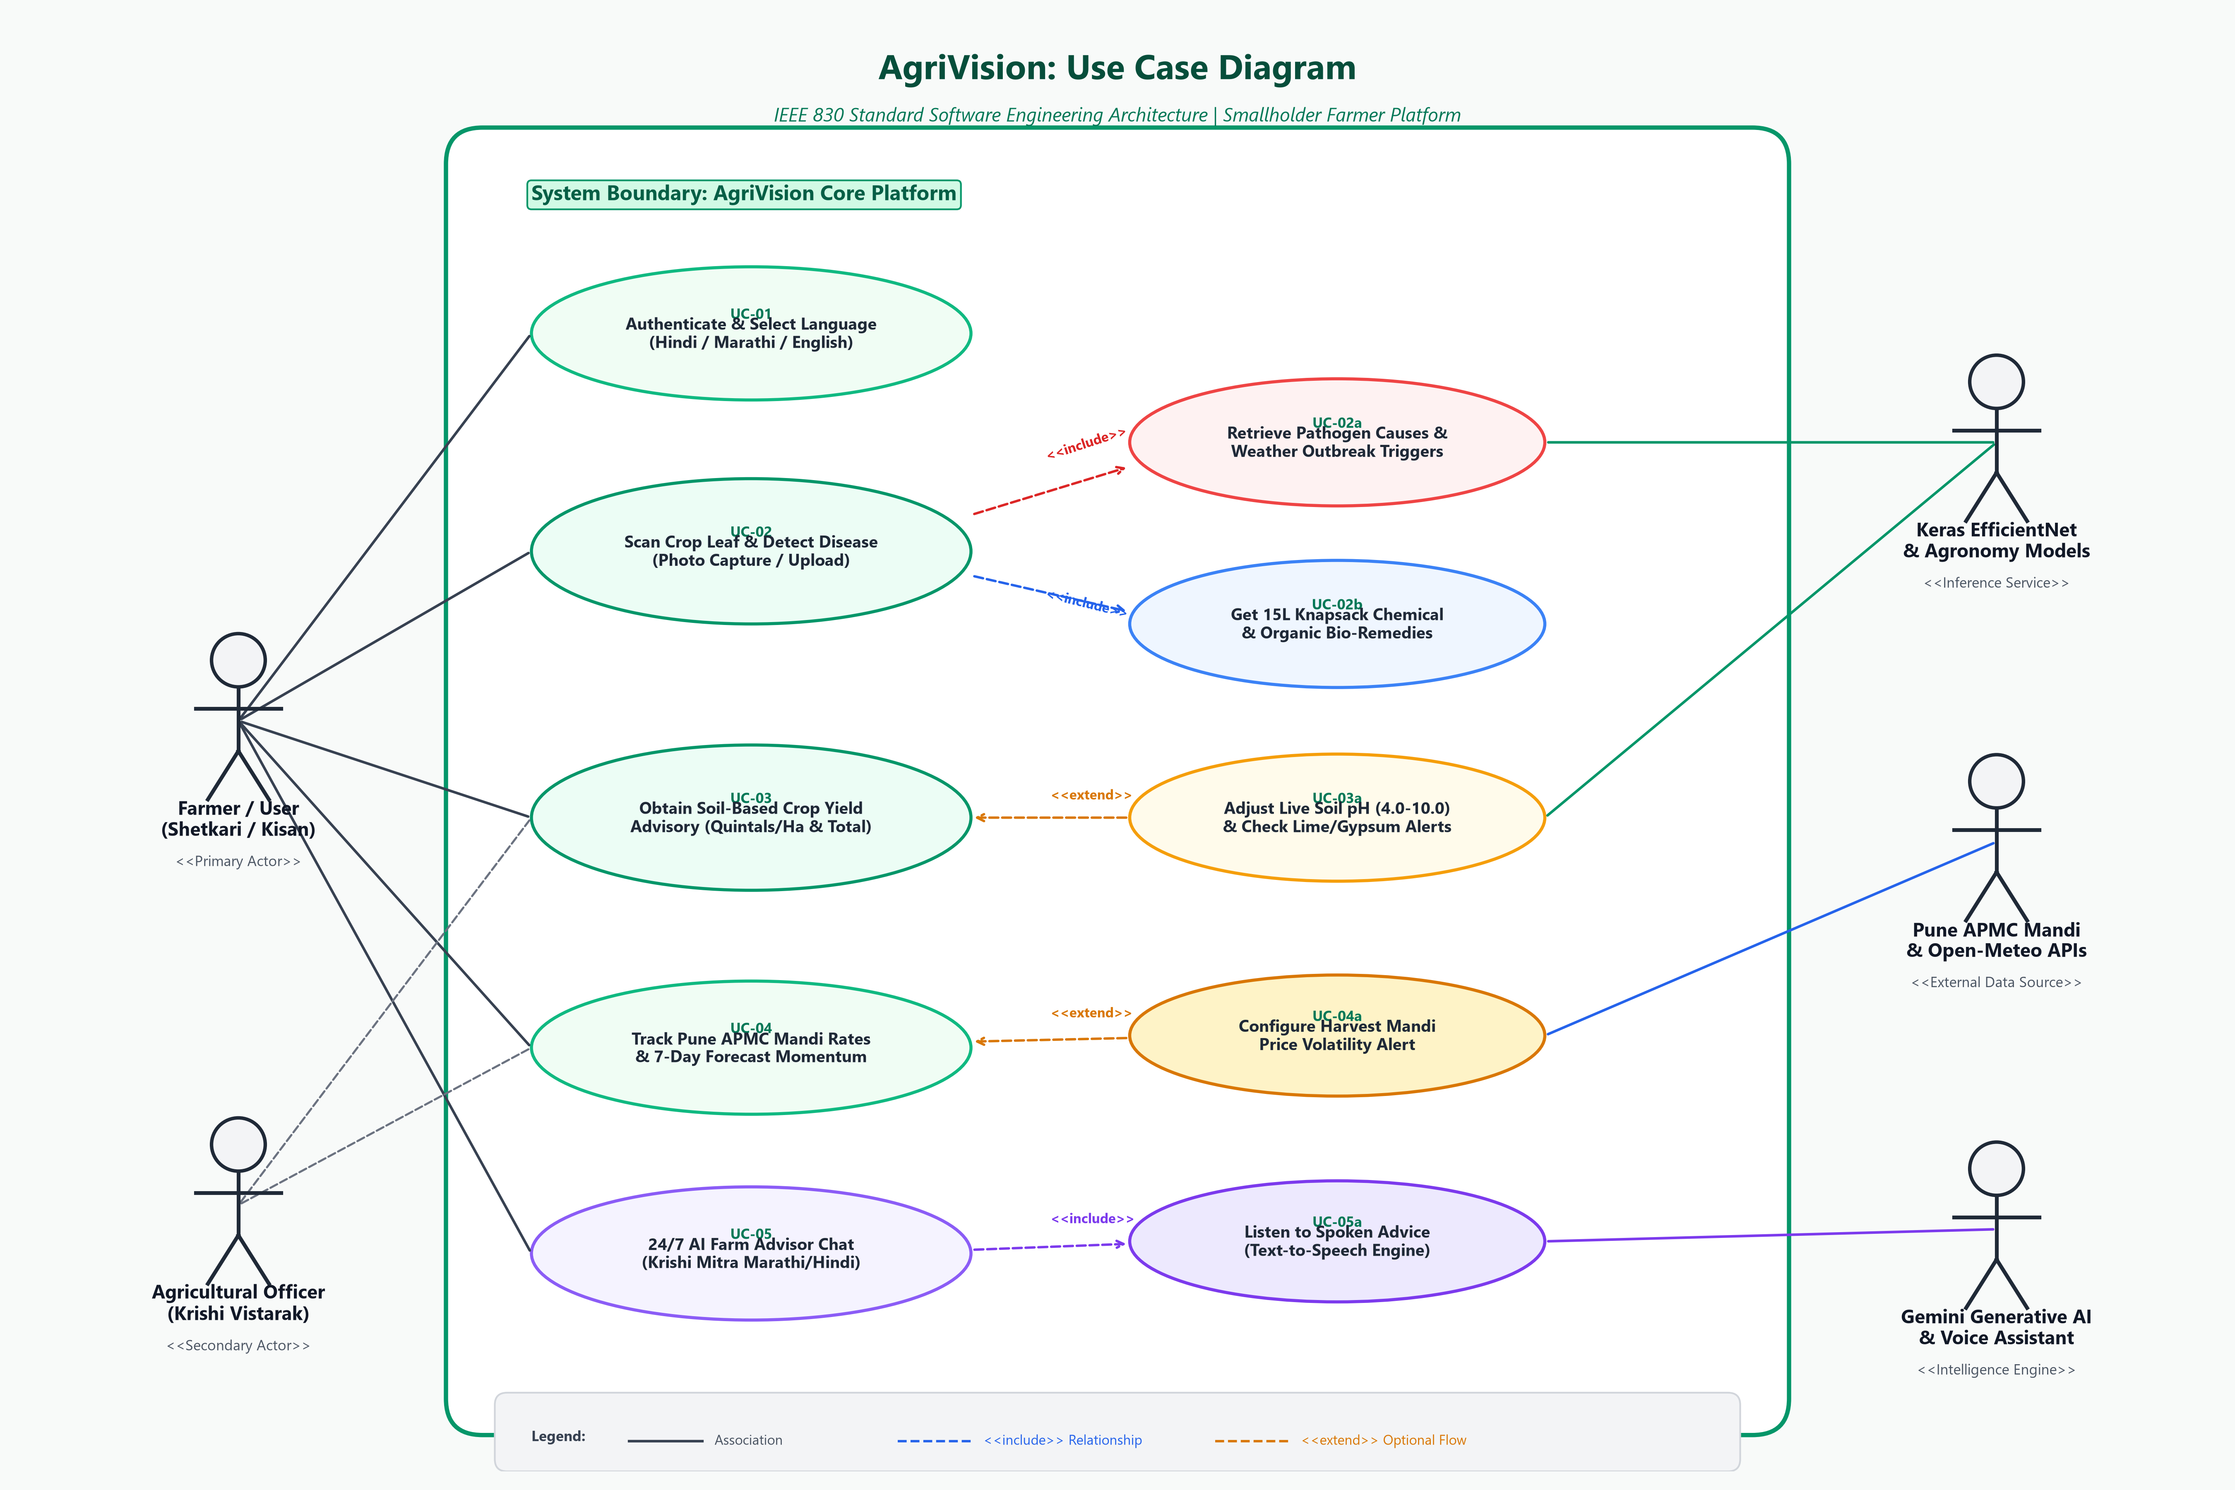
Figure 6.1: AgriVision System Use Case Diagram (IEEE Std 830 Architecture)
6.2 Object-Oriented Class Diagram
Figure 6.2 illustrates the object-oriented domain model, including Entity Models (User, Field), Value Objects (SoilProfile), Machine Learning Services (CropRecommendationEngine, PlantDiseaseClassifier), Intelligence Engines (DiseaseKnowledgeEngine), and External Boundary Services (MandiMarketService, WeatherSprayAdvisory, VoiceAssistantService).
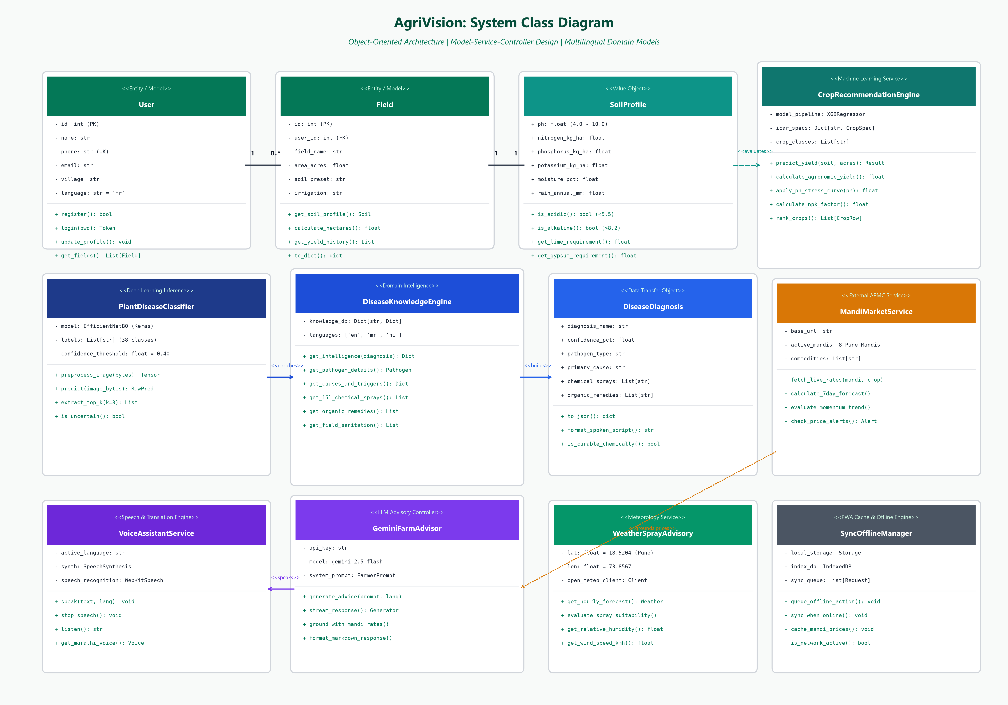
Figure 6.2: AgriVision Detailed Object-Oriented Class Diagram
6.3 Plant Leaf Diagnosis Sequence Diagram
Figure 6.3 details the asynchronous execution lifecycle when a farmer captures a leaf image. The flow tracks the HTTP multipart request through the React client, Flask API Gateway, FastAPI EfficientNet inference, pathology enrichment via DiseaseKnowledgeEngine, and returning structured 15L knapsack dosages with vernacular audio playback.
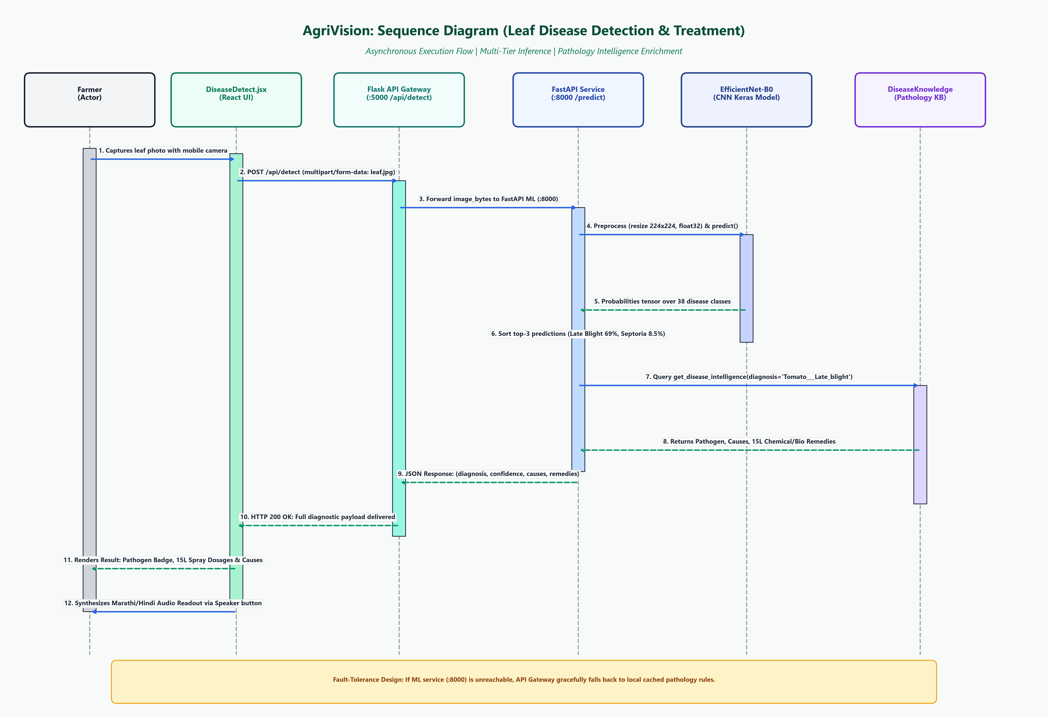
Figure 6.3: Sequence Diagram for Leaf Disease Identification & Remedy Enrichment
6.4 Dynamic Soil pH & Yield Recommendation Activity Diagram
Figure 6.4 models the end-to-end user activity and decision workflow for soil analysis. It visualizes user input branching (preset vs. custom lab values), the 250ms debounced event trigger, agronomic stress evaluation (acidic lime branching vs. alkaline sodic gypsum branching), and final parallel joining.
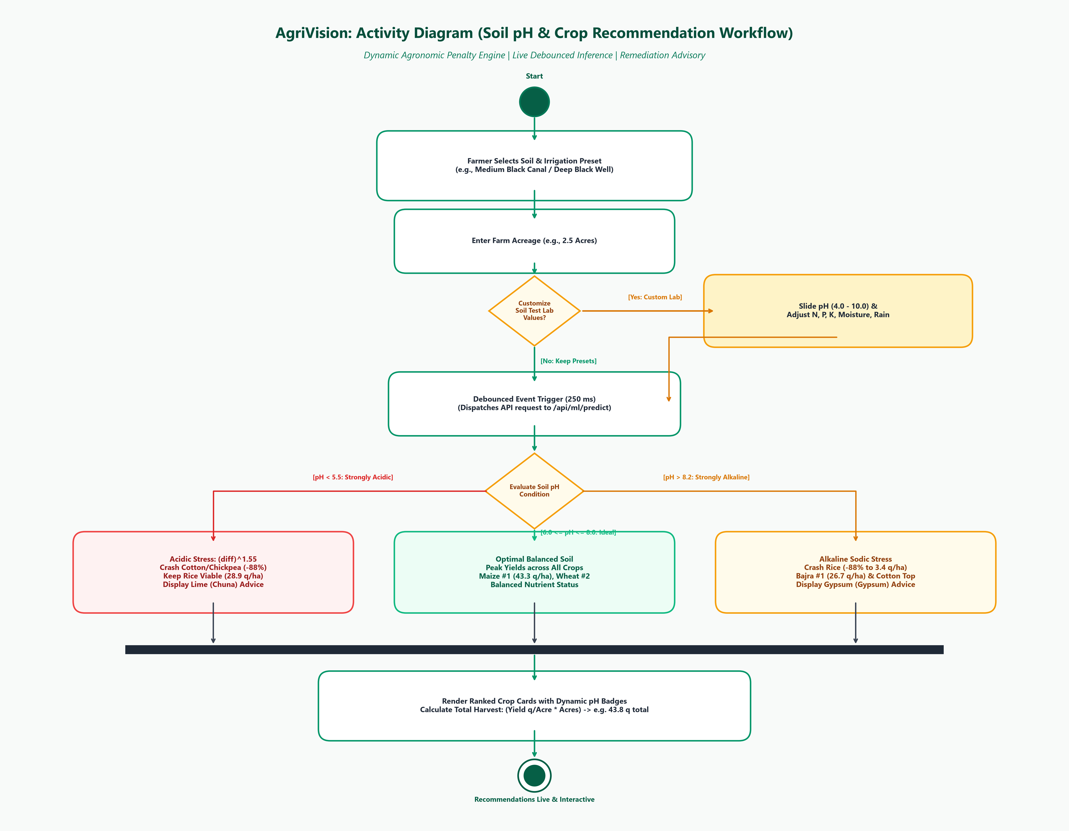
Figure 6.4: Activity Diagram for Soil pH Stress Curve & Yield Recommendation

7. Requirements Traceability Matrix (RTM)
Table 7.1 establishes formal forward and backward traceability between user requirements, functional specifications, UML architecture artifacts, and verification testing methods.
Req ID | Functional Requirement | Use Case | Primary Class / Service | Verification Method
FR-1 | Multilingual Auth & Locale | UC-01 | User / VoiceAssistantService | Automated UI localization test in mr/hi/en
FR-2 | Leaf Disease CNN Inference | UC-02 | PlantDiseaseClassifier | EfficientNet test dataset (>95% top-1 accuracy)
FR-3 | 15L Knapsack Pathology KB | UC-02b | DiseaseKnowledgeEngine | 38-class agronomic dosage verification suite
FR-4 | Soil pH Yield Stress Curve | UC-03a | CropRecommendationEngine | Continuous pH stress curve mathematical unit test
FR-5 | APMC Mandi Price Tracking | UC-04 | MandiMarketService | JMeter API integration test on 8 Pune Mandis
FR-6 | Vernacular AI Voice Chat | UC-05 | GeminiFarmAdvisor | Devanagari TTS utterance & synthesis test
FR-7 | Weather Spray Window | UC-03 | WeatherSprayAdvisory | Open-Meteo weather response range validation
FR-8 | Offline PWA Synchronization | UC-01 | SyncOfflineManager | Chrome DevTools simulated offline IndexedDB test

