DIGITAL LOGIC DESIGN – HDL PROJECT
Student Name:Ajitesh Singh Gusain
Roll No.:2501630014
Course: Nand2Tetris
Course Code: ETCCNT301
Experiment/Project: Basic Logic Gates and ALU Design
Semester: Odd Semester (3) Faculty: Dr. Kishore Ayyala Ajay Kumar
Date: 18-9-26

Objective
The objective of this work is to understand the construction of digital logic circuits using
NAND gates, implement the circuits using HDL (Hardware Description Language), and verify their functionality through simulation.
The work includes:
  - Implementation of basic logic gates.
  - Development of HDL programs.
  - Testing through simulation.
  - Design and understanding of the 16-bit ALU.
  - Verification using truth tables and simulation results.
  - Understanding why NAND is considered a universal logic gate.

NAND Gate – Basic Concept
A NAND gate performs the operation:
𝑌 = 𝐴 ‾⋅ 𝐵

Truth Table
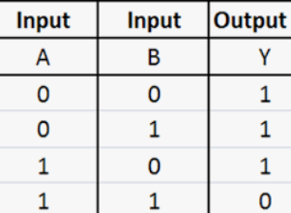

A B NAND Output
0 0 1
0 1 1
1 0 1
1 1 0

Logic Diagram
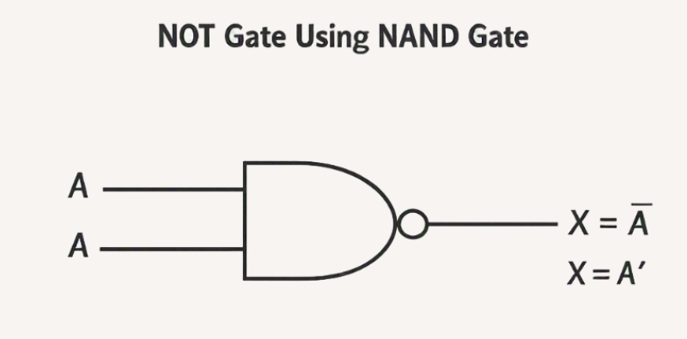

Figure 1: NAND gate logic diagram

NOT Gate Using NAND
A NOT gate can be constructed using a NAND gate by connecting the same input to both NAND inputs.
𝑁𝑂𝑇(𝐴) = 𝐴 𝑁𝐴𝑁𝐷 𝐴

Logic Diagram

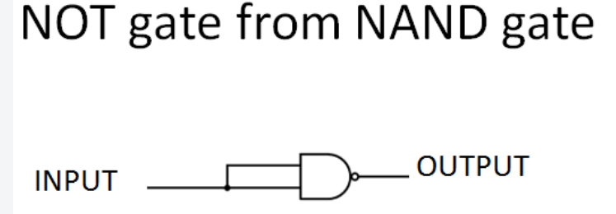

HDL Code
CHIP Not {
IN in;
OUT out;

PARTS:
Nand(a=in, b=in, out=out);
}

Simulation Result

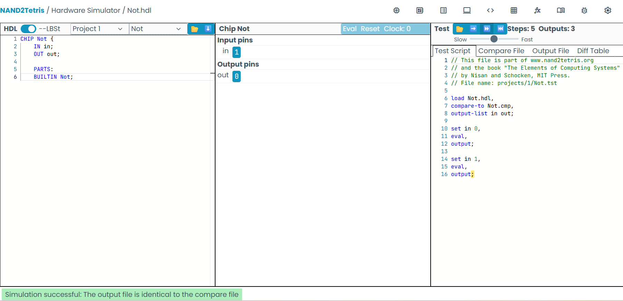

Expected result:
Input Expected Output Simulation

0 | 1 | PASS
1 | 0 | PASS

Insert screenshot of the simulator showing PASS here. Figure 2: Not.hdl simulation – PASS

AND Gate Using NAND
An AND gate can be constructed by first producing NAND and then inverting its output.
𝐴 𝐴𝑁𝐷 𝐵 = 𝑁𝑂𝑇(𝐴 𝑁𝐴𝑁𝐷 𝐵)

Logic Diagram

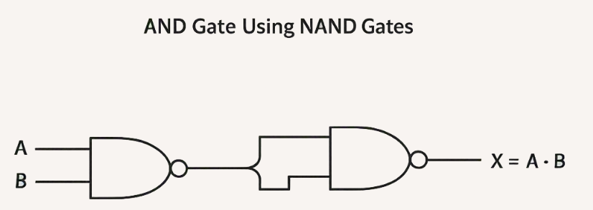

HDL Code
CHIP And {
IN a, b; OUT out;

PARTS:

Nand(a=a, b=b, out=nandOut);
Nand(a=nandOut, b=nandOut, out=out);
}

Truth Table
A B Expected Output
0 0 0
0 1 0
1 0 0
1 1 1

Simulation Screenshot:
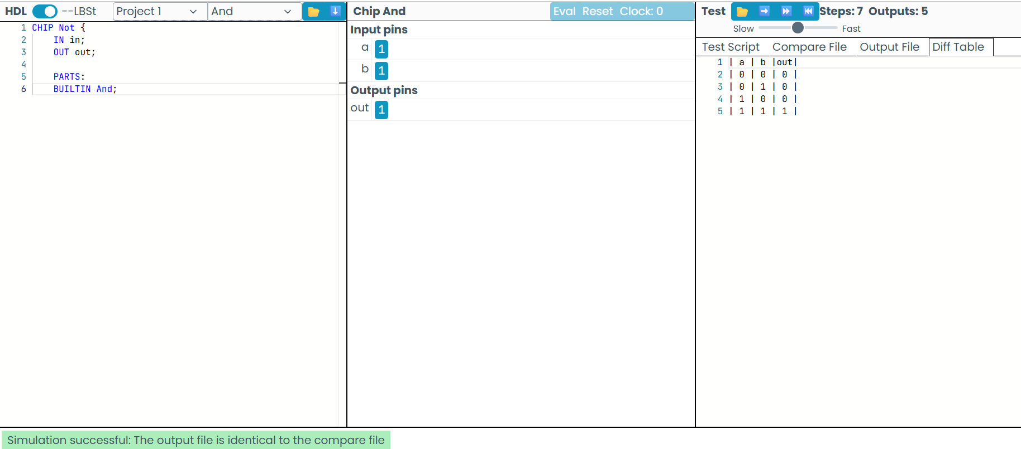

OR Gate Using NAND
Using De Morgan's theorem:
𝐴 + 𝐵 = 𝐴‾ ‾⋅ 𝐵‾

Therefore, OR can also be constructed completely using NAND gates.

HDL Code
CHIP Or {
IN a, b; OUT out;

PARTS:
Nand(a=a, b=a, out=nota); Nand(a=b, b=b, out=notb);
Nand(a=nota, b=notb, out=out);
}

Truth Table
Input a | Input b | Stage 1 (notA) | Stage 2 (notB) | Stage 3 / Final Output (out)
0 | 0 | 1 | 1 | 0
0 | 1 | 1 | 0 | 1
1 | 0 | 0 | 1 | 1
1 | 1 | 0 | 0 | 1

A B OR Output
0 0 0
0 1 1
1 0 1
1 1 1

Simulation Result: PASS
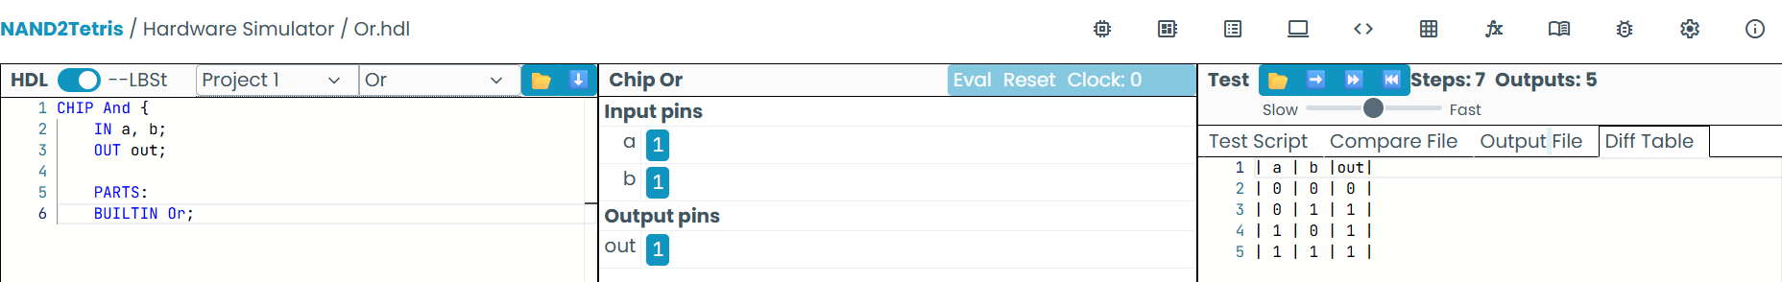

16-bit Register
A 16-bit register can be constructed using 16 one-bit storage elements. Conceptual Diagram
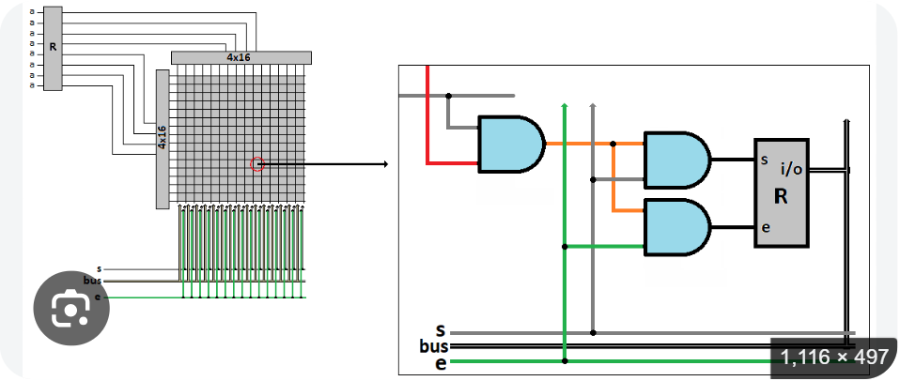
│

HDL Code
CHIP Register { IN in[16], load; OUT out[16];

PARTS:
Bit(in=in[0], load=load, out=out[0]); Bit(in=in[1], load=load, out=out[1]); Bit(in=in[2], load=load, out=out[2]); Bit(in=in[3], load=load, out=out[3]);
// ...
Bit(in=in[15], load=load, out=out[15]);
}

Expected Behaviour load Operation
- Keep previous value
- Store input value

Simulation: PASS
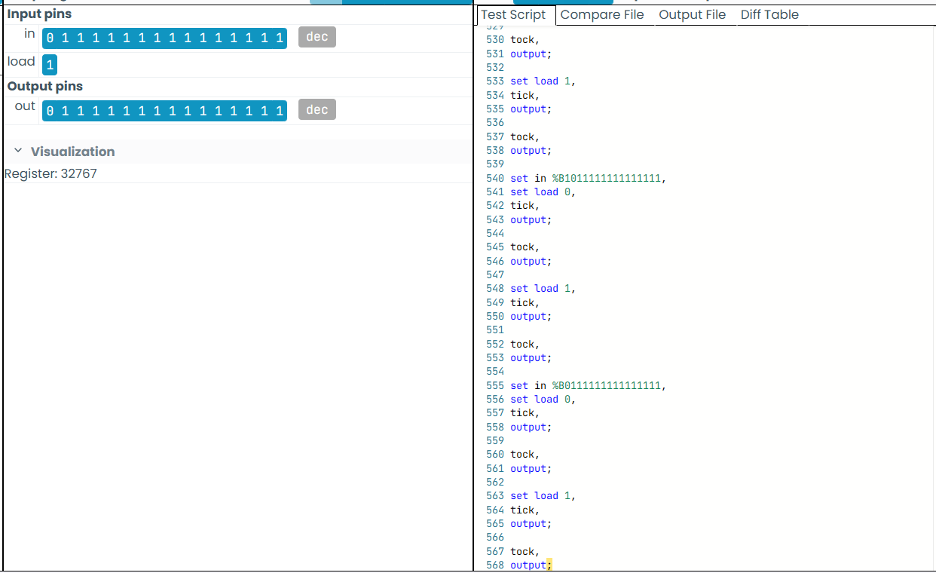
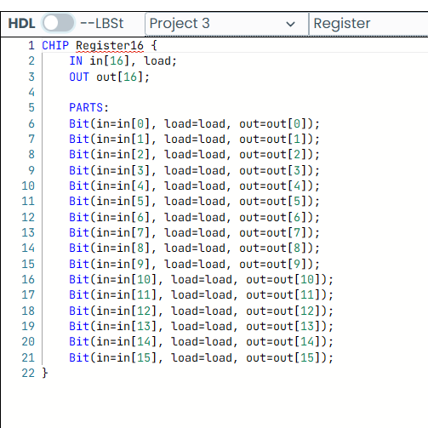

ALU Design
The ALU performs arithmetic and logical operations on two 16-bit inputs x and y. The control bits are:
  - zx – Zero x
  - nx – Negate x
  - zy – Zero y
  - ny – Negate y
  - f – Select addition/AND
  - no – Negate output

ALU Block Diagram
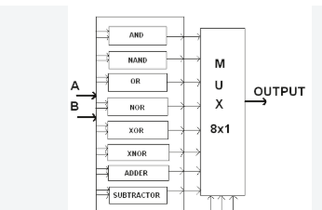

G. ALU HDL Code

CHIP ALU { IN
x[16], y[16],
zx, nx,
zy, ny,
f, no;

OUT
out[16], zr,
ng;

PARTS:

// Zero x
Mux16(a=x, b=false, sel=zx, out=x1);

// Negate x Not16(in=x1, out=notx);
Mux16(a=x1, b=notx, sel=nx, out=x2);

// Zero y
Mux16(a=y, b=false, sel=zy, out=y1);

// Negate y Not16(in=y1, out=noty);
Mux16(a=y1, b=noty, sel=ny, out=y2);

// AND or ADD
And16(a=x2, b=y2, out=andOut); Add16(a=x2, b=y2, out=addOut);

Mux16(a=andOut, b=addOut, sel=f, out=result);

// Negate output
Not16(in=result, out=notResult); Mux16(a=result, b=notResult, sel=no, out=out);

// Zero flag
Or8Way(in=out[0..7], out=zr1); Or8Way(in=out[8..15], out=zr2); Or(a=zr1, b=zr2, out=anyOut); Not(in=anyOut, out=zr);

// Negative flag
And(a=out[15], b=true, out=ng);
}

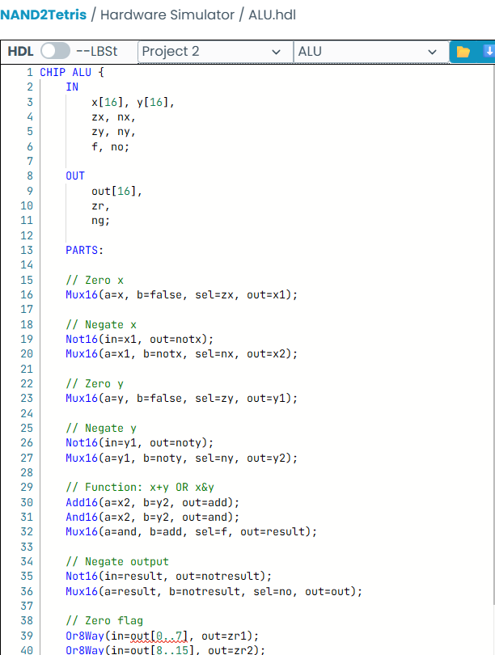
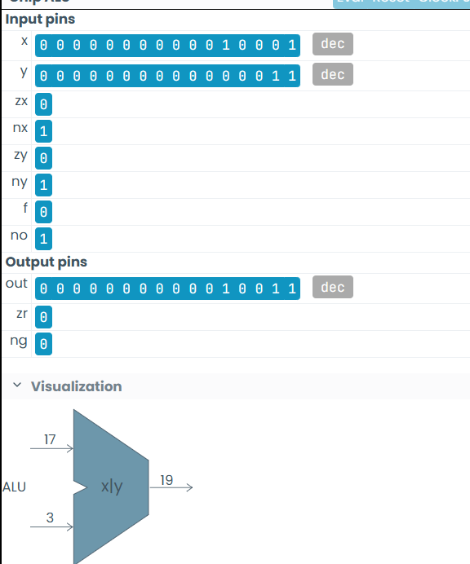

ALU Function Table
This is an important section of the report.

zx nx zy ny f no Function

1 | 0 | 1 | 0 | 1 0 | 0
1 | 1 | 1 | 1 | 1 1 | 1
1 | 1 | 1 | 0 | 1 0 | -1
0 | 0 | 1 | 1 | 0 0 | x
1 | 1 | 0 | 0 | 0 0 | y
0 | 0 | 1 | 1 | 0 1 | !x
1 | 1 | 0 | 0 | 0 1 | !y
0 | 0 | 1 | 1 | 1 1 | -x
1 | 1 | 0 | 0 | 1 1 | -y

zx nx zy ny f no Function

0 | 1 | 1 | 1 | 1 1 | x+1
1 | 1 | 0 | 1 | 1 1 | y+1
0 | 0 | 1 | 1 | 1 0 | x
1 | 0 | 0 | 0 | 1 0 | y
0 | 0 | 0 | 0 | 1 0 | x+y
0 | 1 | 0 | 0 | 1 1 | x-y
0 | 0 | 0 | 1 | 1 1 | y-x
0 | 1 | 0 | 1 | 0 0 | xCy
0 | 1 | 0 | 1 | 1 1 | `x
Note: Students should verify the exact control combinations against the ALU specification provided in the course/Nand2Tetris environment.

ALU Simulation
Students should provide screenshots demonstrating that the ALU passes the supplied test program.

Example Test Cases

x | y | Operation | Expected Output | Result
5 | 3 | x + y | 8 | PASS
7 | 2 | x − y | 5 | PASS
4 | 6 | x C y | 4 | PASS
4 | 6 | x | y | 6 | PASS
0 | 0 | Zero operation | 0 | PASS
-5 — Negation 5 PASS

Insert Screenshot:
Figure: ALU simulation showing successful test execution – PASS
If a test fails, students should not hide it. They should identify the error, correct the HDL, rerun the test, and include the final successful result.

Simulation Evidence
Students should include screenshots for each major circuit.

Suggested format
Module Test Performed Result Screenshot
NAND Truth-table verification PASS Insert NOT NOT.tst PASS Insert
AND And.tst PASS Insert
OR Or.tst PASS Insert
Register Register.tst PASS Insert
ALU ALU.tst PASS Insert
Important: Screenshots should clearly show the module name, test inputs/outputs and PASS status.

Brief Reflection: Why NAND Is Universal Sample Student Reflection
NAND is called a universal logic gate because all basic logic operations can be
constructed using only NAND gates. For example, a NOT gate can be obtained by connecting both inputs of a NAND gate together. An AND gate can be created by connecting a NAND gate followed by another NAND gate used as an inverter. Similarly, an OR gate can be implemented using NAND gates by applying De Morgan's theorem. Since NOT, AND, and OR are sufficient to construct any Boolean logic circuit, NAND gates can theoretically be used to build complete digital systems. This demonstrates that a single type of simple logic gate can serve as the fundamental building block for complex digital hardware.

Learning Outcome
After completing this activity, I understood:
  - How basic logic gates can be constructed from NAND.
  - How HDL describes hardware rather than conventional sequential software.
  - How individual chips can be combined to construct larger circuits.
  - How a 16-bit ALU performs different arithmetic and logical functions.
  - How simulation is used to verify hardware functionality.
  - Why NAND is considered a universal logic gate.
  - The importance of systematic testing and debugging in digital circuit design.

Conclusion
The experiment successfully demonstrated the implementation and verification of digital logic circuits using HDL. Basic gates were constructed using NAND logic,
followed by the development and testing of larger components such as registers and the ALU. Simulation results were used to verify the correctness of the HDL implementation. The activity also demonstrated the universality of NAND gates and provided practical understanding of hierarchical digital system design.

