Software Requirements Specification

for

CLOSED GROUP MAILING SYSTEM

Version 1.0 approved

Prepared by

AJITESH PRAVEEN – 15MIS1104

VELLORE INSTITUTE OF TECHNOLOGY(CHENNAI CAMPUS)

DATE : 7/11/2017

Table of Contents

Table of Contents ii

Revision History ii

1. Introduction 1

1.1 Purpose 1

1.2 Document Conventions 1

1.3 Intended Audience and Reading Suggestions 1

1.4 Product Scope 1

1.5 References 1

2. Overall Description 2

2.1 Product Perspective 2

2.2 Product Functions 2

2.3 User Classes and Characteristics 2

2.4 Operating Environment 2

2.5 Design and Implementation Constraints 2

2.6 User Documentation 2

2.7 Assumptions and Dependencies 3

3. External Interface Requirements 3

3.1 User Interfaces 3

3.2 Hardware Interfaces 3

3.3 Software Interfaces 3

3.4 Communications Interfaces 3

4. System Features 4

4.1 System Feature 1 4

4.2 System Feature 2 (and so on) 4

5. Other Nonfunctional Requirements 4

5.1 Performance Requirements 4

5.2 Safety Requirements 5

5.3 Security Requirements 5

5.4 Software Quality Attributes 5

5.5 Business Rules 5

6. Other Requirements 5

Appendix A: Glossary 5

Appendix B: Analysis Models 5

Appendix C: To Be Determined List 6

Revision History

|  |  |  |  |
| --- | --- | --- | --- |
| **Name** | **Date** | **Reason For Changes** | **Version** |
| Path to file | 25/10/2017 | The path to the files were not correct resulting to a loss of data . | 1.0 |
| Graphic implementation | 5/11/2017 | Addition of styles and css to make the web app look and feel better for the user . | 1.1 |

# Introduction

## Purpose

## This web application for companies or groups who want a personal chatting and mailing system to send files and discuss matters regarding the project or some other work .

## 

## Product Scope

The web-application works online and is secured by data encryption thus making in secure to the external attacks and giving a safe environment for the matters to be discussed within the system or group or office .

# Overall Description

## Product Perspective

The product can be said to be a hybrid of the mailing systems and discussion systems present today.

Thus giving the advantage of the both in a single system.

## Product Functions

* Registration
* Login
* Read Mails
* Send/Compose Mails
* Send Files
* Download Files
* Discussion System
* Logout

## User Classes and Characteristics

* Company Employees
* College
* Groups(Professional)
* Students(Projects/Other confidential stuff)

## Operating Environment

The software is capable of running in almost all the systems(computers) and running a few years back also . The software may experience some rendering problems when used in mobiles or tablets .

The software runs on the Google Chrome , latest edition of chrome or Mozilla is recommended . Rendering problems or unable running may be experienced in Internet Explorer . A good connection is recommended . No special hardware is required .

## Design and Implementation Constraints

The data that is sent by or received by any user will be passed through the server thus sending and displaying of data is the sole responsibility of the server or the company holding the server . If the server in not online nothing could be used or accessed from the software / web application .

## Assumptions and Dependencies

* The user knows how to work on internet
* The user has an internet access
* The user knows how to upload files and a simple understanding how the internet works.

# External Interface Requirements

3.1 User Interfaces :

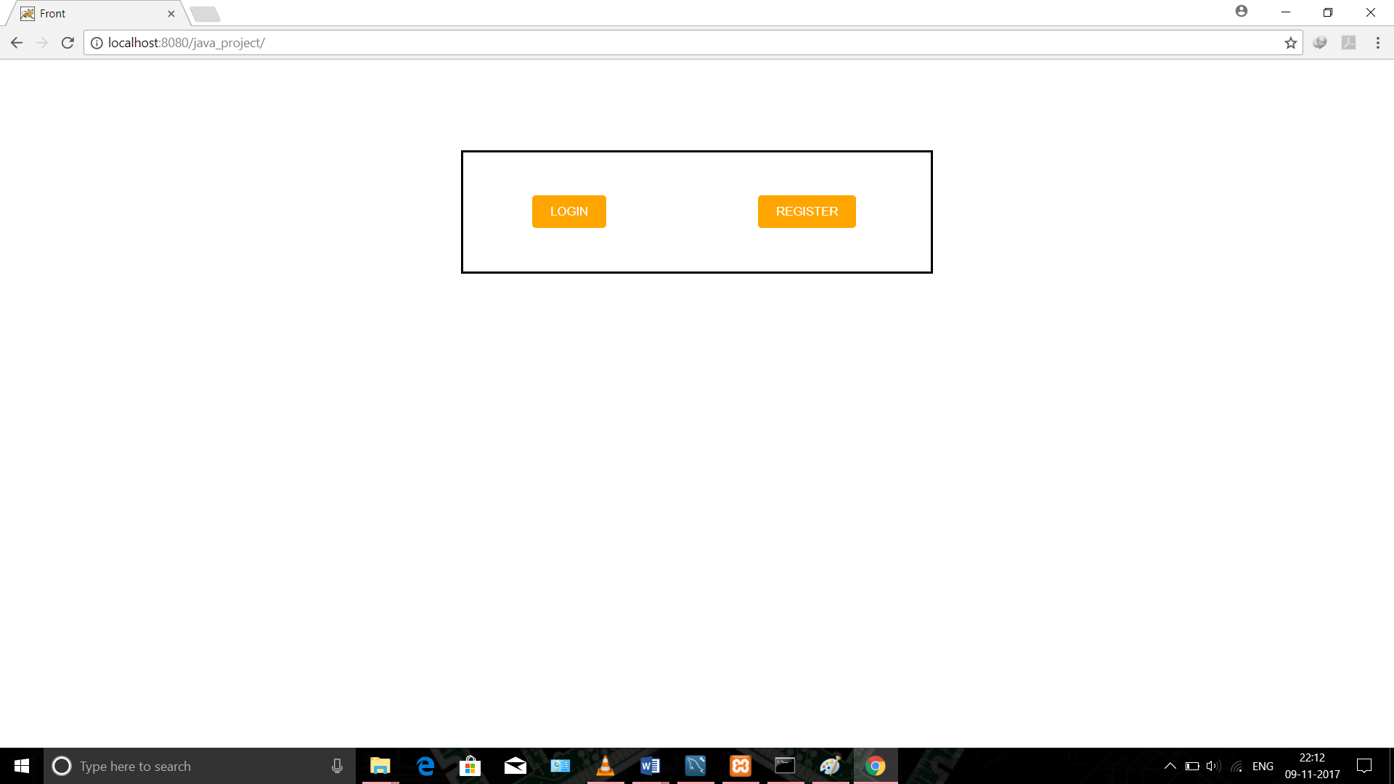

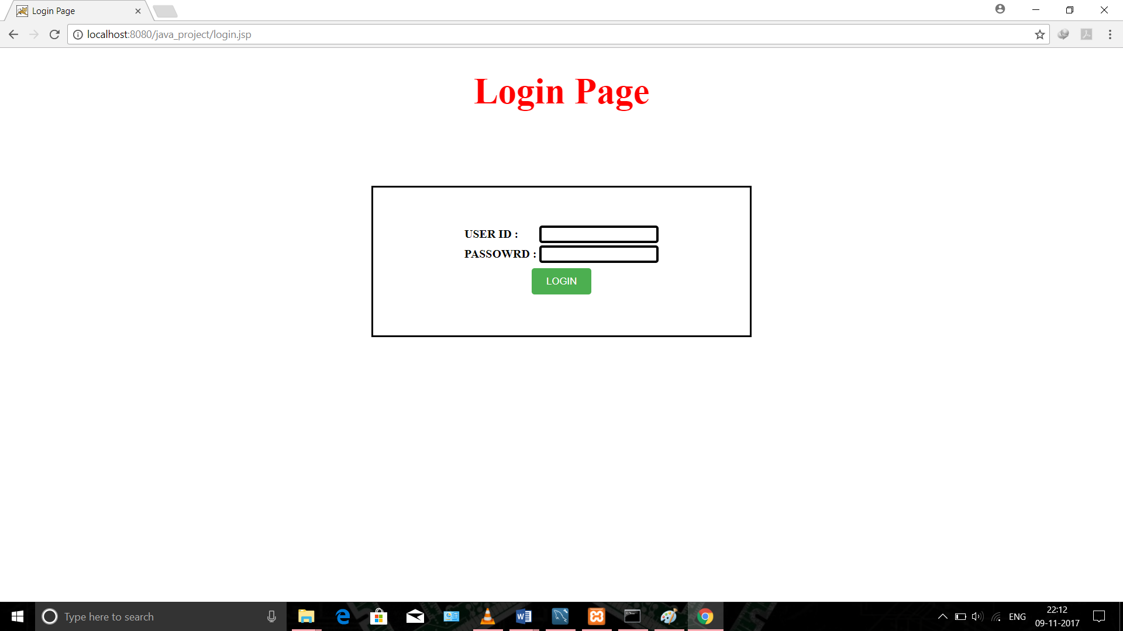

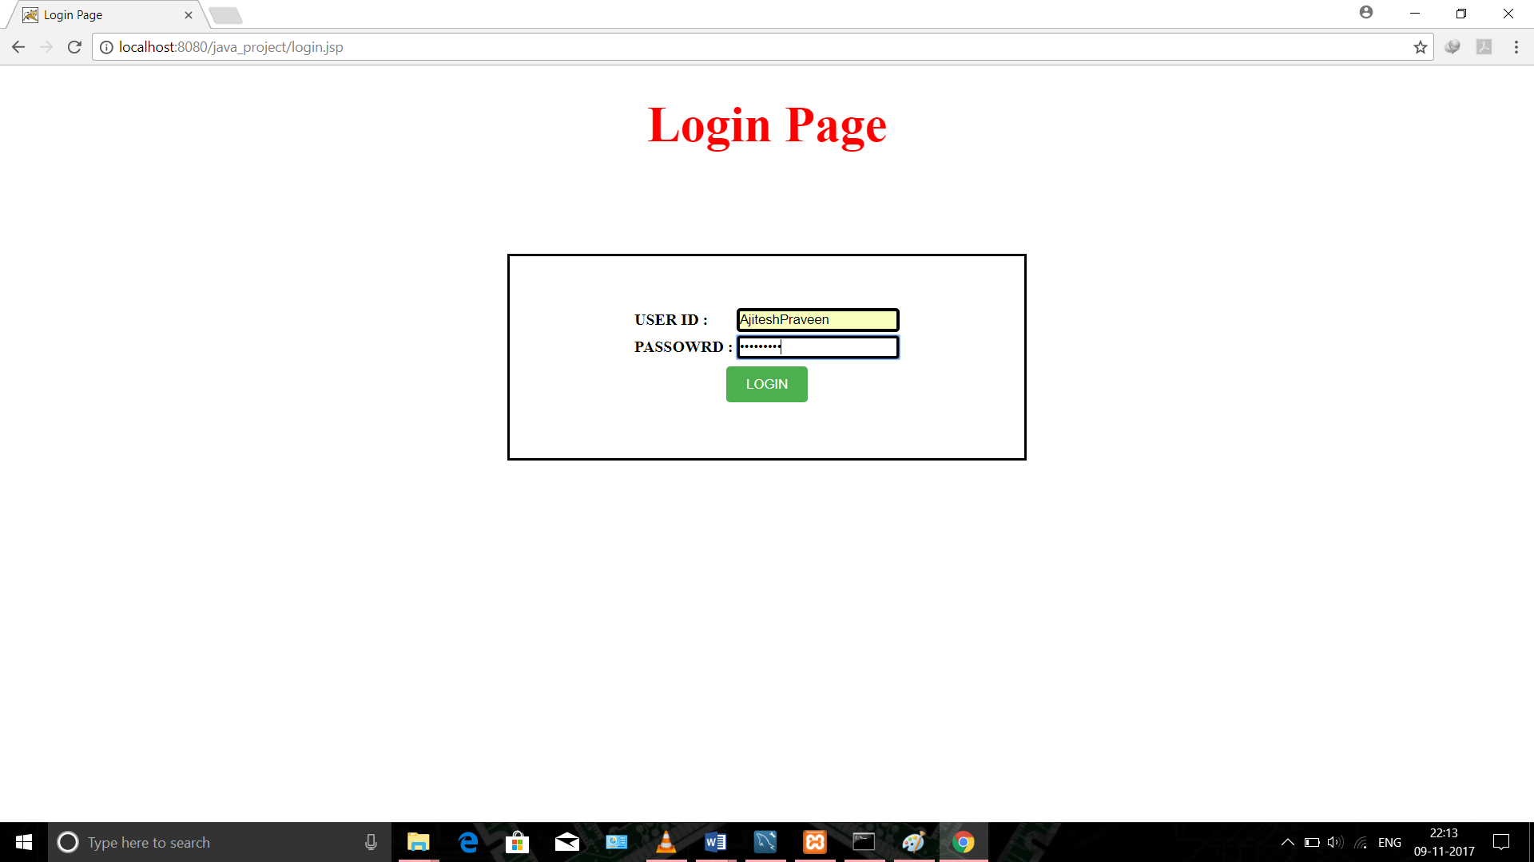

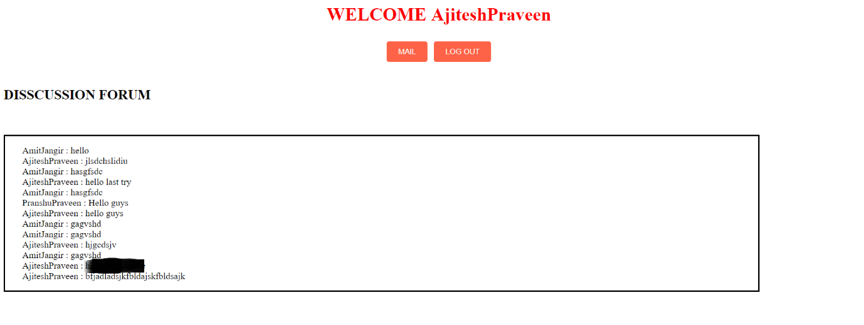

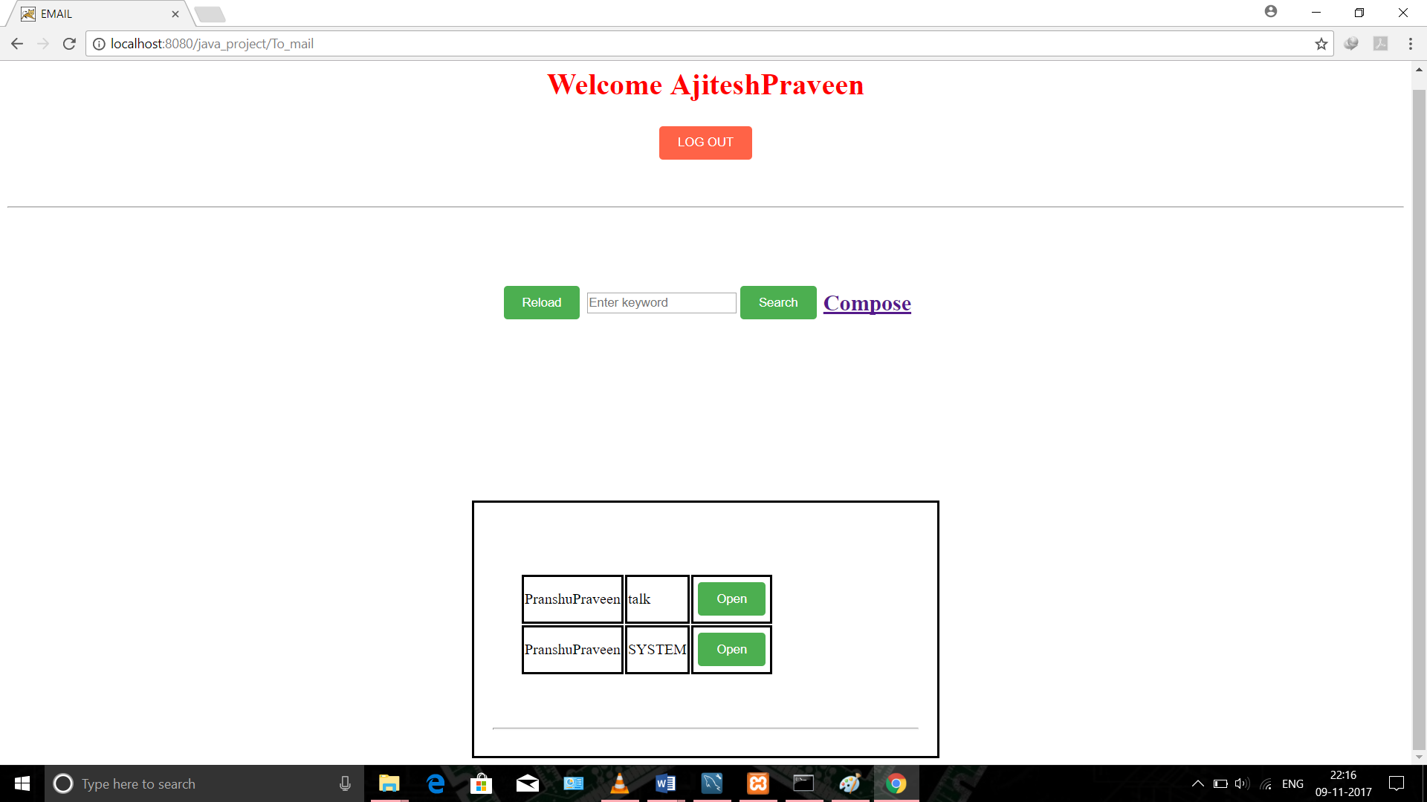

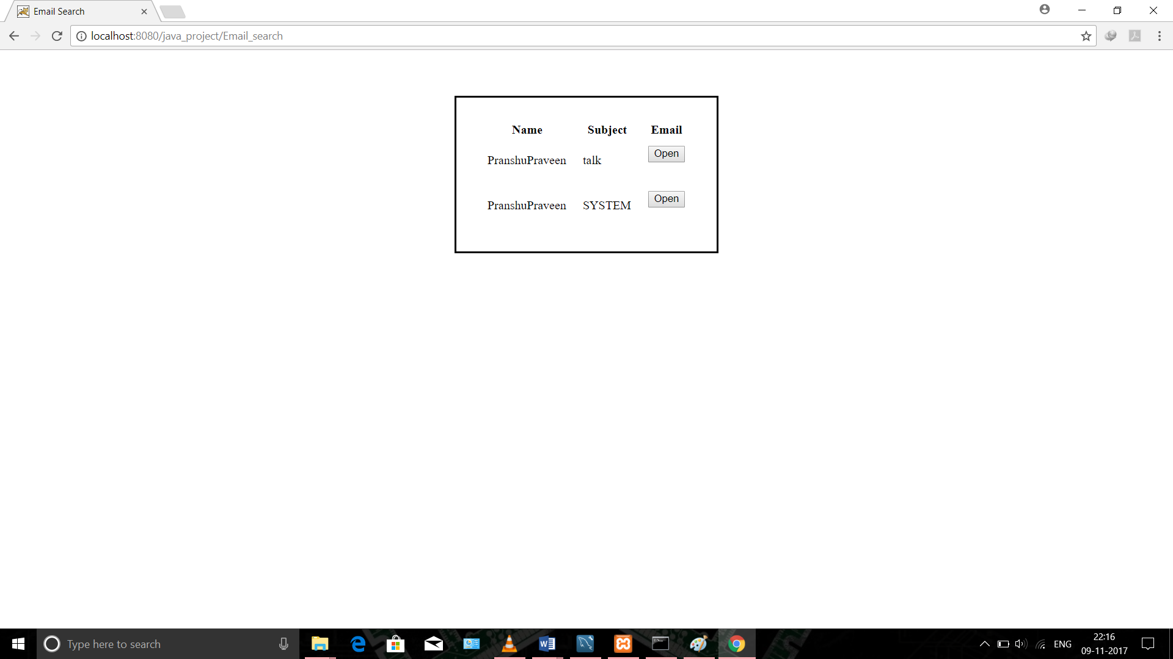

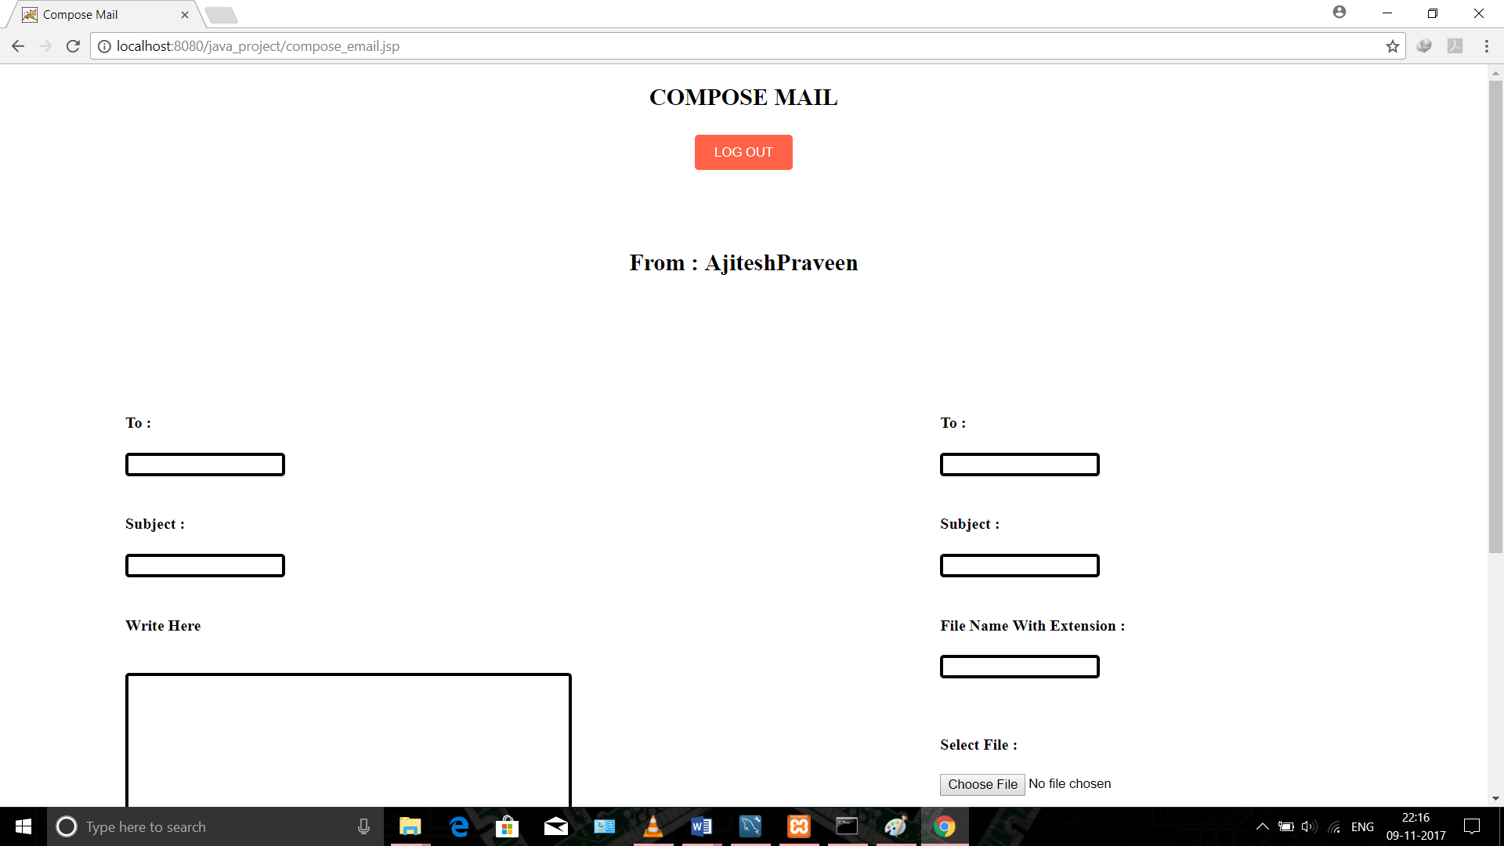

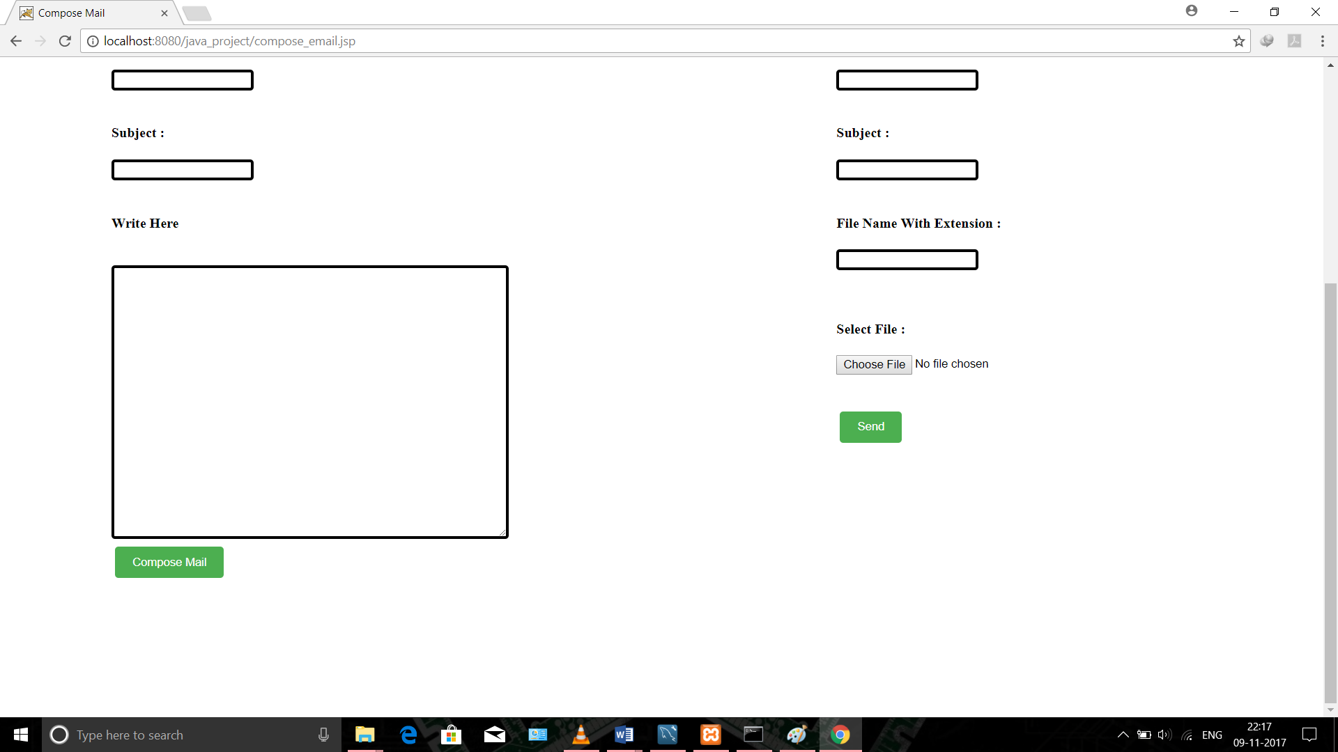

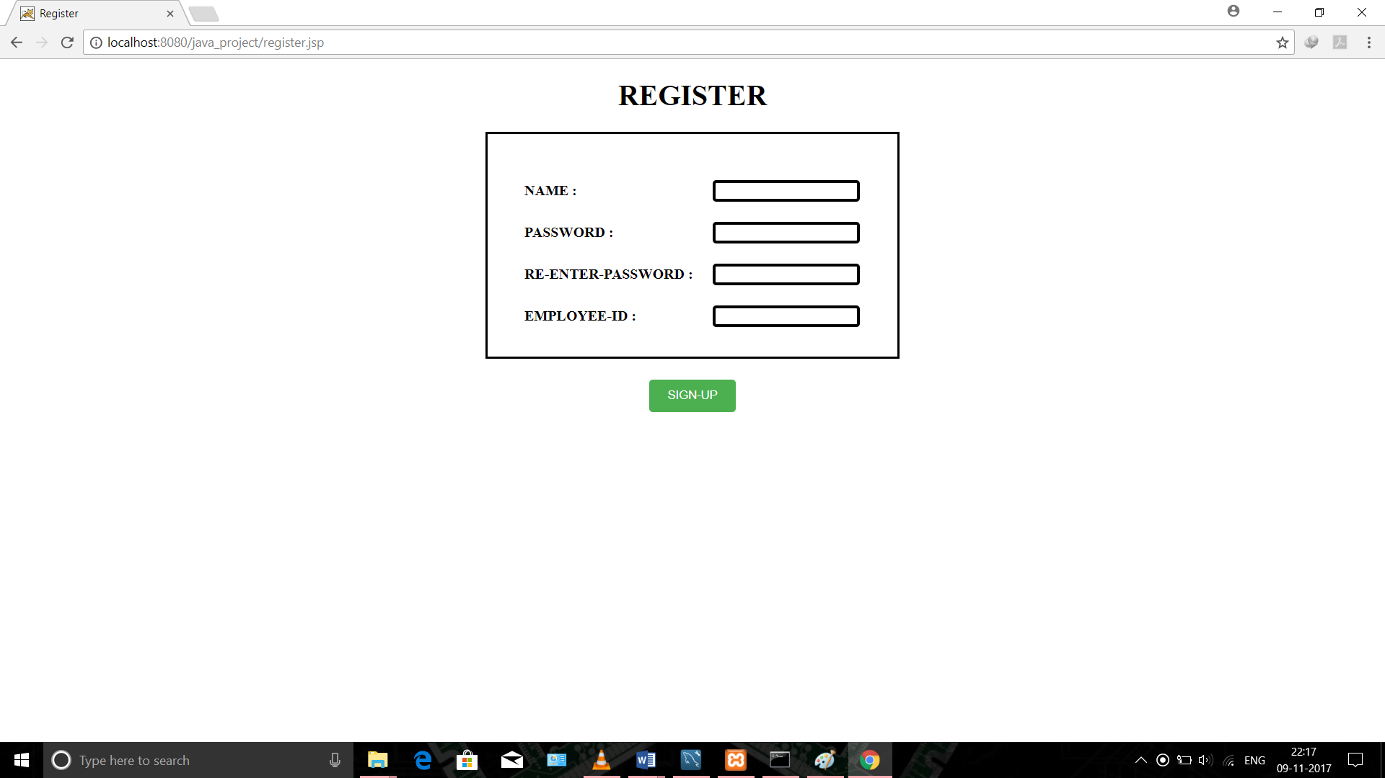

## Software Interfaces

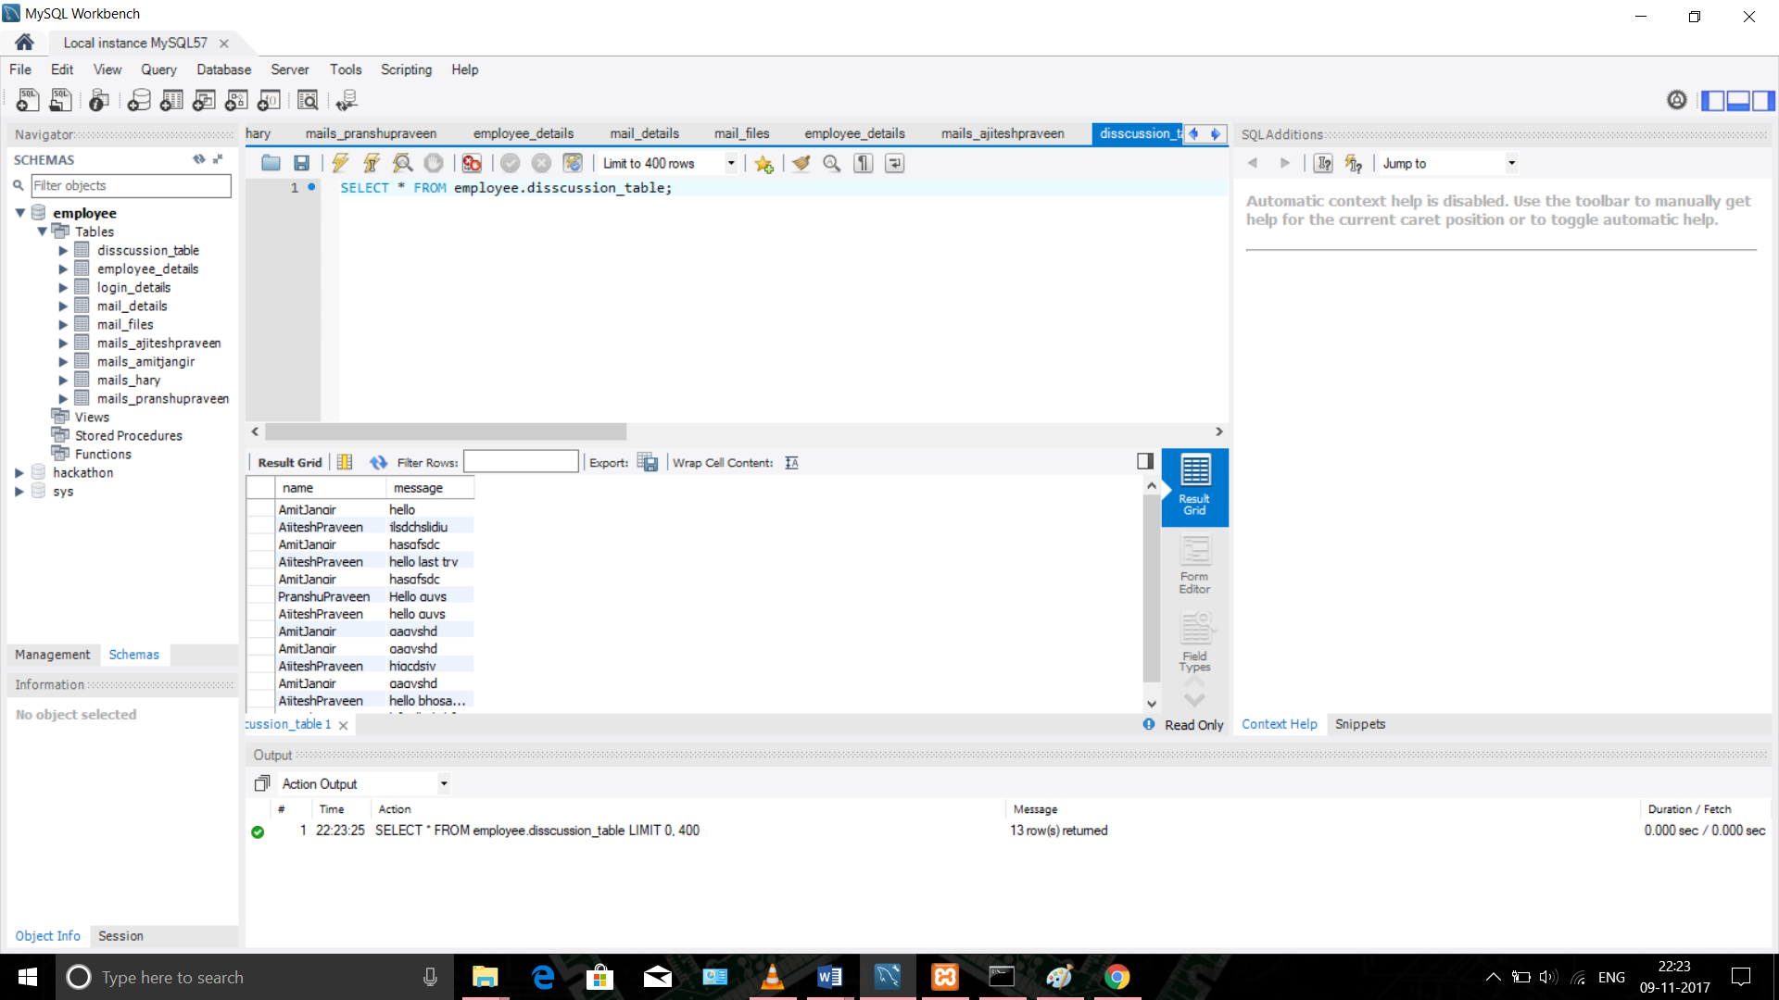

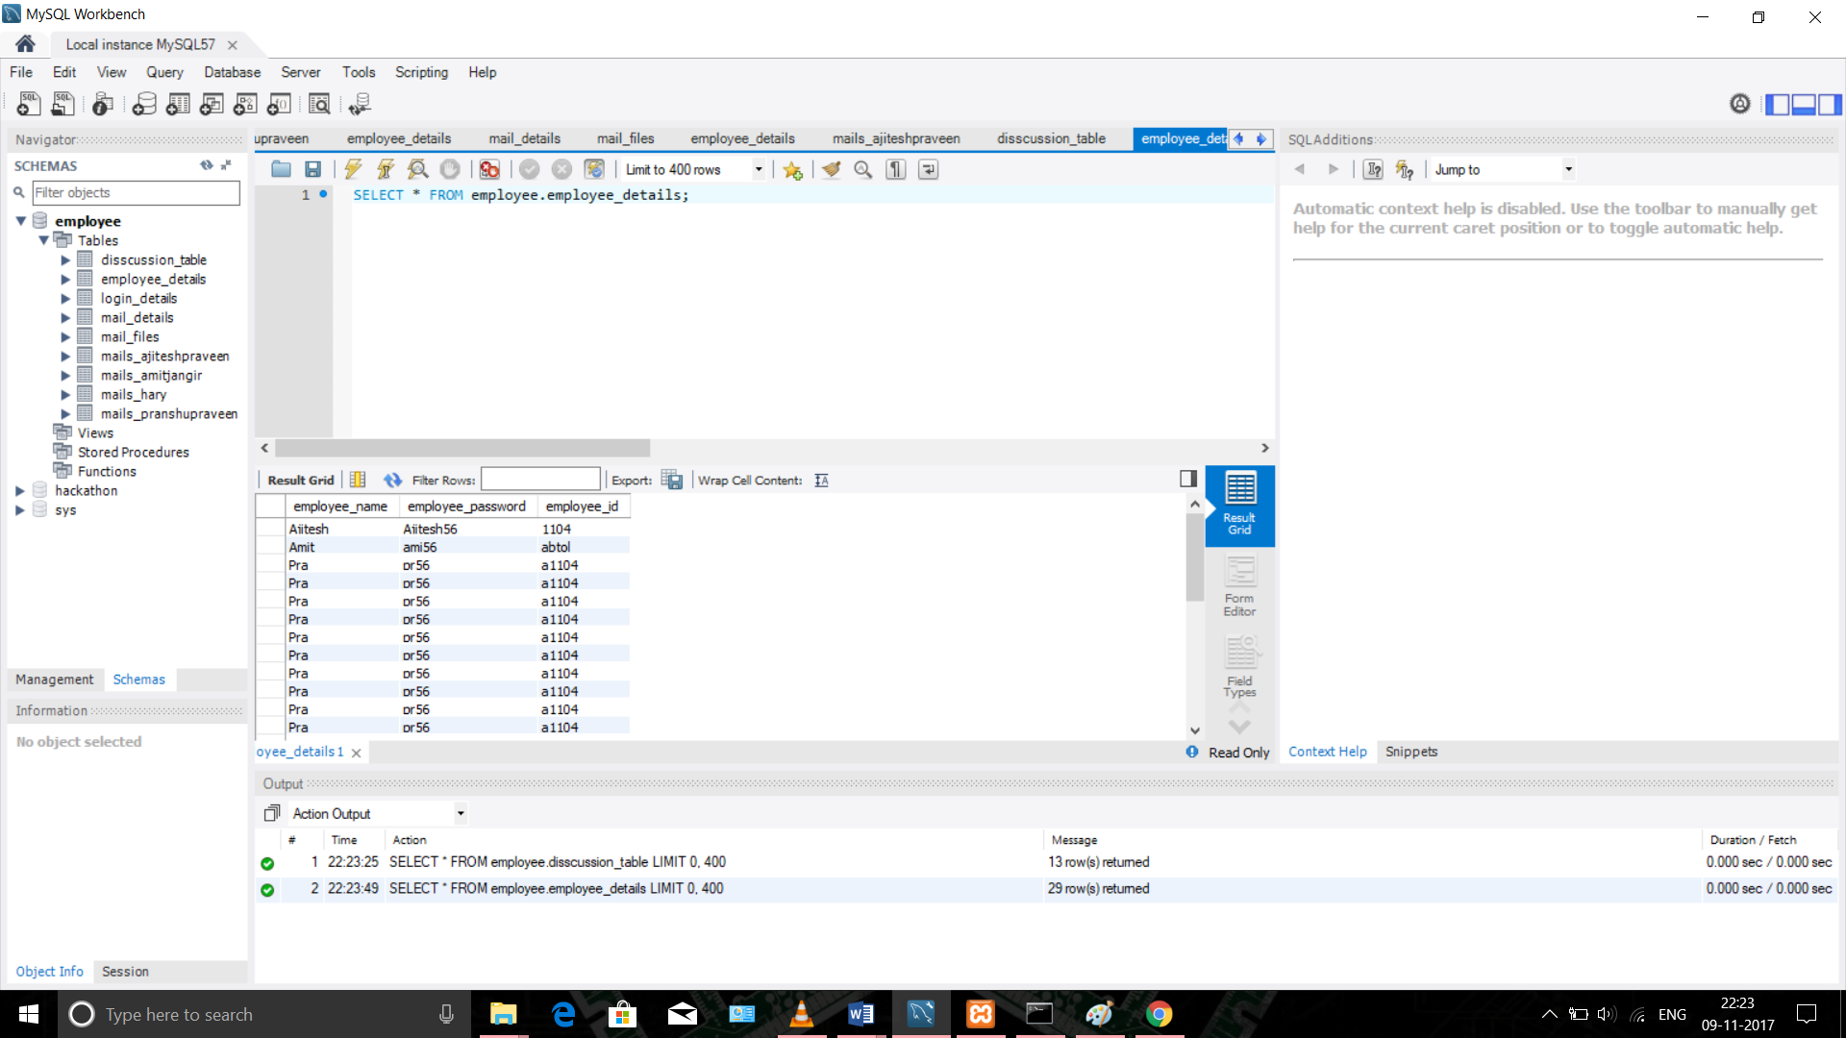

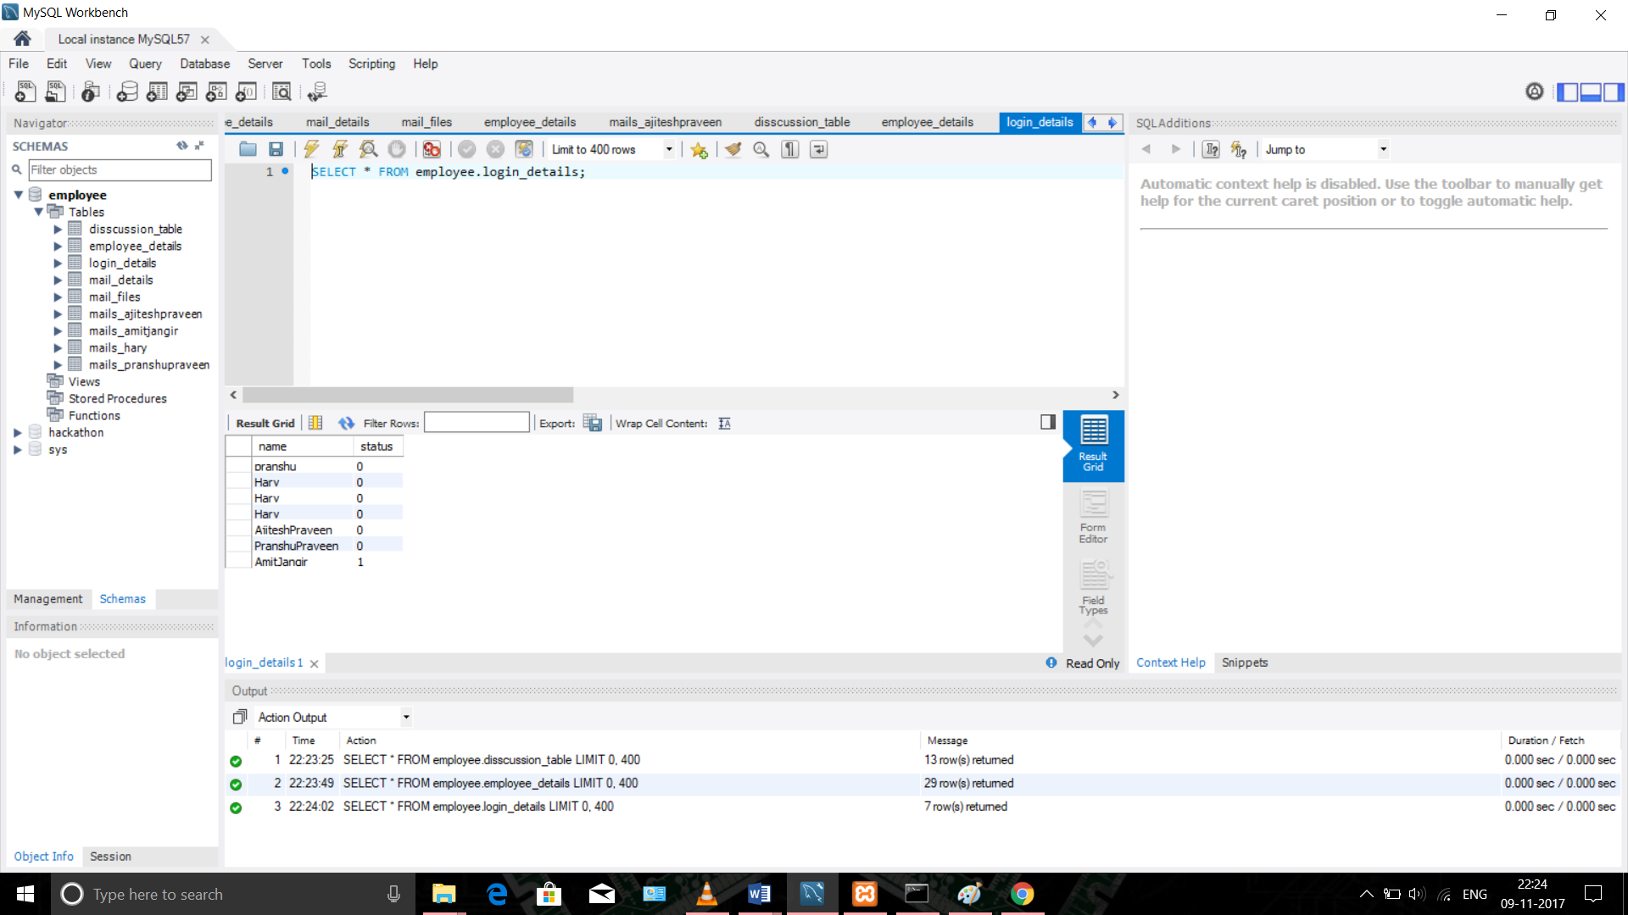

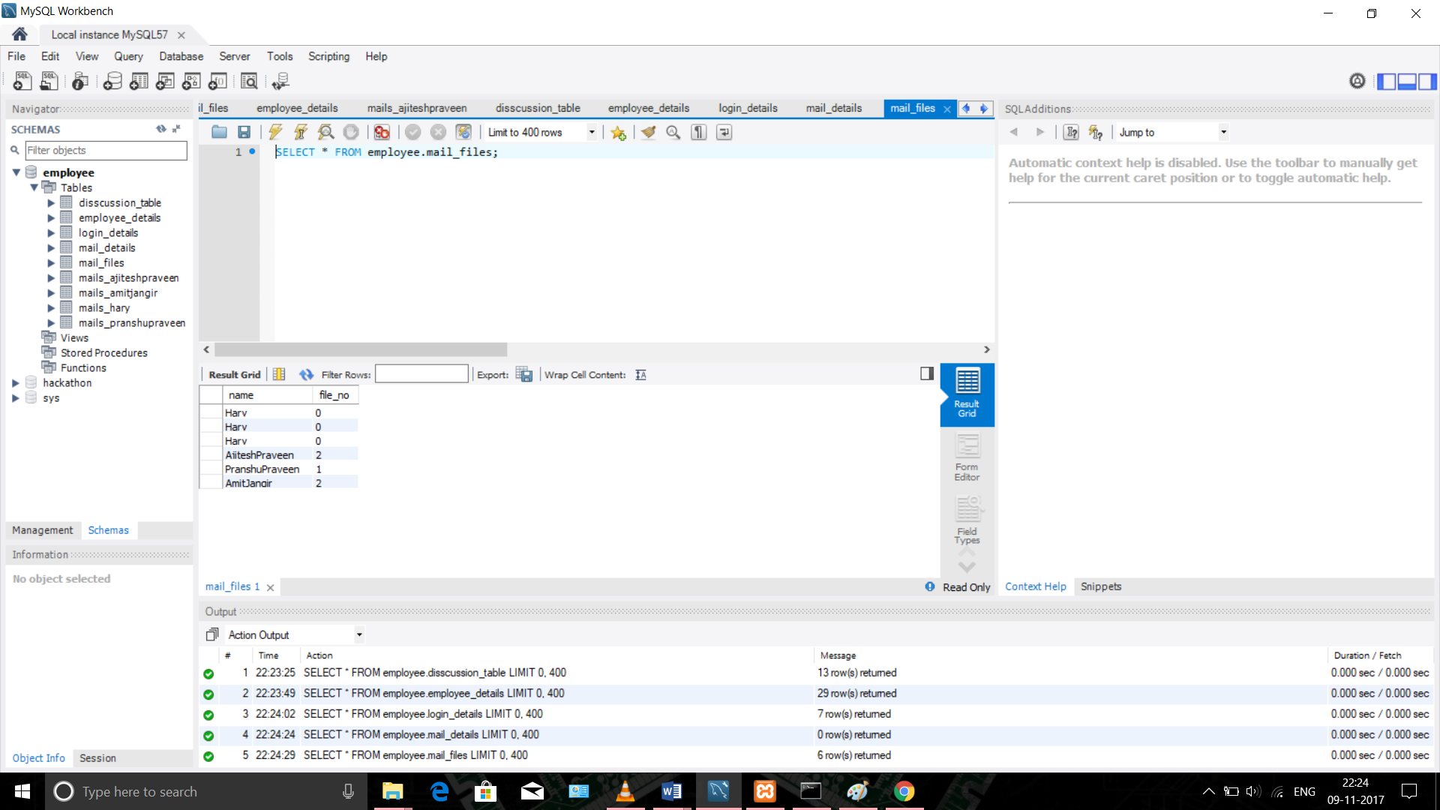

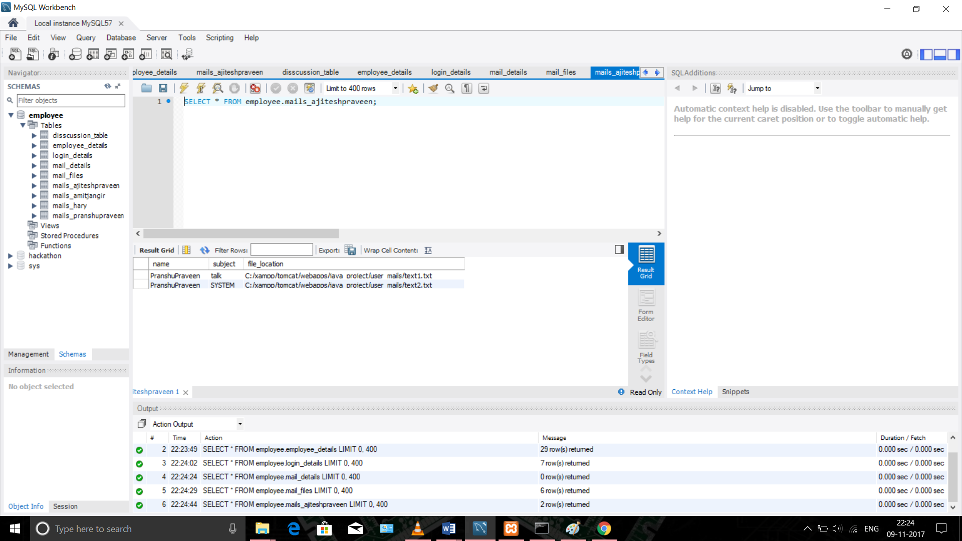

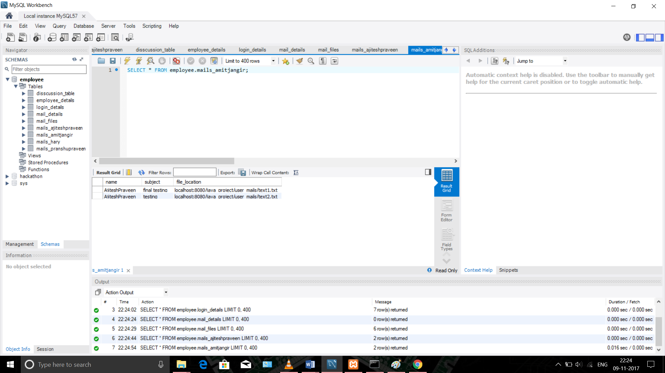

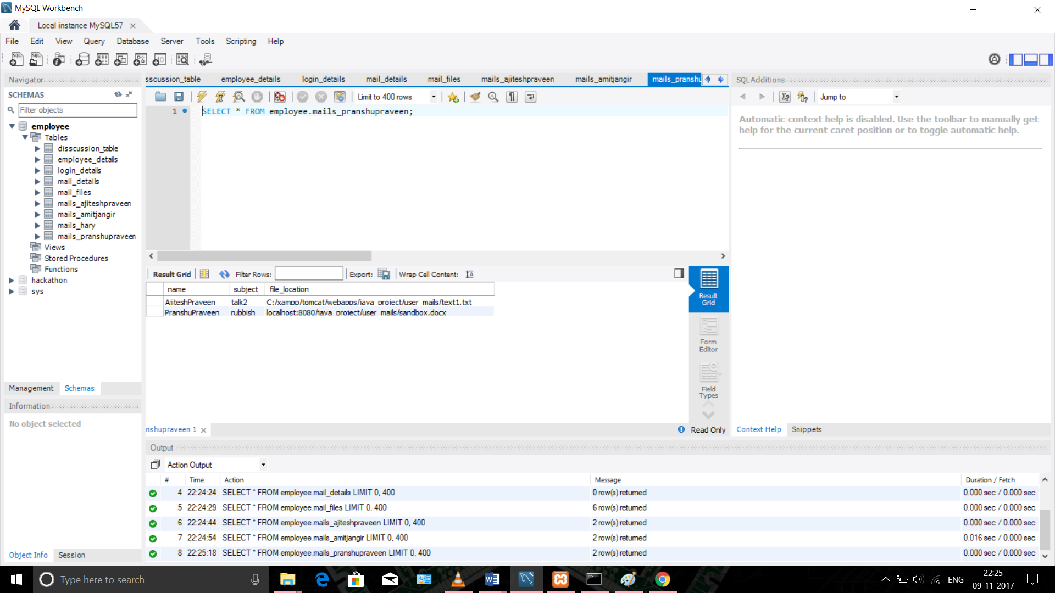

## Communications Interfaces

No Special permissions or soft-wares are required .

# System Features

System features or functions that would be performed by the application.

## System Feature List

Login : For logging in

Register : For registering the user thus creating the required tables fro the proper work.

Discussion page : For discussing (normal messinging).

Email : For sending emails.

File Sending : For sending files .

# Other Nonfunctional Requirements

## Performance Requirements

* High Internet connectivity
* Latest browser

## Safety Requirements

## Security Requirements

No such security requirements .

## Software Quality Attributes

* Maintainability
* Reusability
* Adaptability
* Easy to use