DESIGN DOCUMENT

CROWD FUNDING
Version 1.0

Contents:
- Functional Requirements
- Non-Functional Requirements
- Proposed Architecture
- Tech Stack
- Backend LLD
- Frontend LLD
- Mock Screens

Functional Requirements

1. Application will be used by innovator (that post their projects) and public donors (that fund the projects).
2. Innovators can create projects, request contribution to their projects, and also browse their previous projects.
3. Public donors are able to browse projects from innovators and contribute to fund the projects.
4. When donation on a project reaches requested amount, the project is archived and donation is transfered to innovator.

Non Functional Requirements

1. Production Ready Implementation
2. Unit Test Cases
3. Responsive App

Proposed Architecture

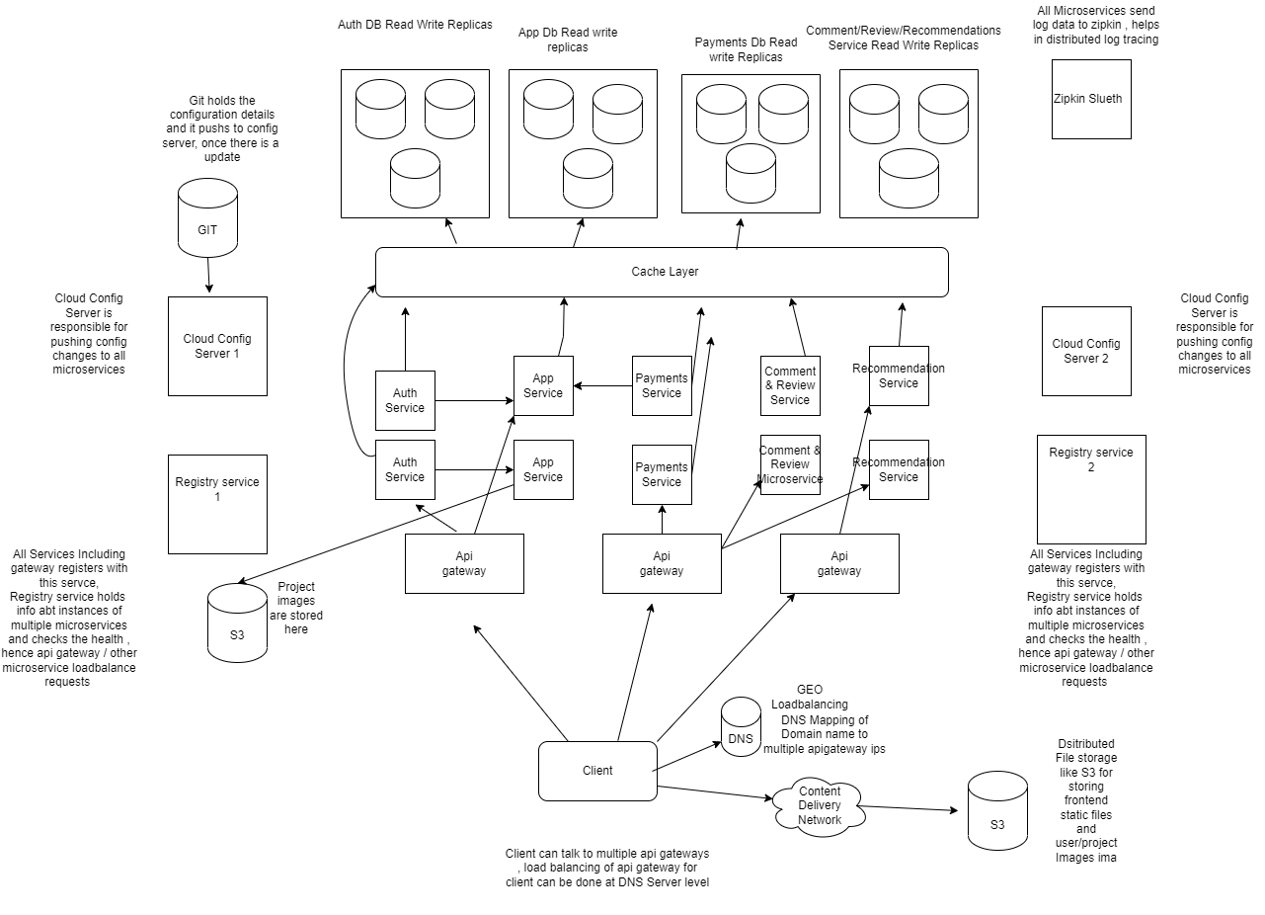

Tech Stack

- Spring Cloud Microservices (Api gateway,slueth,config, service registry)
- Java
- React Js
- SQL DB
(Below are Proposed and Not Implemented)
- Distributed Object Store like S3
- Cache like Redis
- Docker, Kubernetes for Microservices Deployment (Can use AWS Fargate / ECS)
- S3 or any App server to host Frontend static files
- Content Delivery Network like Cloudfront
10. DNS GeoRouting loadbalancing (using like Route 53)

Backend LLD

- Entity Diagram

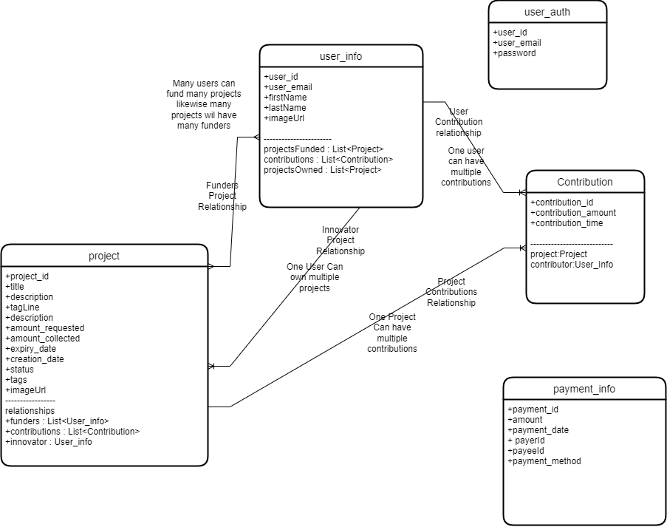

- Sequence Diagram

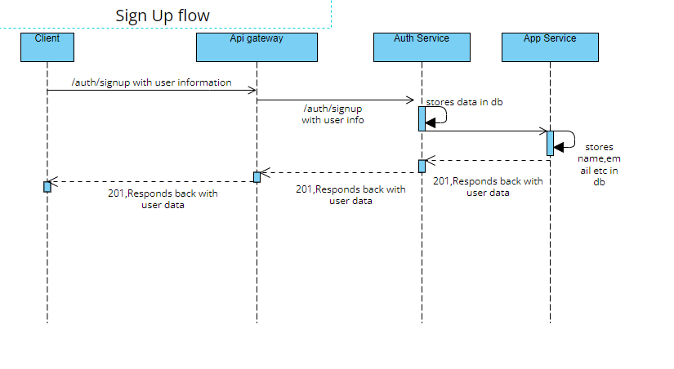
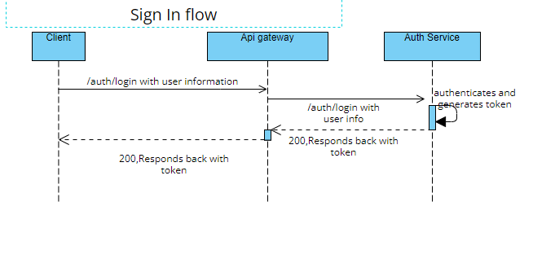

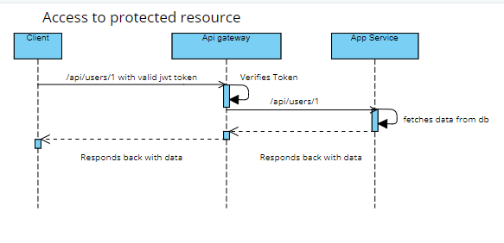

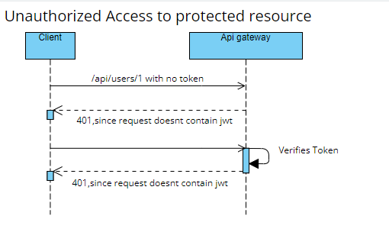

- Api Design

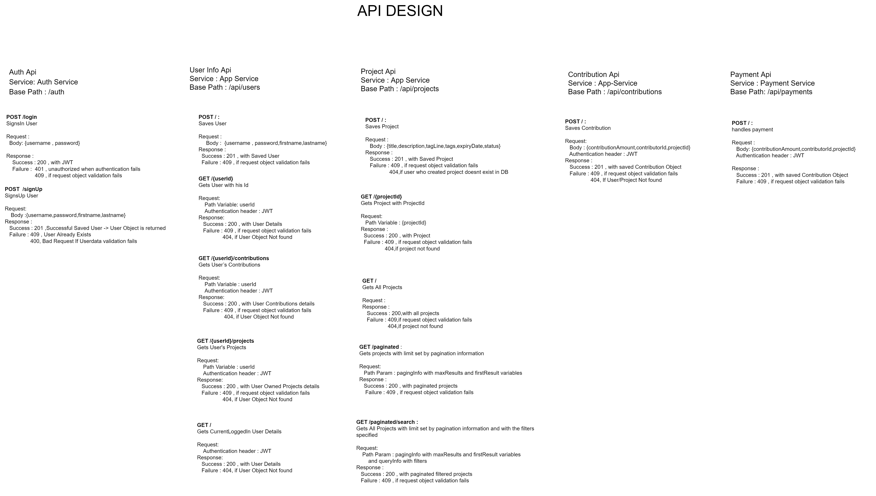

Frontend LLD

- Component Design

- Data Dependency Tree

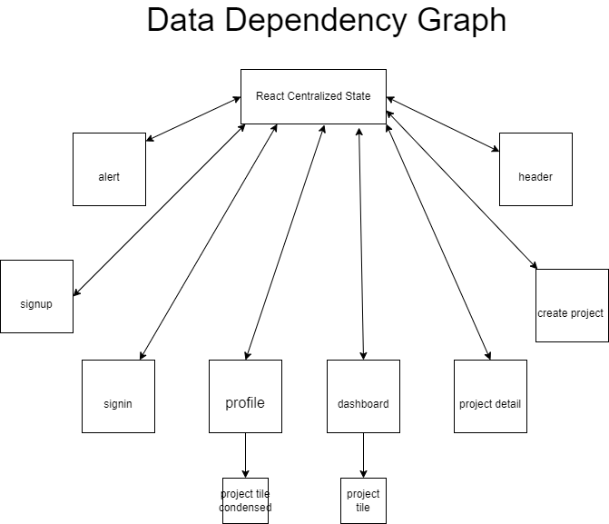

- State Model

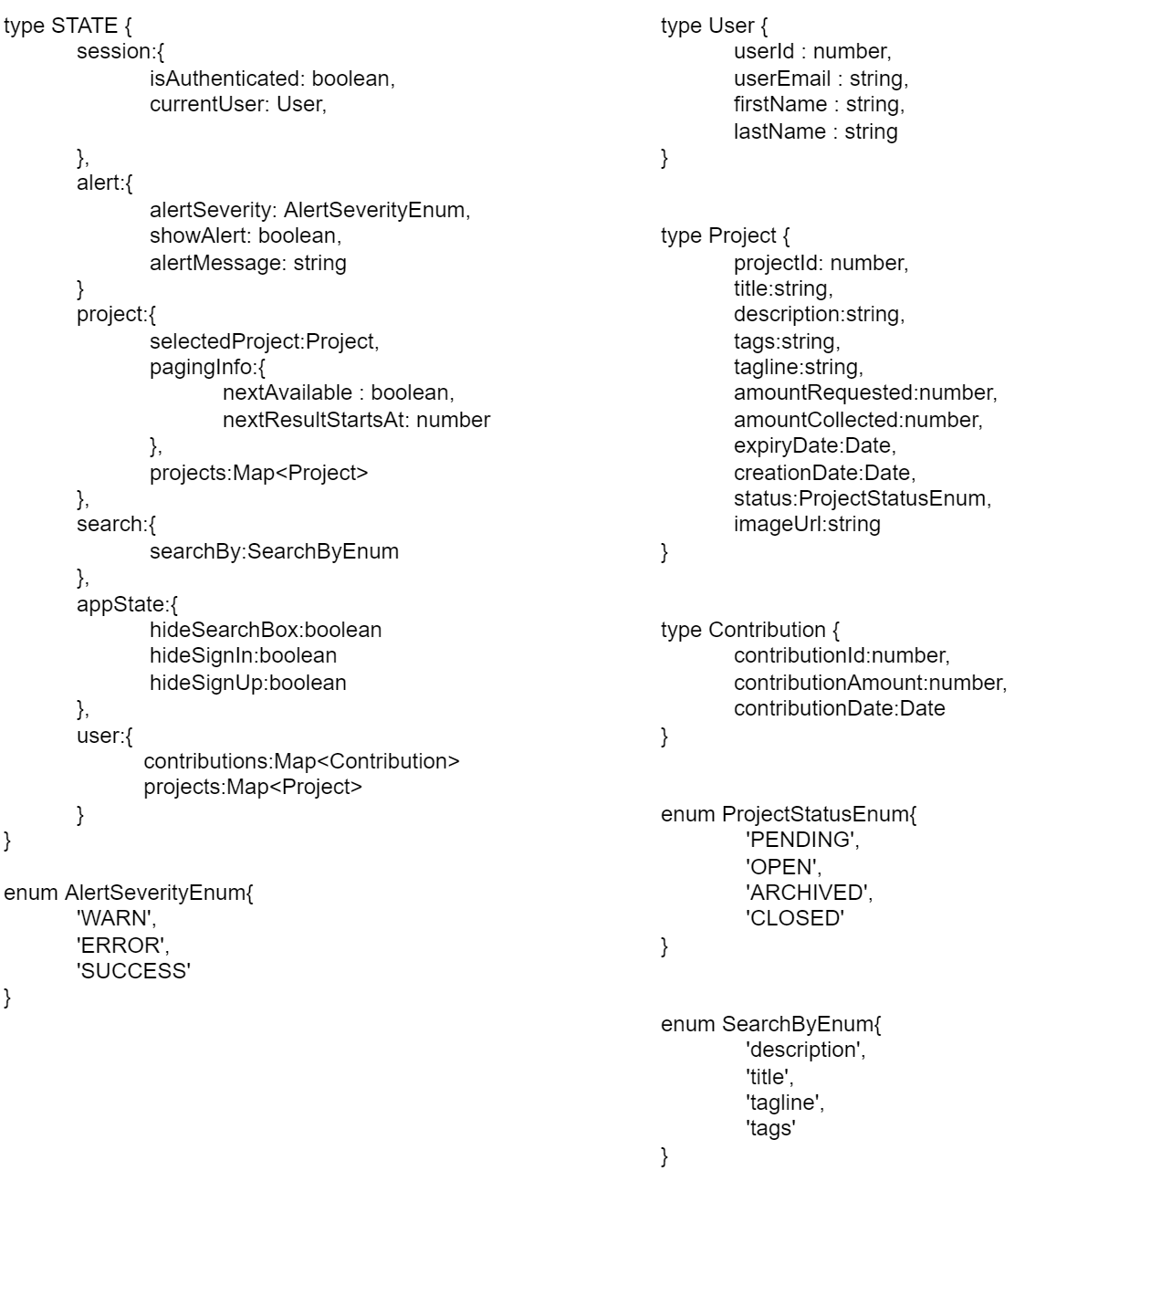

Performance
Currently Inplace
• Using Debouncing strategy to query api in search
• Redux Global Store
• Code minify & bundling & Gziping
• Use webp,png image versions

Proposed
• Using CDN to cache static frontend files
• Use bundle splitting, lazy loading
• Use Image Optimization servers to render image as per viewport and also use CDN to cache images

Accessibilty

Currently Inplace
• Using aria roles , labels for image,input
• Use Semantic html elements like form
• Use Contrast themes
• Responsive Design (currently inplace for 4 pages)

Proposed
• Using Shortcut/hot keys
• Support for Multiple languages
• Consistent font sizes , ability to resize
• Provide distinguishable patterns for color blindness special abled persons

Mockup Screens



