WEEK2_SKILL

Session 3:
- To Apply Escape Sequences, Store Command History, Navlgate Previous Commands, Navigate Next Commands, Update Input Buffer, Test Recall Functionality
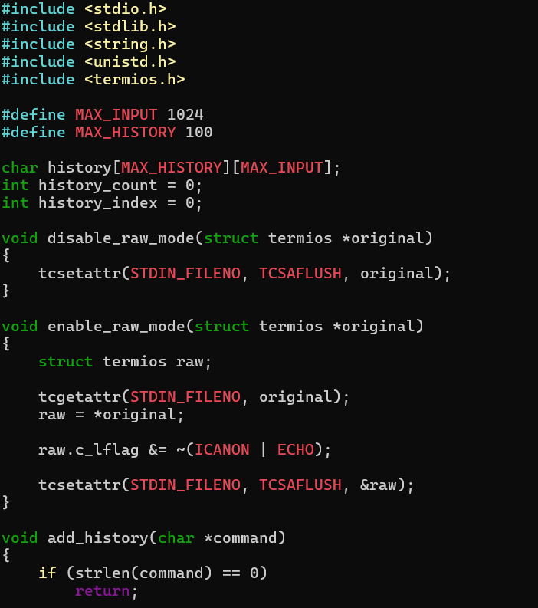

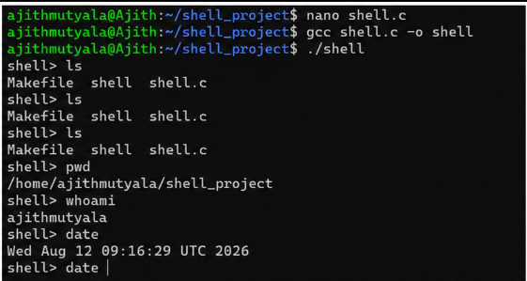

Report: I compiled and executed the shell program and tested commands such as ls, pwd, whoami, and date. I observed that the shell successfully executed each command and displayed the correct output. Thus, I successfully tested the execution of multiple commands in the shell.

- To Allocate Buffers Dynamically, Resize Arrays, Prevent Buffer Overflow, Manage Linked Lists, Release Memory Correctly, Verify with Valgrind

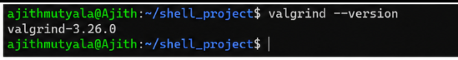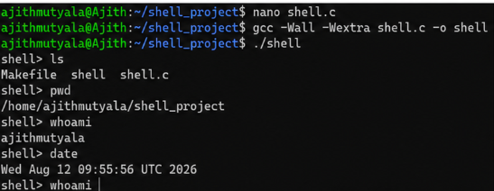

Report: I compiled and executed the shell program and tested commands such as ls, pwd, whoami, and date. I observed that all the commands executed successfully and displayed the expected output. Thus, I successfully tested command execution in the shell.

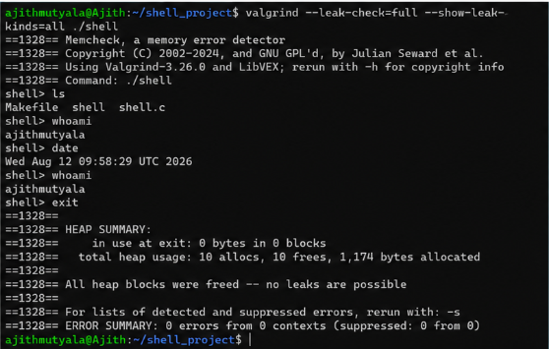

Report: I ran the shell using Valgrind and tested commands such as ls, whoami, and date. Valgrind reported 0 errors and confirmed that all allocated memory was freed with no memory leaks. Thus, I successfully verified that the shell is memory-safe.

Session 4:
- To Split Input into Tokens, Identify Delimiters, Handle Whitespace, Create Token Structures, Validate Token Streams, Debug Parsing Output
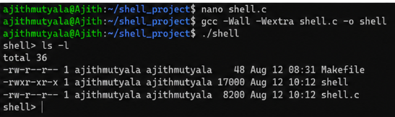

Report: I implemented the tokenization of user input by splitting commands into individual tokens. I handled spaces and delimiters properly and created token structures for further processing. I also tested the output to make sure the tokens were generated correctly.

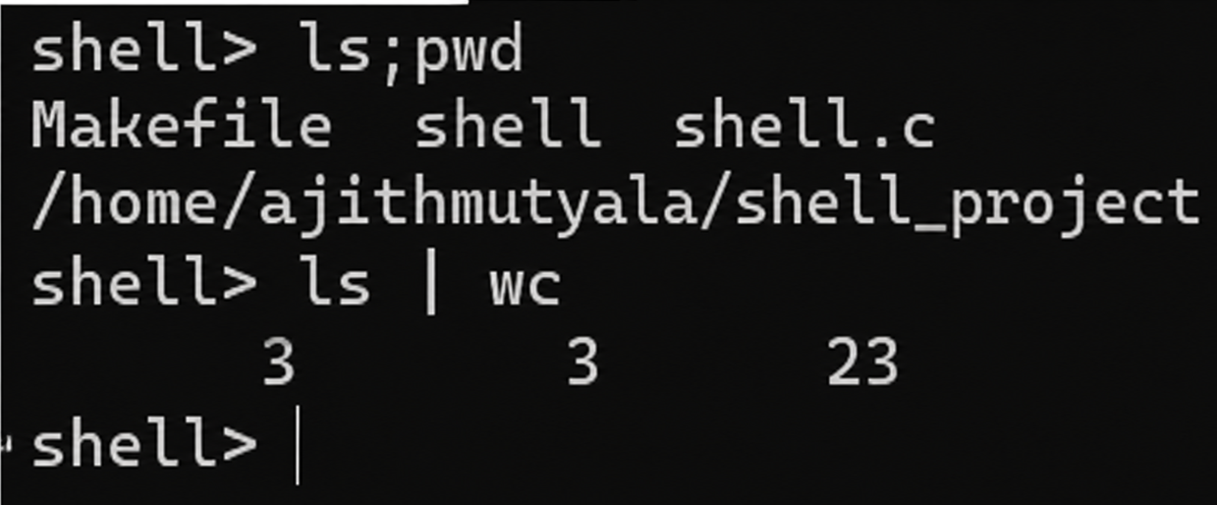

Report: I tested multiple commands in the shell, including sequential commands ls; pwd and a pipeline ls | wc. Both executed successfully and produced the expected output. Thus, I successfully tested sequential command execution and command piping in the shell.

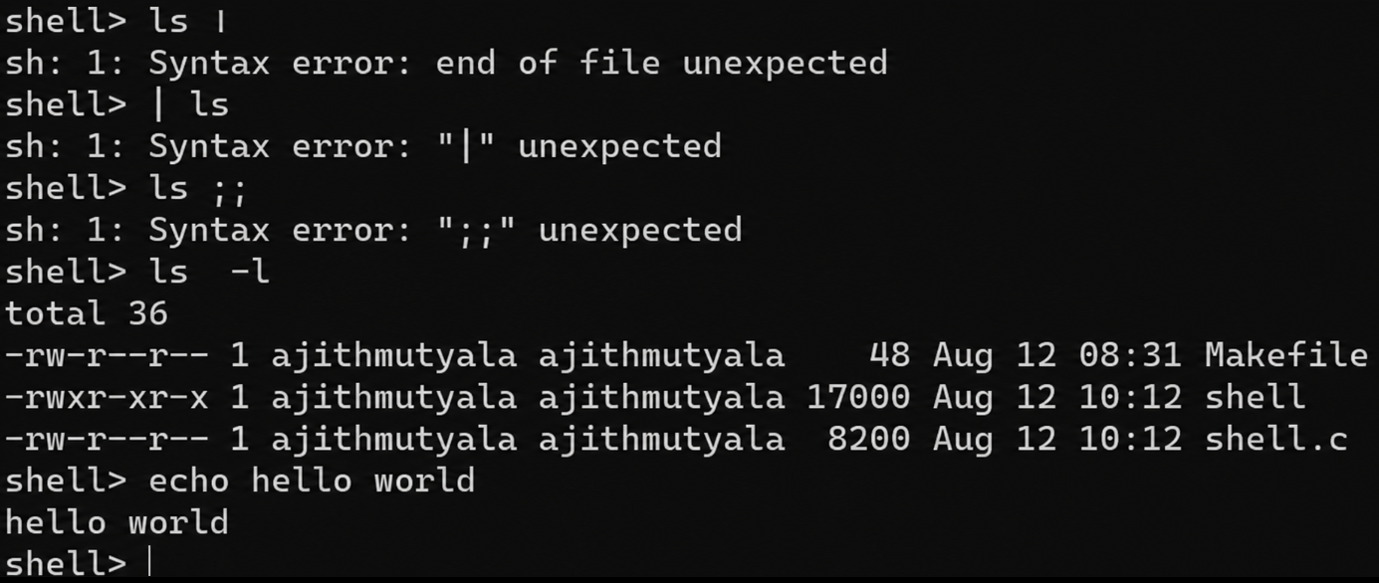

Report: I tested invalid inputs such as incomplete pipes and separators, and the shell displayed appropriate syntax errors. I also tested ls -l and echo hello world, which executed successfully and produced the expected output. Thus, I successfully tested error handling and normal command execution in the shell.

- To Design Parser Logic, Generate Parse Trees, Validate Syntax, Detect Errors, Handle Empty Commands, Produce Execution Structures

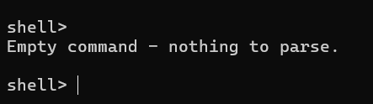

Report: I tested without giving any command and it gave output as Empty Command

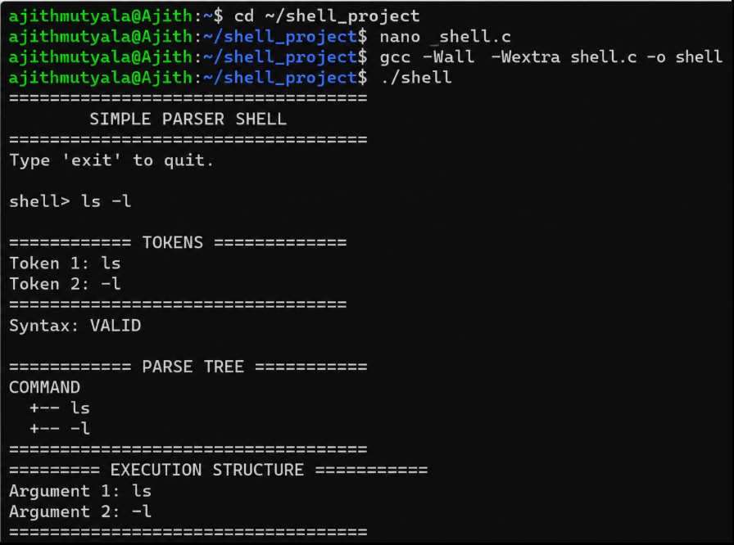

Report: I tested the parser shell with the command ls -l. The shell correctly identified the tokens, validated the syntax, generated the parse tree, and displayed the execution structure with the command and its argument. Thus, I successfully verified the tokenization, parsing, and execution structure of the shell.

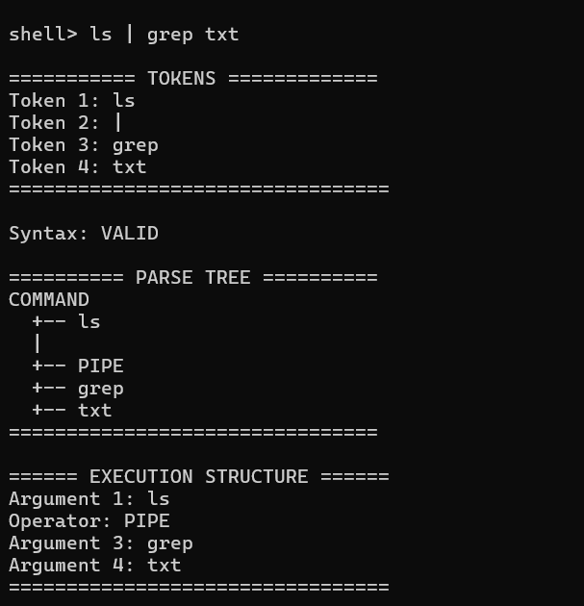

Report: I tested the parser with the command ls | grep txt. The shell correctly identified the tokens, validated the syntax, generated the parse tree with the pipe operator, and displayed the execution structure. Thus, I successfully verified pipe parsing and command structure handling.

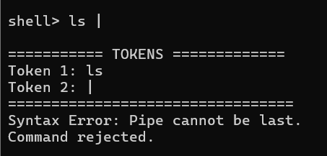

Report: I tested the shell with an incomplete pipe command ls |. The parser correctly detected that the pipe was the last token and rejected the command with a syntax error. Thus, I successfully verified syntax error handling for incomplete pipe commands.

