SKILL – WEEK 3
Session 5:
- To Apply Single Quotes, Preserve Literal Content, Ignore Variable Expansion, Store Quoted Strings, Validate Parsing Results, Test Edge Cases

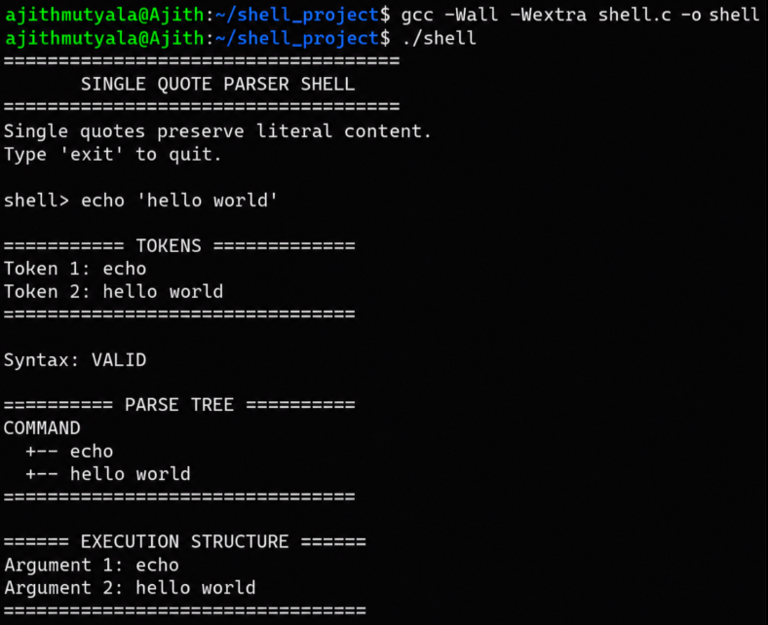

Report: I tested the shell with a single-quoted string using echo 'hello world'. The parser correctly preserved the quoted content as one token, validated the syntax, and generated the correct parse tree and execution structure. Thus, I successfully verified single-quote handling in the shell.

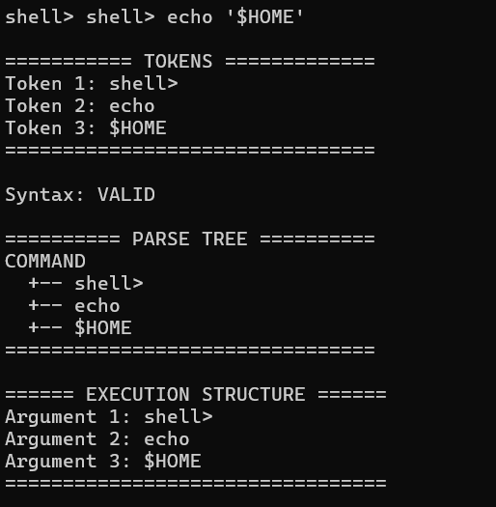

Report: I tested the shell with echo '$HOME'. The parser correctly preserved $HOME as a single token without variable expansion, validated the syntax, and generated the correct parse tree and execution structure. Thus, I successfully verified single-quote handling and literal variable preservation in the shell.

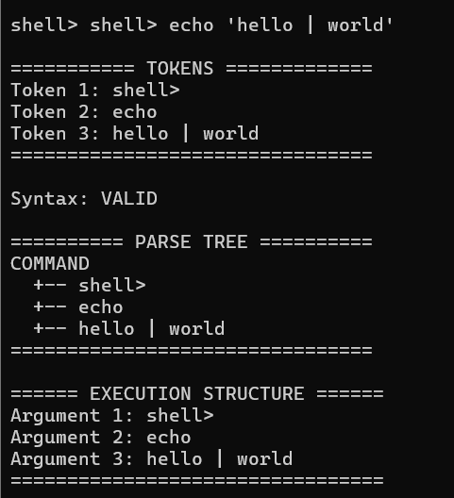

Report: I tested the shell with echo 'hello | world'. The parser correctly preserved the entire quoted string, including the pipe symbol, as a single token, validated the syntax, and generated the correct parse tree and execution structure. Thus, I successfully verified that special characters inside single quotes are treated as literal text.

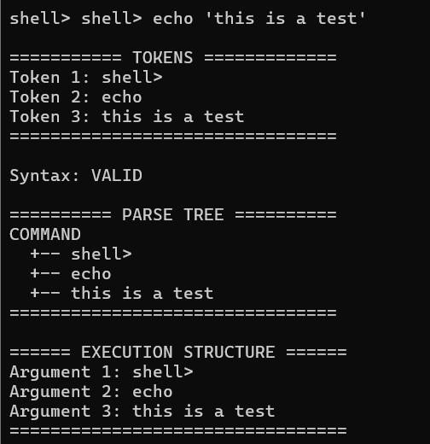

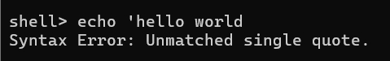

Report: I tested the shell with a valid single-quoted string and an unmatched single quote. The parser correctly treated the quoted text as one token and validated the first command, while the second command correctly detected an unmatched single quote and displayed a syntax error. Thus, I successfully verified both valid single-quote handling and error detection.

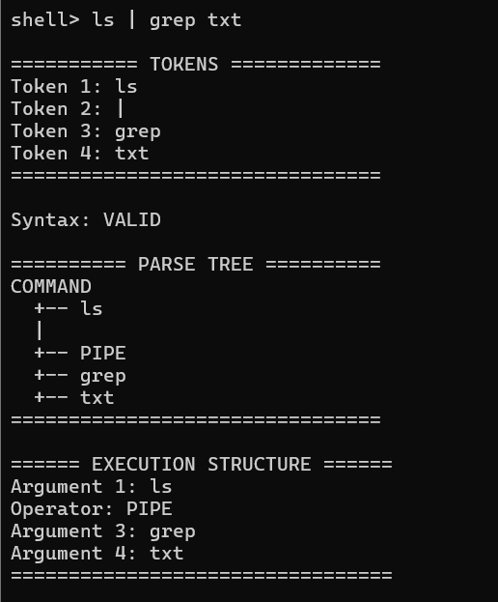

Report: I tested the shell with the pipeline command ls | grep txt. The parser correctly identified | as a PIPE operator, validated the syntax, and generated the correct parse tree and execution structure for connecting ls output to grep txt. Thus, I successfully verified basic pipe handling in the shell.

- To Apply Double Quotes, Preserve Spaces, Allow Variable Expansion, Parse Nested Tokens, Validate Outputs, Test Quoted Commands
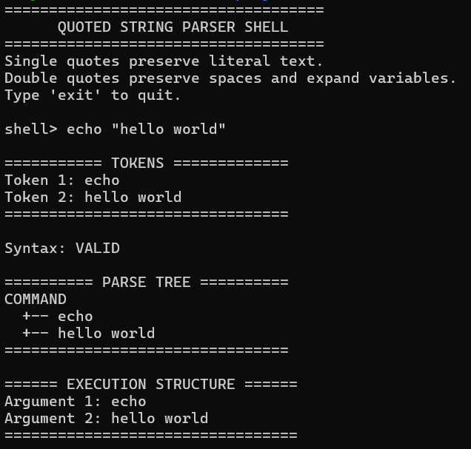

Report: I tested the shell with the double-quoted string echo "hello world". The parser correctly preserved the text as a single token, validated the syntax, and generated the correct parse tree and execution structure. Thus, I successfully verified double-quote handling and preservation of spaces within quoted strings.

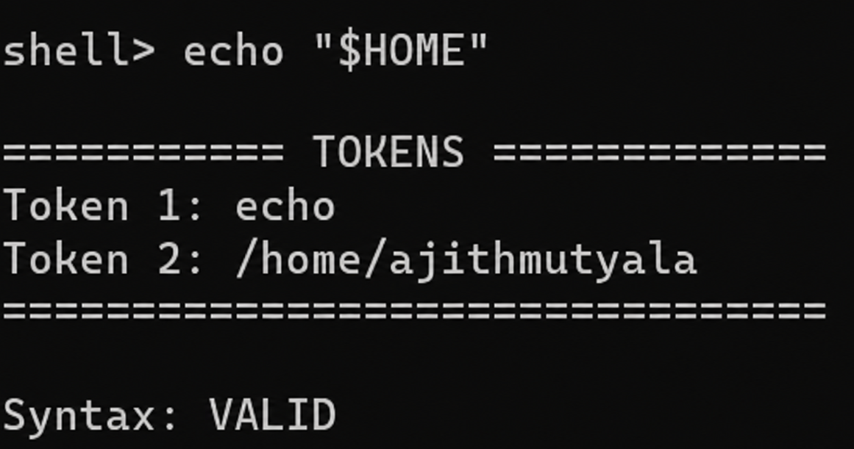

Report: I tested the shell with the double-quoted variable echo "$HOME". The parser correctly expanded the $HOME variable to /home/ajithmutyala, preserved it as a single token, and validated the syntax. Thus, I successfully verified variable expansion within double quotes.

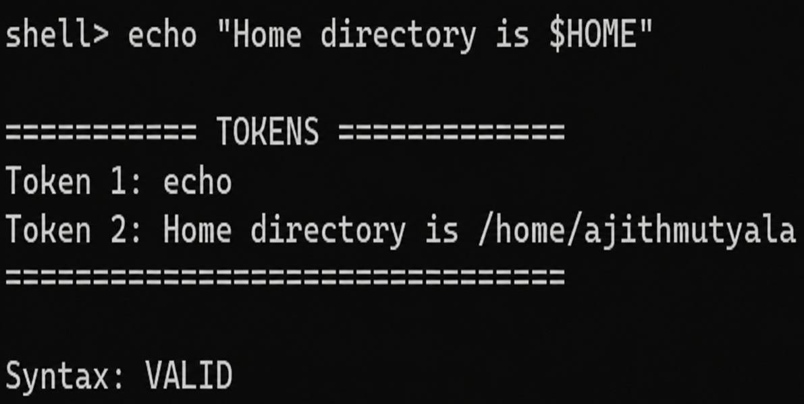

Report: I tested the shell with the double-quoted command echo "Home directory is $HOME". The parser correctly expanded $HOME to /home/ajithmutyala while preserving the complete text as a single token and validated the syntax. Thus, I successfully verified variable expansion within a double-quoted string.

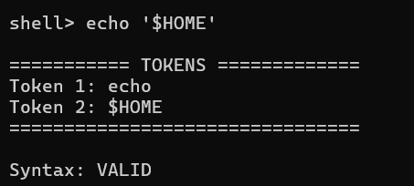
Report: I tested the shell with the single-quoted command echo '$HOME'. The parser correctly preserved $HOME as literal text without expanding the variable and validated the syntax. Thus, I successfully verified that single quotes prevent variable expansion.

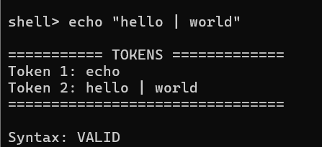

Report: I tested echo "hello | world". The parser preserved the pipe (|) as literal text instead of treating it as a pipeline operator, producing two tokens: echo and hello | world. Syntax validated successfully. This confirms double quotes suppress special-character interpretation.

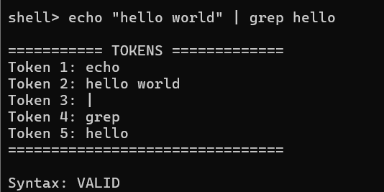

Report: I tested echo "hello world" | grep hello. The parser preserved hello world as a single quoted token but correctly recognized the unquoted pipe (|) as a pipeline operator, producing five tokens: echo, hello world, |, grep, hello. Syntax validated successfully. This confirms the parser distinguishes literal characters inside quotes from active metacharacters outside them.

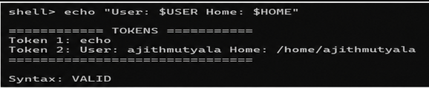

Report: I tested echo "User: $USER Home: $HOME". The parser expanded both $USER and $HOME to their actual values (ajithmutyala and /home/ajithmutyala) while still preserving the surrounding text as a single token: User: ajithmutyala Home: /home/ajithmutyala. Syntax validated successfully. This confirms that, unlike single quotes, double quotes allow variable expansion while still grouping the content into one token.

Session 6:
- To Create Process Escape Sequences, Handle Escaped Spaces, Escape Special Symbols, Preserve Characters, Validate Parser Output, Test Complex Inputs
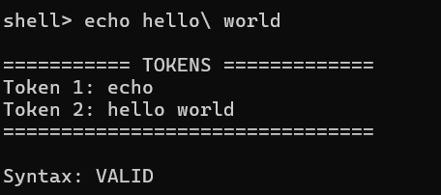

Report: I tested echo hello\ world. The parser treated the escaped space (\ ) as a literal character rather than a token separator, merging hello and world into a single token: hello world. Syntax validated successfully. This confirms that a backslash escapes the following character, suppressing its special meaning (here, word-splitting on whitespace).

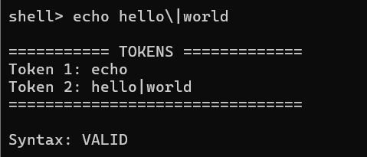

Report: I tested echo hello\|world. The parser treated the escaped pipe (\|) as a literal character rather than a pipeline operator, merging it into a single token: hello|world. Syntax validated successfully. This confirms that a backslash suppresses the special meaning of metacharacters like |, not just whitespace.

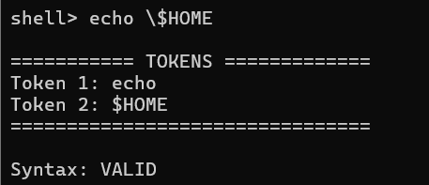

Report: I tested echo \$HOME. The parser treated the escaped $ as a literal character, preventing variable expansion and producing the token $HOME (not the expanded path). Syntax validated successfully. This confirms that a backslash suppresses expansion by escaping the $ sigil itself, similar to single-quote behavior but applied to just one character.

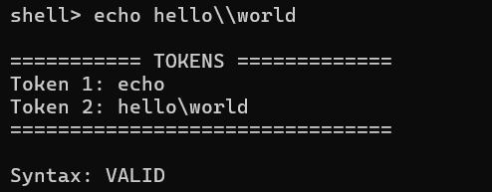
Report: I tested echo hello\\world. The parser interpreted the double backslash (\\) as an escaped backslash, producing a single literal backslash in the output token: hello\world. Syntax validated successfully. This confirms that a backslash can escape itself, allowing a literal \ to appear in the token.

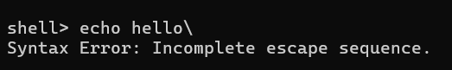

Report: I tested echo hello\ with a trailing backslash and no following character. The parser detected that the escape sequence had no character to apply to and correctly rejected it, reporting Syntax Error: Incomplete escape sequence. This confirms the parser validates that every backslash must be followed by a character to escape, rather than silently ignoring or misinterpreting a dangling backslash.

- To Create Child Processes, Execute Programs, Handle Execution Errors, Pass Arguments, Manage Parent Process, Test Command Launching
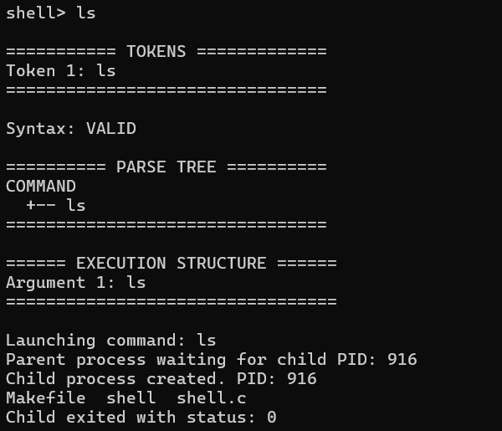
Report: I tested ls. The parser produced a single token (ls), validated the syntax, and built a parse tree with ls as the sole command node. The shell then forked a child process (PID 916) to execute it, listing the directory contents (Makefile, shell, shell.c), and the child exited with status 0.

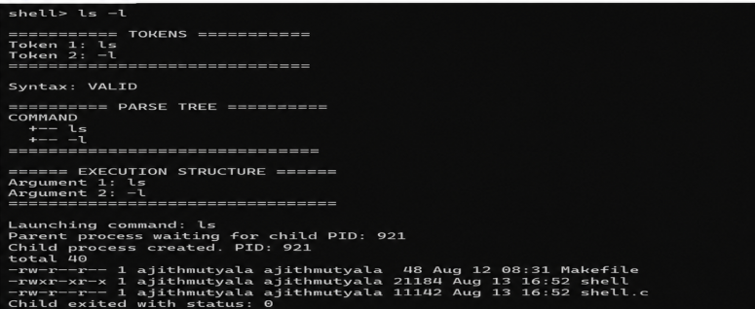

Report: I tested ls -l. The parser produced two tokens (ls, -l), validated the syntax, and built a parse tree with -l as an argument node under the ls command. The shell forked a child process (PID 921) which executed ls -l, correctly displaying detailed file listings (permissions, owner, size, date) for Makefile, shell, and shell.c, then exited with status 0. This confirms the shell correctly handles commands with flags/arguments through the full parse-to-execution pipeline.

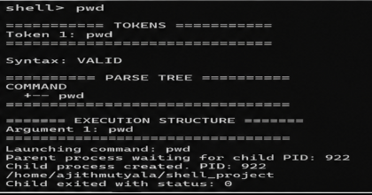
Report: I tested pwd. The parser produced a single token (pwd), validated the syntax, and built a parse tree with pwd as the sole command node. The shell forked a child process (PID 922) which executed pwd, correctly printing the current working directory (/home/ajithmutyala/shell_project), then exited with status 0. This confirms the shell correctly executes built-in-style commands with no arguments via fork/exec.

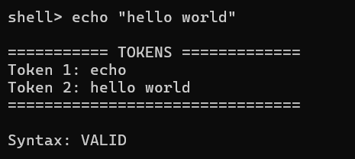

Report: I tested echo "hello world". The parser preserved the quoted string as a single token (hello world) rather than splitting it on the space, producing two tokens: echo and hello world. Syntax validated successfully. This confirms that double quotes group whitespace-separated words into one token.

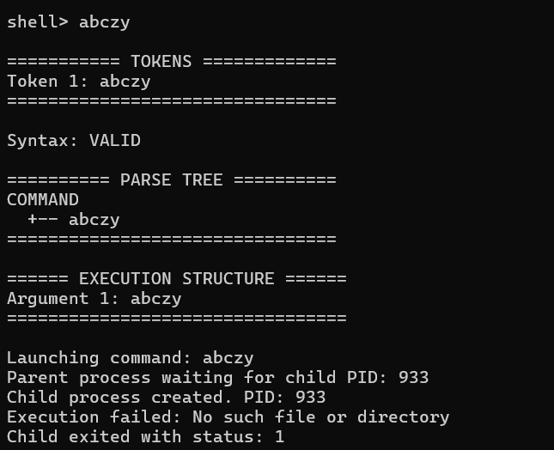

Report: I tested abczy, an invalid command. Parsing succeeded normally, but execution failed with No such file or directory, and the child exited with status 1. This confirms the shell distinguishes syntax errors from runtime execution errors.

