**Name: Ajith Gajanan Shetty**

**Register Number: 211039023**

1:

;ADD NIBBLE N4 AND N0 FORM MEMORY LOCATION 40000004 AND STORE RESULT IN 4000000C

AREA NIBBLE,CODE,READONLY

ENTRY

START

LDR R0,ADD1 ;TAKING THE ADDRESS 40000004

LDR R1,[R0] ;TAKING CONTENT OF R0

MOV R6,R1 ;TAKING THE VALUE IN R6

LDR R3,=0X0000000F;TAKING MASKING BITS

LDR R2,RESULT;TAKING ADDRESS OF RESULT

AND R6,R3;MASKING ALL EXTRA BITS

;MOV R6,R6, LSR#4

MOV R5,R1, LSR#16;SHIFT N4 TO THE END

LDR R7,=0X0000000F;TAKING BITS FOR MASKING

AND R5,R7;MASKING UNWANTED BITS IN R5

ADD R4,R6,R5;ADD BOTH LOWER NIBBLE

STR R4,[R2];STORE THAT IN RESULT PLACE

ADD1 DCD &40000004

RESULT DCD &4000000C

END

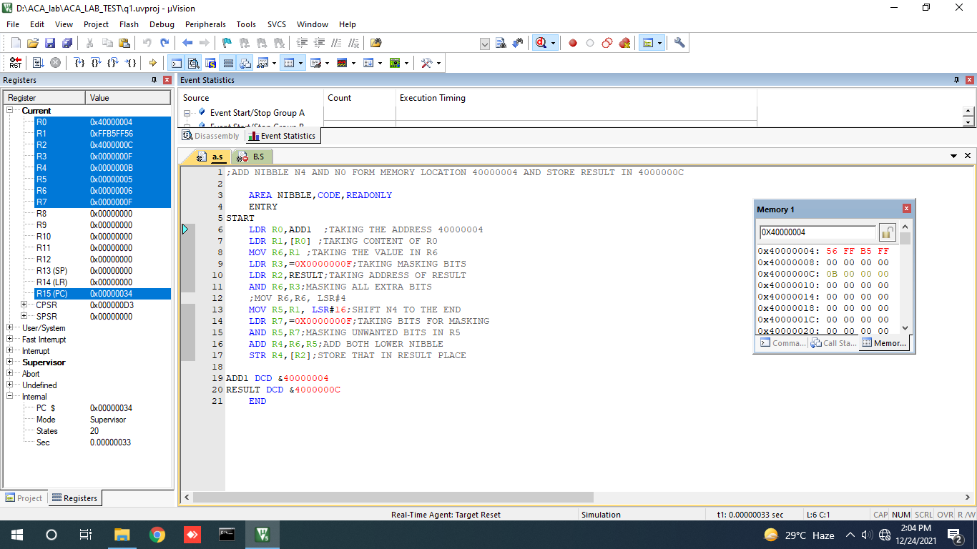  
Output:

For the given input number FFB5FF56

N0 is 6 and N4 is 5

Hence the sum is 0B

2:

;Implement ASM program consider the number in 4000000c,add the array only if possitive and store in 40000000

AREA SECOND,CODE,READONLY

ENTRY

START

LDR R0,VALUE;Get the address of value

LDR R4,RESULT;get the address of result

LDR R1,[R0];load the fist value of array to r1

MOV R2,&4;add the number of array elements

MOV R3, #0X00 ; SUM = 0

LOOP SUB R2,R2,#1;since 1 number is already fetched we decrement

CMP R2,#0;compare the size

BLT STOP;if size is less than zero stop execution

CMP R1,#0;then compare the element

BLT NEXT;if element is less than 0 ie if its negative fetch the next element

ADD R3,R3,R1;then add

STR R3,[R4];store the result in 40000000

B NEXT;fetch next element

NEXT LDR R1,[R0,#4]!;fetch the next element.ie auto increment

B LOOP;start the loop again

STOP B STOP

VALUE DCD &4000000C

RESULT DCD &40000000

END

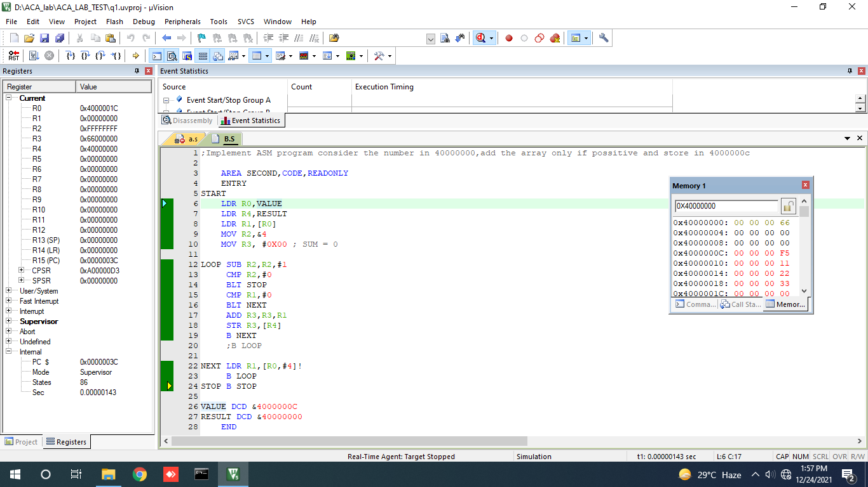

Output

For the given input

-11,11,22,33

-11 has been ignored and sum is obtained as 66