RESUME

Name: AJITHA V
Git Link: Ajitha
Mobile: 8524995697
Mail: ajitha7472@gmail.com
Wordpress: Ajitha-vijayakumar
Technical Summary:
- Active member in GitHub
- Active member in StackOverflow
- Good knowledge in core Java
- Contributed to HTML, CSS Projects
- Contributed to bugs finding in LibreOffice
- Blog writer in Wordpress.com

Educational Qualification
Qualification | Dept | College/Board | Year Of Passing | Percentage
BE., | CSE | MKCE | 2025 | 95
Higher Secondary | Maths/Biology | BHSS | 2021 | 95

Personal Skills:
- Adaptability
- Quick Learner
- Imperturbable
- Positive Thinker

Technical Skills:
Languages :  - HTML  - CSS  - JAVA | DB:  - PostgreSQL | Other fields :  - TESTING

Projects :
- HTML, CSS Resume
- Flags using HTML, CSS
- Registration page

Declaration :
Hereby, I declare that all above furnished information are true to my knowledge and belief.
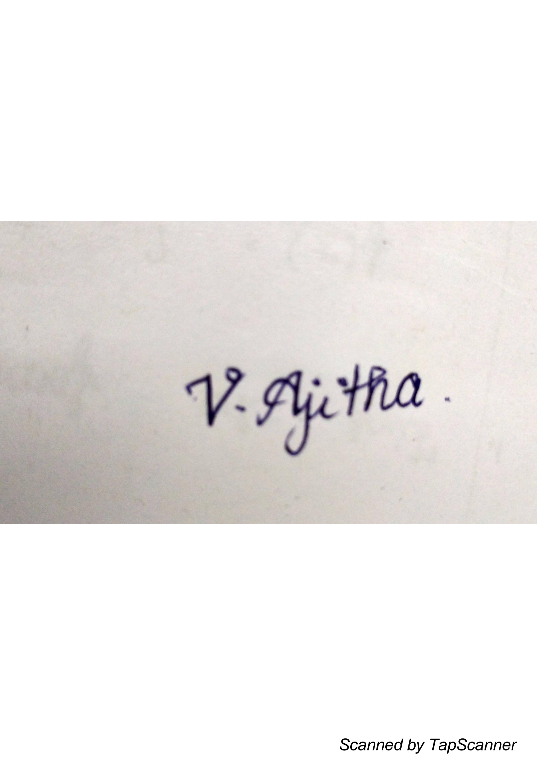
Signature

