Job Acceptance Prediction System

Project Summary
Project Title
Job Acceptance Analysis and Recruitment Analytics Dashboard
Project Overview
The objective of this project was to analyse recruitment and placement data to identify the key factors influencing candidate placement outcomes. The project involved preparing the dataset, performing exploratory data analysis (EDA), developing and evaluating machine learning classification models, and creating an interactive analytics dashboard for visualizing recruitment insights.
The project follows a complete data analytics workflow, beginning with data preprocessing and ending with an interactive dashboard that enables users to explore recruitment trends and model performance.
Workflow Followed
1. Data Collection
The recruitment dataset containing candidate information was used as the primary source of data. The dataset included academic records, technical skills, interview performance, certifications, work experience, salary expectations, company tier, and placement status.

2. Data Cleaning and Preprocessing
The raw dataset was cleaned and prepared for analysis by performing the following tasks:
- Removed duplicate records.
- Handled missing values.
- Corrected inconsistent data formats.
- Encoded categorical variables into numerical values.
- Performed feature engineering where necessary.
- Scaled numerical features for machine learning algorithms.
- Prepared the final dataset for model training.
This step ensured that the dataset was accurate, consistent, and suitable for further analysis.

3. Exploratory Data Analysis (EDA)
Exploratory Data Analysis was conducted to understand the characteristics of the dataset and identify important relationships between variables.

The analysis included:
- Distribution of placement status.
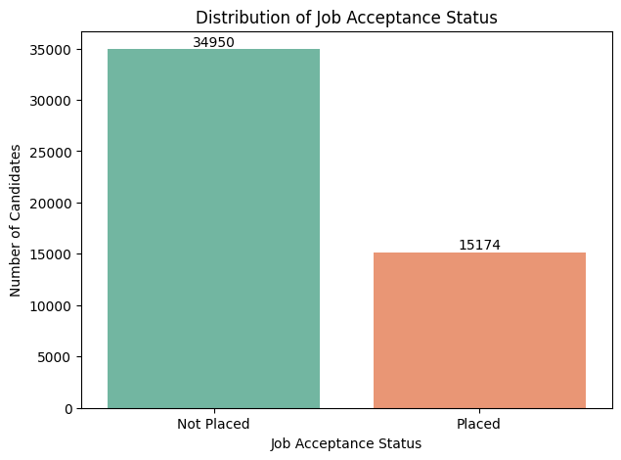
- Academic performance analysis.
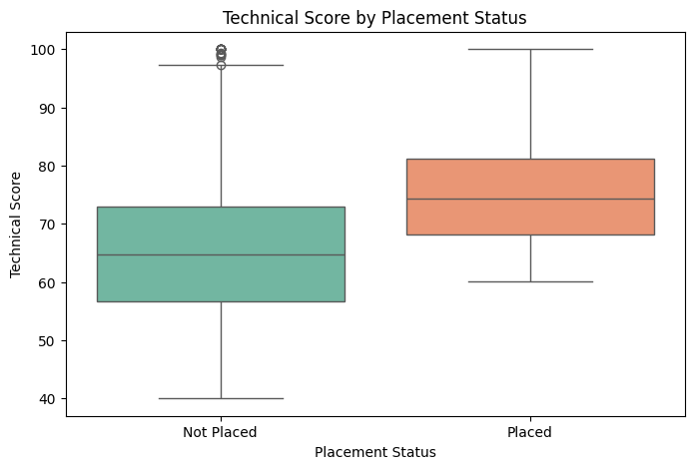

- Interview performance analysis.
- Skills match percentage analysis.
- Certification impact on placement.
- Company tier-wise placement analysis.
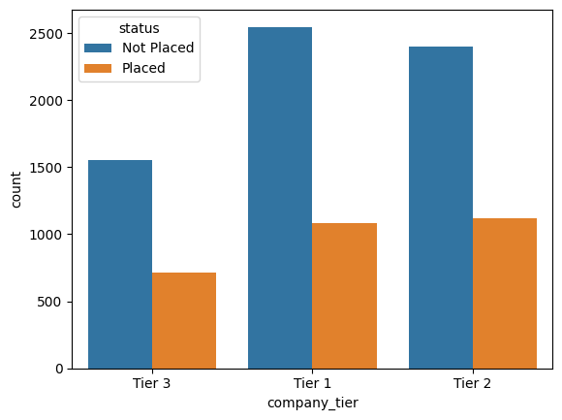
- Experience versus placement success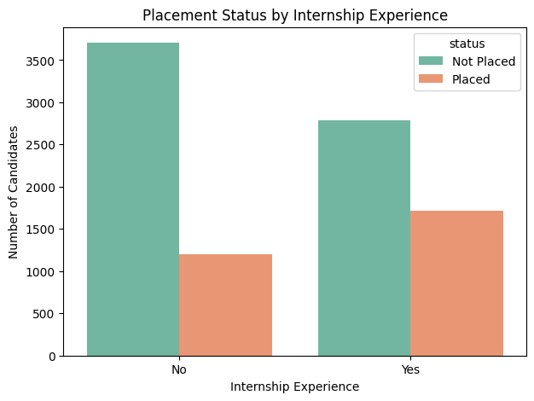
- Correlation analysis between numerical variables.
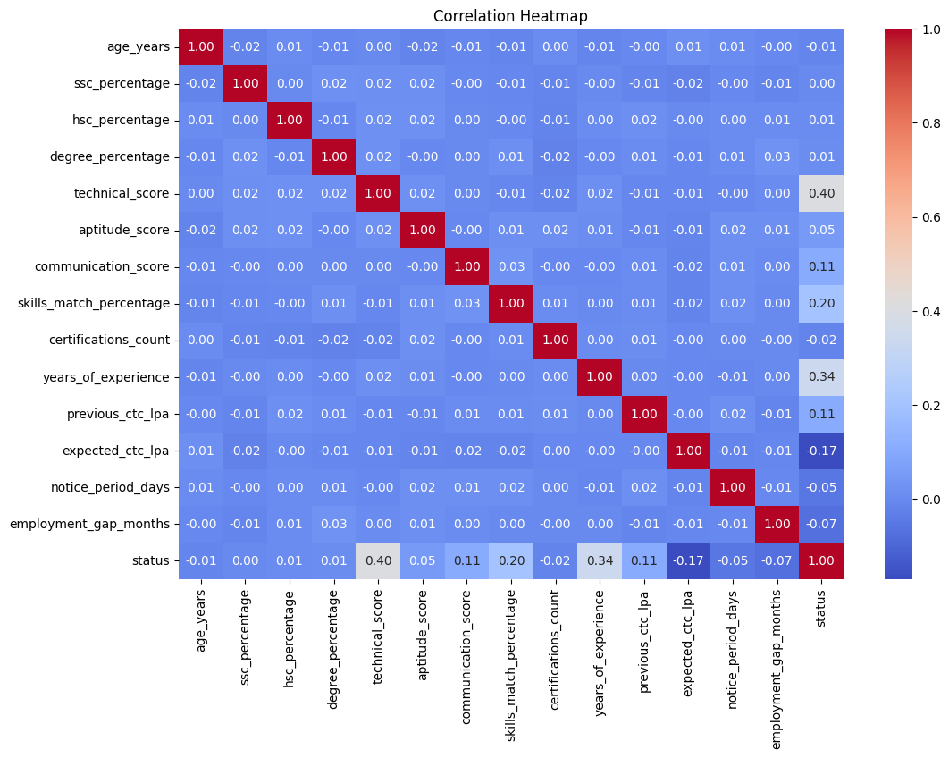
- Identification of important recruitment trends through statistical visualizations.
Various visualization techniques such as bar charts, box plots, scatter plots, histograms, and correlation heatmaps were used to gain meaningful insights from the data.
4. Machine Learning Model Development
After preprocessing, multiple machine learning classification algorithms were trained and evaluated to classify candidate placement outcomes.
The model development process included:
- Splitting the dataset into training and testing sets.
- Training different classification models.
- Hyperparameter tuning to improve performance.
- Comparing model accuracy and evaluation metrics.
- Selecting the best-performing model.
The Random Forest Classifier achieved the best overall performance and was selected as the final model for analysis.
5. Model Evaluation
The selected model was evaluated using several performance metrics, including:
- Accuracy
- Precision
- Recall
- F1-Score
- Confusion Matrix
Feature importance analysis was also performed to identify the variables that contributed most significantly to the model's decisions. Important features included technical score, years of experience, skills match percentage, interview performance, expected salary, previous salary, job role match, communication score, aptitude score, and internship experience.
6. Recruitment Analytics Dashboard
A Streamlit-based interactive dashboard was developed to present recruitment insights in an easy-to-understand format.
The dashboard includes:
- Total candidate statistics.
- Placement rate.
- Average interview performance.
- Skills match percentage.
- Expected salary analysis.
- Academic performance comparison.
- Certification impact analysis.
- Placement rate by company tier.
- Experience versus placement analysis.
- Interview performance comparison.
- Average employability test scores.
- Model performance metrics.
- Classification report.
- Confusion matrix.
- Feature importance visualization.
The dashboard enables users to interactively explore recruitment data and understand the factors affecting placement outcomes.
Technologies Used
- Python
- Pandas
- NumPy
- Matplotlib
- Seaborn
- Scikit-learn
- Joblib
- Streamlit
- Jupyter Notebook

Conclusion
This project successfully implemented a complete recruitment analytics workflow, including data preprocessing, exploratory data analysis, machine learning model development, performance evaluation, and interactive dashboard creation. The analysis identified the key factors influencing candidate placement outcomes and demonstrated how machine learning and data visualization techniques can support recruitment decision-making. The final dashboard provides an effective platform for presenting recruitment insights and model evaluation results in a user-friendly manner.

