Project-2

# Part1:

* Creation of azure repo and commiting all the codes and terraform script there.

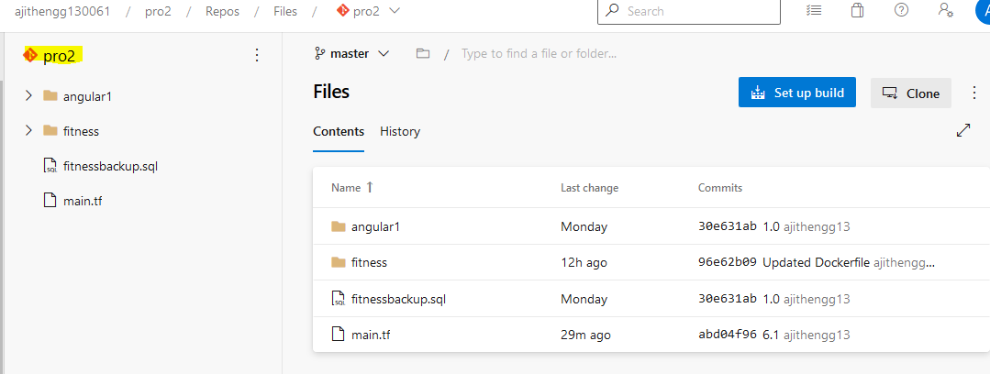

* Creation of azure resources using terraform terraform script.
* Creation of azure resource group
* Creation of azure mysql db
* Creation of storage account with blob container.
* Creation of app service plan
* Creation of app services
* Creation of azure kubernetes services

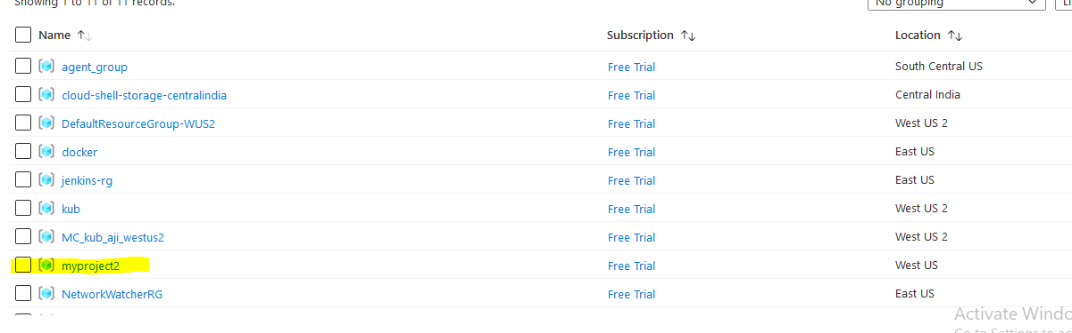

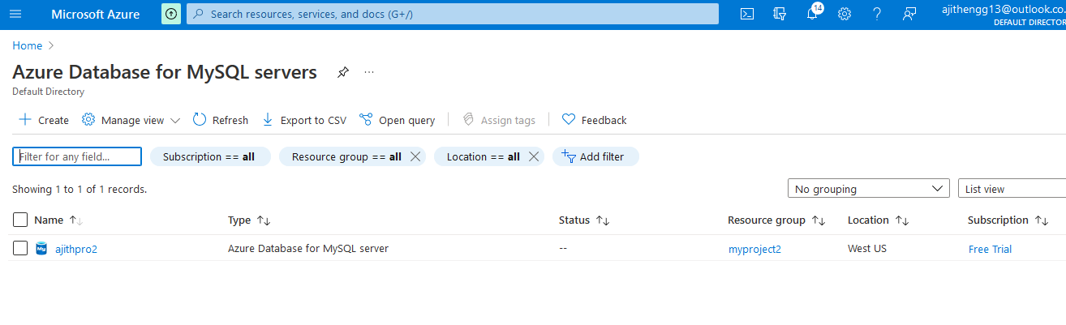

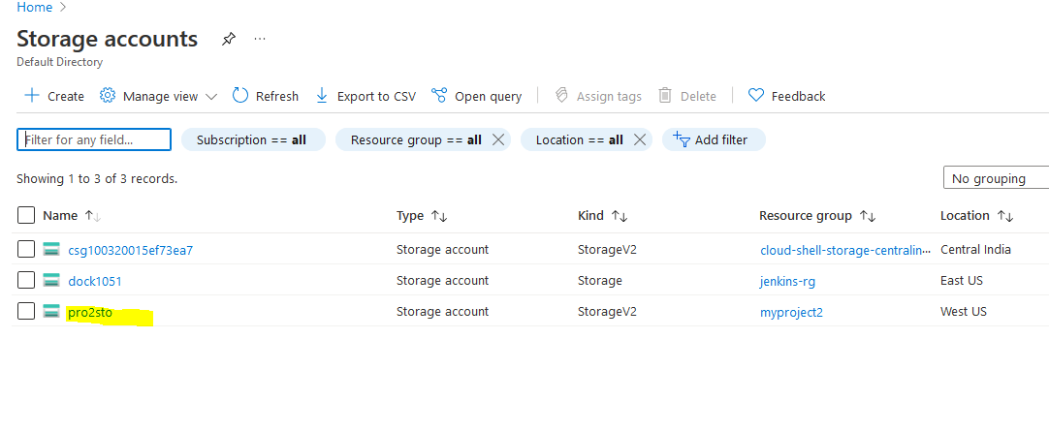

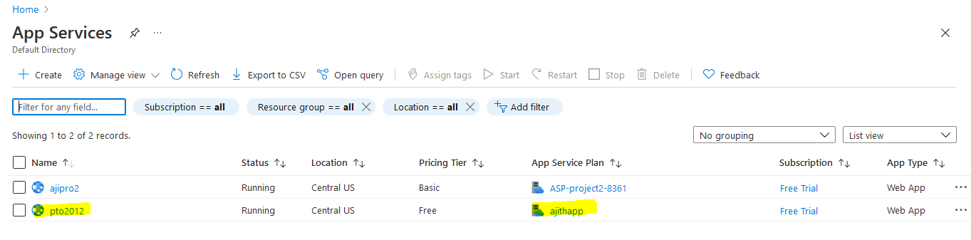

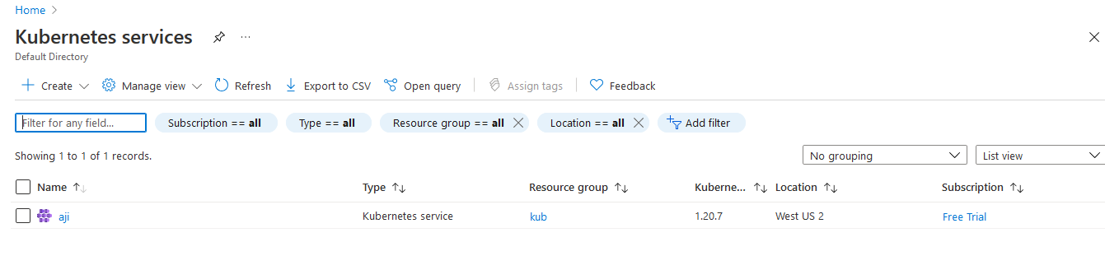

Creating azure container registry manually:

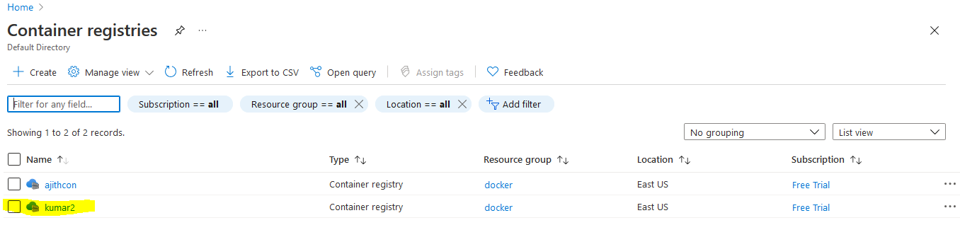

# Part-2

* Uploading all the images to azure container and restoration of mysql backup.

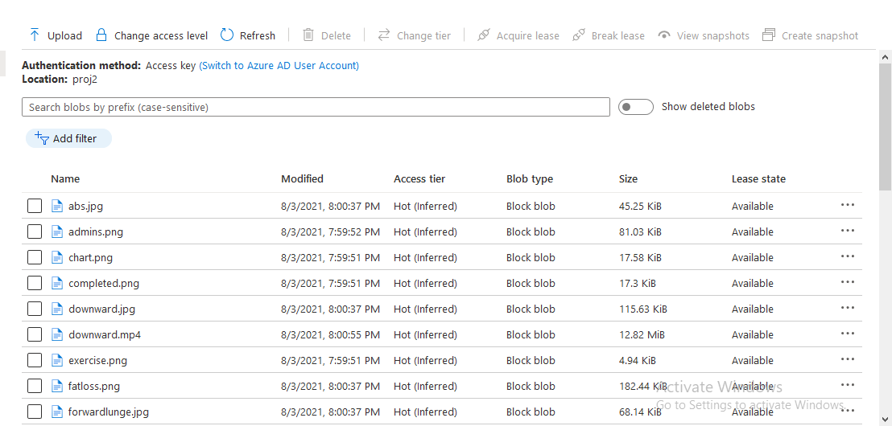

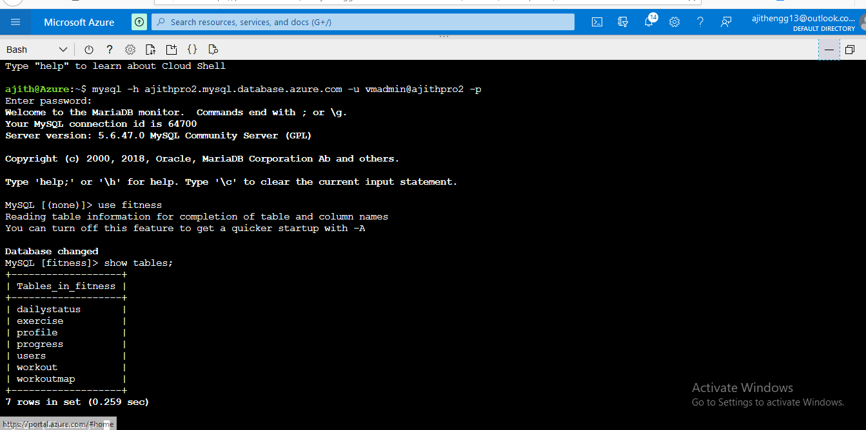

# Part-3 azure devops pipeline

* Creation of azure environment using terraform .
* Creation of azure pipeline.

First pipeline to create a docker container using python code to create the API for the fitness app.

The pipeline should build the code and push it to azure container registry.

The pushed image should be containerized using kuberneters.

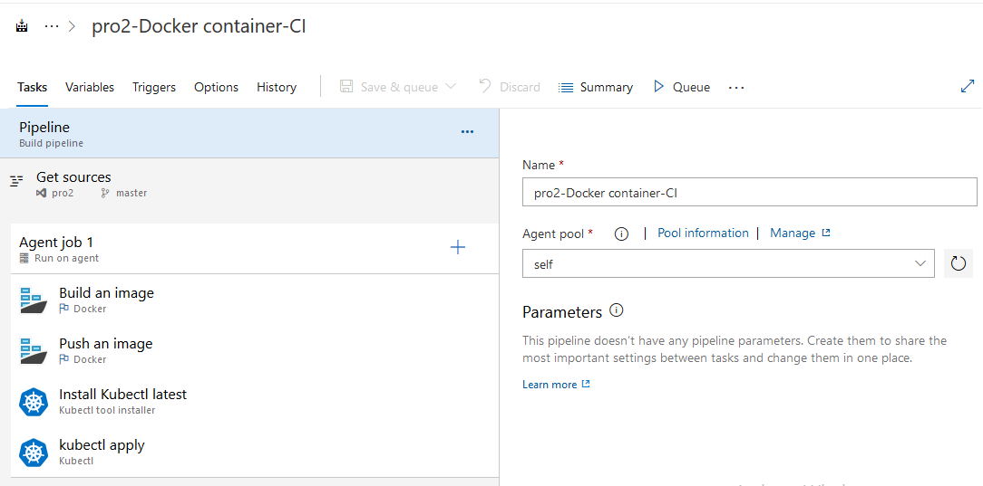

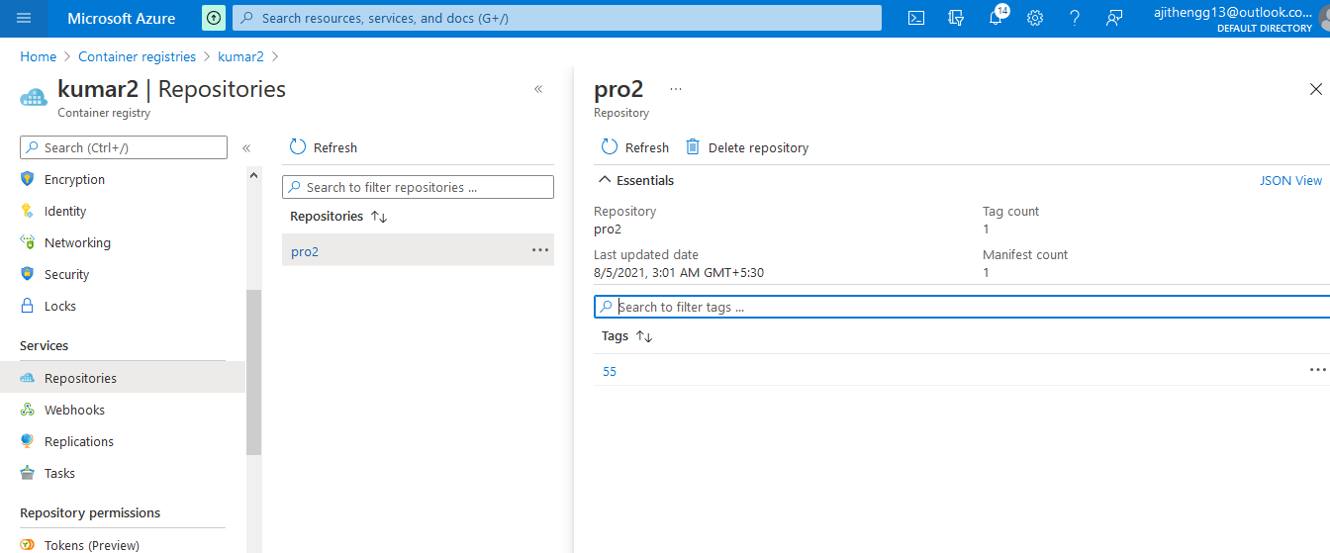

* Build image is deployed using kubernetes services.

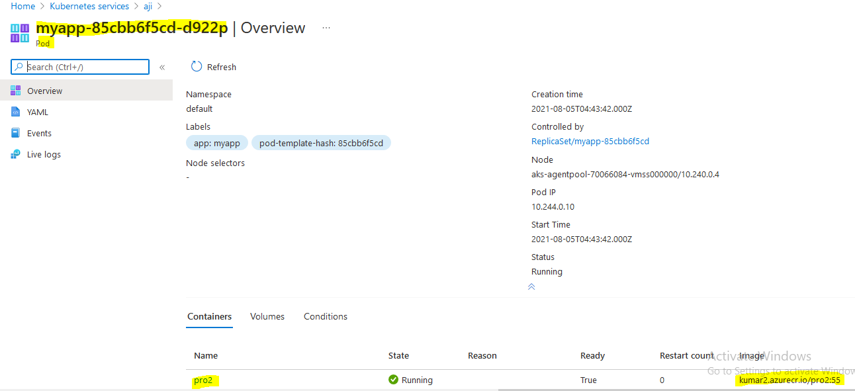

* Changing the load balancer IP of the pod in angular code to communicate with the microservices.

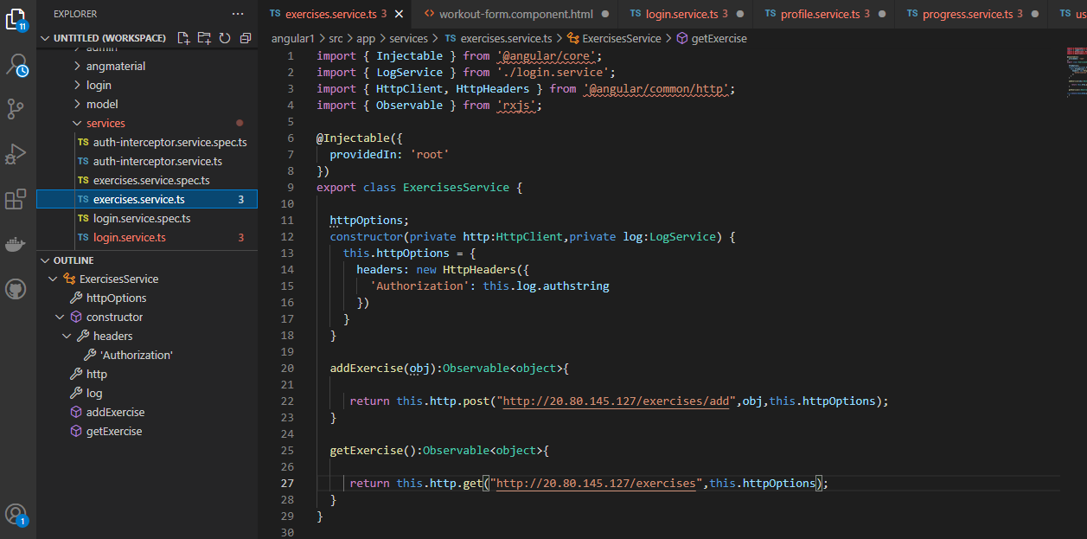

Updating the azure container url in angular code.

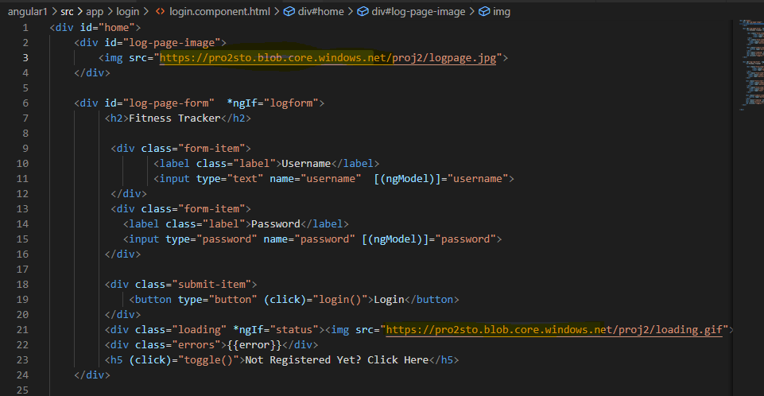

Building the image in the pipeline to deploy in azure app services.

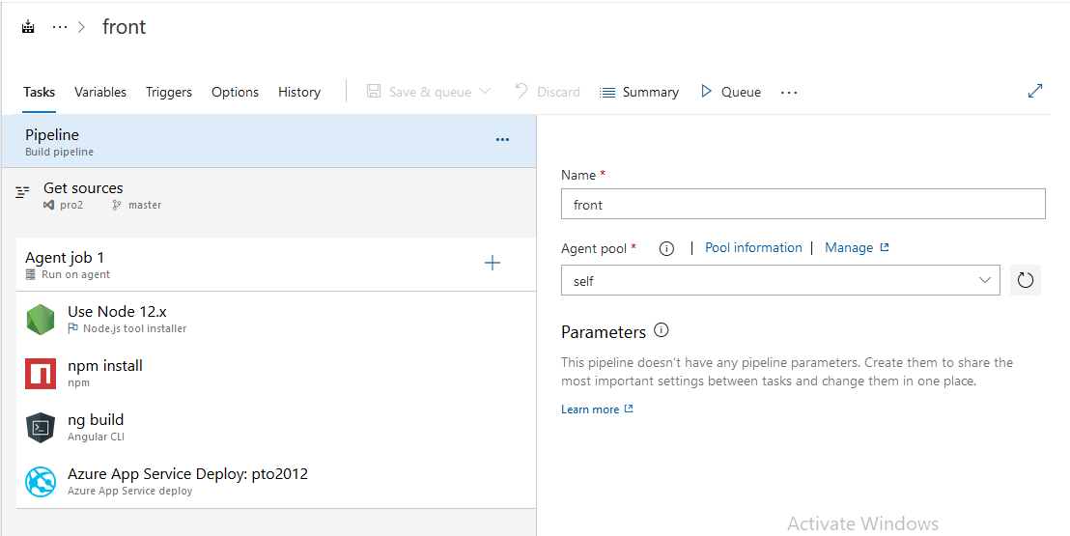

* Accessing the application

