Zayo IDP Platform
Architecture & Design Manual
Manual 1 of 2 — Platform Engineer Reference
For platform engineers building, operating, and evolving the IDP
Zayo Platform Engineering · Confidential · Living Document
v0.2 · Draft · May 2026

What we're building
Every component described in this manual exists to deliver one experience: this dashboard.
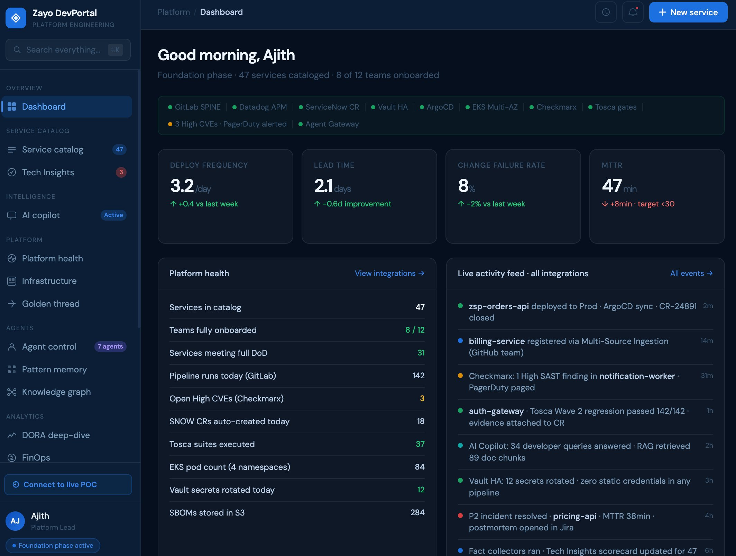
Figure 0. Foundation-phase DevPortal — illustrative
Platform engineer's dashboard view: catalog, scorecards, DORA metrics, integration health, live activity feed.
L1 surface backed by L2 plugins, L3 backends, L4b copilot, L5a integrations, L5b storage, and L6b runtime — every layer represented in one screen.

1. Introduction

1.1 Purpose
This is the technical reference for the Zayo Internal Developer Platform (IDP). It documents the target architecture across all four maturity phases. It is the agreed source of truth for design decisions on the platform team.

1.2 Audience
- New platform engineers — use this to understand the system and its rationale.
- Existing platform engineers — use this as the reference for ongoing design debates.
- Not for application engineers (see Service Owner's Guide) or executives (the framework poster is the leadership view).

1.3 Scope
- In scope: target architecture across all 4 phases, all 10 layers. Foundation components in depth; Intelligence and Agentic at the level of architectural intent; Autonomous at the level of vision.
- Out of scope: current build state (lives in the roadmap board), how to spin up a new environment (Manual 2), service-owner workflows (Service Owner's Guide).

1.4 How to read this manual
New engineers: read sections 1, 2, and 3 in order, then any Foundation layer in any order. Each layer section is self-contained.
Existing engineers: use as a reference. Each component section follows the same structure: what it is, why it exists, how it connects, configuration, extension points, operational notes, known limitations.
The architecture poster (Appendix A) is the fastest visual reference. The poster and this manual are kept in sync; if they disagree, file an issue.

1.5 Conventions
- Layer numbers (L1–L6, with sublayers L4a/L4b/L4c, L5a/L5b, L6a/L6b) refer to the architecture defined in section 2.3.
- Phase names (Foundation, Intelligence, Agentic, Autonomous) refer to the maturity phases defined in section 2.4. Each component is tagged with the phase that activates it.
- Code identifiers and file paths appear in monospace. Environment-specific values appear as patterns (<account-id>, <cluster-name>). Literal values live in Manual 2.
- Diagrams are versioned in the source repository. The poster (Appendix A) is the master visual; figures in this manual are derived views.
Living document. This manual is versioned and PR-reviewed. Propose changes as MRs against the platform-docs repository. Stale documentation is worse than no documentation — keep it current.

2. Platform Overview

2.1 North star
North star. Any team onboards a new service end-to-end in under one day, with zero tickets to the platform team. The same north star is reached faster, with less human effort, in each successive phase — by AI agents under human governance.
The platform is measured by what it enables, not what it contains. Every architectural decision should trace back to this outcome.

2.2 Design principles
Seven principles. Durable across phases. The lens for design debates.
Principle | What it means
Build-Operate-Transfer | Platform team builds standards. App teams consume. Capability transfers from operated to self-served over time. Anything requiring platform-team intervention is incomplete.
Platform as a product | Versioned releases, published DoD, named on-call, SLAs to consumers. Measured by adoption and outcomes, not uptime.
Security by default | SAST/SCA/secrets/container scanning in every pipeline. No secrets in repos. Zero static credentials — OIDC tokens only.
AI embedded in SDLC | AI is built into the platform's surfaces, not bolted on. Advisory in Foundation, assistive in Intelligence, executive in Agentic.
Governance as a layer | L6a is cross-cutting and enforced upward on agents, integrations, and deployments. Built before agentic activation, not after.
Phase-triggered maturity | Phases unlock on capability prerequisites, not calendar dates. The framework stays valid through external change.
Acquired-team aware | Multi-source catalog ingestion, multi-tenant policy isolation, per-team scorecards. No team forced to migrate before ready.

2.3 The 10-layer architecture
The platform is organised into ten layers grouped into six sections. Each layer depends only on the layer below, with two named exceptions (see 2.3.7). Strict layering keeps change safe — a redesign in one layer does not ripple uncontrollably.
Figure 1. Zayo IDP — 10 layers, 4 phases
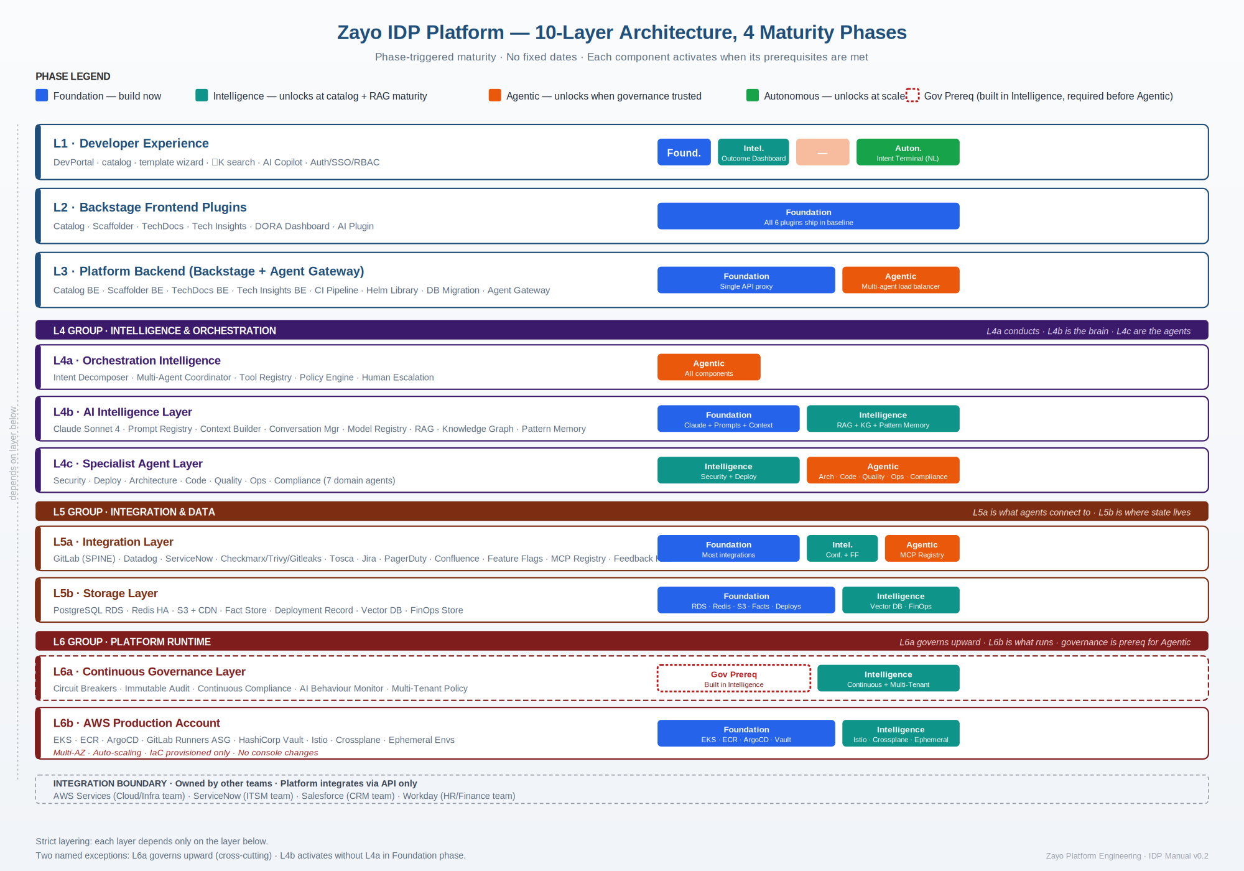
Each layer's phase chips show what activates when. Color = phase. L6a's dashed border indicates it is governance — cross-cutting.

2.3.1 L1 — Developer Experience
The only layer a developer touches. DevPortal SPA, catalog, template wizard, search, AI Copilot. Foundation = forms. Autonomous = natural-language Intent Terminal.

2.3.2 L2 — Backstage Frontend Plugins
Six plugins: Catalog, Scaffolder, TechDocs, Tech Insights, DORA Dashboard, AI. Each owns one UI domain. Communicates with L3 via Backstage Plugin Protocol over HTTP REST.

2.3.3 L3 — Platform Backend
Single Node.js process on EKS, port 7007. All Backstage backends + Agent Gateway. Hosts CI Pipeline Templates, Helm Chart Library, DB Migration tooling — platform-team-owned artefacts that downstream services inherit.

2.3.4 L4 — Intelligence & Orchestration
- L4a Orchestration Intelligence — the conductor. Intent decomposer, multi-agent coordinator, policy engine. Activates in Agentic.
- L4b AI Intelligence Layer — the brain. Claude + Prompt Registry + Context Builder in Foundation; RAG + Knowledge Graph + Pattern Memory in Intelligence. Active from Foundation.
- L4c Specialist Agent Layer — seven domain agents. Security and Deploy in Intelligence; Architecture, Code, Quality, Ops, Compliance in Agentic.

2.3.5 L5 — Integration & Data
- L5a Integration Layer — GitLab (the spine), Datadog, ServiceNow, Jira, the security scanner suite, Tosca, PagerDuty, Confluence, Feature Flags, MCP Server Registry.
- L5b Storage Layer — PostgreSQL RDS, Redis, S3+CDN, Fact Store, Deployment Record, Vector DB, FinOps Store.

2.3.6 L6 — Platform Runtime
- L6a Continuous Governance — cross-cutting. Circuit Breakers, Audit Trail, AI Behaviour Monitor, Multi-Tenant Policy. Built in Intelligence; required before Agentic.
- L6b AWS Production Account — EKS, ECR, ArgoCD, GitLab Runners, Vault. Foundation. Istio, Crossplane, Ephemeral Envs in Intelligence.

2.3.7 Layering exceptions
- L6a governs upward. L6a applies rules to L4 agents, L5a integrations, and L6b deployments. Governance must be central, not spread across what it governs.
- L4b activates without L4a in Foundation. L3 calls L4b directly via the Anthropic Messages API. L4a is inactive until Agentic.

2.4 Phase-triggered maturity
Four phases. Each unlocks on capability prerequisites, not dates. The bar is set such that early entry would degrade quality; deferred entry preserves quality at the cost of timeline.
Figure 2. Phase progression — prerequisites and key deliverables
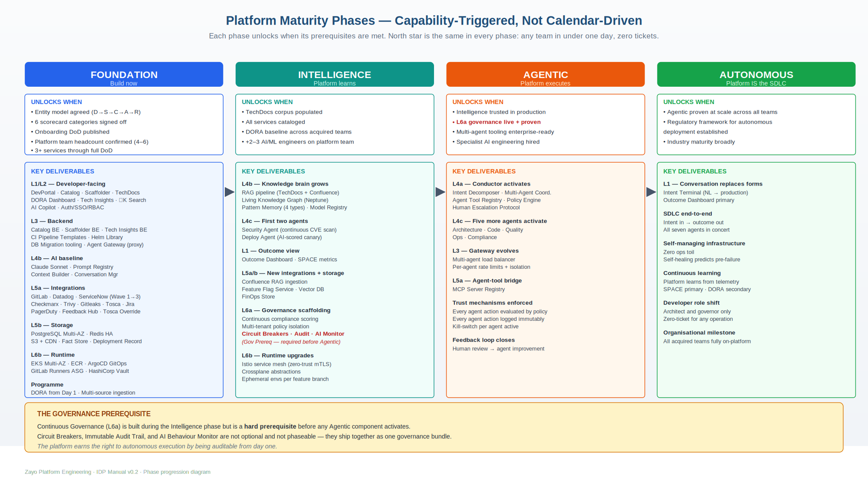
Color = phase. The amber callout at the bottom is the governance prerequisite — L6a is non-negotiable before Agentic.
Foundation | Intelligence | Agentic | Autonomous
Build now  Self-service onboarding. Golden CI/CD. GitOps. DORA from day one. Security gates. AI Copilot reads live catalog. | Platform learns  RAG + Knowledge Graph + Pattern Memory. Security and Deploy agents (AI-assist). Governance scaffolding (L6a). Outcome Dashboard. | Platform executes  Conductor (L4a) activates. Five more agents go autonomous. Every action evaluated, logged, watched. Begins only when L6a is live. | Platform IS the SDLC  Intent Terminal replaces forms. Developer = architect + governor. Self-managing infra. SPACE > DORA. Begins only when Agentic is proven at scale.

2.5 One worked example
To make the layering concrete, here is a single user action — "create a new service" — traced through every layer in Foundation phase.
Figure 3. Click to live service — Foundation-phase end-to-end flow
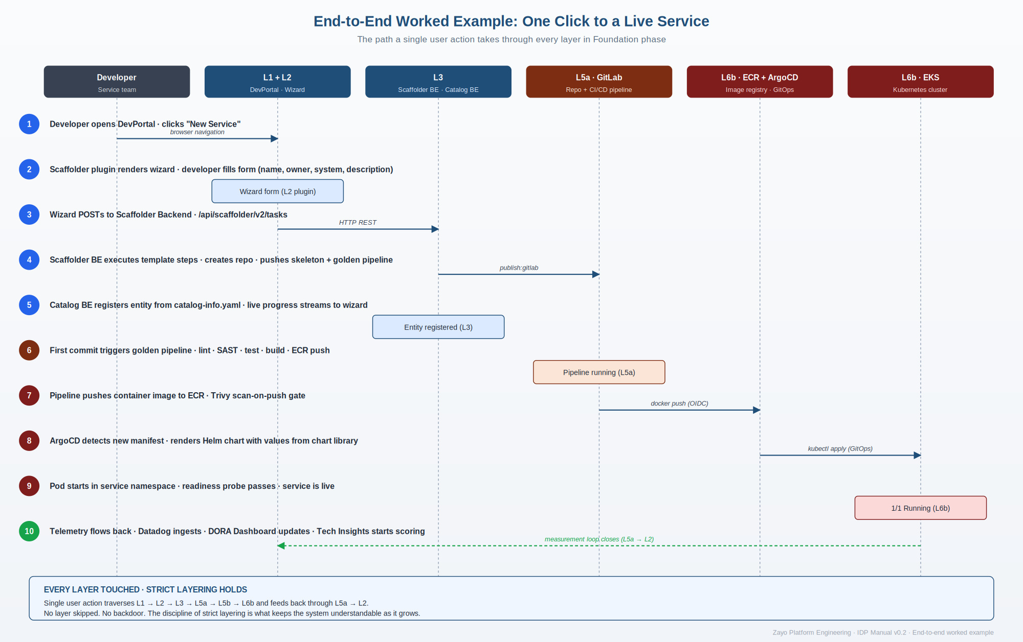
Strict layering holds: each step touches the layer immediately below, returning telemetry through L5a back into L2 dashboards.
In summary:
- Click in DevPortal (L1) → Wizard plugin renders form (L2) → POSTs to Scaffolder Backend (L3).
- Scaffolder BE (L3) creates GitLab repo (L5a), pushes skeleton + golden pipeline, registers entity in Catalog BE (L3).
- First commit triggers golden pipeline (L5a) → lint, SAST, test, build, image to ECR (L6b).
- ArgoCD (L6b) detects new manifest → renders Helm chart with values from chart library → applies to EKS (L6b).
- Pod runs in service namespace (L6b). Telemetry flows to Datadog (L5a) → DORA Dashboard plugin (L2). Tech Insights starts scoring.
Every layer touched. No layer skipped. The discipline of strict layering is what keeps the system understandable as it grows.

2.6 What comes next
Sections 3–11 work through each layer in order, with depth proportional to phase. Foundation components: detailed (data flows, interfaces, file paths, configuration, runbooks). Intelligence and Agentic: architectural intent. Autonomous: vision.
- Section 3 — L1 Developer Experience
- Section 4 — L2 Backstage Frontend Plugins
- Section 5 — L3 Platform Backend (the densest section)
- Section 6 — L4 Intelligence & Orchestration
- Section 7 — L5 Integration & Data
- Section 8 — L6 Platform Runtime
- Section 9 — Integration boundary
- Section 10 — Cross-cutting concerns (DoD, golden thread, feedback loops, multi-tenant)
- Section 11 — Operating the platform
- Section 12 — Roadmap by phase

End of v0.2
This draft contains sections 1 and 2 only — Introduction and Platform Overview. Subsequent sections will follow the same shape: short prose, embedded diagrams, tables for structured comparisons, callouts for things that must not be missed.
Feedback wanted. Please mark up directly. Specific asks: (1) is the prose tight enough? (2) do the three diagrams carry their weight? (3) is the worked example in 2.5 the right depth? Disagreements with stated principles especially welcome.

