Healthcare Claims Authentication POC
Architecture Diagram
Final version: hybrid retrieval + RAG grounding + confidence-driven decision gate + circuit breaker + guardrails + cache

1. Diagram
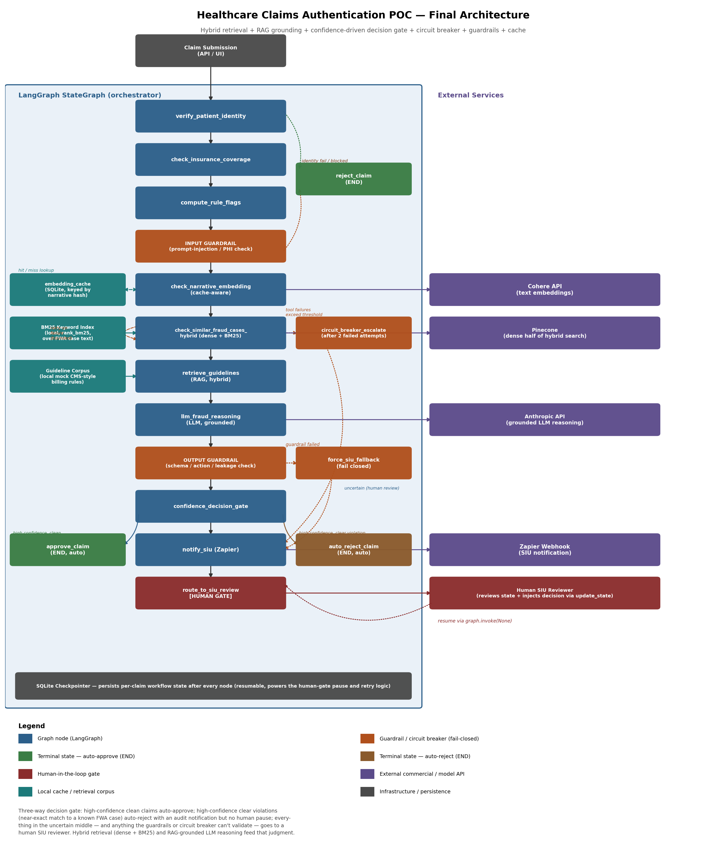

2. Component Walkthrough

2.1 Entry point
A claim submission (from an API or UI, not built in this POC) provides the initial state: patient ID, claim amount, and a free-text narrative describing the claim.

2.2 Main pipeline
- verify_patient_identity — validates the patient ID format. Routes to reject_claim (terminal) or check_insurance_coverage.
- check_insurance_coverage — validates claim amount is within policy limits.
- compute_rule_flags — deterministic rule checks computed before the LLM step, giving it concrete signals to reason over.
- INPUT GUARDRAIL — runs before anything is sent to Cohere, Pinecone, or the LLM. Blocks prompt-injection attempts, oversized/malformed narratives, and unredacted SSN-shaped strings. On failure, routes to reject_claim.
- check_narrative_embedding — cache-aware: looks up a persistent SQLite cache keyed by a hash of the narrative before calling Cohere. On a cache hit, Cohere is never called.
- check_similar_fraud_cases_hybrid — queries Pinecone for dense similarity AND a local BM25 keyword index for exact-term matches, then fuses the two rankings. Wrapped with a circuit breaker: on tool failure, retries up to a bounded limit, then escalates.
- retrieve_guidelines — the RAG step: retrieves actual billing-guideline text from a local corpus using the same hybrid approach, so the LLM has real source material to ground its reasoning in.
- llm_fraud_reasoning — calls an LLM (Anthropic) with the claim, rule flags, hybrid similarity results, AND the retrieved guideline text, instructed to answer only from what's provided. Returns a structured recommendation with a rationale and a confidence score.
- OUTPUT GUARDRAIL — validates the LLM's response: well-formed JSON, an allowed action value, confidence in range, no sign of leaked/injected instructions. On failure, routes to force_siu_fallback.
- confidence_decision_gate — reads the LLM's recommended_action AND confidence together, and routes three ways: auto-approve, auto-reject, or human SIU review.

2.3 The three-way outcome
- approve_claim (auto) — high-confidence clean claim, terminal, no human involved.
- auto_reject_claim (auto) — high confidence AND a near-exact match to a known FWA case; terminal, no human pause, though a Zapier notification still fires for audit purposes.
- notify_siu (Zapier) → route_to_siu_review [HUMAN GATE] — everything in the uncertain middle, plus anything the guardrails or circuit breaker couldn't validate, pauses here. A human reviews the full state and calls update_state() to inject a decision; the graph resumes via invoke(None, config).

2.4 Side components
- reject_claim — a shared terminal state reached either from a failed identity check or a blocked input guardrail.
- embedding_cache (SQLite) — persistent, content-addressed cache for embeddings, separate from the LangGraph checkpointer.
- BM25 Keyword Index — a local, in-process rank_bm25 index over the same FWA case text Pinecone holds embeddings for; no external call, no cost.
- Guideline Corpus — a small local store of mock CMS-style billing rules, retrieved by retrieve_guidelines to ground the LLM's reasoning.
- circuit_breaker_escalate — fires after MAX_TOOL_ERRORS consecutive failures in check_similar_fraud_cases_hybrid. This is a reliability concern (can we trust the tool responded at all), distinct from the guardrails (can we trust the content).
- force_siu_fallback — the guardrails' fail-closed path: if the output guardrail can't validate the LLM's response, the claim is treated as flagged rather than guessed at.

2.5 External services
- Cohere API — text embedding generation, called on a cache miss.
- Pinecone — the dense half of hybrid similarity search.
- Anthropic API — the grounded LLM reasoning call.
- Zapier Webhook — notifies a human SIU reviewer (or logs an audit trail for an auto-rejected claim).

2.6 SQLite checkpointer
Every node's output is checkpointed before the next node runs. This is what makes the human-in-the-loop pause possible (the graph can sit suspended indefinitely with no process needing to stay alive), what makes failure recovery possible (a crashed run resumes at the failed node, not from scratch), and what makes the circuit breaker's bounded retry loop safe (the retry count itself is part of persisted state).

3. Design Notes
- Fail-closed by design, in two independent ways: the output guardrail defaults to human review on any validation failure; the circuit breaker defaults to human review on any unresolved tool failure. Neither ever silently proceeds on data it can't vouch for.
- The input guardrail runs before any external call is made — a prompt-injection attempt in the narrative never reaches Cohere, Pinecone, or the LLM at all.
- The confidence gate deliberately uses the LLM's raw similarity score (not a rank-normalized fused score) for its absolute auto-reject threshold — a ranking score and an absolute-confidence score answer different questions, and conflating them was an early bug caught during development (see the README's troubleshooting table).
- The cache and the two local retrieval corpora (BM25 index, guideline corpus) are intentionally separate from the LangGraph checkpointer: the checkpointer holds per-claim workflow state; these hold data shared across every claim.
- All four external integrations (Cohere, Pinecone, Zapier, Anthropic) run through a thin wrapper layer that can run in either live mode (real API calls) or mock mode (deterministic local logic) via a single flag.

