Claims Authentication POC
Architecture Diagram

1. Diagram
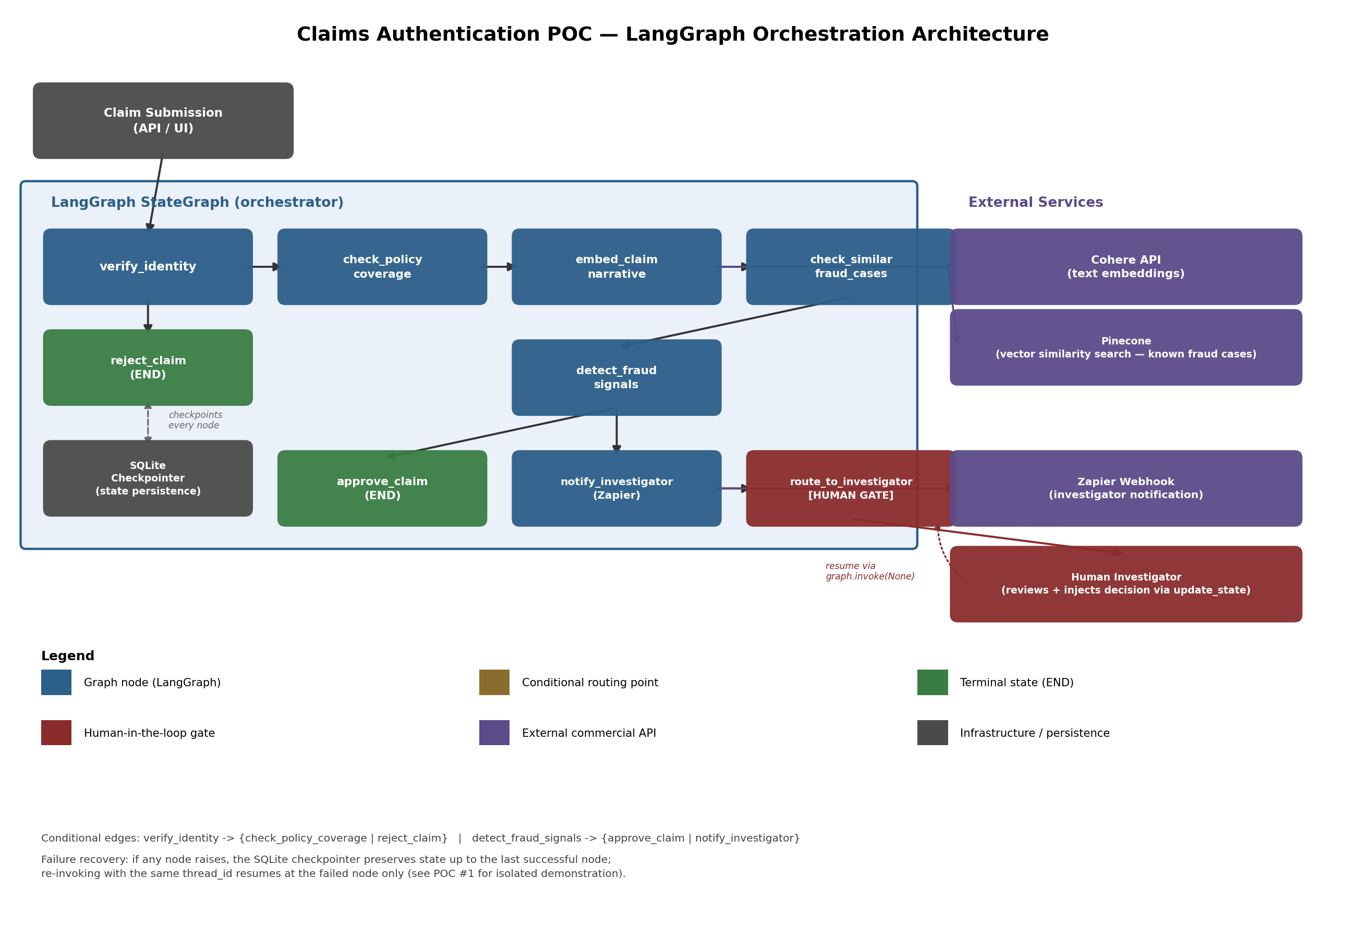

2. Component Walkthrough

2.1 Entry point
A claim submission (from an API or UI, not built in this POC) provides the initial state: claimant ID, claim amount, and a free-text narrative describing the claim.

2.2 LangGraph StateGraph (orchestrator)
All workflow logic lives inside a single compiled LangGraph StateGraph. Every node reads the shared ClaimState object and returns a partial update; a SQLite checkpointer persists a snapshot of that state after every node completes.
- verify_identity — validates the claimant ID format. Routes to reject_claim (terminal) or check_policy_coverage.
- check_policy_coverage — validates claim amount is within policy limits.
- embed_claim_narrative — calls Cohere to convert the claim's free-text narrative into a vector embedding.
- check_similar_fraud_cases — queries Pinecone for the nearest known-fraud-case embeddings and their similarity scores.
- detect_fraud_signals — combines rule-based checks (policy limit, high value) with the Pinecone similarity result against a threshold to produce a list of fraud flags.
- approve_claim — terminal state reached when no fraud flags are present.
- notify_investigator (Zapier) — terminal-adjacent node reached when fraud flags are present; sends a webhook notification so a human investigator knows a claim needs review.
- route_to_investigator [HUMAN GATE] — the graph is configured with interrupt_before on this node, so execution pauses here until a human supplies a decision.

2.3 External services
- Cohere API — text embedding generation, called from embed_claim_narrative.
- Pinecone — vector similarity search against a store of previously confirmed fraud case embeddings, called from check_similar_fraud_cases.
- Zapier Webhook — receives the flagged-claim payload and is responsible (in a live deployment) for routing that alert to wherever investigators actually watch, e.g. Slack or email.

2.4 Human investigator
Once notified, a human reviews the paused claim's state (identity result, policy result, fraud flags, similarity matches) and calls graph.update_state() to inject a decision. The graph is then resumed with graph.invoke(None, config), which executes route_to_investigator using that human input and finalizes the claim's decision.

2.5 SQLite checkpointer
Every node's output is checkpointed before the next node runs. This serves two purposes in this architecture: (1) it is what makes the human-in-the-loop pause possible — the graph can sit suspended indefinitely with no process needing to stay alive — and (2) it is what makes failure recovery possible: if a node raises an exception, re-invoking the graph with the same thread_id resumes at the failed node rather than restarting the whole claim from scratch.

3. Design Notes
- Two conditional routing points exist: after verify_identity (identity pass/fail) and after detect_fraud_signals (flagged / not flagged). Each is a plain Python function reading state — no separate rules engine required.
- The human gate is placed after the Zapier notification, not before, so the investigator is alerted immediately even though the graph itself is paused waiting on their decision.
- All three external integrations (Cohere, Pinecone, Zapier) are called through a thin wrapper layer that can run in either live mode (real API calls) or mock mode (deterministic local logic) via a single flag — see the accompanying code and README for details.

