**Scenario - 2**

1) What are different artifacts you need to create- name the artifacts and its purpose?

* If we are deploying the ARM templates from Release Pipeline. Then we need the Build artifacts which contains the our ARM templates from our Source control systems.

* If we want to deploy the ARM Templates from Build Pipeline. Then we don't need any artifacts for that, we can directly run the code source control systems.

* If we have any project dependencies we can go Azure artifacts. Where we will be having the different artifacts feeds, which contains nuget , NPM, Maven, Gradle, Pip, Universal packages.

* If we have a custom dependencies project then, we can package that project has Nuget package and Push to our artifacts feed. So, we can able to access across the Project.

2) List the tools you will to create and store the ARM Templates?

We can able to create the ARM templates from the below tools,

* Visual Studio Code.

* Azure Portal we can use classic editor for creating the services and at last we can download the .Json file.

We Can able to store the our ARM templates from the below tools,

* Source control Systems( Git, GitHub, etc)

* Azure Storage account

3) Explain the Process and steps to create automated deployment Process?

**Procedure to create a new Build Pipeline for Continuous Deployment Process**

* Select **Pipelines** tab.

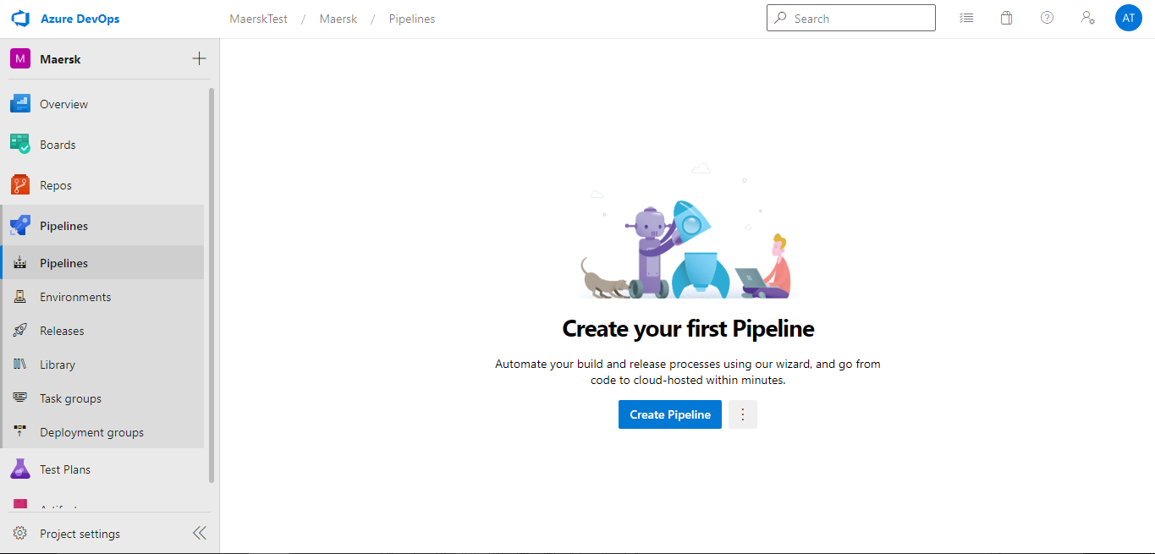

* Under Builds, click on **New Pipeline**
* Select what kind of pipeline need to be developed. In our case we are developing Yaml based Pipeline.

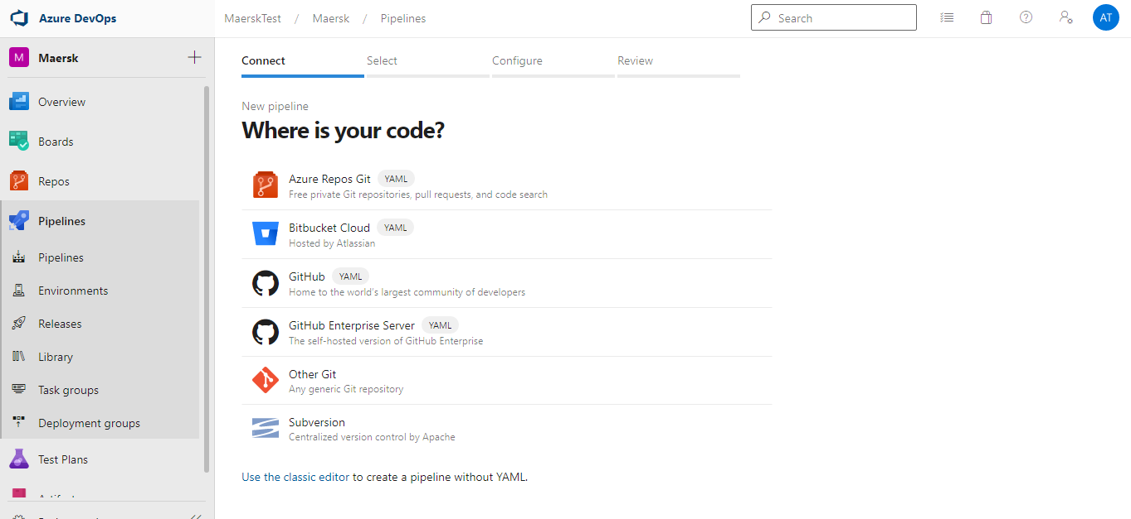

* Select the repository and branch from the available sources

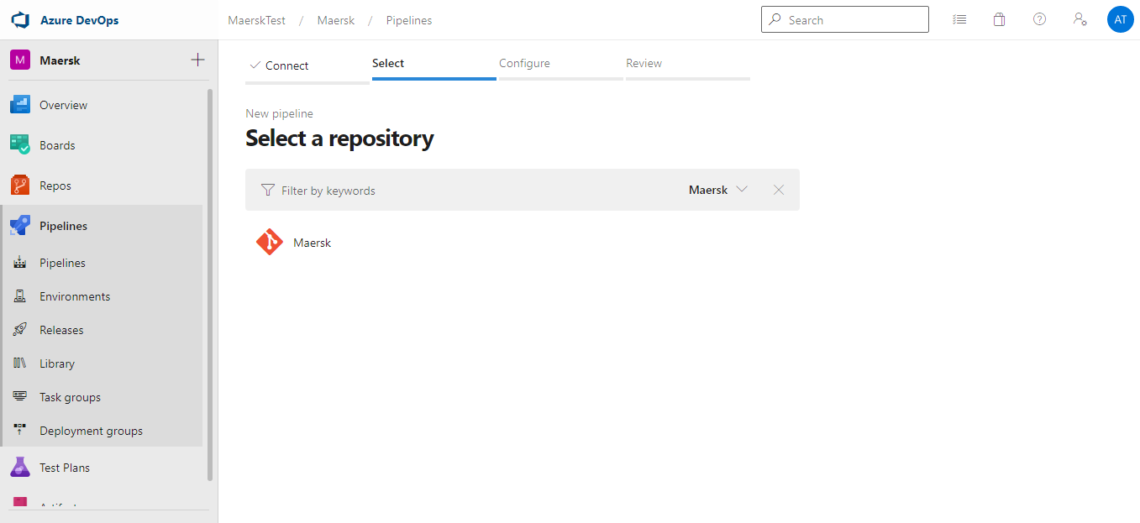

* Select a suitable template for the project

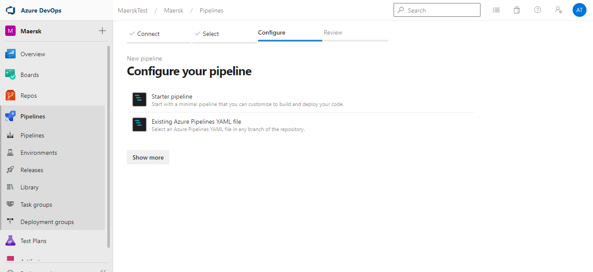

* Build Yaml Pipeline is created and modify according to the requirement

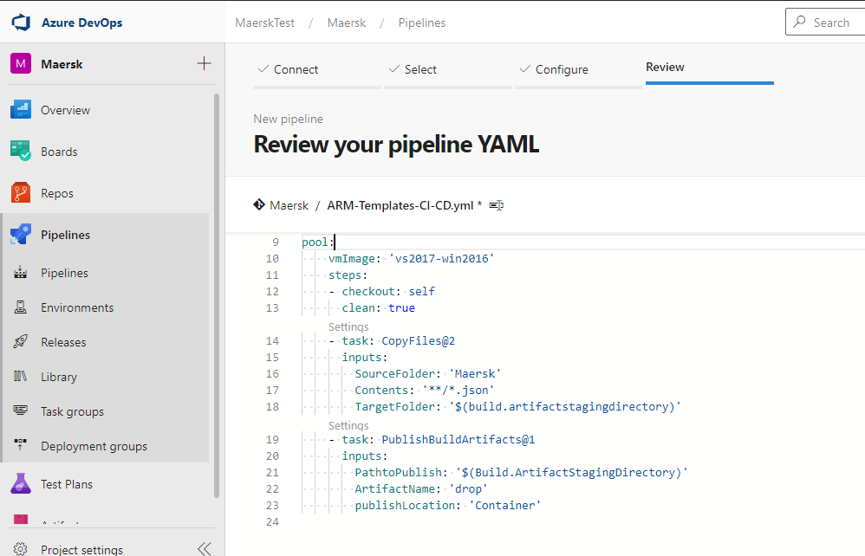

* Under the Build Yaml Pipeline tab, Provide the Build agent from the agent pool

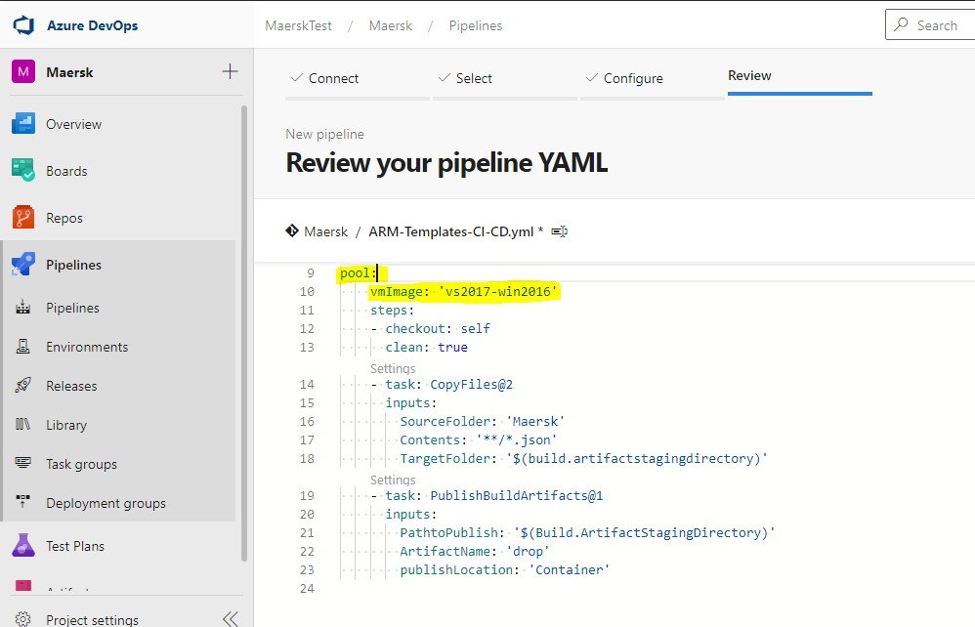

* Add Copy task to copy the ARM templates to the artifacts staging directory

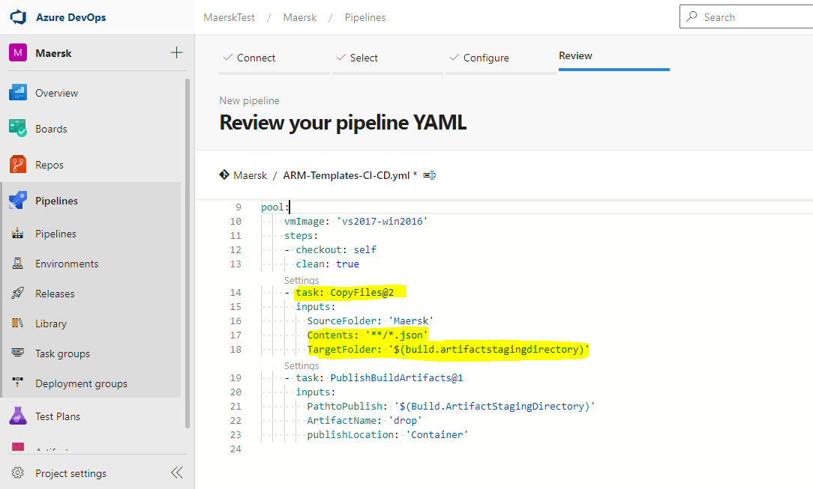

* Here, we have add **Publish** task to Build artifacts.

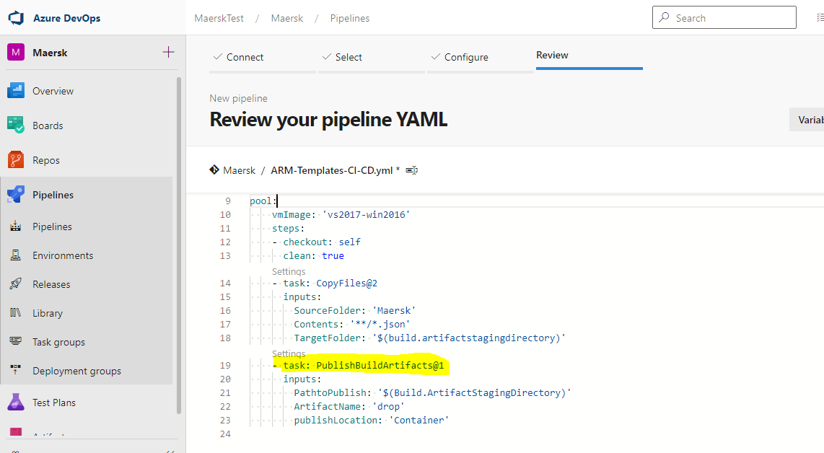

* Go to Project Settings ->Service Connection -> New Service Connection -> Select from the Azure Subscription dropdown.

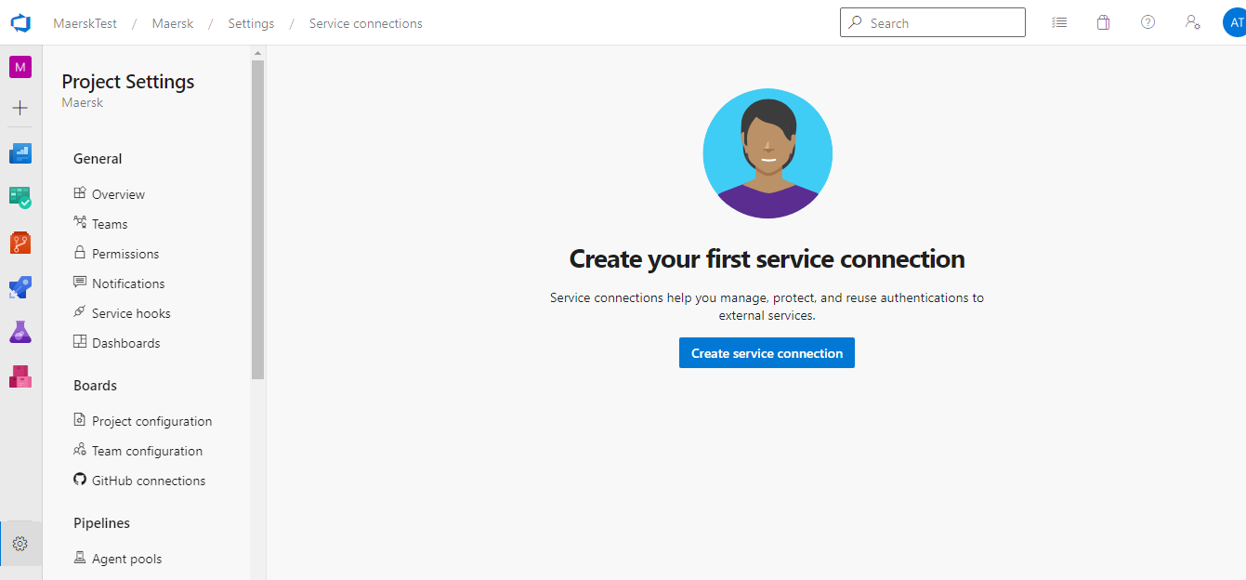

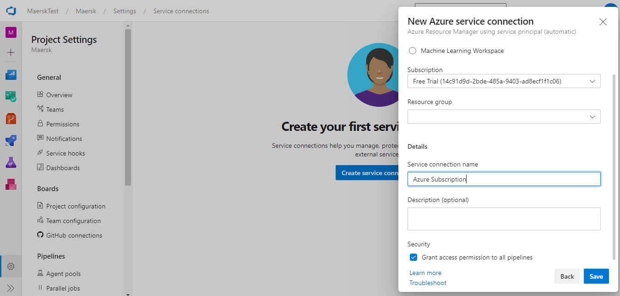

* if you have already created a service connection or click on **Manage** to provide the Azure Subscription details
* Select Azure Resource Manager from the dropdown list and provide the following details and save.

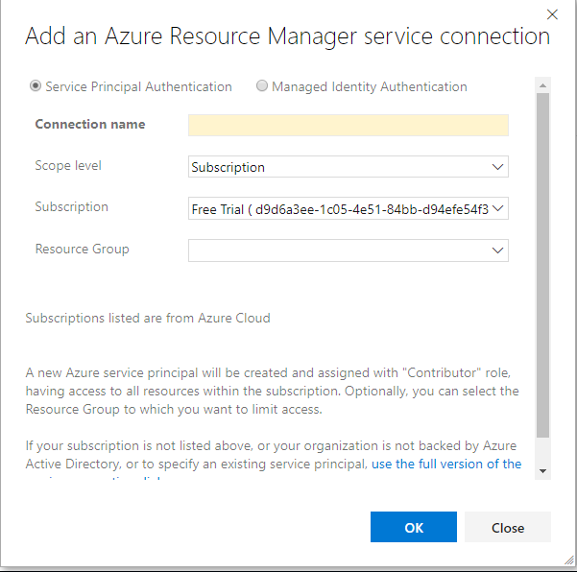

**Procedure to create a new Release Pipeline for Continuous Deployment**

* Select **Release** **Pipelines** tab.

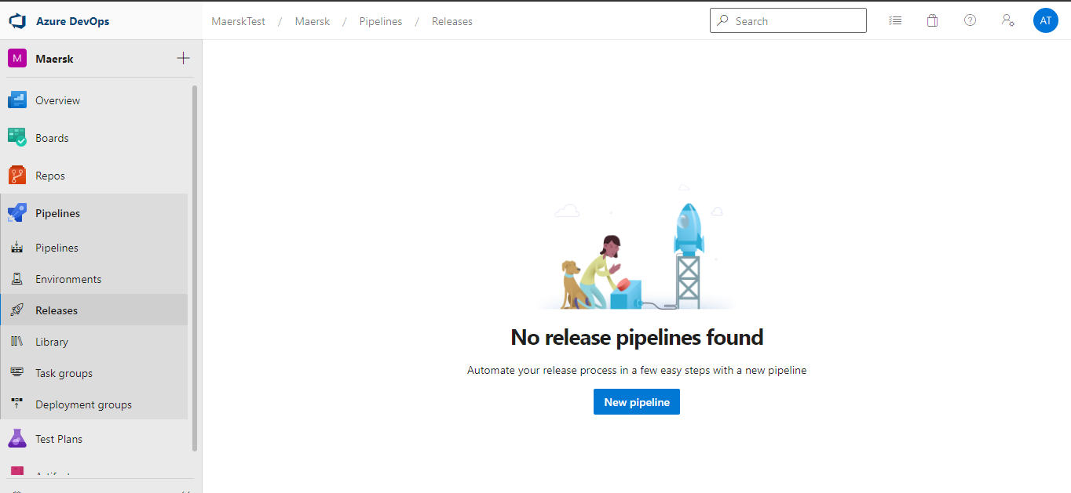

* Under Release, click on **New Pipeline**
* Select **Artifacts**

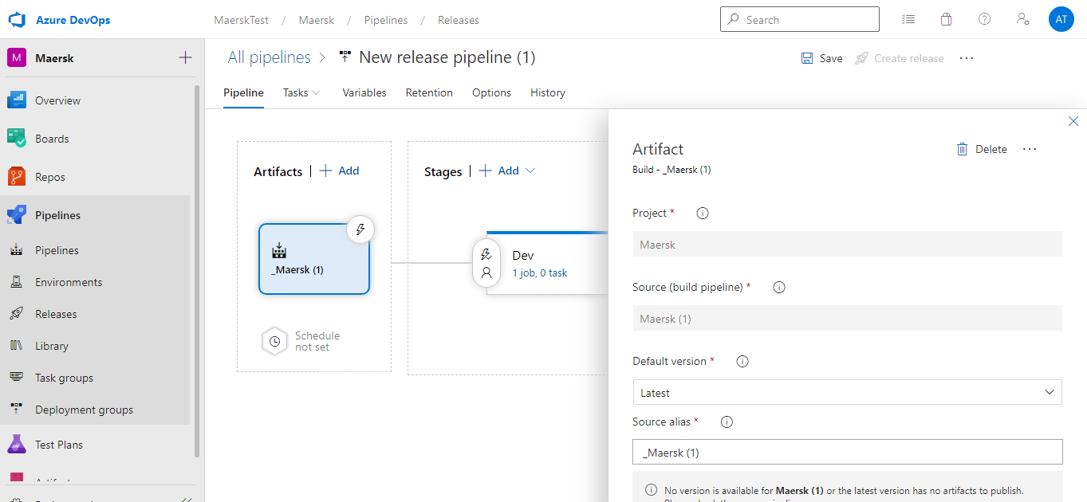

* As we are implementing the CD Pipeline. We have enable CD in the artifacts.

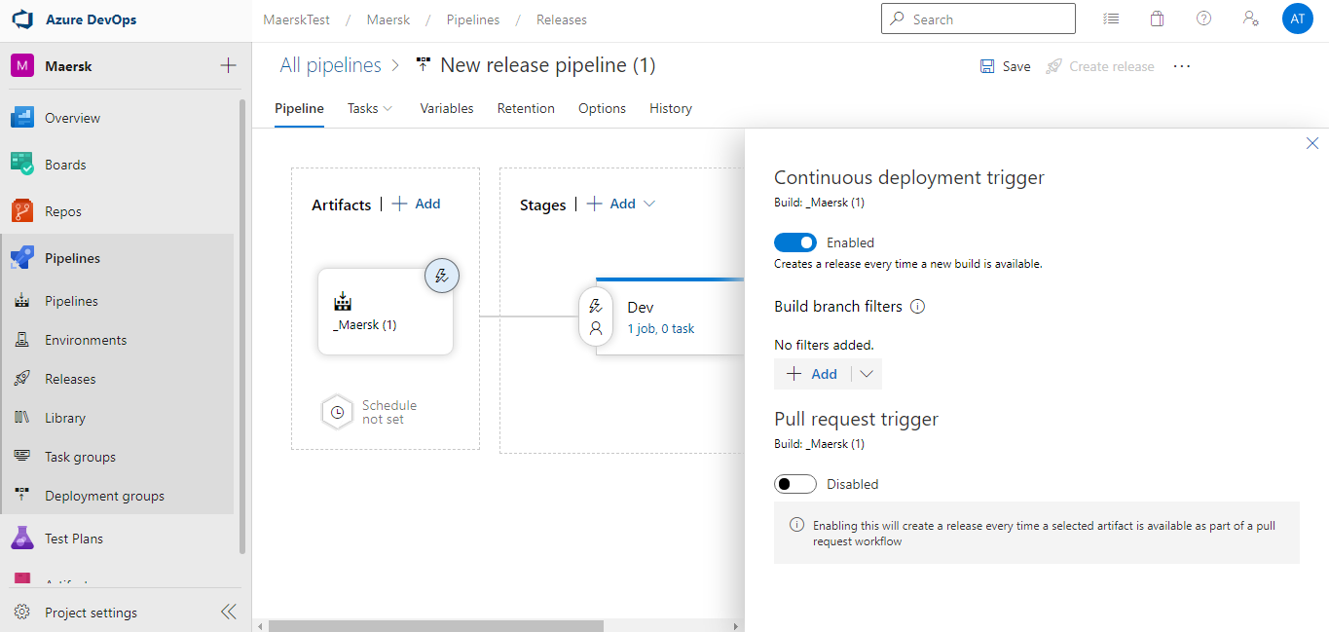

* If we need to implement CD for Specific branch only then,

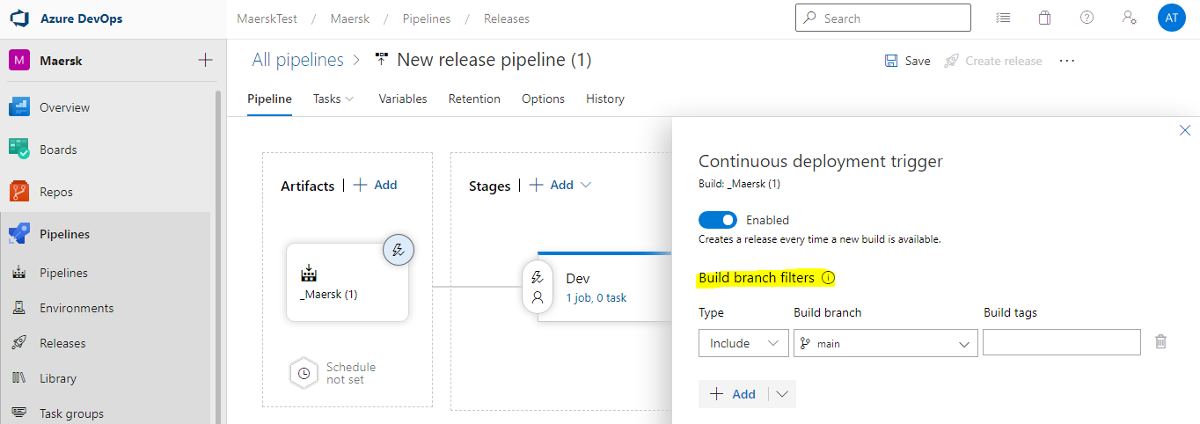

* If we need to implements CD for the Pull requests only,

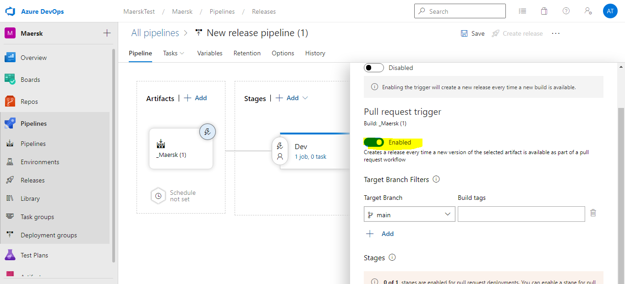

* Select the **Agent Pool**

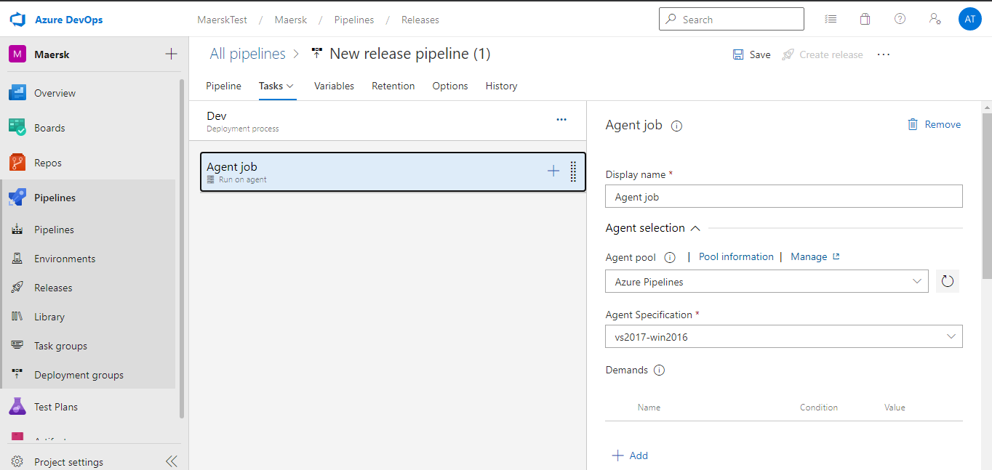

* Go to Project Settings ->Service Connection -> New Service Connection -> Select from the Azure Subscription dropdown.



* If you have already created a service connection or click on **Manage** to provide the Azure Subscription details.
* In Different stages, we can have Manual trigger or automatically after the release.

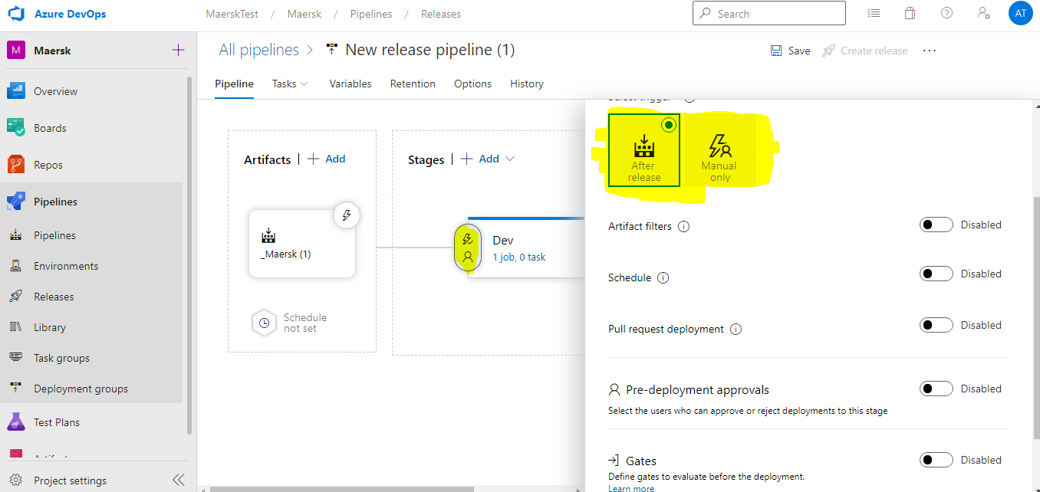

* In case if we want filter the artifacts then,

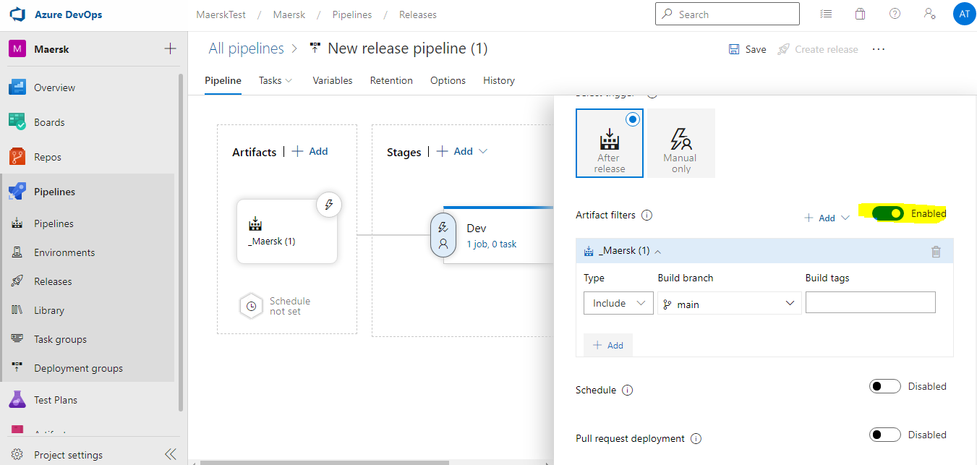

* In case, If we need the schedules release to be triggered on a specific time.

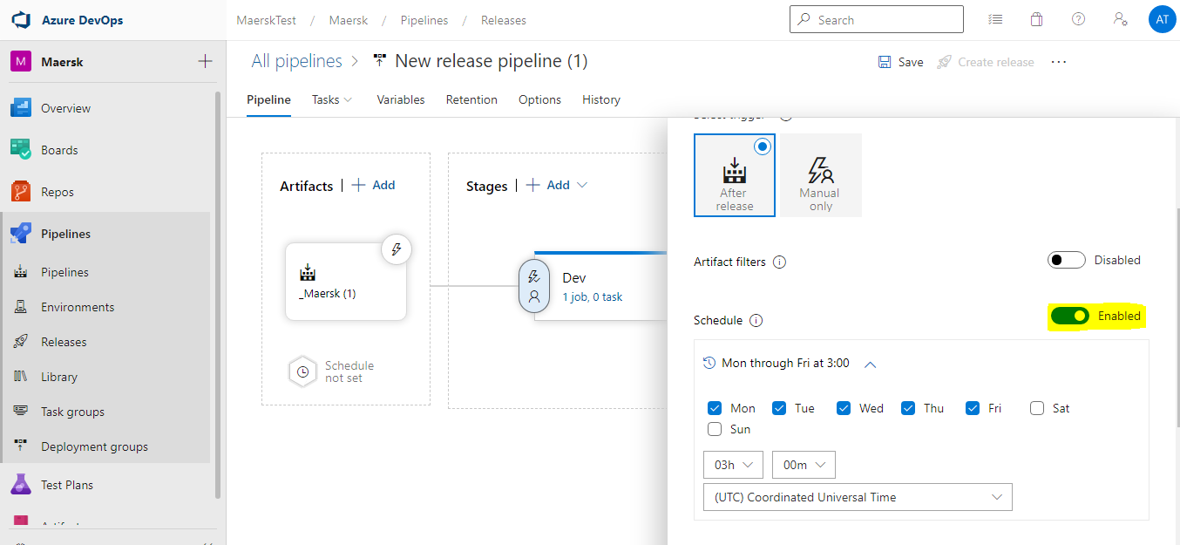

* In case, If we need only the pull request deployments,

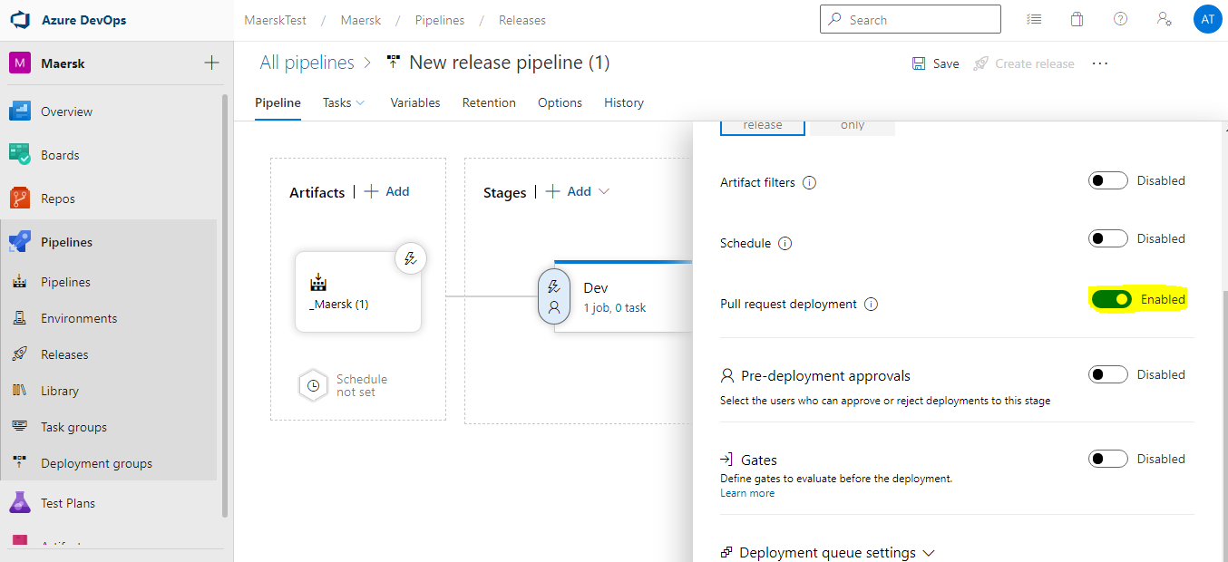

* In case, if we need the pre approvals for the deployment to this stage and add the specific filters for the same,

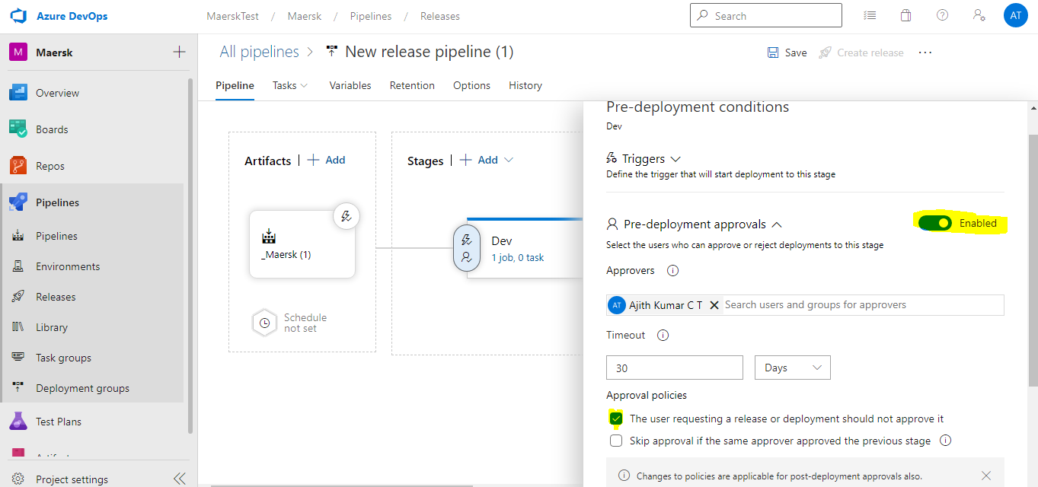

* In case, if we need add the deployments gates to this stage,

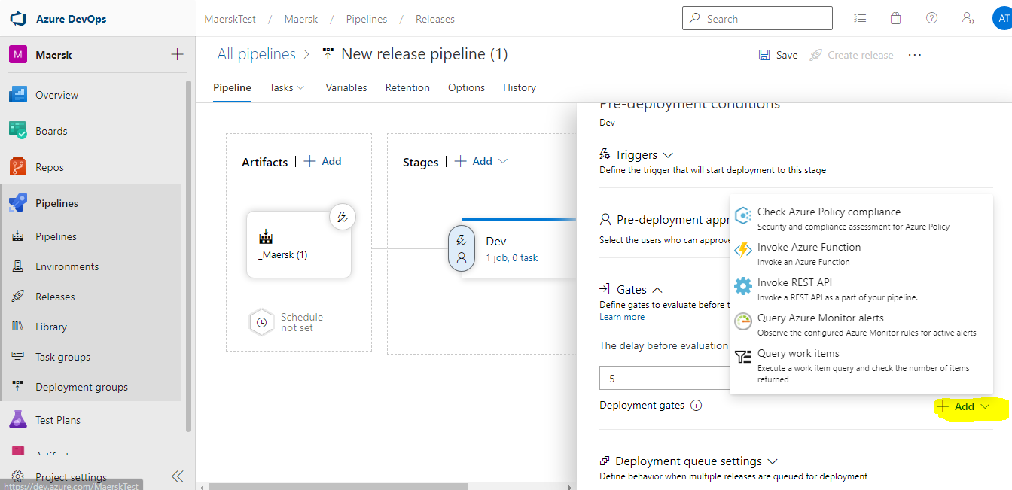

* In case we have multiple deployment is running. Then we can modify the Deployment Queue settings here for the Parallel deployment.

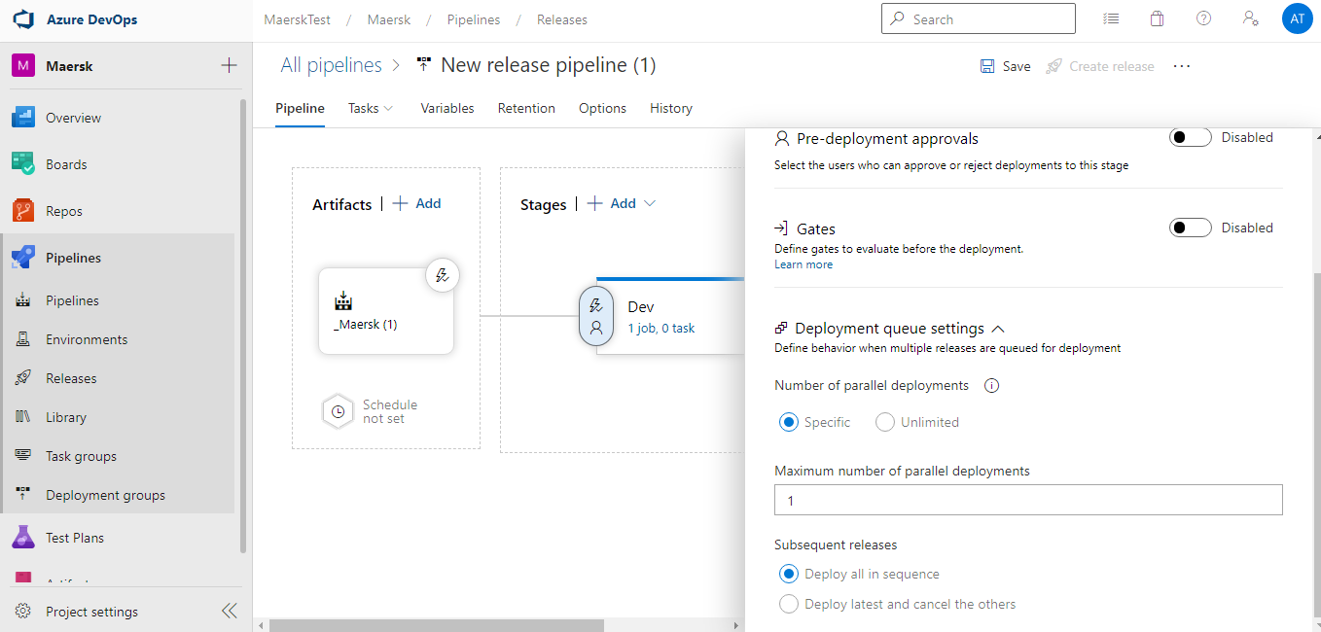

* For, Arm Template deployment we will be adding the ARM Deployment task. Please specify the all the required details, like Service connection details, Resource Group, etc.

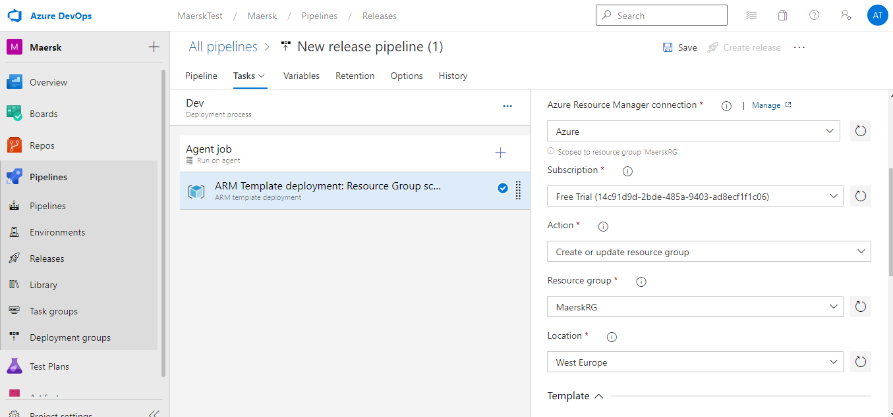

* Specify the Template and parameter details. Always choose incremental instead of complete. Because, complete deployment will delete the all the existing resource inside the Resource group and create only the resource we are deploying.

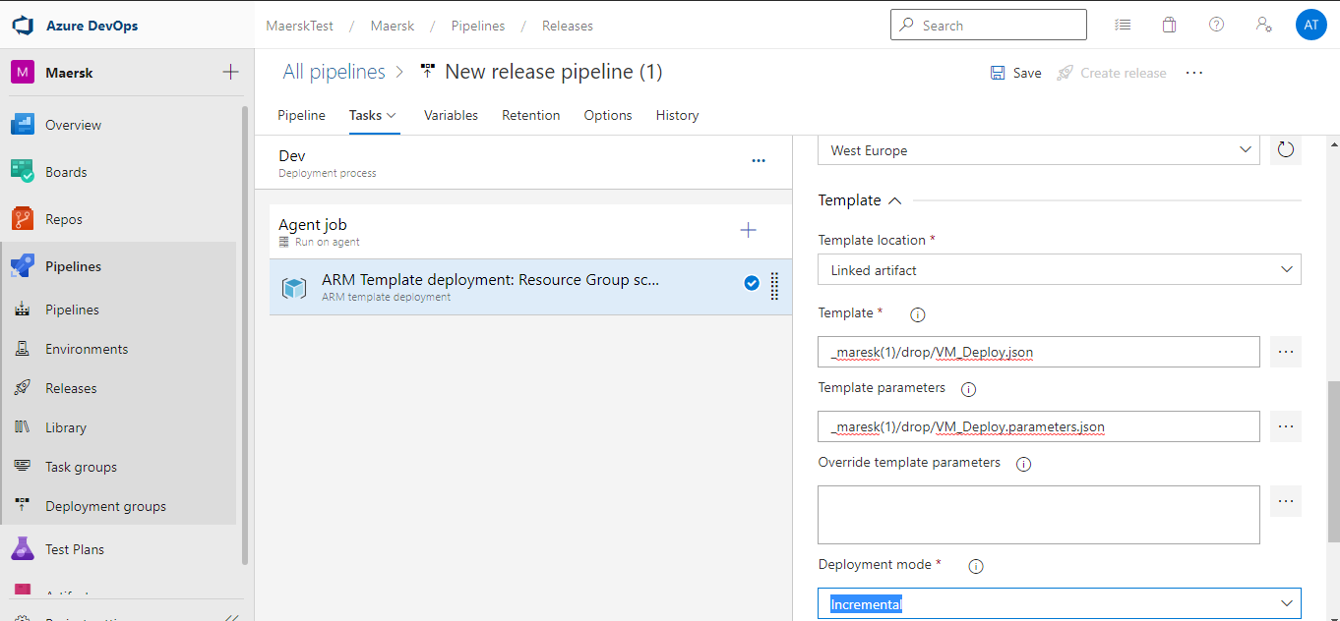

* As we are creating the VM here, we are accessing the VM Adminpassword from the Key Vaults. We have provide the access to arm templates to access secrets during the deployment as shown below,

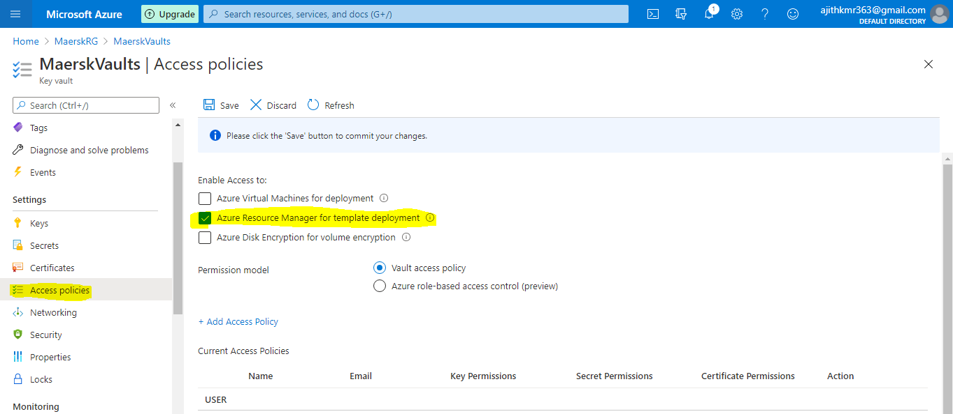

* Please reference the Key vaults details and secret name in the ARM template Parameters file.

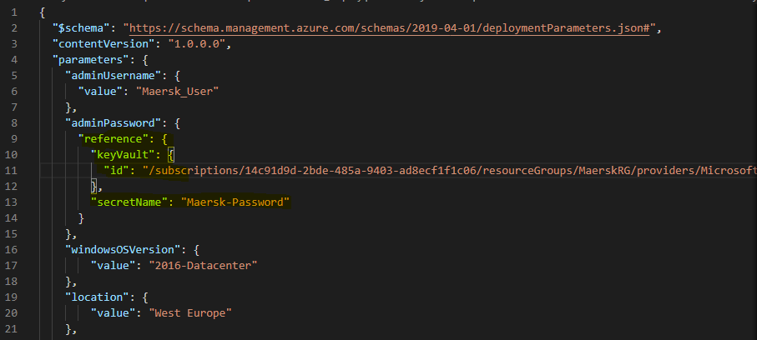

* Deploy the release and VM will be created automatically.