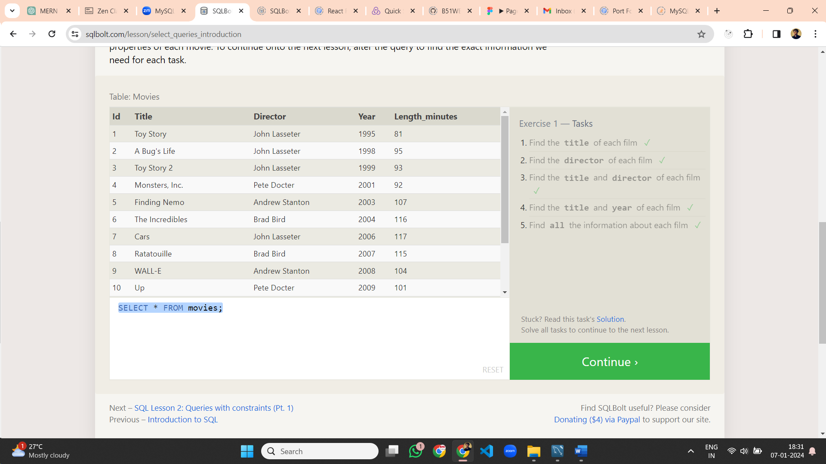

**Lesson 1 Queries :**

1. SELECT title FROM movies;
2. SELECT director FROM movies;
3. SELECT director,title FROM movies;
4. SELECT title,year FROM movies;
5. SELECT * FROM movies;

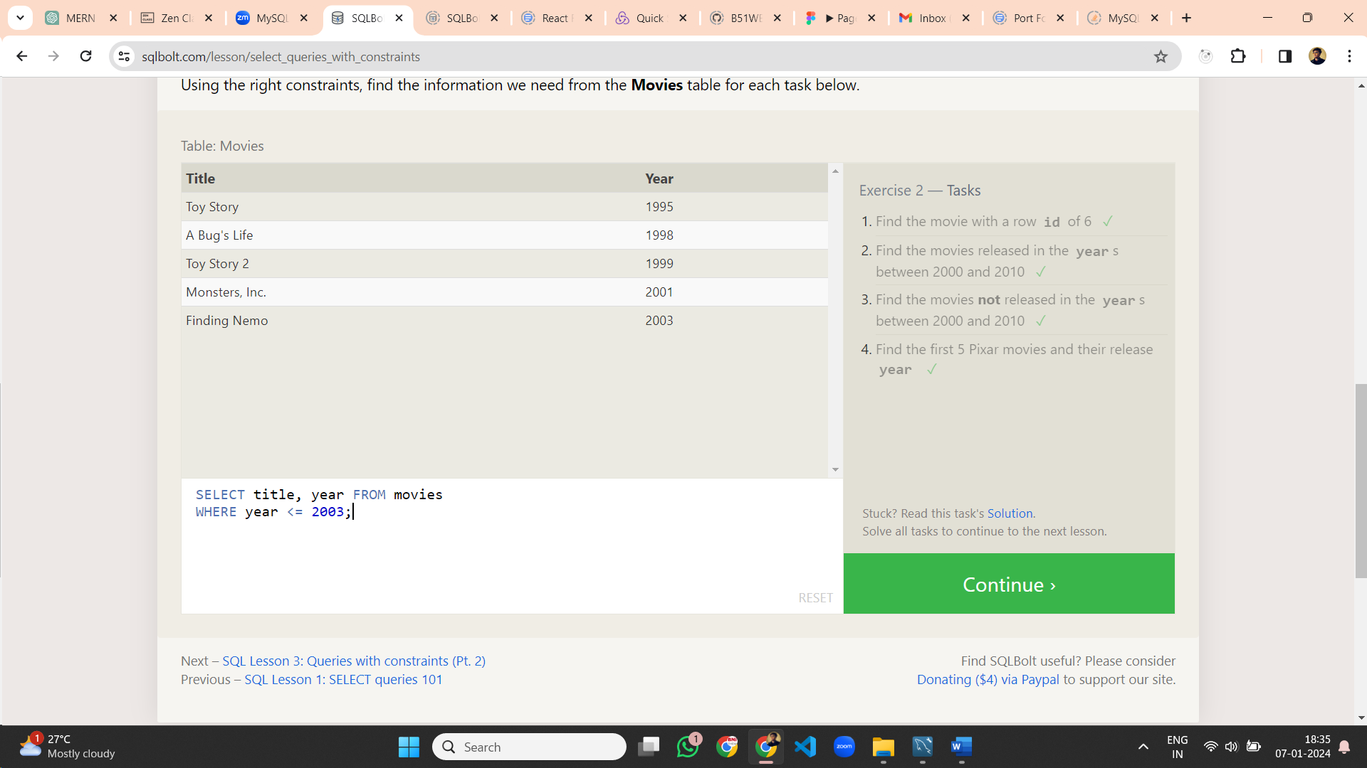

**Lesson 2 Queries :**

1. SELECT * FROM movies where id = 6;
2. SELECT * FROM movies where year between 2000 and 2010;
3. SELECT * FROM movies where year not between 2000 and 2010;
4. SELECT title, year FROM movies WHERE year <= 2003;

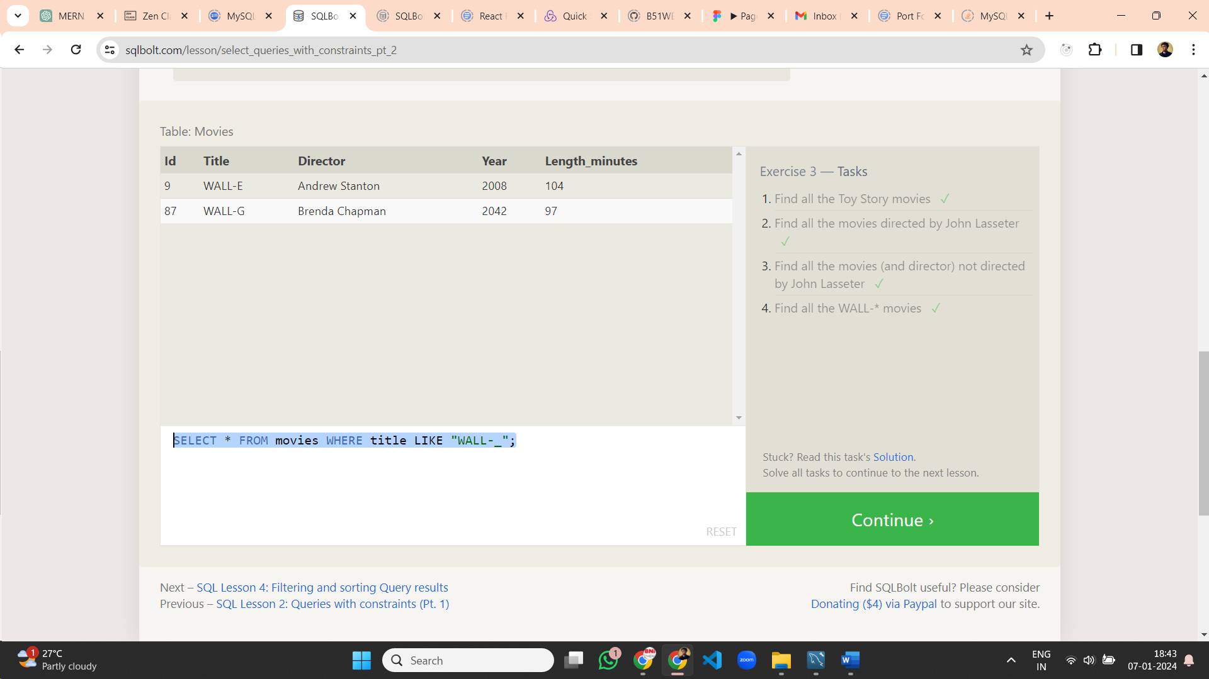

**Lesson 3 Queries :**

1. SELECT title, director FROM movies WHERE title LIKE "Toy Story%";
2. SELECT title, director FROM movies WHERE director LIKE "John Lasseter";
3. SELECT title, director FROM movies WHERE director not LIKE "John Lasseter";
4. SELECT * FROM movies WHERE title LIKE "WALL-_";

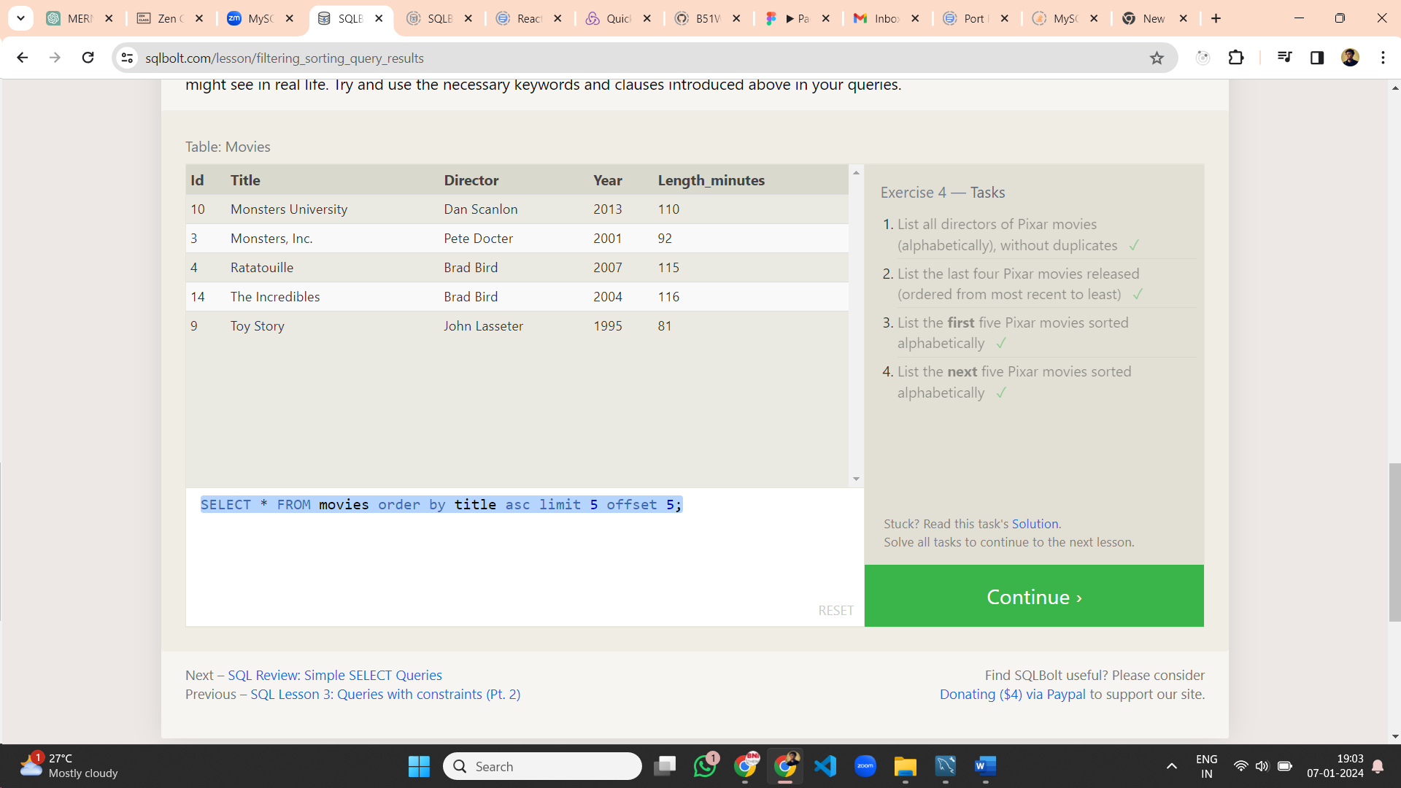**Lesson 4 Queries :**

1. SELECT distinct director FROM movies order by director asc;
2. SELECT title, year FROM movies ORDER BY year DESC LIMIT 4;
3. SELECT * FROM movies order by title asc limit 5;
4. SELECT * FROM movies order by title asc limit 5 offset 5;

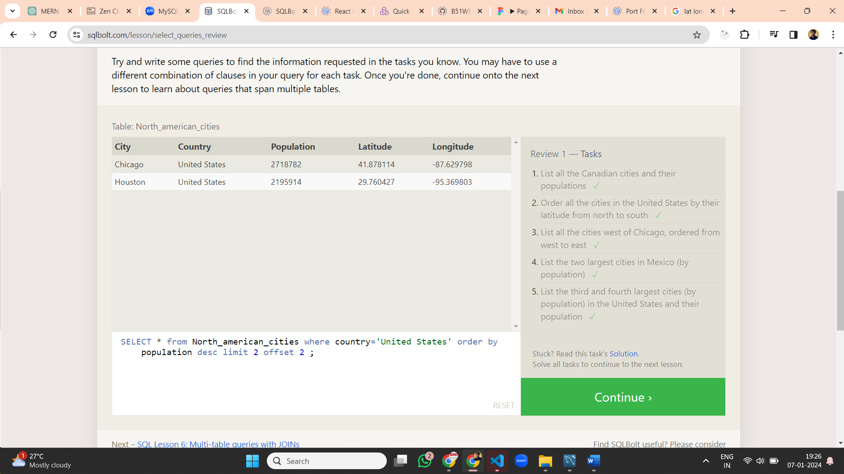**Lesson 5 Queries :**

1. SELECT city, population FROM north_american_cities WHERE country = "Canada";
2. SELECT * from North_american_cities where country = "United States" order by latitude desc;
3. SELECT * from North_american_cities where longitude<-87.629798 order by longitude asc;
4. SELECT * from North_american_cities where country='Mexico' order by population desc limit 2;
5. SELECT * from North_american_cities where country='United States' order by population desc limit 2 offset 2 ;

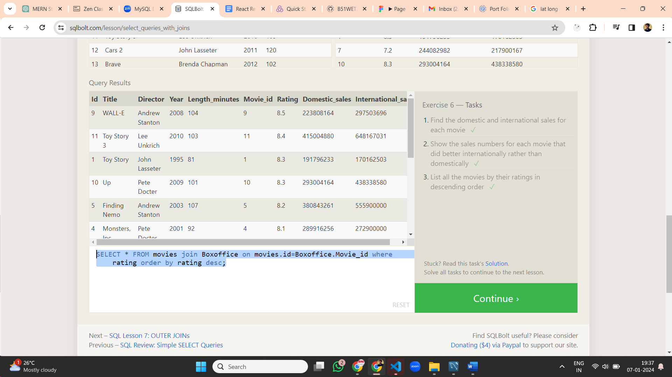

**Lesson 6 Queries:**

1. SELECT * FROM movies join Boxoffice on movies.id=Boxoffice.Movie_id;
2. SELECT * FROM movies join Boxoffice on movies.id=Boxoffice.Movie_id where domestic_sales<international_sales;
3. SELECT * FROM movies join Boxoffice on movies.id=Boxoffice.Movie_id where rating order by rating desc;

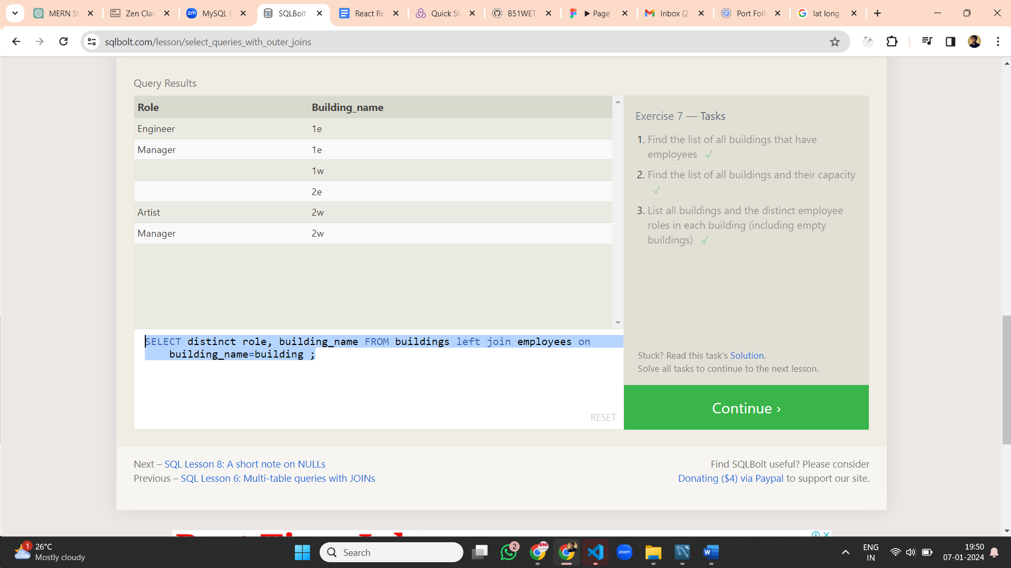**Lesson 7 Queries:**

1. SELECT distinct building FROM employees ;
2. SELECT * FROM buildings ;
3. SELECT distinct role, building_name FROM buildings left join employees on building_name=building ;

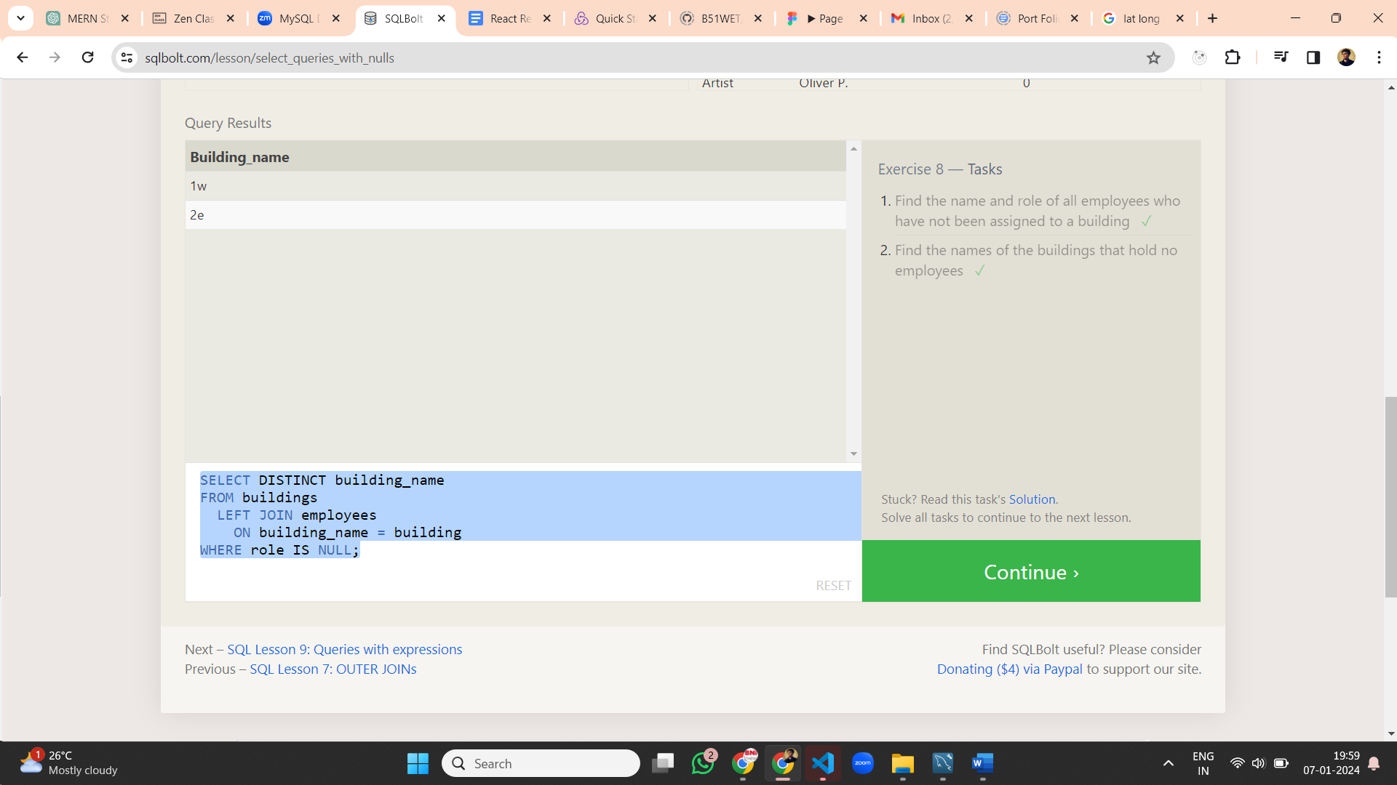 **Lesson 8 Queries:**

1. SELECT * FROM employees where building is NULL;
2. SELECT DISTINCT building_name FROM buildings LEFT JOIN employees ON building_name = building WHERE role IS NULL;

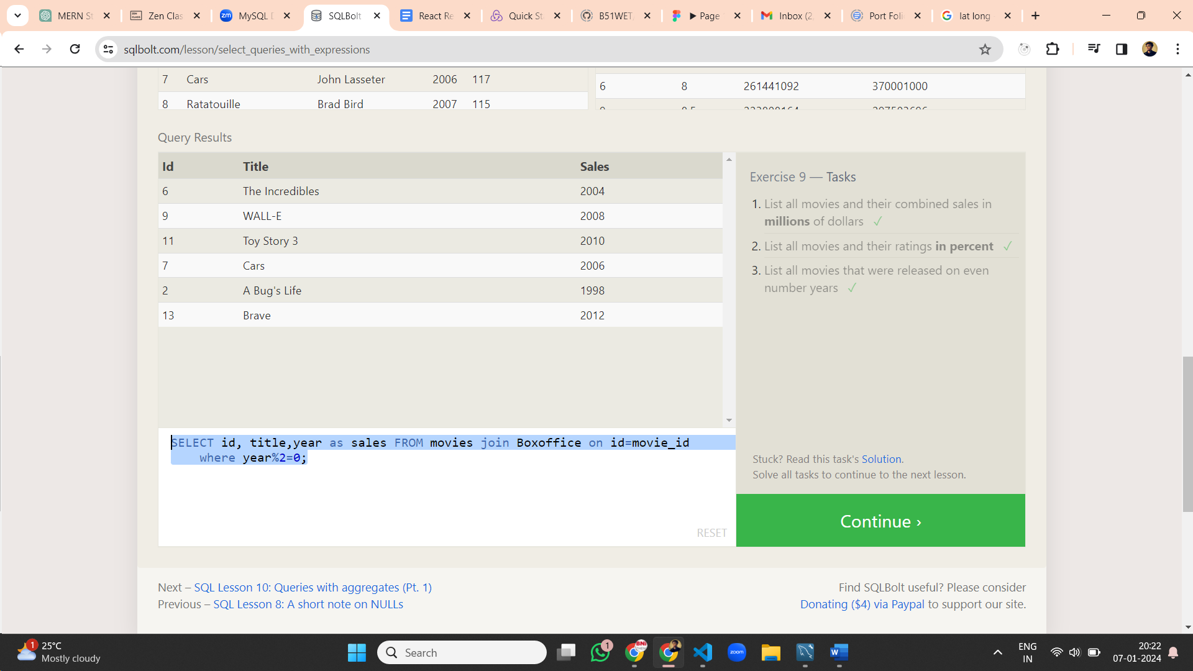**Lesson 9 Queries:**

1. SELECT id, title,(Domestic_sales+International_sales)/1000000 as sales FROM movies join Boxoffice on id=movie_id ;
2. SELECT id, title,(rating)*10 as sales FROM movies join Boxoffice on id=movie_id ;
3. SELECT id, title,year as sales FROM movies join Boxoffice on id=movie_id where year%2=0;

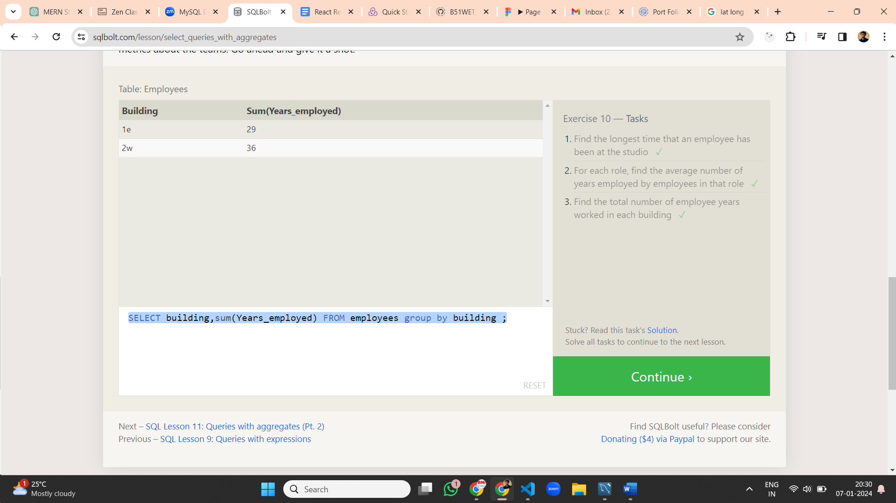**Lesson 10 Queries:**

1. SELECT max(Years_employed) FROM employees ;
2. SELECT role,avg(Years_employed) FROM employees group by role ;
3. SELECT building,sum(Years_employed) FROM employees group by building ;

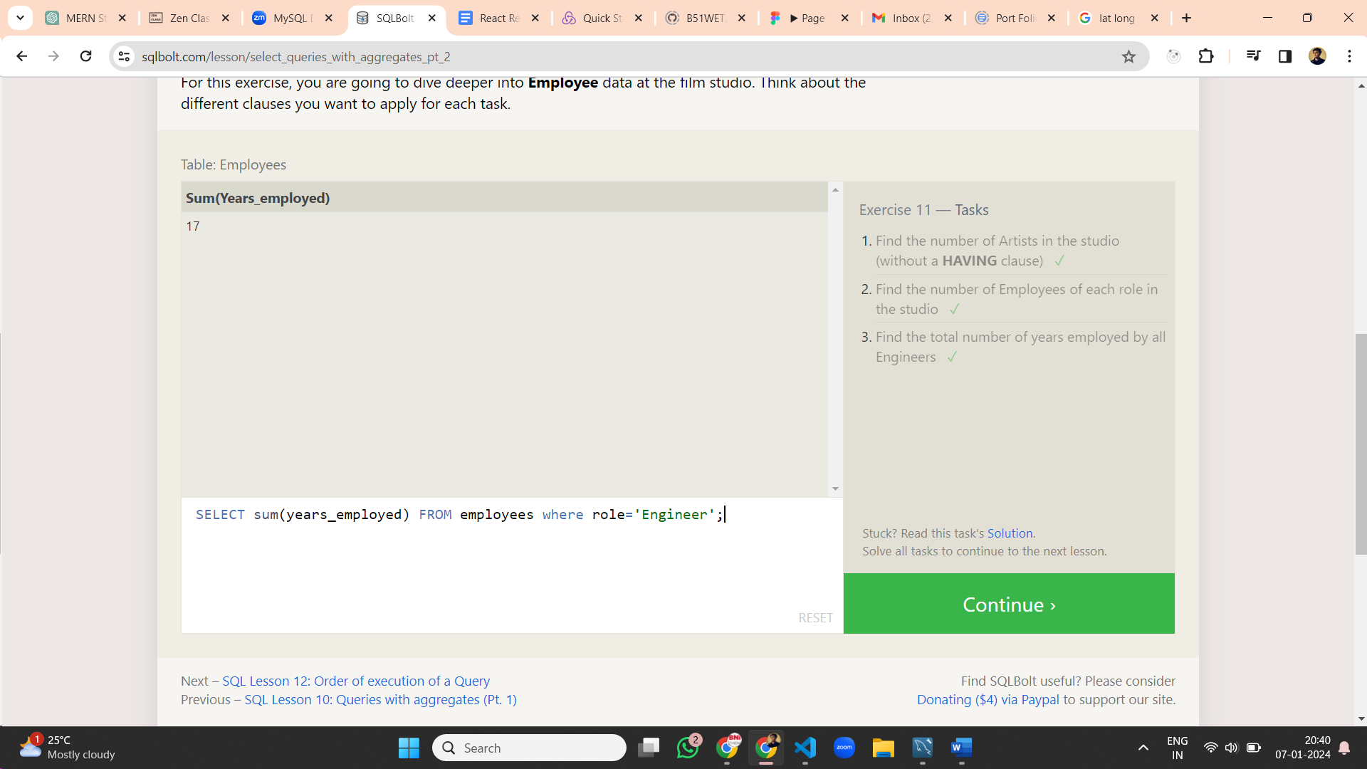**Lesson 11 Queries:**

1. SELECT count(*) FROM employees where role='Artist';
2. SELECT role,count(*) FROM employees group by role;
3. SELECT sum(years_employed) FROM employees where role='Engineer';

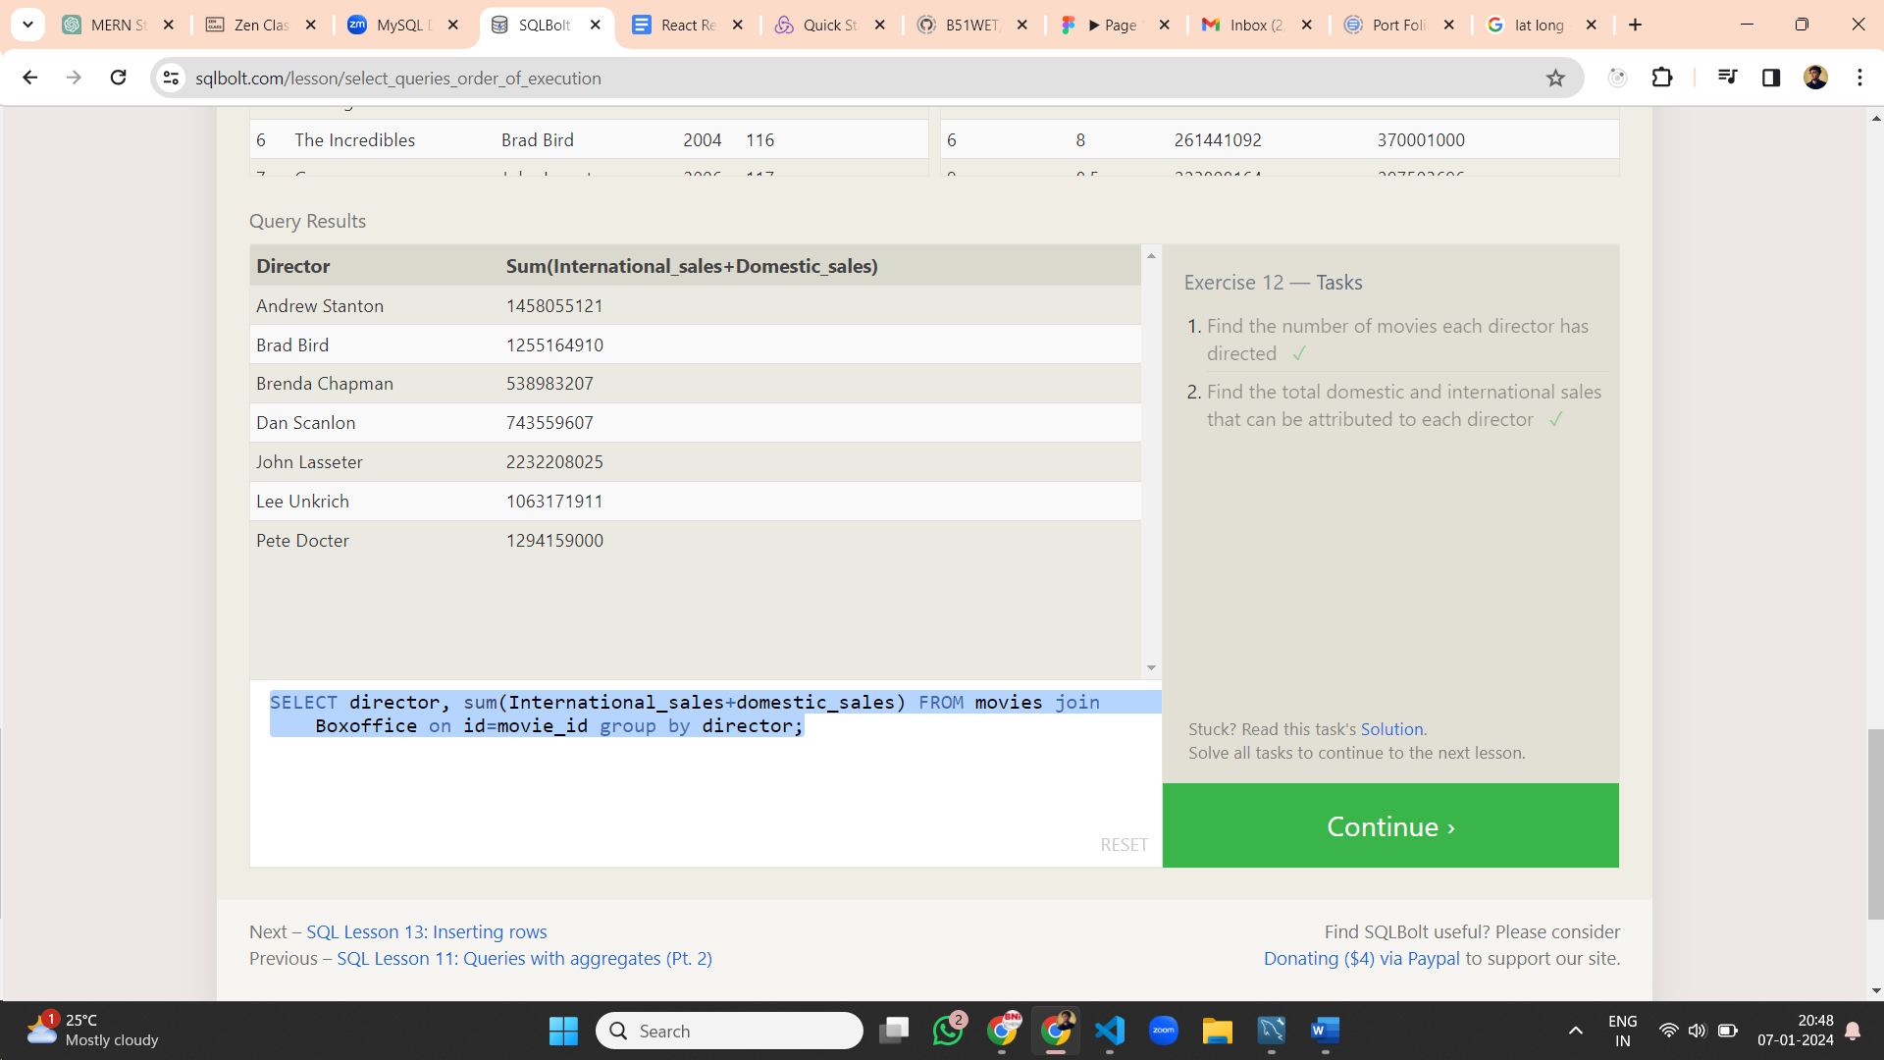**Lesson 12 Queries:**

1. SELECT director, count(*) FROM movies group by director;
2. SELECT director, sum(International_sales+domestic_sales) FROM movies join Boxoffice on id=movie_id group by director;

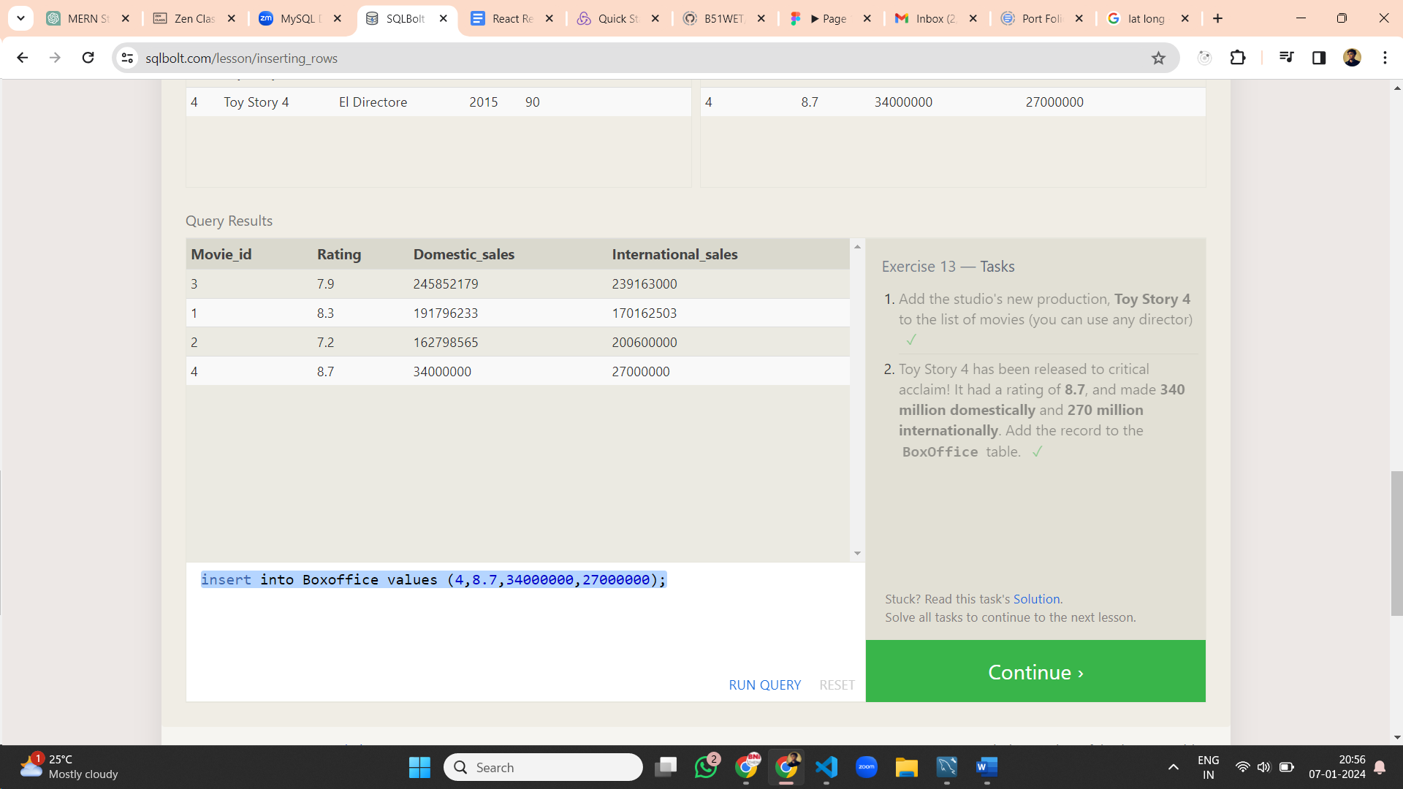

**Lesson 13 Queries:**

1. INSERT INTO movies VALUES (4, "Toy Story 4", "El Directore", 2015, 90);
2. insert into Boxoffice values (4,8.7,34000000,27000000);

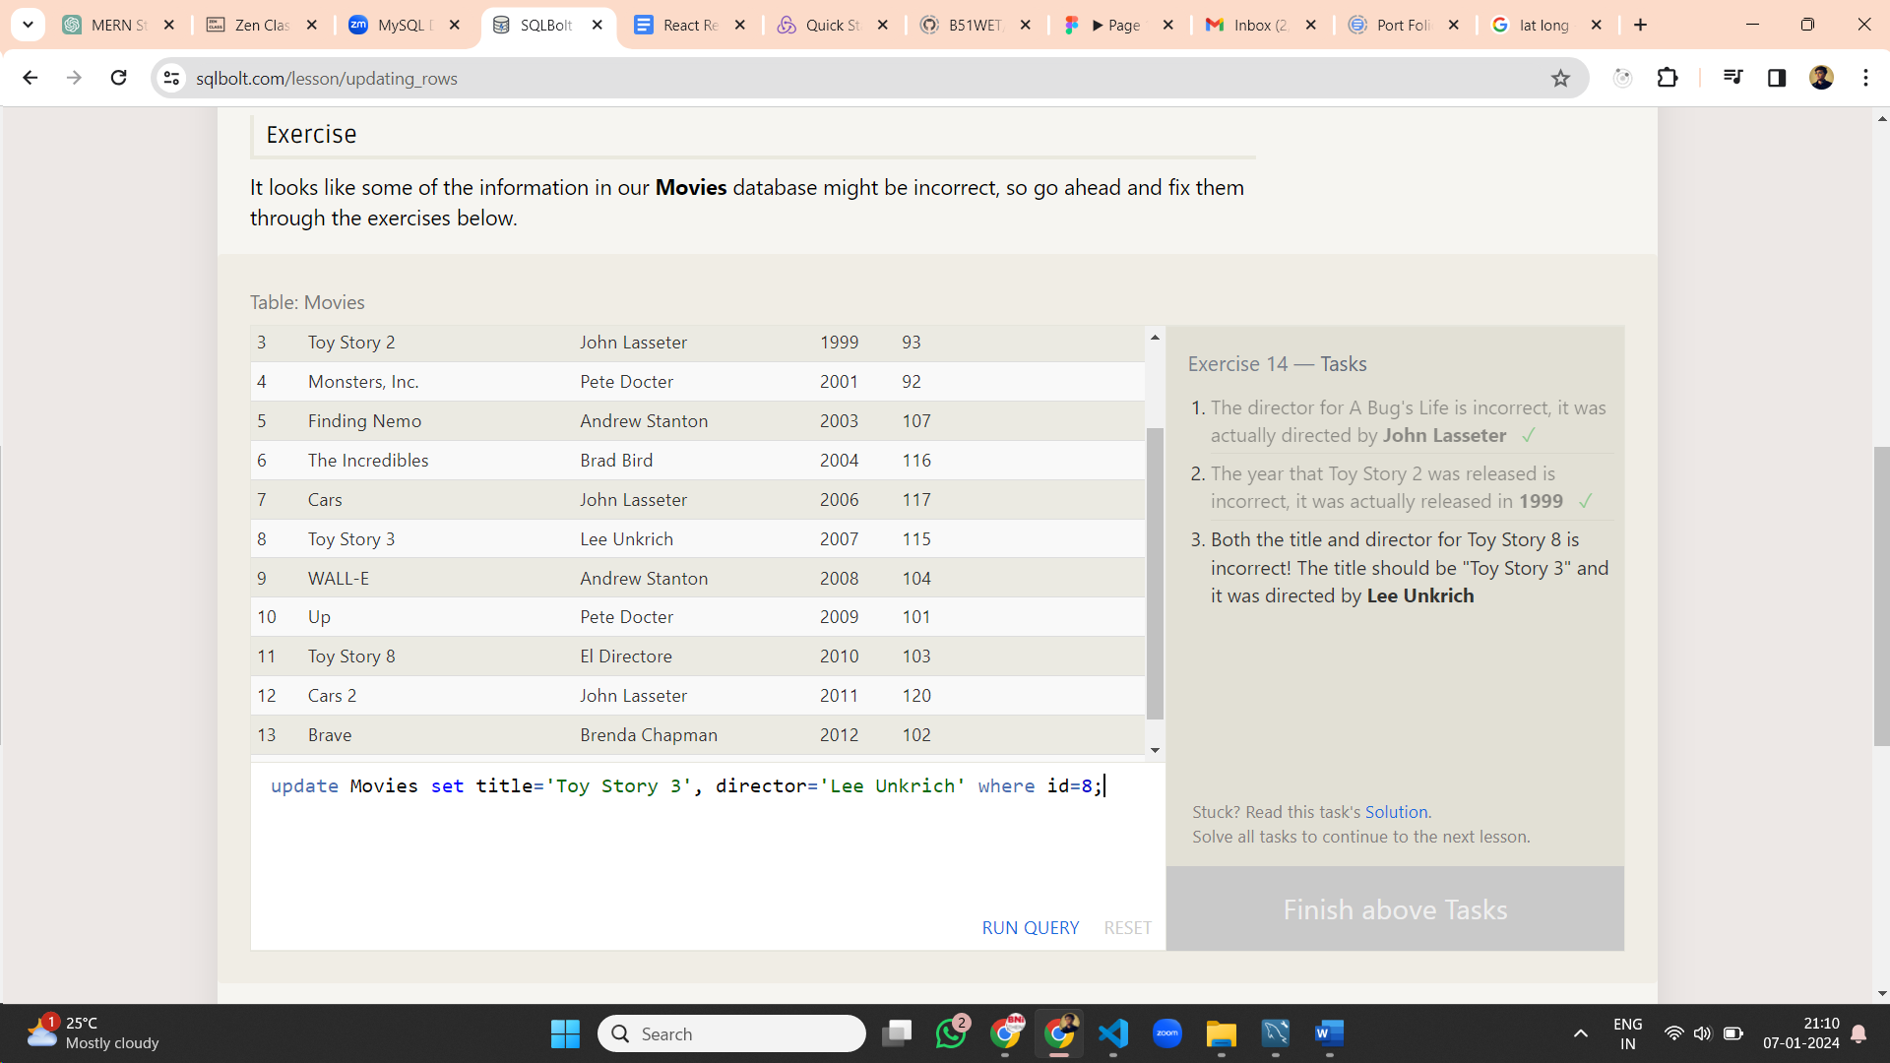

**Lesson 14 Queries:**

1. update Movies set director='John Lasseter' where id=2;
2. update Movies set year=1999 where id=3;
3. update Movies set title='Toy Story 3', director='Lee Unkrich' where id=8;

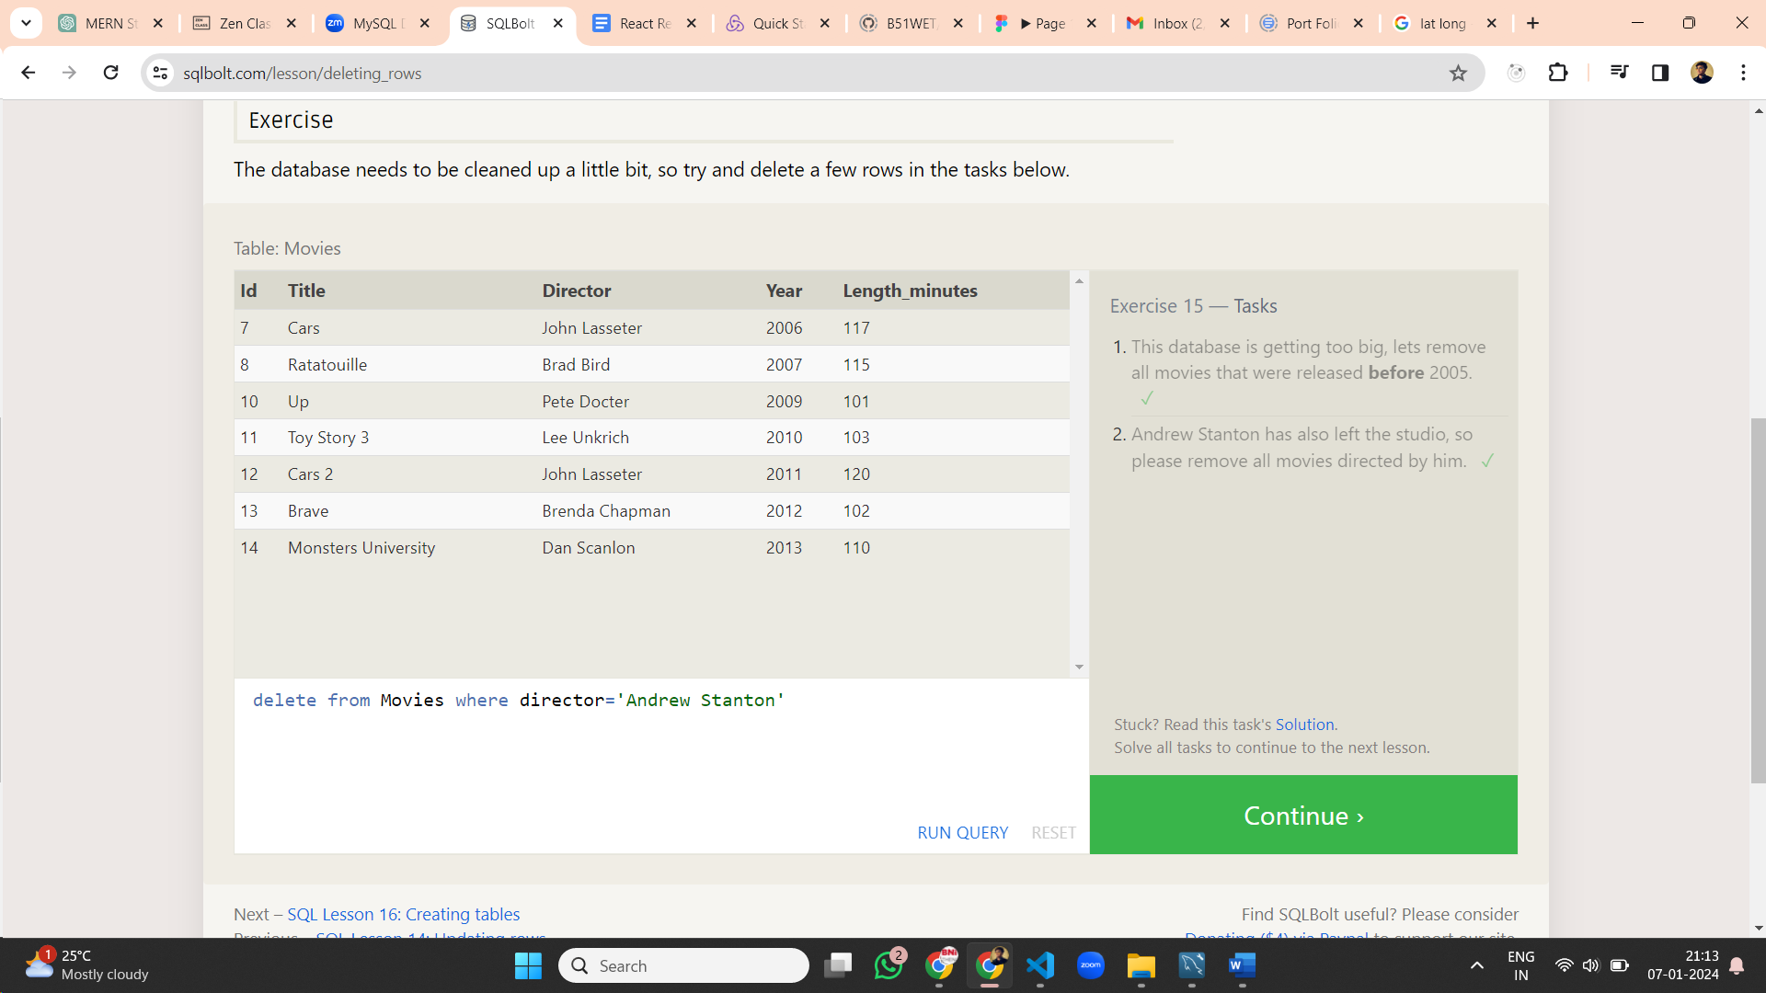**Lesson 15 Queries:**

1. delete from Movies where year<2005;
2. update Movies set year=1999 where id=3;
3. update Movies set title='Toy Story 3', director='Lee Unkrich' where id=8;

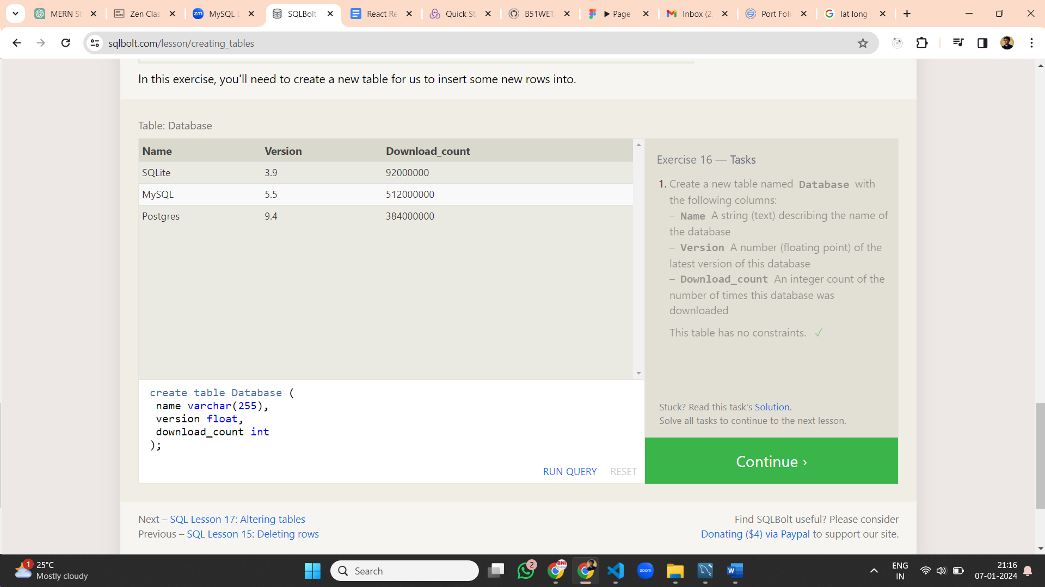

**Lesson 16 Queries:**

create table Database (

name varchar(255),

version float,

download_count int);

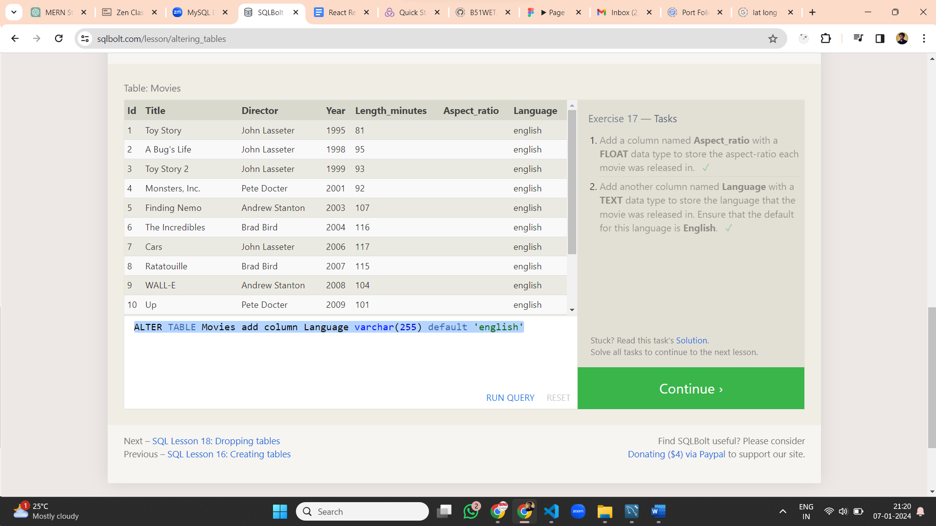

**Lesson 17 Queries:**

1. ALTER TABLE Movies add column Aspect_ratio float
2. ALTER TABLE Movies add column Language varchar(255) default 'english'

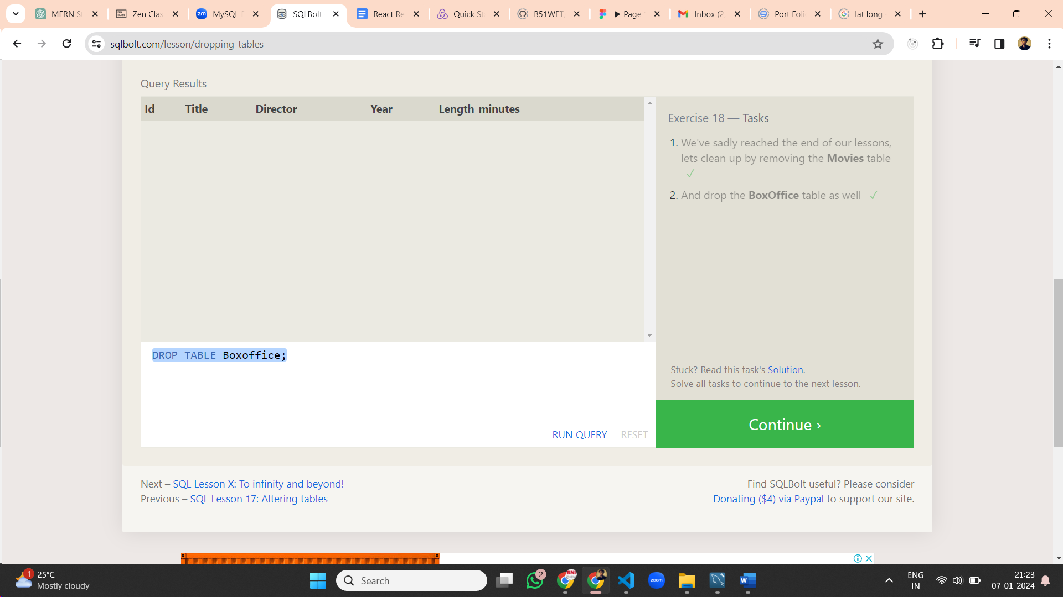**Lesson 18 Queries:**

1. DROP TABLE IF EXISTS Movies;
2. DROP TABLE Boxoffice;